Hi
First of all, I want to thank you for your purchase.
I have worked hard to make this package and thank you for choosing it
I ask you not share it for free so that I do not lose motivation for future updates.
I also ask you to ask your questions and problems from my email(aliyeredon@gmail.com) and try to not write a negative comment on the Store page. This drastically reduces package sales and reduces my motivation to update the package
Thank you

Video tutorials playlist on YouTube channel:
https://www.youtube.com/watch?v=mKi0jX2O2G0&list=PLVXvfvDWvto32hdpX_e-mkzhdgUWczkyK
After importing URP Lighting Box 2 and installing URP based on quick start guide, you can open it from Window->Universal Lighting Box 2 menu:
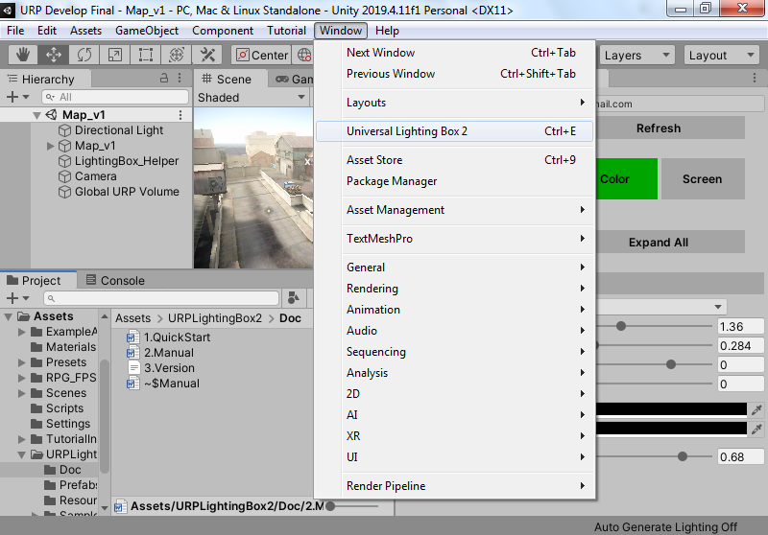

Now you can see Universal Lighting Box window inside Inspector:

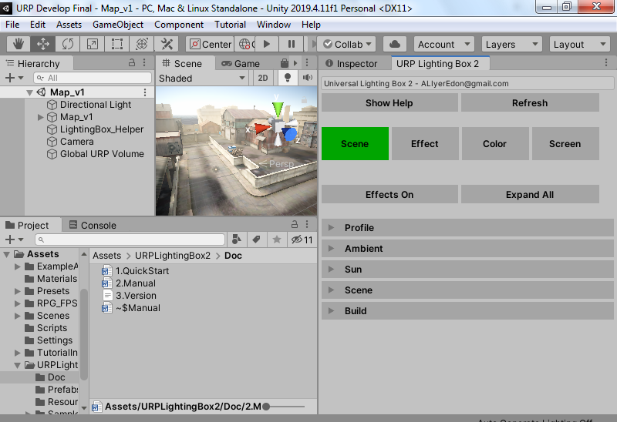
To use Universal Lighting Box 2 you must create an separate profile for each scene. It called Lighting Profile.
To create it, first you must save your scene. After that click on the New button in the Profile section of the Lighting Box. Now you must select a path to let Lighting Box to create an Lighting Profile and URP Volume profile for your current scene:
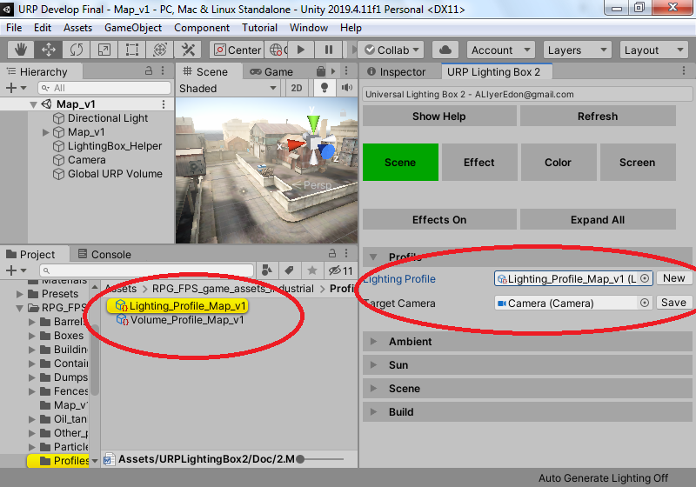
As you can see two game objects has been created in your scene:
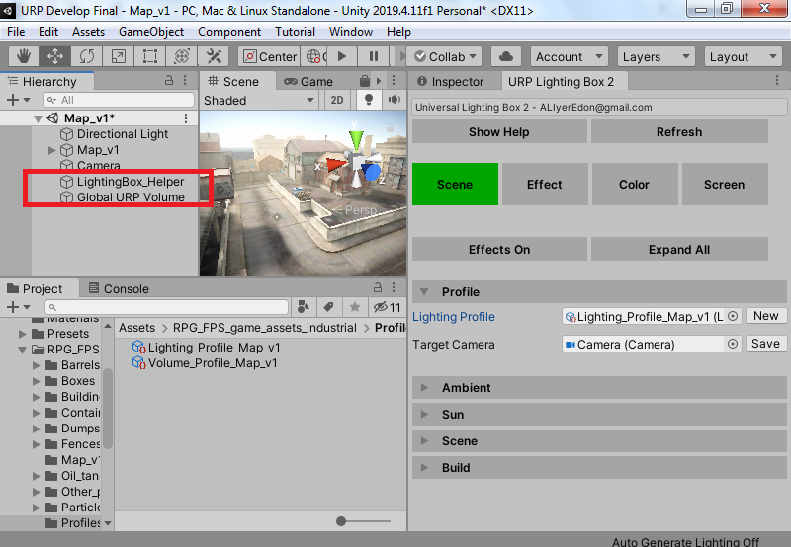
These objects is always available and creating when opening Lighting Box window. You can’t delete them when Lighting Box 2 window is open. You can disable Lighting Box Helper object when you don’t like to use lighting box at the future during play mode
Now you are ready to use Universal Lighting Box 2

Lighting box consists of four parts, You have to set these 4 parts in order at the beginning. After that, you can change any part to your liking
1.Scene 2.Effect 3.Color 4.Screen

Part 1: Scene
In this section you can adjust the general lighting settings of the scene. For example, Skybox settings, Baked or real-time lighting, and sun or moonlight settings.
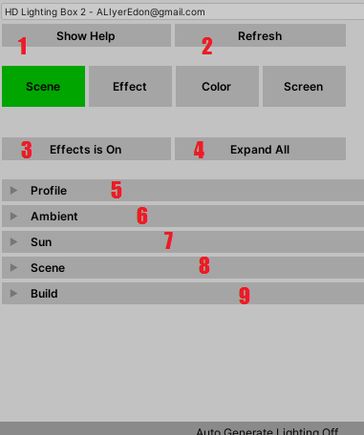
- Show Help
By clicking this button on any part of the lighting box, you will see helpful help
2. Refresh
After making changes during the game and returning to the scene, you can refresh the settings by pressing this button
3. Effects On
By pressing this button, you can turn the effects on or off in the scene
4. Expand All
By pressing this button, you can open or close the settings section of the Lighting box parts generally
5. Profile
In this section, you can create a profile for each of your scenes. You have to do this for each scene
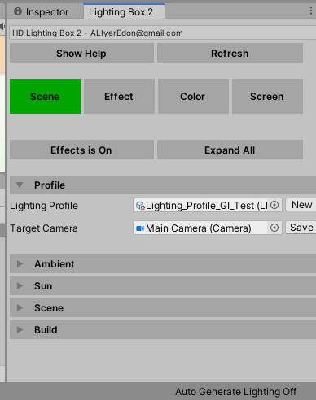
Lighting Profile: View or edit the current scene profile
Target Camera: Which camera is affected by the effects?
6. Ambient
In this section, you can make the Skybox settings
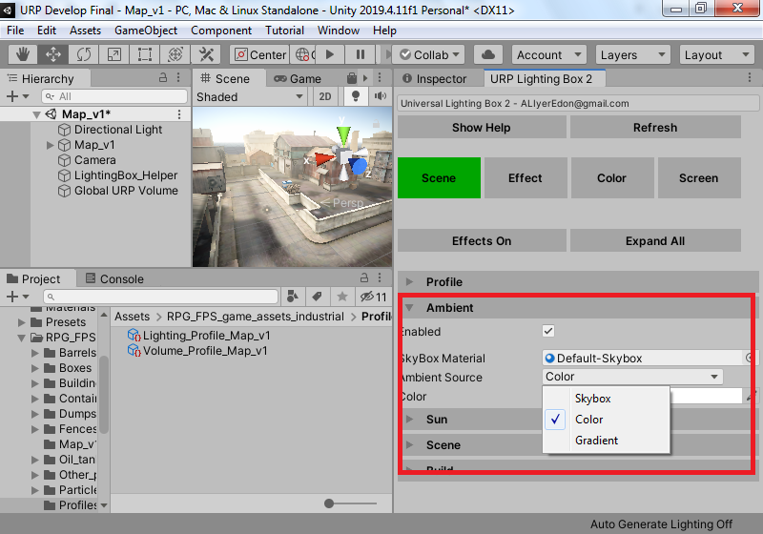
Default is Color mode that has been used a simple color(HDR) as sky light and an simple material as sky box. Watch the video to learn how to create and set up a cube map as sky box:
https://youtu.be/bta10oJsDiw
Search google for free HDRI sky box download

6. Sun
7. In this section you can assign sun or moon light (an directional light) and adjust its settings
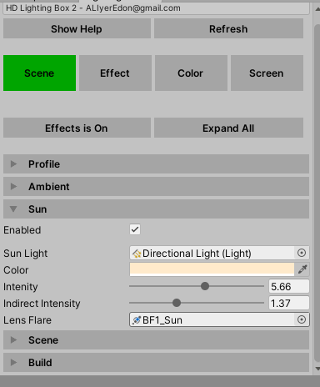
Enabled: By activating this option, sunlight will be applied based on the settings of the lighting box window. Disable this if you want to use personal settings yourself
Sun Light: An directional light as sun light. Will be found automattilly by lighting box
Color: Sun light color
Intensity: Sun light intensity
Indirect Intensity: Indirect intensity for light mapping. Only works on Realtime or baked GI mode.
Lens Flare: An lens flare for your sun light. Watch my video in YouTube to learn how make lens flares:
https://youtu.be/kSG1NTS6RxM
8. Scene
In this section you can set the general lighting settings of the scene
By the way, for example, real-time or baked lighting
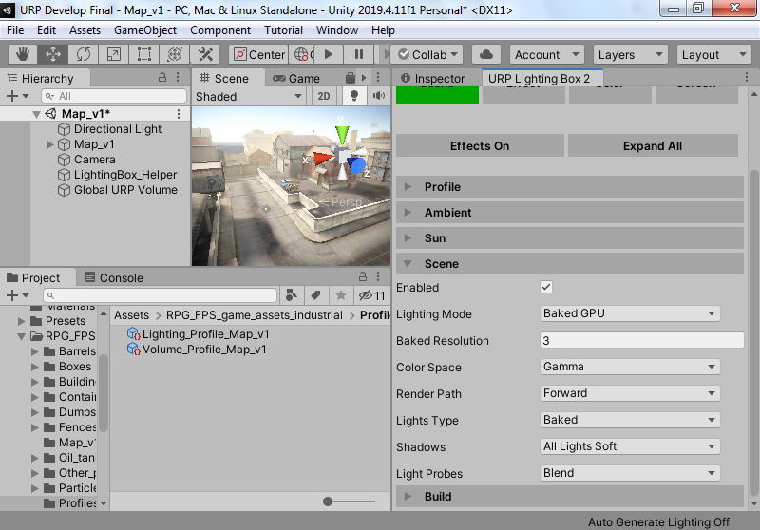

Enabled: By activating this option, your scene lighting settings will be applied based on the settings of the lighting box window. Disable this if you want to use personal settings yourself
Lighting Mode: use this to switch between lighting mode like Realtime GI, Baked GI(CPU and GPU) or Fully realtime or mixed of them
Baked Resolution: Adjust scene lightmapping resolution. Higher make your bake time longer and have cleaner lightmaps
Color Space: Define color space for your project. Gamma is much faster than Linear for low end devices with no difference (you can fix Gamma mode color issues in the Color Grading section)
Rendering Path: Currently URP only supports forward rendering path. It’s good enough for baked and low end targets
Lights Type: Change all scene light’s type to this option
Shadows: Change all lights shadows settings in the scene quicklly
Lights Probes : Select scene light probes mode automatically
9. Build
In this section, you can use Lighting Box useful actions:
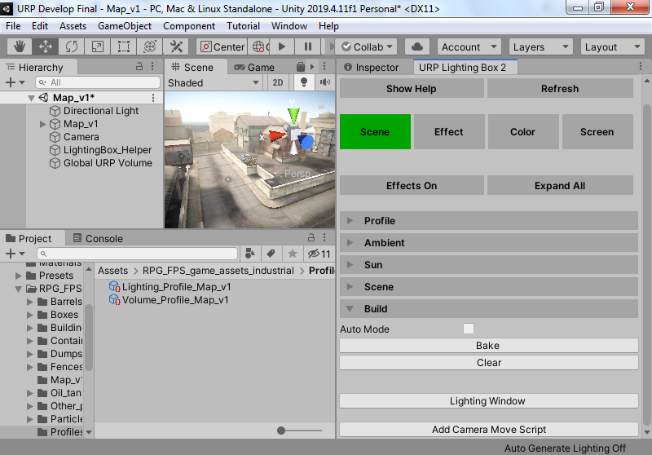
Bake & Clear: Bake or clear light mapping data or Reatime GI data
Lighting Window: An shortcut to open lighting window from Window->Rendering->Lighting Window menu
Camera Move Script: Add an camera movement script to control game view like scene view camera

Part 2: Effect
In this section you can add different effects to the scene. Watch my videos in URP Lighting Box 2 play list to learn how it works for more detail descriptions
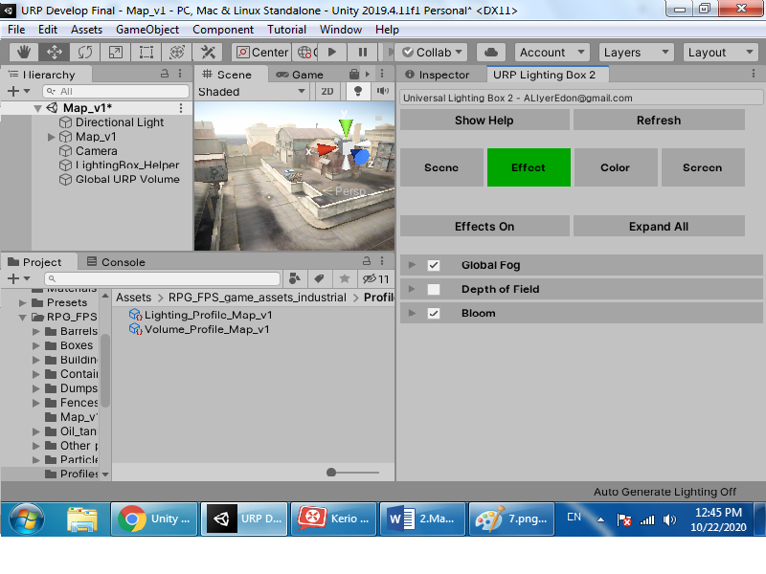
- Global Fog
Add fog effect into your scene
2. Depth of Field
Add depth of field effect into your scene
3. Bloom
Add bloom effect into your scene

Part 3: Color
In this section you can add color settings such as brightness and shadows to your game. Watch my videos in URP Lighting Box 2 play list to learn how it works for more detail descriptions
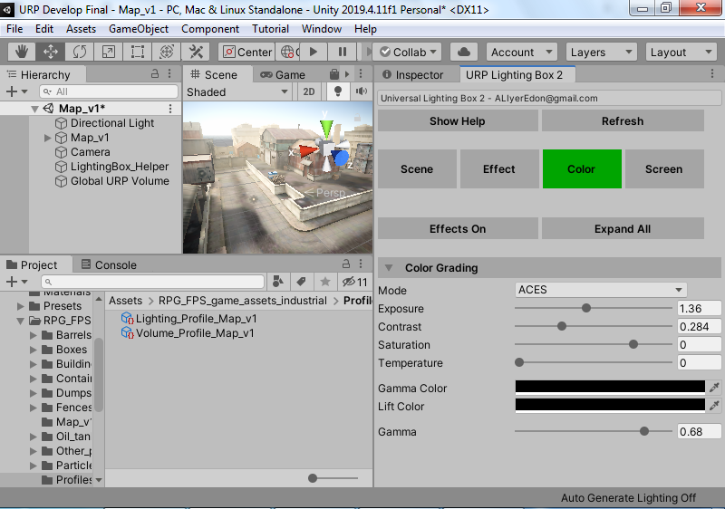
Color Grading
Customize color grading settings for your scene

Part 4: Screen
In this section, you can add the final effects to your game. Watch my videos in URP Lighting Box 2 play list to learn how it works for more detail descriptions
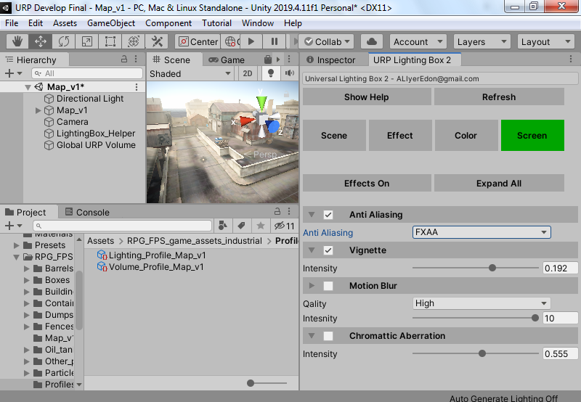
Anti-Aliasing
Select AA mode from your camera
Vignette:
Add vignette effect for your volume component’s profile
Motion Blur:
Add motion blur feature works for Camera and moved objects
Chromatic Aberration:
Add chromatic aberration effect for your volume component

I hope you have these explanations
I recommend watching the videos in the YouTube playlist to learn how to use Lighting Box 2 in practice:
https://www.youtube.com/channel/UCKGKwkmZagsc0QKTkWn_w-w?view_as=subscriber

