AS5

**A20423189**

1

1. An outlier is a data point that diverges from an overall pattern in a sample. It influences the model fitting estimation and leads to not fitting the right model. Hence, we need to use algorithms to detect outliers and discard such points before model fitting.
2. Objective function of robust estimation:



Differences:

In standard least square objective function, Outliers will have higher value and influence the model more.



However, in robust estimate objective function will lower the influence of the outliers.



1. German-Mcclure estimator.



Advantages:

It will lower the influence of the outlier.

Captures the error points and reduces their effect on the objective function.

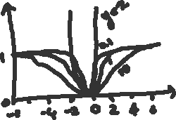

It has an upper bound.

If 6 is smaller, smaller valley, the model becomes more selective to outliers.

1. Principle of RANSAC algorithm:

Repeat k times:

* Draw n points uniformly at random with replacement.
* Fit a model to points.
* Find inliers in entire set with distance less than t.
* Recompute model (if at least d inliers)
* Update parameters (k, t).

Number of points drawn at each attempt should be small in a hope that atleast one set will not have any outliers.

1. Parameters:

N = # points drawn at each evaluation.

D = min # points needed to estimate model

K = # trails

t = distance threshold to identify inliers.

w =

(1-p) = (1 – wn)k  => log( 1 – p) => k log(1-wn) => k

1. Objective of Image Segmentation:

Separating foreground from background.

2 Approaches of segmentation.

* Agglomerative(merge)

Start with each pixel in a separate cluster. Merge cluster with small distance. Repeat while cluster are not satisfactory.

* Divisive(split)

Start with all pixels in one cluster. Split cluster to produce large distance between them. Repeat while clusters are not satisfactory.

1. k-Means:

* Select k
* Select initial guess of means:m1, m2, m3, m4.
* Take each pixel, choose closest cluster center and label. Recompute mj
* Repeat until mj change.

Mixture of Gaussians:

Instead of using d = || fi – mj||2 as the evaluation of distance it uses d = (fi – mj)T ∑j (fi – mj)

d = Mahalanobis distance

mj =Mean of clusters.

j = covariance of cluster.

1. Mean shift



Similar to k-means. The mean computation is replaced with a weighted sum based on distance from center.

2

1. Forward projection: Given world points P and translation matrix M, compute image point p.

Calibration: Given some points in real world with co-ordinates, compute some points in image with co-ordinates such as focal length, size of pixel, external translation and rotation.

Reconstruction: Given the image points p, compute the world points P.

Forward projection is the easiest and reconstruction is most difficult.

1. Necessary input for camera calibration:

Corresponding points.

Image points in pixel and world points in meters.

1. Steps:

1.Find projection matrix M

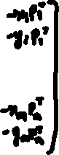

The is a homogenous equation. The projection matrix can be estimated using SVD.

A = u d vt

Solution is the column of v belonging to zero singular value.

2.Find parameters from M like K*, R* and T*

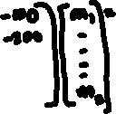

1. Need at least 6 points pairs to get matrix M. i.e. For each point 2 equation with 12 unknows hence needs at least 6 points.

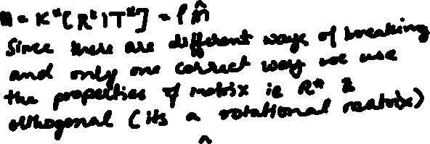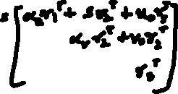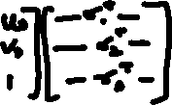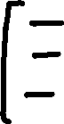

1. In order to perform planar camera calibration, we need to show the view to the camera for more than one time, minimum of three times to calibrate for planar.

* Estimate 2D homography (Projection Map) between calibration plane and image(for several images.
* Estimate intrinsic parameter
* Compute extrinsic parameters for view of interest.

Planar solve 2DH points, Non-planar solve 3DH points.

In non-planar calibration, it uses 3D image as calibration target. So, we need to find the pixel of all the corners and based on these values camera calibration is done. While in planar, a single plane picture is used with different views.

1. Difference between homography and projection matrix.

Homography : Projects a 3DH world point to a 2DH image point.

Projection Matrix: Projects a 2DH world point to a 2DH image point.

