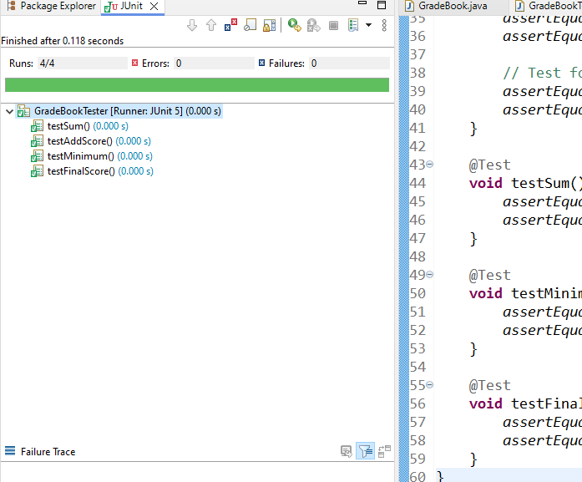

**Screenshot expanded above**

**Jedidiah Dawit CMSC203 LAB 3**