Ai-pixels software called aiNodes

Dokumentation

Inhalt
Installation 4
Startup 5
Create your first images 6
Low Memory 6
Dream Button 6
The Prompt text field 6
I Have a Lucky day Button 9
Advanced Options 10
Stop Button 10
Width and Height 10
HiRes Mode Checkbox 10
HiRes Strength 10
Steps 10
CFG (sometimes it also gets called Scale) 11
Preview Mode 11
Negative Prompt 11
Weighted together with Normalized 13
Multi Dim Prompt 13
MD Seed Mode 14
Clean Memory Button 14
Sampler checkbox 14
Sampler Drop Down 14
Model Drop Down 20
VAE Drop Down 21
Hypernetwork Drop Down 25
Seed Text field and Mode drop down 25
Batch 25
Samples 25
DDIM ETA 25
Speed/Ram checkbox 26
Live checkbox 26
Karras / Sigma Min / Sigma Max 26
Output Options 26
Init image setup (img2img) checkbox 27
Mask image setup 28
Outpaint 29
Plotting 29

Installation

This product does not yet have a sophisticated installer mechanics.
So you have to follow the few but very simple installation steps
- Install Conda, download from here https://docs.conda.io/en/latest/miniconda.html
- Install [git](https://git-scm.com/download/win).
- Once Conda is installed start the conda prompt
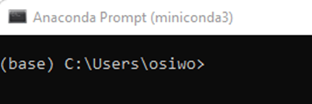
- from within the conda prompt you follow this steps:
- Cd to your copy of aiNondes
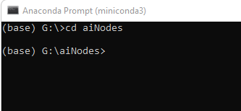
- Run clean_install.bat as normal, non-administrator, user.
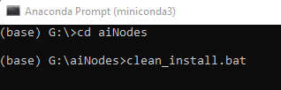

This will run quite a while and do all the necessary steps to get the application installed and finally started for the first time.

- First start
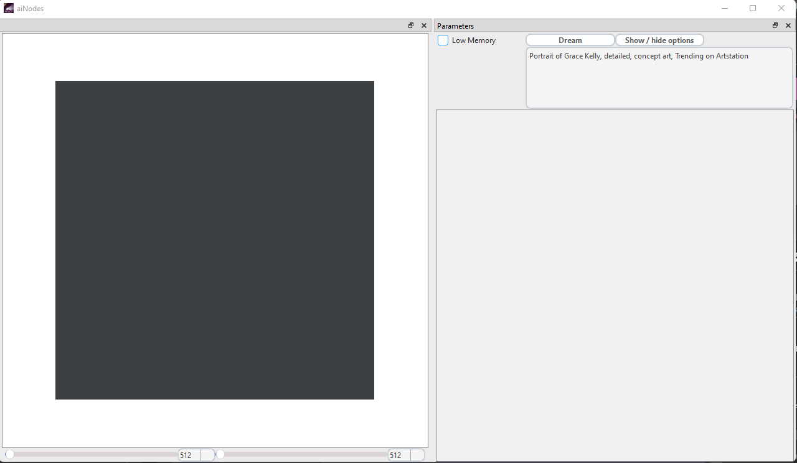

Startup

After the setup was done and you may have done youre very first steps in using aiNodes the time will come when you shutdown the application and want to restart it again, for this you run start.bat from within the conda prompt
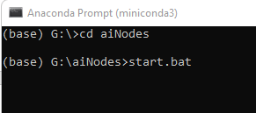

Create your first images

On the startup screen there is very limited UI elements. We did this intentionally to not to scare you directly at the first run. The number of checkboxes and values can be overwhelming at first, but you will get used to it quick.
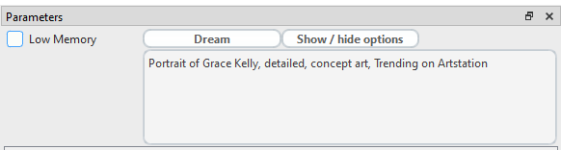

Low Memory
Enable low memory if your GPU has only very limited VRAM. We advise to use this on RTX 2060 cards with 6GB of VRAM if other applications are using VRAM too. Using the application on a RTX 2060 should be possible with no low memory activated if no other application is using VRAM.

Dream Button
The dream button is used to generate the images, feel free to click it and you will see your images appear shortly after. The first time you click the dream button after start or after changing the model takes a little extra time as the model has to be loaded into your GPUs VRAM, it depends on your HDD/SSD how fast that process will be, those model files are quite large so expect it to take a little time. Once the model was loaded and the image was rendered it will show up like for example this image
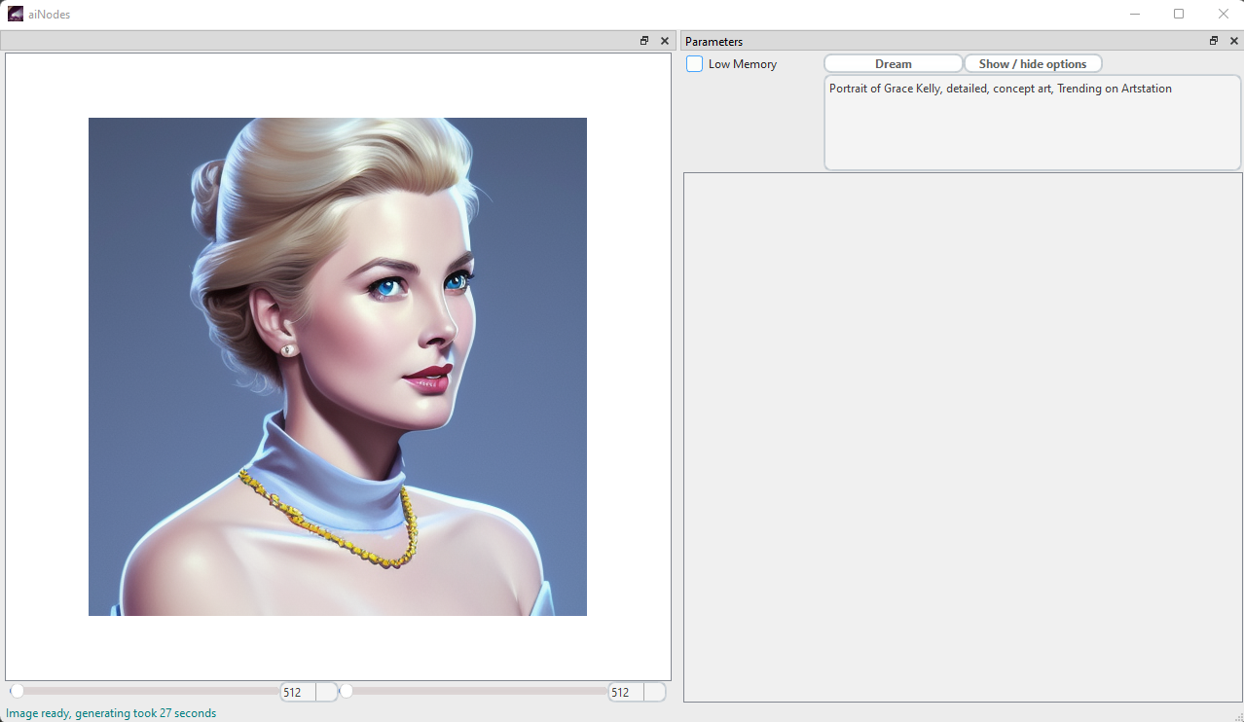

The Prompt text field
Here you enter the text describing the image you want to see as detailed as possible. The more exact and detailed you design your prompt the better the results will get. It has become a form of art to generate those prompts. But we got you, there is a few little helpers which will help you find a prompt that fits your needs, the helpers go from a AI some search engines for prompts as well as image to prompt. You will see the start into the world of text to image will be soft.
Here you see just a few examples of what proper prompts can achieve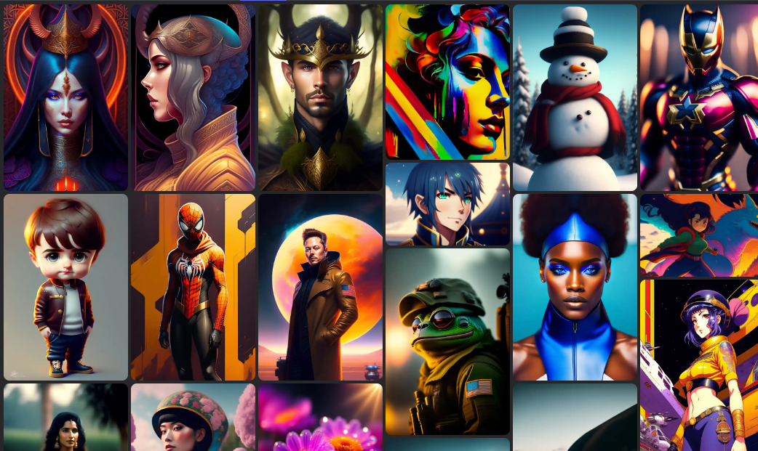

You will get there; trust us. We help you all the way.
Just as a little contrast, if things go south it might look like this
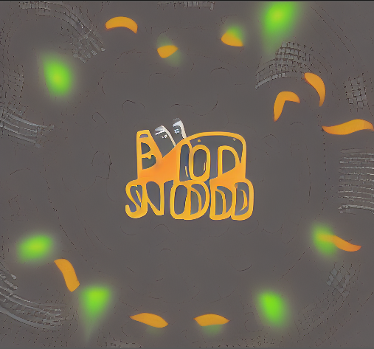

Here are a few numbers to give you a hint what kind of generation power is at your fingertips now.
For each single prompt you can do 2^32 Images that alone is 4’294’967’296 images. It is ~4.2 billion images for each single prompt. Just think how many prompts there is and multiply that with 4.2 billion, the idea of the number alone is mind blowing.
But…
Then there is 4 additional Layers of style helpers you can add to the process, this number of those helpers is growing as you read the text here as well as you are able to create those helpers yourself.
On top of that there is a ever growing number of models around which again will multiply your possibilities. In the end you are very close to a infinite number of images the application can generate for you. Again, you can also create models by yourself.
This very very large number of possibilities is good and bad news. Sometimes it will take you some time to generate the best image from a prompt. Check the document about prompting to get some hints and help.
But it also means that other people using the same app and tools as you do will have a very hard time to copy your images, there is so many parameters which are involved in creating a single image that it is near to impossible for someone not knowing those parameters will be able to reproduce your work.
So yes, it is an AI everybody can use, but the possible number of images is close to infinity it is like winning a lottery to be able to blind reproduce someone others images. You can feel confident to create and sell those images as there is not many people if not zero who are offering the exact same image as you do. When choosing from custom models please check the licenses before you start selling images, some models don’t allow commercial use. Other models even allow you to sell the model as such.
Welcome to a new world of ready to use images and/or just a machine producing ideas at a rate no human could ever have done.

I Have a Lucky day Button
We named that button after a button from some popular search engine. The idea here was that the app is very powerful but only after you start looking deeper, so with clicking this button you open the door into the more powers of the application. Once you clicked the button you will see this.
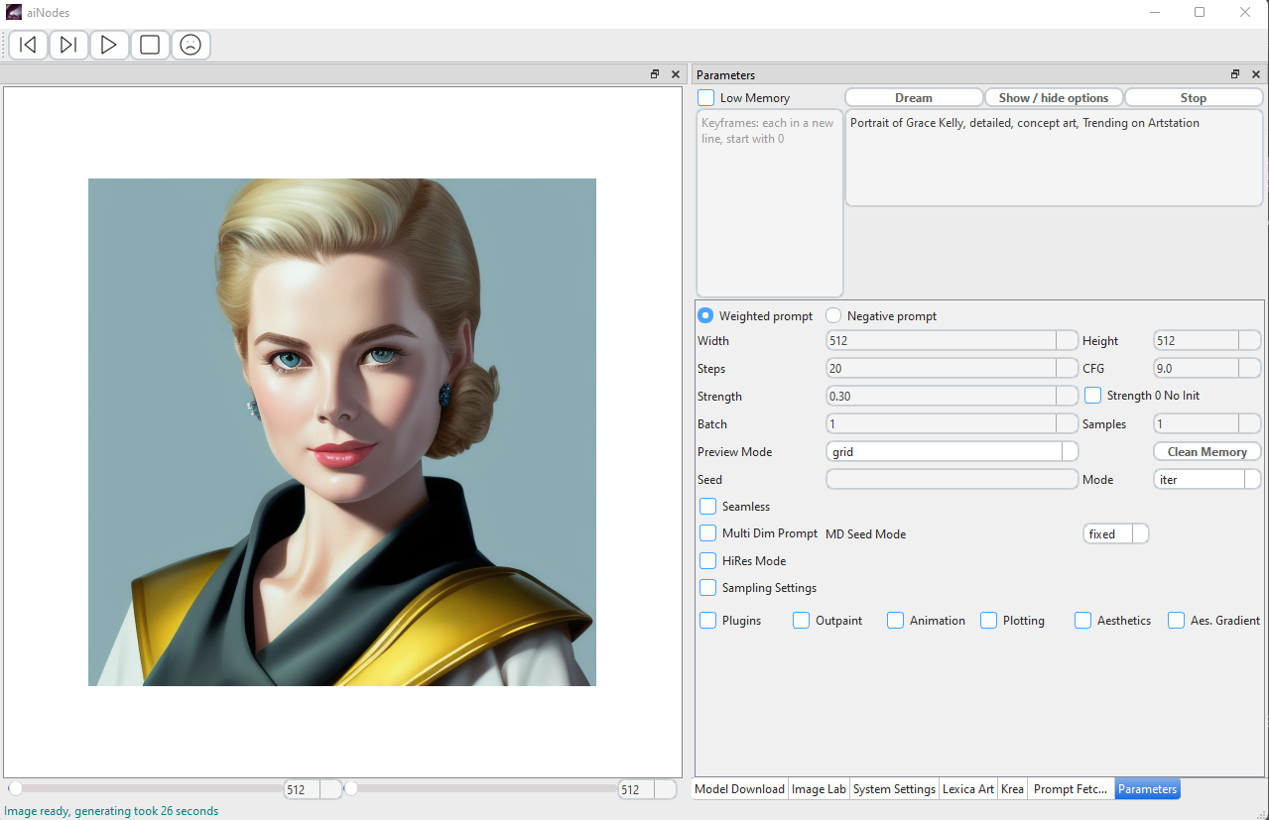

Its much more to see but we still hide things so you can choose what you see based on what is your need to achieve the things you want to do.
If you click the button again you go back to the very simple view from at the startup.

Advanced Options

Stop Button
The stop button is used when you like to stop larger batch jobs or rendering animations. It will not immediately stop the rendering but it will stop the process with the next iteration, so the image which is in progress of being rendered will be finished first.

Width and Height
With this you control the image size, the maximum for now is 2048 minimum is 256.
The size has to be dividable by 64 therefore the steps are 64 when you klick the little up and down buttons.
The larger the image gets the more VRAM hungry the calculation get, it grows fast. Find the limits of your machine.
Also be aware that 1.x Models have been trained with images of 512x512 and so they are very good at producing images at that scale. If you produce larger images it tends to replicate the prompt multiple times instead of producing just a larger image. For 2.x there is models that have been trained at 768x768 so there you can produce 768x768 with no risk of replication. It still needs plenty VRAM.

HiRes Mode Checkbox
If you use the hires Mode checkbox it will produce an image at a lower resolution like 512x512 and then scale up the tensors to the resolution you have selected, this way you can render images much bigger then 512x512 with a 512x512 only model without the risk of replicating. It takes more time as it is two processes and it will also use some more VRMA then just 512x512. It is not upscaling that’s a different technique

Steps
With this you control the denoising process, the simple rule is, more steps more better results. It just takes more time. There is people who do render images at 200 steps and others who say 60 is more then enough. It is up to you, you decide what quality the images have to be.
Also the schedulers or sampler however you want to name it have different results at different numbers of steps. DDIM for example has kind of good results at 30-40 steps but DPM 2 Ancestral starts to produce good results beginning with 70-80 steps and is also much slower then DDIM.
You have to experiment what is best for your situation.
If you have to do batch image processing to get a few from a large number of images there is two different strategies to do so, here is examples how they impact the time you spend
At 60s per 100 steps.
A) 60s * 100 images = 6000s (100 images at -s100, manually picking 3 favorites)
B) 6s 100 images + 60s 3 images = 780s (100 images at -s10, manually picking 3 favorites, and running those 3 at -s100 to polish details)
The result is 1 hour and 40 minutes for Variant A, vs 13 minutes for Variant B.
With Variant B you spend less time to get the same results. Maybe it takes some experience to see which are the good results out of the images with low steps.
This gives you an idea what the number of steps can do. In this case it is Grace Kelly at 1, 5, 10, 15, 20, 25, 30, 35, 40, 60, 80 steps

CFG (sometimes it also gets called Scale)
CFG stand for classifier-free guidance scale and so sometimes the short version is just scale. This is a number which decides how hard the AI has to follow the prompt the lower the number the freer the AI is to add more randomness to your prompts output. The higher the number is the stricter the AI will follow your prompt.
If you want to use this in multi dim prompts it is called --scale

Preview Mode
Preview mode is to select if you want to see a grid of images presented on the canvas or if you just get a single image all the time and the old image gets deleted from the canvas once you render a new one.

Negative Prompt
This enables a second prompt field; in there you type everything that you don’t want to have in your image. You put it like “cats” if you don’t want to see cats for some reason don’t put “no cats” or “not cats” as this if negative means you want cats.
Negative Prompting became much more relevant with 2.x models there its like a must while with 1.x Models it was a feature to play with in the beginning until it was found quite useful which might be the reason why 2.x is relying on it so much

Here is some samples of how to use negative prompting to get different results.
(source : https://getimg.ai/guides/guide-to-negative-prompts-in-stable-diffusion)
Guide to negative prompts in Stable Diffusion
How to use negative prompts in Stable Diffusion.
The negative prompt is a parameter that tells Stable Diffusion what you don't want to see in the generated images. When specified, it guides the generation process not to include things in the image according to a given text.
A negative prompt may prevent generating specific things, styles or fix some image abnormalities. Let's look at examples comparing the same images with and without negative prompts:

Removing 'moss' from the 'elven forest':
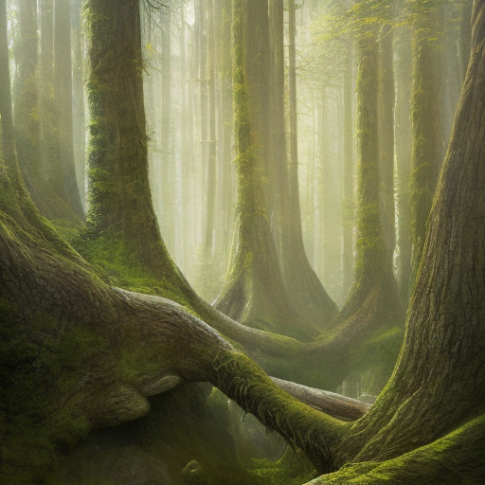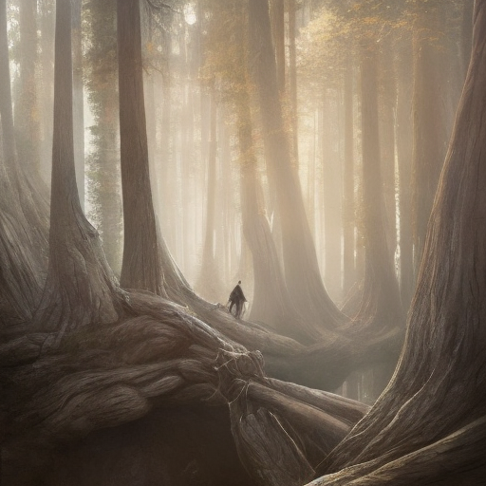
Without negative promptNegative prompt: 'moss'
Removing 'duplication artifact' from 'portraits':
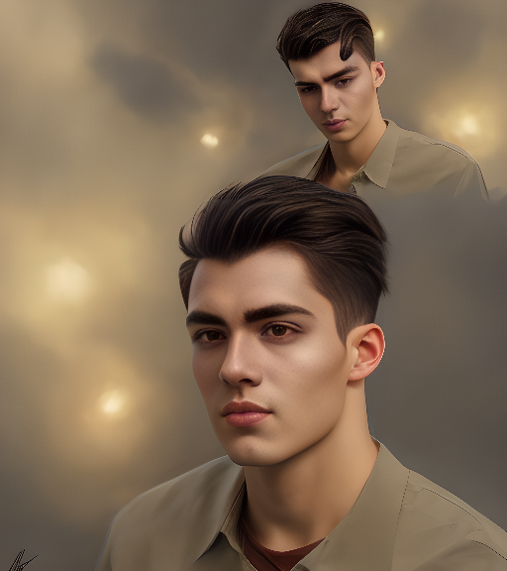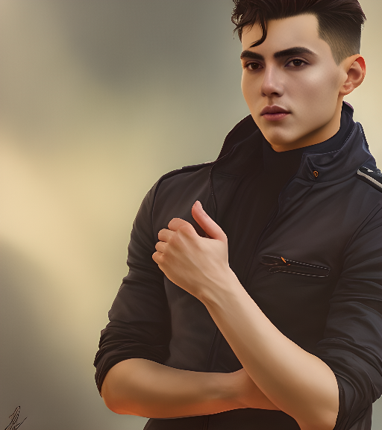
Without negative promptNegative prompt: 'duplicate'

Changing the image style completely and adding more light with a longer negative prompt:
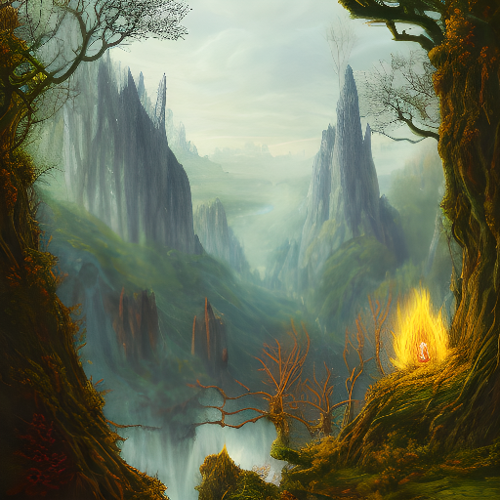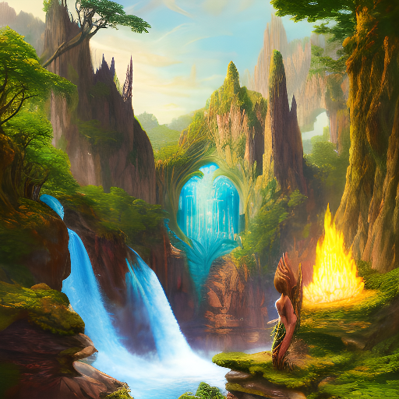
Without negative promptNegative prompt: 'fog, darkness, grain'

Weighted together with Normalized
Weightes is a different form of prompting, you can give things a weight to make clear how important you think that part of the prompt is. You do this by some prompt:1 or some other prompt:-1 (negative prompting again) Normalized will make the sum of all weights 1 which it has to be or you run into very strange result situations, normalize will calculate the correct numbers based on what ever you entered to be 1 in the end, the dimensions of your numbers will be preserved as hard as possible.

Multi Dim Prompt
The full name would be multi-dimensional prompt
This is a very powerful tool in case you need to see what setting has what impact to your image. With a very simple syntax in the prompt you can render multiple versions of the single prompt based on different setting situations. You can add as many settings as you want, but you have to be aware it will generate a single image for each and every possible mix of the given settings.
A simple example is:
Elvis Presley on stage –steps=10,20,30,40
This will result in 4 Images with each has a different number of steps, this way you can see how much steps might be needed for the larger batch of such images
Two settings will be like
Elvis Presley on stage –steps=10,20,30,40 –seed=1,2
This will produce 8 Images for each steps it will produce 1 image with seed 1 and a second one with seed 2
3 Settings
Elvis Presley on stage –steps=10,20,30,40 –seed=1,2 –scale=7,8.1,8.2
This will produce 24 Images
You see the number of produced images is growing fast here, be careful what you do.

MD Seed Mode
With this you set the seed to fixed for multi dim prompts, this helps to see the difference the settings alone do. You can also choose iter or random. Iter will start with a random seed or the given seed and does +1 all the time. Random will produce a random seed value for each image. Changing seeds make it very hard to understand what the impact of the settings was. Therefore, fixed is the default.

Clean Memory Button
This button will execute a garbage collection to help free some more memory. It will only clean memory allocated by the application, memory used by other application stays untouched and does not get cleaned even if cleaning would be possible. This application does have no access to any other applications memory.

Sampler checkbox
This will open the settings for anything related to the sampling process or rendering, what every you like to call it. If you enable that checkbox additional settings get displayed.
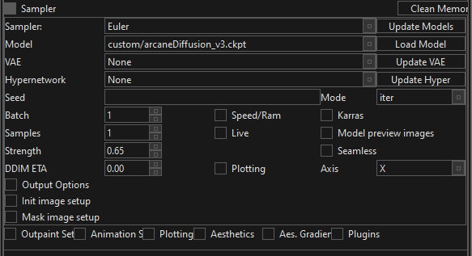

Sampler Drop Down
Here you select the Sampler/scheduler to be used for generating the image.
There is quite a number of samplers and they all do something a little different, there is vast amounts of scientific papers describing what each sampler does, we keep it simple here and tell you just a few very simple things about some of the samplers. It is up to some try and error to find which sampler fits your workflow best.
The possible samplers are:
Euler
Euler Ancestral
LMS
DPM 2
DPM 2 Ancestral
Heun
DPM Fast
DPM Ancestral
DPMPP SDE
DPMPP 2S Ancestral
DPMPP 2M
DDIM
PLMS
Here is a comparison found in the internet
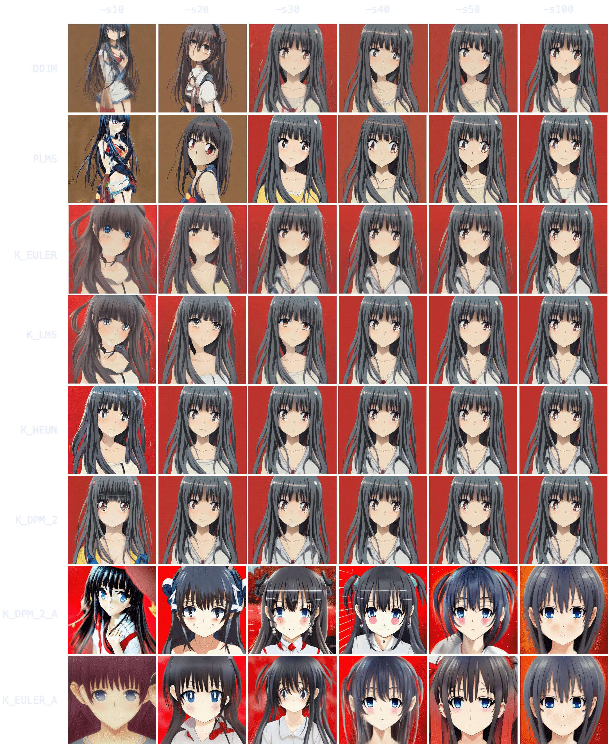

How does it look for landscapes
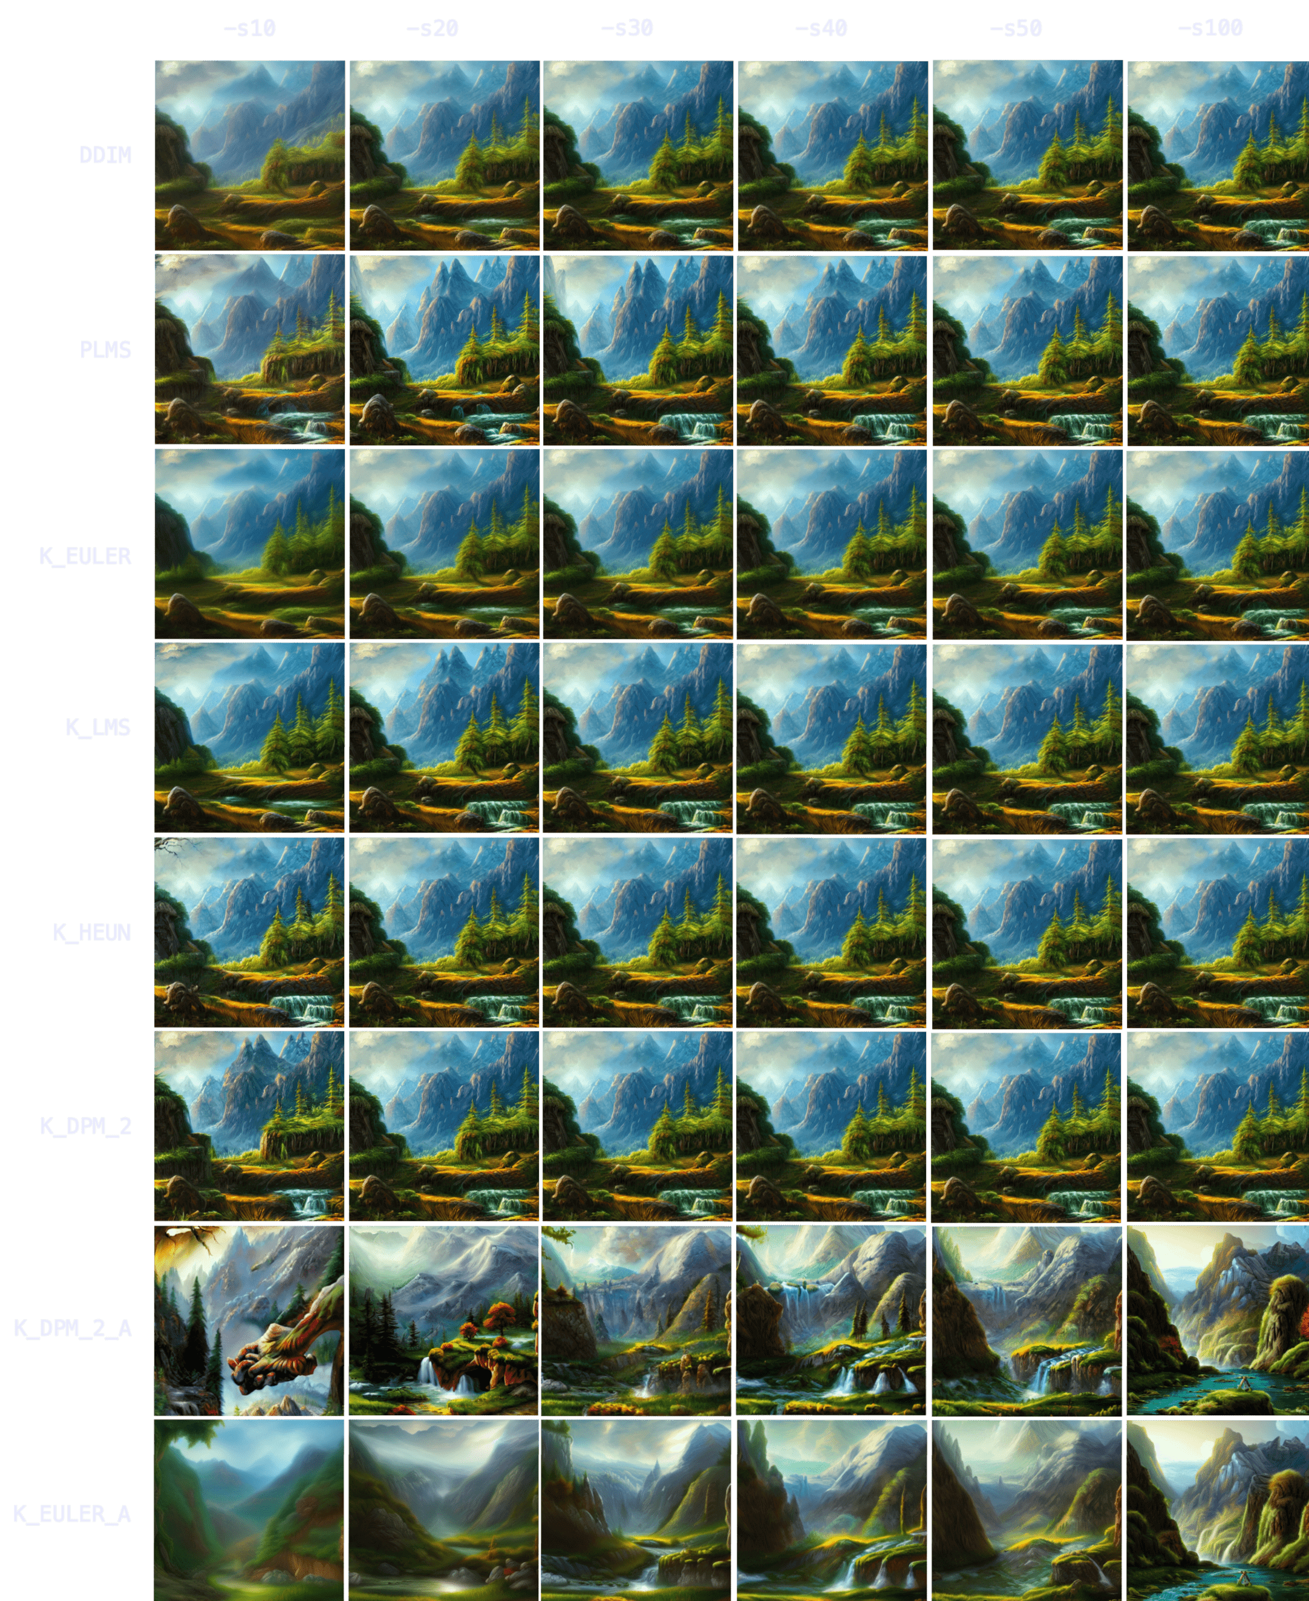
Food
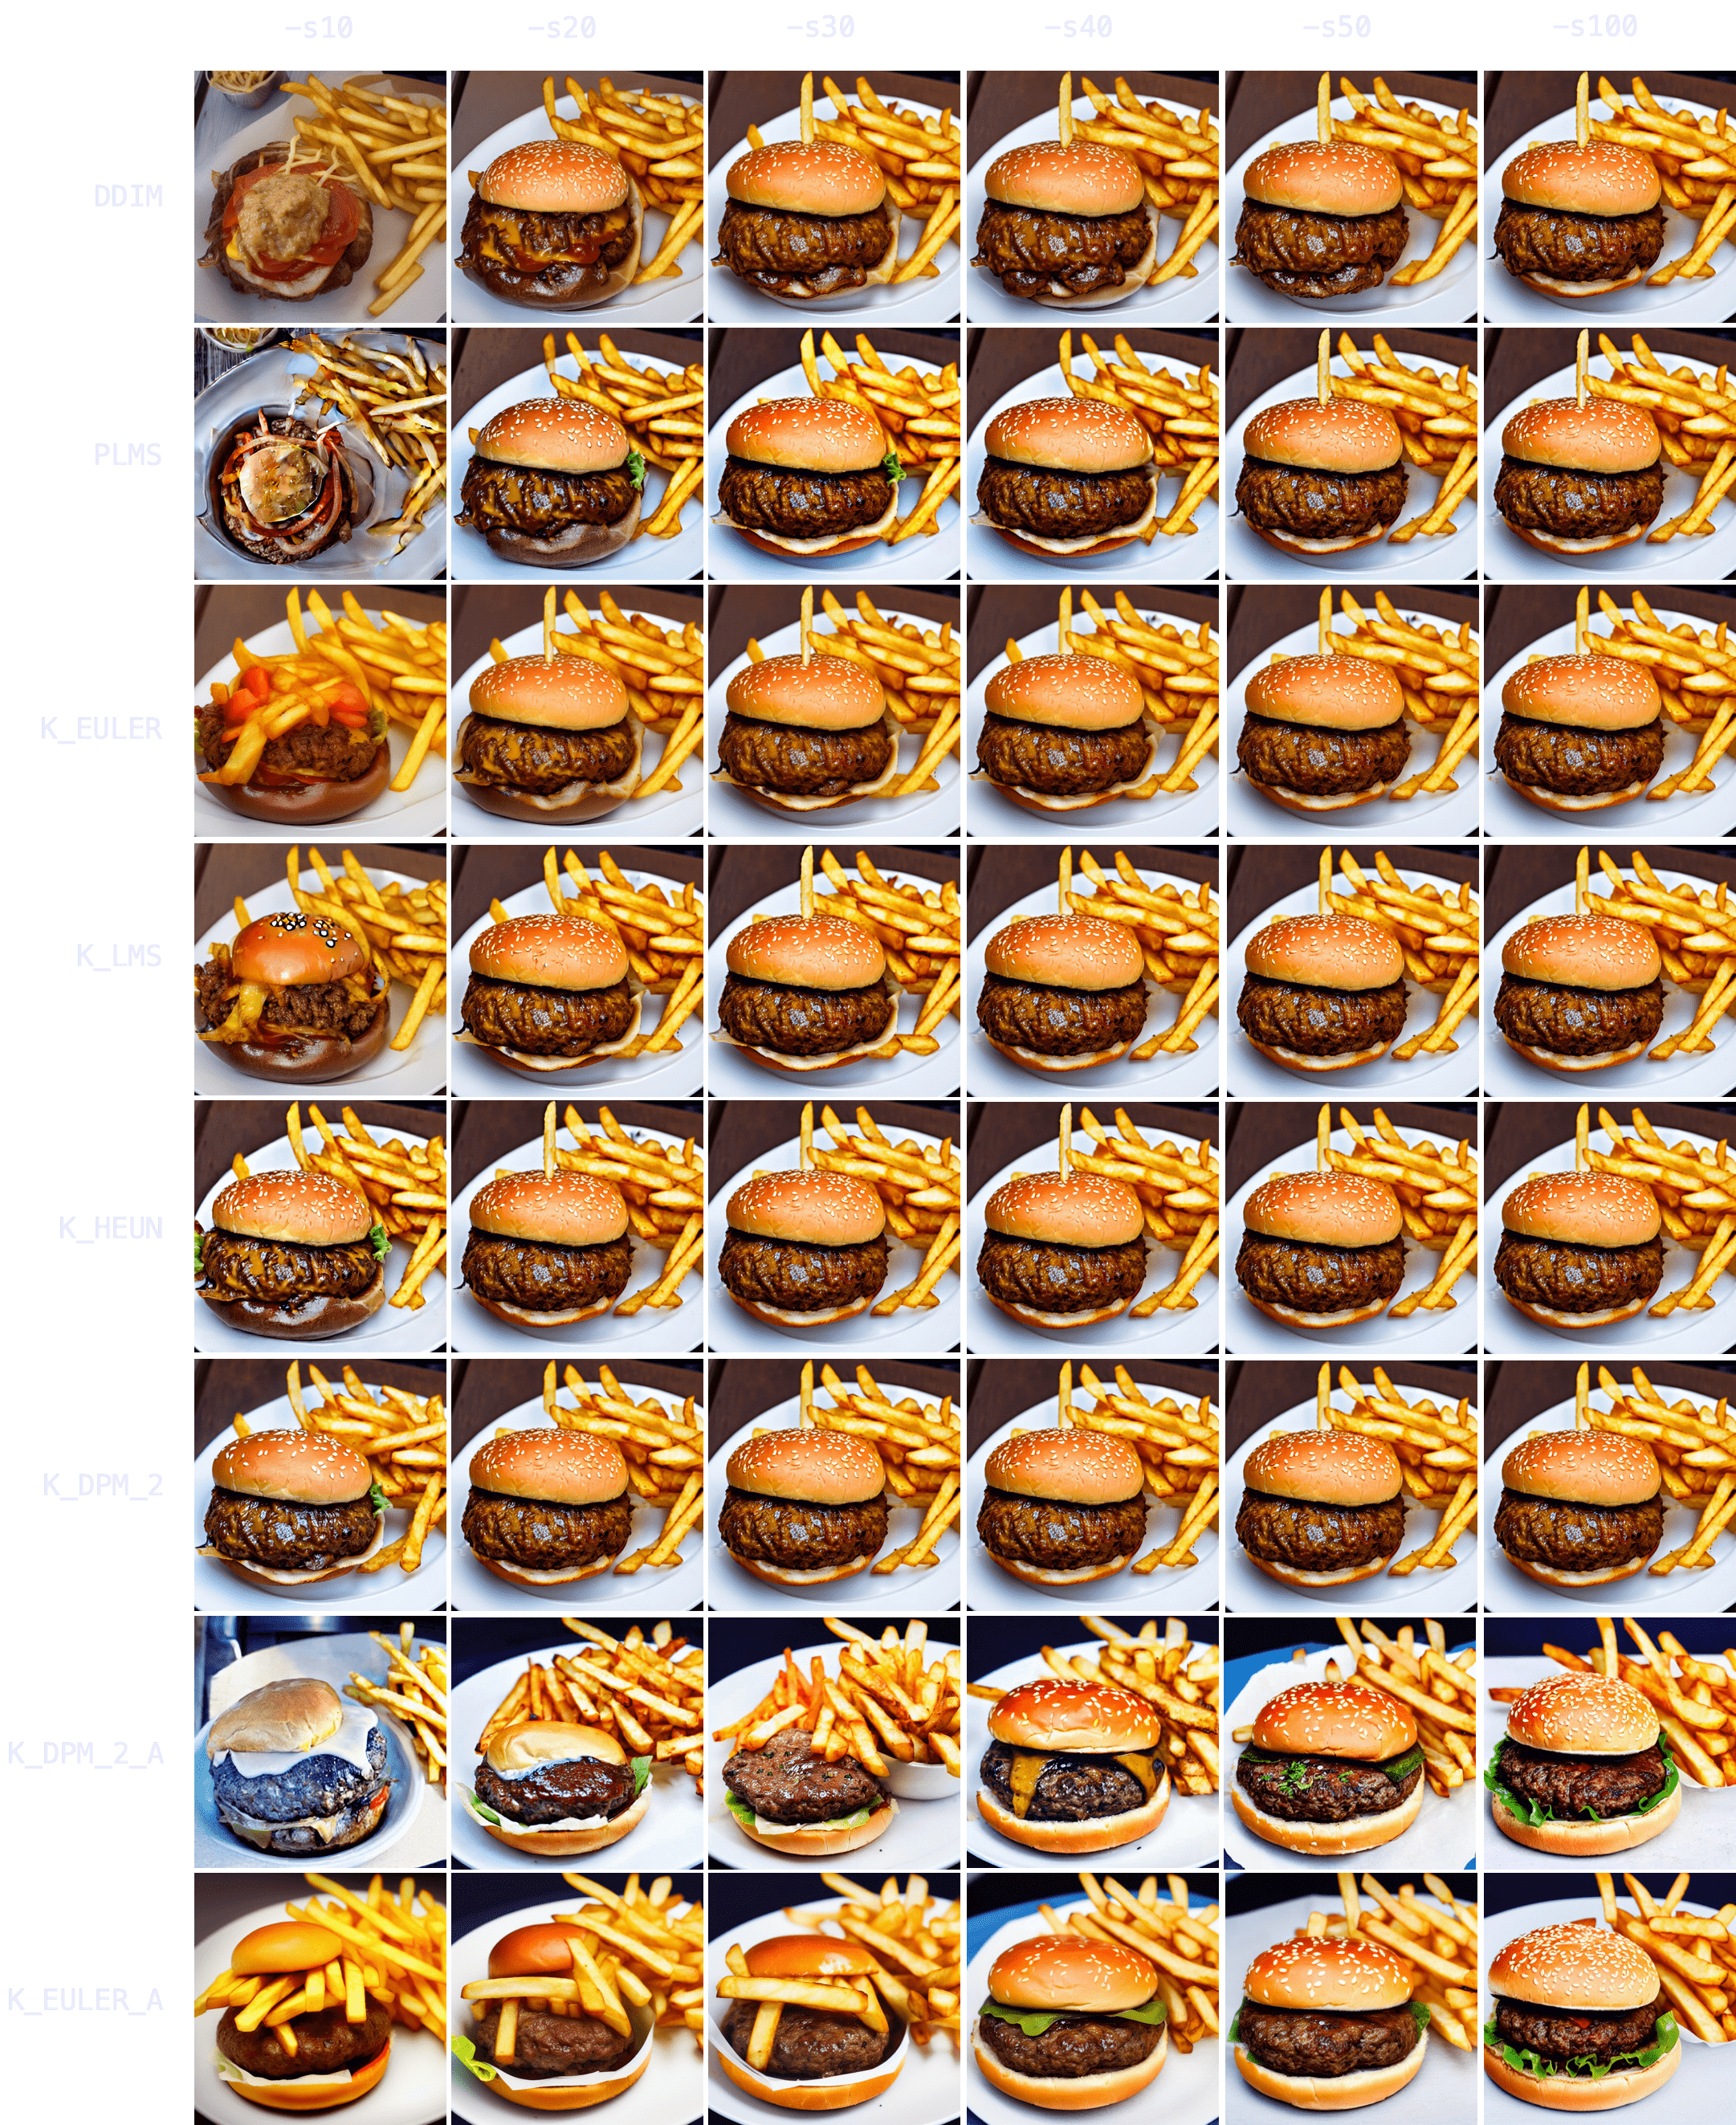
Animals
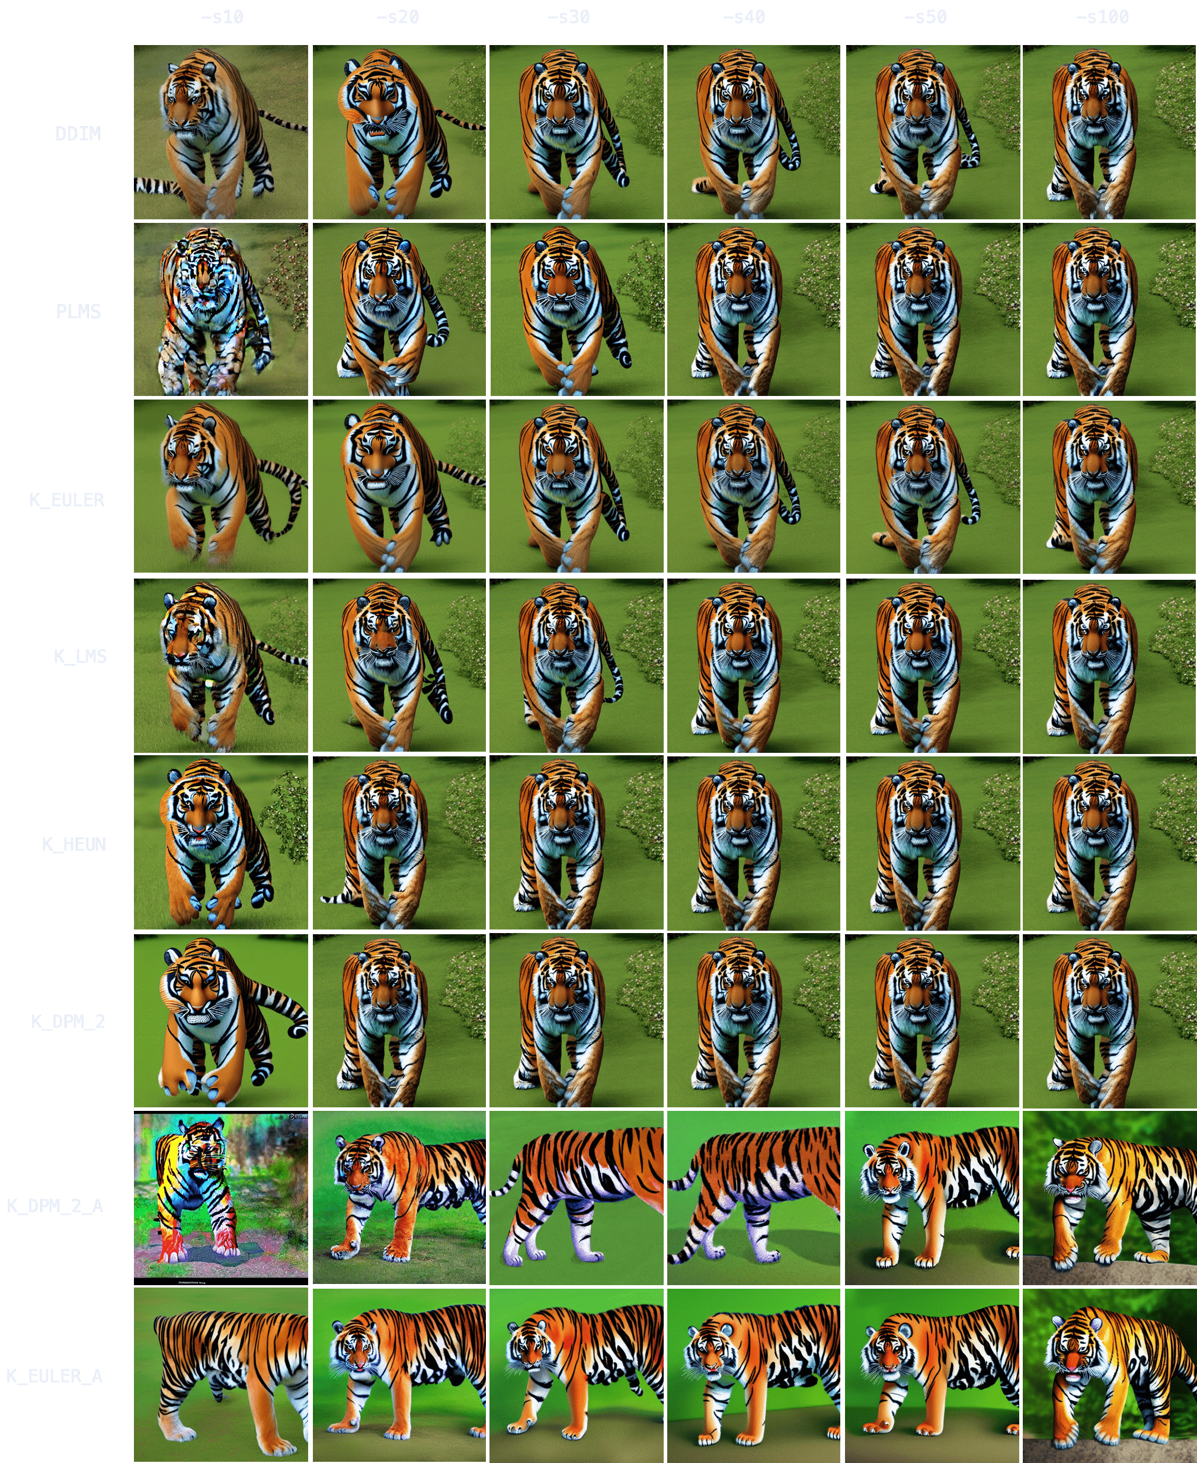
Photo realistic people at up to 300 steps
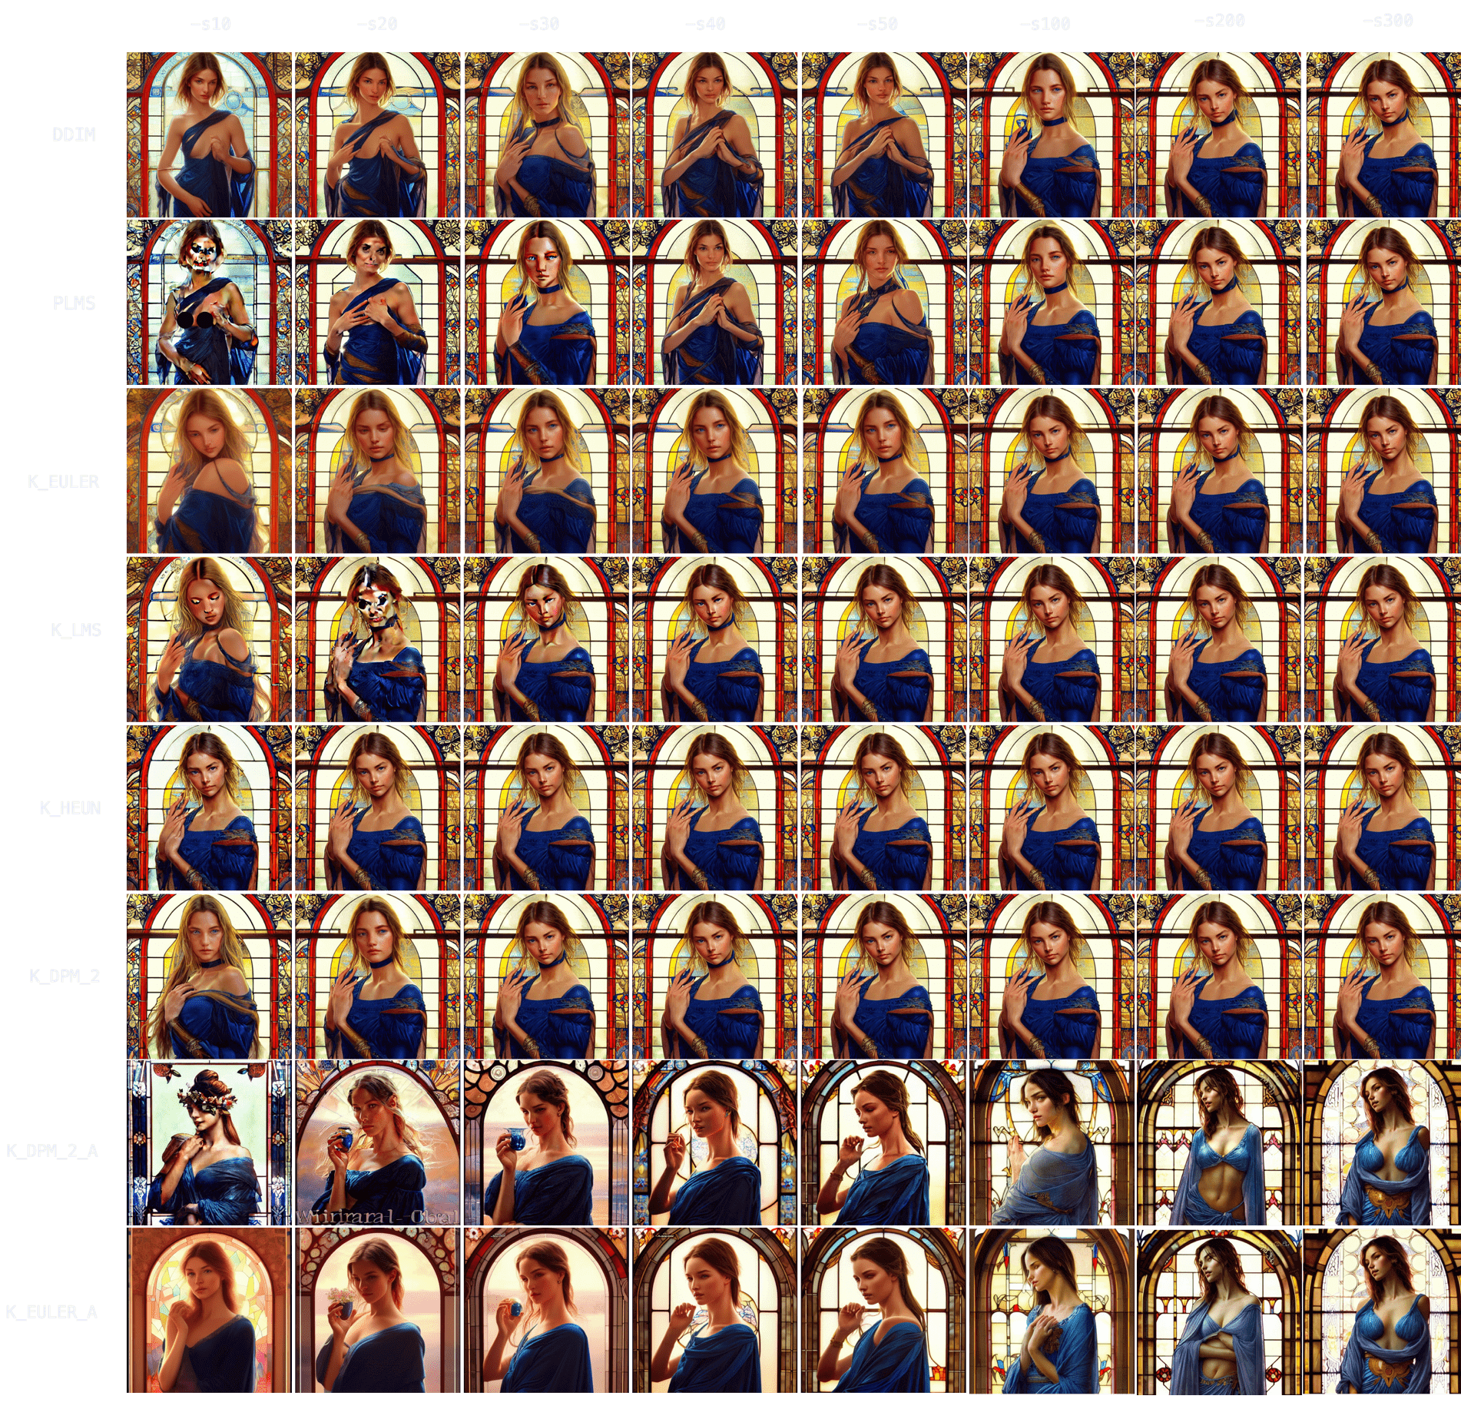
Up to 700 steps
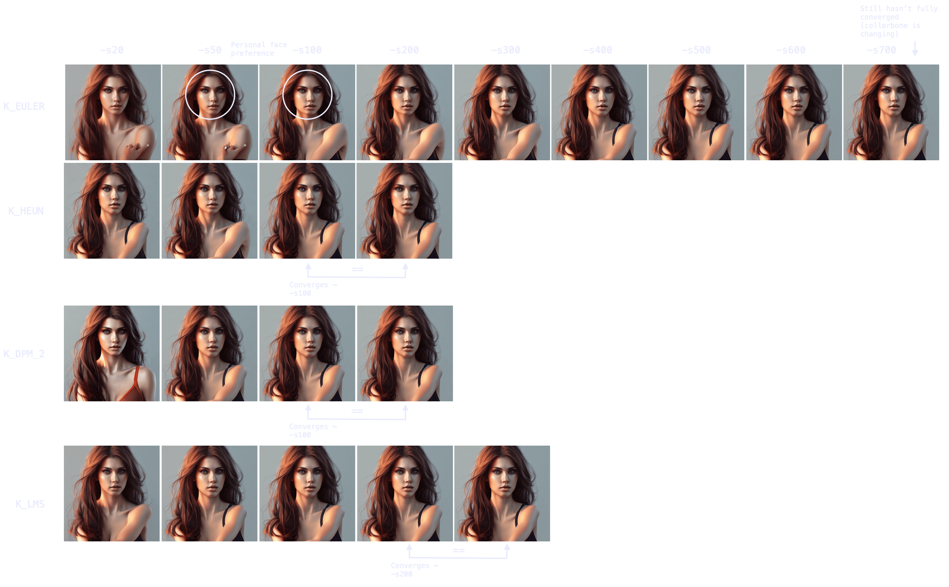
What happens at very low step numbers
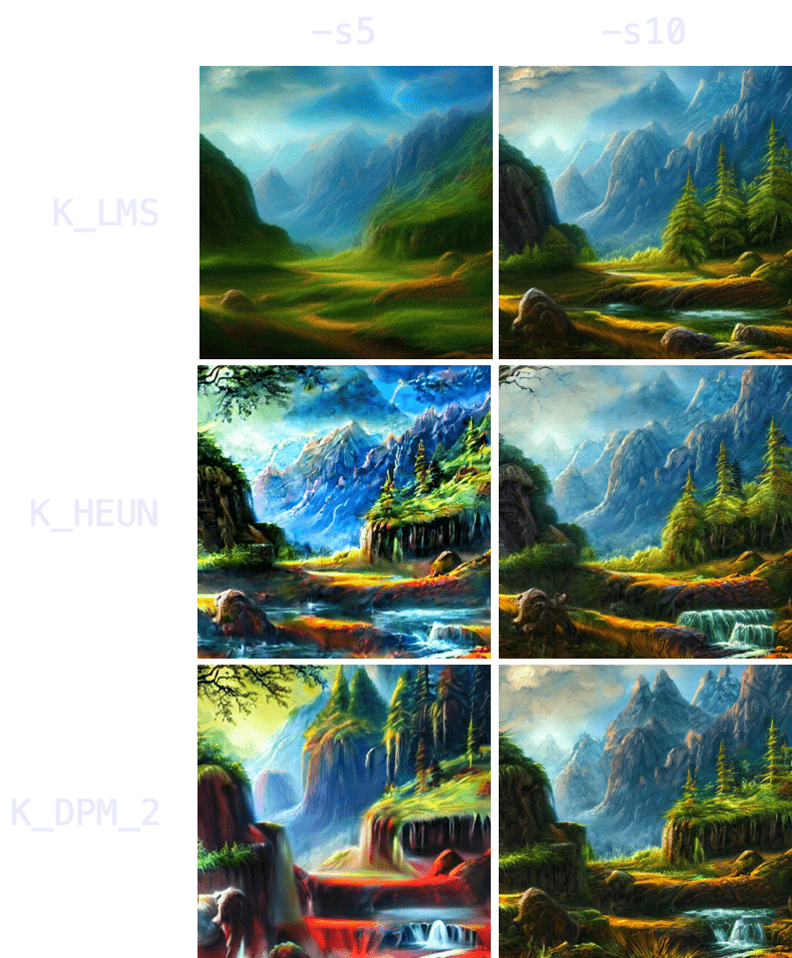

Model Drop Down
The model drop down shows you the models you got available in your system.
There is multiple types of models, there is the original stable diffusion released models, then there is custom models which can be found at plenty different sources, Then there is models which are made for inpainting which is a process of changing only parts of a image based on a mask, its one type of image to image processing. For a large number of custom models we have implemented the model downloader which will be explained later in this document.
There are different sources for models, be aware that this is a open source world and therefore you will find models in every niche of society. It is not up to us as the provider of the application to filter or judge any of those models. We just offer information where to find models.

A list of links where to find models which are compatible with Stable Diffusion workflows.
https://huggingface.co/nitrosocke
https://civitai.com/ (they got a NSFW filter active at default)

Maybe NSFW
https://gigazine.net/gsc_news/en/20221004-stable-diffusion-models-matome/
https://rentry.org/sdmodels#bukkake-b4a14787
https://bt4g.org/search/.ckpt/1
https://rentry.org/sdgoldmine#models

Textual Inversion ( this is the oldest method and so there is a page dedicated to only this as at the time there was just textual inversion)
https://cyberes.github.io/stable-diffusion-textual-inversion-models/

The best source at the time of creating this document is https://civitai.com/
They have the largest number of models as well they allow filtering for SFW and they not only offer full models they also offer Textual Inversion, Hypernetwork, VAE, Aesthetic Gradients and last but not least LORA.
Also they do checks for if some virus or other malicious software got embedded into the model which also makes it the most safes source for models. Our advice is to go there. Which is the same as if you use the build in model downloader, that will help you to download and implement models from civitai with just a few clicks.

Those models come with different specialty’s every model has some special it is extra good with, aside of that they are based on the original 1.x or 2.x stable diffusion models.

Here is a short sample of how civitai.com looks.
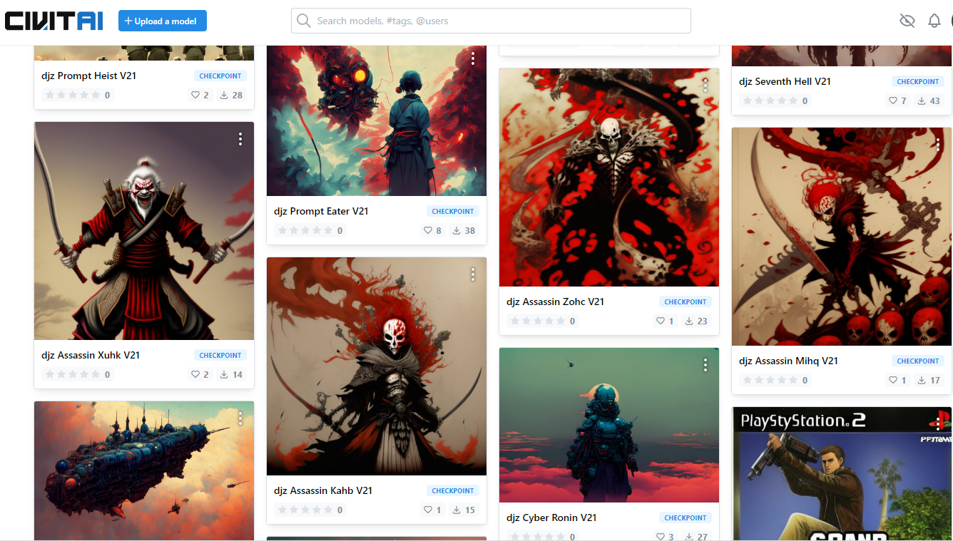
At the time this document is written they offer like 1700 different files and the number is growing fast every day. Remember every model is good for new exciting possible images. But also check the license as some of them are not open for commercial use.
If you need to have a model for commercial use you need to make sure that all the images used for the additional training are safe from a copyright perspective. Best way to have commercial useable models is to produce your own models based on images which you own by copyright.

VAE Drop Down
Here you select the VAE you want to use, VAE can be downloaded with the model Downloader or from other sources in the internet, here a short story about VAE, 2.x does not support VAE

What is VAE? (source : https://stable-diffusion-art.com/how-to-use-vae/)
VAE stands for variational autoencoder. It is the part of the neural network model that encodes and decodes the images to and from the smaller latent space, so that computation can be faster.
Do I need a VAE?
You don’t need to install a VAE file to run Stable Diffusion. Any models you use, be it v1, v2 or custom, already comes with a default VAE.
When people say downloading and using a VAE, they refer to using an improved version of it. This happens when the model trainer further fine tuned the VAE part of the model with additional data. Instead of releasing a whole new model, which is a big file, they release only the small part that has been updated.

What is the effect of using VAE?
Usually, it’s pretty small. An improved VAE decodes the image better from the latent space. Fine details are better recovered. It helps rendering eyes and text where all fine details matter.
Stability AI released two variants of fine-tuned VAE decoders, EMA and MSE. (Exponential Moving Average and Mean Square Error are metrics for measuring how good the autoencoders are.)
See their comparison reproduced below.
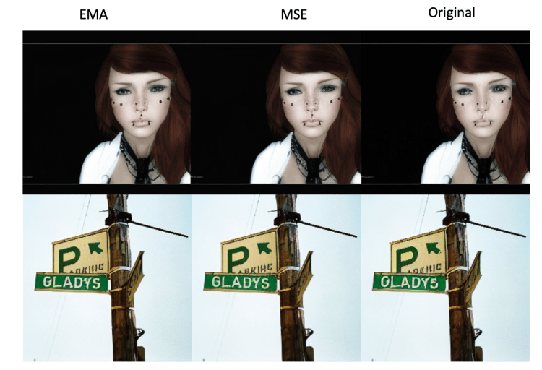Stability AI’s comparison between EMA, MSE and the original decoder. (256×256 images)
Which one should you use? Stability’s assessment with 256×256 images is that EMA produces sharper images while MSE’s images are smoother. (That matches my own testing.)
In my own testing of Stable Diffusion v1.4 and v1.5 with 512×512 images, I see good improvements to rendering eyes in some images, especially when the faces are small. I didn’t see any improvements to rendering text but I don’t think many people are using Stable Diffusion for this reason anyway.
In no case the new VAE performs worse. Either doing better or nothing.
Below is a comparison between original, EMA and MSE using Stable Diffusion v1.5 model. (Prompt can be found here.) Enlarge and compare the difference.
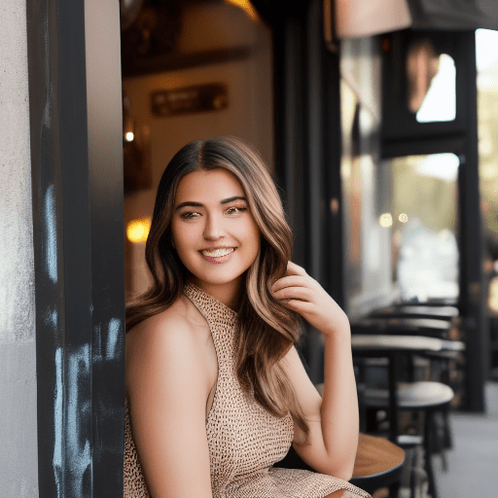Original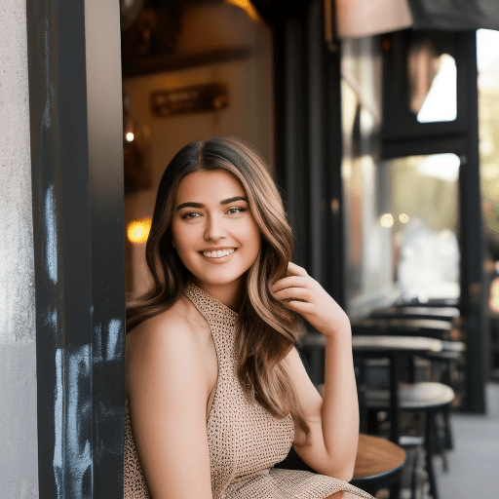EMA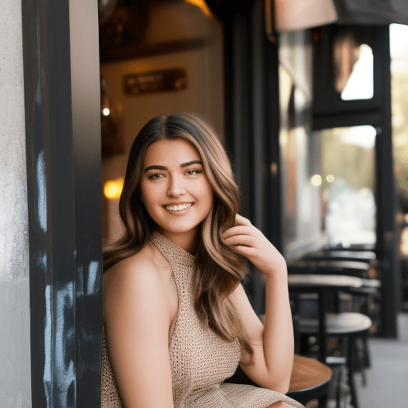
MSEComparison of VAE between original, EMA and MSE using SD v1.5. Note the garbled eyes in the original image are recovered.
Improvements to text generation is not as clear (Added “holding a sign said Stable Diffusion” to the prompt):

Original
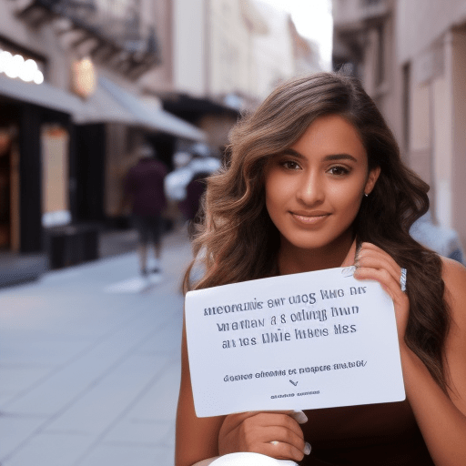
EMA
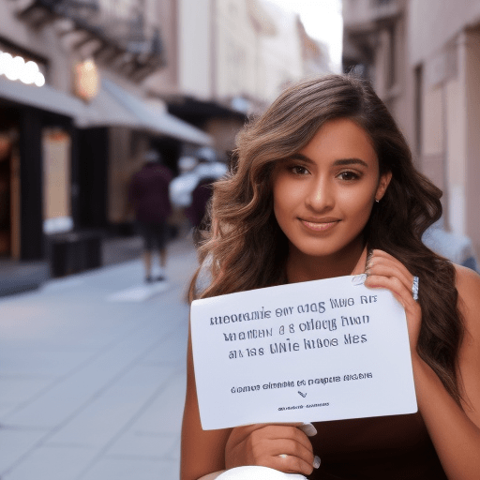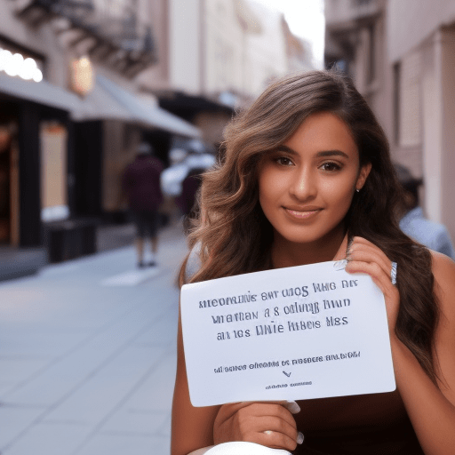
MSEComparison of VAE between original, EMA and MSE. Improvement to text rendering is unclear.
You can also use these VAEs with a custom model. I tested with some anime models but didn’t see any improvements. I encourage you to do your own test.
As a final note, EMA and MSE are compatible with Stable Diffusion v2.0. You can use them but the effect is minimal. 2.0 is already very good at rendering eyes. Perhaps they have already incorporated the improvement to the model.
Should I use a VAE?
You don’t need to use a VAE if you are happy with the result you are getting. E.g. you are already using face restoration like CodeFormer to fix eyes.
You should use a VAE if you are in the camp of taking all little improvements you can get. You only need to go through the trouble of setting it up once. After that the art creation workflow stays the same.
Currently there are two improved versions of VAE released by Stability. Below are direct download links.
Download link for EMA VAE
Download link for MSE VAE

Hypernetwork Drop Down
Hypernetworks are a controversial topic, first they came into public view by a leak from stolen data, so first question would be are they legal? Well we don’t really know yet, self-generated data as such might be legal but the codes around who knows. We know for sure there was a visible fight between stability.ai and one of the open source UI authors. This dispute ended in an open apology from stable.ai. For now we think generating and using hypernetworks is fine. What the technically do is described in vast scientific papers which we do not copy here as they are quite big.
Long story short, hypernetworks again are a way to improve the quality of the images generated by a prompt and a given model. So you would use them to enhance output.
Hypernetworks can be downloaded with the model downloader or from other sources in the internet.

Seed Text field and Mode drop down
Here you enter a number from 0 to 4’294’967’296, if you leave the field empty or you put -1 the seed will be a random number. With seed you select the initial noise which gets used to then generate the image, each seed will produce a slight different image to your prompt.
With the mode drop down you can select the way seed will change if you produce a larger number of images from one prompt, you can choose between iter, random and fixed. Iter will do seed + 1 each new image, random will be a random number each image and fixed will have the seed fixed to the same same number each image, (last might not always make much sense its only used in edge cases)

Batch
Here you enter the number of iterations that will be made, each iteration will generate 1-n Images based on your Samples selection

Samples
With this number you select how many images per 1 batch run will be generated. This number will have a impact to the VRAM usage of the rendering the more images in one iteration the more VRAM will be used, every image will have its own seed so they are all different, your not generating 10 times the same here.

DDIM ETA
This is a diffusion model variable that mixes in a random amount of scaled noise into each timestep. 0 is no noise, 1.0 is more noise. As with most DD parameters.
Only has any effect when using DDIM sampler

Speed/Ram checkbox
This is some way to get the calculation faster at the cost of more VRAM usage. Technically it does calculate cond and uncond simultaneously

Live checkbox
This will enable a live preview of the noise used during the rendering, it is a funny effect but has no impact to the rendering.

Karras / Sigma Min / Sigma Max
Does have no effect with DDIM and PLMS
With sigma min and sigma max to cheknge the effect of karras

Output Options
Here you change the output behavior of the generated images

Subfolders drop down
You can choose between date-folders or prompt-folders.
Prompt Folders will create a folder with parts of the prompt in the name, makes most sense if you do more then 1 image per prompt. The prompt gets shortened to 120 character’s so there is no issues with how long the path will get
Date folders will create a folder per data and put any generated file into that folder, this way you can later see what images have been generated at a given date

Save Settings checkbox
With this you enable if a little text file for each image is generated with most of the parameter information which have been used to generate that image, this help to reproduce images if you need later on.

Make Grid checkbox
This does create a grid of the images which have been generated the run.
The grid gets stored in the base output folder for text to image

Init image setup (img2img) checkbox
Here you select a image to be used for initial noise generation, this way you can choose a image where your prompt will get sampled on top. Like you can see here with the examples which have been provided by stability.ai
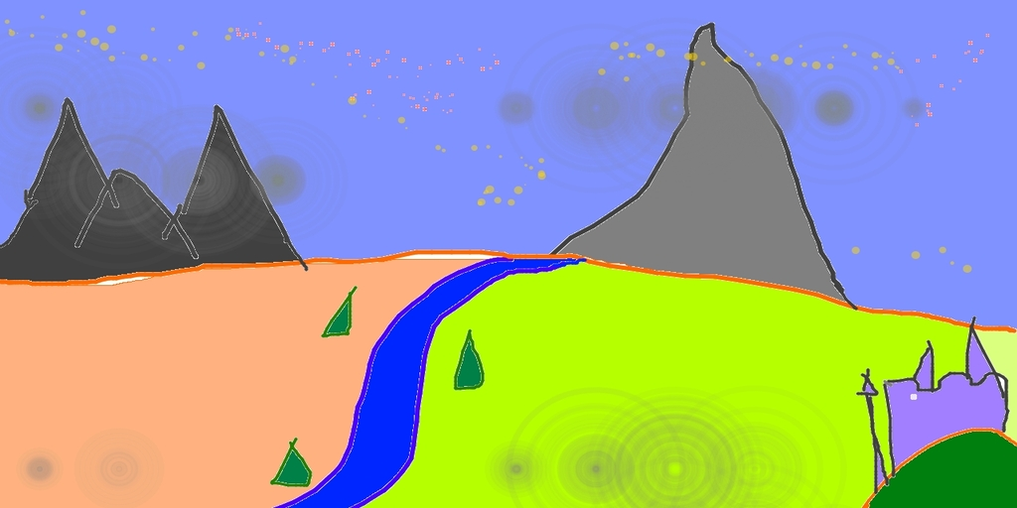

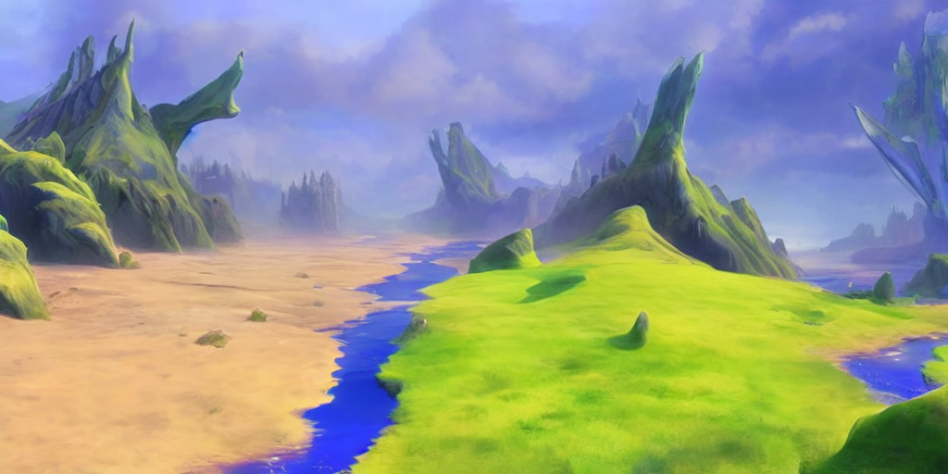

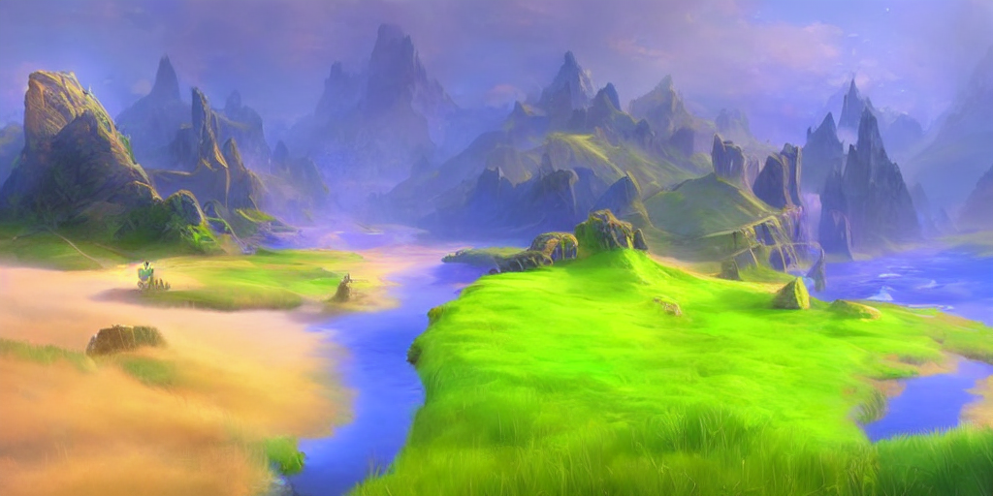

Use as Init checkbox / select Path
You have to enable the use as init checkbox to enable image 2 image processing, next you have to enter a path to your init image or press the select button to find the image in your file system

Strength
With this number you select how strong the prompt should be applied to your source. Experiment with the value to see what gives you the best result

Strength 0 No Init
You select this if you want to make sure you’re not rendering your Init image at 0 Strength as it would just be a copy of your init image, with this checkbox selected you will just get a image based on your prompt ignoring the init image.

Mask image setup
With this you enable masks to be used on top of your init image. You can define a Mask to only generate changes in that place also known as inpainting. You could use specialized models for inpainting to get better results as with the normal models. Its up to you to experiment to get the best result. A hint, there is a more comfortable way of inpainting in the canvas, it allows you to manual inpaint into the image. The mask makes sense if you plan to work on bulk inpainting.

Mask Contrast / Mask Brightness Spinbox
With these two values you manage how strong the mask gets during the process. Lower values make a weaker mask.

Mask Overlay Blur
With this value ylou manage how the init image the rendered image and the mask gets blured in to each other, experiment with the value to find the best setting for your requirements

Use Alpha as mask
This will enable to use the alpha channel of the mask image to be used as the mask instead of the color layers.

Invert Mask
This will invert the mask. It will just work the other way around.

Overlay Mask
TBD

The left-hand tool bar
This toolbar helps you with some easy to find options.
Select a rectangle on the canvas
Move the canvas by dragging it
Add a new rectangle to render a image in it
Inpaint
Inpaint current frame
Move the active (selected) rectangle
Sava as json
Save as PNG
Load from json
Load from image
Clean the canvas
Enable playback
Stop playback

Outpaint Checkbox
For now the size of a single image is kind of limited to the size the model was trained with, that’s 512 for 1.x models and up to 768 for 2.x models. With some HiRes tricks in the Tensors we can go to get larger images but in the end there is always hard limits at which it stops to produce high quality images.
With in / outpaint we get rid of those limits as we just add multiple tiles together into one large image. Since every tile is generated on its own we never break the native size limits of a models but we can create quite large high quality images
Outpaint is for out and inpaint images directly on the canvas, you can interactively work on your larger image and create a handcrafted image out of many single generated images with as many prompts as you need or wish. You can not just create larger images as the Ai can render you can also do a assisted image to image process at scale far from what would be possible with single image to image processes. This is a really amazing feature that will help you create amazing results.

With inpaint
This forces an inpaint model to be used
With PreLoad Inpaint Model you can load the model manually befor you start generating images

Update Params
TBD
There is 3 different processes you can follow for inpaint / outpaint

Manual In/Outpaint
Here you are totally free and can place the images on the canvas where ever you want to create the artwork you like. With every image you render you can choose a different prompting
With the + from the left-hand tool bar you add a new rectangle to the canvas. Click on dream to generate the image in that rectangle
If you overlap your rectangles the image should be seamless integrate into each other. Works best with inpaint models
With the redo button you can regenerate a image in a rectangle, you can do this at any time as the rectangles are still there even after you created a new one already. The image is a puzzle of objects rather than an image yet.
With delete you can delete the selected rectangle
Reconstruction Blur is used for inpainting when you use the brush to mark some space which should be inpainted. The reconstruction blur helps to reduce artefacts at the edges of the brushed space.

Batch in/outpaint
With this we give a feature which will ease the process of generating very large images but still leave you all the free hand options from before.
Think of this a a automated preparation of your canvas with filling it already with content and then you come and do the detailed work. This saves you the preparation manual tasks.
To do so there is quite some parameters to handle but they are easy going and mainly work with the default values already very good.

Outpaint Mask Offset
Batch Outpaint Overlap
Batch Rows
Batch Columns
Start Offset X
Sets the initial distance from the left corner of the canvas
Start Offset Y
Sets the initial distance to the top corner of the canvas
Mask Blur
Randomize
Spiral Batch
Reverse
Enable Overlap

Plotting
This enables you to generate a grid image which shows the results along two different settings.

Aesthetics
This is some Tricks which got implemented into the Deforum workflow for stable diffusion. It is to interfere with the CLIP encode before the image gets rendered to make more beautiful images.
The whole thing is quite complex you can also check the tool tips when using, it will help to remember what value does what. Also it only works with 1.x models since 2.x models use a different clip implementation.
It looks old and feels complicated but it allows for astonishing results. It may worth the time spending to find proper values for your requirements.

From the original documentation:

Exposure/Contrast Conditional Settings

mean_scale
Pushes the pixel values towards middle gray
Samples have values between -1 and 1. Mean_scale guides pixels toward 0, hence gray

var_scale
Pushes pixels towards lower variance

exposure_scale
Targeted mean loss. Uses exposure_target variable.
When exposure_target == 0, exposure_scale is equivalent to mean_scale
Use it to compensate for very high cfg scale, for example.
exposure_target [ -1.0 to 1.0 ]
Used with exposure_scale
Negative values push towards a darker image, positive values toward a brighter image

Color Match Conditional Settings

colormatch_scale
Guides the image towards a color palette.
Palette is extracted from an input image colormatch_image
Best matching results when decode_method == “autoencoder”
Works best when gradient_wrt == "x0_pred”, but will still work well with “x”

colormatch_image
Image to extract a color palette from

colormatch_n_colors
Number of colors in the palette

ignore_sat_weight (default None)
Amount to ignore the saturation when using colormatch_scale.
High ignore_sat_weight will allow a higher colormatch_scale without making the colors look overblown

CLIP\Aesthetics Conditional Settings
clip_name ['ViT-L/14', 'ViT-L/14@336px', 'ViT-B/16', 'ViT-B/32']
Used with aesthetics_scale>0 and clip_scale>0
Recommended to use with gradient_wrt=’x’

aesthetics_scale
Recommended to use with gradient_wrt=’x’

clip_scale
CLIP Guidance!

cutn
Used when clip_scale > 0
Number of times CLIP views the image for each step
This variable only matters under these conditions:
Extremely large images bigger than 2688 x 2688px, or
decode_method = autoencoder
This is because clip looks at the decoded image, which is small when decode_method=linear

cut_pow
Used when clip_scale > 0
Affects the size of the view window when CLIP sees the image
When cut_pow is very small, the view window is large, and vise versa
Only matters for extremely large images or autoencoder decode_method, see cutn

Other Conditional Settings

init_mse_scale
init_mse_image
Guide the image to match init_mse_image pixel-by-pixel

Conditional Gradient Settings
gradient_wrt ["x", "x0_pred"]
“x0_pred”
Applies the gradient calculation only to the denoised image at each step
Much faster
May require higher *_scale values
Does not work very well with clip_scale or aesthetic_scale guidance
“x”
Applies the gradient calculation through the unet
Much slower
Takes the content of the image more into consideration because the grad uses the unet

gradient_add_to ["cond", "uncond", "both"]
Gradient is added to the cfg cond or uncond or both
"cond" or "uncond" only applies if cond_uncond_sync == False

decode_method ["autoencoder","linear"]
Gradient conditioning decodes the latent at every step.
Linear is a shortcut that quickly translates the latent to a small (default 64x64) image. linear decoding is not implemented for every model, so if your results with conditioning look noisy, try “autoencoder”.
Autoencoder is much slower, but higher quality. It uses the same decoding method the model already uses after the last step.

Clamping
Keeps the gradient from getting too big and making the image all washed out.
If you find that a conditioning setting isn’t changing an image much no matter how high the conditioning scale, try increaseing one of these clamp numbers or using grad_threshold_type = "dynamic".

grad_threshold_type ["dynamic", "static", "mean", "schedule"]
The final gradient is clamped before it’s added to the image. This is to avoid the overexposed look.
dynamic: thresholding from the imagen paper (May 2022)
static: simple clamping
mean: rescales out of range values based on the mean
schedule: uses clamp_start and clamp_stop to set a threshold value that changes linearly at each step. Like “mean” but with changing clamp_grad_threshold over time

clamp_grad_threshold
used with grad_threshold_types “static” “mean” and “dynamic”
clamp_start
used with grad_threshold_type “dynamic”
clamp_grad_threshold value at the first step, linearly changes to clamp_stop at the last step
clamp_stop
used with grad_threshold_type “dynamic”
clamp_grad_threshold value at the last step, linearly changes from clamp_start from the first step

Inject Timing
grad_inject_timing
Applies the gradient only at a limited number of steps
Interpreted differently based on the type of grad_inject_timing
if grad_inject_timing is:
int: compute every inject_timing steps, eg. 2 mean apply grad every other step
list of floats: compute on these decimal fraction steps (eg, [0.5, 1.0] for 50 steps would be at steps 25 and 50)
list of ints: compute on these steps
None: Compute on all steps
This can be used to generate an image faster, or apply conditioning to different sections of the gen. For example, overall composition is usually decided in the first 20% of steps, so if colormatch conditioning is only applied in the last half of steps it will result in practically the same image but with different colors.

