Prompting and the art of to create amazing art using stable diffusion

The images coming out of stable diffusion are related to the quality of your prompting skills.
A simple prompt might end up in a very simple image
Prompt: a women’s face
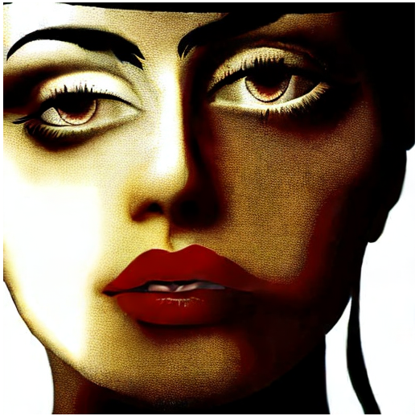
While the result is not bad, its maybe artistic it might not really be what you expected from a sophisticated system like stable diffusion.
Well lets try a different prompt then.
Prompt: 2 4 year old olive skinned female model, wearing v - neck top, zoomed in, photo realistic, extreme detail skin, natural beauty, no filter, slr, golden hour, 4 k, high definition, selfie
Negative prompt: limbs, Gross proportions, Missing arms, Mutated hands, Long neck, Duplicate, Mutilated, Poorly drawn face, Deformed, Bad anatomy, Cloned face, Malformed limbs, Missing legs, Too many fingers, Worse, Text, Error, Cropped, Worst quality, Low quality, Jpeg artifacts, Out of frame, Dehydrated, Disfigured, Username, Watermark, Signature, Fused fingers, Extra arms, Extra legs
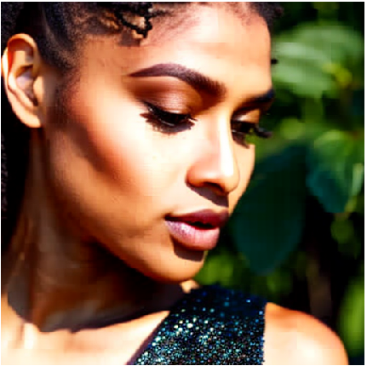
We end up with a completely different result. Its not on us to decide which image is the better one. We just talking about more complex prompt leads to more complex results. Its up to you to learn how to get the best out of stable diffusion. Over time you will get better and better.
It is your task to learn how to get whyt you expect. Its so complex that there is no simple guide, especially as every user might want to get different things which will need complete different prompting.
What we can give is a few hints on how to get a given style or what modiefiers will do to your result.
To get this we like to point to a few webpages where some nice people did the work for us and present styles, modifiers and artists as they can be used in stable diffusion.
Be warned they might be NSFW.
- Stable Diffusion Artist Style Studies — A non-exhaustive list of artists Stable Diffusion might recognize, as well as general descriptions of their artistic style. There is a ranking system to describe how well Stable Diffusion responds to the artist’s name as a part of a prompt.
- Stable Diffusion Modifier Studies — a list of modifiers that can be used with Stable Diffusion, just like the artist page.
- The AI Art Modifiers List — A photo gallery showcasing some of the strongest modifiers you can use in your prompts, and what they do. They’re sorted by modifier type.
- Top 500 Artists Represented in Stable Diffusion — We know exactly what images were included in the Stable Diffusion training set, so it is possible to tell which artists contributed the most to training the AI. Generally speaking, the more strongly represented an artist was in the training data, the better Stable Diffusion will respond to their name as a keyword.

Search engines for prompts are those two which are also useable directly from the UI as pure text search or also as search showing the images for the prompts.
- Lexica — a repository of images generated using Stable Diffusion and the corresponding prompt. Searchable by keyword.
- Krea – another repository of prompts showing the resulting images
Then there is the “official” stable diffusion reddit. All kind of people talk about prompting and show what they did using stable diffusion
- https://www.reddit.com/r/StableDiffusion/

A experienced user told us this for 2.x models
with SD 2.1
if you want photorealism, you can do Photo [PROMPT] negative painting, drawing, fake, anime, cartoon (Bearbeitet)
and [PROMPT] should be "backwards" (Bearbeitet)
so it will always pay more attention to the last thing you say
so doing:
hyperdetailed blanchitsu, warhammer 40k, baroque, Space Marine Primarch Standing in Light Shafts, walls with circuitry and wires, smoke from vents in walls, plugs, hoses, ventilation, night scene, hyperrealism, octane render, defuse light, high detail, 8k, photo realistic , art style john blanche, establishing --ar 21:9 --no dof --iw 5 --uplight
is a nice descriptive Midjourney prompt
but the Stable Diffusion equivalent is:
photorealistic, hyperrealism, octane render, defuse light, high detail, 8k, walls with circuitry and wires, smoke from vents in walls, plugs, hoses, ventilation, night scene, blanchitsu, warhammer 40k, baroque, Space Marine Primarch Standing in Light Shafts
so you put your qualifiers in first and then your main subject focus described last

