Table of Contents
- Introduction
- Purpose of this Document
- Overall Description
- Project Objectives
- Technologies Used
- Database Design
- Functional Requirements
- Usage Flow
- Data Models
- AI-Based Features
- Testing Strategy
- Deployment Strategy
- GitHub
- Conclusion

CourseFlix - Project Documentation
Project Title: CourseFlix — Arabic Online Learning Platform
Team Members: 1. Mohamed Elgendy 2. Albraa Nawara 3. Nabile El-Ghannam 4. Abdullah Habsa 5. Seif El-Din
Supervisor: (to be filled — course instructor)

Introduction
CourseFlix is an Arabic-first, RTL (right-to-left) online learning platform built as a graduation-project MVP. It connects teachers and students in a complete learning loop: teachers publish structured courses, upload PDF lecture notes, and monitor student progress; students enroll, watch lessons, take quizzes, ask a grounded AI Tutor questions, and pay for courses through a deterministic test checkout. The platform combines course delivery, progress tracking, objective quiz grading, PDF-grounded AI assistance, deterministic learning interventions, test commerce, teacher sales analytics, and privacy-safe product analytics.

Purpose of this Document
The primary purpose of this Software Requirements Specification (SRS) document is to clearly and precisely define the functional and non-functional requirements of the CourseFlix platform. This document serves as a foundational blueprint for the development team, guiding the design, implementation, and testing phases of the project. It also acts as a formal agreement between stakeholders, ensuring a shared understanding of the system’s capabilities and limitations. This SRS aims to minimize ambiguities, reduce rework, and facilitate effective communication throughout the software development lifecycle.

Overall Description

User Needs and Characteristics
CourseFlix addresses critical needs for both teachers and students in the Egyptian/Arabic education market. Teachers need a reliable way to structure course content, share lecture material, track how their students are performing, and communicate announcements. Students need an intuitive, mobile-friendly way to access lessons on demand, test their understanding, and get help when they are stuck — without leaving the platform.
The application caters to three primary user roles, each with distinct needs and characteristics:
- Students: Learners who enroll in courses, watch video lessons, submit objective quizzes, interact with a course-scoped AI Tutor, receive notifications and interventions, and purchase courses through the checkout flow. They need accurate progress tracking, honest AI answers, and a seamless mobile-first experience.
- Teachers: Educators who create and manage structured courses (sections → lessons), upload PDF lecture notes that feed a document-searchable AI, assign quizzes, post announcements, and review sales metrics and analytics about their own courses. They need efficient dashboards and full control over their content.
- Assistants: Staff members who share the teacher’s course/student surface and help manage the community, support tickets, and teaching duties. They operate within the same role surface as teachers but without payment- or analytics-adjacent access.

Assumptions and Dependencies
Several assumptions and dependencies underpin the development of the CourseFlix platform:
- Internet Connectivity: It is assumed that both users (Students, Teachers, Assistants) and the application servers will have stable internet connectivity to ensure real-time data exchange and functionality.
- AI Provider Credentials: The AI Tutor and embedding pipeline depend on external OpenAI credentials (API keys, model names). Any changes or limitations in these APIs could impact AI functionality. A deterministic mock provider is used in all tests so development never depends on paid API calls.
- Vector Store: ChromaDB is used as the vector database for document embeddings. Its availability and isolation filters are critical for the RAG (Retrieval-Augmented Generation) pipeline.
- Job Queue / Redis: The document ingestion worker depends on Redis and BullMQ. If Redis is unavailable, background ingestion jobs cannot be processed.
- Payment Integration: The MVP uses a deterministic internal test-payment adapter; real payments (Paymob) are explicitly out of scope for the MVP and exist only as a post-MVP branch.
- User Compliance: It is assumed that users will comply with the application’s terms of service and accept the legal agreements during registration.
- Scalability: The system is designed with a production-hardened schema in mind (soft deletes, versioning, job queue), assuming a gradual increase in user base and transaction volume.
- Security: The system implements industry-standard security measures (argon2id hashing, HTTP-only signed session cookies, role guards, input validation, rate limiting, correlation IDs, PII redaction). It is assumed that users will also take necessary precautions to secure their accounts.

Project Objectives
- Deliver an Arabic-First RTL Learning Experience — Provide a fully localized, right-to-left, responsive UI based on the approved ui5 design handoff.
- Enable Teachers to Structure and Manage Courses — Let teachers organize courses into sections and lessons, upload PDF notes, post announcements, and review progress.
- Enable Students to Learn, Track Progress, and Get Graded — Let students watch lessons (with resume + attendance), submit objective quizzes that are graded server-side, and track per-item progress.
- Provide a Grounded, Honest AI Tutor — Answer student questions using only the teacher’s uploaded documents, always citing the grounding chunks, and explicitly say “no answer” when the material does not cover the question.
- Add a Deterministic Learning Intervention System — Detect struggling students (e.g., low quiz score) and generate a weak-concept report, a mini-quiz, and a notification without ever auto-suspending a student.
- Enable Test Commerce with Authoritative Receipts — Let students purchase courses through a deterministic checkout whose orders, not the client, remain the financial source of truth.
- Give Teachers Backend-Sourced Sales and Analytics — Show revenue and order metrics computed only from paid backend orders, plus a limited Analytics Agent with three allowlisted intents.
- Keep Everything Traceable and Privacy-Safe — Correlation IDs, redacted agent logs, GTM/GA4 events with a runtime PII denylist, and PostgreSQL as the single source of truth.

Technologies Used

Frontend (React + TypeScript)
- React with functional components and hooks
- React Router for navigation and role-guarded routes
- Vite as the build tool and dev server
- TanStack Query for server-state management
- Custom http-client with credentials: 'include' and typed ApiError
- Context API for global state (auth, theme)
- TailwindCSS + custom design-system tokens (CSS variables) for UI
- Full Arabic RTL responsive design for all screen sizes

Backend (NestJS + TypeScript)
- NestJS with modular architecture (30+ feature modules)
- REST API with DTO validation (class-validator), guards, and OpenAPI
- TypeORM migrations against PostgreSQL
- Argon2id password hashing and HTTP-only signed session cookies
- BullMQ + Redis for the async ingestion worker (apps/worker)
- ChromaDB as the vector store with mandatory course/document/version isolation filters
- OpenAI embeddings/LLM through provider-agnostic adapters + a deterministic mock provider
- Port-based contracts (RetrievalPort, JobQueuePort, NotificationProducerPort) so modules never depend on each other’s internals

Testing
- Jest + Supertest for backend unit and e2e tests
- Vitest + React Testing Library + MSW + jsdom for frontend tests
- Playwright-oriented E2E and visual/responsive checks
- Postman collection for manual API exploration

Workspace & Infra
- npm workspaces (monorepo: apps/web, apps/api, apps/worker)
- Docker Compose for Postgres, Redis, and ChromaDB
- dev.sh one-command launcher (infra + migrations + seed + API + web + worker)

Database Design
The system uses a normalized relational schema in PostgreSQL to ensure data consistency, eliminate redundancy, and support efficient queries. The schema (schemaV2.sql, 35 tables, 28 enum types) is a relational translation of the original v2 document design, preserving the same business rules. Below are the key database tables grouped by domain:

1. Users
Stores information about all users of the system including students, teachers, and assistants. - id: Primary key (UUID) - full_name: Full name of the user - email: Unique email address - password_hash: Argon2id hash - role: User role (student, teacher) - status: active, suspended, inactive - avatar_url, settings_*, last_login_at, deleted_at, created_at

2. Courses
Represents the courses taught by teachers — the central entity everything else scopes to. - id: Primary key - teacher_id: Foreign key referencing the Users table - title, description, thumbnail_url, category - status: draft, published, archived - max_students: Enforced atomically on enrollment

3. Sections & Lessons
Turns a flat content list into a real curriculum. - sections: course_id, title, order_index, unlock_at (drip scheduling), status - lessons: section_id, course_id (denormalized), title, order_index, estimated_duration_min, unlock_at, status - Content (videos, quizzes, homework, documents) attaches to a section/lesson by its own foreign key.

4. Enrollments
Tracks the student↔course relationship and its state. - id: Primary key - student_id: Foreign key referencing the Users table - course_id: Foreign key referencing the Courses table - status: active, suspended, completed - override_active / status_changed_by: prevent background agents from silently overriding teacher decisions - suspended_by_submission_id: links a suspension to the exact failing submission - Unique (student_id, course_id) — no duplicate enrollments

5. Documents, Files & Document Chunks
Powers the entire RAG pipeline. - files: central asset store with checksum (SHA-256 dedup) and storage_path - documents: course_id, section_id, lesson_id, file_id, file_type, processing_status, vector_namespace, checksum, version - document_chunks: document_id, chunk_index, text_preview, vector_id (bridge to ChromaDB), page_number, token_count, is_active

6. Videos & Attendance
Represents the teaching medium and its watch tracking. - videos: course_id, section_id, lesson_id, title, video_url, type (recorded/live), duration_seconds, status, min_attendance_percentage - attendance: student_id, video_id, watched_seconds, watched_percentage, is_present, last_heartbeat_at, device_session_id (fraud prevention) - Unique (student_id, video_id)

7. Questions, Quizzes & Homework
Assessments built on a reusable question bank. - questions: course_id, type (mcq/true_false/short_answer), text, options, correct_answer, tags, difficulty - quizzes: course_id, section_id, lesson_id, source_document_id, created_by, generation_type (manual/rag_generated), is_mini_quiz, title, version - quiz_questions: junction between quizzes and the shared question bank (with order_index) - quiz_submissions: quiz_id, student_id, score, quiz_version (locks grading to the exact quiz taken) - homework / homework_submissions: assignment config + student submissions with optional AI/teacher grading

8. Chat (AI Tutor)
The most sensitive tables — grounding, cost, and moderation. - chat_conversations: student_id, course_id, status, started_at, last_message_at - chat_messages: conversation_id, sender_type (student/ai_tutor), role, message_text, summary_state, moderation_status, model_name, provider, temperature, prompt_version, tokens_used, flagged - chat_message_source_chunks: provenance — which document chunk grounded each AI answer (chunk_id, relevance_score, excerpt, vector_id)

9. Content Progress, Certificates & Reviews
Learner activity and completion records. - content_progress: student_id, course_id, item_type (video/quiz/homework/lesson), one-of FK via CHECK constraint, status, progress_percentage, last_video_position (resume) - certificates: student_id, course_id, certificate_number (unique), issued_at, pdf_url - reviews: student_id, course_id, rating (1–5), comment

10. Notifications & Progress Reports
Communication and at-risk reporting. - notifications: user_id, type, title, message, related_entity_type/related_entity_id, priority, delivery_status, scheduled_at, read_at, is_read - progress_reports: student_id, course_id, teacher_id, flagged_concept, related_quiz_id, teacher_notified, email_sent_at

11. AI Agents, Jobs & Audit
Observability and traceability across human, agent, and student actions. - agent_logs: agent_type (content_scout/proactive_proctor/tutor_llm), course_id, target_entity_*, action, status, tokens_used, error_message - ai_jobs: async pipeline jobs (chunk, embed, generate_quiz) with status/priority/retries - activity_logs: manual user action audit trail - student_events: student lifecycle/risk history (enrolled, homework_failed, warning_issued, suspended, restored)

12. Commerce (Orders, Items & Payments)
The financial source of truth. - orders: student_id, status (pending/paid/failed), payment_status, currency (EGP), total_minor (integer minor units), idempotency_key, paid_at - order_items: order_id, course_id, title_snapshot, price_minor - payments: order_id, attempt_no, plus payment attempt metadata

13. Community & Support
Teacher/student collaboration. - posts / post_attachments: course announcements and their attached files - discussions (threads/replies/helpful votes): course-scoped Q&A community - support_tickets: support conversations between students and support staff
Key design decisions: UUID primary keys, soft deletes (deleted_at) on nearly every table, junction tables for normalized arrays (permissions, quiz questions, post attachments, source chunks), polymorphic references as loose (entity_type, entity_id) pairs where no FK is appropriate, and content_progress using exclusive nullable FKs enforced by a CHECK constraint.

Functional Requirements
Functional requirements define what the system must do. They describe the interactions between the system and its users, as well as the system’s behavior under specific conditions. Each requirement is clear, unambiguous, and testable.

User Authentication and Authorization
FR 1: User Login Description: Users log in with their email and password. The system verifies the argon2id hash server-side and issues an HTTP-only, signed, same-site session cookie. Role guards redirect the user to the correct dashboard. - Pre-conditions: Registered and active account. - Post-conditions: User is authenticated and redirected to their role home. - Dependencies: Auth API, session management.
FR 2: Student Self-Registration Description: New students can register with name, email, and password. The role is assigned server-side (student), never accepted from the client. The account is created inactive and a verification OTP is emailed; redeeming it activates the account and signs the user in. - Pre-conditions: User is not logged in; email not already registered. - Post-conditions: Account created (pending), verification code sent, then activated on redeem. - Dependencies: Auth API, OTP service, email service, rate limiting.
FR 3: Google “Continue with Google” Sign-In Description: Users can sign in with Google OAuth 2.0. The callback validates the state token, exchanges the code, verifies the email, and pauses at a one-time code step (purpose google_oauth) before opening any session. Existing accounts are linked by email; first-timers are created active with no password. - Pre-conditions: Google OAuth credentials configured. - Post-conditions: Account linked/created; OTP mailed; user redeems it to sign in. - Dependencies: OAuth service, OTP service, users service.
FR 4: OTP Verification and Re-Send Description: Every code-based flow (register verification, Google sign-in, password reset) issues a 6-digit, single-use, expiring OTP (10-minute TTL, max 5 attempts). Re-send is available for register and Google flows. In dev (no email configured) the code is echoed as devCode. - Pre-conditions: A flow that mails an OTP. - Post-conditions: Code verified (or new code issued on resend). - Dependencies: OTP service, mail service.
FR 5: Logout and Session Revocation Description: Users can sign out, which revokes their server-side session. - Pre-conditions: Logged in. - Post-conditions: Session revoked, cookie cleared. - Dependencies: Sessions service.

Student-Specific Functionalities
FR 6: Enrolled-Course Dashboard Description: The student dashboard lists the courses they are enrolled in with their progress status and course details, filtered by status and grade level. - Pre-conditions: Logged in as a student. - Post-conditions: Enrolled courses and progress shown. - Dependencies: Student API, enrollment data.
FR 7: Lesson Playback, Resume and Attendance Description: Students watch video lessons in a lesson player. Watch time is reported via a throttled heartbeat (max 1/15s), progress is monotonic and server-derived, and attendance is awarded exactly once when the watched percentage reaches the per-video threshold (default 70%). - Pre-conditions: Logged in, enrolled, lesson accessible. - Post-conditions: Progress saved, attendance awarded once. - Dependencies: Lesson/progress API, attendance logic.
FR 8: Quiz Submission with Server-Side Grading Description: Students take objective quizzes (MCQ + True/False). The answer key is never serialized to the client; grading happens server-side. One attempt per student (a second submission returns 409), and the exact quiz version is locked with the grade. - Pre-conditions: Enrolled and quiz accessible. - Post-conditions: Score stored, feedback shown. - Dependencies: Quiz API, grading service.
FR 9: Course-Scoped AI Tutor Description: Students ask questions about a course’s material. The AI answers using only the active documents of that course, citing the grounding chunks (with excerpts and relevance scores). If no chunk passes the relevance threshold, the system returns an explicit no_answer with zero citations and makes no model call. - Pre-conditions: Logged in, enrolled, documents ingested. - Post-conditions: Grounded answer with citations, or explicit no-answer. - Dependencies: Retrieval port, ChromaDB, LLM adapter, prompt template.
FR 10: Video Q&A Assistant Description: Where a video has a transcript (YouTube captions or Whisper transcription), students can ask questions about the video content specifically. If no transcript exists, the panel shows an honest “assistant not available” state. - Pre-conditions: Video transcript processed. - Post-conditions: Video-grounded answer or unavailable state. - Dependencies: Video ingestion, transcript store, video Q&A API.
FR 11: Notifications Description: Students receive in-app notifications (announcements, quiz ready, interventions, support updates). They can filter by status/type, mark one or all as read, and deep-link straight to the related entity (course, quiz, discussion, ticket, announcement). - Pre-conditions: Logged in. - Post-conditions: Notification feed and unread badge updated. - Dependencies: Notifications API, event wiring.
FR 12: Learning Interventions Description: When a student struggles (e.g., quiz score below 60%, explicit phrases like “مش فاهم”, repeated questions about the same concept), a versioned deterministic rule evaluator triggers a weak-concept report, generates a mini-quiz, sends a notification, and logs an agent entry — deduplicated per rule window. Interventions never suspend or mutate enrollment. - Pre-conditions: A rule trigger is detected. - Post-conditions: Report + mini-quiz + notification created. - Dependencies: Intervention rule engine, mini-quiz service.
FR 13: Test Checkout Description: Students purchase courses through a deterministic checkout: draft order → confirm → paid/failed via an internal test adapter. Idempotency keys and transactional confirms prevent duplicate paid orders or enrollments. The backend order is the financial truth. - Pre-conditions: Course published, not already owned. - Post-conditions: Order confirmed, payment recorded, enrollment granted. - Dependencies: Commerce API, order entities, payment adapter.
FR 14: Course Community (Discussions & Announcements) Description: Students ask questions in course-scoped discussions (threads, replies, helpful votes, pinned, accepted answers) and read teacher announcements with attachments. Both feed into notifications and deep-links. - Pre-conditions: Enrolled in the course. - Post-conditions: Threads/announcements listed and interactable. - Dependencies: Community API, attachments.
FR 15: Support Tickets Description: Students open support tickets and chat with support staff about their account, courses, or payments. Ticket updates generate notifications. - Pre-conditions: Logged in. - Post-conditions: Ticket created/updated and routed. - Dependencies: Support API, notifications.

Teacher-Specific Functionalities
FR 16: Course Management Description: Teachers manage their seeded/published courses: structure them into sections and lessons, control status, set enrollment caps, and edit content placement. - Pre-conditions: Teacher/assistant owns the course. - Post-conditions: Course structure saved. - Dependencies: Teacher course API.
FR 17: PDF Upload and Ingestion Description: Teachers upload PDF lecture notes. The API validates MIME type, %PDF magic bytes, size, checksum, and ownership; the file is stored outside served directories and an async ingestion job (chunking → embedding → Chroma upsert with mandatory course/document/version metadata) processes it with a full status lifecycle. - Pre-conditions: Teacher owns the course. - Post-conditions: Document processed and searchable by the Tutor, or marked failed with retry. - Dependencies: Files/documents API, ingestion worker, ChromaDB.
FR 18: Quiz and Mini-Quiz Management Description: Teachers create quizzes from a shared question bank and review submissions. The intervention system generates deterministic mini-quizzes (3 objective questions) from weak concepts with evidence references. - Pre-conditions: Teacher owns the course. - Post-conditions: Quiz published / mini-quiz generated. - Dependencies: Quiz API, question bank, mini-quiz service.
FR 19: Announcements and Community Moderation Description: Teachers post, pin, edit, and delete announcements (with attachments); moderate discussion threads (pin, accept answers); and manage course community pages. - Pre-conditions: Teacher owns the course. - Post-conditions: Post/thread updated and visible to students. - Dependencies: Community API, attachments.
FR 20: Sales Metrics Description: Teachers see revenue, successful order count, and best-selling courses computed only from paid, teacher-owned backend orders (failed/declined excluded). - Pre-conditions: Teacher owns paid courses. - Post-conditions: Sales summary shown. - Dependencies: Sales API, order data.
FR 21: Limited Analytics Agent Description: Teachers ask the Analytics Agent natural-language questions about their sales. Exactly three intents are allowlisted (revenue for a period, successful-order count, best-selling courses). Unsupported or ambiguous questions return examples and execute no aggregate query; no raw SQL path exists. Every run is logged with a trace ID. - Pre-conditions: Teacher identity session-derived. - Post-conditions: Answer (or examples) returned and logged. - Dependencies: Analytics intent parser, analytics functions, log service.
FR 22: Agent Logs Description: Teachers review scoped, redacted agent activity (Tutor, ingestion, interventions, analytics) with correlation IDs for debugging — never raw question/answer/document text. - Pre-conditions: Teacher. - Post-conditions: Logs listed. - Dependencies: Agent-log service.
FR 23: Support Inbox (Support Staff) Description: Teachers/assistants/admins triage support tickets and reply to students. - Pre-conditions: Support-staff role. - Post-conditions: Ticket handled. - Dependencies: Support API.

Cross-Cutting / Admin Functionalities
FR 24: Admin Platform Oversight Description: Admins manage users (create teachers/assistants/admins, view user details, delete students), courses, orders, quizzes, documents, interventions, notifications log, agent logs, and send notifications to any user. - Pre-conditions: Admin role. - Post-conditions: Admin action performed and audited. - Dependencies: Admin API, users service.
FR 25: Health and Observability Description: The API exposes /health, /health/live, and /health/ready reporting the status of the API, database, Redis/BullMQ, Chroma, and AI dependencies — with safe degraded responses and no secrets. All requests carry a correlation ID. - Pre-conditions: None (public). - Post-conditions: Health status returned. - Dependencies: Health module, dependency checks.
FR 26: GTM/GA4 Product Analytics Description: A dataLayer helper emits lifecycle events (lesson start/progress/complete, quiz, tutor question/answer, intervention, checkout/purchase/error) with opaque IDs only. A runtime PII denylist (email, password, names, raw document/question/answer/chat text, payment data) rejects any event that leaks PII. Purchase value comes only from the backend order response. - Pre-conditions: Analytics consent/configuration. - Post-conditions: Events pushed with no PII. - Dependencies: dataLayer, event dictionary, denylist validation.

Usage Flow (How the System Works)
This section explains how different users interact with the system in their typical journey. The experience is tailored for three primary user roles: Student, Teacher, and Assistant/Admin.

Student Flow
- Sign In
  - Logs in with email/password (or “Continue with Google” → OTP step), or registers a new student account.
  - HTTP-only session cookie is set; role-based redirect to the student dashboard.

Figure: Student login screen
- Dashboard & Enrolled Courses
  - Sees enrolled courses with progress and status filters.
  - Opens a course to view its sections, lessons, and progress.
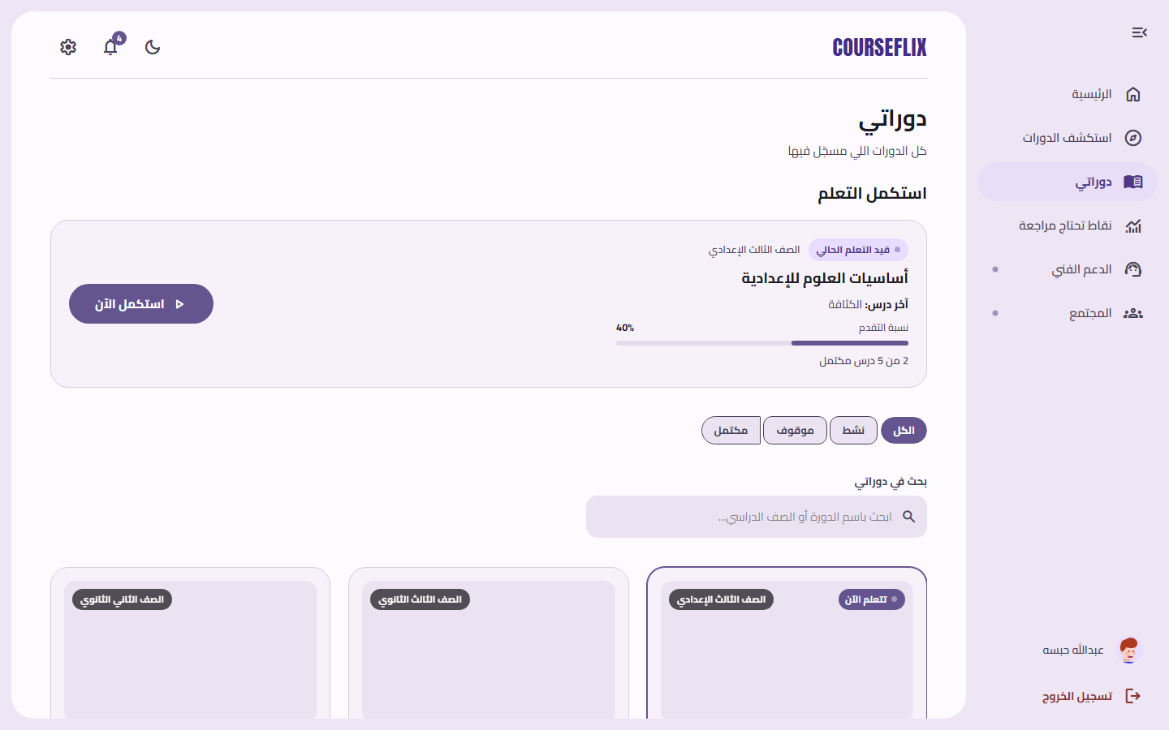
Figure: Student dashboard with enrolled courses and progress
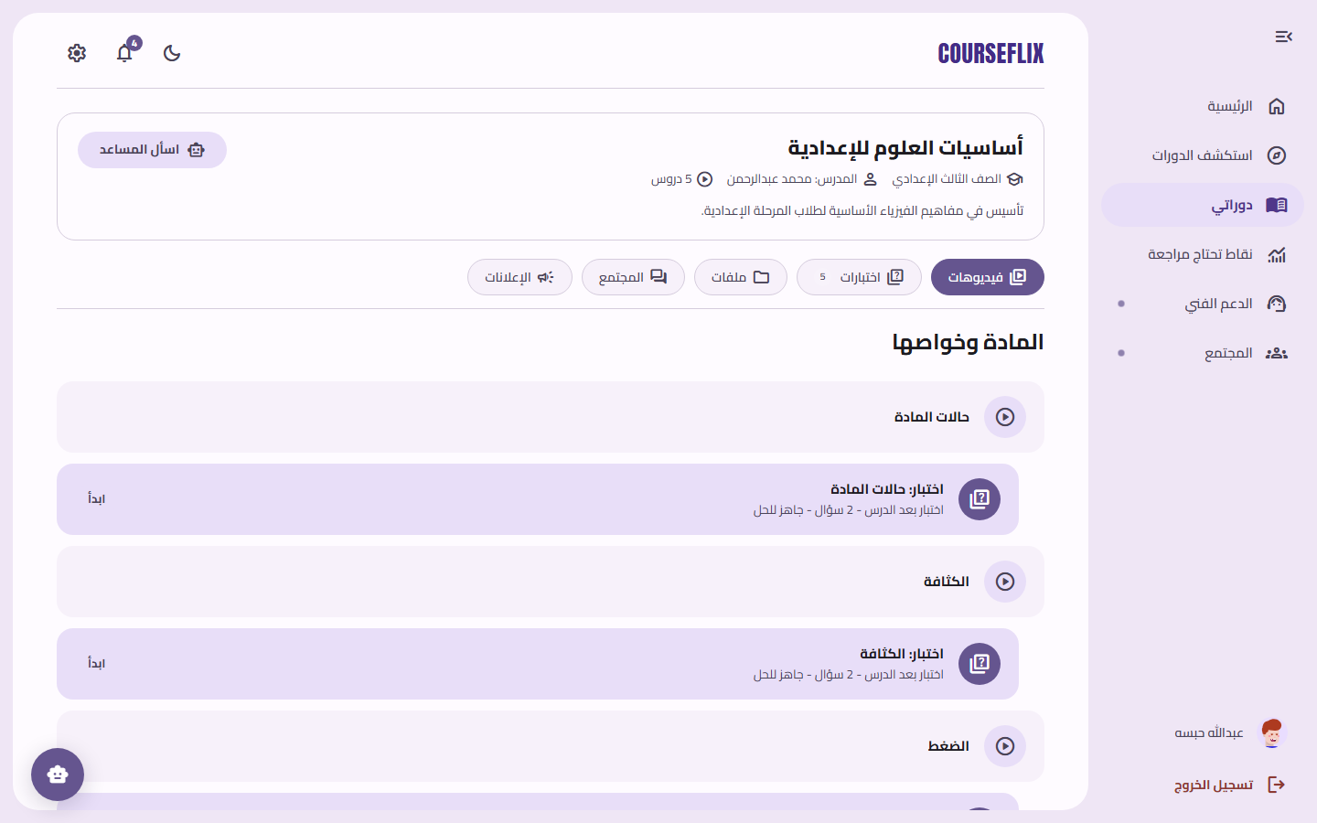
Figure: Course detail — sections, videos and quizzes
- Lesson Playback
  - Watches video lessons in the lesson player; position resumes automatically.
  - Heartbeat reports progress; attendance is awarded once at the threshold.
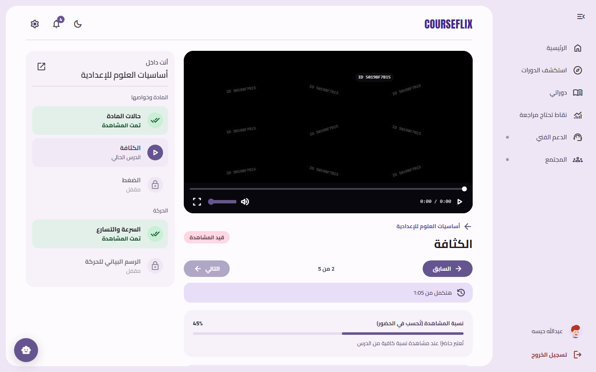
Figure: Lesson player with resume position and attendance progress
- Quizzes
  - Takes an objective quiz; answers are graded server-side and the result survives reload.
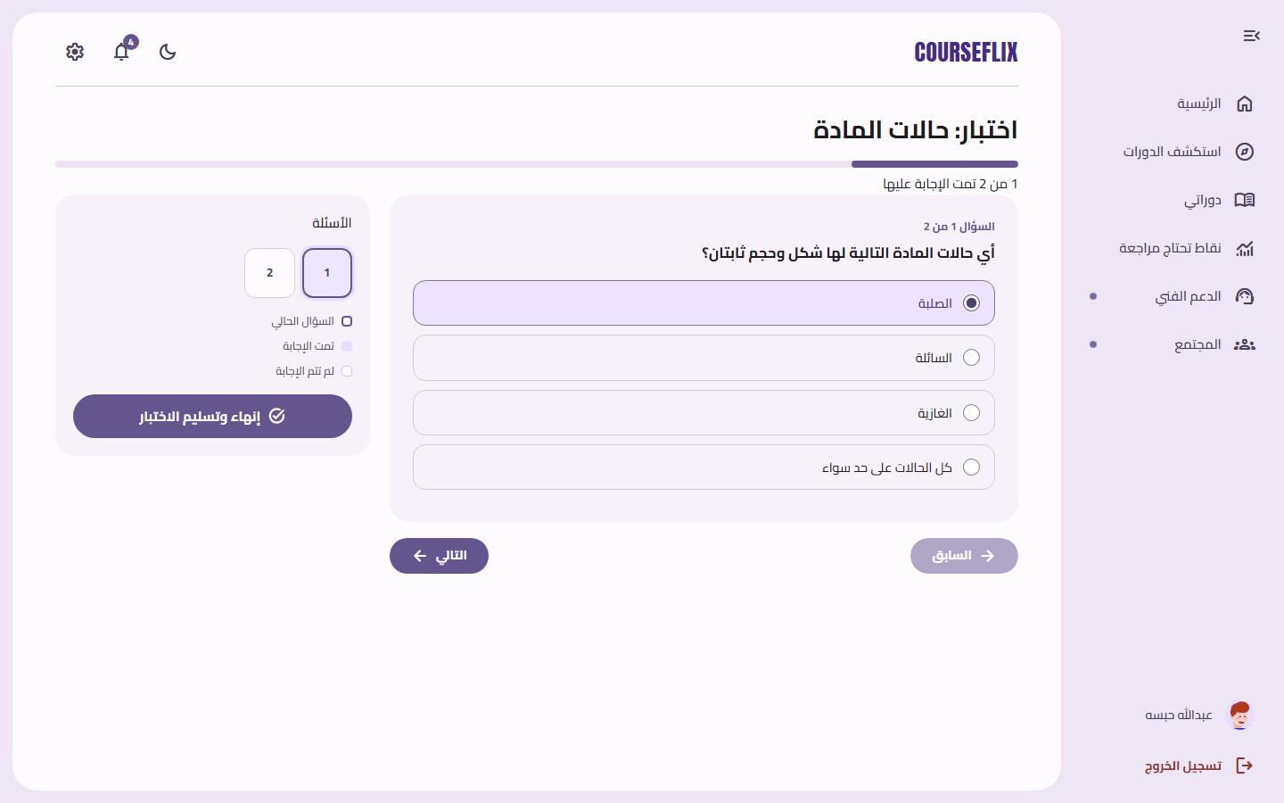
Figure: Student taking an objective quiz
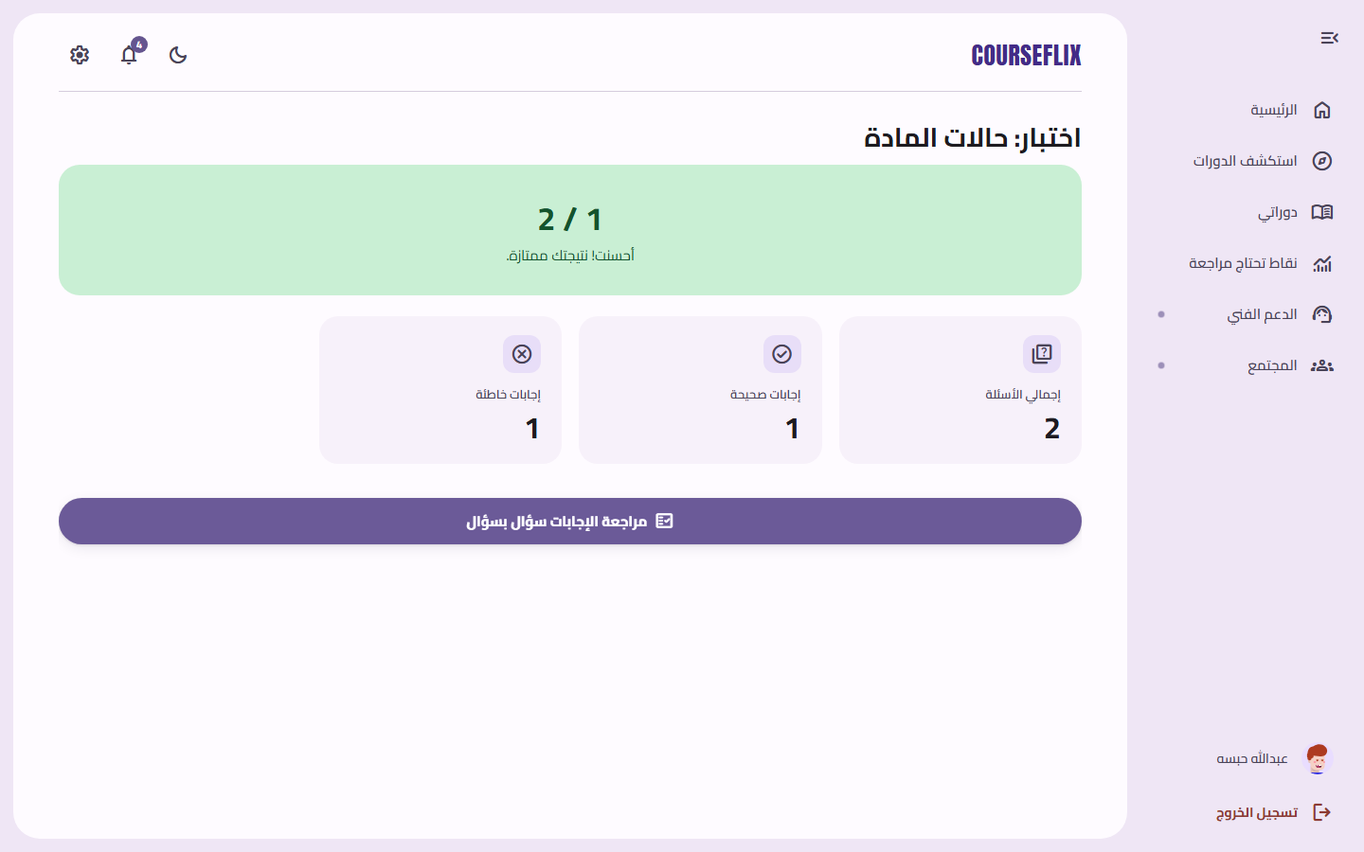
Figure: Server-graded quiz result
- AI Tutor
  - Asks the course Tutor a question; gets a grounded answer with citations — or an explicit “the uploaded material does not cover this” response.
  - Optionally asks about a specific video when a transcript exists.
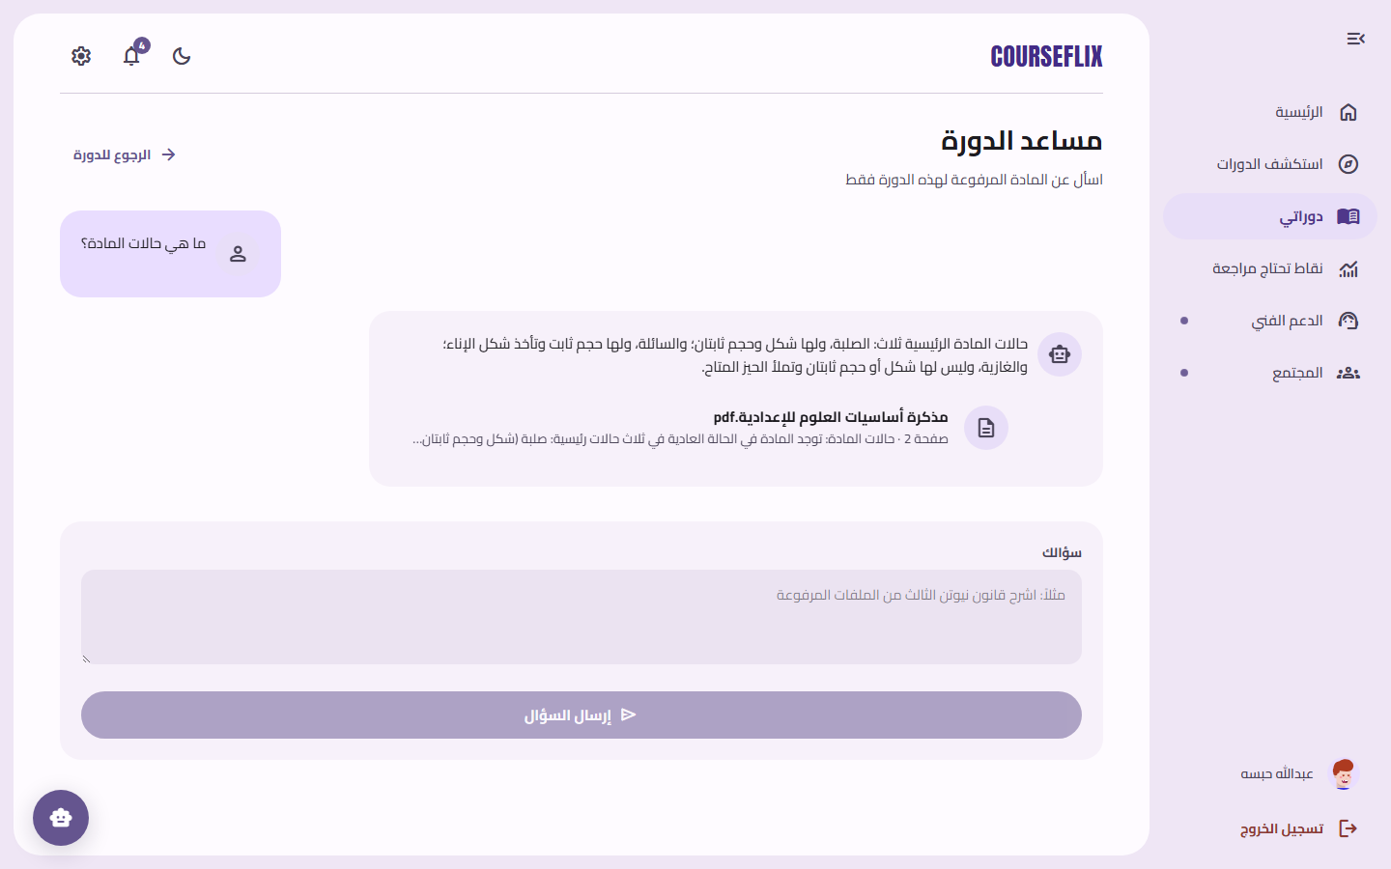
Figure: AI Tutor answering with a citation to the source PDF and page number
- Community & Announcements
  - Reads teacher announcements (with attachments) and participates in course discussions.
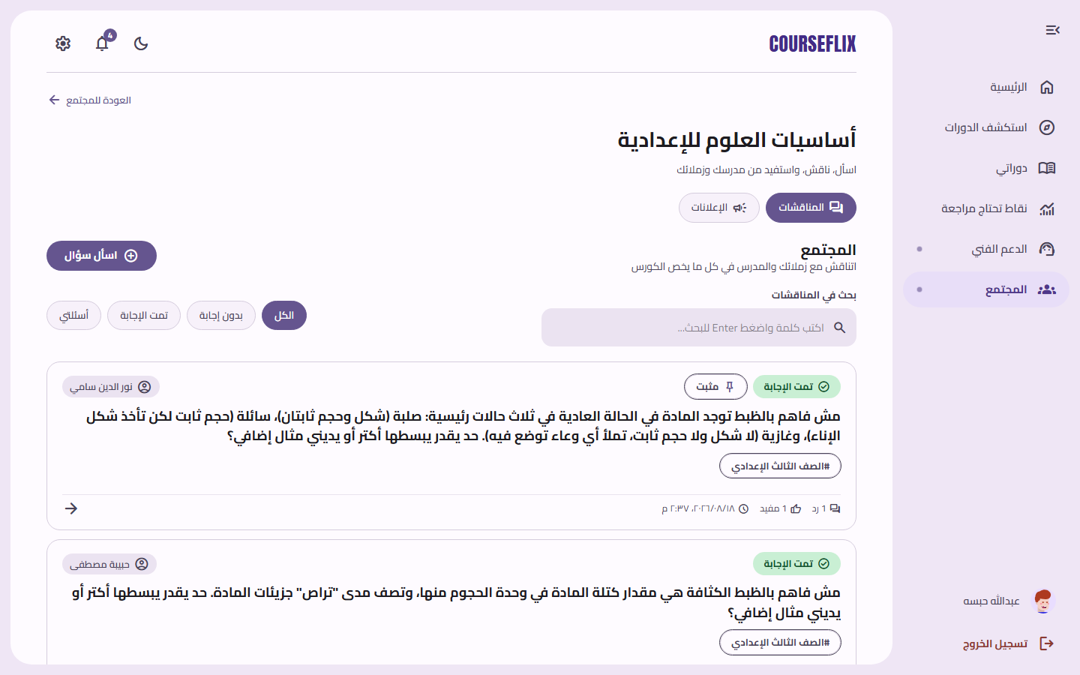
Figure: Course community — discussions and Q&A
- Interventions
  - If struggling, receives a weak-concept report + mini-quiz + notification from the deterministic rule engine.
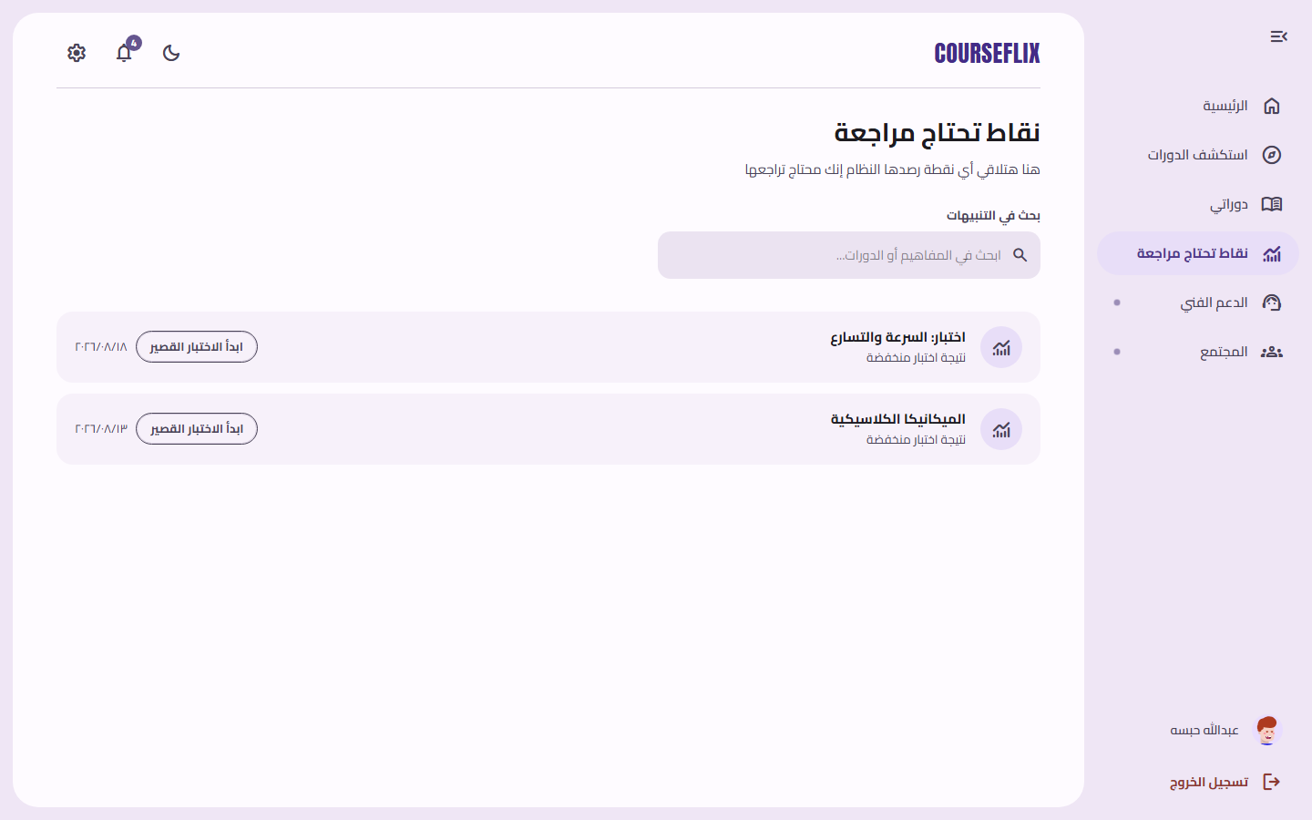
Figure: Student view of weak-concept intervention reports
- Notifications
  - Gets notified about announcements, quiz readiness, interventions, and support updates; clicks deep-link to the exact entity.
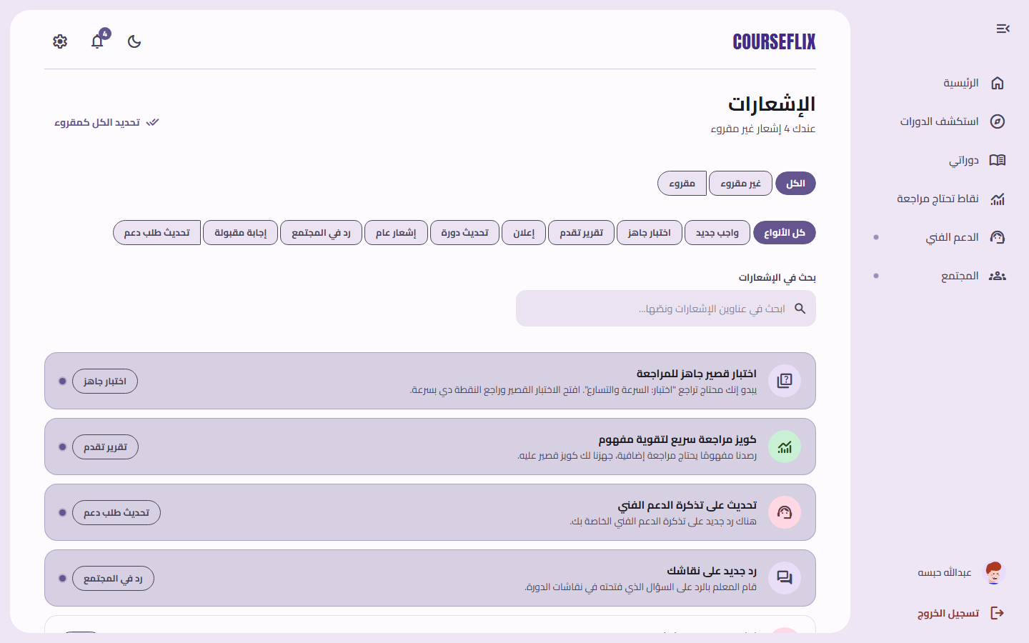
Figure: Student notifications feed
- Checkout
  - Purchases a course through the deterministic checkout → receives an authoritative receipt.
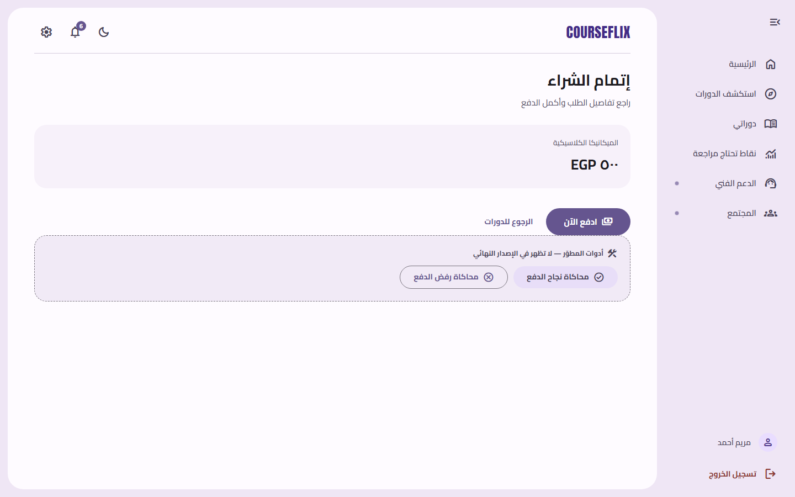
Figure: Deterministic test checkout page
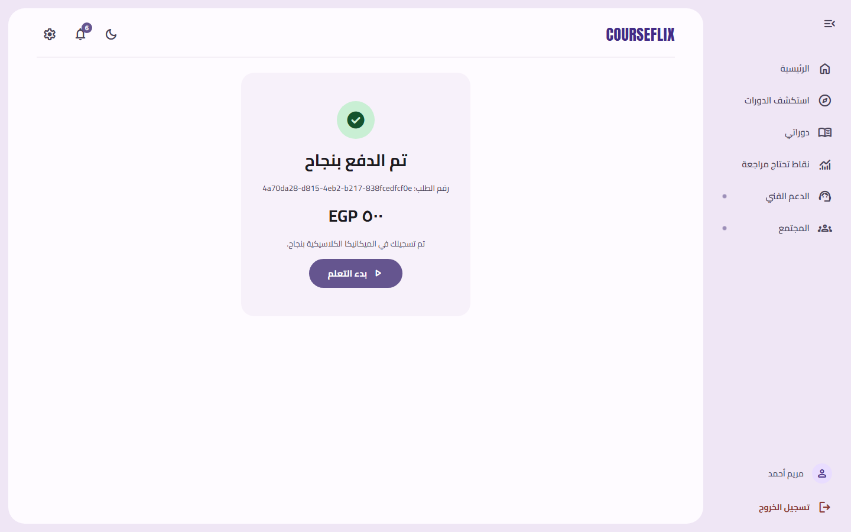
Figure: Authoritative payment receipt after checkout
- Support
  - Opens a support ticket if anything goes wrong.
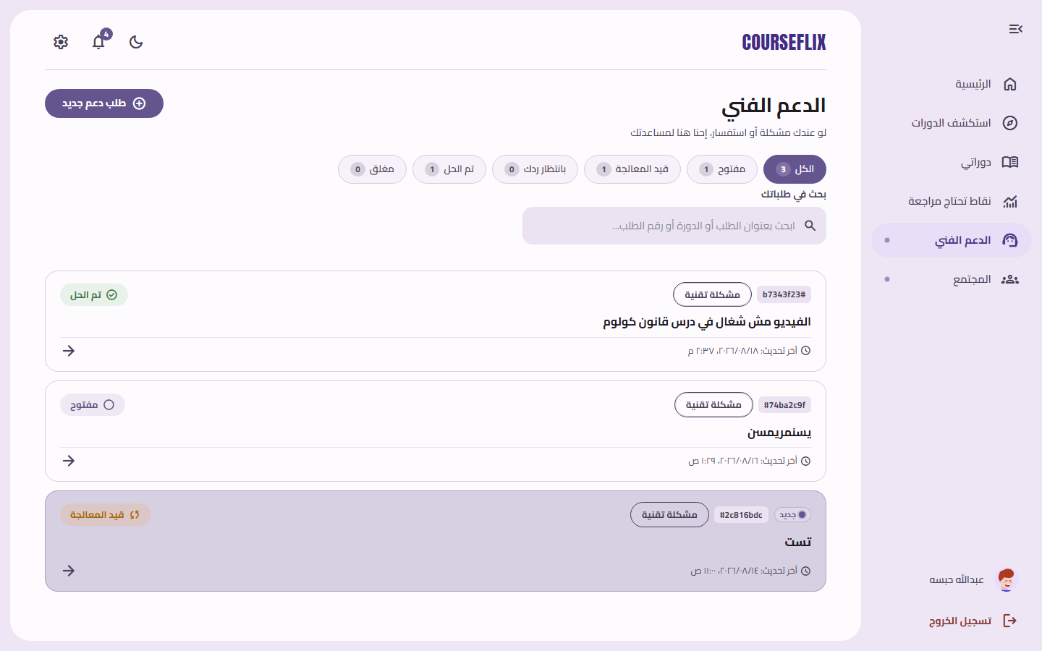
Figure: Student support tickets

Teacher Flow
- Sign In
  - Logs in; redirected to the teacher dashboard.
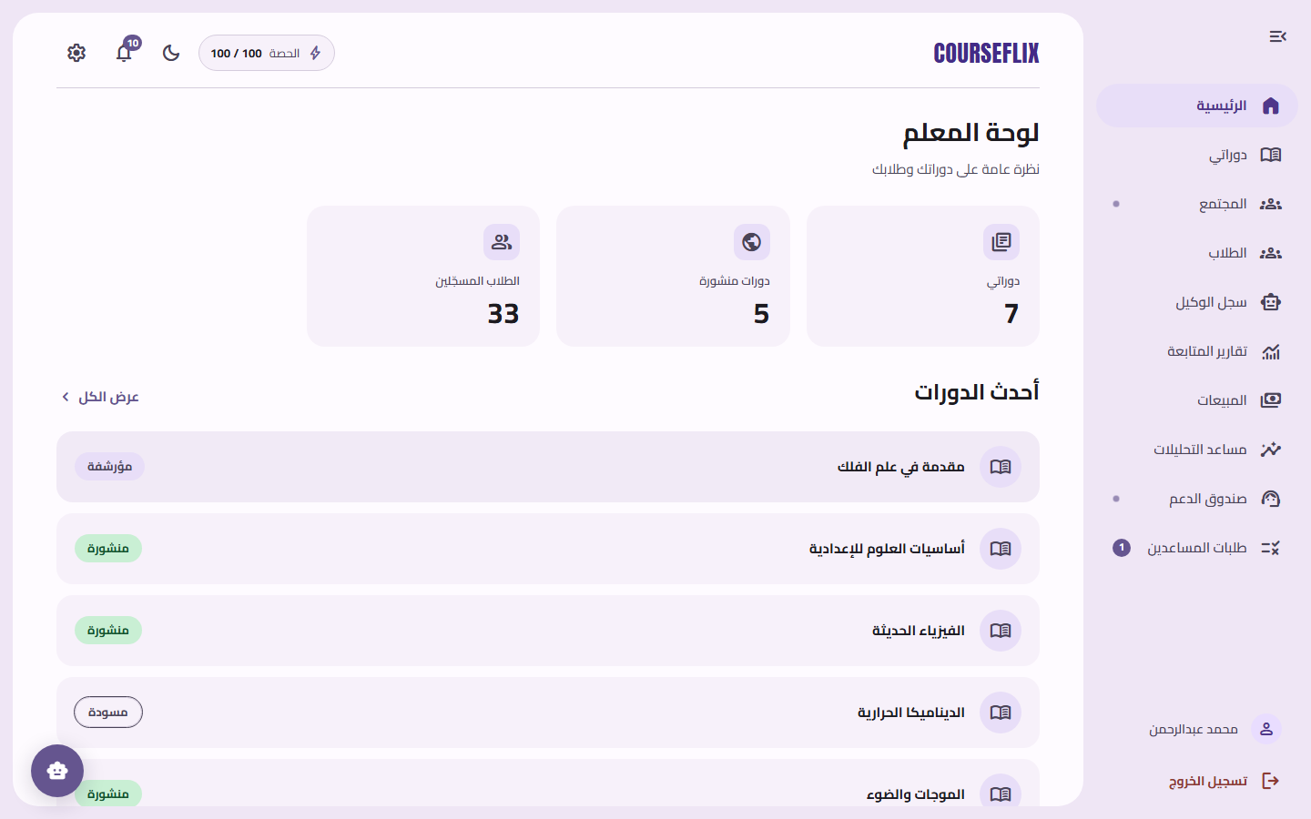
Figure: Teacher dashboard overview
- Course Management
  - Structures courses into sections and lessons; edits content; posts announcements.
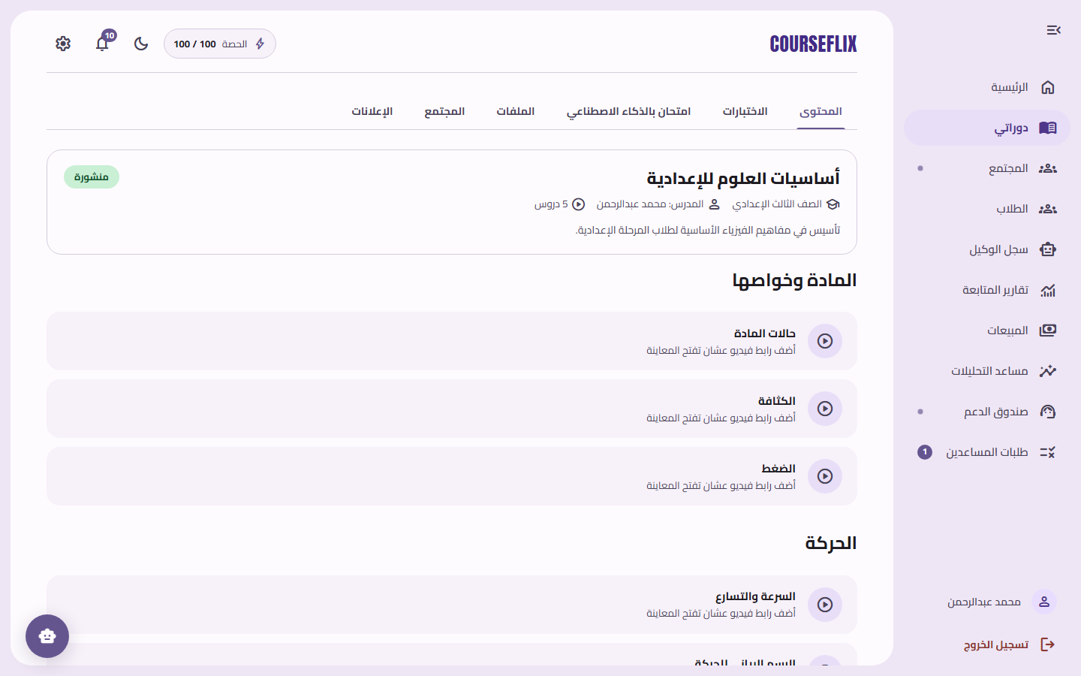
Figure: Teacher course structure (sections and lessons)
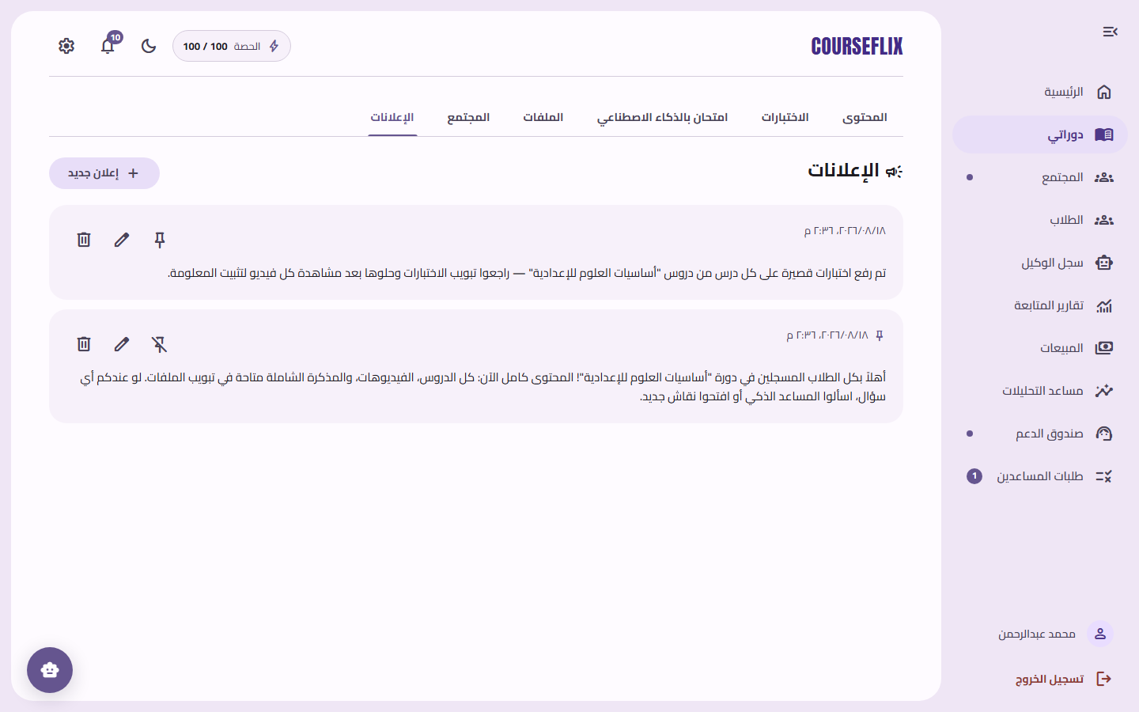
Figure: Teacher managing course announcements
- PDF Upload & Ingestion
  - Uploads a PDF; watches the processing status until it becomes searchable.
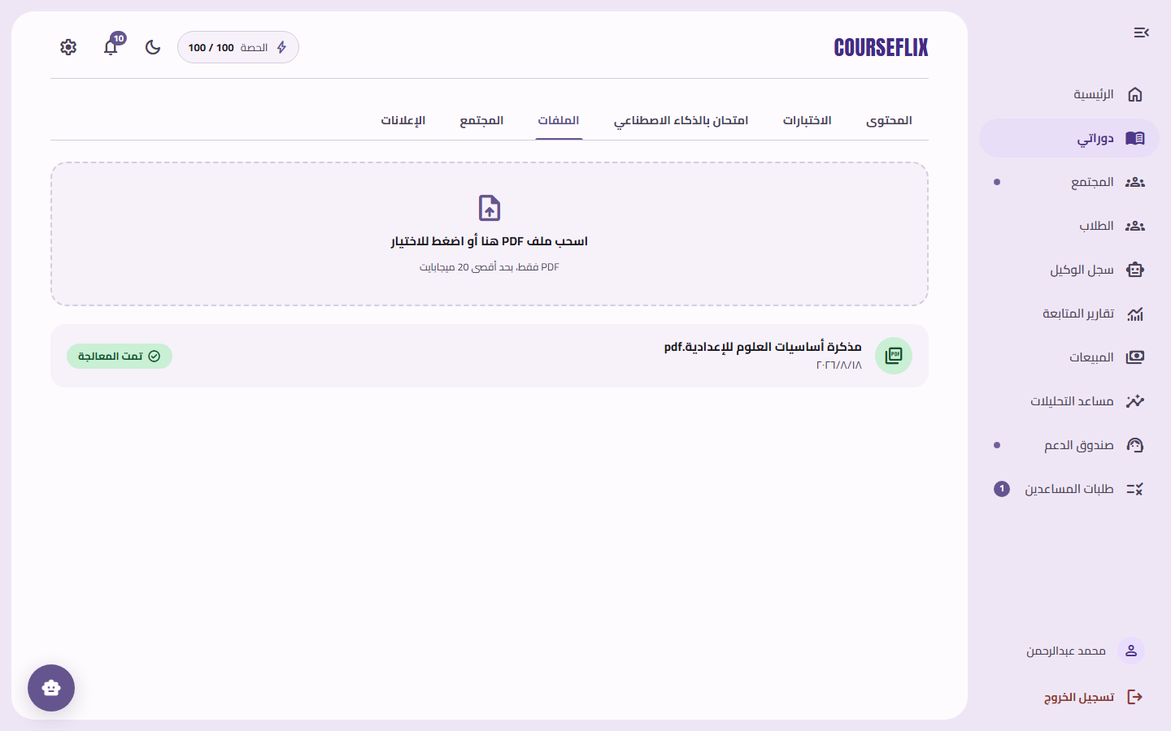
Figure: PDF upload and ingestion status
- Quiz Management
  - Builds quizzes from the question bank and reviews student submissions.
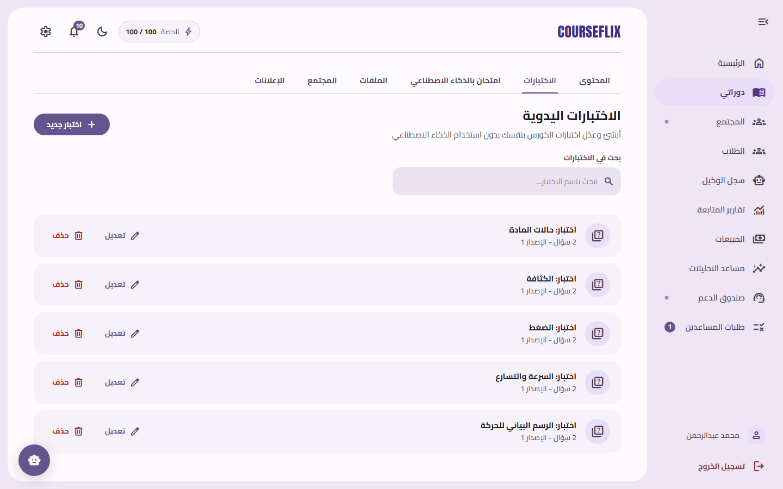
Figure: Teacher quiz management
- Progress & Interventions
  - Reviews weak-concept reports and student intervention activity.
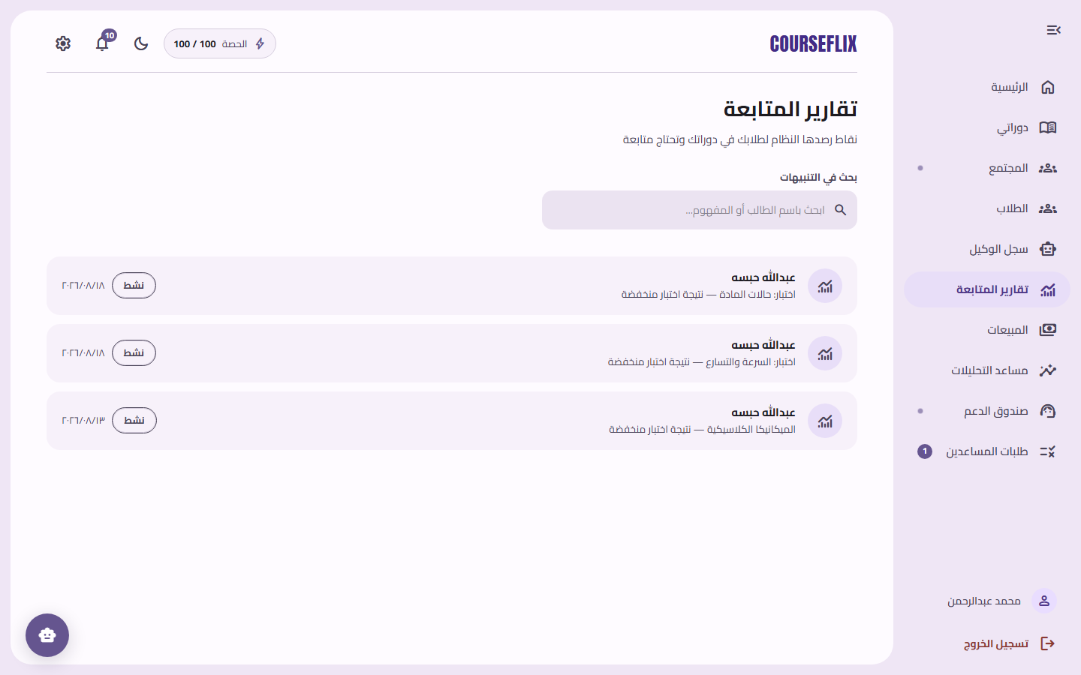
Figure: Teacher view of student progress reports and interventions
- Sales & Analytics
  - Views revenue and order metrics; asks the Analytics Agent sales questions.
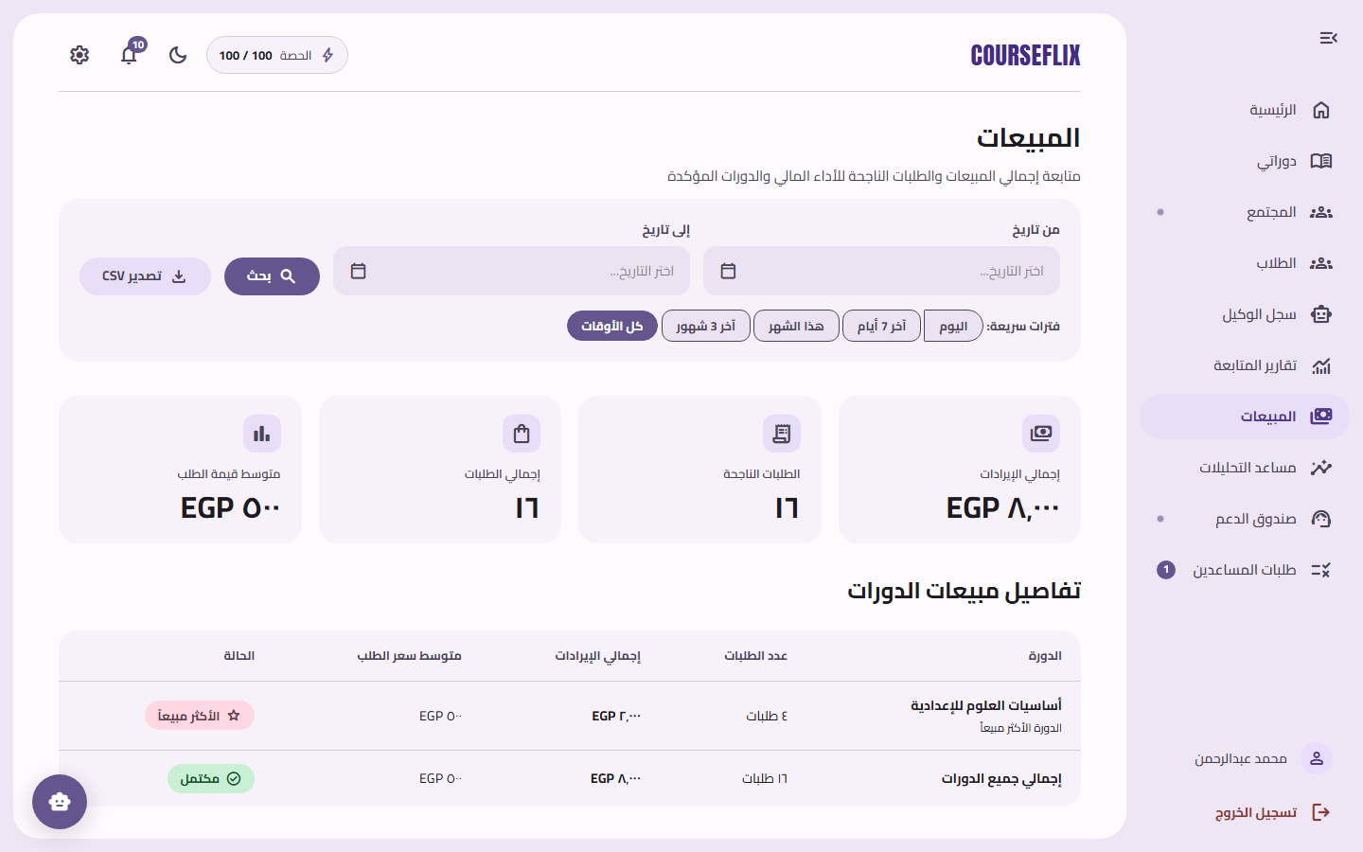
Figure: Teacher sales metrics dashboard
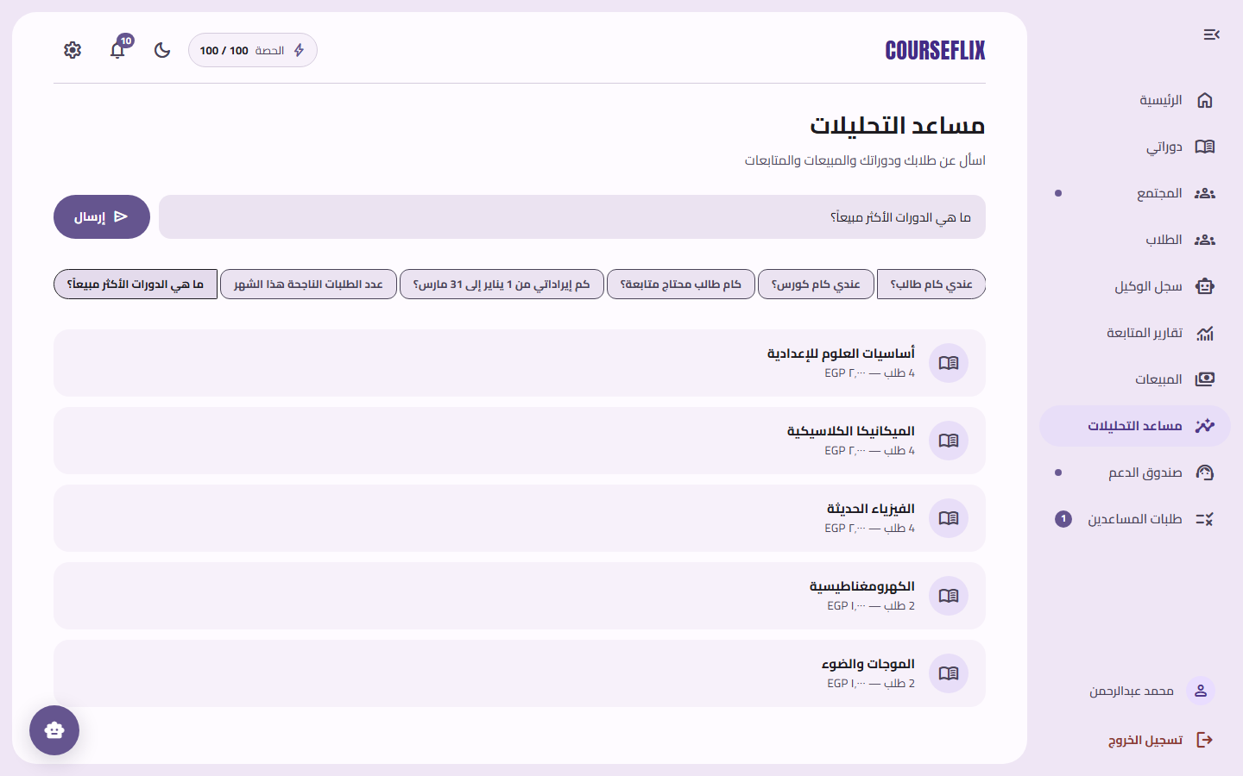
Figure: Limited Analytics Agent answering a sales question
- Agent Logs
  - Reviews scoped, redacted AI agent activity for debugging.
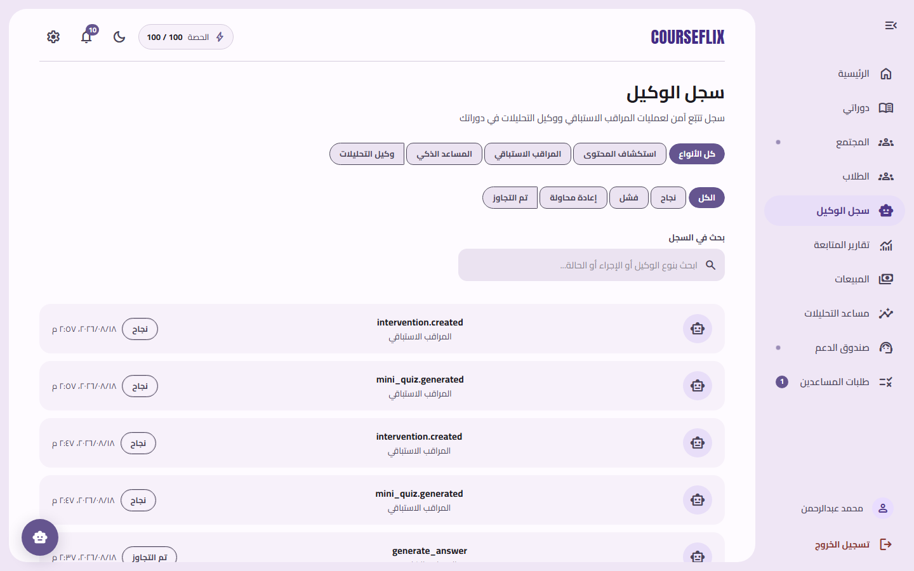
Figure: Agent logs (Proactive Proctor, Analytics Agent, Content Scout)
- Community & Support
  - Moderates discussions and triages support tickets.
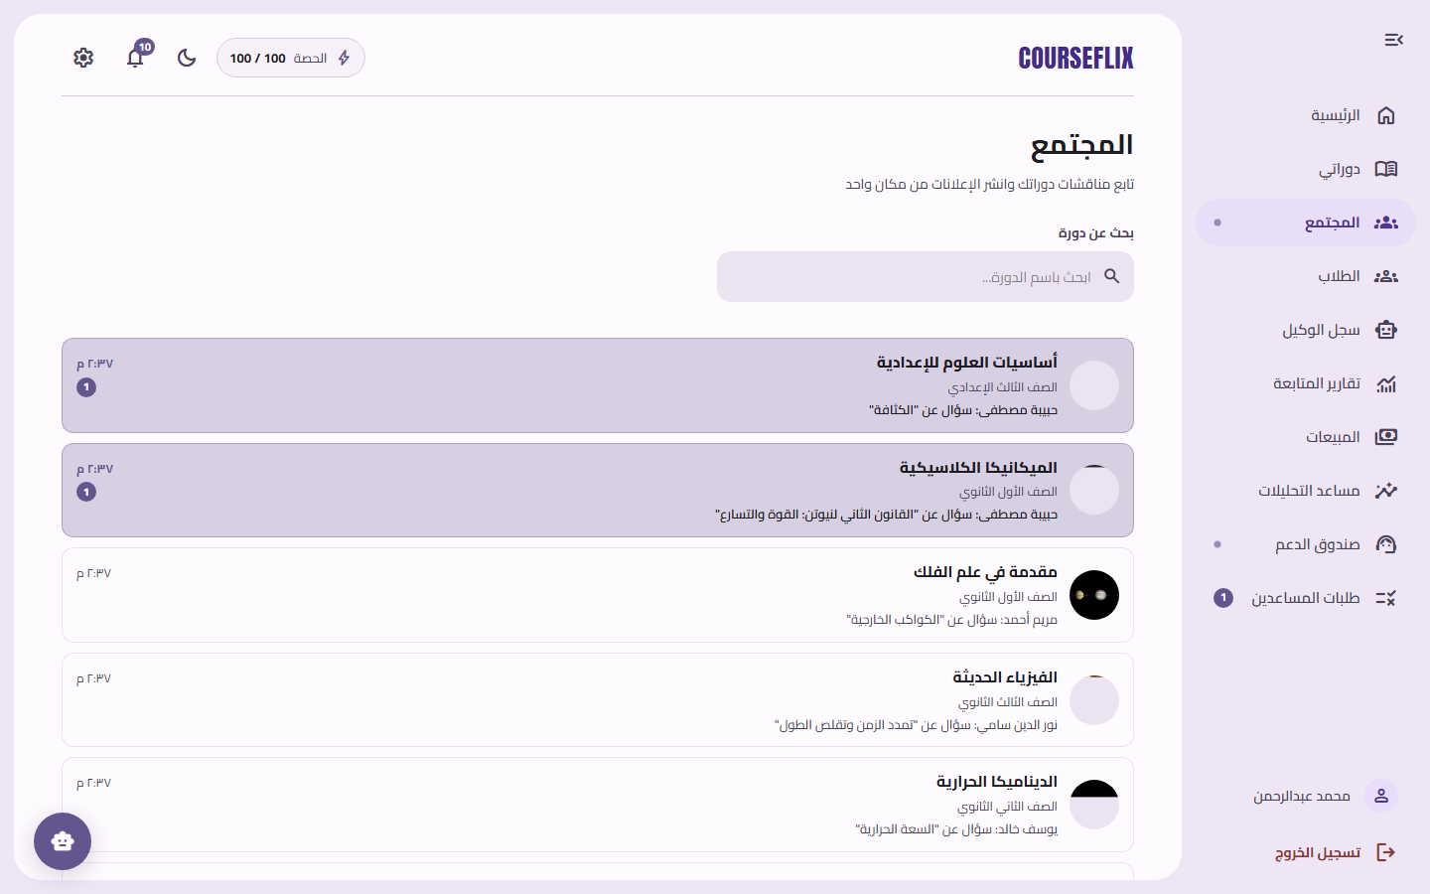
Figure: Teacher community overview across courses
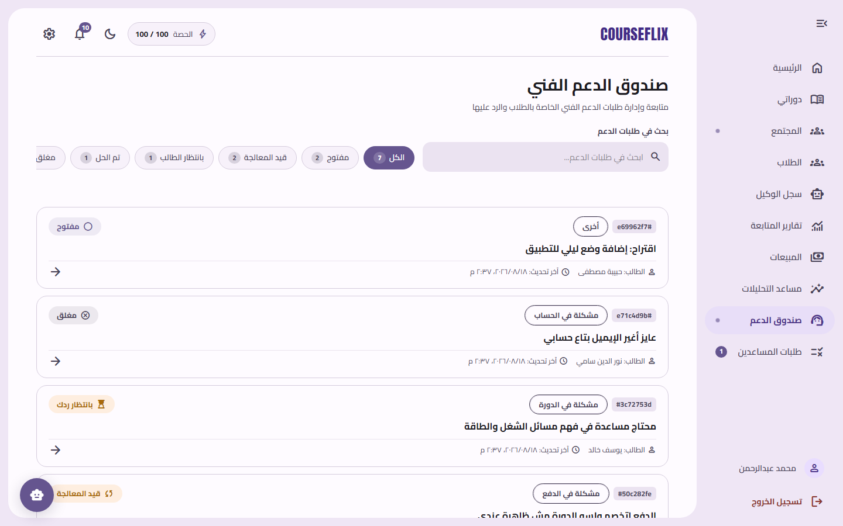
Figure: Teacher support ticket inbox

Assistant / Admin Flow
- Assistant: Shares the teacher course/student surface; manages community and support. No payment/analytics access.
- Admin: Platform-wide oversight — users, courses, orders, quizzes, documents, interventions, notifications log, agent logs — plus sending notifications to any user.
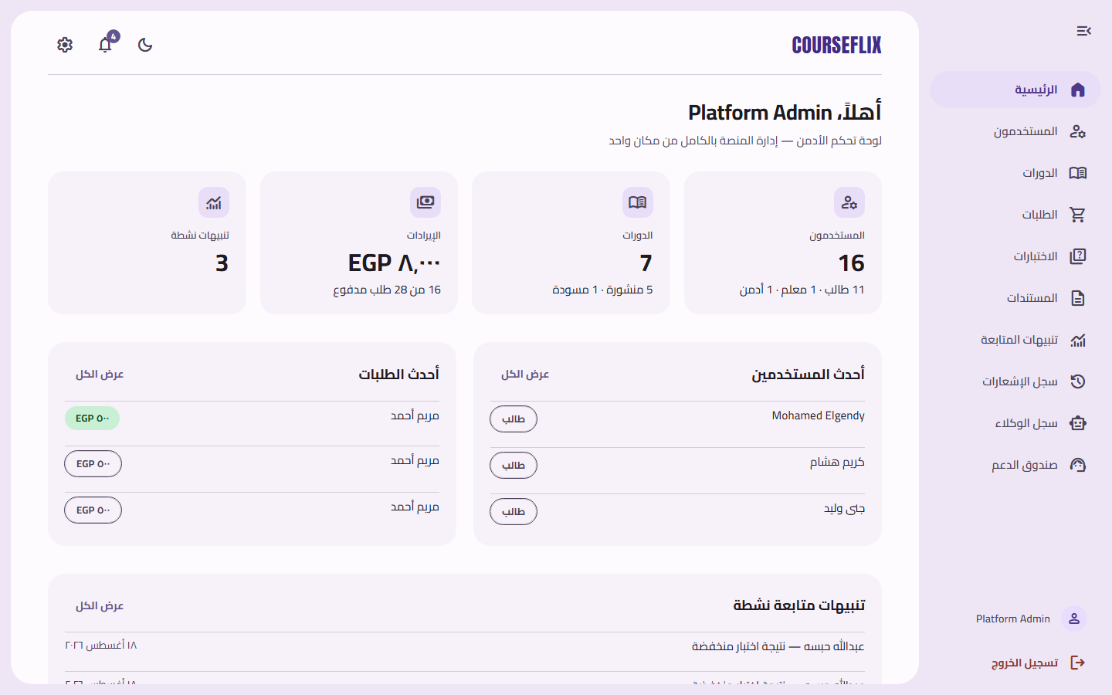
Figure: Admin platform oversight dashboard

Data Models
This section details the implemented data models, outlining their fields and relationships. These models are designed to support the functional requirements and ensure efficient data storage and retrieval.

1. User Model
Description: Represents all users of the system (Students, Teachers, Assistants).
Fields: - id (UUID, Primary Key) - full_name (Text) - email (Text, Unique) - password_hash (Text, Argon2id) - role (Enum: student, teacher) - status (Enum: active, suspended, inactive) - avatar_url (Text, Optional) - settings_theme / settings_language / settings_email_notifications (flattened embedded settings) - settings_notification_preferences (JSONB — per-type opt-in booleans) - google_id (Text, Optional — for “Continue with Google”) - last_login_at (Timestamptz) - deleted_at (Timestamptz, soft delete) - created_at / updated_at (Timestamptz)
Relationships: One-to-Many with Sessions, Enrollments, Courses (as teacher), Posts, QuizSubmissions, ChatConversations, Notifications.

2. Course Model
Description: Stores the top-level curriculum aggregate.
Fields: - id (UUID, Primary Key) - teacher_id (FK → User) - title / description / thumbnail_url / category - status (Enum: draft, published, archived) - max_students (Integer) - deleted_at / created_at / updated_at
Relationships: One-to-Many with Section, Enrollment, Document, Video, Quiz, Post, Discussion.

3. Section & Lesson Models
Description: The curriculum structure inside a course.
Section Fields: - id, course_id (FK), title, order_index, unlock_at, status, deleted_at
Lesson Fields: - id, section_id (FK), course_id (FK, denormalized), title, description, order_index, estimated_duration_min, unlock_at, status, deleted_at
Relationships: Section One-to-Many Lesson; Lesson One-to-Many Video/Quiz/Homework/Document.

4. Enrollment Model
Description: Records the student–course relationship and its lifecycle.
Fields: - id (UUID, Primary Key) - student_id (FK → User) - course_id (FK → Course) - status (Enum: active, suspended, completed) - suspended_reason / suspended_at - suspended_by_submission_id (FK → HomeworkSubmission) - status_changed_by (Enum: system_agent, teacher) - override_active (Boolean) - progress_percentage (Numeric — legacy, superseded by content_progress) - enrolled_at / deleted_at - Unique (student_id, course_id)

5. Document & DocumentChunk Models
Description: Source documents and their vector chunks feeding the RAG pipeline.
Document Fields: - id, course_id (FK), section_id/lesson_id (FK, optional), uploaded_by (FK → User), file_id (FK → File) - file_name, file_type (Enum: pdf, pptx), processing_status (Enum: pending, processing, completed, failed) - vector_namespace, checksum (SHA-256), version (Integer), deleted_at
DocumentChunk Fields: - id, document_id (FK), chunk_index, text_preview, vector_id (bridge to ChromaDB), page_number, token_count, is_active, deleted_at

6. Video & Attendance Models
Description: Video lessons and watch tracking with anti-fraud.
Video Fields: - id, course_id/section_id/lesson_id (FK), title, video_url, type (Enum: recorded, live) - duration_seconds, status (Enum: scheduled, live, ended, recorded), scheduled_at, min_attendance_percentage, deleted_at
Attendance Fields: - id, student_id (FK), video_id (FK), watched_seconds, watched_percentage, is_present - last_heartbeat_at, device_session_id, last_updated_at - Unique (student_id, video_id)

7. Question, Quiz & Submission Models
Description: Assessments built on a shared question bank.
Question Fields: - id, course_id (FK), type (Enum: mcq, true_false, short_answer), text, options (Text[]), correct_answer, tags (Text[]), difficulty, deleted_at
Quiz Fields: - id, course_id/section_id/lesson_id (FK), source_document_id (FK), created_by (FK), generation_type (Enum: manual, rag_generated), is_mini_quiz (Boolean), title, version, deleted_at
QuizSubmission Fields: - id, quiz_id (FK), student_id (FK), score, quiz_version (locks grading), submitted_at, deleted_at

8. ChatConversation & ChatMessage Models
Description: The AI Tutor’s conversation history with full grounding and cost metadata.
ChatConversation Fields: - id, student_id (FK), course_id (FK), status (Enum: active, closed), started_at, last_message_at, deleted_at
ChatMessage Fields: - id, conversation_id (FK), sender_type (Enum: student, ai_tutor), role (Enum: user, assistant, system), message_text - summary_state, moderation_status (Enum: pending, approved, blocked) - model_name, provider, temperature, prompt_version, tokens_used, flagged, flag_reason, deleted_at

9. Notification Model
Description: Per-user in-app notifications.
Fields: - id, user_id (FK), type (Enum), title, message - related_entity_type / related_entity_id (polymorphic deep-link target) - priority (Enum: low, normal, high, critical), delivery_status, scheduled_at, read_at, is_read, deleted_at

10. Intervention & ProgressReport Models
Description: Deterministic learning interventions and at-risk reporting.
Intervention Fields: - id, student_id/course_id (FK), rule_key (versioned rule), trigger data, weak_concept, related_mini_quiz_id, status, window_start, deleted_at
ProgressReport Fields: - id, student_id/course_id/teacher_id (FK), flagged_concept, related_quiz_id (FK), teacher_notified, email_sent_at, deleted_at

11. Order, OrderItem & Payment Models
Description: The financial source of truth for course purchases.
Order Fields: - id, student_id (FK), status (Enum: pending, paid, failed), payment_status, currency (EGP), total_minor (Integer), idempotency_key, paid_at, created_at, updated_at
OrderItem Fields: - id, order_id (FK), course_id (FK), title_snapshot, price_minor
Payment Fields: - id, order_id (FK), attempt_no, payment attempt metadata

12. Community, Support & AgentLog Models
Description: Discussions, announcements, support tickets, and AI traceability.
Discussion Thread/Reply Fields: - Thread: id, course_id, author_id, author_role, title, body, tags, accepted_reply_id, reply_count, helpful_count, is_pinned, deleted_at - Reply: id, thread_id, author_id, author_role, body, is_accepted, deleted_at
SupportTicket Fields: - id, student_id, category, subject, status, priority, assignee, messages, deleted_at
AgentLog Fields: - id, agent_type (Enum), course_id, target_entity_type/target_entity_id, action, status (Enum: success, failed, retrying), tokens_used, error_message, executed_at

AI-Based Features
CourseFlix’s differentiators are its AI-powered features. Each one is grounded, deterministic where it matters, and fully traceable.

AI Tutor (RAG — Retrieval-Augmented Generation)
Feature Summary: A course-scoped AI assistant that answers student questions using only the teacher’s uploaded documents. Every answer cites the exact grounding chunks (with excerpts and relevance scores), and the system returns an explicit no_answer with zero citations — and no model call — when nothing relevant is found.
Who Can Use It: Students (per enrolled course), Teachers (via their own course material).
Implemented By: - Backend: Retrieval port (ChromaDB with mandatory courseId + active-version filtering), an answer-policy service with a relevance threshold (TUTOR_MAX_DISTANCE), a server-owned versioned prompt template with retrieved content in an untrusted block, and injection checks. - Frontend: Tutor chat page with a citation list.
Capabilities: - Answers grounded in the course’s own active documents only. - Honest “no answer” when the material does not cover the question. - Prompt-injection safety and redacted traces (never question/answer/chunk text in logs). - Conversation persistence and history read-back.

Video Q&A Assistant
Feature Summary: Where a video has a transcript (YouTube captions or Whisper transcription), students can ask questions specifically about that video’s content.
Who Can Use It: Students, on videos with a processed transcript.
Implemented By: - Backend: Video ingestion worker (YouTube captions or local Whisper transcription), transcript store, video Q&A API. - Frontend: A panel on the lesson player showing answers or an honest “assistant not available” state.

RAG Document Ingestion Pipeline
Feature Summary: Teacher PDFs are validated, chunked deterministically, embedded, and indexed into ChromaDB with full lifecycle and isolation.
Who Can Use It: Teachers (upload), Students (search).
Implemented By: - Backend: File/document API + BullMQ worker in apps/worker. Deterministic chunking (800 tokens / 120 overlap, byte-stable boundaries), provider-agnostic embeddings (mock provider in tests), Chroma upsert with mandatory courseId/documentId/version metadata. - Frontend: Teacher Files tab with status polling.
Capabilities: - Two-course isolation: zero cross-course chunk leakage. - Document versioning with old chunks deactivated, never deleted. - Checksum dedup to avoid redundant embedding. - Failure contract with retry and failure notifications.

Deterministic Learning Interventions (Proactive Proctor)
Feature Summary: A versioned, deterministic rule engine that detects struggling students (e.g., quiz score below 60%, explicit phrases like “مش فاهم”, repeated concept questions) and produces a weak-concept report, a mini-quiz, a notification, and an agent-log entry — deduplicated per rule window. It never suspends or mutates enrollment.
Who Can Use It: Students (receive), Teachers (review).
Implemented By: - Backend: Intervention rule evaluator + mini-quiz service. - Frontend: Student/teacher intervention views.

Mini-Quiz Generation
Feature Summary: When an intervention flags a weak concept, the system generates a deterministic mini-quiz of 3 objective questions with evidence references, graded server-side.
Who Can Use It: Students (take), Teachers (review).

Limited Analytics Agent
Feature Summary: A natural-language sales assistant for teachers with exactly three allowlisted intents — revenue for a period, successful-order count, best-selling courses. Unsupported questions return examples and execute no aggregate query; no raw SQL path exists. Every run is logged with a trace ID.
Who Can Use It: Teachers only.
Implemented By: - Backend: Analytics intent parser + analytics functions + log service. - Frontend: Analytics Agent UI on the teacher dashboard.

Testing Strategy
A multi-layered testing strategy is employed to ensure the quality, reliability, and security of the CourseFlix platform:
- Unit Testing: Individual functions, services, rules, and components (both frontend and backend) are tested in isolation — validation, auth helpers, progress/attendance rules, grading, chunk metadata, idempotency, event schemas, and every deterministic rule.
- API/Integration Testing: Tests verify sessions/RBAC, ownership, migrations, upload lifecycle, Chroma filtering, orders, aggregates, and agent logs — including the critical two-course isolation test proving zero cross-course chunk leakage.
- RAG Evaluation Testing: Supported/no-answer behavior, citation validation against actually-retrieved chunks, and three canonical prompt-injection cases — all on deterministic mock providers (no paid API calls in tests).
- Browser/Component Testing: Role shell, course/lesson/quiz/chat/checkout/sales/notifications/logs pages via Vitest + React Testing Library + MSW.
- End-to-End Testing: A canonical flow — teacher upload → student learns → Tutor → intervention → checkout → teacher analytics/logs — via smoke e2e specs.
- Visual/Responsive Testing: RTL at 390/768/1024/1440 px, light/dark themes, standard states, no overlap.
- Security/Privacy/Operational Testing: Role bypass, file spoofing (spoofed MIME/PNG-bytes-as-PDF), oversized/empty files, non-owner 403s, notification cross-user isolation, dataLayer PII-denylist rejections, rate limits, price/idempotency tamper, clean migration, seed reset, dependency health, correlation IDs.
Verification commands:
npm run test:api # Jest + Supertest (backend)
npm run test:web # Vitest + RTL + MSW (frontend)
npm run build:api # NestJS build
npm run build:web # Vite build

Deployment Strategy

Local Development (Committed MVP Baseline)
The MVP runs locally via a one-command launcher (./dev.sh) that brings up the whole stack:
- Infrastructure (Docker Compose): postgres:16-alpine (5432), redis:7-alpine (6379), chromadb/chroma (8000).
- Migrations & Seed: TypeORM migrations run automatically, then a deterministic seed inserts 2 teachers, 10 students, 7 courses (14 sections, 44 lessons), ~30 enrollments, documents, and a notification feed per user. Re-running is safe (upserts).
- Apps: apps/api (NestJS, port 3000), apps/web (Vite, port 5173), apps/worker (BullMQ consumer, background).
./dev.sh # start everything
./dev.sh stop # stop processes + Docker services (keeps data)
./dev.sh reset # wipe DB volume and rebuild
./dev.sh status # show what's running
./dev.sh logs # follow API and web logs

Production (Blueprint)
The production blueprint (Render-based) is tracked on a dedicated branch and covers:
- Containerization: Multi-stage Dockerfiles under deploy/ (node:22-bookworm-slim; npm ci; build; run migrations then start) for the API, web, and worker.
- Services on Render: courseflix-api (health-checked, runs migrations before start), courseflix-worker, courseflix-web (Vite SPA on nginx), plus managed Redis and Postgres.
- Monitoring & Health: /health/live and /health/ready per-dependency checks, correlation IDs, and structured logs.
- Environment: AI/embedding credentials, storage root, attendance threshold, commerce config, and GTM keys via environment variables.
- Known caveats: free-tier services sleep after ~15 min idle; the filesystem is ephemeral (uploaded PDFs lost on redeploy — move to Bunny/S3); hardcoded URLs must be updated.
- Real payments (Paymob) are post-MVP and tracked on a dedicated branch.

GitHub Repositories
- Repository: https://github.com/Xmerlin7/CourseFlix
Branching model: main is release-only (no direct pushes). Normal work starts from dev, uses a Jira-named feature//fix//test/docs branch, and returns to dev through a reviewed pull request with passing checks. Only reviewed release or emergency-hotfix PRs may target main. Migrations and authorization changes require two approvals.
CI/CD: GitHub Actions CI is described as “as workflows become available”; required checks for RAG evaluation, security, and GTM validation are to be added once those workflows become stable.

Conclusion
CourseFlix represents a comprehensive solution designed to modernize Arabic online learning. By leveraging a modern React + NestJS architecture, a production-hardened PostgreSQL schema, and a grounded, deterministic AI layer, the platform addresses key challenges faced by both teachers managing courses and students learning on demand. From the Arabic RTL UI to the cited AI Tutor, the deterministic interventions, and the authoritative test checkout, CourseFlix is poised to deliver a complete, demonstrable, and trustworthy online learning experience.

