COURSEFLIX
User Manual
An Arabic RTL learning platform — a complete guide for every user type: Student, Teacher, Assistant, and Admin

Team Members:
1. Mohamed Elgendy
2. Albraa Nawara
3. Mahmoud Nabile
4. Abdullah Habsa
5. Seif-Allah Ahmed

Contents
1. Introduction
2. Signing In and Creating an Account
3. Student Guide
4. Teacher Guide
5. Teaching Assistant Guide
6. Platform Admin Guide

1. Introduction
CourseFlix is an Arabic-first learning platform with a fully right-to-left (RTL) interface. It combines video course delivery, student progress tracking, objective quizzes, a course-grounded AI tutor that answers from the course's own PDF material, automated learning-intervention alerts, a course-purchase checkout flow, and teacher sales analytics.
The system splits users into four roles, each with its own dashboard and permissions:
Student — Enrolls in courses, watches lessons and videos, takes quizzes, and asks the AI tutor questions.
Teacher — Creates and manages courses, lessons and quizzes, tracks student progress, and reviews sales and analytics.
Assistant — Helps the teacher manage courses and students, but has no access to sales, analytics, or the agent log.
Admin — Manages every user account, course, and order platform-wide, and reviews all logs and notifications.

Demo Credentials (Local Demo Environment)
Role | Email | Password
Student | student@courseflix.local | Student123!
Teacher | teacher@courseflix.local | Teacher123!
Assistant | sara.assistant@courseflix.local | Teacher123!
Admin | admin@courseflix.local | Admin123!
Sign-in URL: http://localhost:5173/login (local development environment)
Note: the credentials above are demo-only and are not used in a real production environment.
The app's interface itself is Arabic-only (no language switch). This manual keeps the Arabic sidebar/button labels in quotes next to each English instruction so you can match them to what you see on screen.

2. Signing In and Creating an Account
Every user signs in from the same login page. The system automatically routes them to the dashboard for their role (student / teacher / assistant / admin) based on their account type.

Login Page
The first page any user sees before entering the system.
1. Enter your email in the “البريد الإلكتروني‏” (Email) field.
2. Enter your password in the “كلمة المرور‏” (Password) field.
3. Click “تسجيل الدخول‏” (Sign In) to enter your account.
4. If you forgot your password, click “نسيت كلمة المرور؟‏” (Forgot password?) to reset it by email.
5. If you don't have an account yet, click the sign-up link to go to the registration page.
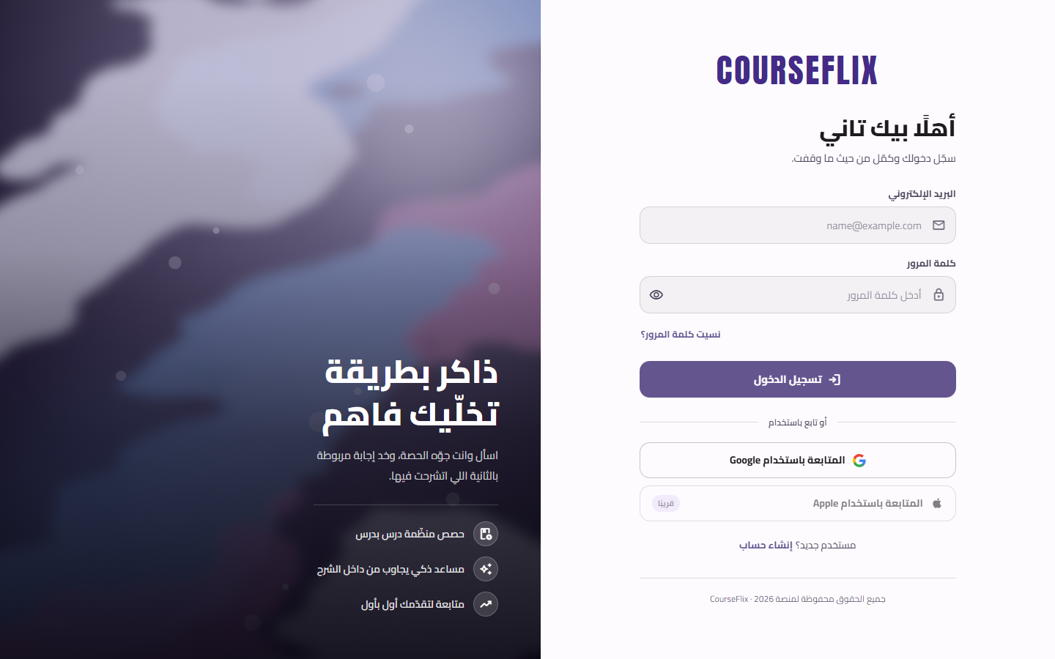

Registration Page
Used to sign up a new student account (teacher and admin accounts are created by the admin from their dashboard).
1. Fill in the required fields: full name, email, and password.
2. Accept the terms and conditions and the privacy policy.
3. Click the create-account button; a verification code will be sent to your email to confirm the account.
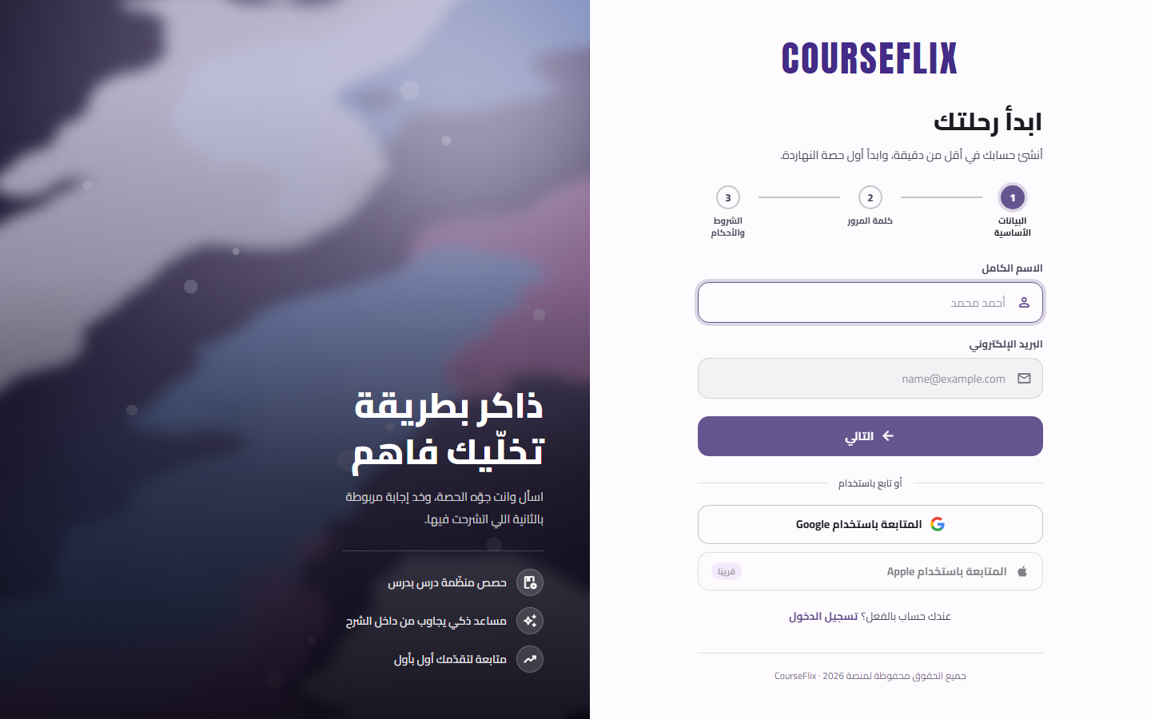

3. Student Guide
After signing in as a student, you land directly on the “دوراتي‏” (My Courses) page. The right-hand sidebar gathers every page available to a student.

My Courses (landing page after sign-in)
Shows every course the student is enrolled in, with a progress percentage for each.
1. Open “دوراتي‏” (My Courses) from the sidebar.
2. Click any course to open its details and resume its lessons.
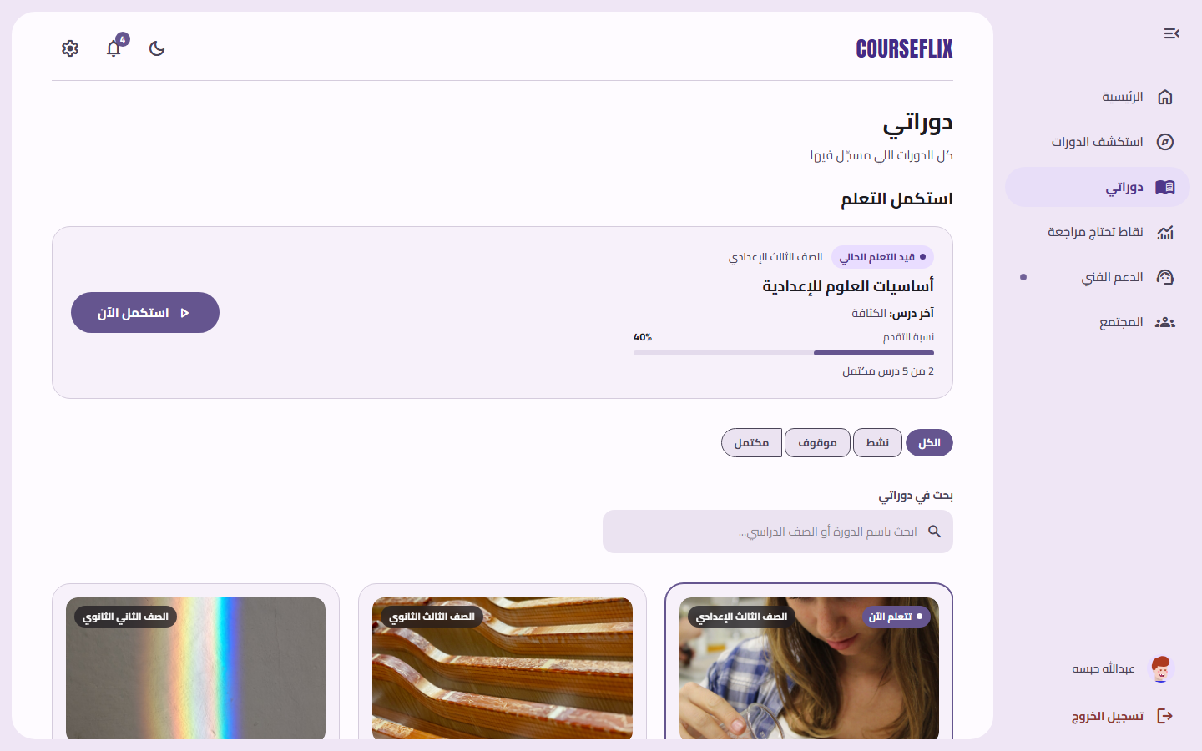

Home / Dashboard
A quick overview of the student's activity: recent lessons, notifications, and points that need review.
1. Click the “COURSEFLIX” logo or “الرئيسية‏” (Home) at any time to return here.
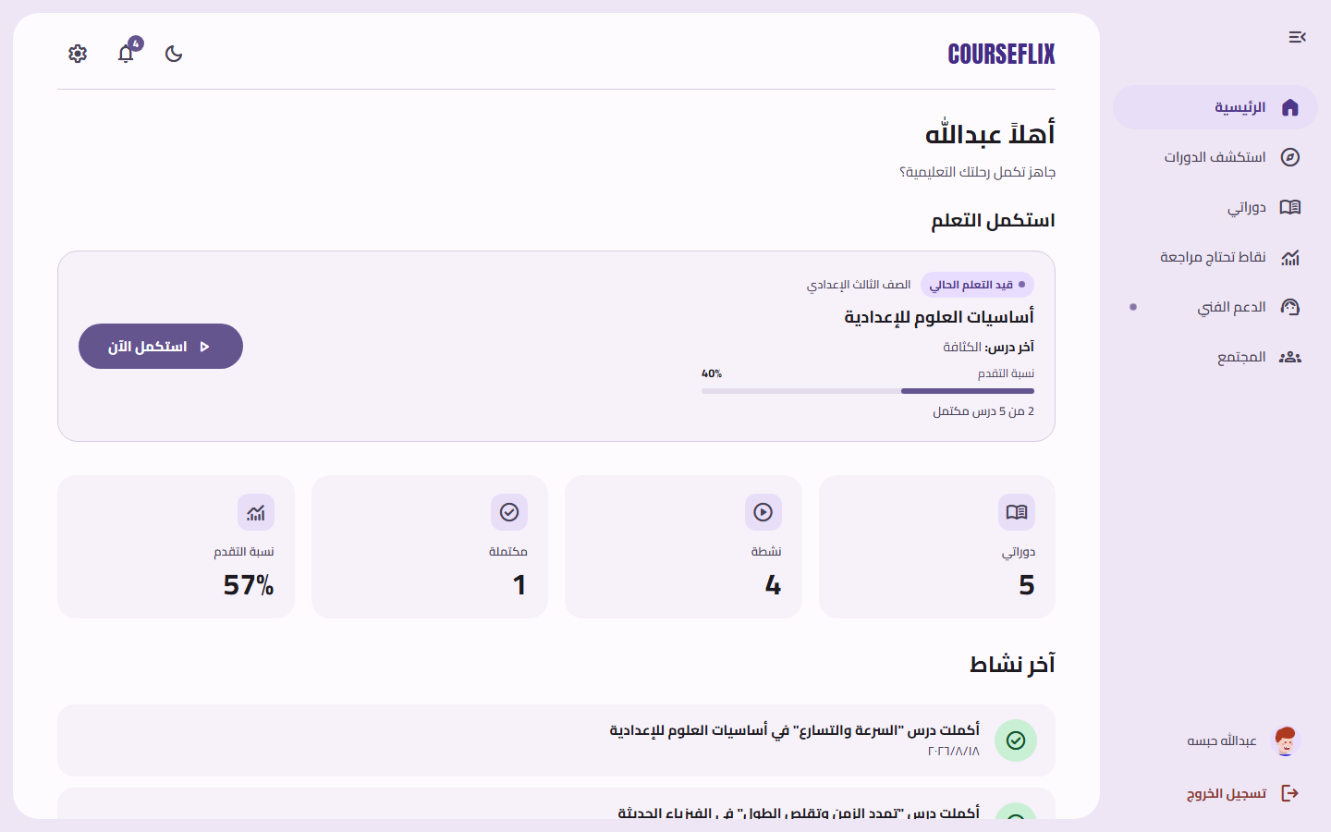

Browse Courses
Shows every course available on the platform (enrolled and not yet enrolled) so the student can join new ones.
1. Open “استكشف الدورات‏” (Explore Courses) from the sidebar.
2. Use the search box or filters to find a specific course.
3. Click a course to view its details and enroll.
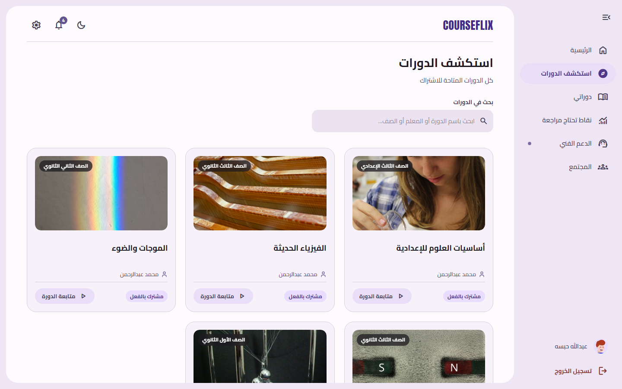

Course Detail Page
Shows the full course content — sections and lessons, quizzes, the AI assistant, files, community, and announcements — organized into tabs.
1. Click any lesson to open and watch it.
2. Use the “الاختبارات‏” (Quizzes) tab to take the course's quizzes.
3. Use the AI-assistant tab to ask questions about the course content.
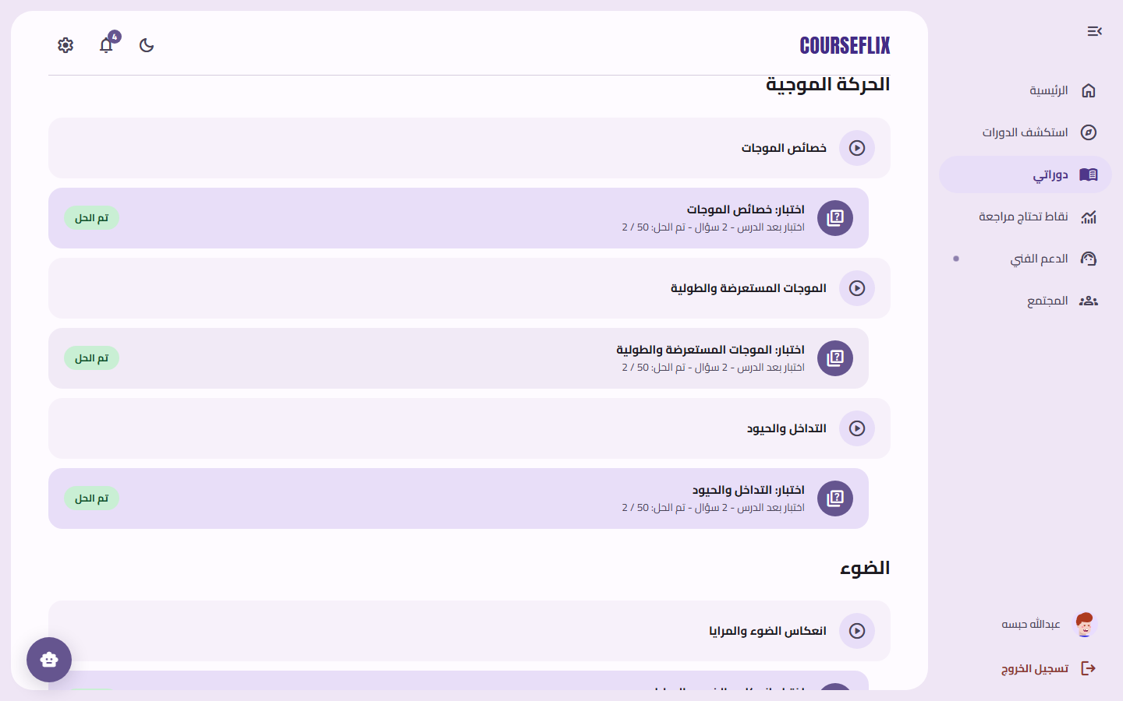

Lesson Page
Plays the lesson video with automatic progress tracking, and automatically opens the next lesson once you finish.
1. Play the video from the lesson page.
2. Once you finish watching, your progress is saved automatically and the next lesson opens.
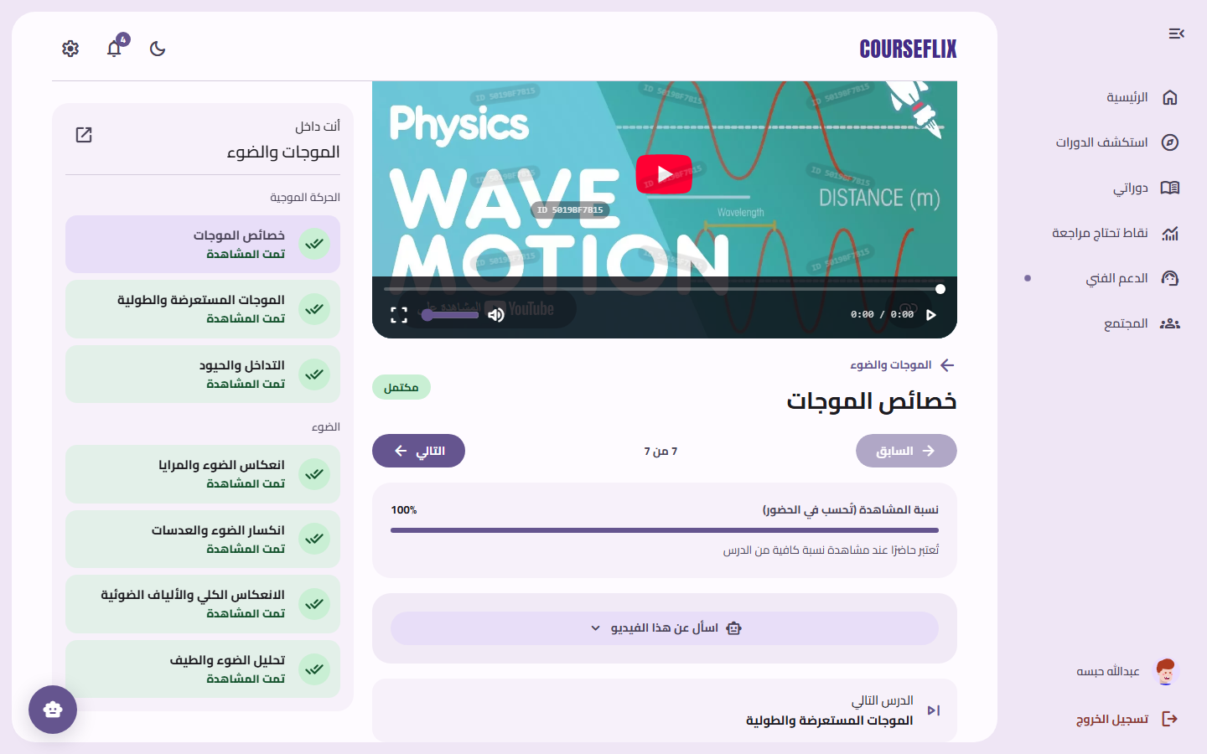

Course Assistant (AI Tutor)
An AI assistant grounded only in that course's own material (the files the teacher uploaded); it answers student questions and cites its source.
1. Open “مساعد الدورة‏” (Course Assistant) from inside the course page.
2. Type your question in the text box at the bottom.
3. Click “إرسال السؤال‏” (Send Question) and wait for the reply.
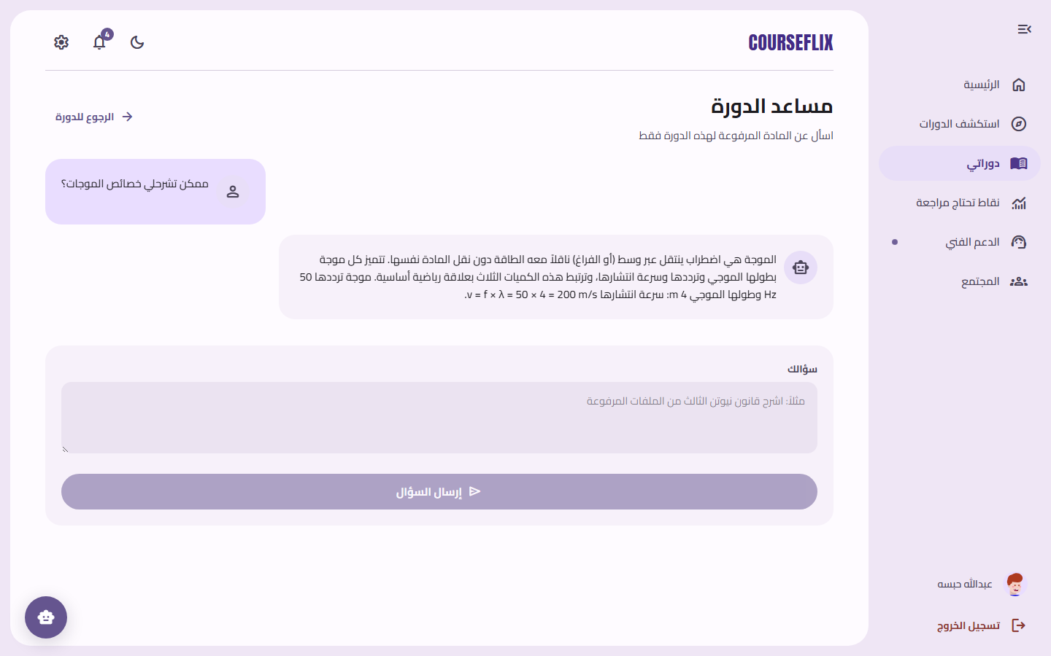
Note: The assistant answers only from that course's own material, and explicitly says so when an answer isn't found in the content.

Notifications
Every alert relevant to the student: quiz results, teacher announcements, and replies in discussions.
1. Open the bell icon 🔔 at the top of the page, or “الإشعارات‏” (Notifications) in the sidebar.
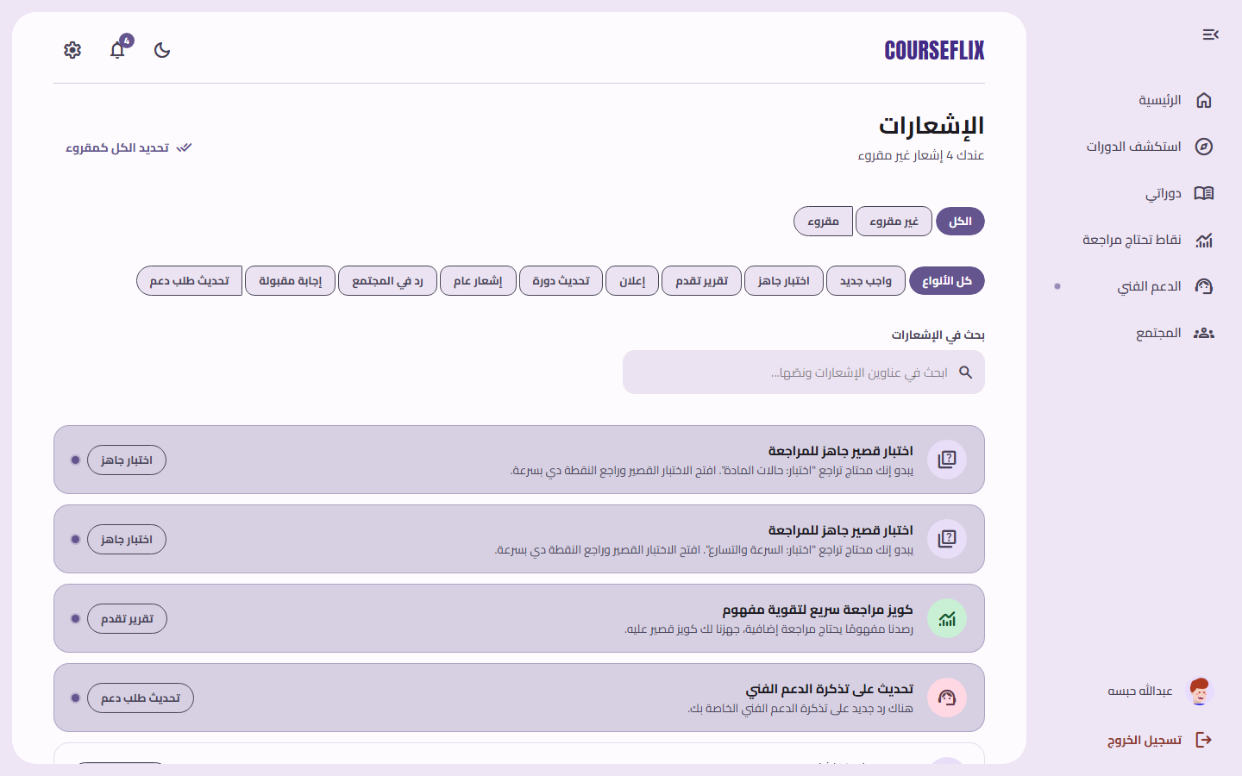

Points That Need Review
The system automatically detects weak spots for the student (based on quiz results) and suggests a short quiz to review them.
1. Open “نقاط تحتاج مراجعة‏” (Points That Need Review) from the sidebar.
2. Click “ابدأ الاختبار القصير‏” (Start Short Quiz) next to any point to review it.
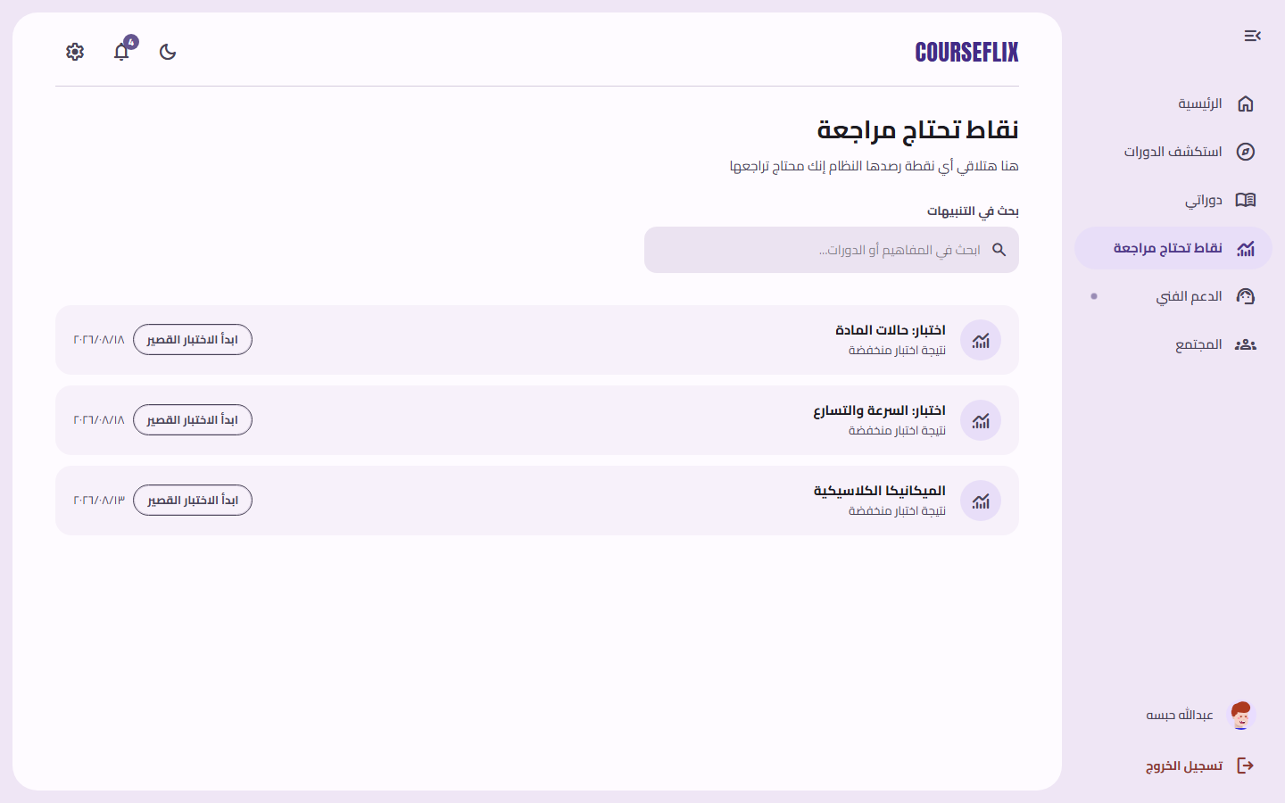

Community
A discussion space per course, where students can ask questions and discuss with classmates in the same course.
1. Open “المجتمع‏” (Community) from the sidebar.
2. Search for a course, or click an existing discussion to open it.
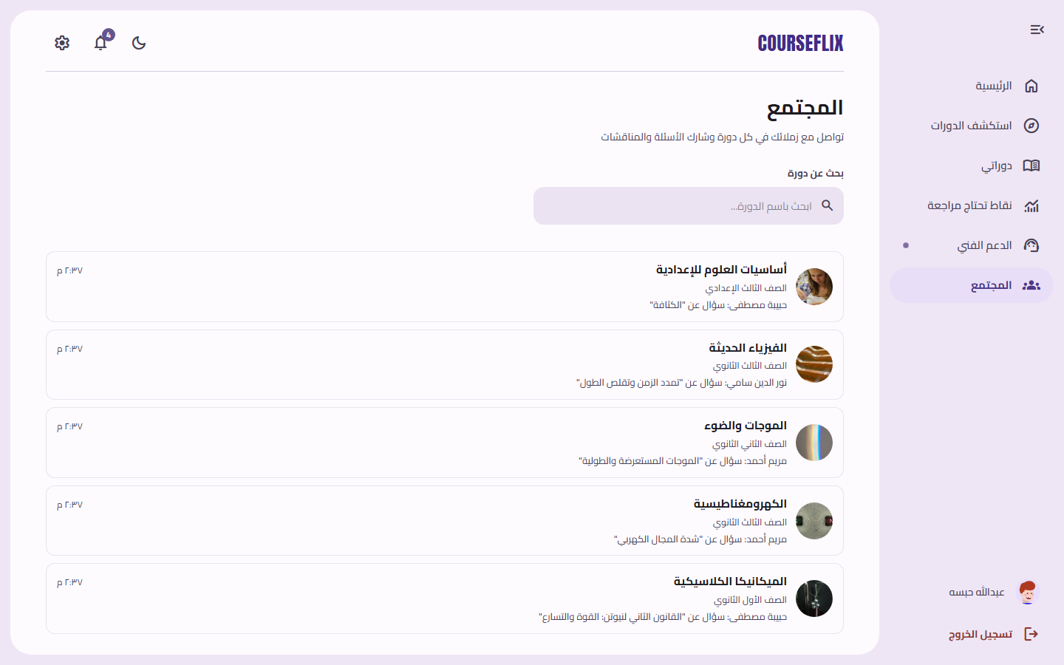

Support
Lets the student open a support ticket for any technical issue or question.
1. Open “الدعم الفني‏” (Support) from the sidebar.
2. Click “طلب دعم جديد‏” (New Support Request) and describe the issue.
3. Track your request's status (open / in progress / resolved).
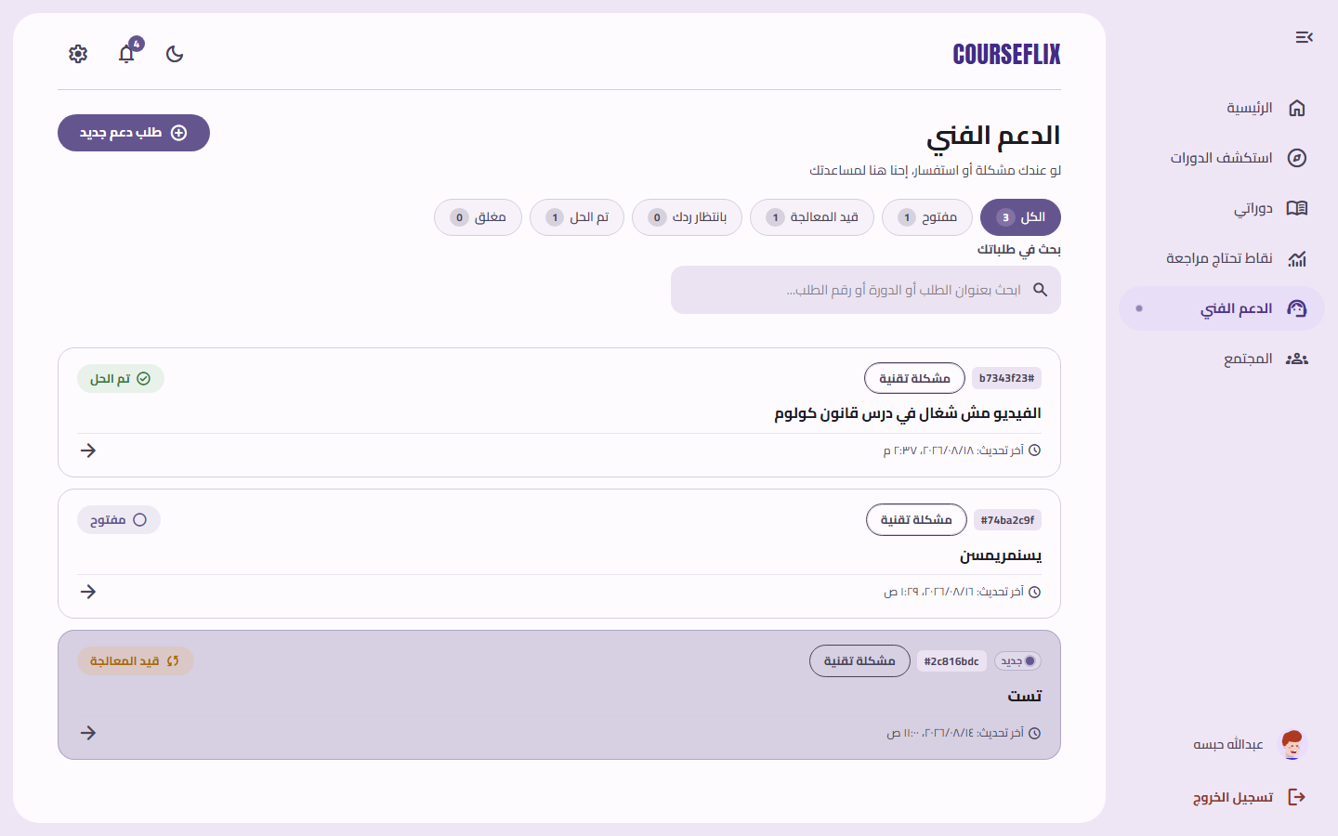

Settings
Manage general account settings, such as password and notification preferences.
1. Open the gear icon ⚙️ at the top of the page, or “الإعدادات‏” (Settings) in the sidebar.
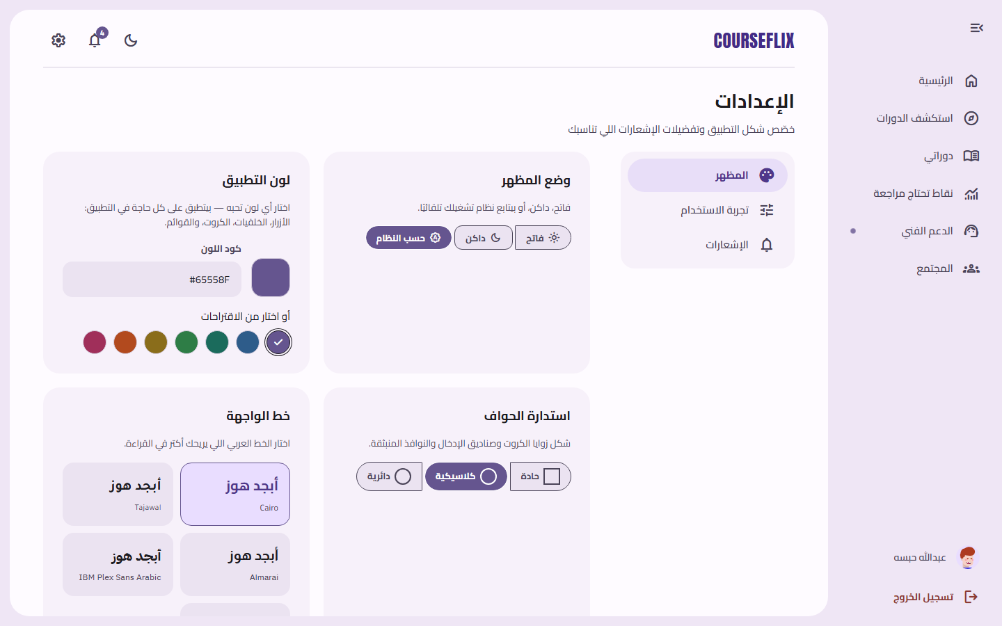

Profile
The student's basic details and enrolled courses.
1. Click your name at the bottom of the sidebar to open your profile.
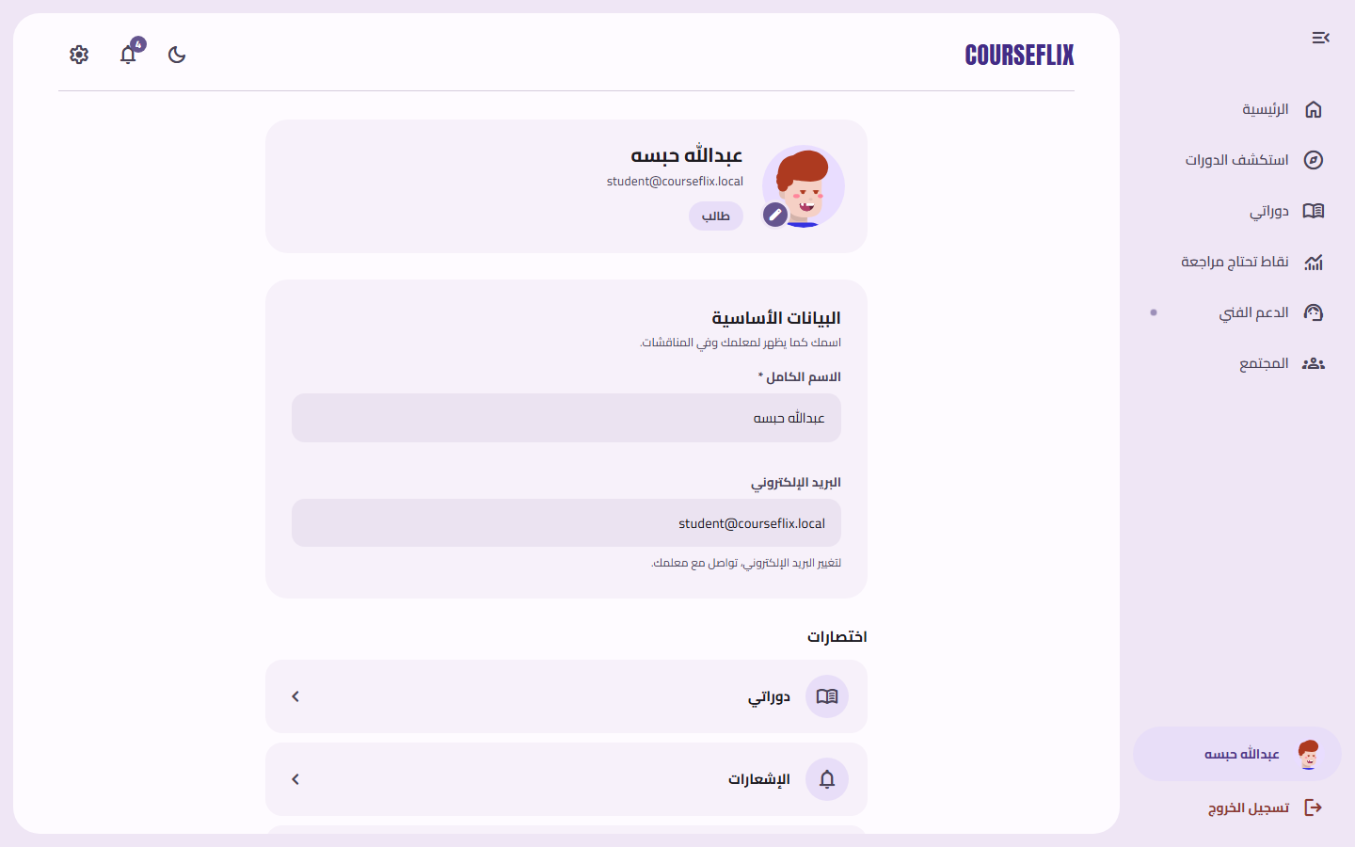

4. Teacher Guide
The teacher has the widest permissions on the platform after the admin: creating and managing courses, tracking students, reviewing assistant requests, and viewing sales and analytics.

Teacher Dashboard (Home)
A quick overview of the teacher's activity: number of courses, students, sales, and recent alerts.
1. Appears automatically after signing in with a teacher account.
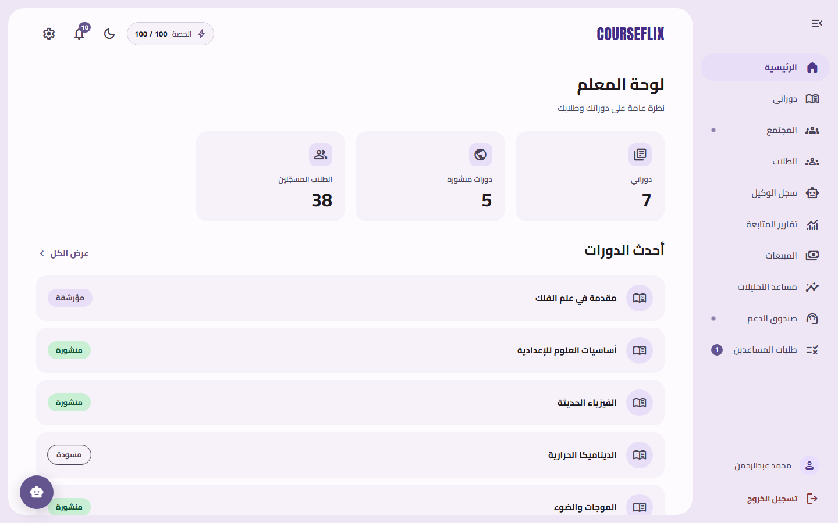

My Courses
A list of every course the teacher created, with its status (published / draft).
1. Open “دوراتي‏” (My Courses) from the sidebar.
2. Click any course to manage its content.
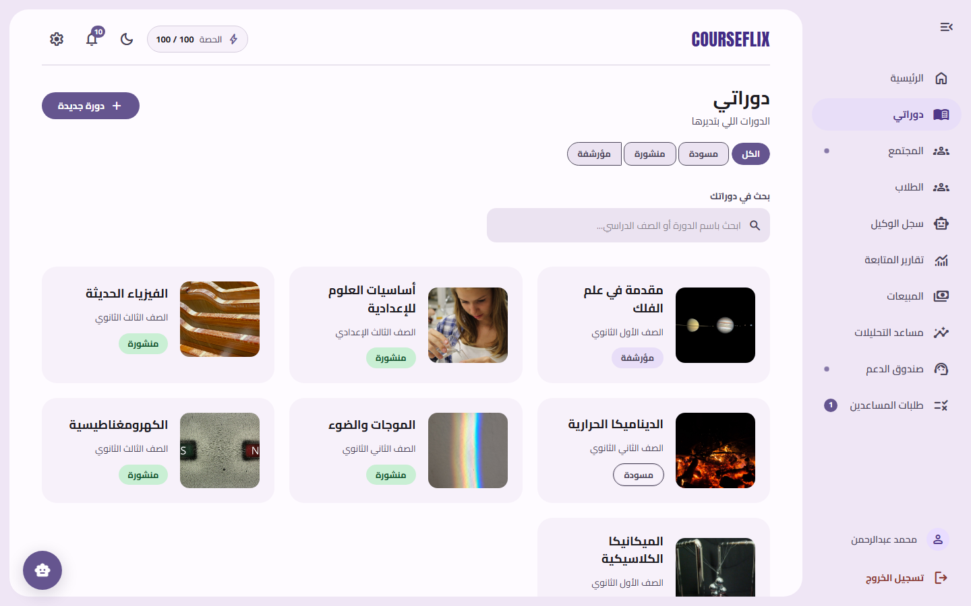

Create a New Course
A form to create a new course with its title, description, and target grade level.
1. Open “دوراتي‏” (My Courses), then click the “دورة جديدة‏” (New Course) button.
2. Fill in the course's basic details and save.
3. You'll be automatically taken to the new course's content-management page.
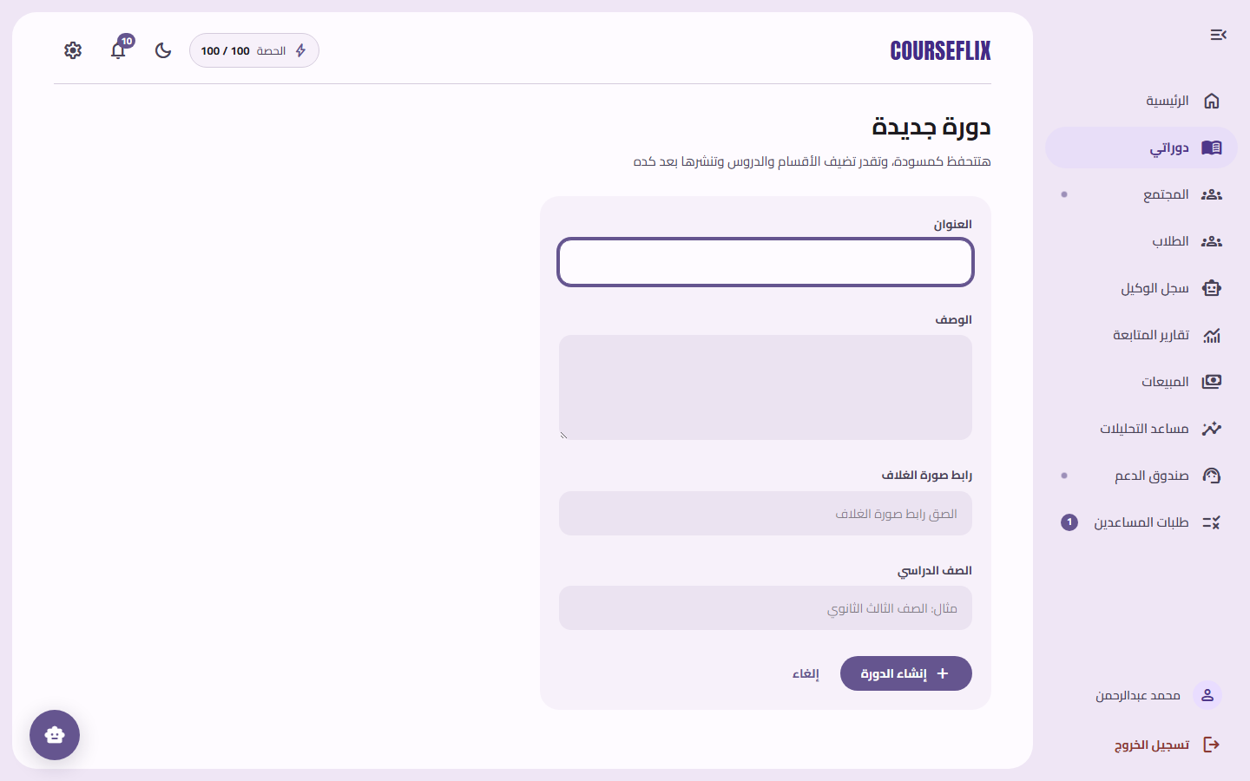

Manage Course Content
The main page for managing a course: adding sections and lessons, uploading videos, creating quizzes, and uploading PDF files for the AI assistant.
1. Click “إضافة قسم‏” (Add Section) to create a new section inside the course.
2. Use the tabs at the top to switch between Content, Quizzes, AI Exam, Files, Community, and Announcements.
3. Use the “Edit”, “Hide”, or “Delete” buttons next to each section or lesson to manage it.
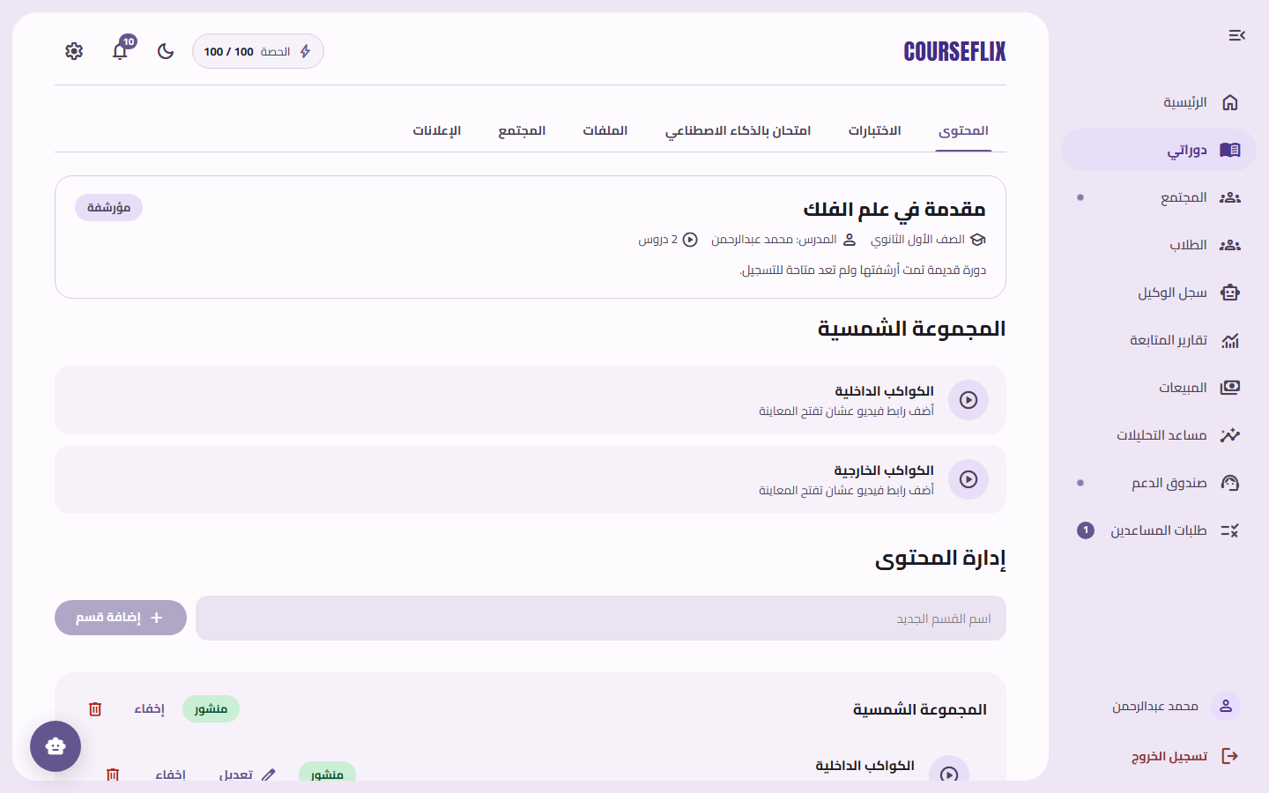

Students
A list of every student enrolled across the teacher's courses, with their progress percentages.
1. Open “الطلاب‏” (Students) from the sidebar.
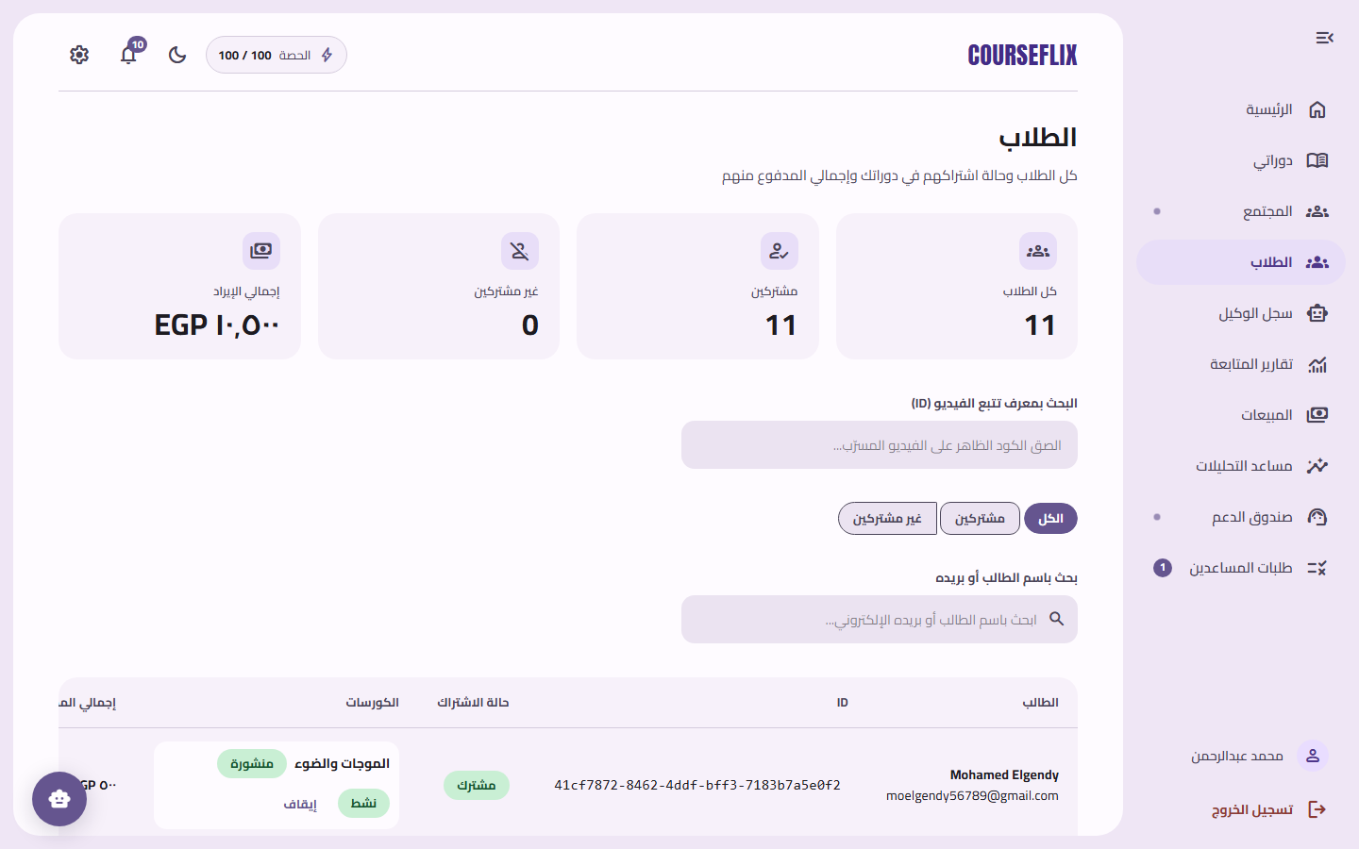

Assistant Requests
Every action a teacher's assistant has taken (such as editing a course description) that needs the primary teacher's review and approval.
1. Open “طلبات المساعدين‏” (Assistant Requests) from the sidebar.
2. Review each request's details, then click “موافقة‏” (Approve) to apply it or “رفض‏” (Reject) to cancel it.
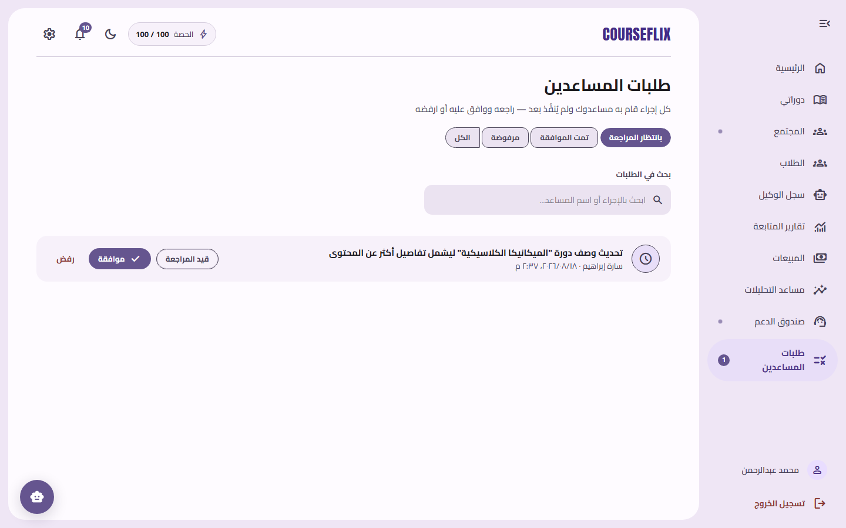

Notifications
Every alert relevant to the teacher: new assistant requests, purchases, and student-progress alerts.
1. Open the bell icon 🔔 or “الإشعارات‏” (Notifications) in the sidebar.
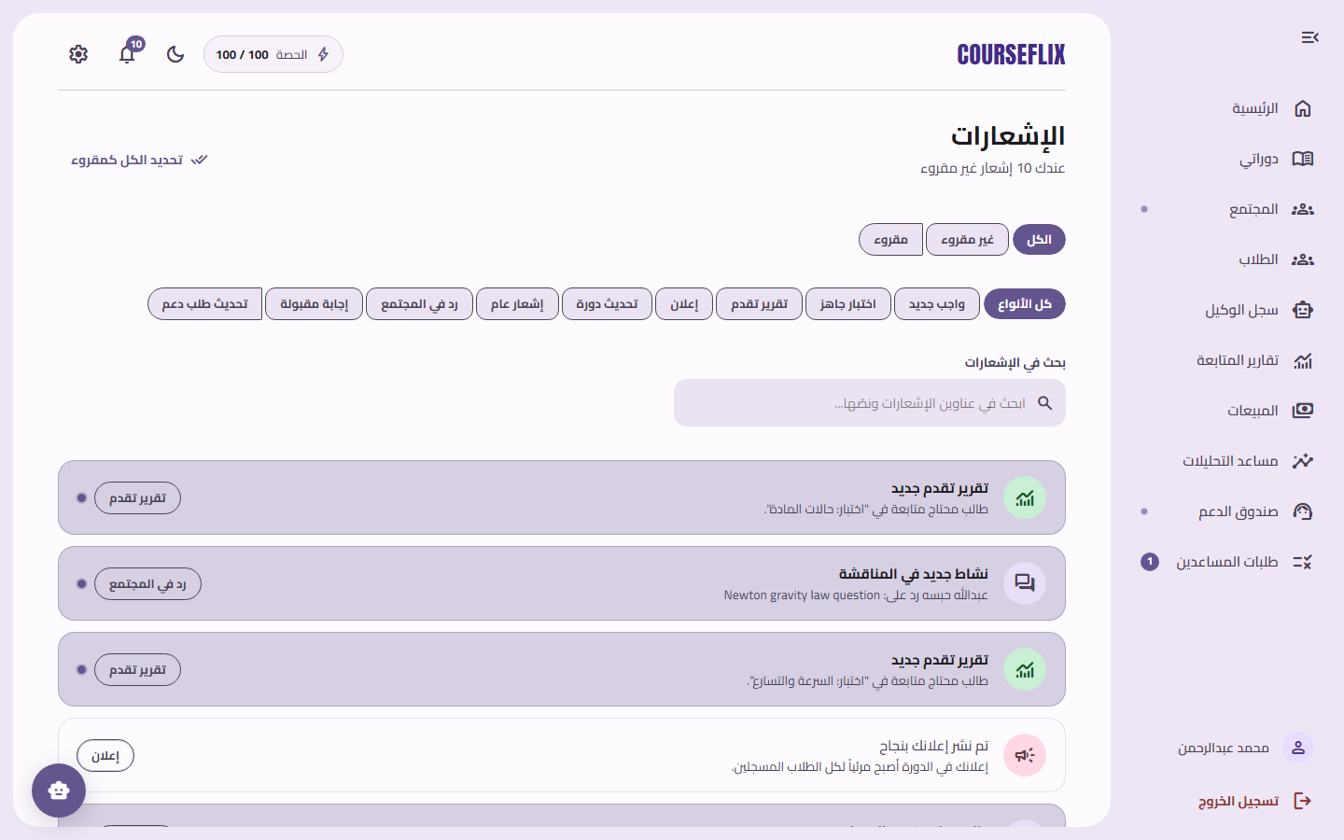

Agent Log
A transparent log of every automated action taken in the teacher's courses by the platform's AI agents (the proactive monitor, the AI tutor, the analytics agent).
1. Open “سجل الوكيل‏” (Agent Log) from the sidebar.
2. Use the filters to show a specific agent type or a specific outcome (success / failure).
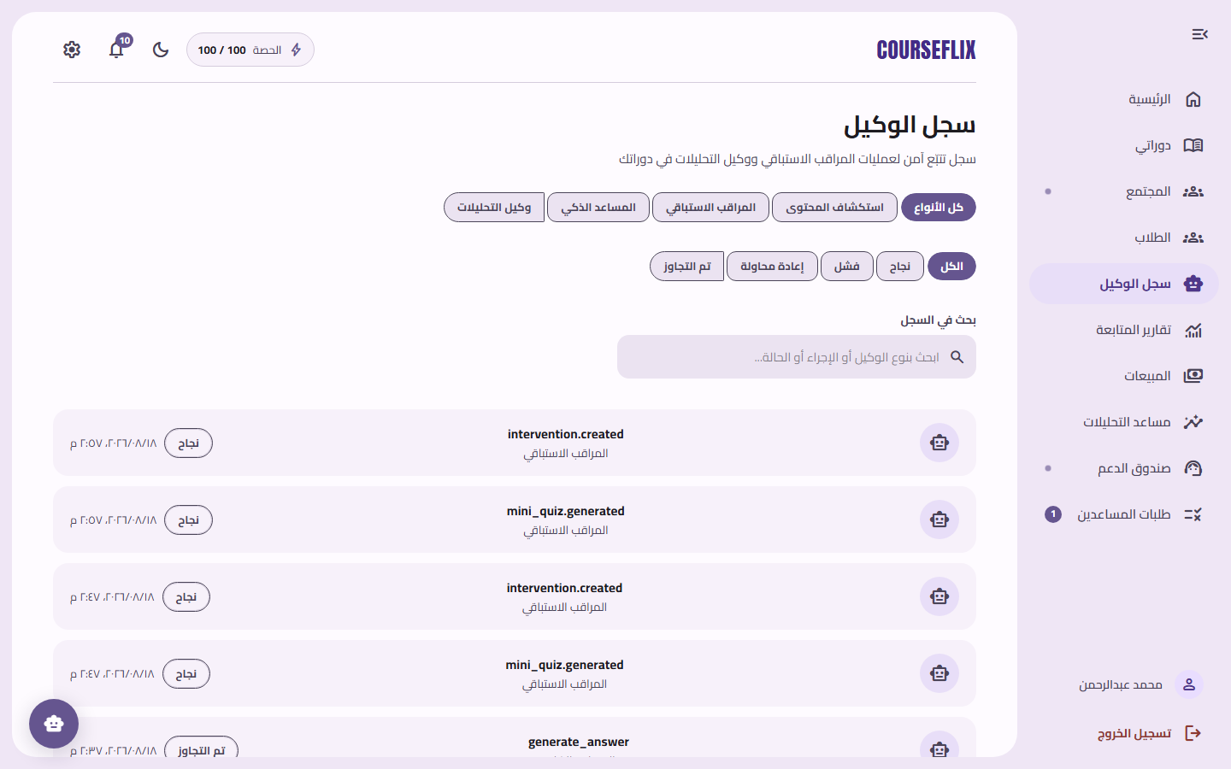

Progress Reports
The weak spots the system has automatically detected across students, for the teacher to follow up on.
1. Open “تقارير المتابعة‏” (Progress Reports) from the sidebar.
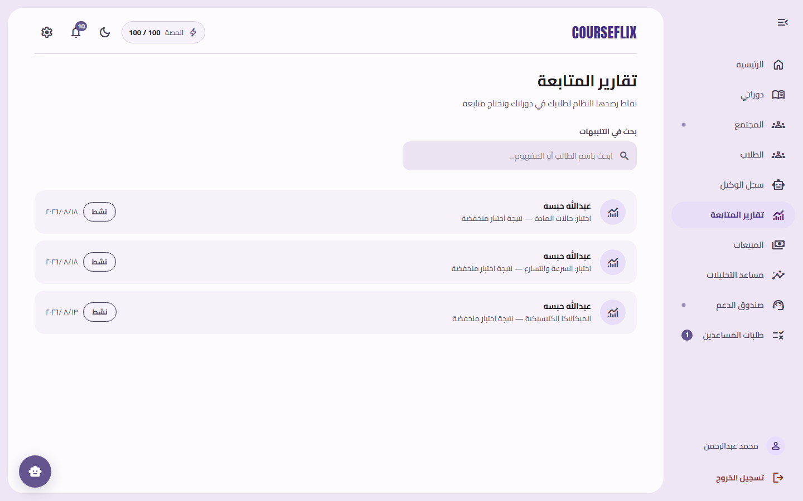

Sales
A financial report of total revenue and successful orders, with per-course sales breakdowns.
1. Open “المبيعات‏” (Sales) from the sidebar.
2. Pick a date range, or use the quick ranges (today, last 7 days, ...).
3. Click “تصدير CSV‏” (Export CSV) to download a detailed report.
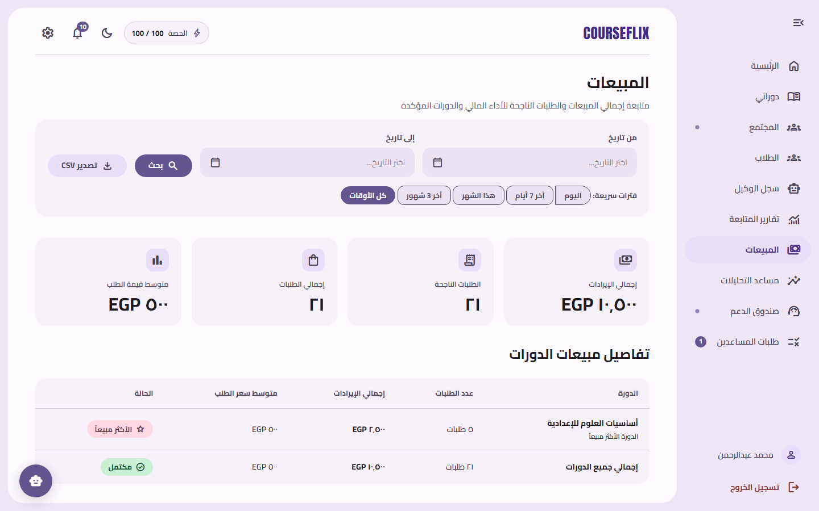

Analytics Assistant
An AI assistant that answers preset questions about the teacher's performance (student count, revenue, best-selling courses).
1. Open “مساعد التحليلات‏” (Analytics Assistant) from the sidebar.
2. Click one of the preset questions, or type your own.
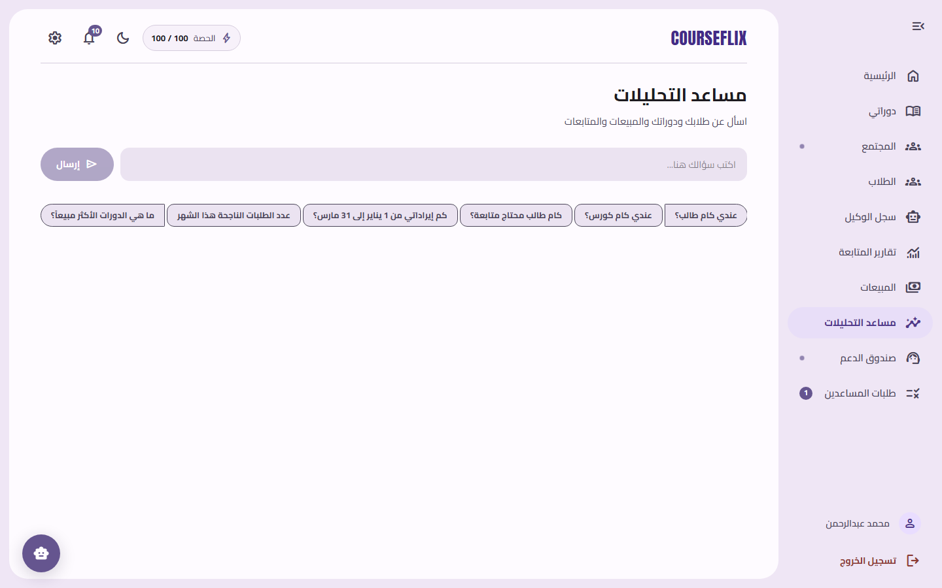
Note: The assistant only answers specific, pre-approved questions and cannot run open-ended database queries.

Community
Follow every discussion students have opened in the teacher's courses, and reply to them.
1. Open “المجتمع‏” (Community) from the sidebar.
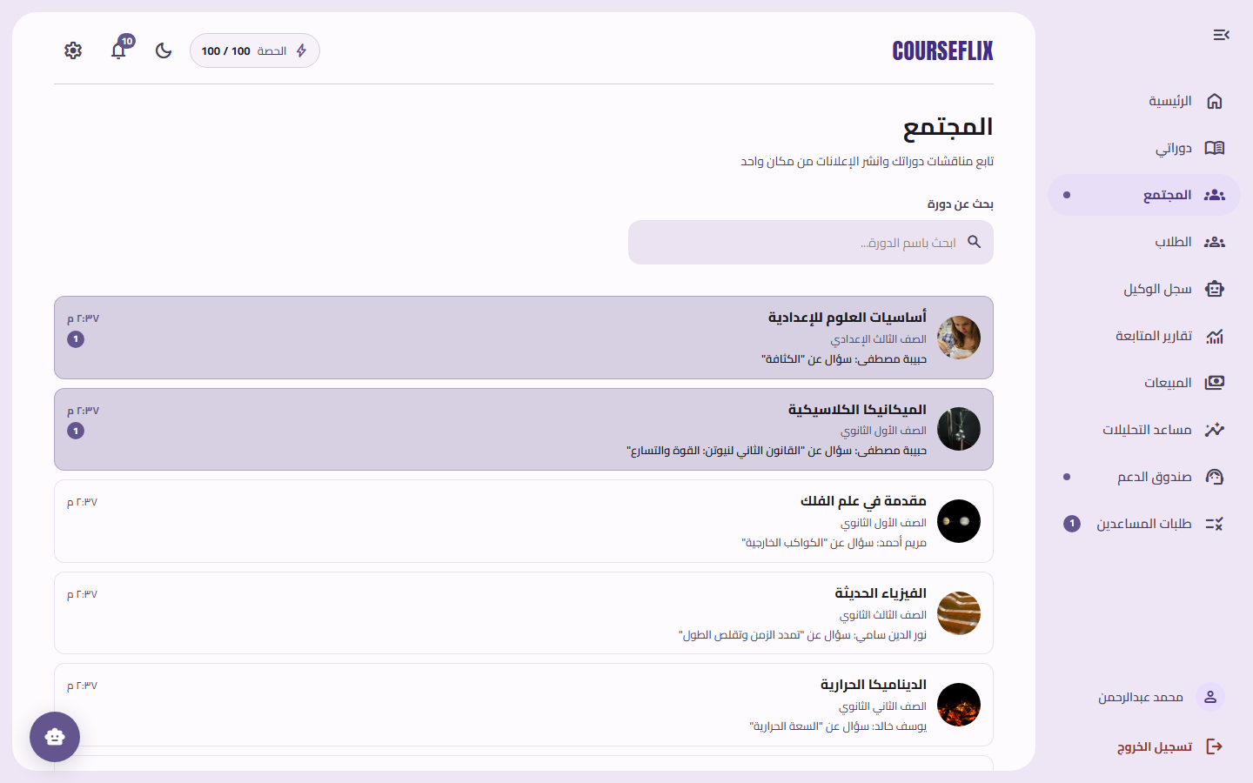

Support Inbox
Every support ticket students have opened, for the teacher or assistant to respond to.
1. Open “صندوق الدعم الفني‏” (Support Inbox) from the sidebar.
2. Click any ticket to reply or change its status.
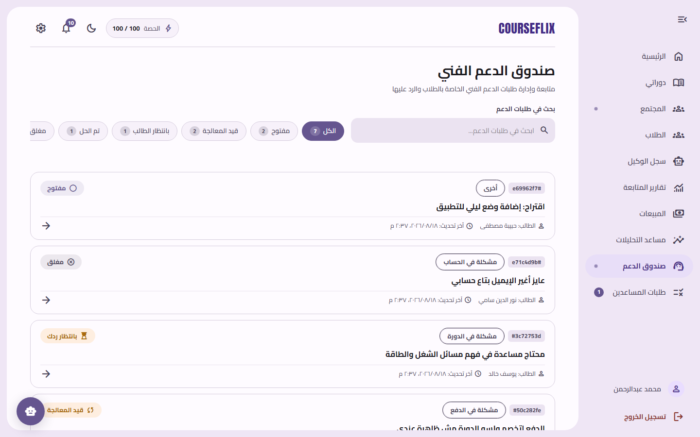

Settings
Manage general account settings.
1. Open the gear icon ⚙️ or “الإعدادات‏” (Settings) in the sidebar.
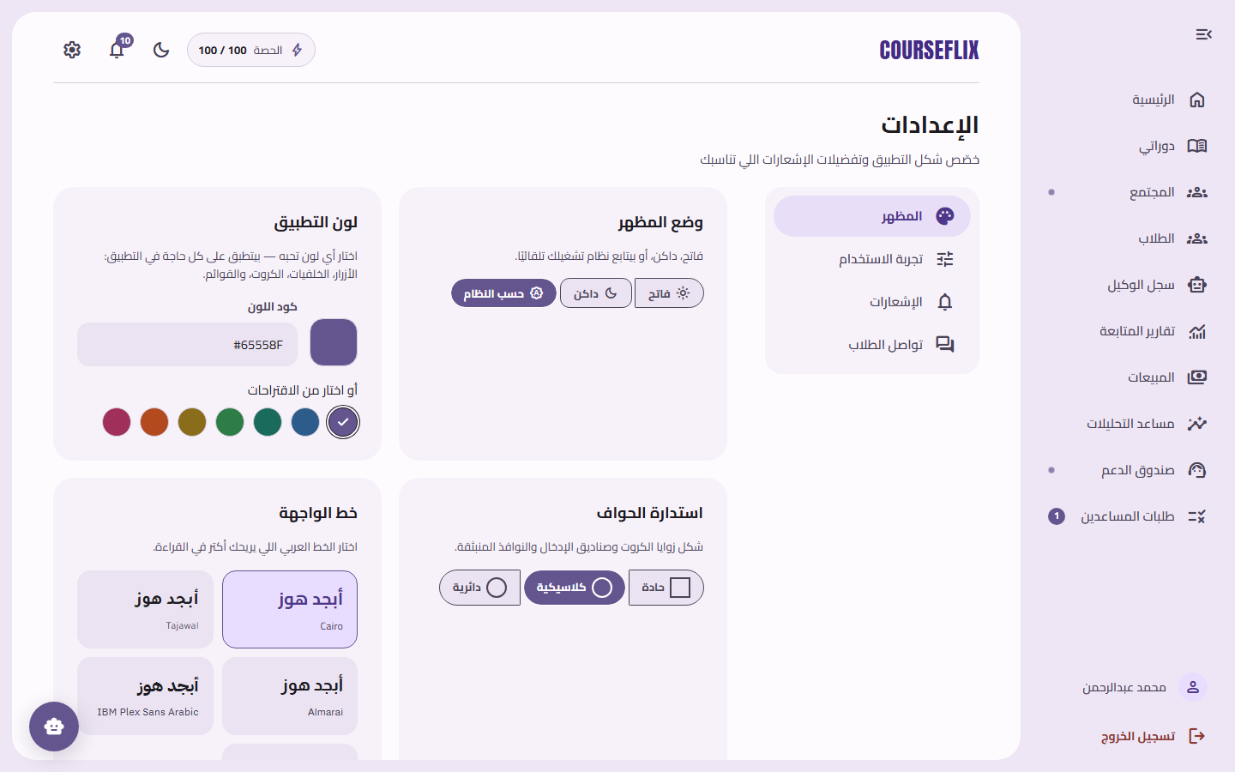

Profile
The teacher's basic details.
1. Click your name at the bottom of the sidebar.
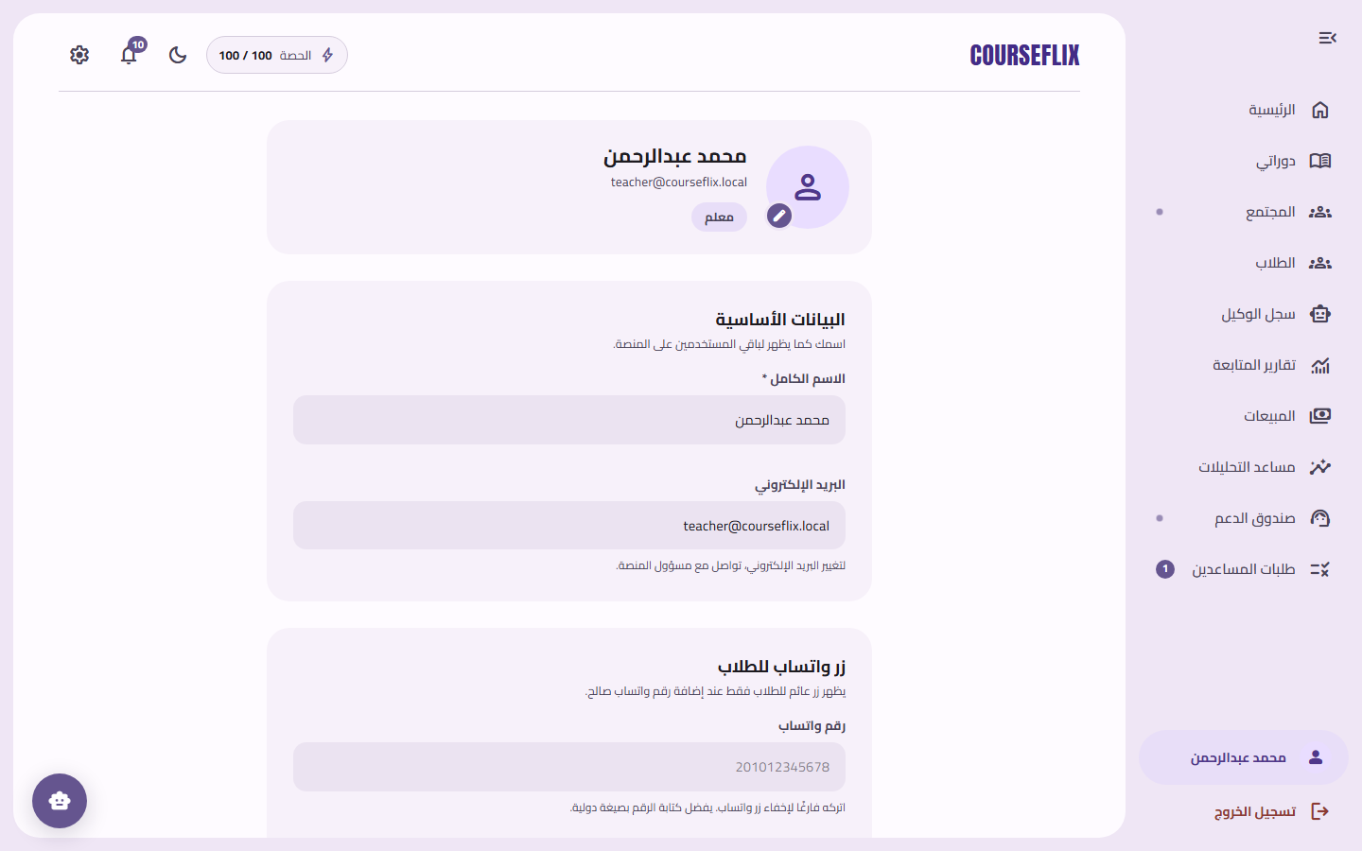

5. Teaching Assistant Guide
The assistant account shares the teacher's interface for managing courses and students, but with narrower permissions: no access to “Agent Log”, “Progress Reports”, “Sales”, or “Analytics Assistant” — those are reserved for the primary teacher only. Any significant edit the assistant makes (such as editing a course description) is logged in “Assistant Requests” and waits for the teacher's approval.

Dashboard
The same teacher dashboard, but with a shorter sidebar matching the assistant's permissions.
1. Appears automatically after signing in with an assistant account.
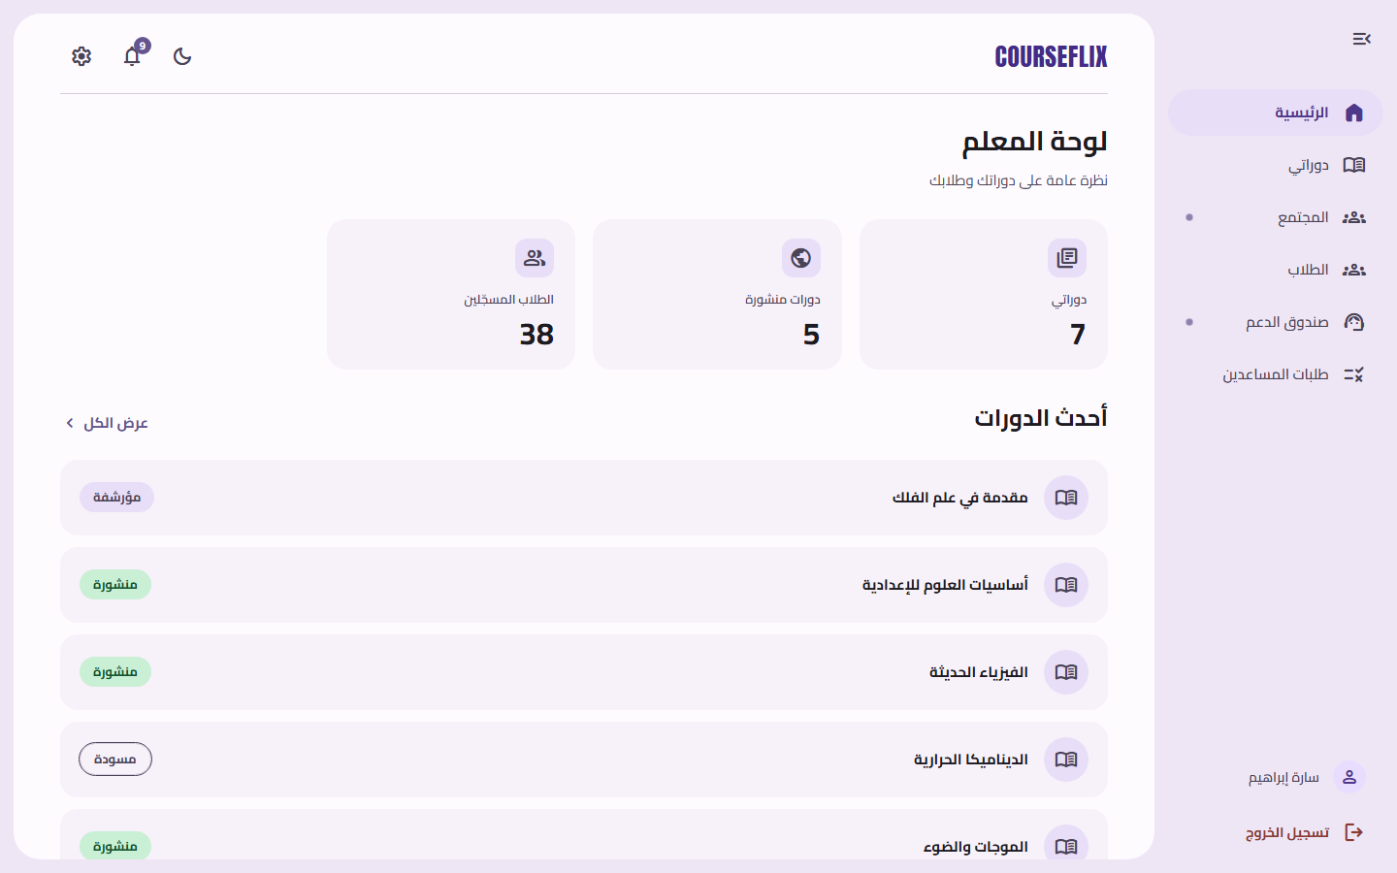

My Courses
The courses the assistant is authorized to work on.
1. Open “دوراتي‏” (My Courses) from the sidebar.
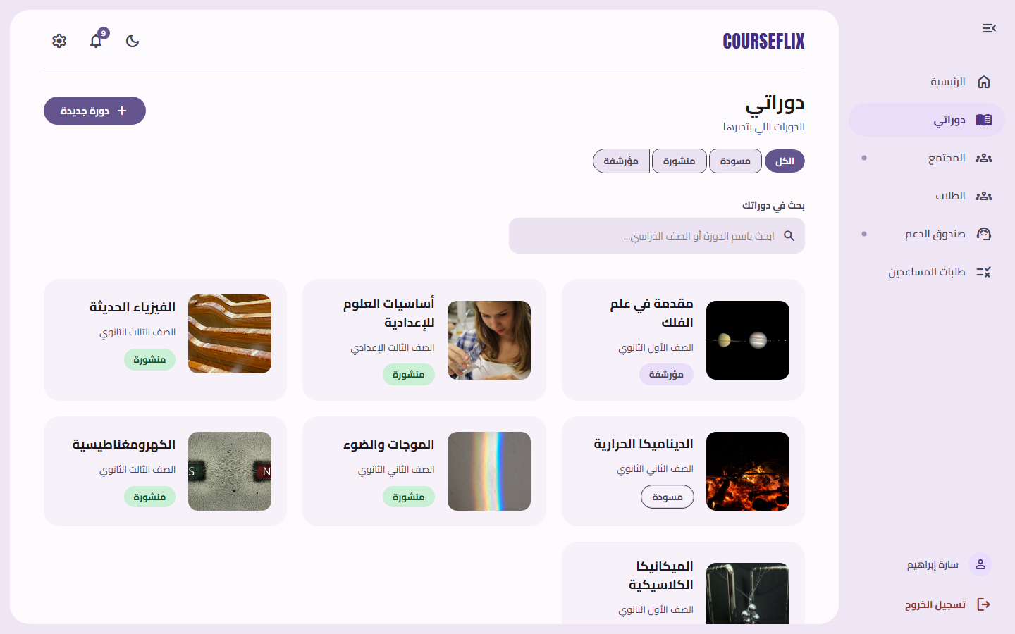

Students
The students enrolled in the courses the assistant manages.
1. Open “الطلاب‏” (Students) from the sidebar.
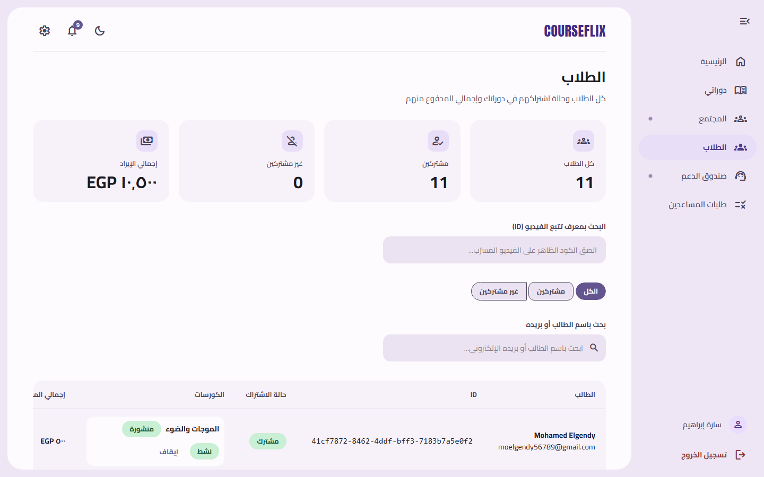

My Requests
Every action the assistant has submitted that is awaiting the primary teacher's approval.
1. Open “طلباتي‏” (My Requests) from the sidebar to track each request's status (pending review / approved / rejected).
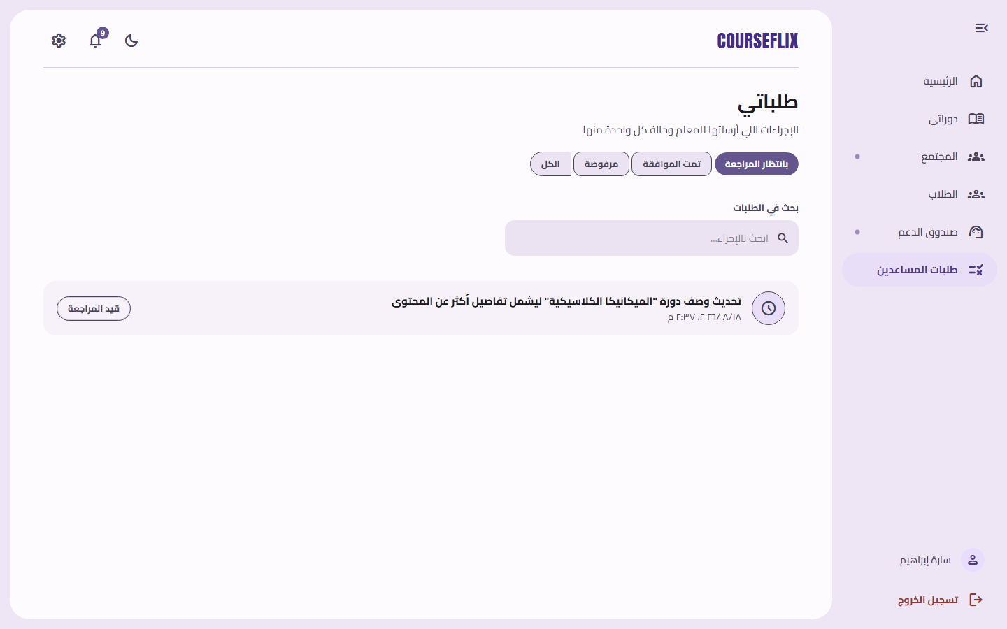

Support Inbox
Reply to students' support tickets.
1. Open “صندوق الدعم الفني‏” (Support Inbox) from the sidebar.
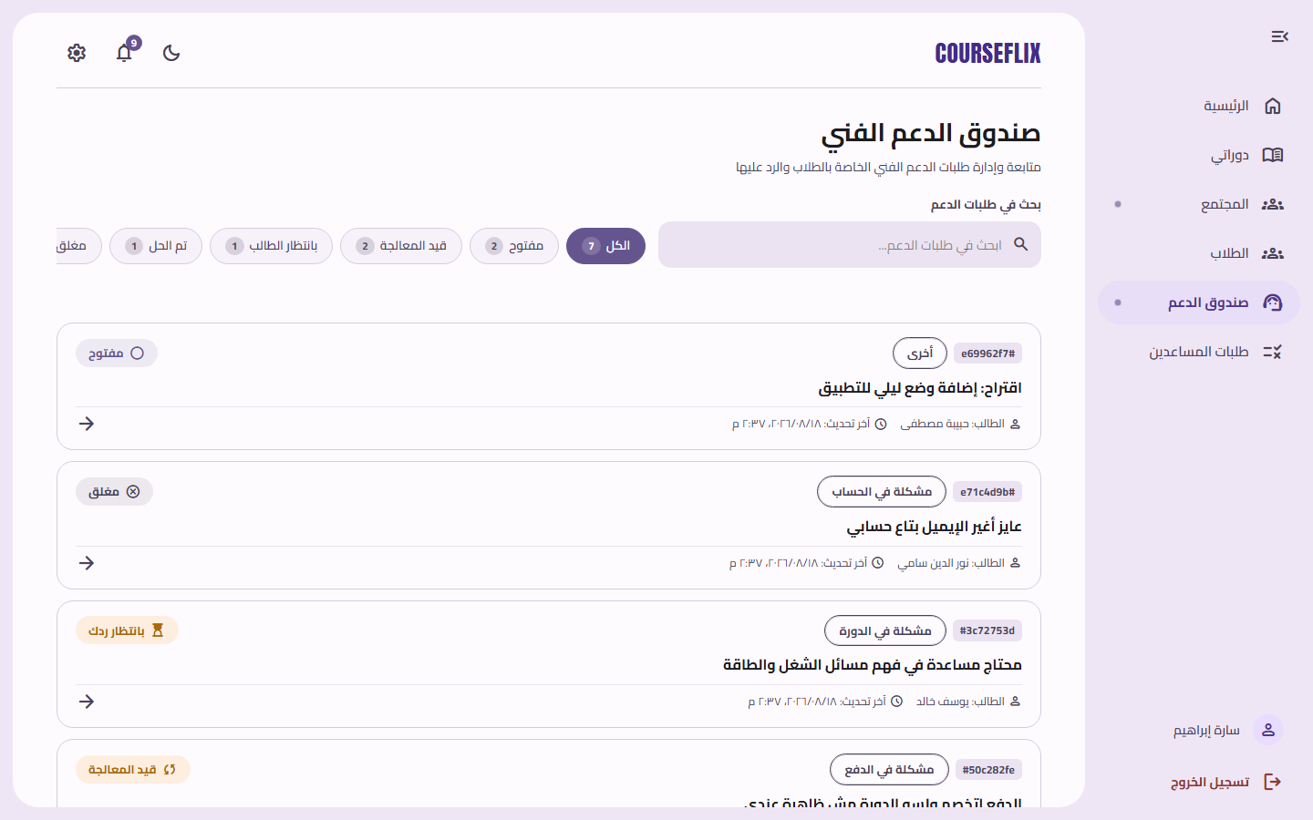

Settings
Manage the assistant account's settings.
1. Open the gear icon ⚙️ or “الإعدادات‏” (Settings) in the sidebar.
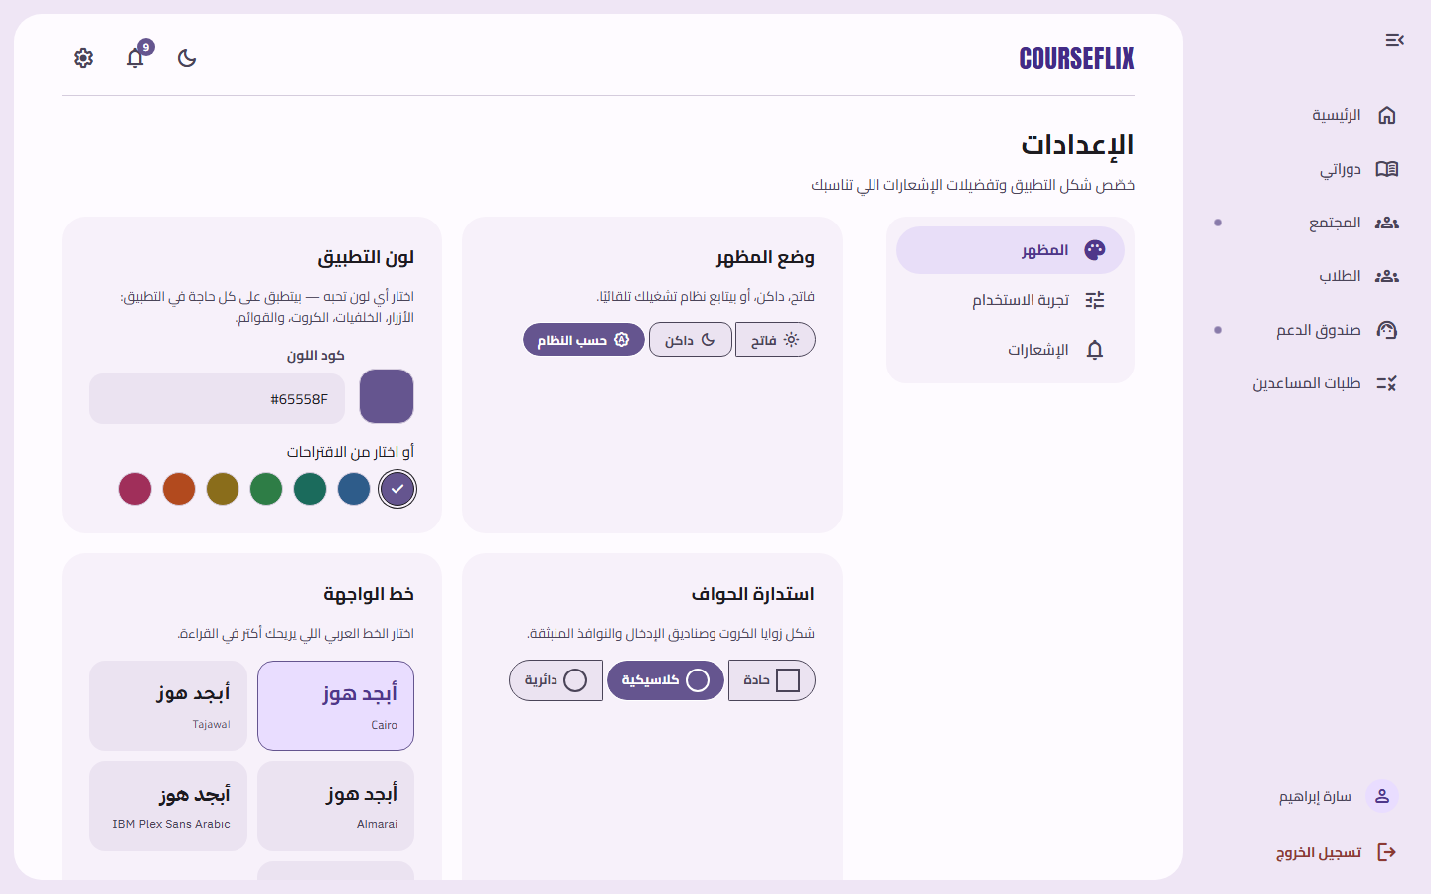

6. Platform Admin Guide
The admin has full authority over the platform: managing every account (students, teachers, assistants, admins), courses, financial orders, quizzes, documents, and every log and notification system-wide.

Admin Dashboard
A platform-wide overview: number of users, courses, revenue, and recent activity.
1. Appears automatically after signing in with an admin account.
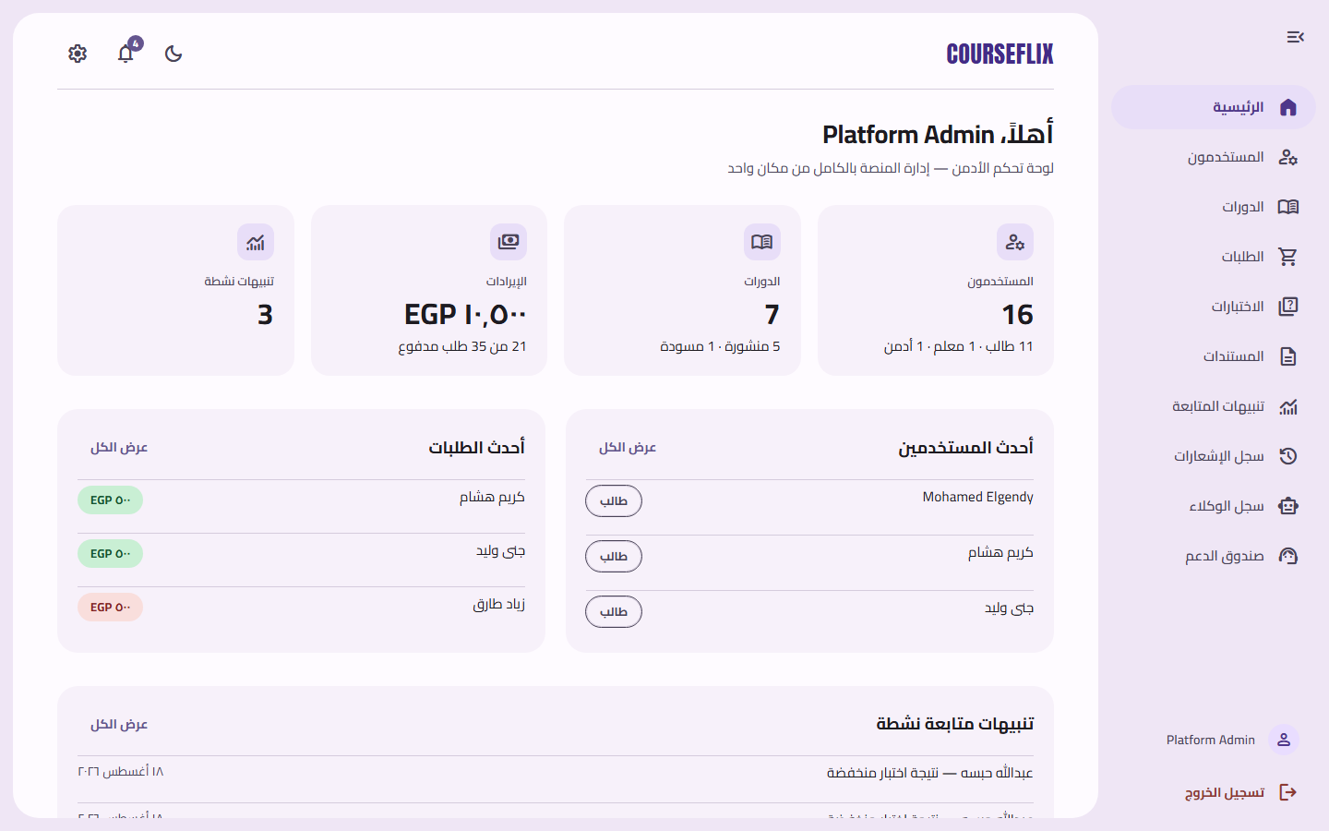

Users
A list of every account on the platform (students, teachers, assistants, admins) with each account's status.
1. Open “المستخدمون‏” (Users) from the sidebar.
2. Click any user to view their details or edit their data.
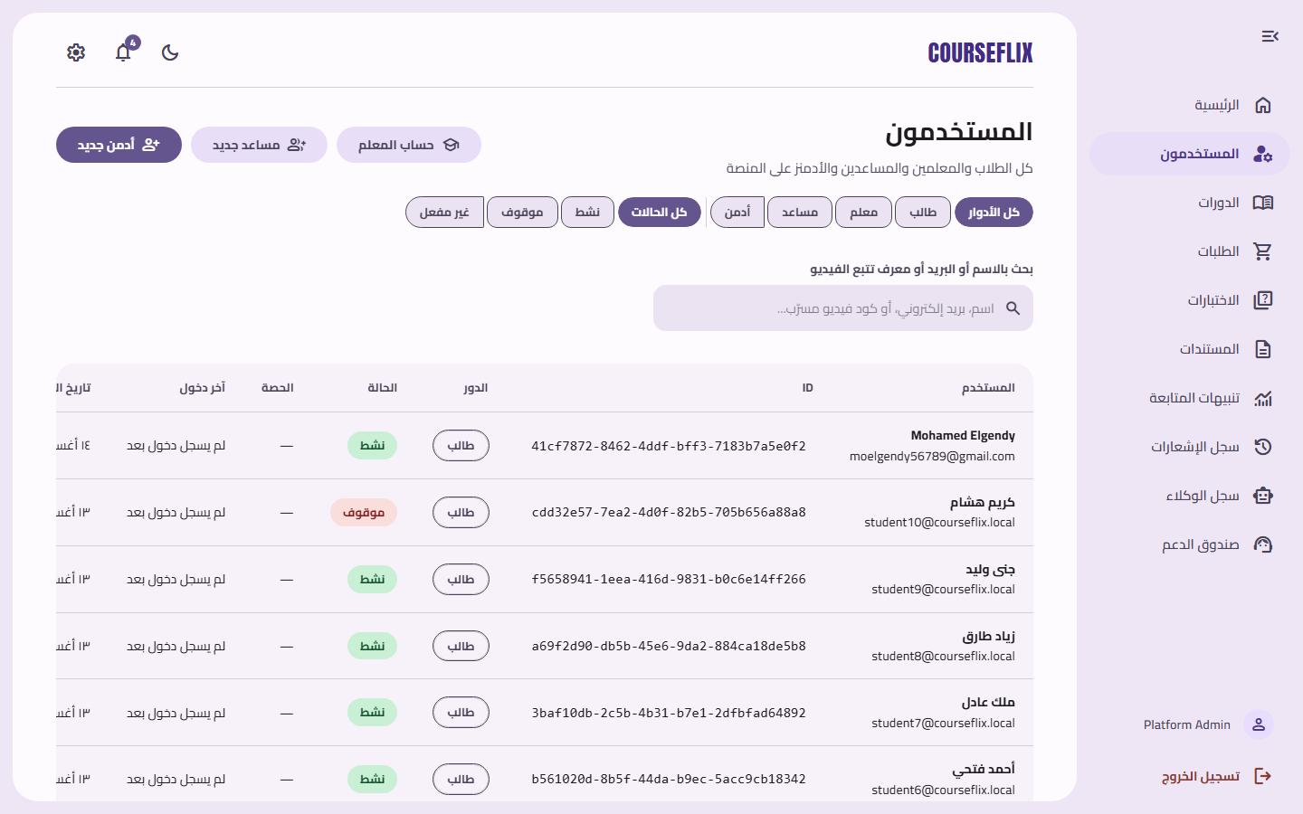

Create a New Teacher Account
A dedicated form for the admin to create a teacher account.
1. From the “Users” page, click the new-teacher-account button.
2. Fill in the teacher's details and save.
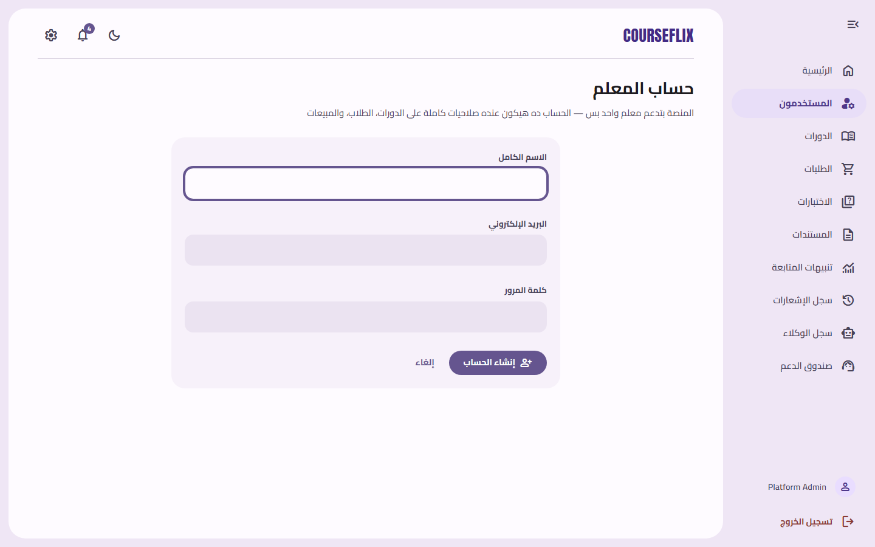

Create a New Assistant Account
A form to create an assistant account and link it to a specific teacher.
1. From the “Users” page, click the new-assistant-account button.
2. Choose the responsible teacher and fill in the assistant's details.
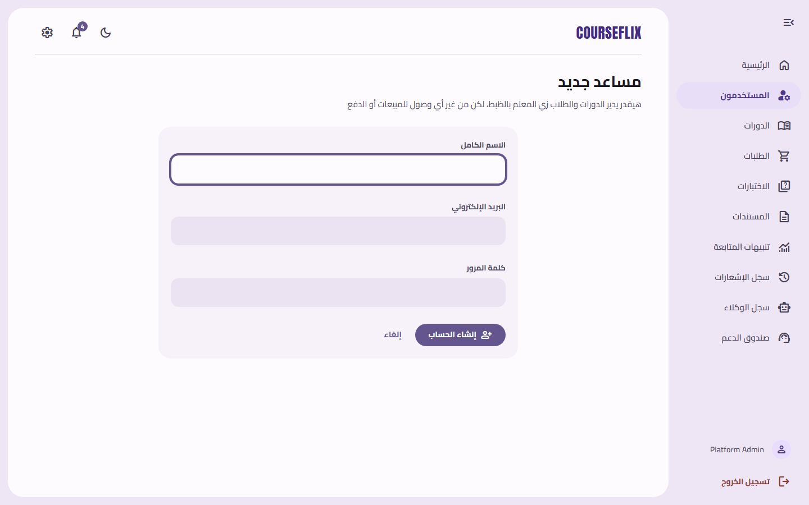

Create a New Admin Account
A form to add a new platform admin.
1. From the “Users” page, click the new-admin-account button.
2. Fill in the required details and save.
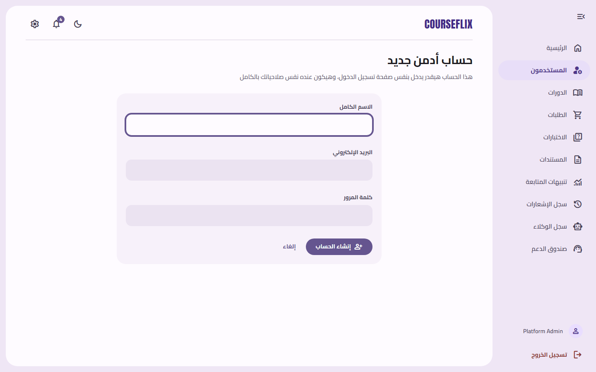

User Detail Page
Full details for any user: role, status (active/suspended), activity stats, and contact log.
1. Click any user from the “Users” list to open this page.
2. The admin can change the role or status and save the changes.
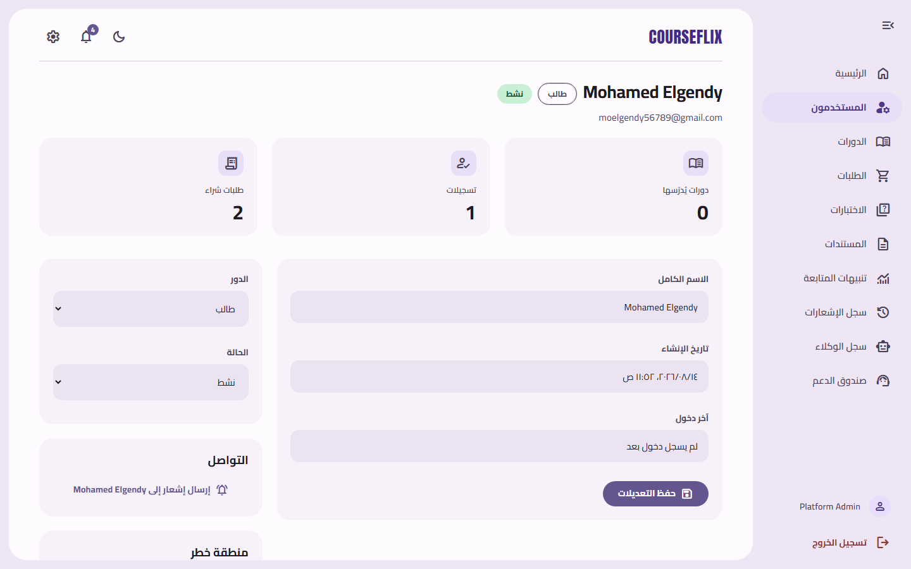

Courses
Every course on the platform, regardless of which teacher owns it.
1. Open “الدورات‏” (Courses) from the sidebar.
2. Click any course to view its details.
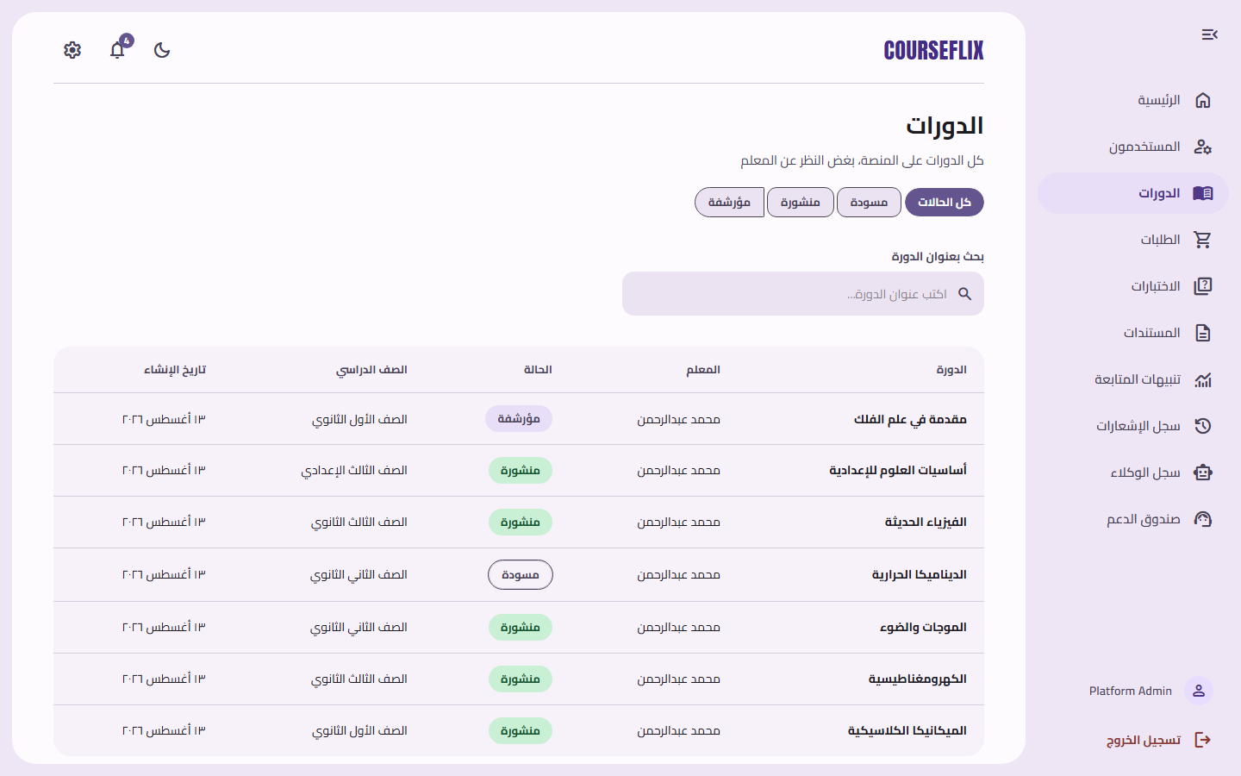

Course Detail (Admin View)
A full review of any course's content, for oversight and moderation.
1. Click any course from the “Courses” page.
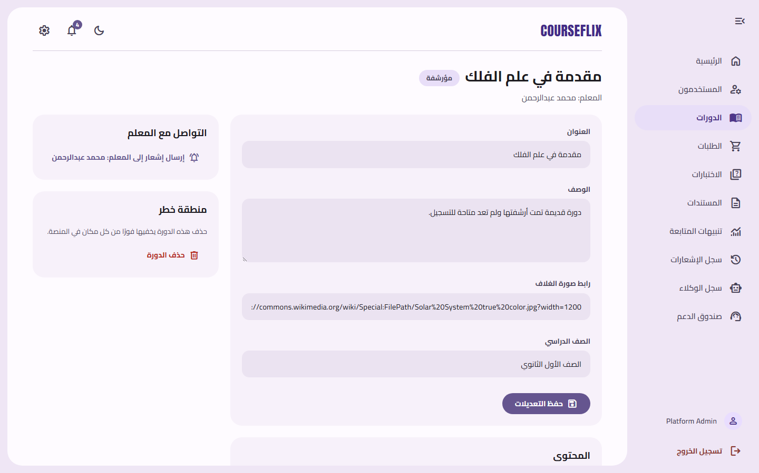

Orders
Every purchase (financial order) made on the platform.
1. Open “الطلبات‏” (Orders) from the sidebar.
2. Click any order to view its payment details.
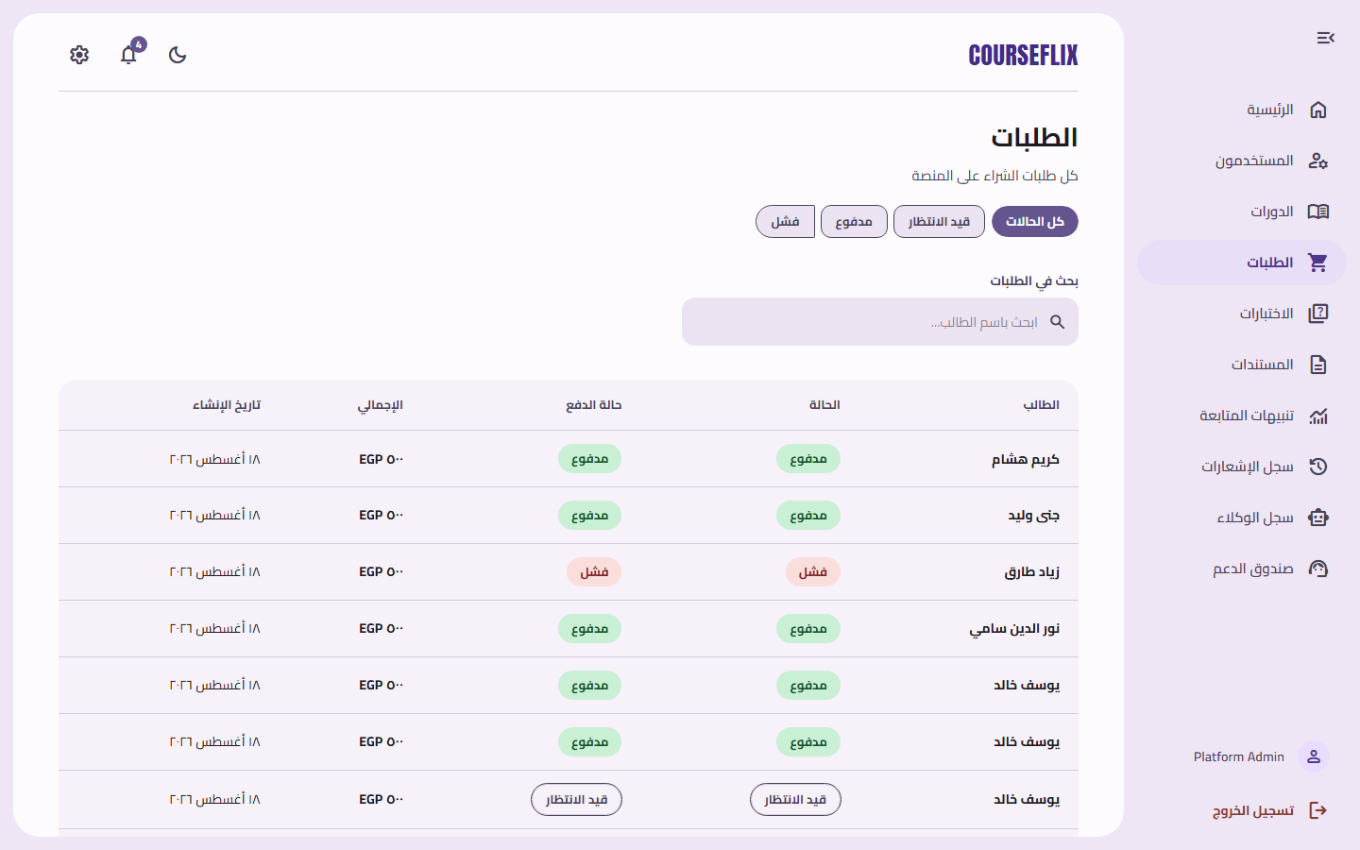

Order Detail
Details of a single purchase: student, course, amount, and payment status.
1. Click any order from the “Orders” page.
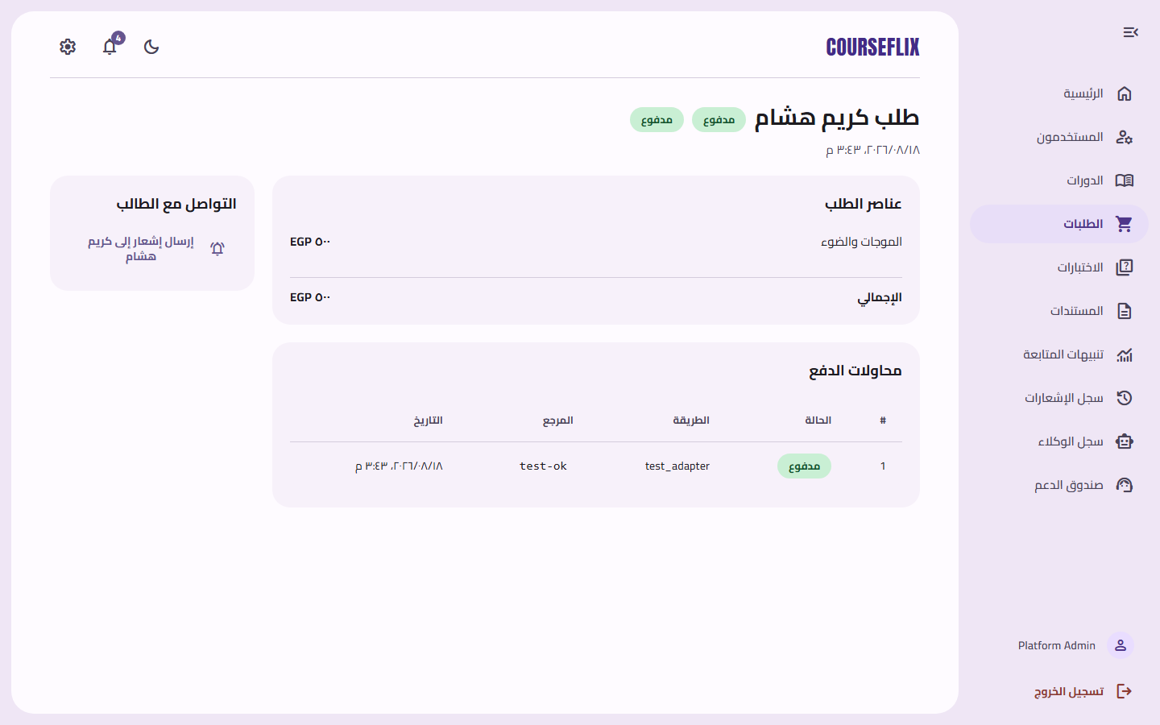

Quizzes
Every quiz created across the platform, linked to the course it belongs to.
1. Open “الاختبارات‏” (Quizzes) from the sidebar.
2. Use the search box to find a specific quiz.
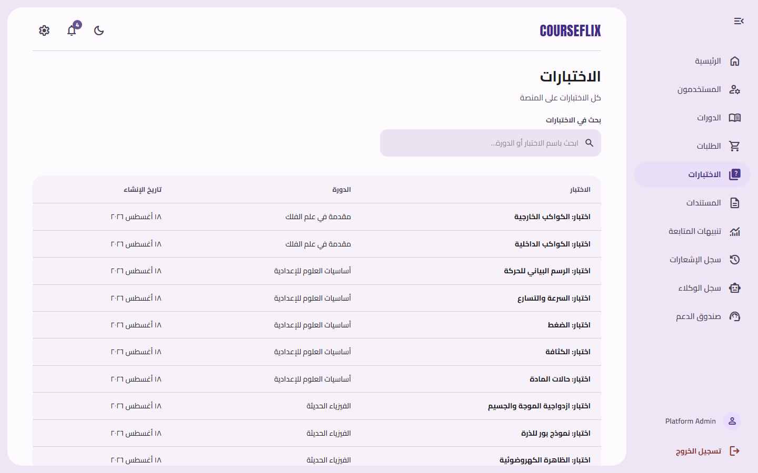

Documents
Every PDF file uploaded by teachers, and its processing status (processed / pending).
1. Open “المستندات‏” (Documents) from the sidebar to track each file's status.
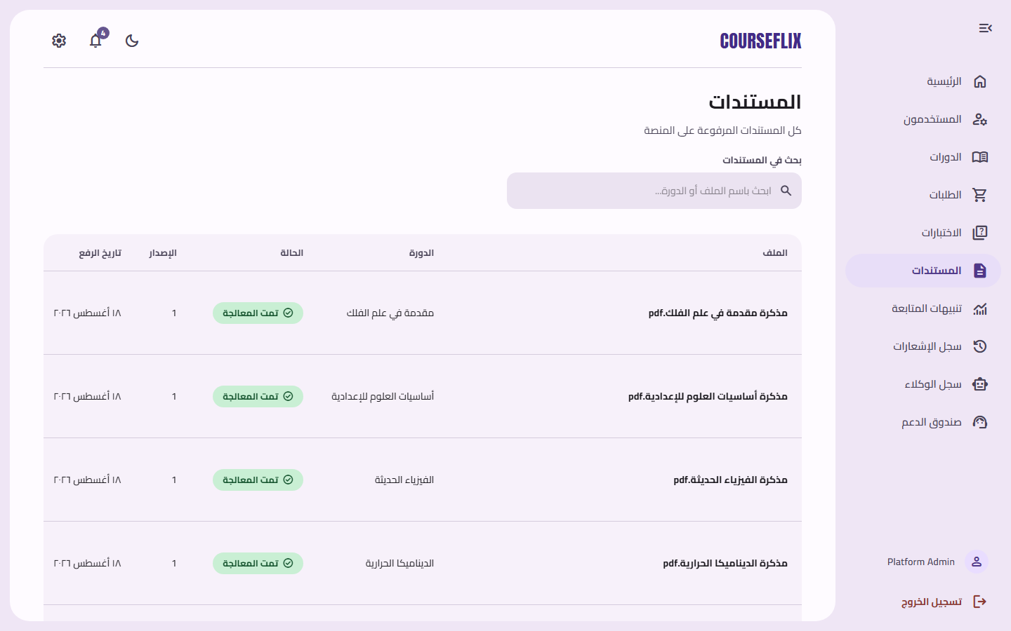

Progress Alerts
A platform-wide view of every weak spot the system has detected across all students.
1. Open “تنبيهات المتابعة‏” (Progress Alerts) from the sidebar.
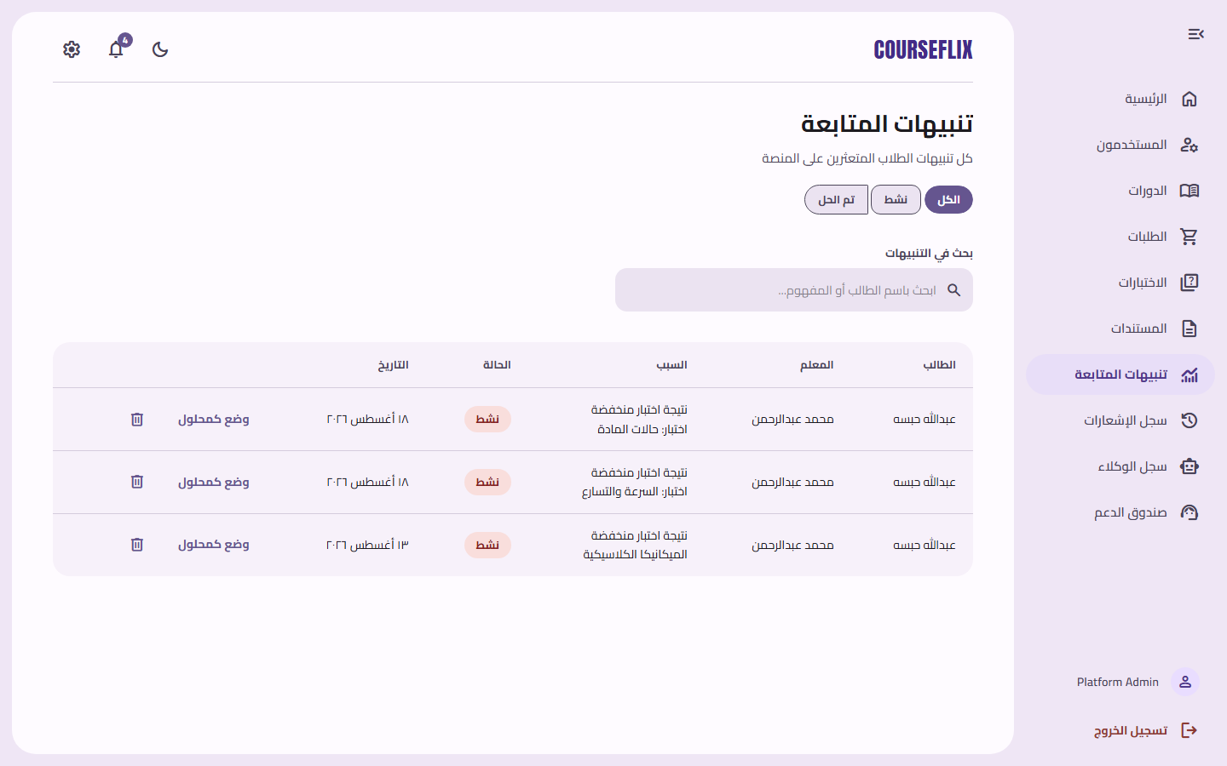

Notifications
The admin's own notifications.
1. Open the bell icon 🔔 or “الإشعارات‏” (Notifications) in the sidebar.
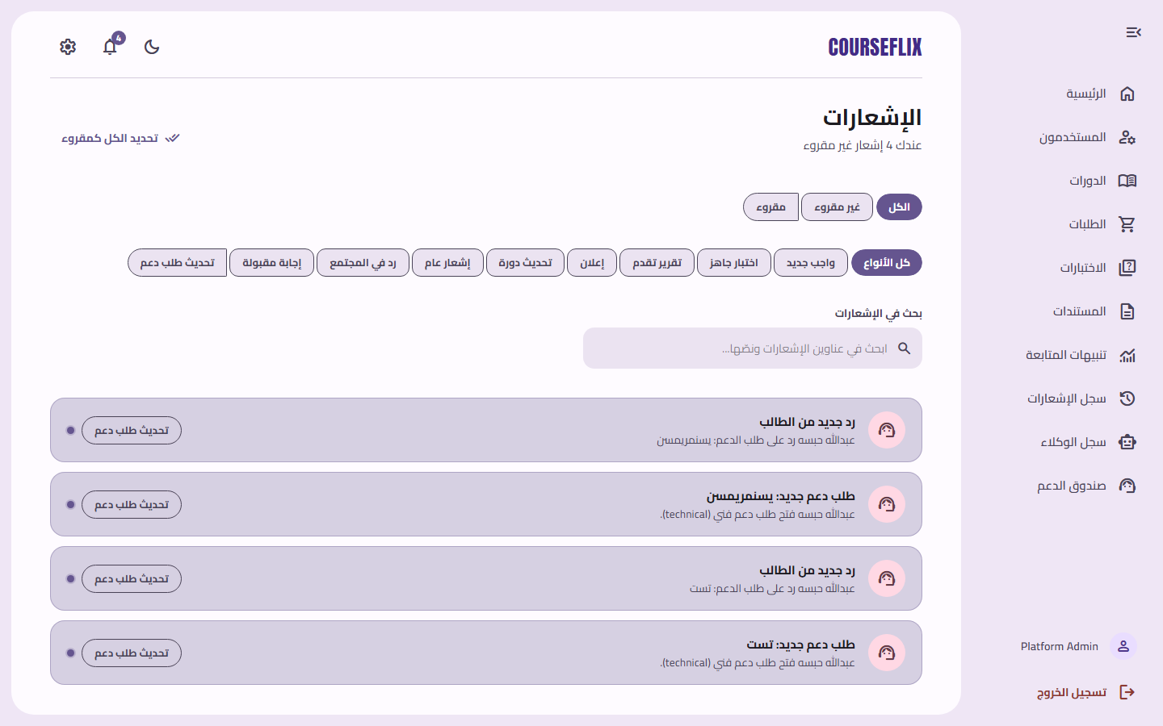

All Notifications Log
A complete log of every notification sent to every user on the platform, for review and auditing.
1. Open “سجل الإشعارات‏” (Notifications Log) from the sidebar.
2. Use the search box to filter results by user name or notification title.
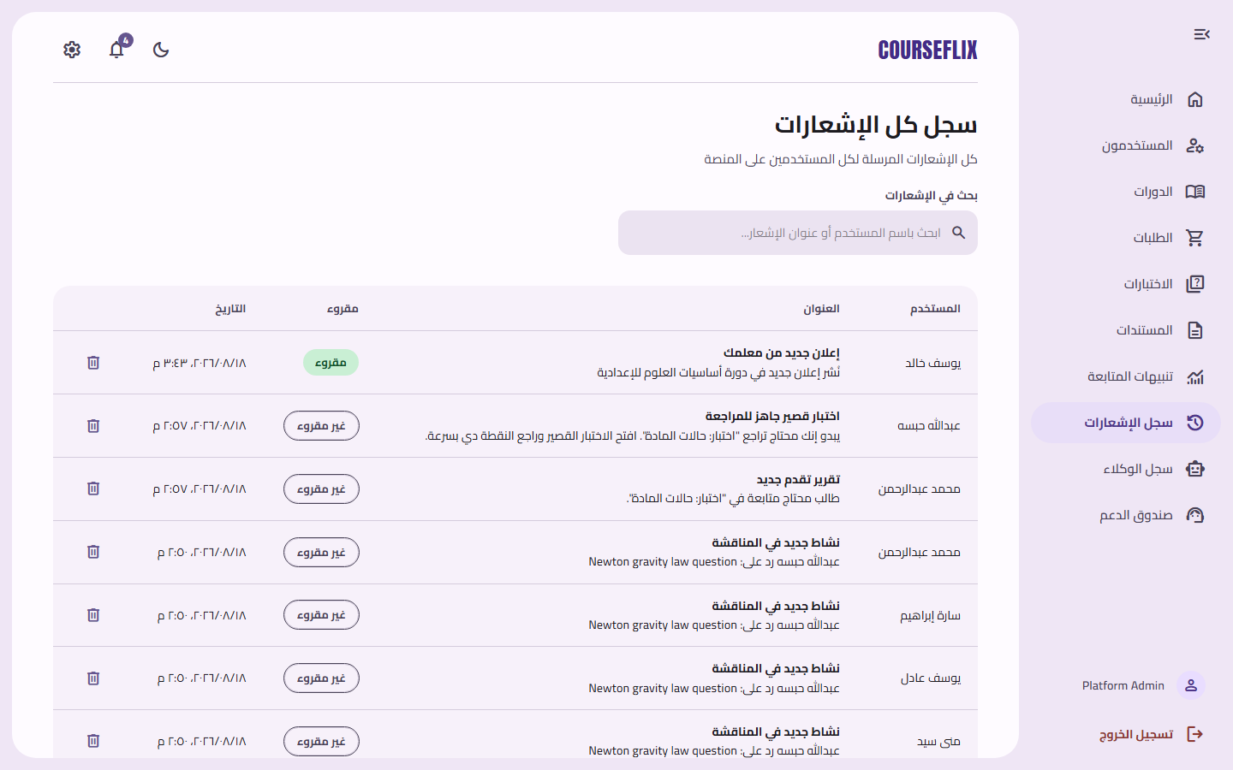

Agent Logs
A unified log of every AI-agent action platform-wide (not limited to a single course, unlike the teacher's view).
1. Open “سجل الوكلاء‏” (Agent Logs) from the sidebar.
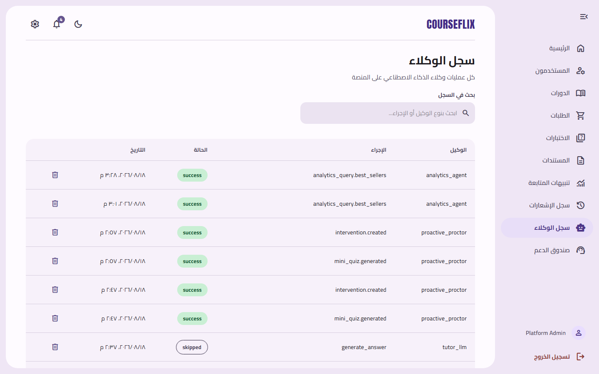

Support Inbox
Every support ticket platform-wide, from all students and teachers.
1. Open “صندوق الدعم الفني‏” (Support Inbox) from the sidebar.
2. Click any ticket to reply to it.
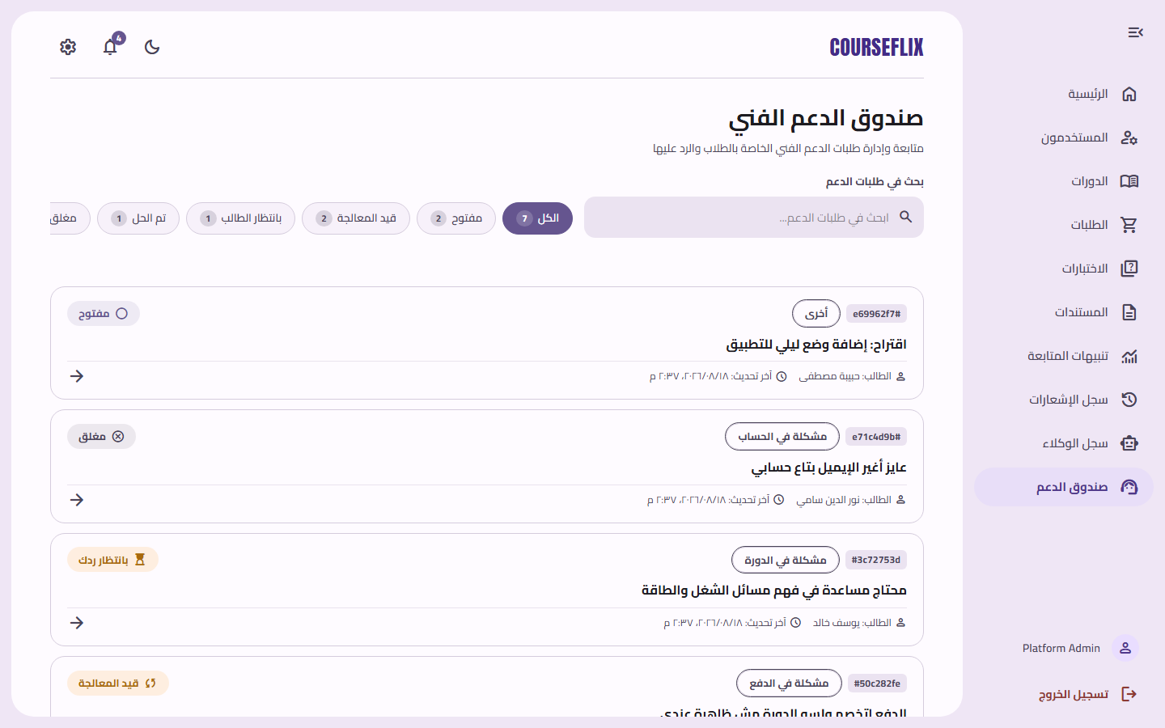

Settings
Manage the admin account's settings.
1. Open the gear icon ⚙️ or “الإعدادات‏” (Settings) in the sidebar.
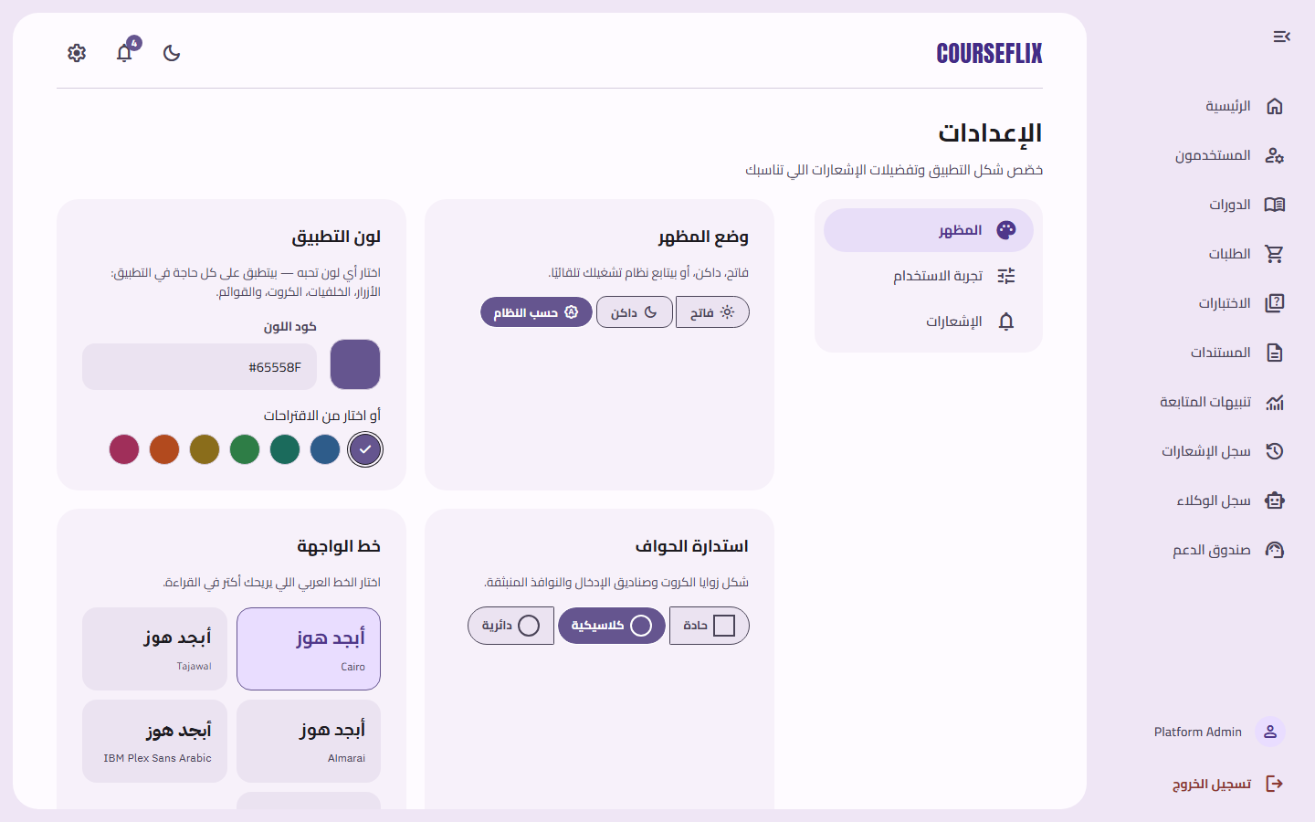

Profile
The admin account's basic details.
1. Click your name at the bottom of the sidebar.
