

MSc/PGDip/PGCert Health Data Science
Assignment cover sheet

Module:  (Please tick the appropriate box). | ☐ PMIM102/J Scientific Computing in Healthcare  ☐ PMIM202/J Health Data Modelling  ☒ PMIM302 Introductory Analysis of Linked Health Data  ☐ PMIM402/J Machine Learning in Healthcare  ☐ PMIM502/J Health Data Visualisation  ☐ PMIM602 Advanced Analysis of Linked Health Data
Module part (if applicable): | Reflective Journal
Title of assignment: | Reflective Journal
Student ID number: | 2311233
Word count (if applicable): | n/a
Declaration: | I understand the following conditions which apply throughout this course:  - I confirm that I am the sole author of this work.  - I understand that proof reading by a third party is not permitted.  - I understand the need for academic integrity and that all my submitted work will adhere to its principles.  - I understand that the teaching team will take measures to deter, detect and report any academic misconduct.  - I agree to my work being submitted to the TurnItIn academic database.  - I understand the importance of assignment deadlines and the need to seek help in good time where personal circumstances interrupt my work.
Please copy and paste this declaration onto the front of the submission.

Issue #1:
- What was/were the problem(s) experienced and in what specific exercise(s)?
Problem Location: Faced difficulty in understanding the creation of ‘vasseq’ variable in day 2 exercise in step 11.
Context: As per the IALHD workbook, an index sequence variable is a variable that acts as an identifier for the ordinal sequence of records to the same individual. Given the target condition (here in this example vasectomy treatment = 1), it is understood that ‘vasseq’ variable (index sequence variable) would be assigned as 1 and subsequent records of the individual will be incremental integers of the index sequence variable. The records prior to the index sequence variable would be the decremental integers of the index sequence variable. If the understanding is correct, then assigning the ‘vasseq’ variable to the subsequent records should follow the similar logical syntax as creating the ‘morbseq’ (morbidity sequence). However, the syntax is not straightforward as the understanding. Would it not be the same if the data was grouped by ‘rootlpno’ unique identifier, filtered as per the treat = 1, assigned a row number function to generate the sequence for the block of data? It does not look the same and it seems like there is a difference or gap in the perspective or understanding towards the creation of ‘vasseq’ variable. After inspecting the ‘vasseq’ variable object from the syntax output, there are no negative integer values that would represent the records of the individual before the treatment (decremental integers). Unique values in the ‘temp’ variable created in the syntax example are positive integer values and zero. So, the question is to reflect and investigate “Why is the syntax different for creating a vasseq variable and how it is different?”

- What was/were the reason(s) or contributing factor(s) for the problem(s) that arose?
First factor, there was a lack of clarity in how the ‘vasseq’ sequence variable is created in the IALHD workbook. The workbook only mentions the creation of the variable on a high level. In the workbook, point 15 under chapter 2, training section; provides with a hint to visualize the file blocks and supports the fact that, vasseq creation does not have elaborate description. Second factor, the reference code html file does not provide a line-by-line breakdown of what is happening in the syntax, why for loop was used in this scenario, while majority of the reference code implemented mutate functions via pipe operators.

- How did you investigate the problem(s) encountered and how did you solve the issue(s)?

Investigation: The problem investigation was carried out in two parts.
Part 1: Understand the logic behind ‘vasseq’ variable
The logic for creating ‘vasseq’ variable was developed by using a file block diagram in excel.
Following is the snapshot for file block diagram of ‘vasseq’ variable.
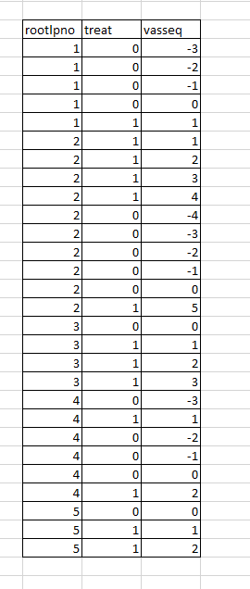

Part 2: To understand the given reference syntax and compare the results with self-written syntax
Firstly, there are three sections to the concept implementation and creation of ‘vasseq’ variable. Each section was investigated by commenting all the syntax and inspecting the output by running the syntax line by line. In section 3 of the implementation, ‘browser’ was used inside the for-loop control to pause and check the intermittent results. Secondly, the syntax like the ‘morbseq’ variable approach and comparing the data frames output side by side.

Solution:
Part 1: A comprehensive understanding of ‘vasseq’ variable creation is attained.

Part 2.1: Running the code line by line and inspection of the output at every step helped to re-structure understanding and shift the perspective based on the obtained results. More comments were added to support understanding of the syntax. Below is the snapshot of the before – after states syntax.
Before:
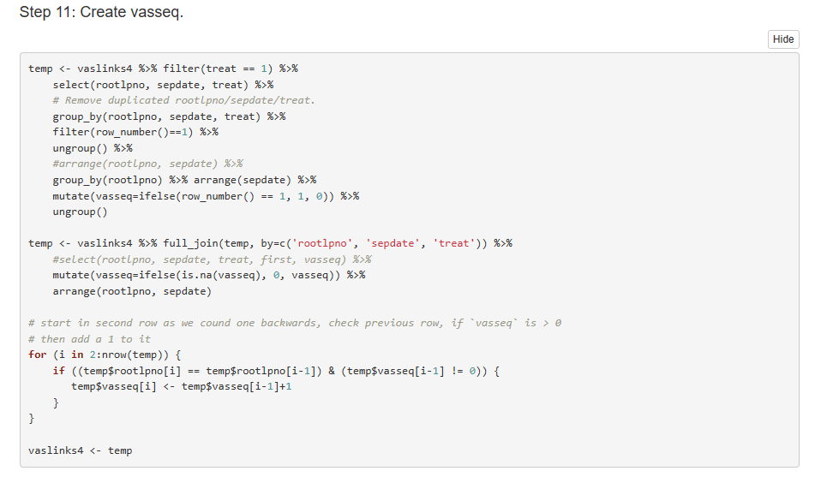

After:
Section1:
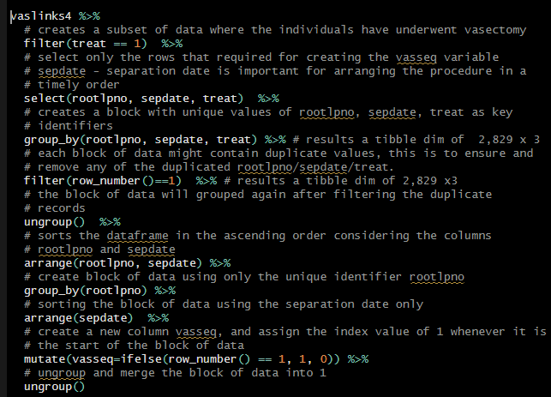
Section2:
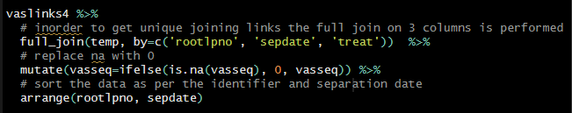
Section 3:
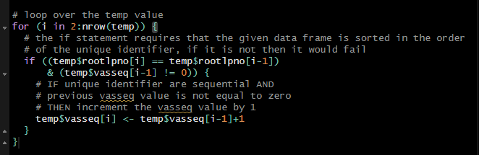
Additional insight was found, that there was a line of syntax in section 1 that really did not add any value to the logic, but would have utilized more computation power and time that is linearly proportional to the size of the data. A comparative analysis of the results was performed with and without the syntax statement. Here, test1 was created with the syntax statement ‘arrange (rootlpno, sepdate)’ and test2 without the statement. Then, unique vasseq sequence variable was compared in both the data frames. The output of the test1 and test2 were same.
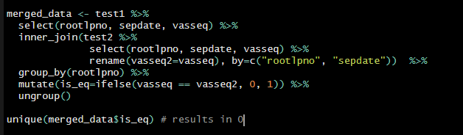

Part 2.2:
Part 2.1 results aided to understand better the data transformation that was required for creating the ‘vasseq’ variable. The output of the syntax that was written for creating the ‘vasseq’ variable following the same logic as ‘morbseq’ variable did not match. The limitation in the logic and approach were realized. The logic would have become more complicated if mutate with pipe operators were used for checking the previous ‘vasseq’ variable values. Indexing functionality is difficult and the resultant code would not have been as intuitive as the for loop implemented for incrementing the variable value.

- What conceptual and analytical understanding was gained from experiencing the problem(s)?
Conceptual: Limitations of inbuilt functionality of the syntax was realized. Overcoming the limitations with simplistic approach is better than condensed and composite functions that could have been used to achieve the task.

Analytical: Comparative analysis of syntax outputs helped to derive better understanding of the implementation of approaches that could be used for long term purposes. Different approaches to solve the same problem could help realize more about the nature and practical applications and limitations of the syntax.
- How could your learning(s) from this experience be applied to prevent the problem(s) occurring in future research work?
Data linkage and data engineering is a crucial part of creating datasets with quality. Low quality data, mismatches or incorrect creation of variables that could lead to unexpected or misleading results. Firstly, learning from this experience not only reinforced my confidence in the debugging skills and syntax knowledge, but also help develop better understanding of limitations of certain inbuilt functionality available in the syntax. It emphasized on checking the syntax to ensure that the implementation does what it is intended to do. Secondly, emphasize on readability of the code. The need for better commenting of the code is essential for transfer of knowledge and understanding of the implementation of syntax. The learning from this experience would help save my time and the future syntax reader’s time. Better commented syntax would provide clarity of the syntax and easy transfer of knowledge.

Issue #2:
- What was/were the problem(s) experienced and in what specific exercise(s)?
Problem Location: In day 5, from steps 6 – 8 faced difficulty in understanding examination of confounding variable and risk adjustment of variables.
Context: I understand confounding as a form of bias, where the effects caused by two variables are mixed. Confounding by indication is a type of confounding that can be controlled by risk adjust. When it comes to data, questions of the form “how is it affecting the outcome of interest”, and how risk adjustment “controls” it, in a practical scenario is difficult for me to visualize and comprehend. So, the question to reflect and investigate is “how does risk adjustment change the data distribution for a confounding variable?”

- What was/were the reason(s) or contributing factor(s) for the problem(s) that arose?
The problem stems from two factors. First, limited knowledge and experience working with risk adjustment in epidemiology context. Second, a possibility of misunderstanding the concept of risk adjustment that is leading to unexpected understanding.

- How did you investigate the problem(s) encountered and how did you solve the issue(s)?
In-order to solve the problem, the investigation was split into two components, the concept and syntax.
Concept:
Concept investigation used a drill down technique. Drill down technique starts from the main concept and drills down into nested concepts that are associated with it. Consider the following visual for reference of process that I followed.
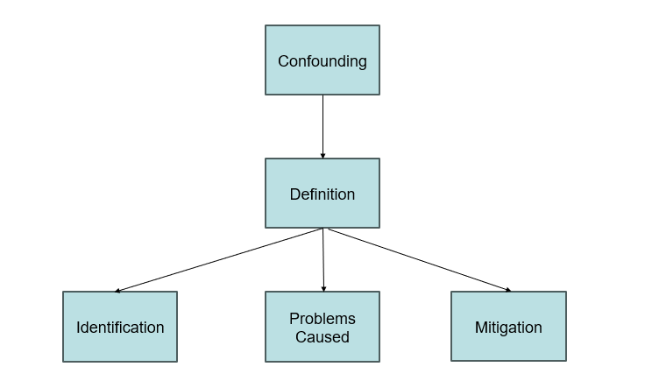
I revisited and understood the definition of confounding variables and the difference between effect modifiers. Realized how identification works. Recognized the shift in the estimate calculation on outcome of interest that was the effect of confounding variables. I understood that to fix the shift, risk adjustment is necessary. Explored the approaches that are used in risk adjustment, especially “charlson index” that is practically used in the syntax.

Syntax:
Age variable is identified as one of the confounding variables. BHPSURG is the outcome of interest. The mean age and year of separation is checked for BPHSURG = 0 and BPHSURG = 1 to understand the potential effects of confounding. The mean value for BPHSURG = 1 seems to be lesser than mean value for BPHSURG = 0.

So, what exactly is missing that would aid in improving understanding?
Age is identified as confounding variable based on prior knowledge. But there was no comparison of cox regression output before and after non-linearity continuous covariate adjustments. It was missing in the solution file. Step 5 does cox regression without including the age variable and in step 7 adjusted age variable is used in cox regression. The step 6 - examination of confounding variable is only limited to comparing the mean values without directly including the age variable in the cox regression equation. It would make more sense if the output of cox regression with and without adjustments of age variable is used.

Following is the syntax for before adjustments:
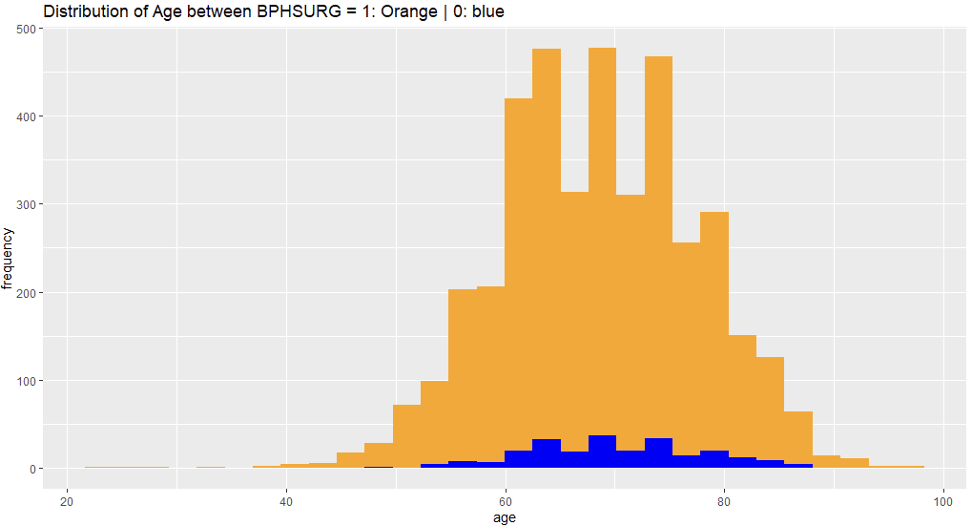
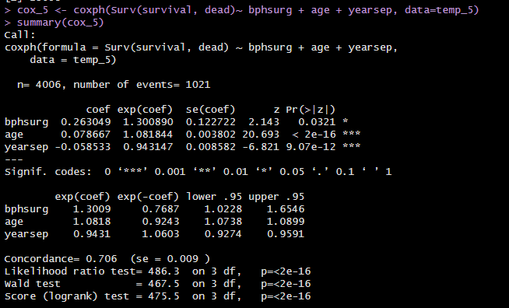

Following is the syntax for after adjustments:

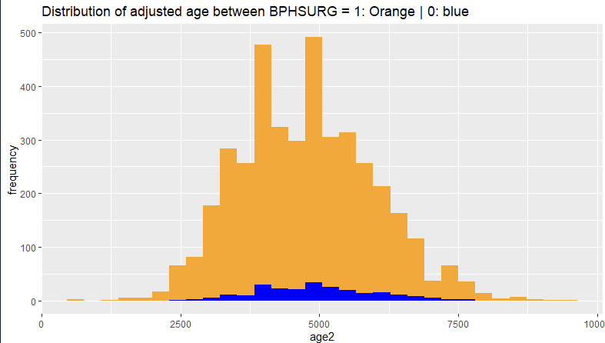
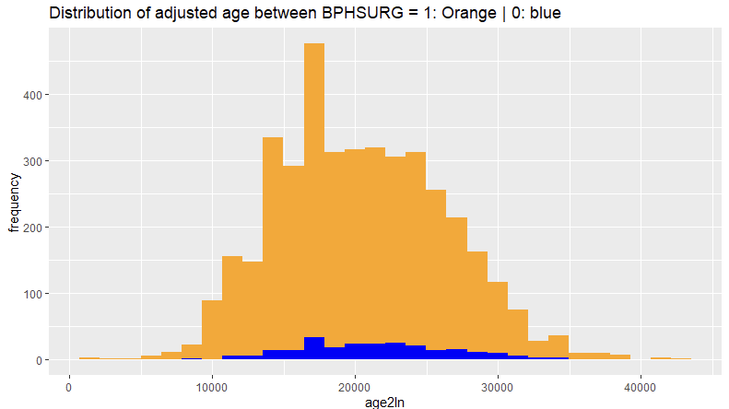
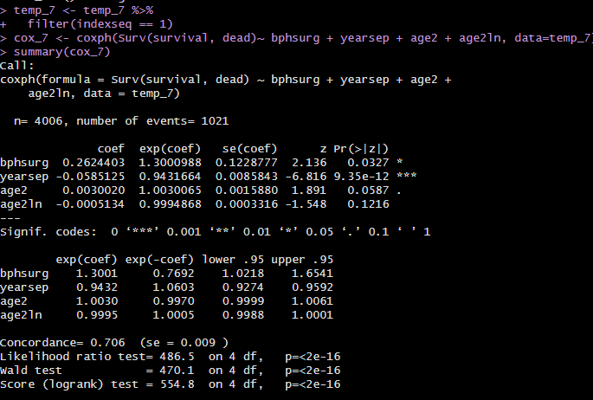

It is observed from before screenshots that in cox regression age turns up as a significant variable but after adjustment, only the squared age variable is observed as a significant variable. This proves that age is confounding variable. The natural log changes the distribution of age, while the squared age distribution looks almost similar.

- What conceptual and analytical understanding was gained from experiencing the problem(s)?

Conceptual Understanding:
I understood the effects of a confounding variable in practice. The intuition and experience of dealing with confounding variable and its corresponding risk adjustment solidified with the investigation and implementation.

Analytical Understanding:
The before-after analysis has changed my thought process to be more objective of the concept. The effects of confounding were practically understood by approaching the solution file syntax with the different angle. This enabled me to clearly distinguish between the two scenarios and instate the importance of risk adjustments to the confounding variable.

- How could your learning(s) from this experience be applied to prevent the problem(s) occurring in future research work?

