NOTE: When you search for either qualitative or quantitative research, you will inevitably bring back some articles where mixed methods have been included. There is no simple way to exclude these.
CINAHL – Finding Qualitative Studies.
- Use CINAHL Headings.
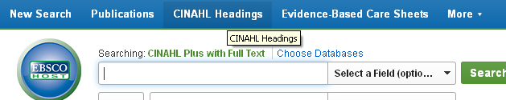

- Search for Qualitative. Select Qualitative Studies and tick to explode the term so that it will also find: ethnographic, action research, etc.

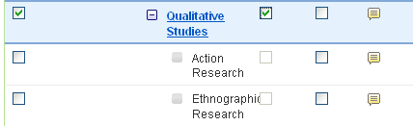

- (MH "Qualitative Studies+") is what will appear in your search box. (See below.)

- You can now enter search terms for you topic in the lines below the Qualitative Studies search. For example, if you were looking for qualitative research about how teenagers feel about their body image, you might do something like this:
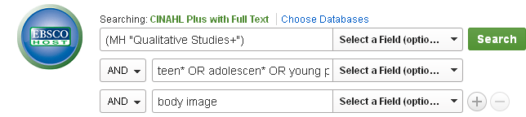
- Set LIMITS to your search:
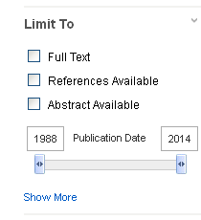
LIMITS – to view the full choice of limits, look at the list to the left of your results. Click on Show More to see the full set of Limits.
Choose: a)Research Articles; b) peer reviewed; c) date of publication (e.g. 2008-2014); d) English language.

Cinahl – Finding Quantitative Studies
There is a CINAHL Subject Heading for Quantitative Studies (MH “Quantitative Studies”), but it is not as good as the qualitative one.
You need to think of the sort of terms associated with Quantitative Research and add these to the heading for quantitative studies. For example,
MH “Quantitative Studies” OR Clinical trial* OR statistic* OR questionnaire* OR survey*
There may be other terms that would be appropriate to use e.g. “logistic regression” OR “chi square” OR “linear regression” etc.
As before add your topic terms to the lines below. Remembering always each line should have only one concept and its related/alternative terms.
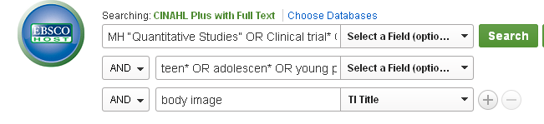

MEDLINE – Searching for Qualitative & Quantitative Studies
In MEDLINE, use the MESH headings search to find the terms for qualitative and quantitative studies. You do this in the same way as you did for CINAHL headings, only this time they are called MESH.
QUALITATIVE |  | QUANTITATIVE
MESH term | (MH "Qualitative Research") | MESH term – | There is NO Mesh term for Quantitative Research/Studies.  There are other options but a keyword search (as below) will probably work well enough for you.
Keywords | Interview* -- focus group* -- ethnographic -- “action research” -- any others you can think of! | Keywords | Clinical trial* -- statistic* -- questionnaire* -- survey* -- “Chi-Square” -- regression -- “statistics & numerical data”
Combined Search String | (MH "Qualitative Research") OR Interview* OR focus group* OR ethnographic OR “action research” | Search String | (Clinical trial* OR statistic* OR questionnaire* OR survey* OR “Chi-Square” OR regression OR “statistics & numerical data” )

As with CINAHL, you just need to get the Qualitative OR Quantitative search string on the first search line and then add your topic terms below.
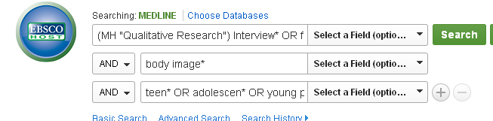

When looking for Quantitative Studies, the type of study and the question the research is trying to answer, will influence which of the search terms work best. But you can still use a variety of keywords (linked by OR ) and then explore your results to see what you can find.

ASSIA – Finding Qualitative & Quantitative Studies
ASSIA is good for Social & Health topics. It is good for qualitative research too.
When using ASSIA always choose Advanced Search.
ASSIA has a thesaurus which is like the MESH and CINAHL headings. However, with ASSIA, it is best to use a keyword search using the same terms as we used before and a couple of additions:
QUALITATIVE: (“qualitative research” OR “qualitative method*” OR interview* OR "focus group*" OR ethnographic OR phenomenolog* OR "action research")
QUANTITATIVE: (Clinical trial* OR statistic* OR questionnaire* OR survey* OR “Chi-Square” OR regression )
Put this search string (copy and paste if you like) into the top line on the Advanced Search screen, and add your topic keywords as below:
Use the Search Options to limit your results to PEER-REVIEWED & Scholarly journals, as well as English language and publication years.
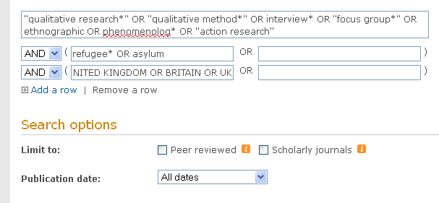

NOTE: When you search for either qualitative or quantitative research, you will inevitably bring back some articles where mixed methods have been included. There is no simple way to exclude these.
FINDING THE FULL-TEXT OF ARTICLES
- Some databases may give you a link to the pdf of the article which you can download and save or email to yourself. But this will only be for a few of the articles found by your search.
- If you don’t see the pdf link, click on IGetIT@Swansea. This will check if we have access to a copy of the article. If we have, then it will link you to the article.
SAVING RESULTS
- In CINAHL & Medline, select results you want to save using the folder icon. Results saved to the folder will be available from the folder link at the top of the screen. You can choose to email or save results. IF your results included some records with a pdf icon then you will receive the full-text of the article. Otherwise, you will only receive citation and abstract details. Items in the folder will disappear when you log-out. If you want to keep your saved records for longer, you need to create a MYEBSCO account (see other guide).

- In ASSIA, you select your results using the tick boxes. At the top of the screen, you will see “Saved Results”. Again you can save or email the results to yourself. You will not have the IgetIt@Swansea links in the email. If you want to save results permanently (with the iGetit link), you need to create a MyResearch account. This is much like the MyEbsco account.

- MyEbsco/My Research accounts. If you have saved some results permanently, then when you revisit the database, so long as you login to your MyEbsco / MyResearch account, you will be able to see those saved items.

