Title: Performance evaluation of synthetic clinical coding corpora trained NER model on natural corpora

Supervisor: Dr. Arron Lacey

- What is the aim of the dissertation?
To train a Named Entity Recognition model on synthetic clinical coding corpora and evaluate the performance on the natural corpora
- How are you going to prepare the Synthetic data?
  - UMLS is the form of clinical coding that is intended for synthesizing the corpora.
  - Option1: The exploration of input and output sentence structure would include
    - synthetic_hpi_ner/data/annotation/synth at main · UTHealth-CCB/synthetic_hpi_ner · GitHub
    - Sample generated in this form and data transformed to be in the IOB name tagging format
Patient: John Doe
Age: 45 years
Gender: Male
Diagnosis: Hypertension (ICD-10-CM code: I10)
Medications:
- Amlodipine (RxNorm code: 197361)
- Hydrochlorothiazide (RxNorm code: 197362)
Lab Results:
- Serum Creatinine: 1.2 mg/dL (LOINC code: 14682-9)
- Blood Pressure:
- Systolic: 140 mm Hg
- Diastolic: 90 mm Hg
Procedures:
- ECG (CPT code: 93000)
- Renal Ultrasound (CPT code: 76770)
A NER model would classify as per the IOB tagging ( Personal Info – Procedures – Diagnosis – Medication ) , a classifier / lookup model will be used for retrieving the actual clinical code.
  - Option2: Need a sample of input and output structure of the data from Dr. Arron, based on the structure, do prompt engineering to figure out the best prompt that generates the required structure.
- What are the LLMS models intended to use for generating the data
  - Gemma Open Models
  - ChatGPT3.5 OpenAI API
  - Claude-3 API
  - Mistral API
  - Hermes API
- What type of NER models are intended to be trained
As the scope of the dissertation is to demonstrate learning skills including Data processing and machine learning models, the intention is to use the following
  - LSTM
  - Bidirectional – LSTM
  - Fine Tuned Transformers example – Clinical Bert (Extended Scope)
  - LLMs
- What does the process of developing the model looks like?
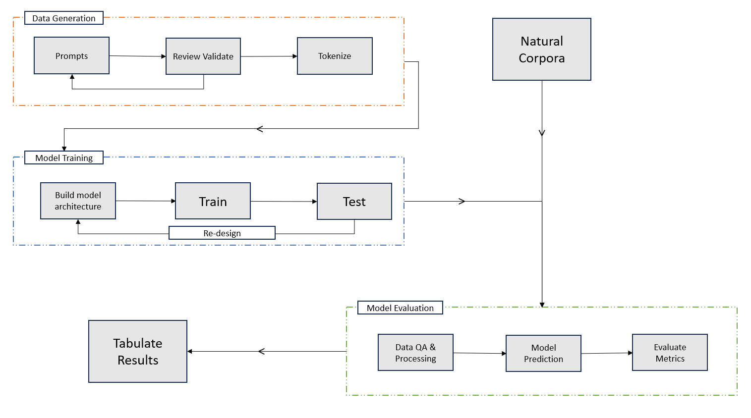
- Which platform and coding language is preferred for developing the model?
  - Tensorflow + keras + python
  - Google cloud colab / Kaggle notebooks
- Real dataset samples for initial experimentation
  - Gold standard annotation of epilepsy clinic letters for the development of information extraction tools (zenodo.org)
  - Gold standard annotations for 200 synthetic epilepsy clinic letters in JSON format (zenodo.org)

