Лекция 19

ПСКП, ПОИТ-3

**Node.js: Express**

1. **Express:** Router, монтирование маршрутов

<https://expressjs.com/ru/guide/routing.html>

1. **Express:** Router

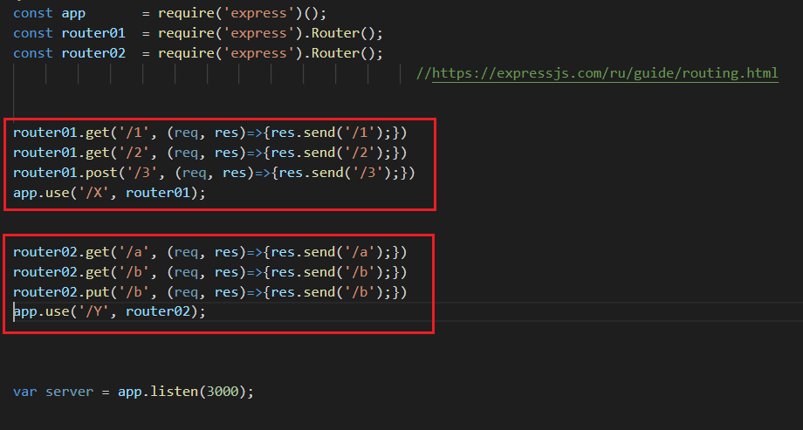

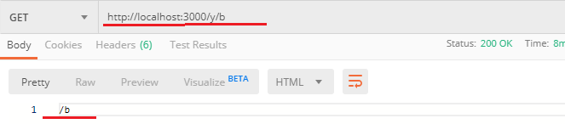

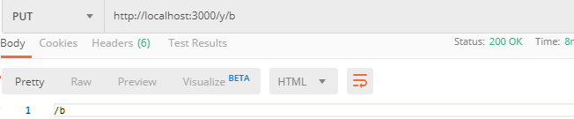

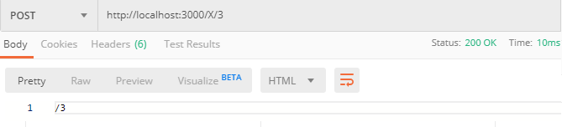

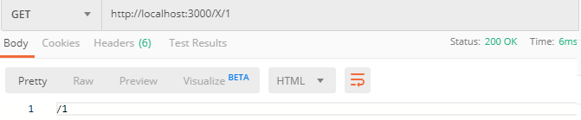

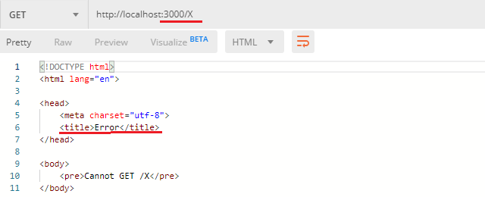

1. **Express:** шаблонымаршрутов

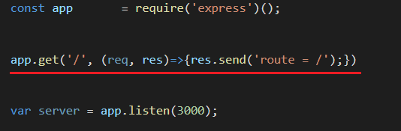

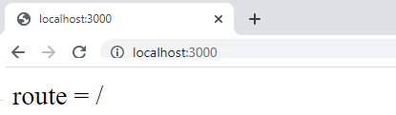

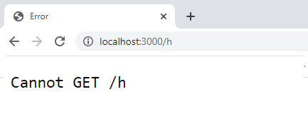

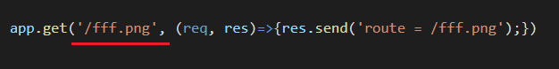

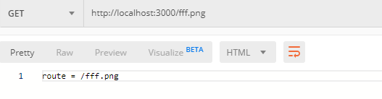

*(произвольная строка)

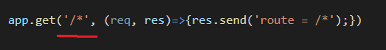

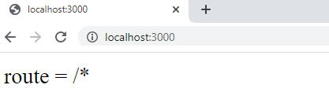

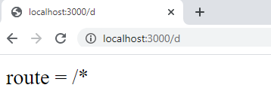

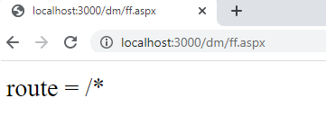



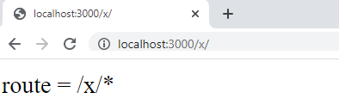

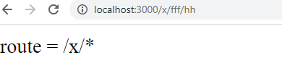



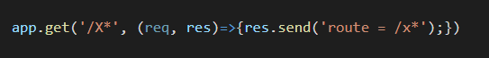

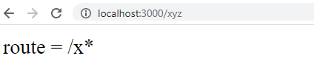

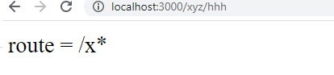



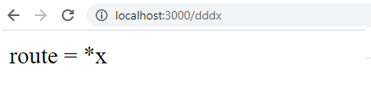

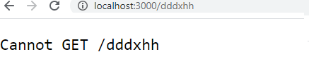

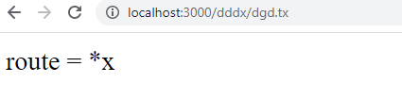

? (0 или 1)

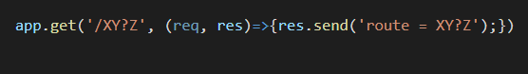

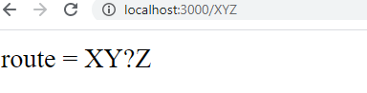

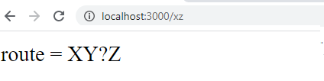



+ (1 и более)

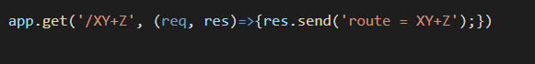

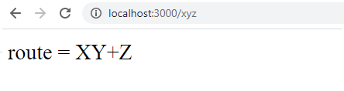



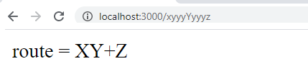

() (группировка нескольких символов)

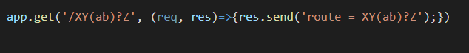

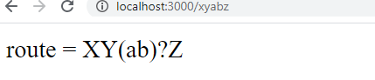

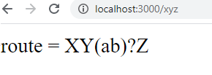

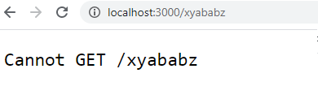

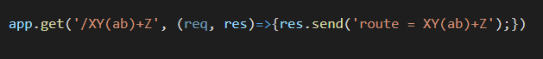

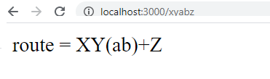

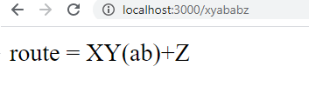

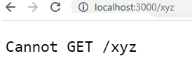

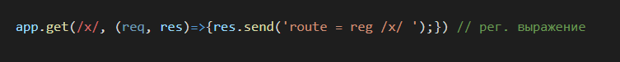

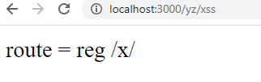

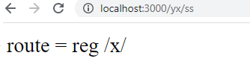



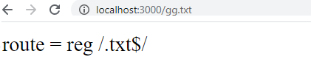



1. **Express:** параметры в маршруте

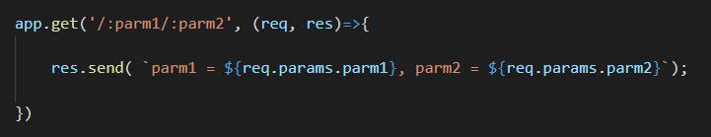

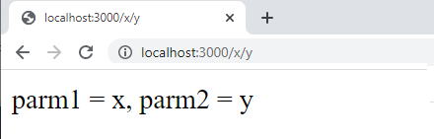



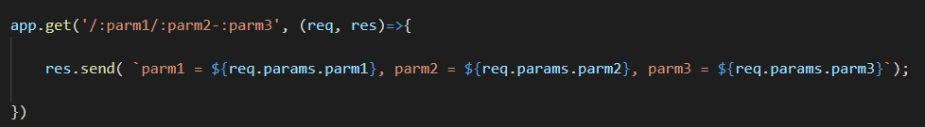

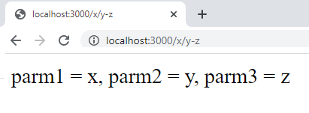

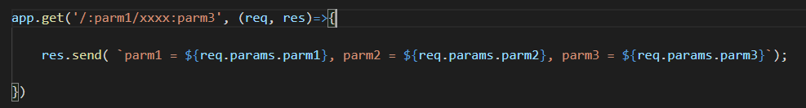

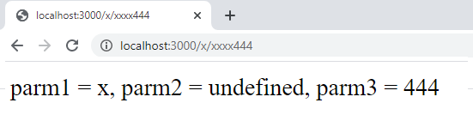

1. **Express:**пример маршрутизации

|  |  |  |
| --- | --- | --- |
| **Метод** | **Маршрут** | **Результат** |
| GET | /**home**/**index** | home/index |
| GET | api/**home**/**index**/*param* | home/index |
| GET | loc/lex/**home**/*param*/**index** | home/index |
| GET | /**home**/**account** | home/account |
| GET | api/**home**/**account**/*param* | home/account |
| GET | loc/lex/**home**/*param*/**account** | home/account |
|  |  |  |
| GET | /**calc**/**salary** | calc/salary |
| GET | api/**calc**/**salary**/*param* | calc/salary |
| GET | loc/lex/**calc**/*param*/**salary** | calc/salary |
| GET | /**calc**/**trans** | calc/trans |
| GET | api/**calc**/**trans**/*param* | calc/trans |
| GET | loc/lex/**calc**/*param*/**trans** | calc/trans |

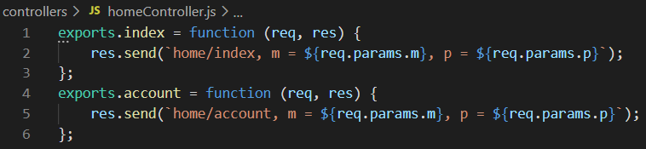

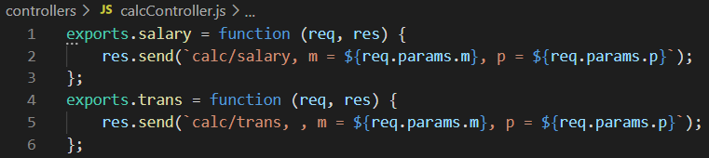

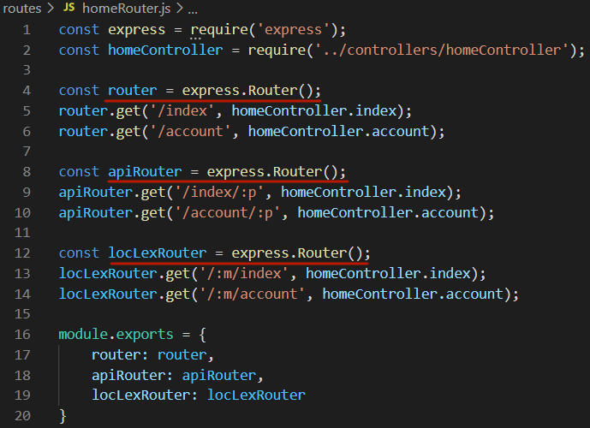

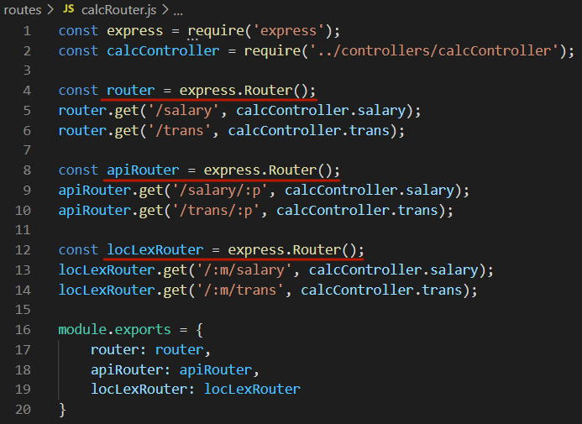

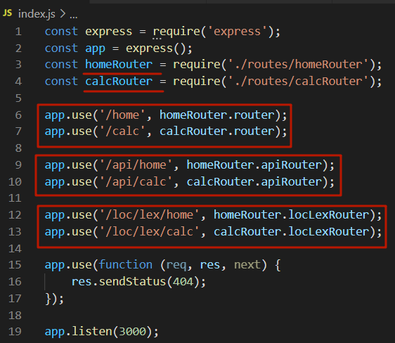

1. **Express:**пример кода MVC-приложения



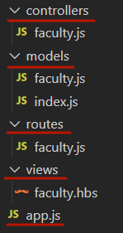

**models/faculty.js**

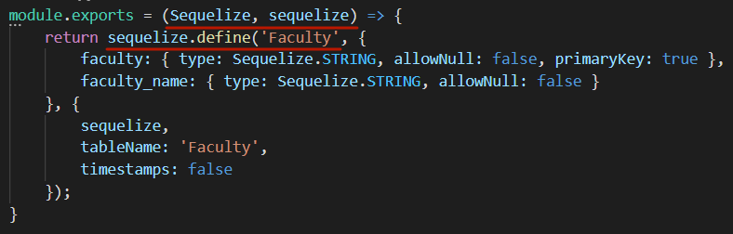**\**

**models/index.js**

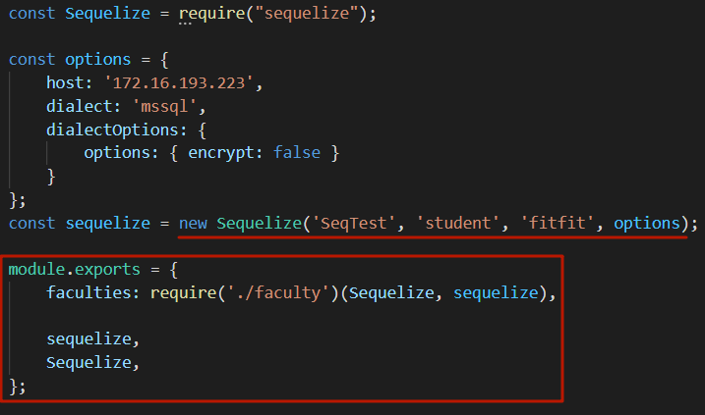

**controllers/faculty.js**

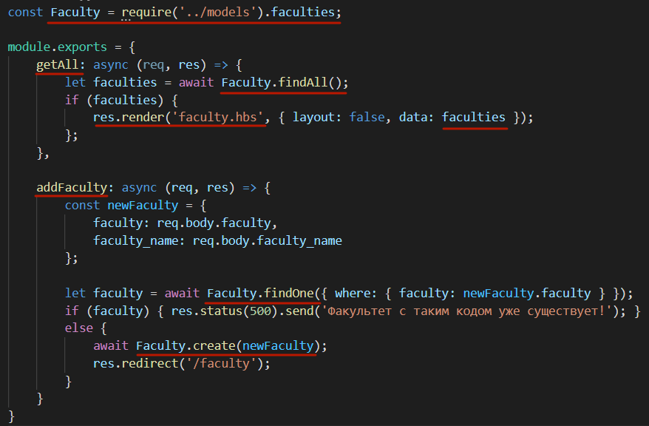

**routes/faculty.js**

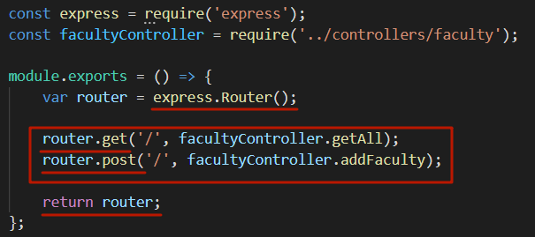

**views/faculty.hbs**

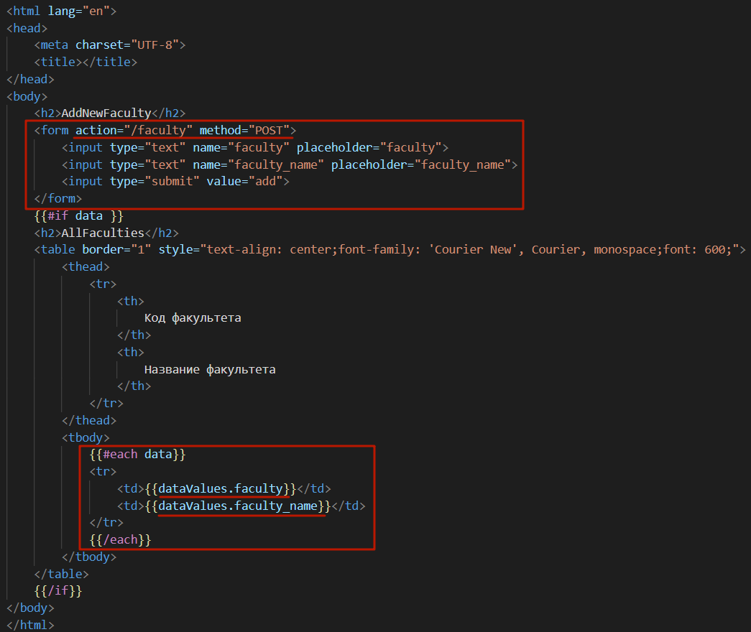

**app.js**

