Connect to Snowflake in DBeaver

This procedure describes how to connect to Snowflake in the DBeaver database management tool.

**NOTE**: Before you begin, install or upgrade to the latest version of [DBeaver](https://dbeaver.io/download/).

To create a Snowflake connection in DBeaver, complete these steps:

1. Select **New Database Connection** from the Database menu.
2. In the Connect to database window, enter *snowflake* in the search bar, and select **Snowflake**.  
     
   The Connect to a database dialog box appears.  
   A screenshot of a computer

   Description automatically generated
3. Click **Next.**
4. The Connect to a database dialog box appears.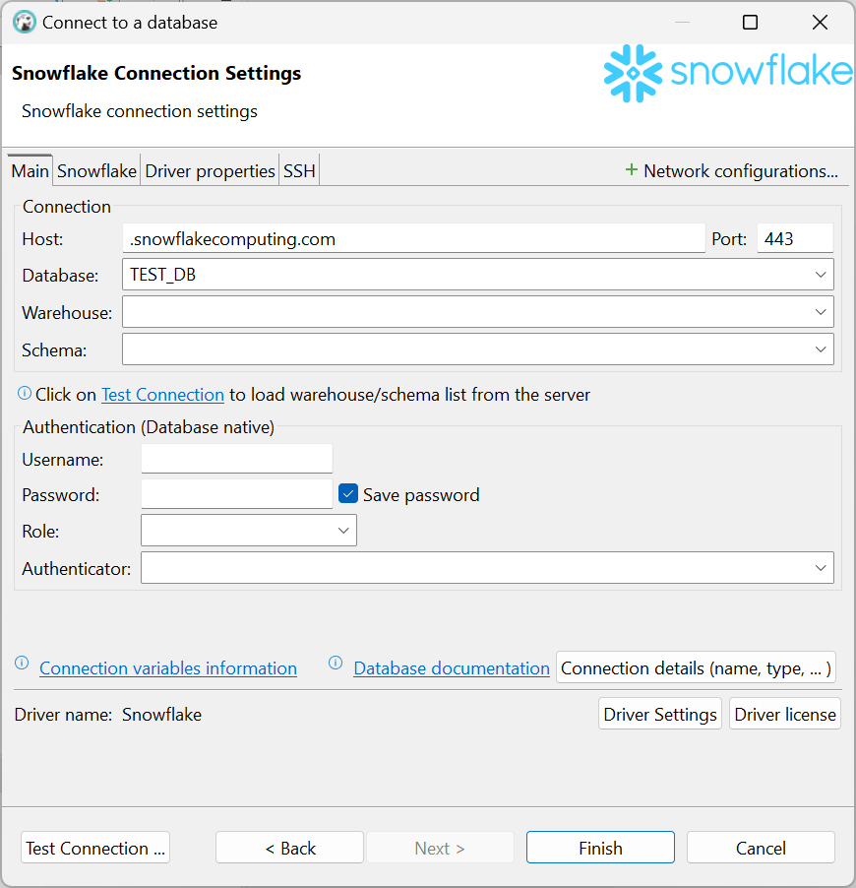
5. In the Connect to a database dialog box, configure the Snowflake connection settings:  
   1. In the Host name, enter **company.snowflakecomputing.com**.
   2. In the Database field, enter **DB_NAME**.
   3. In the Schema field, enter **DEMO**.
   4. In the Username field, enter your email address.
   5. Clear the Save Password checkbox.
   6. In the Role field, enter **DEMO**.
   7. From the Authenticator drop-down list, select **externalbrowser**.

The Connection settings should appear similar to the following image:

1. Click **Test Connection**.  
   **Note**: If the Snowflake jdbc driver is not installed, you will be prompted to install it.
2. In the User Credentials window, enter your password, and click **OK**.
3. If prompted, log in using your Snowflake credentials and Duo Two-Factor Authentication.
4. Close the browser window, and return to DBeaver.  
     
   The following dialog box appears if the connection is successful:  
   A screenshot of a computer

   Description automatically generated