# How to Create a Demo Dashboard

The following procedure describes how to create a demo dashboard from an existing Tableau customer workbook.

## Prerequisites

* You must have Tableau Desktop installed on your local machine.
* In Tableau Desktop, you must be signed into the following server:  
  https://tableau-stage.company.com/

## Procedure

1. In Tableau, access the customer dashboard from which you want to create a demo dashboard.
2. In the Tableau toolbar, click the **Download** button.  
     
   **NOTE**: If you do not see the Tableau toolbar, remove the query string from the URL; that is, remove all text after and including the question mark (?).
3. In the Download dialog window, click **Tableau workbook**, and then click **Download**.
4. Once the download completes, double-click the .twbx file to open it in Tableau Desktop.
5. In the Sheets pane, click the icon to open the customer_name worksheet.  
   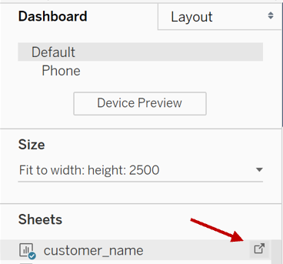
6. In the Parameters section of the customer_name worksheet, right-click the parameter you want to change, and select **Edit**.

**Note**: For a list of suggested modifications, see Suggested Parameter Modifications.

1. In the Edit Parameter window, enter a generic value in the Current value field, and click **OK**.   
   A screenshot of a computer

   Description automatically generated
2. Once you have modified the parameters, click **Save** to save your changes.
3. Publish your changes:
   1. From the Server menu, click **Publish workbook**.
   2. In the Publish Workbook to Tableau Server window, select the **Demo Dashboards** folder from the Project drop-down list.
   3. Enter a new name for the dashboard in the Name field.  
      A screenshot of a computer

      Description automatically generated
   4. Click **Publish**.
4. Once the workbook is published, verify the changes on the Tableau server, and ensure no proprietary or confidential information appears on the dashboard.

## Suggested Parameter Modifications

Here is a list of suggested parameters to change:

|  |  |
| --- | --- |
| **Parameter** | **Suggested Value** |
| customer_ name | Customer Name |
| customer_partner_name | Partner Name |
| customer_contracts | 123456, 234567 |
| customer_inventory_name | INVENTORY_NAME |