

**โครงงาน**

KAB Phone

**จัดทำโดย**

6604062636348 นายธีรภัทร โคตะนารถ

6604062636453 นายพงศ์ศิริ เลิศพงษ์ไทย

6604062616215 นายอิทธิวรรธน์ ขุนพิชัย

6604062636348 นายธีรภัทร โคตะนารถ

**เสนอ**

ผู้ช่วยศาสตราจารย์ ดร. คันธารัตน์ อเนกบุณย์

**วิชา System Analysis and Design**

ภาคเรียนที่ 1 ปีการศึกษา 2567

ภาควิชาวิทยาการคอมพิวเตอร์และสารสนเทศ คณะวิทยาศาสตร์ประยุกต์

มหาวิทยาลัยเทคโนโลยีพระจอมเกล้าพระนครเหนือ

**สารบัญ**

**หน้า**

Requirement 1

1 Use case 2

2 Fully use case description 3

Context diagram 4

DFD Level 0 5

2 Sequence diagram 6

Interface 7 - 10

Testing 11

**Requirement**

|  |  |  |  |  |  |  |
| --- | --- | --- | --- | --- | --- | --- |
| **Stakeholder** | **Hardware** | **Input** | **Output** | **Functional requirement** | **Nonfunctional requirement** | **When** |
| Admin |  | New phone data |  | An admin adds new phone to stock or remove outdated phone from stock |  | They launched a new phone or there is an outdated phone |
| Admin |  | Tracking number |  |  |  | Paid order occurred |
| Customer | * Payment * Address * Tel no. |  | * Updated stock * Invoice receipt |  | When customer add item to basket. It will not deduct from stock until payment success | Daily |
| Customer | * Name * Address * Tel no. * Line ID |  |  |  | Customer can edit name, address, Tel no., or Line ID | Daily |

**Use case**

**รูปภาพประกอบด้วย การวาดภาพ, ร่าง, ข้อความ, แผนภาพ

คำอธิบายที่สร้างโดยอัตโนมัติ**

**2 Fully use case description**

|  |  |  |
| --- | --- | --- |
| **Use Case Name:** | **Report** | |
| **Scenario:** | **Make a sales and income report.** | |
| **Triggering Event:** | **Once it reach set time, daily, weekly, monthly, quarterly, and annually.** | |
| **Brief Description:** | **Create a sales report, and income report. For admin (owner) of the shop. Also including best sell, worst sells and Inventory product.** | |
| **Actors:** | **Admin** | |
| **Related Use Cases:** | **Including: Time Box, Best-Worst Sell Data, Inventory Report, Financial Report** | |
| **Stakeholders:** | **Admin: to provide owner a selling data** | |
| **Preconditions:** | **Raw data from sales.** | |
| **Postconditions:** | * **Provide daily income report.** * **Provide weekly income report.** * **Provide monthly income report.** * **Provide quarterly income report.** * **Provide annually income report.** * **Provide worst sell report.** * **Provide best sell report.** * **Provide Inventory report.** | |
| **Flow of Activities:** | **Actor** | **System** |
|  | 1. **User get into report page.** 2. **User see income reports.** 3. **User also see sell reports.** 4. **User see Inventory reports.** | **2.1 Provide income reports.**  **3.1 Provide sell reports.**  **4.1 Provide Inventory report** |
| **Exception Conditions:** | * **If data is empty** | |

|  |  |  |
| --- | --- | --- |
| **Use Case Name:** | **Buy Product** | |
| **Scenario:** | **Customer buy a product.** | |
| **Triggering Event:** | **When customer buy a new product and make purchase.** | |
| **Brief Description:** | **Customer login to website, pick item. Then purchase for product. And wait for parcel to drop-off at their house.** | |
| **Actors:** | **Customer** | |
| **Related Use Cases:** | **Including: Payment, Order Cancel Request, Track Order** | |
| **Stakeholders:** | **Admin: to accept the order and process shipping** | |
| **Preconditions:** | **Ready-to-sell items in stock** | |
| **Postconditions:** | * **Provide complete order to admin** * **Admin provide shipping and send order tracking** | |
| **Flow of Activities:** | **Actor** | **System** |
|  | 1. **Customer add item into basket** 2. **Customer click preview order in basket** 3. **Customer add a discount coupon**   **3a. Customer sign up if not exist**   1. **Customer choose payment method** 2. **Customer confirm payment**   **5a. If card declined, refer to step 1.**   1. **Customer see success page**   **6a. If out of stock, refer to step 1.** | **3.1 Find if coupon works**  **3.2 Provide sign-up page**  **4.1 Provide payment methods**  **5.1 Provide payment refer by selected payment method**  **6.1 Check for item in stock** |
| **Exception Conditions:** | **5. Customer’s card is declined for any reasons**  **6. Item is out of stock** | |

**Context diagram**

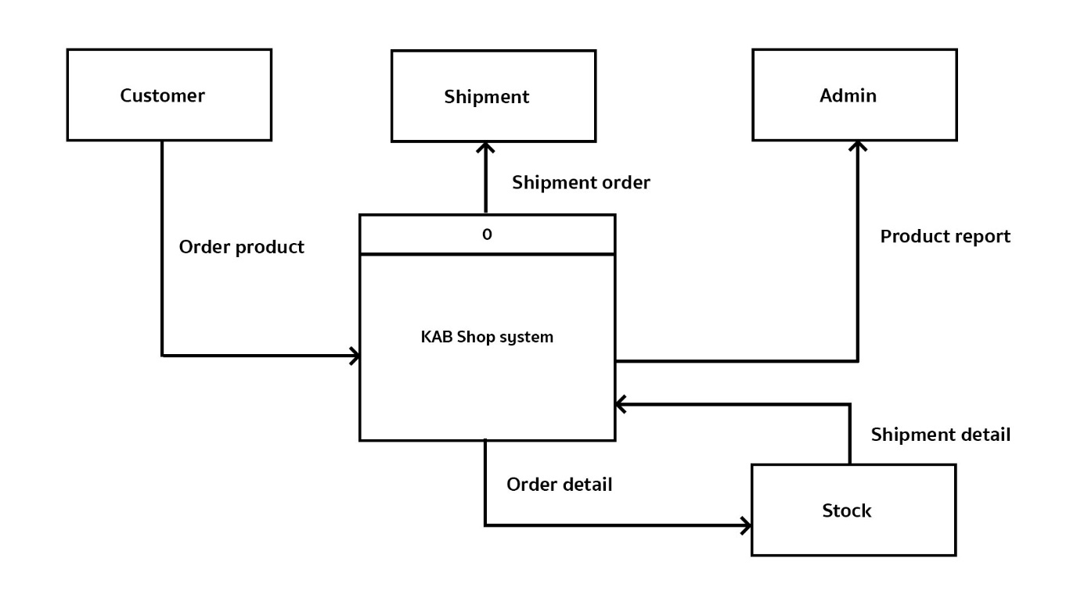

**DFD Level 0**

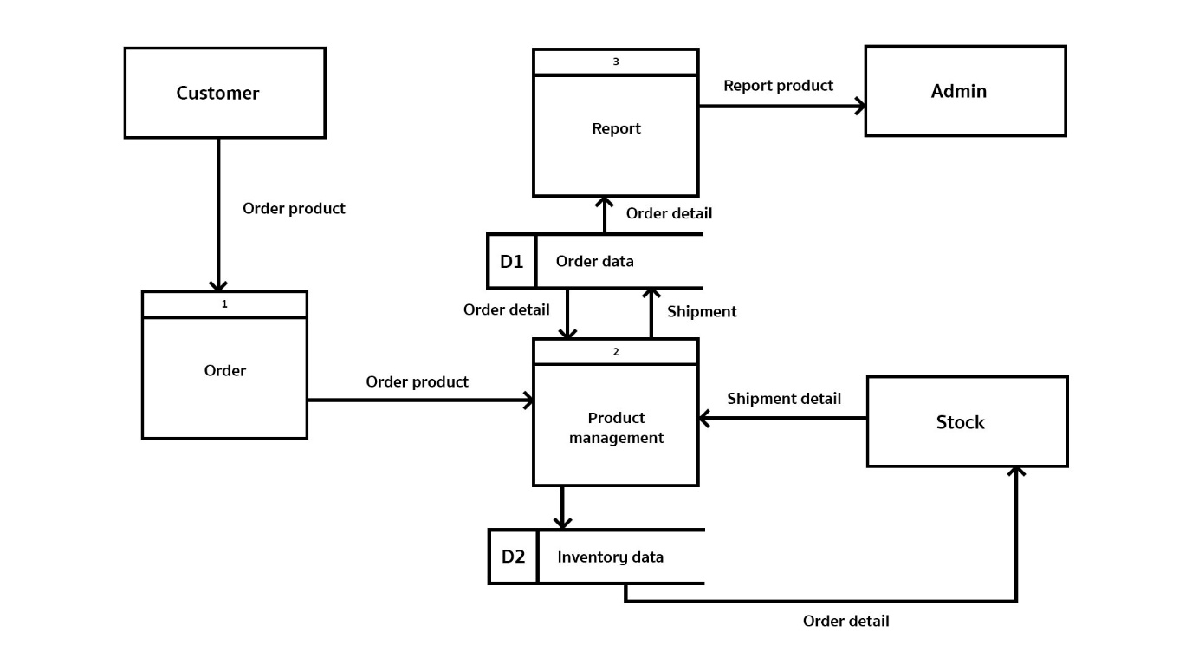

**2 Sequence diagram**

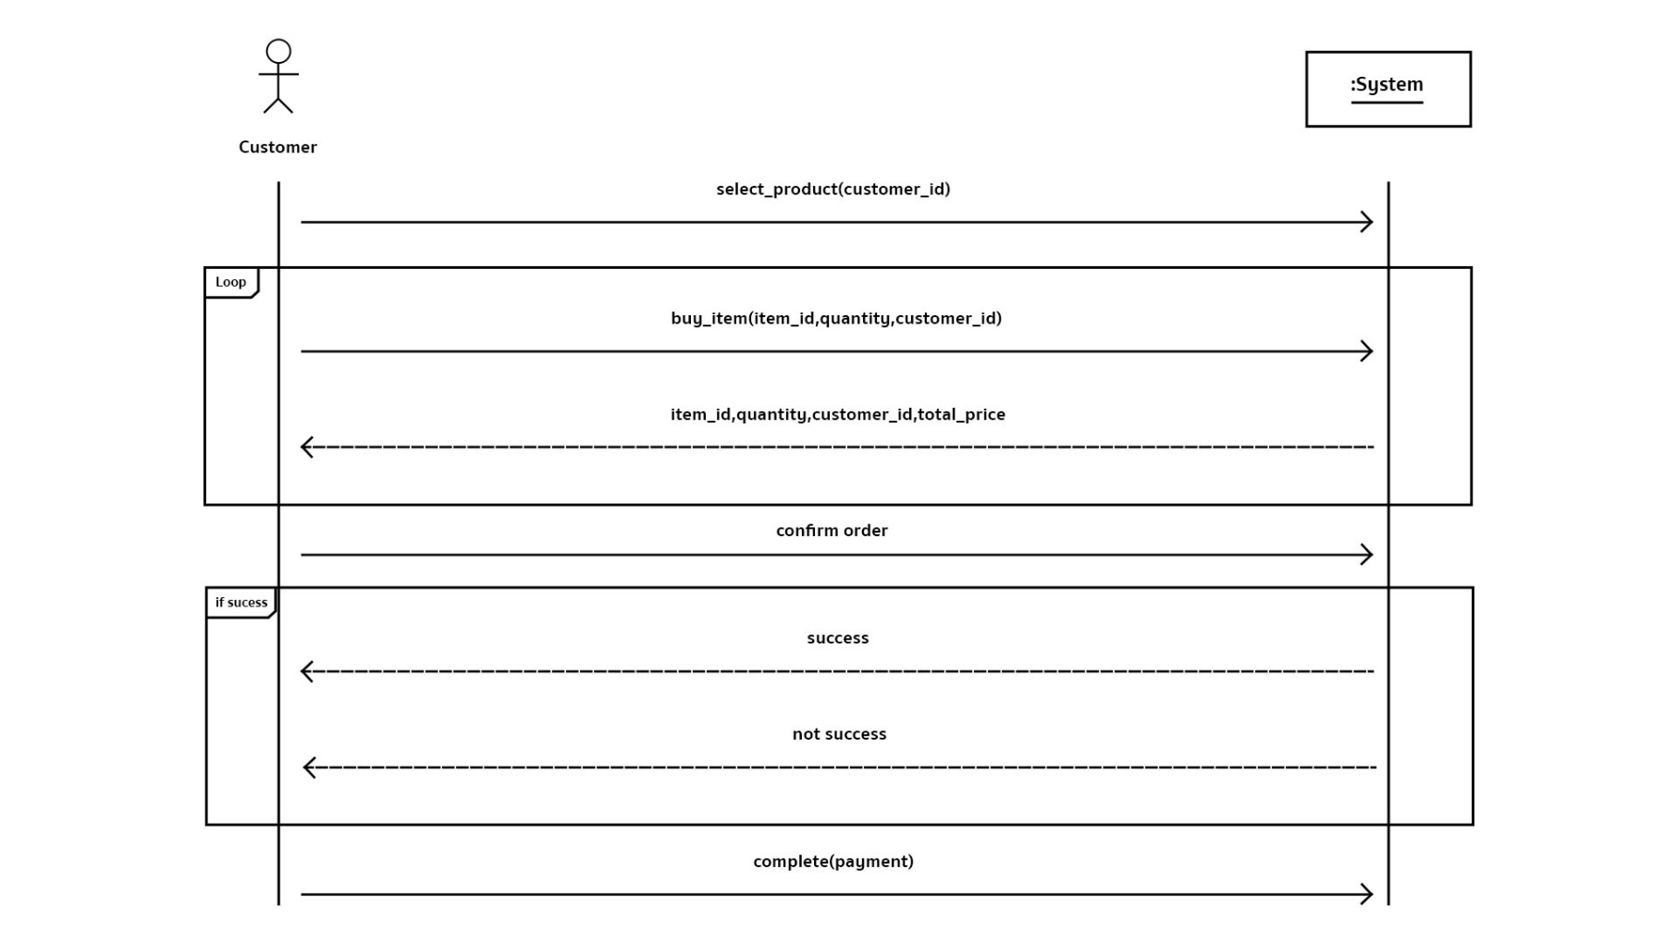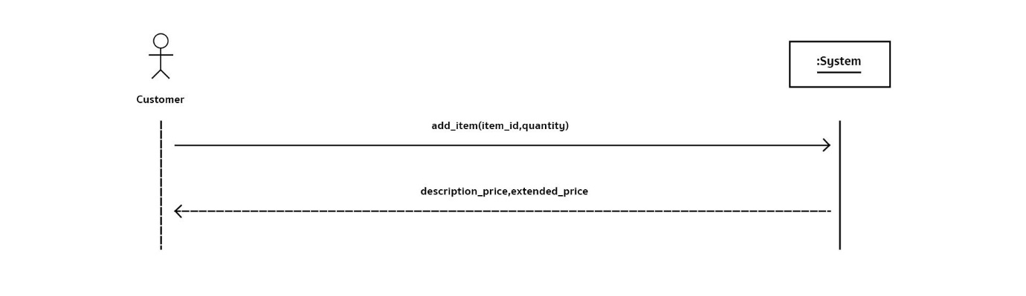

**Interface**

**Login**

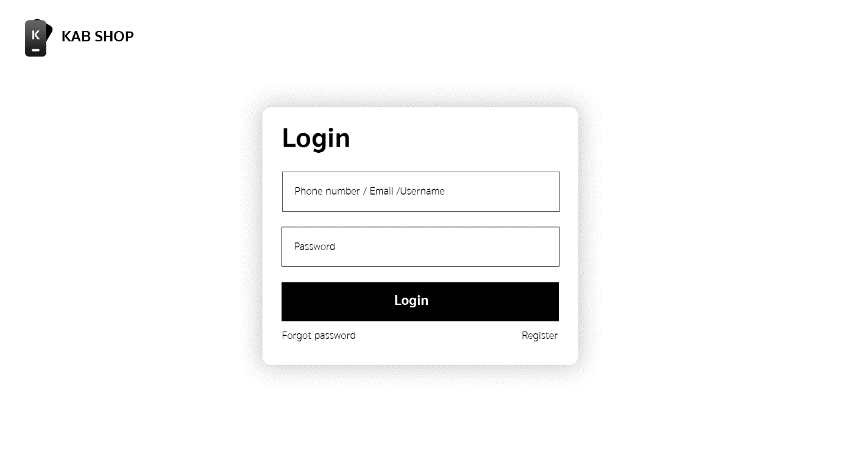

**Register**

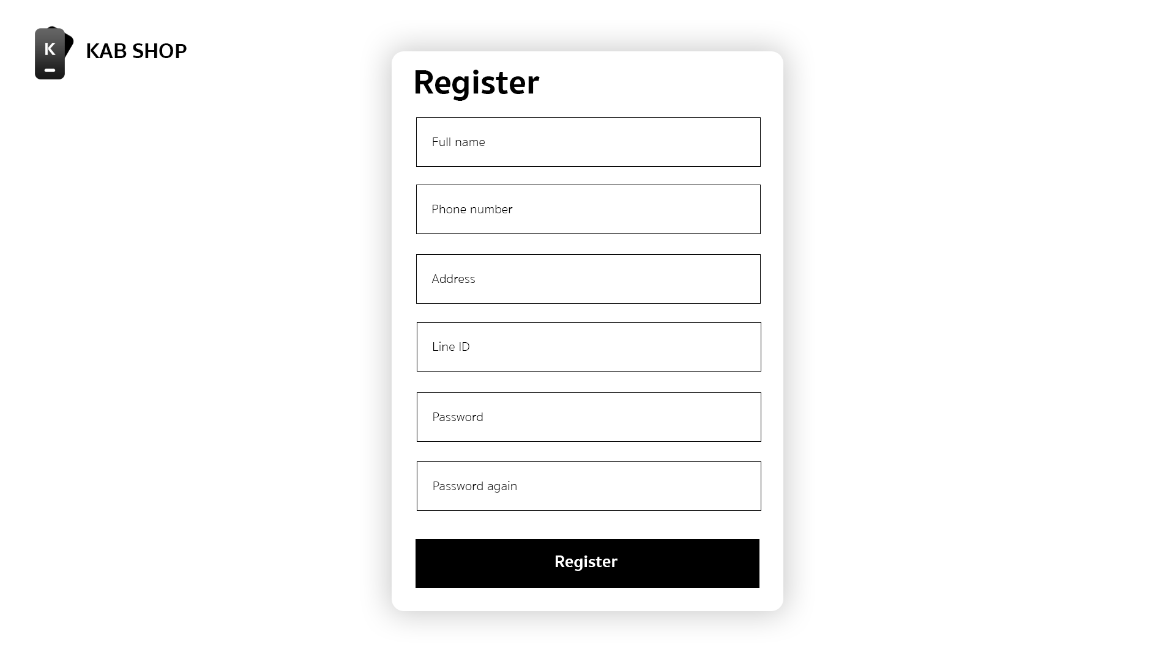

**Home page**

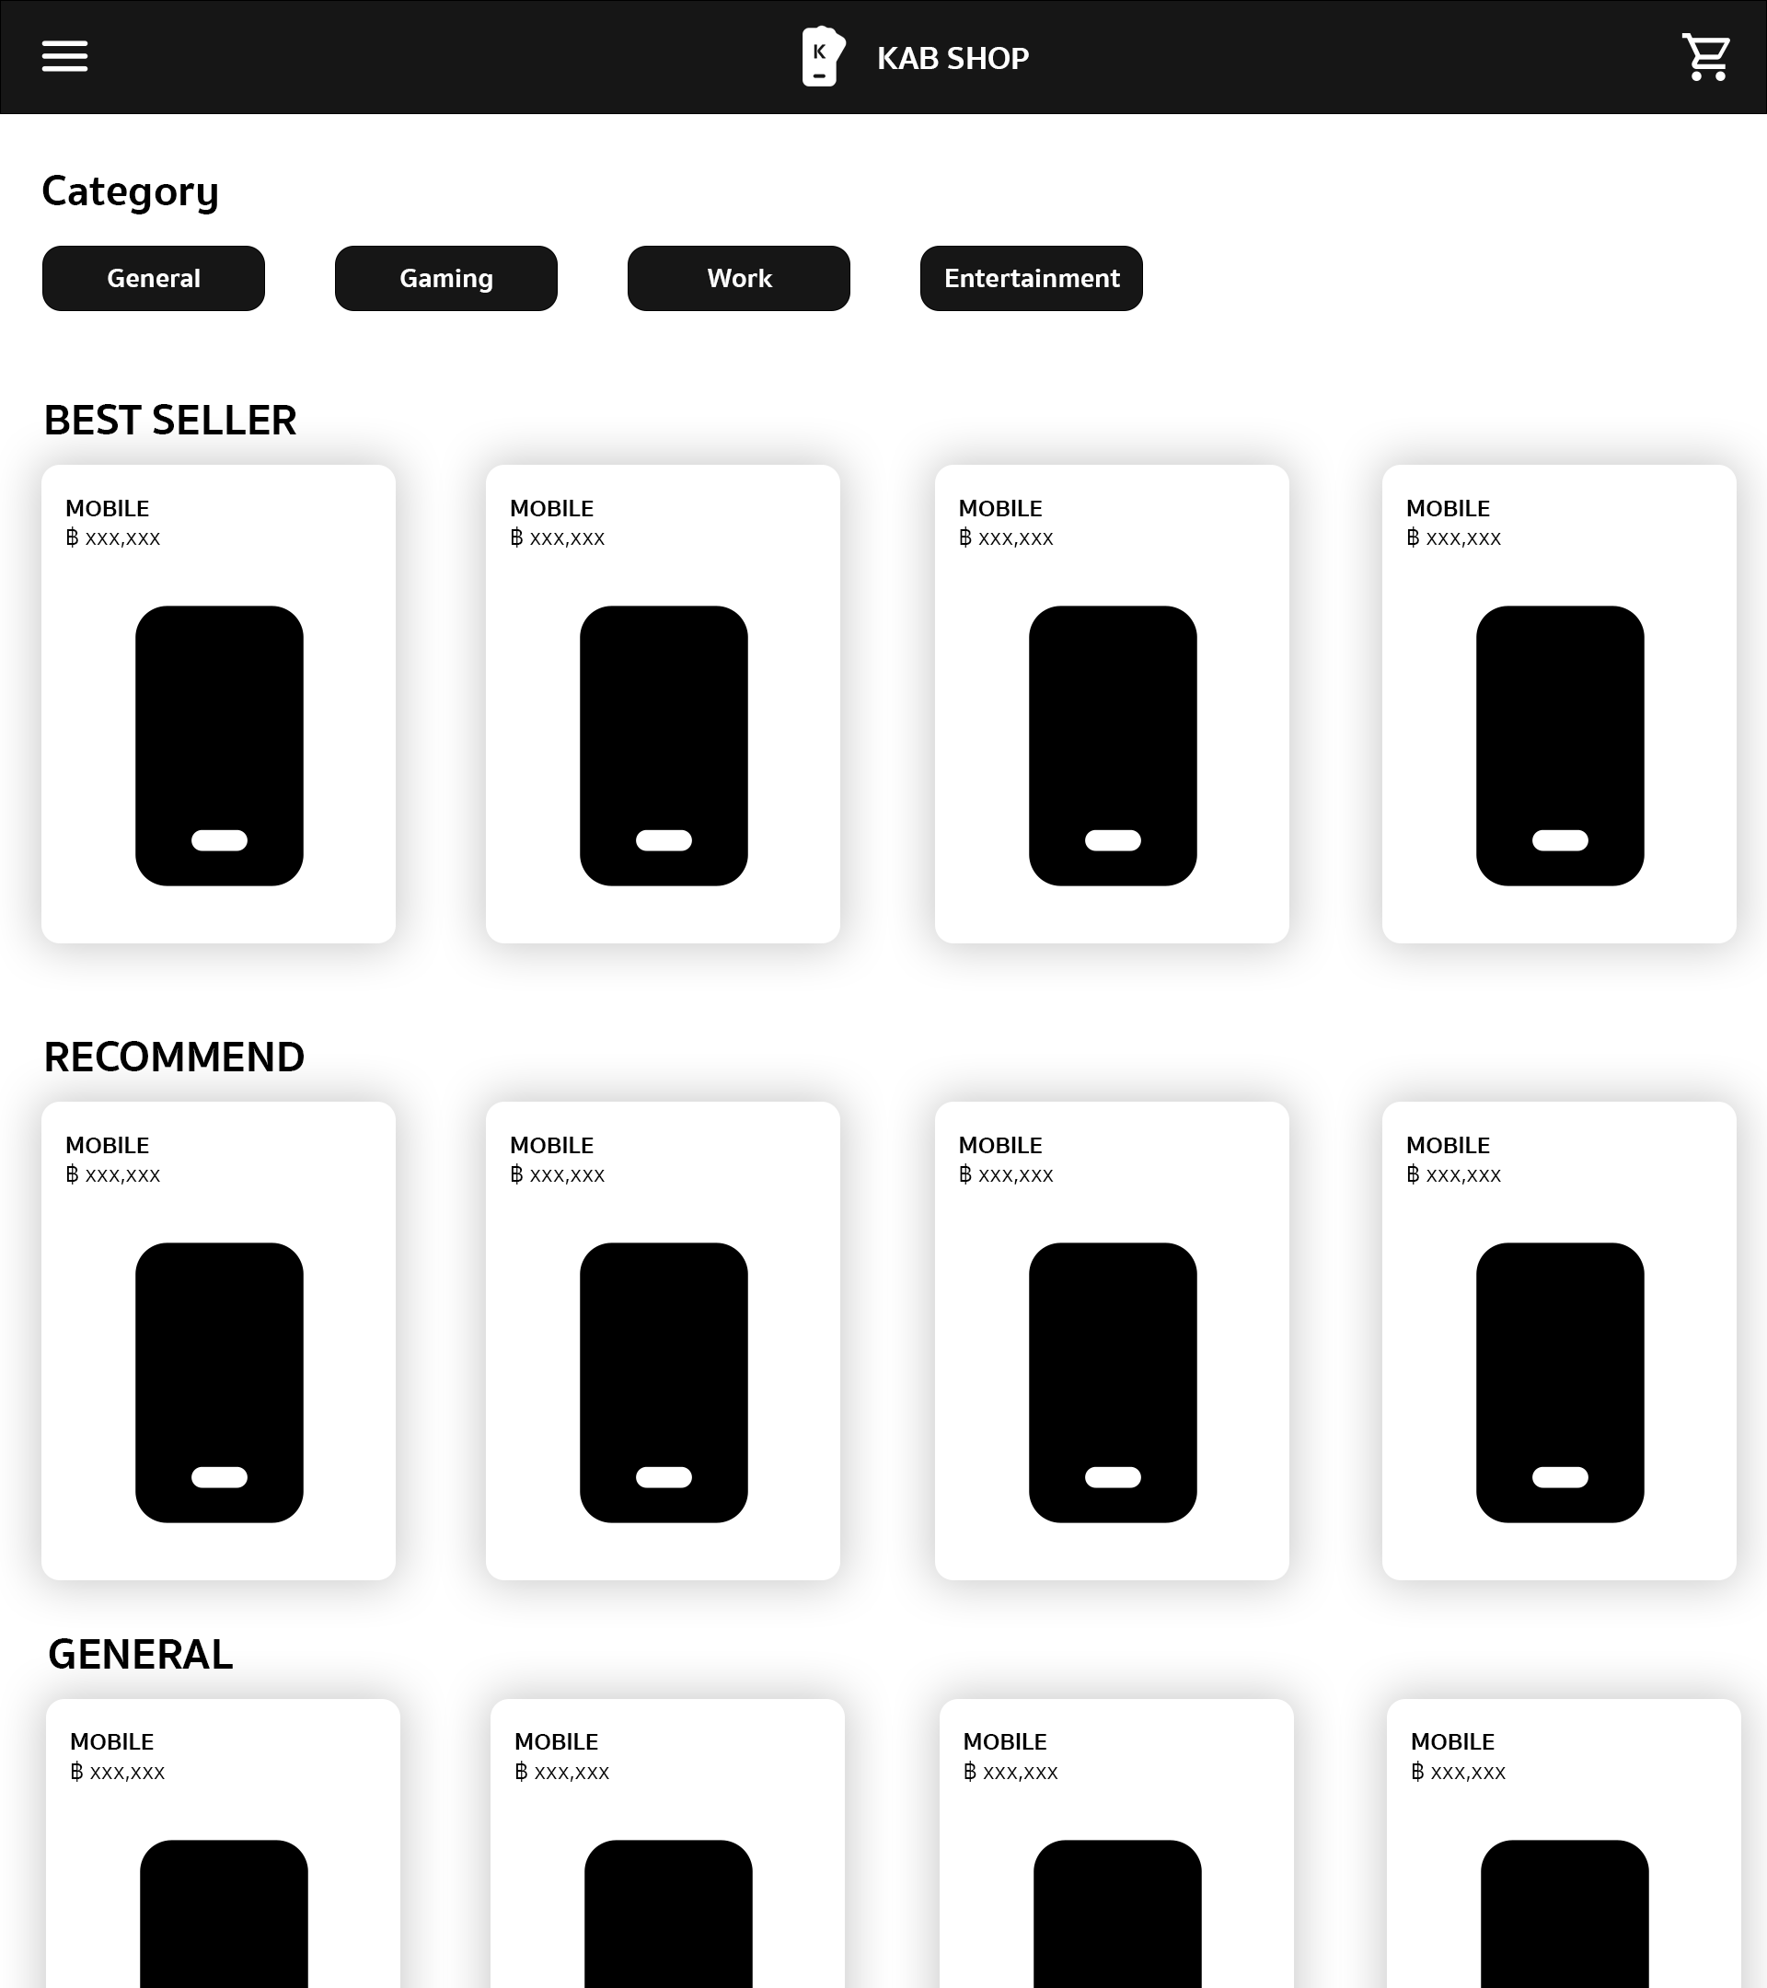

**Menu**

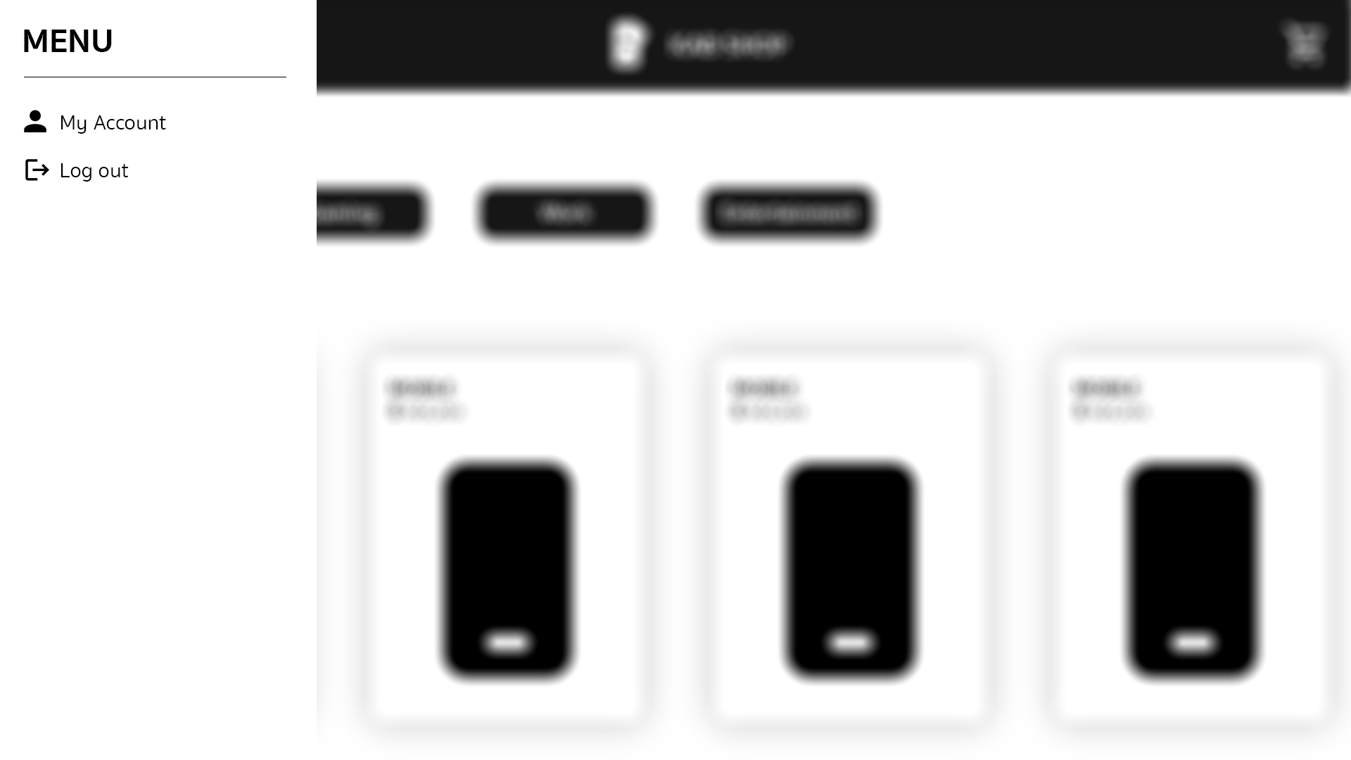

**Product**

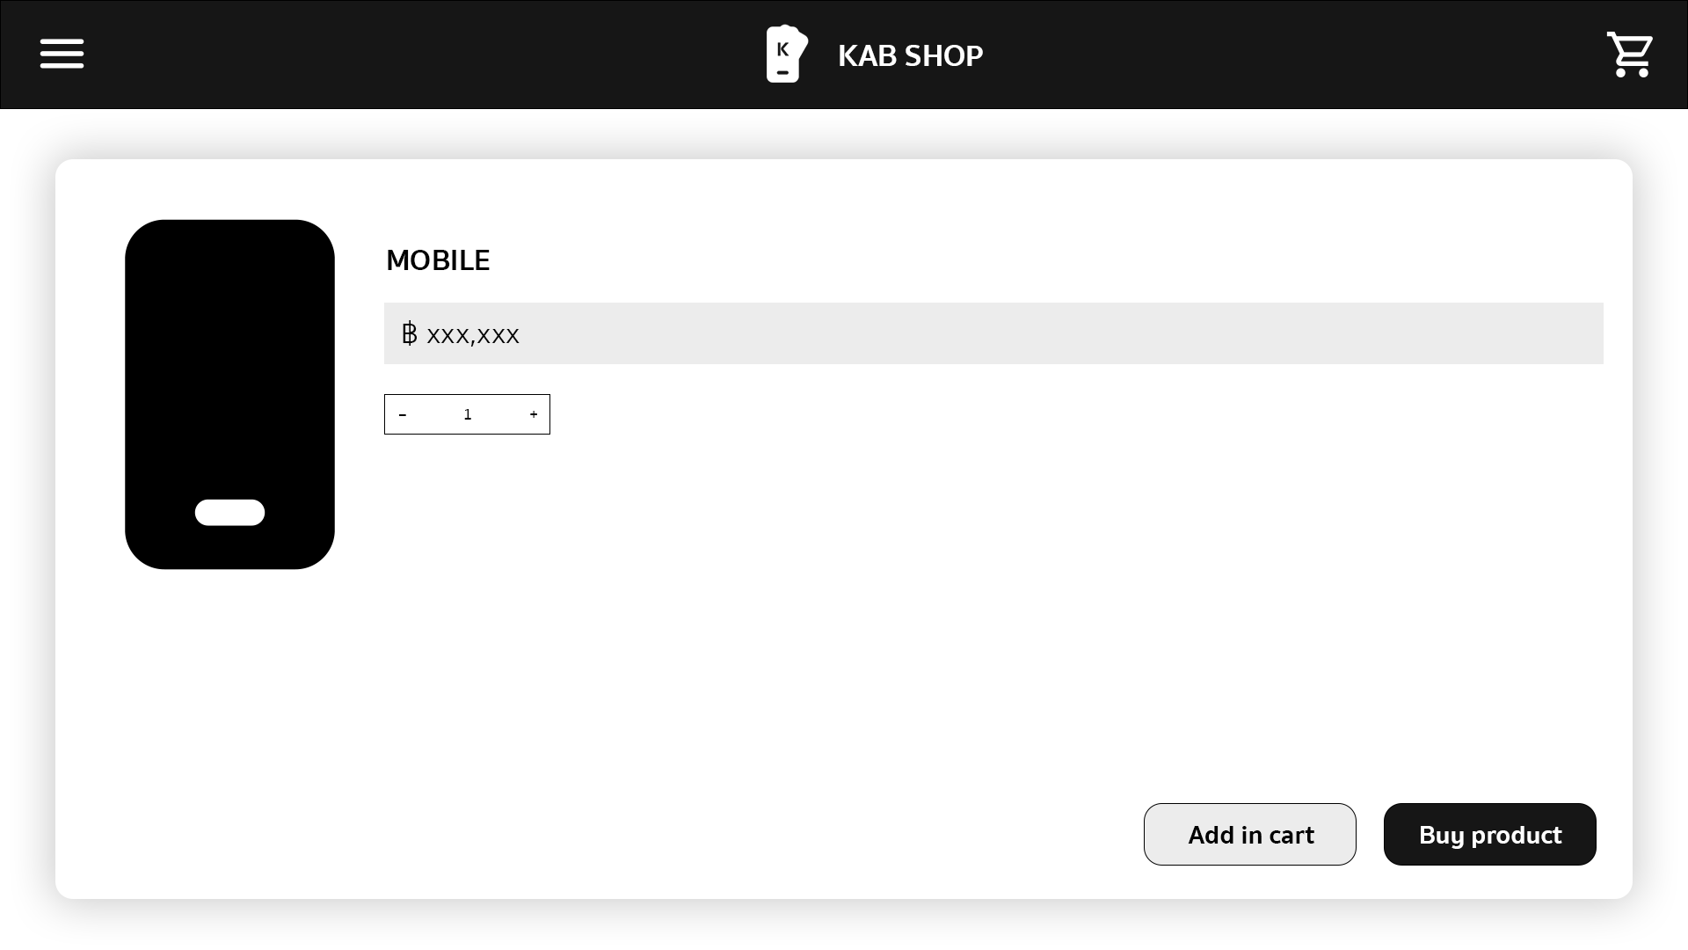

**Cart**

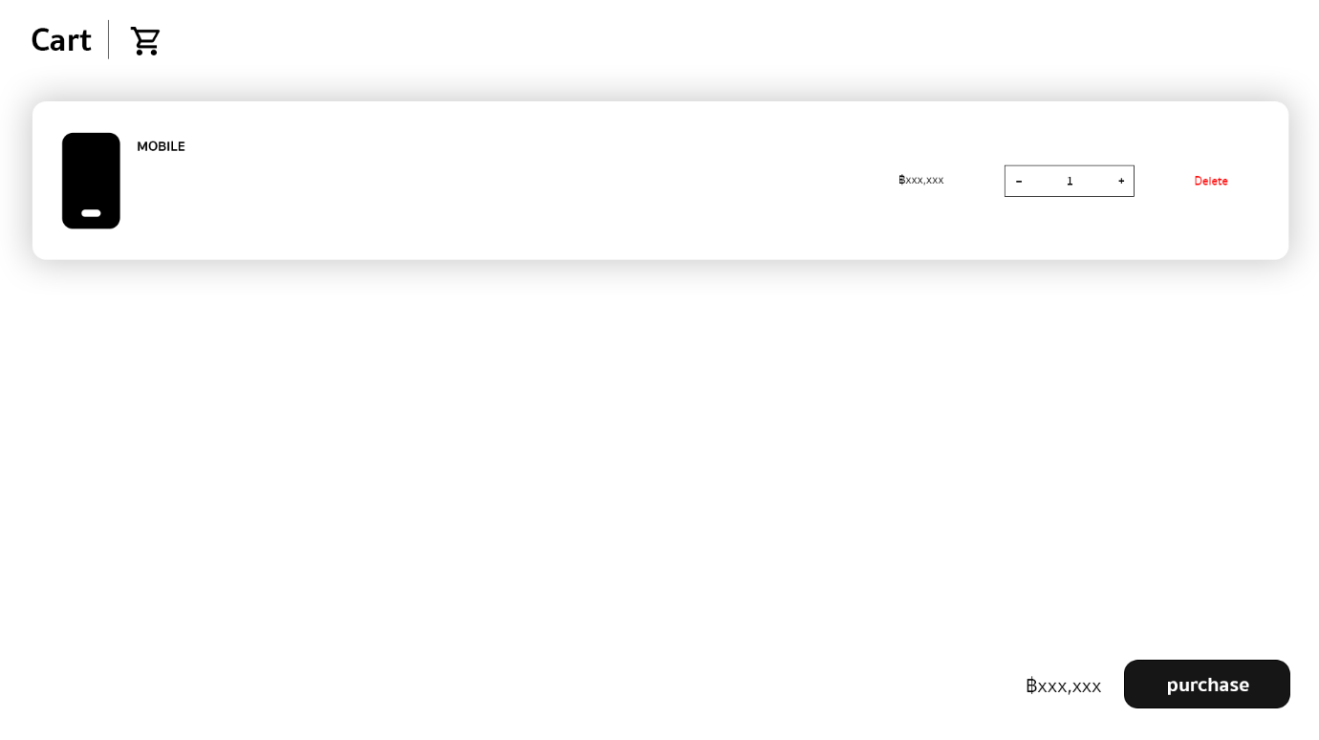

**Purchase**

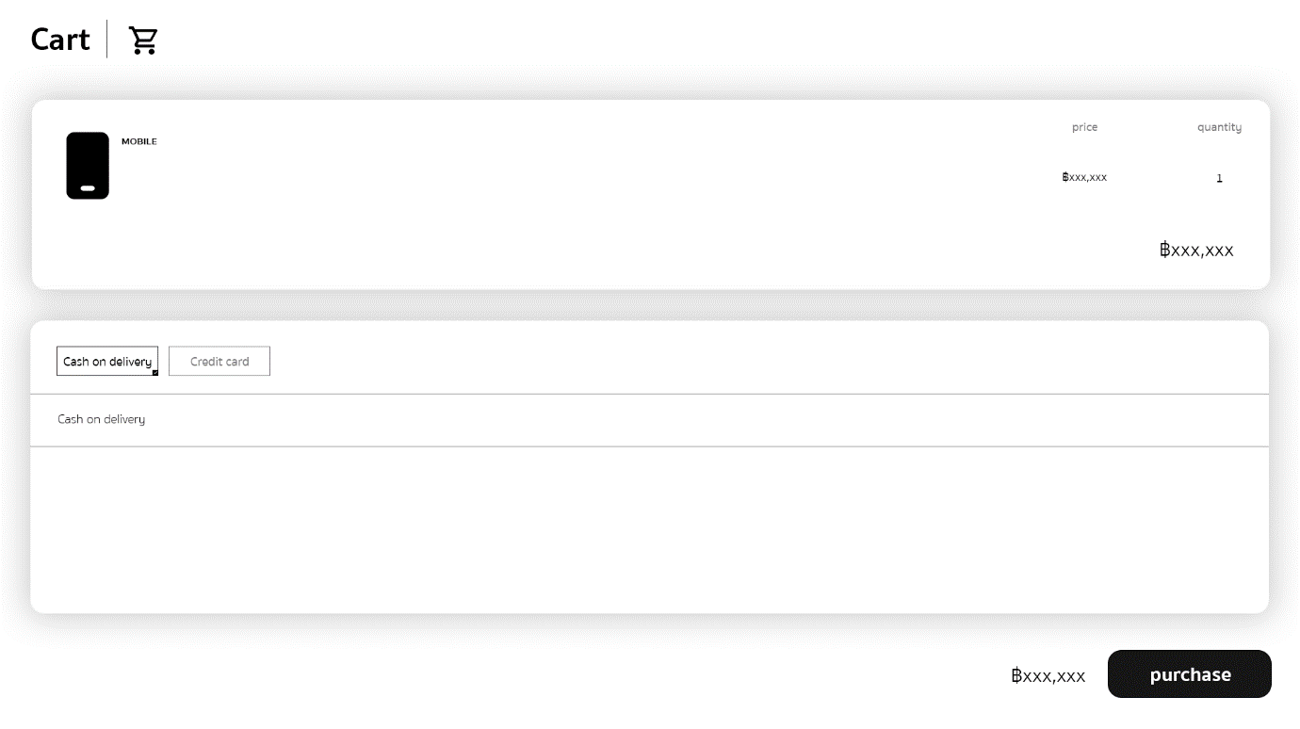

**Testing**

* **NULL**