Xavier Grunitzky
Module 5.2 Assignment
11/16/25

The CURRENT_TIME function is used when you need to find the current time of your current location.Could be used to store the current time and display it.

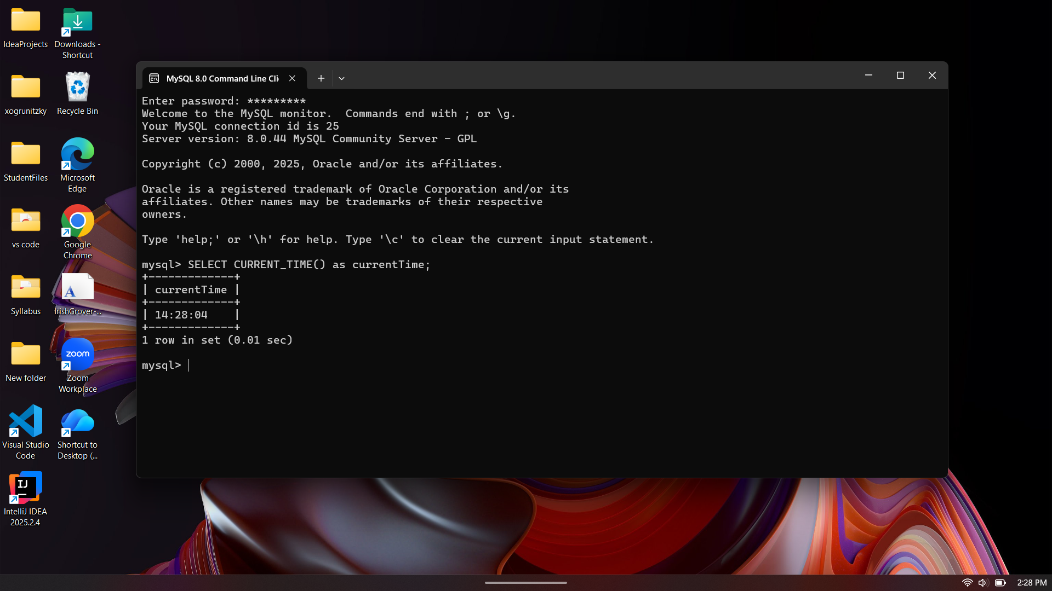

The LCASE function is used for making a string lowercase. Anytime you have an uppercase string you can change to lowercase using this function.
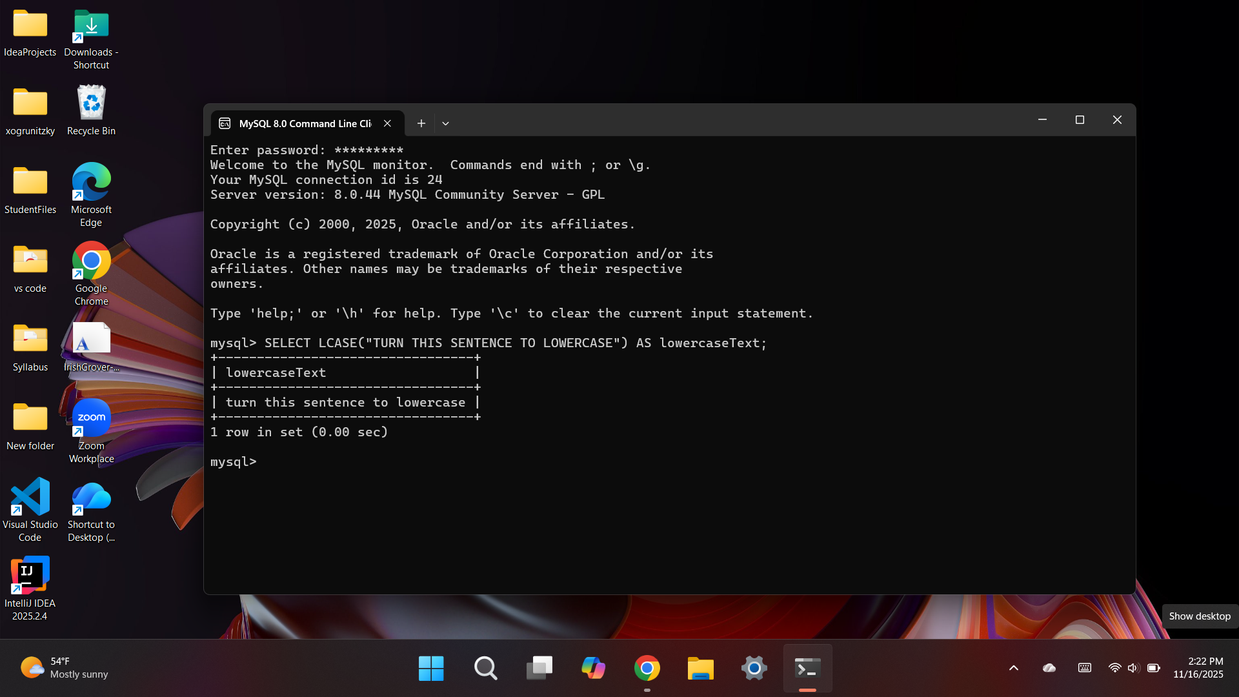

The CHARCTERLENGTH function is used to count the number of characters in a string. This can be useful when validating data and number of strings