Xavier Grunitzky
Module 7.2 Assignment
11/30/25

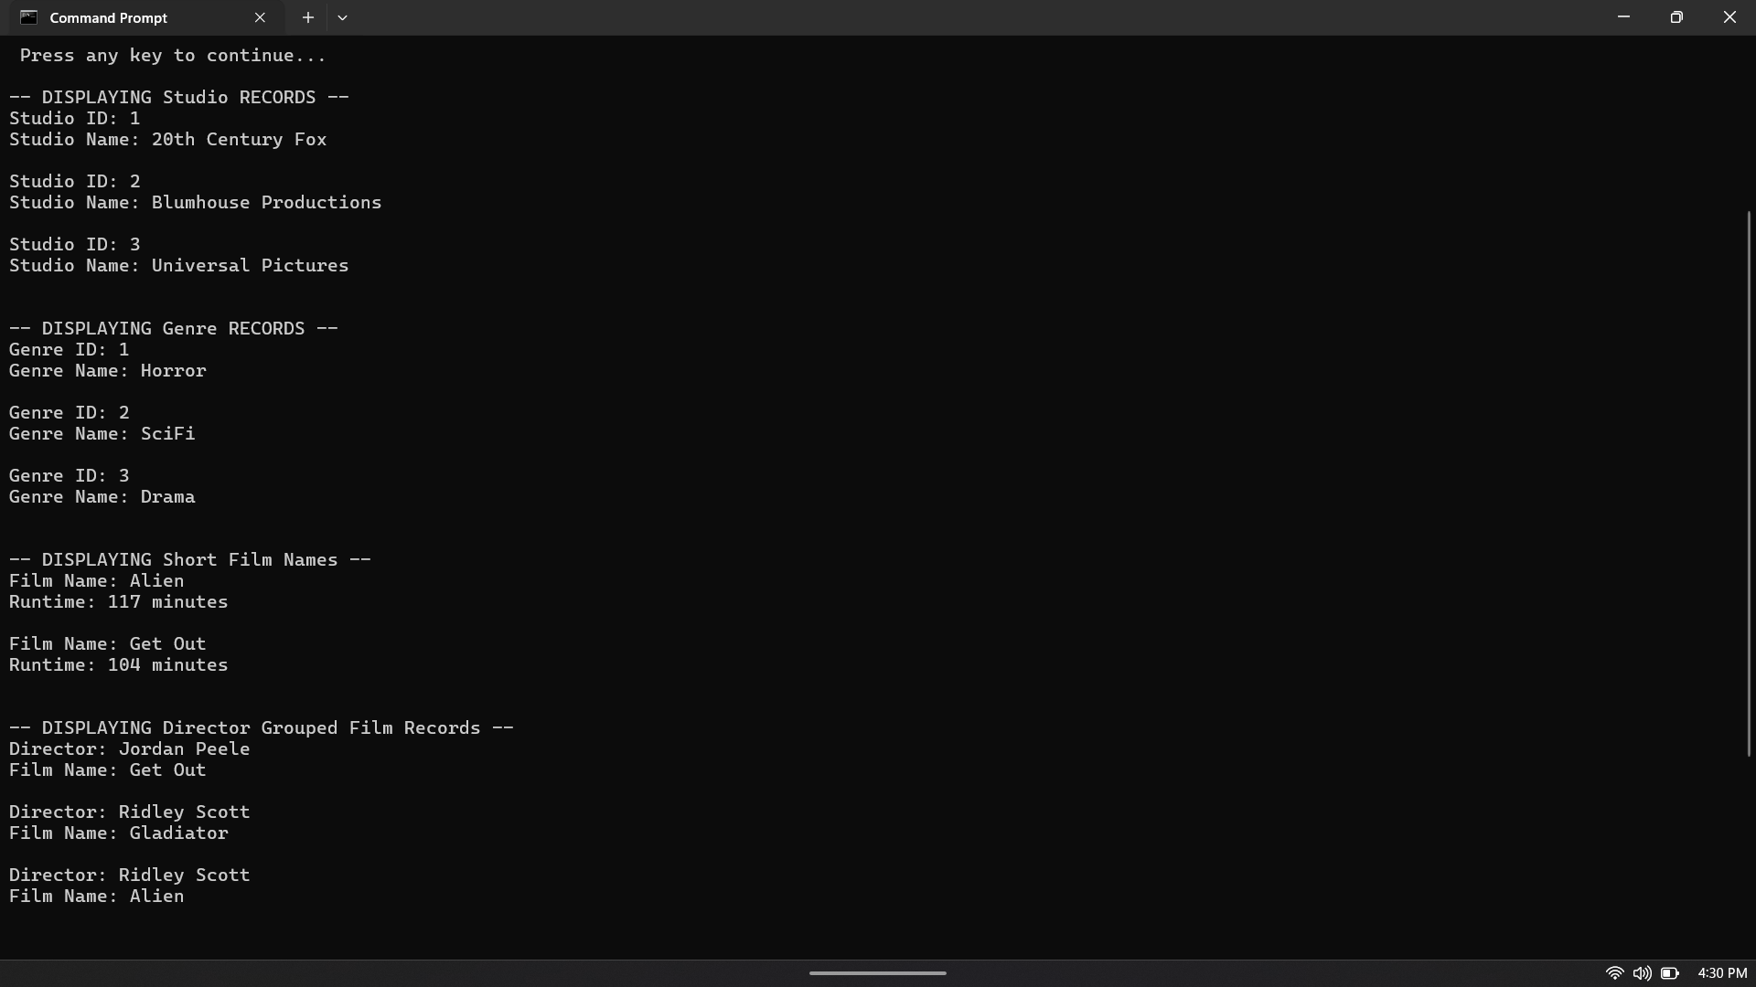

https://github.com/Xogrunitzky/csd-310/tree/main/module-7

