Xavier Grunitzky
Module 2.3 Assignment
11/2/25

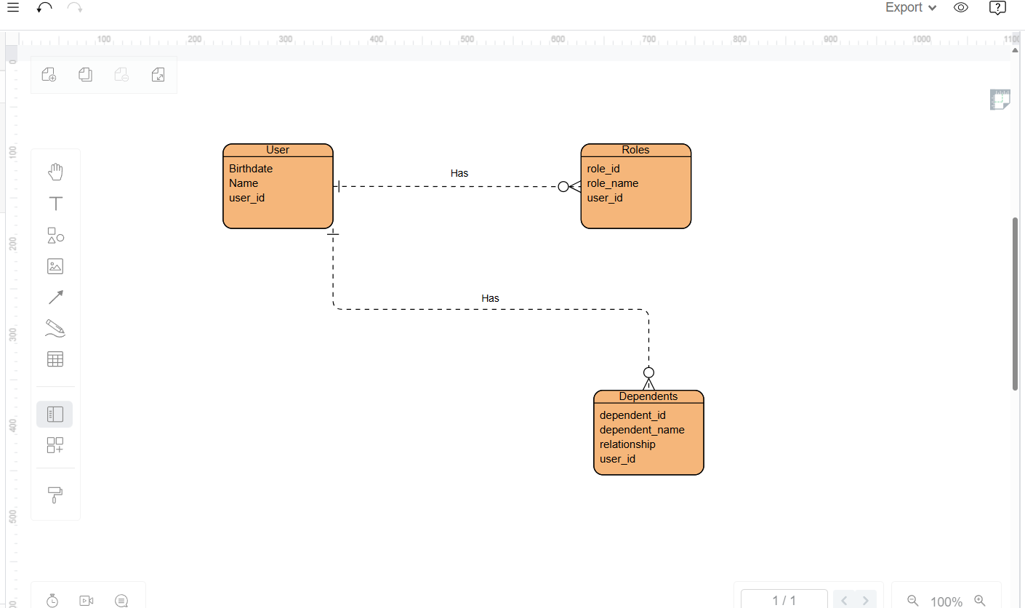

NoSQL Data Structure:
{
"_id": "user1",
"name": "Jake Gray”
"birthdate": "04/06/1999",
"roles": [
{
"role_id": "role_1",
"role_name": "Admin"
},
{
"role_id": "role_2",
"role_name": "Editor"
}
],
"dependents": [
{
"dependent_id": "dep_1",
"dependent_name": "Bob Gray",
"relationship": "Son"
},
{
"dependent_id": "dep_2",
"dependent_name": "Sarah Gray",
"relationship": "Daughter"
}
]
}

