Xavier Grunitzky
Module 11.2 Assignment
12/13/25

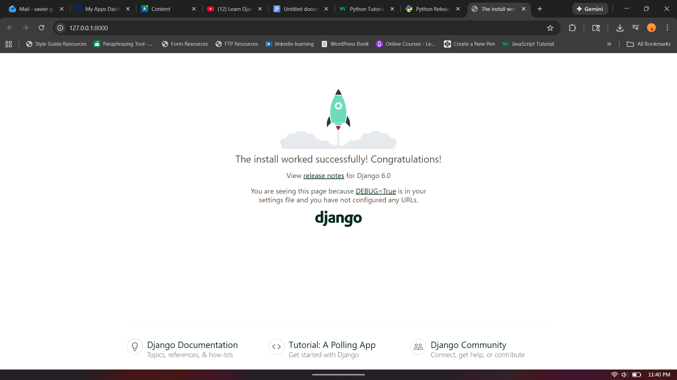

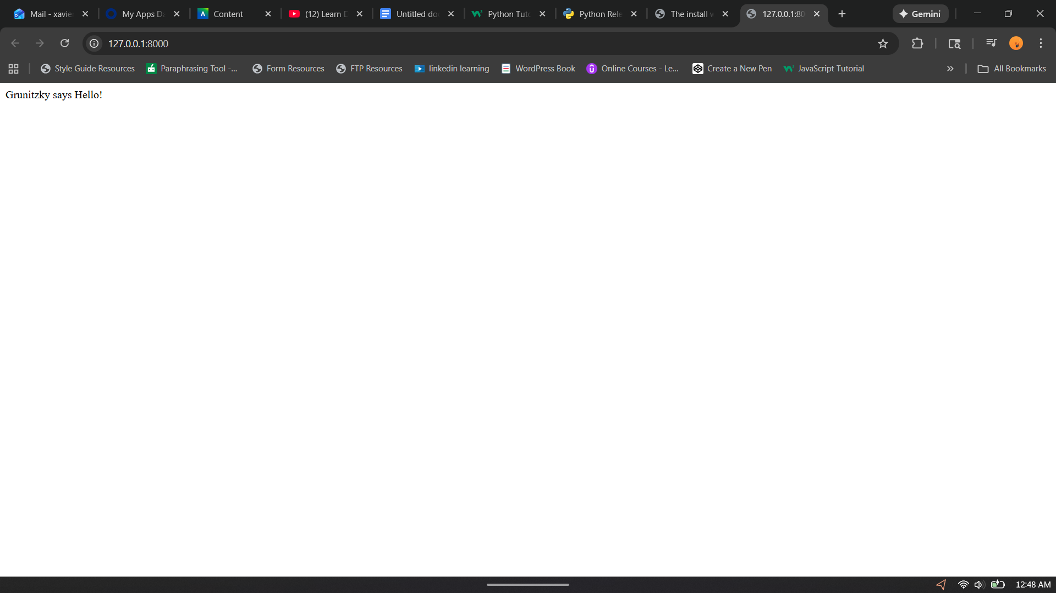

https://github.com/Xogrunitzky/csd-325/tree/main/module-11

