Xavier Grunitzky
Module 9.2 Assignment 9.2
11/30/35
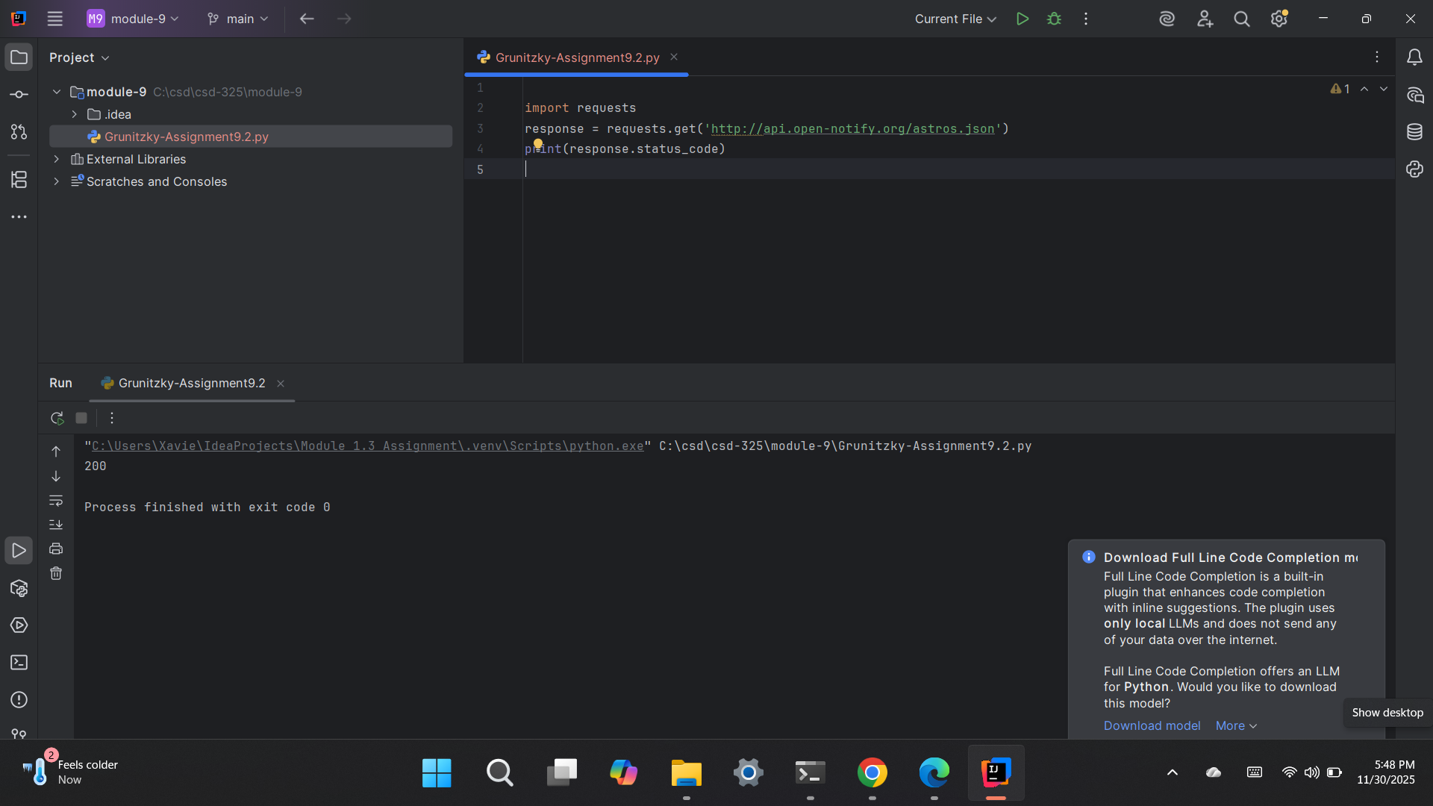

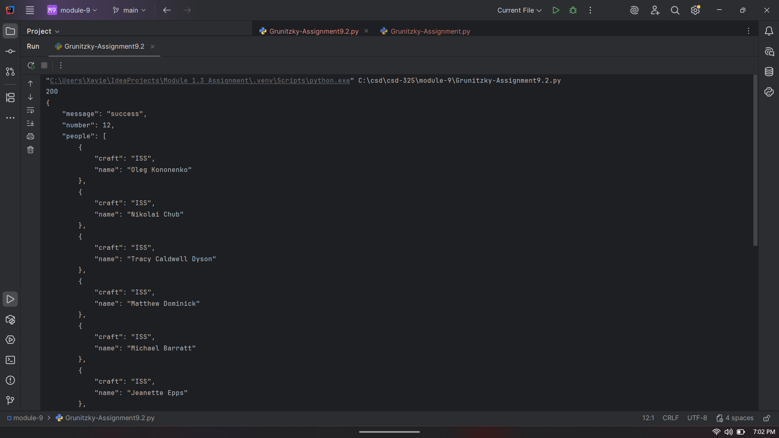

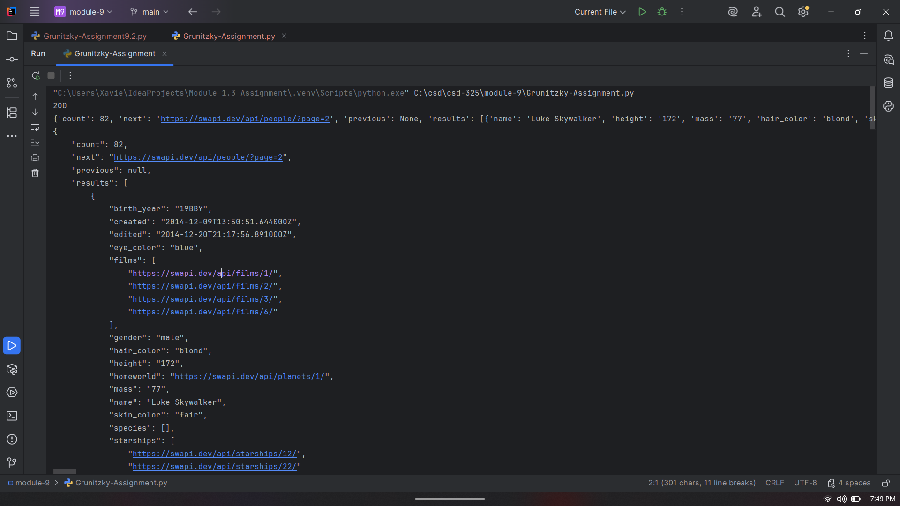
https://github.com/Xogrunitzky/csd-325/tree/main/module-9

