Xavier Grunitzky

Module 2.2 Assignment

10/26/25

Error in code debug

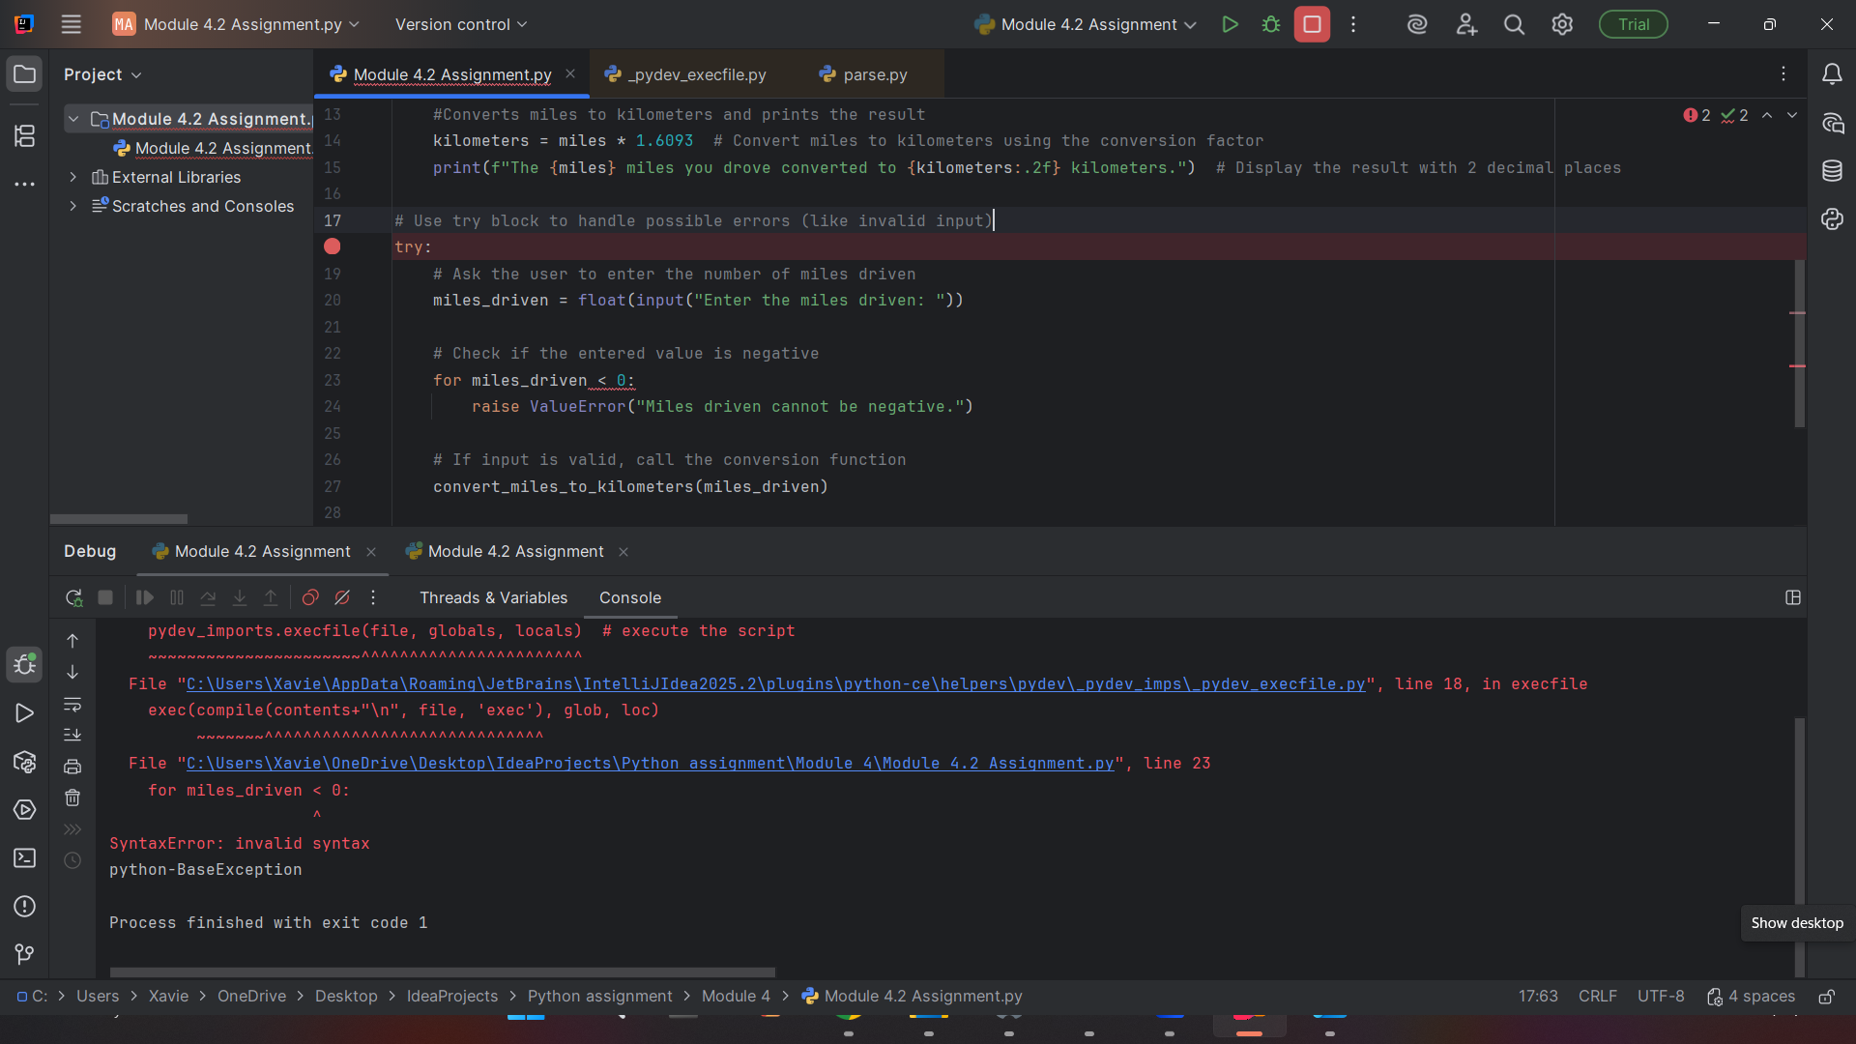

Breakpoint debug

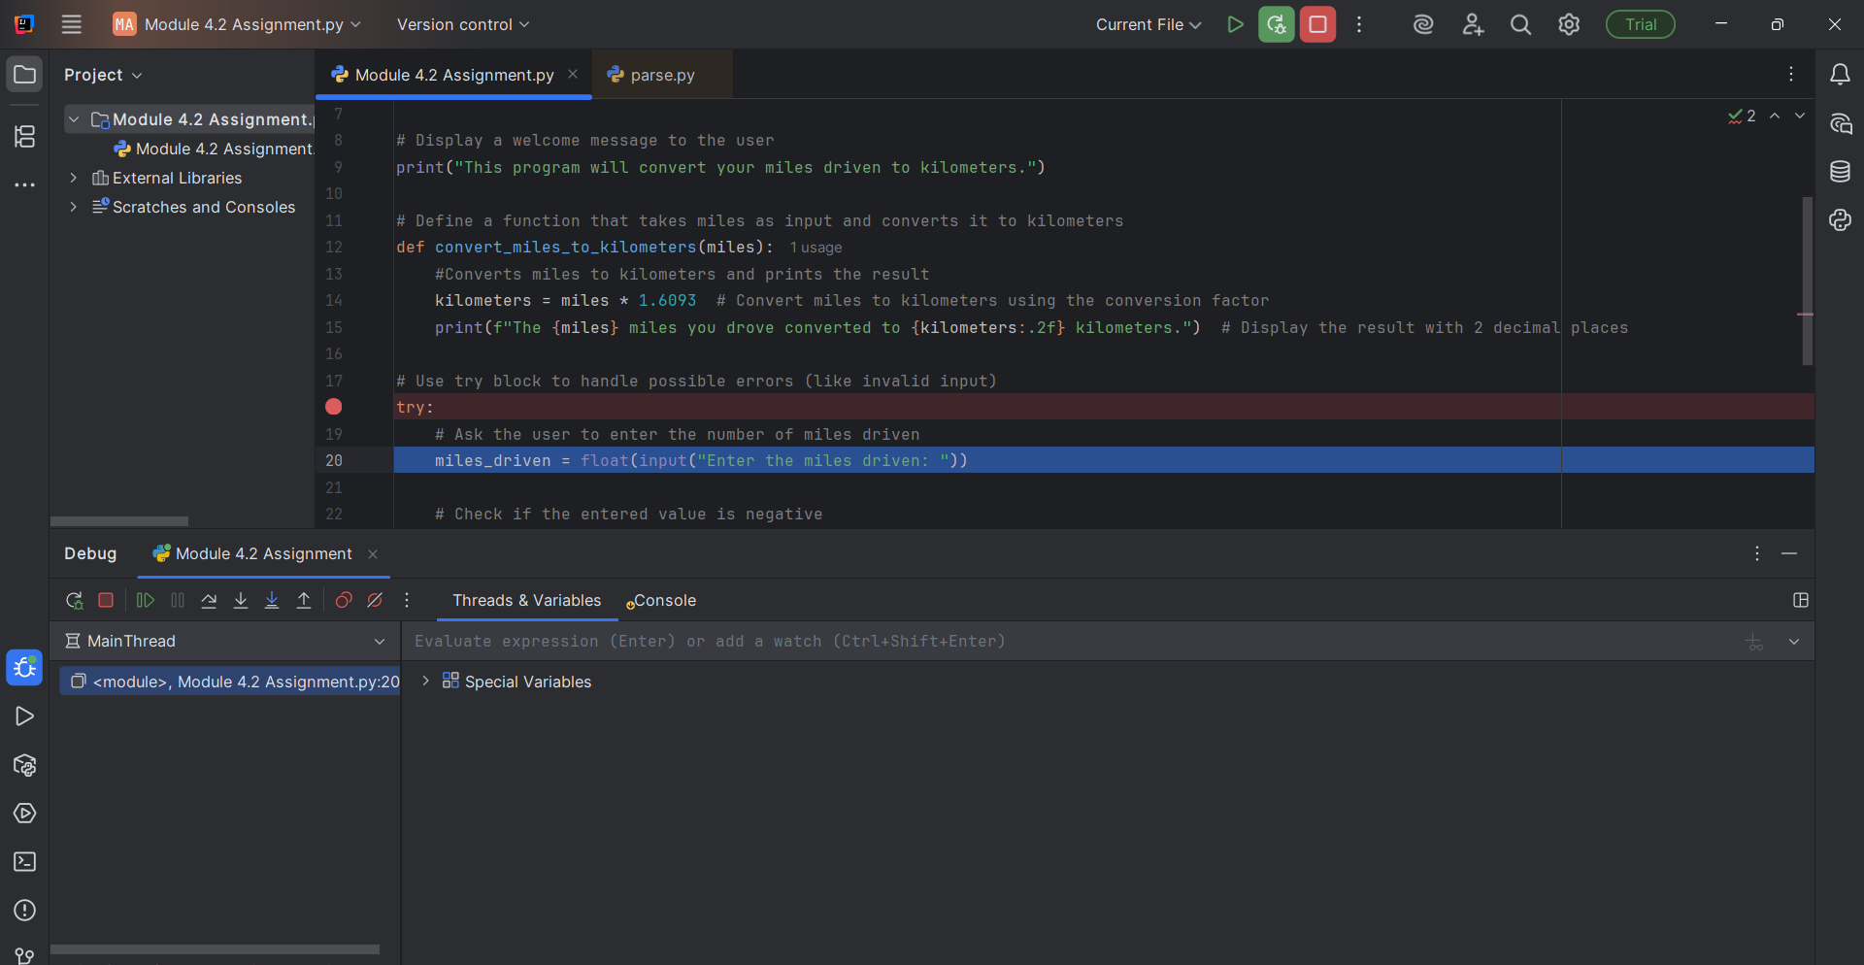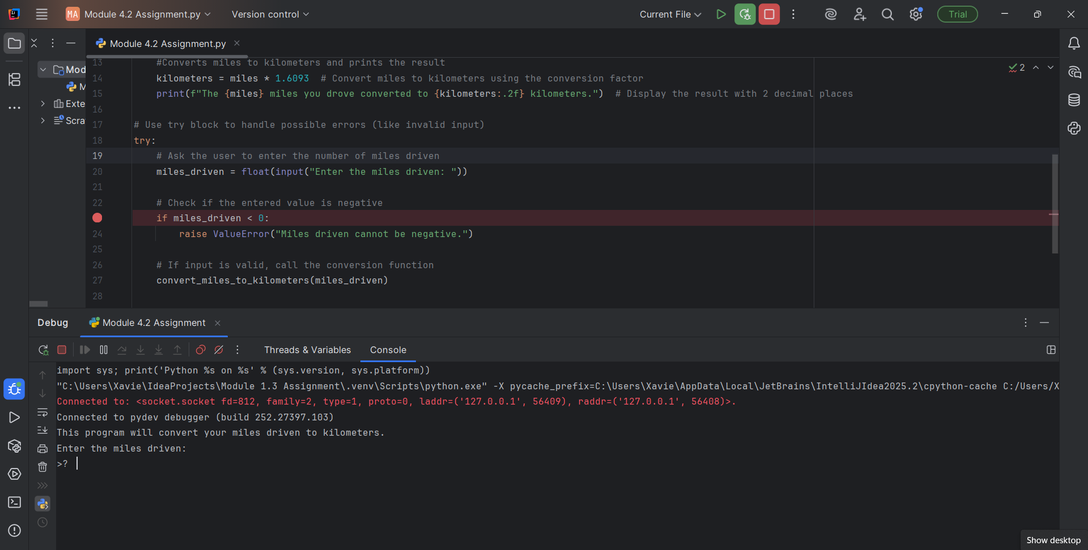Step into