Interview Questions
Interviewer: Can you tell me a little about yourself and how you’d describe your personality?
Interviewee: I would describe myself as outgoing. I enjoy connecting with others while still valuing my independence and personal space.
Interviewer: What are your main hobbies or interests?
Interviewee: I enjoy gardening and cooking, especially trying new recipes. I also love exploring new places, trying new things, spending quality time with my family, and taking time to be alone when I need to recharge.
Interviewer: Do you have any personal goals you’re currently working toward?
Interviewee: Right now, my main goals are to become more organized in my home, at work, and within myself. I’m focused on creating balance and structure in all areas of my life.
Interviewer: What accomplishments or milestones are you most proud of?
Interviewee: I’m most proud of earning my degree and making the decision to return to school to pursue a bachelor’s degree in psychology.
Interviewer: What characteristics best describe you?
Interviewee: I pride myself on being honest, speaking the truth, and staying loyal to the people and values that matter most to me.
Interviewer: What message or story do you want your website to communicate about you?
Interviewee: I want my website to encourage people to be themselves, follow their own goals, and confidently chase their dreams.
Interviewer: Are there specific colors or styles that represent you best?
Interviewee: I prefer a basic, simple, and classy style. Black and white best represent my personality and aesthetic.
Interviewer: What skills or qualities do you value most in yourself?
Interviewee: I value my patience and my ability to understand people and their behavior. I’m good at identifying problems and working through them thoughtfully.
Interviewer: What challenges have you faced while pursuing your goals, and how did you overcome them?
Interviewee: One of my biggest challenges was being a single mother early on while continuing my education. I overcame this through determination, resilience, and staying committed to my long-term goals.
Interviewer: How have your hobbies influenced your personal growth or mindset?
Interviewee: Gardening has taught me patience and consistency. It’s shown me that growth takes time and that putting in the work eventually leads to results.
Images
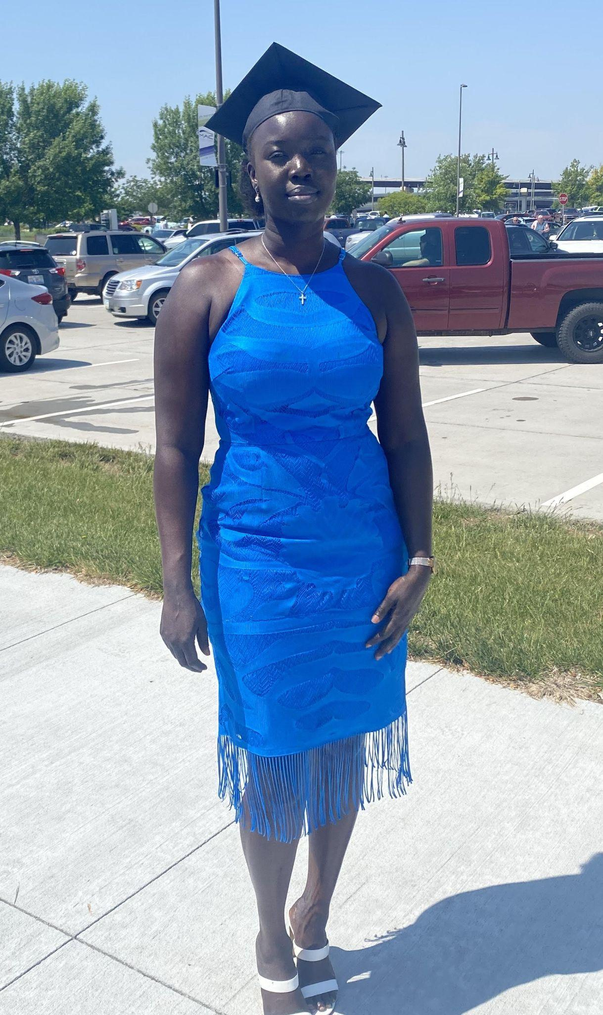
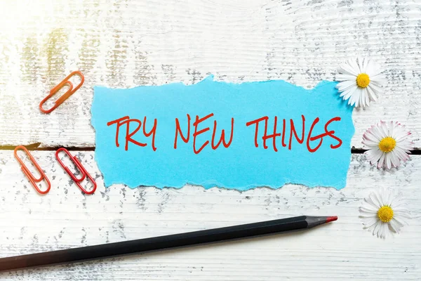

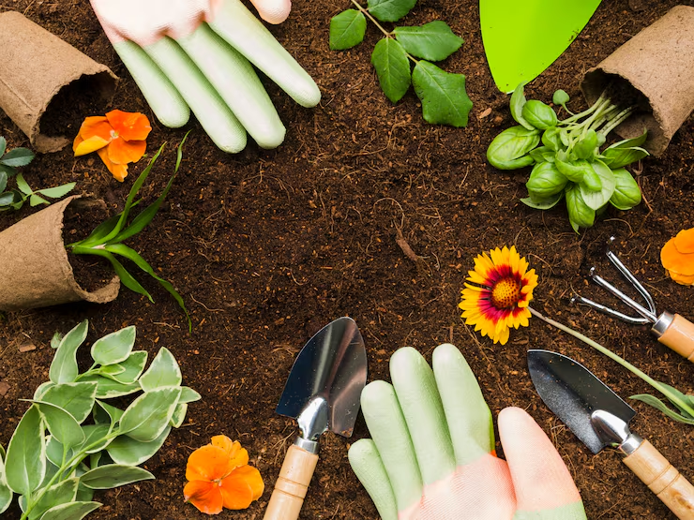

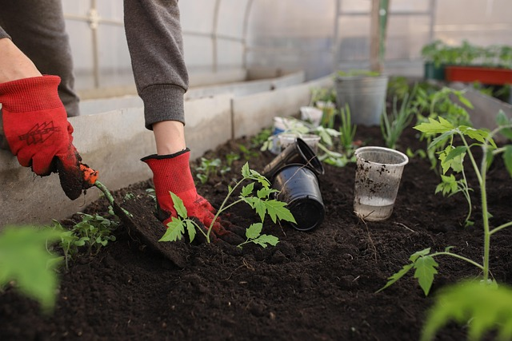

Bio of Ajo Othow
I am an outgoing and motivated individual who values honesty, loyalty, and personal growth. I enjoy connecting with others while also appreciating time alone for reflection and self-improvement. Finding a balance between these two has helped shape my mindset and the way I approach life.
One of my greatest accomplishments is earning my degree and later returning to school to pursue a bachelor’s degree in psychology. This decision reflects my strong interest in understanding people, behavior, and problem-solving. I consider myself patient and thoughtful, often taking time to understand situations before responding. These qualities support both my academic goals and my personal relationships.
My hobbies play an important role in my personal growth. Gardening is especially meaningful to me because it has taught me patience, consistency, and the value of steady effort over time. It reminds me that growth does not happen instantly and that progress requires care and commitment. I also enjoy cooking, which allows me to try new things and express creativity. In addition, I enjoy traveling, discovering new places, and experiencing new environments, which helps me stay open-minded and adaptable.
Family is a central part of my life and provides constant motivation. Earlier in my life, I faced challenges as a single mother while continuing my education. Managing financial responsibilities while raising a child required resilience, determination, and strong time-management skills. These experiences shaped my work ethic and personal strength.
Currently, my goals focus on becoming more organized at home, at work, and within myself. Overall, my story reflects perseverance and purpose, guided by a clear message: be yourself, follow your own path, and continue working toward your goals.

Design
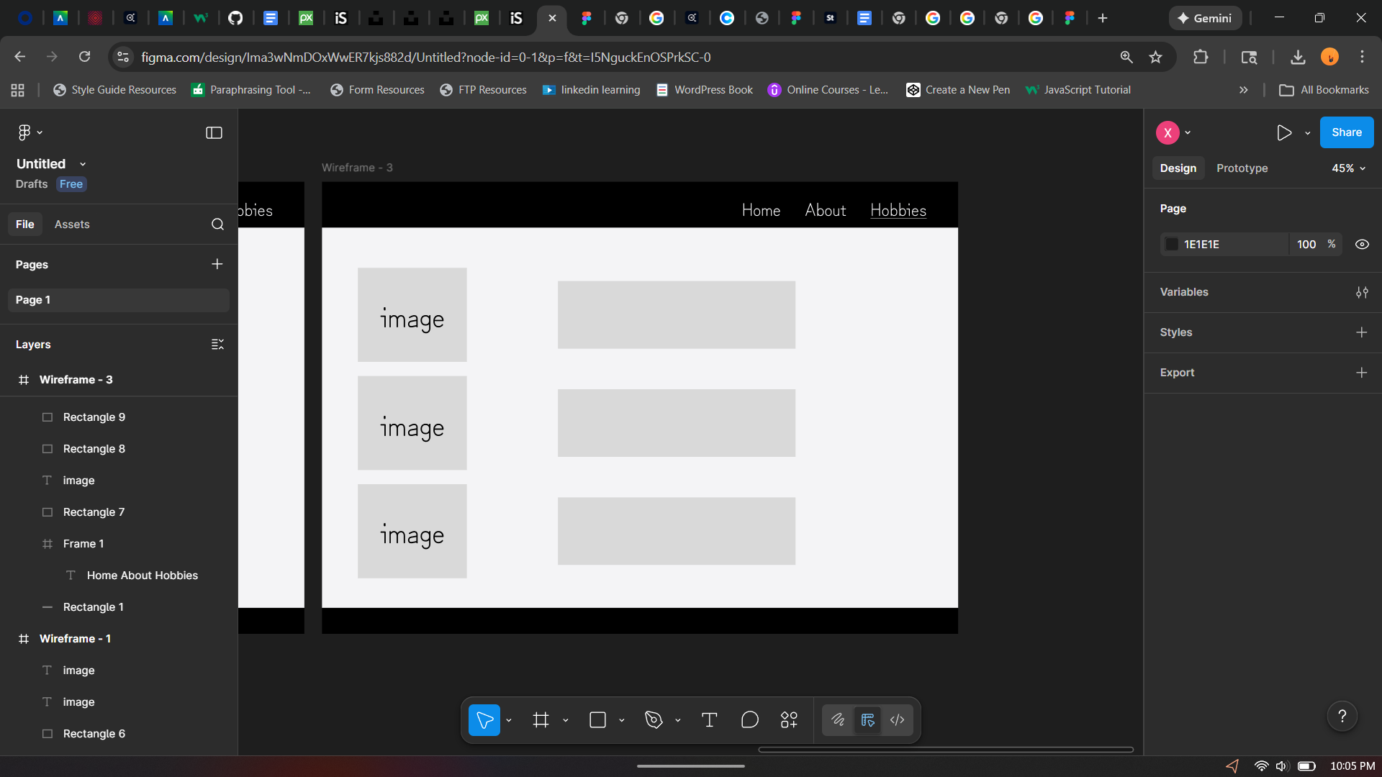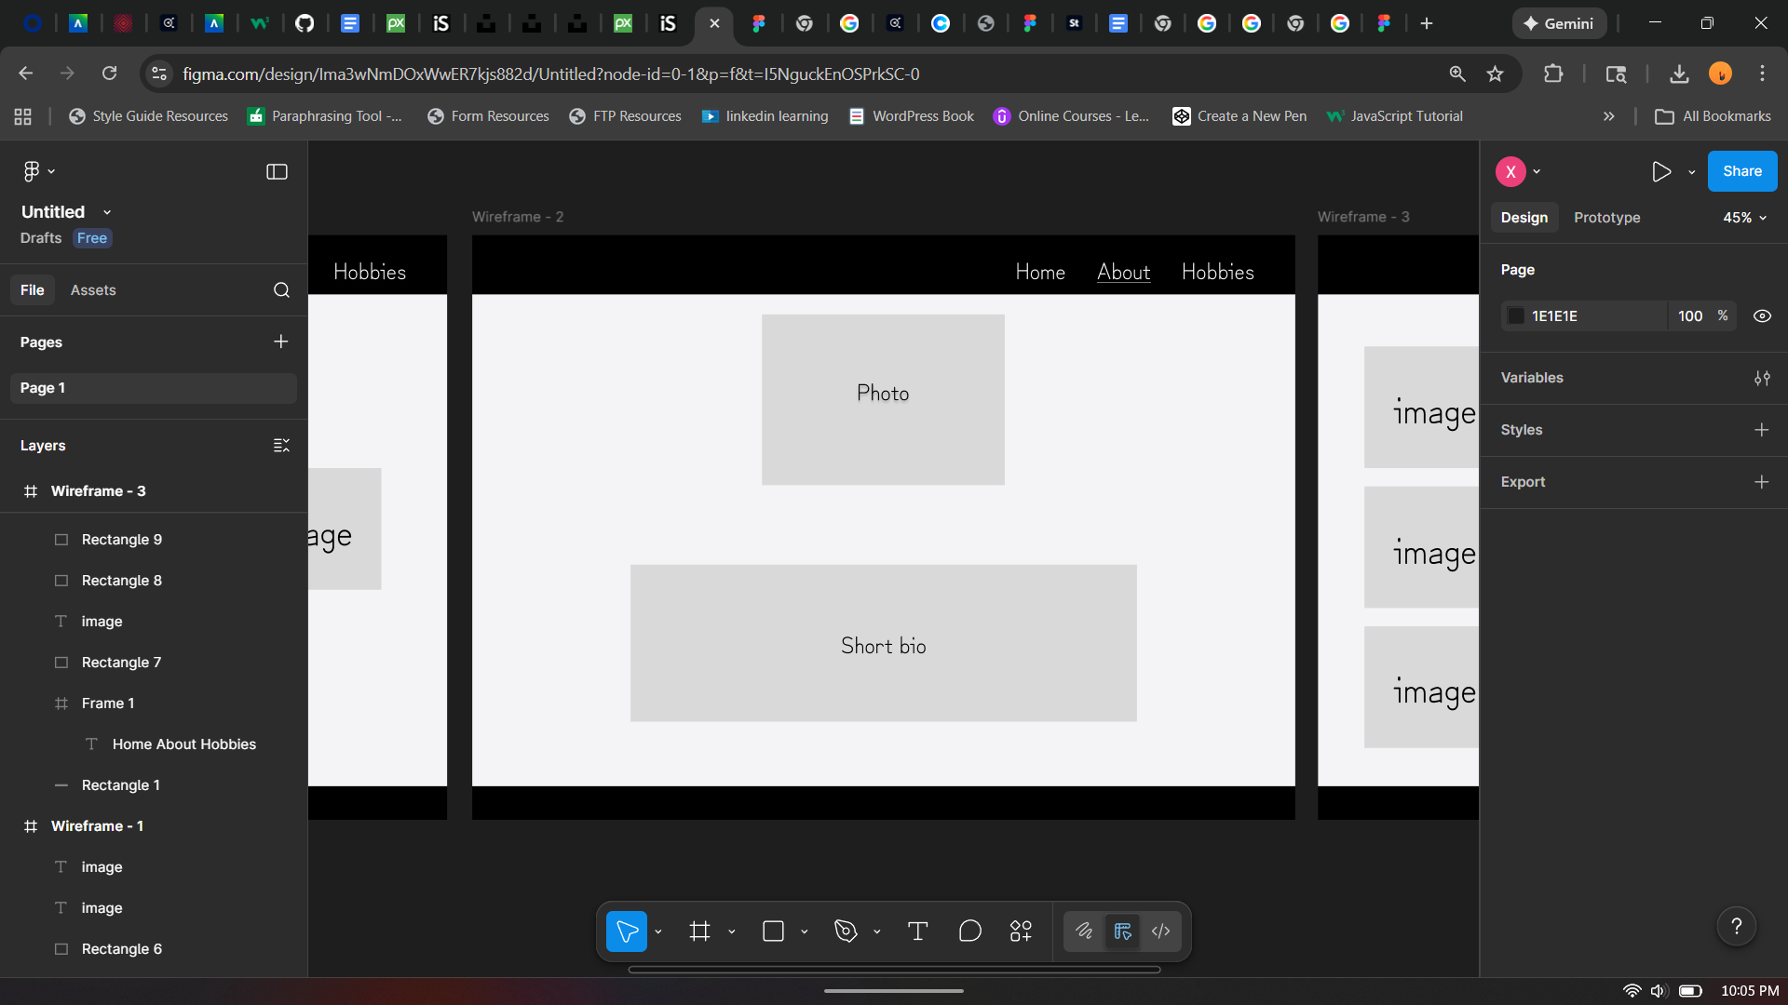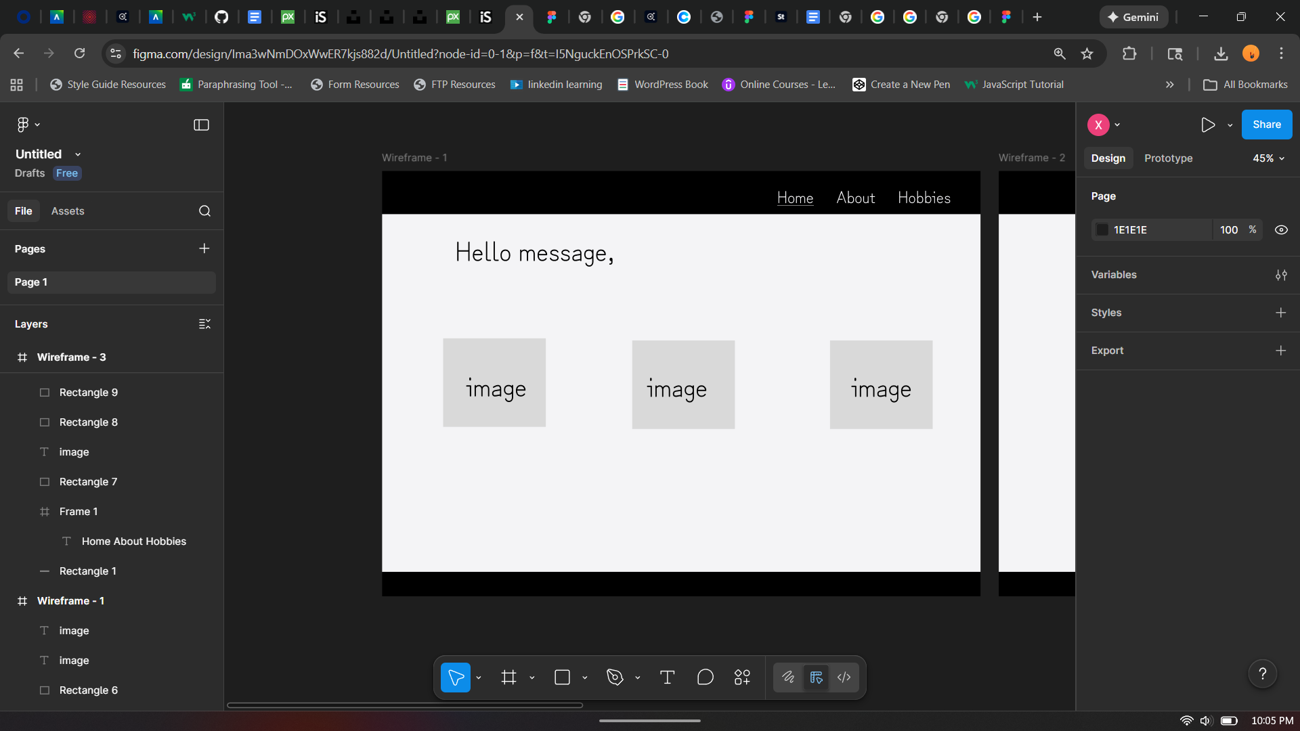

Colors:

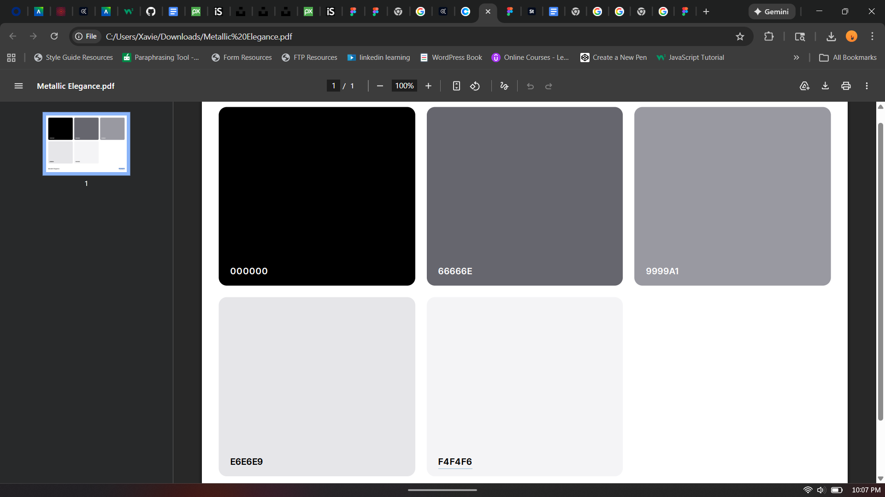

Font: Zen Kurenaido Regular

