QUAL-KĪ v2.0: Quantum-Aware Agentic AI SOC Framework

Complete Architecture, Roadmap & Research Foundation
Target: IEEE paper-ready architecture + functional prototype
Date: August 2026
Extends: QUAL-KĪ v1.0 (QML IDS + PQC Zero Trust)

1. Executive Summary
QUAL-KĪ v2.0 evolves from a monolithic QML intrusion detection model into a fully autonomous, multi-agent Security Operations Center (SOC) secured by a hybrid PQC + QKD cryptographic backbone. This document defines:
- The 8+ agent architecture with specialized roles mimicking a Tier-1/2/3 SOC team
- The QKD-secured inter-agent communication channel (BB84 simulation)
- The integration bridge between the existing 4-Branch Quantum Ensemble IDS and the agentic decision layer
- A phased implementation roadmap from prototype to paper
- A benchmarking strategy aligned with emerging SOC-agent evaluation frameworks
[!IMPORTANT] What already exists (QUAL-KĪ v1.0):
- ✅ Multi-modal dataset: 19,275 time-windows × 132 features (Network + OS telemetry)
- ✅ 4-Branch Quantum Ensemble Classifier (16 qubits, PennyLane/PyTorch)
- ✅ Supervised Semantic Autoencoders (4 domains → 16 latent features)
- ✅ PQC Authentication Layer design (ML-KEM/Kyber)
- ✅ Hybrid ZTA Architecture (PDP/PEP with AES-256 continuous encryption)
- ✅ MITRE Caldera adversary emulation lab (10 PCs, 32 VMs)
- ✅ Classical baseline benchmarks (XGBoost F1: 0.39 ceiling)

2. The Research Gap: Why an Agentic Layer Is Required

2.1 Gap in Existing QUAL-KĪ v1.0
The current framework provides a binary/multiclass verdict — "this 1-second time-window is Normal / DoS / Recon / Brute Force / Malware." But a verdict alone is not an operational SOC. Real SOCs require:
SOC Capability | QUAL-KĪ v1.0 | QUAL-KĪ v2.0 (Agentic)
Detection | ✅ QML Ensemble | ✅ QML Ensemble → feeds Detection Agent
Triage & Prioritization | ❌ None | ✅ LLM-powered Triage Agent with CVSS scoring
Correlation | ❌ Isolated verdicts | ✅ Threat Intel Agent correlates with MITRE ATT&CK
Automated Response | ❌ Manual PEP | ✅ Response Agent issues firewall rules, token revocations
Forensic Analysis | ❌ None | ✅ Forensics Agent reconstructs kill chains
Deception | ❌ None | ✅ Deception Agent deploys honeypots dynamically
Vulnerability Scanning | ❌ None | ✅ Vuln Agent continuously assesses attack surface
Compliance Reporting | ❌ None | ✅ Compliance Agent generates SOC 2 / ISO 27001 reports
Inter-Agent Security | N/A | ✅ QKD (BB84) secures agent-to-agent messages

2.2 Gap in the Wider Literature (Novel Contribution)
Existing Work | What They Do | What They Miss | Our Novelty
Agentic AI SOCs (Torq, Dropzone, 2025-26) | LLM-based triage, ReAct agents | No quantum detection layer; classical crypto only | Quantum detection backbone feeds the agentic layer
QML-IDS papers (2023-25) | QML models for anomaly detection | No operational SOC integration; just a model | Full SOC orchestration around the QML engine
QKD + ZTA research (2024-25) | QKD for network micro-segmentation | No AI agent coordination; static policy | QKD secures dynamic multi-agent communication
ExCyTIn-Bench / SOC-Bench (2025) | Benchmark AI SOC agents | No quantum-aware benchmarks | Quantum-aware SOC benchmark extension

[!TIP] The Q1 Paper Pitch (4 Pillars of Novelty):
- Quantum Detection → Agentic Reasoning: First framework where a QML ensemble directly feeds multi-agent LLM triage
- QKD-Secured Agent Communication: BB84-simulated inter-agent channel (no classical agent trust)
- Multi-Modal Telemetry: Custom dataset fusing Network + OS + Agent decision logs
- Quantum-Aware Benchmarking: Extended ExCyTIn-Bench with quantum-specific evaluation metrics

3. Complete System Architecture

3.1 High-Level Architecture

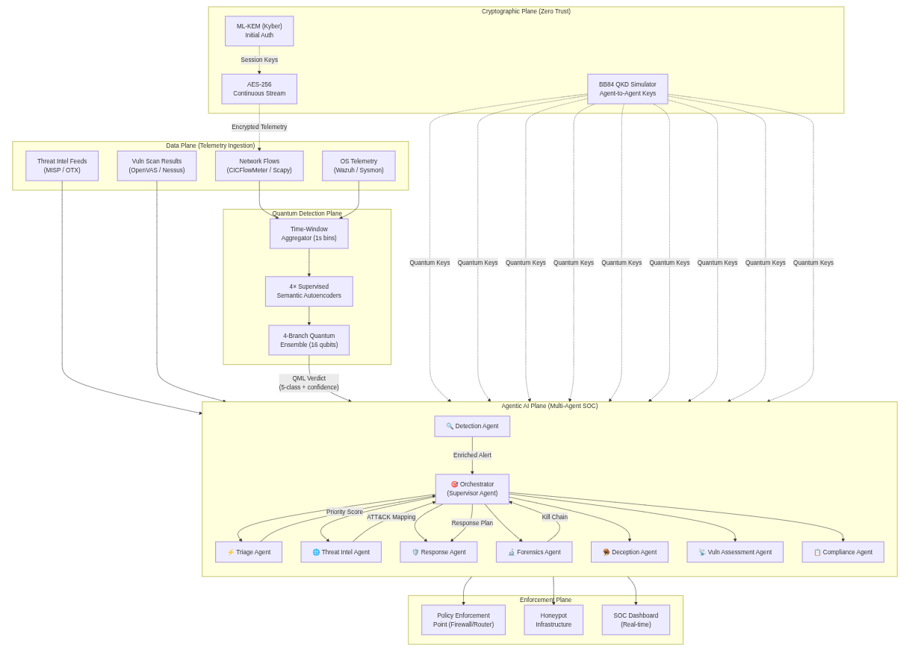
3.2 Agent Roles & Responsibilities
Agent | Role | Input | Output | Tools/APIs
🎯 Orchestrator | Supervisor; routes tasks, resolves conflicts, enforces human-in-the-loop for critical actions | Agent messages, escalation requests | Task assignments, final verdicts | Agent messaging bus, approval queue
🔍 Detection Agent | Receives QML verdicts, adds context (source IP, timestamp, confidence score), creates structured alerts | QML 5-class output + raw telemetry metadata | Structured AlertObject (JSON) | QML inference API, flow metadata DB
⚡ Triage Agent | Prioritizes alerts using LLM reasoning; auto-closes false positives, escalates true positives | AlertObject stream | Priority-ranked alert queue with reasoning trace | LLM (GPT-4/Gemini), CVSS calculator, historical alert DB
🌐 Threat Intel Agent | Correlates alerts with MITRE ATT&CK, CVE databases, and external threat feeds | Alert + IoCs (IPs, hashes, domains) | ATT&CK technique mapping, campaign attribution | MITRE ATT&CK API, MISP, VirusTotal, AbuseIPDB
🛡️ Response Agent | Executes containment and remediation actions (block IP, isolate host, revoke token) | Approved response plan from Orchestrator | Firewall rules, DNS sinkhole entries, token revocations | PEP API, firewall API, Active Directory, ZTA token service
🔬 Forensics Agent | Reconstructs attack kill chains, timeline analysis, evidence preservation | Alert history + raw logs | Kill chain report, IOC extraction, evidence bundle | Log analysis tools, PCAP parser, timeline reconstruction
🪤 Deception Agent | Dynamically deploys/reconfigures honeypots based on detected attack patterns | Active threat intelligence | Honeypot configurations, attacker engagement logs | Honeypot framework (T-Pot/HoneyDB), network config API
📡 Vuln Assessment Agent | Continuous vulnerability scanning, correlates vulns with active threats | Asset inventory, CVE feeds | Risk-prioritized vulnerability reports | OpenVAS/Nessus API, CVE database, asset management
📋 Compliance Agent | Generates compliance reports, tracks SLA violations, audit trail maintenance | All agent decisions + response logs | SOC 2 Type II reports, ISO 27001 evidence, SLA dashboards | Report generator, audit log aggregator

3.3 Inter-Agent Communication: QKD-Secured Message Bus
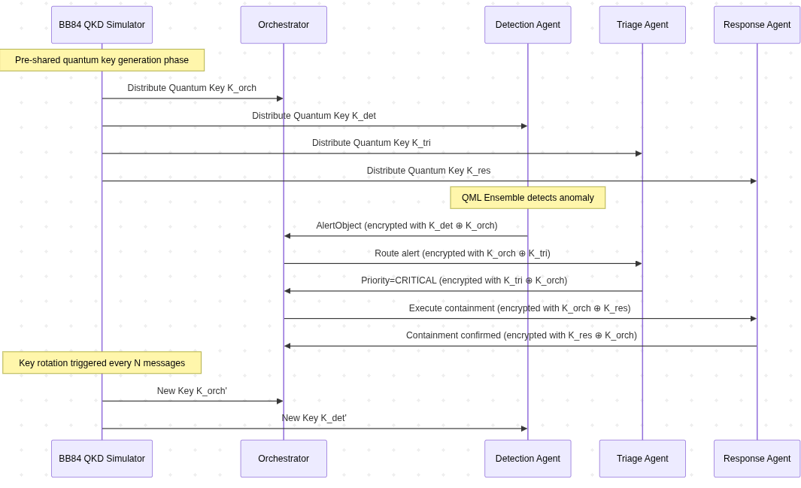
[!NOTE] Why QKD for Agent Communication? Traditional multi-agent systems use TLS or mTLS for inter-agent communication. In a Zero Trust SOC, if any agent is compromised (e.g., via prompt injection), the attacker gains access to the entire message bus. QKD provides:
- Information-theoretic security — no computational assumption can be broken
- Eavesdropping detection — any interception disturbs quantum states (QBER monitoring)
- Forward secrecy — compromised keys reveal nothing about past/future communication
- Agent authentication — quantum identity verification prevents agent impersonation

4. Technology Stack & Framework Selection

4.1 Recommended Stack
Layer | Technology | Justification
Agent Orchestration | LangGraph (LangChain ecosystem) | Graph-based state machines for complex SOC workflows; supports conditional branching, human-in-the-loop, and persistent state
Agent LLM Backend | Gemini 2.5 Pro / GPT-4o (configurable) | Reasoning capability for triage and forensic analysis
Quantum ML | PennyLane + PyTorch (existing) | Already implemented; 4-Branch Quantum Ensemble
QKD Simulation | SimulaQron / Custom BB84 (Python) | Lightweight quantum network simulator for BB84 key exchange
Message Bus | Redis Streams or RabbitMQ | Low-latency pub/sub for agent communication
Encryption Layer | pqcrypto (Python) + cryptography (AES) | ML-KEM for auth, AES-256-GCM for stream, OTP for QKD messages
Threat Intel | MISP (self-hosted) + pyattck | MITRE ATT&CK mapping, IoC enrichment
SIEM Integration | Wazuh (existing) + Elasticsearch | Log aggregation, searchable alert index
Dashboard | Streamlit or Grafana | Real-time SOC visualization
Containerization | Docker Compose | Multi-agent deployment

4.2 Why LangGraph (Not CrewAI or AutoGen)
Framework | Pros | Cons | Fit for QUAL-KĪ
LangGraph | Graph-based workflows, state persistence, human-in-the-loop, conditional edges, streaming | Steeper learning curve | ✅ Best fit — SOC workflows are inherently stateful DAGs
CrewAI | Simple role-based agents, easy setup | Limited state management, no conditional routing | ❌ Too simple for SOC decision trees
AutoGen | Multi-agent conversations | Conversation-based (not workflow-based), less control | ❌ SOC needs deterministic routing, not chat
Google ADK | Google ecosystem integration | Newer, less community tooling | ⚠️ Worth monitoring

5. Phased Implementation Roadmap

Phase 0: Foundation (Weeks 1-2)
Goal: Project scaffolding and environment setup
- ☐ Create monorepo structure: qual_ki_soc/
  - agents/ — Individual agent modules
  - quantum/ — QML ensemble + QKD simulator
  - crypto/ — PQC + AES + QKD key management
  - telemetry/ — Data ingestion pipeline
  - orchestrator/ — LangGraph workflow definitions
  - dashboard/ — SOC visualization
  - benchmarks/ — Evaluation framework
  - tests/ — Unit + integration tests
- ☐ Docker Compose setup for all services
- ☐ Port existing QML ensemble into quantum/ module with inference API
- ☐ Set up Redis Streams message bus

Phase 1: Core Detection Pipeline (Weeks 3-4)
Goal: Connect QML Ensemble → Detection Agent → Orchestrator
- ☐ Wrap QML Ensemble in a FastAPI inference service
- ☐ Build DetectionAgent — consumes QML verdicts, enriches with metadata, emits AlertObject
- ☐ Build OrchestratorAgent — LangGraph supervisor node that receives alerts and routes to specialists
- ☐ Implement basic message schema (AlertObject, TaskAssignment, AgentResponse)
- ☐ Unit test: QML verdict → Detection Agent → Orchestrator routing

Phase 2: Triage & Threat Intel Agents (Weeks 5-6)
Goal: LLM-powered alert triage and ATT&CK correlation
- ☐ Build TriageAgent — LLM-based priority scoring (CVSS-aligned)
  - Input: AlertObject + historical context
  - Output: Priority (P1-P4), confidence score, reasoning trace
  - Auto-close logic for known false positive patterns
- ☐ Build ThreatIntelAgent — MITRE ATT&CK technique mapping
  - Input: Alert IoCs (IPs, ports, Sysmon Event IDs)
  - Output: ATT&CK technique IDs, related campaigns, CVE links
  - Integration: pyattck library + MISP threat feed
- ☐ LangGraph conditional edges: HIGH priority → fast-track to Response; LOW → auto-close with audit

Phase 3: Response & Forensics Agents (Weeks 7-8)
Goal: Automated containment and kill chain reconstruction
- ☐ Build ResponseAgent — executes containment actions
  - Firewall rule injection (iptables / nftables API)
  - ZTA token revocation (existing PDP integration)
  - Host isolation via Wazuh active response
  - Human-in-the-loop gate for destructive actions (network segment isolation, account lockout)
- ☐ Build ForensicsAgent — attack timeline reconstruction
  - Correlates alerts into incident timelines
  - Maps to MITRE ATT&CK kill chain phases
  - Generates evidence bundles (logs, PCAPs, screenshots)
- ☐ Integration test: Full alert → triage → response → forensics pipeline

Phase 4: QKD Integration (Weeks 9-10)
Goal: BB84-simulated quantum key distribution for inter-agent communication
- ☐ Implement BB84 QKD simulator in Python
  - Alice (key sender) + Bob (key receiver) protocol
  - Basis reconciliation, privacy amplification
  - QBER (Quantum Bit Error Rate) monitoring
  - Eavesdropper (Eve) detection simulation
- ☐ Implement QKD Key Manager
  - Key pool management (pre-generated keys per agent pair)
  - Automatic key rotation (configurable interval)
  - Key exhaustion handling (fallback to PQC)
- ☐ Encrypt all inter-agent messages with QKD-derived OTP/AES keys
- ☐ Security validation: Inject simulated Eve → verify QBER spike → agent quarantine

Phase 5: Deception, Vuln Assessment & Compliance (Weeks 11-12)
Goal: Complete the SOC agent roster
- ☐ Build DeceptionAgent — dynamic honeypot orchestration
  - Deploy decoy services matching detected attack vectors
  - Log attacker interactions for threat intel enrichment
  - Integration with T-Pot or custom honeypots
- ☐ Build VulnAssessmentAgent — continuous attack surface monitoring
  - Scheduled scans via OpenVAS/Nessus API
  - Correlates vulnerabilities with active threat intelligence
  - Risk-prioritized remediation recommendations
- ☐ Build ComplianceAgent — automated audit trail and reporting
  - SOC 2 Type II evidence collection
  - ISO 27001 control mapping
  - SLA tracking and violation alerts
  - Generates human-readable compliance reports

Phase 6: Benchmarking & Evaluation (Weeks 13-14)
Goal: Rigorous evaluation aligned with academic standards
- ☐ Implement QUAL-KĪ Benchmark Suite (extending ExCyTIn-Bench)
  - Detection Accuracy: Precision, Recall, F1, AUC-ROC of QML ensemble
  - Triage Quality: Agreement with expert labels, false positive suppression rate
  - Response Latency: MTTD (Mean Time to Detect), MTTR (Mean Time to Respond)
  - Kill Chain Coverage: % of ATT&CK techniques correctly identified
  - QKD Security: QBER under normal vs. adversarial conditions
  - Agent Coordination: Task completion rate, escalation accuracy
  - Quantum Advantage Metrics: Parameter efficiency ratio (QML vs classical MLP at matched scale)
- ☐ Run red team scenarios using MITRE Caldera (existing lab)
  - Scenario 1: Multi-stage APT (Recon → Exploitation → Lateral Movement → Exfiltration)
  - Scenario 2: Insider threat (Credential abuse → Privilege escalation → Data theft)
  - Scenario 3: DDoS + Distraction attack (Volumetric DDoS covering lateral movement)
- ☐ Ablation studies:
  - With vs without QML (use classical XGBoost detection instead)
  - With vs without QKD (use TLS for agent communication instead)
  - With vs without agentic layer (monolithic detector vs multi-agent SOC)

Phase 7: Paper Drafting & Publication (Weeks 15-16)
Goal: IEEE Transactions-ready manuscript
- ☐ Structure: Abstract → Introduction → Related Work → Architecture → Implementation → Evaluation → Discussion → Conclusion
- ☐ Key figures:
  - System architecture diagram (Section 3.1 of this document)
  - QKD message flow (Section 3.3)
  - Benchmark comparison tables
  - Ablation study results
  - QML ensemble circuit diagrams (existing)
- ☐ Target journals:
  - Primary: IEEE Transactions on Information Forensics and Security (IF: ~7.2)
  - Secondary: Computers & Security (Elsevier, IF: ~5.1)
  - Conference: IEEE S&P Workshop on Quantum Security

6. Benchmarking Framework: QUAL-KĪ-Bench

6.1 Benchmark Dimensions
Dimension | Metric | Target | Measurement Method
Detection | Macro F1-Score (5-class) | > 0.40 (QML) vs 0.39 (XGBoost ceiling) | Stratified 5-Fold CV on 19,275 samples
Detection | Parameter Efficiency Ratio | QML params < 500 vs MLP params > 1000 for same F1 | Parameter count comparison
Triage | False Positive Suppression | > 60% of low-priority alerts auto-closed correctly | Expert-labeled validation set
Triage | Reasoning Fidelity | LLM triage traces match human analyst reasoning > 80% | Human evaluation (Cohen's Kappa)
Response | MTTR (Mean Time to Respond) | < 30 seconds for automated containment | Timestamp delta: alert → response execution
Forensics | Kill Chain Completeness | > 70% ATT&CK techniques identified per scenario | Scenario ground truth comparison
QKD | QBER (Normal) | < 5% | BB84 simulation measurement
QKD | QBER (Under Attack) | > 25% (Eve detected) | Eavesdropper injection test
QKD | Key Generation Rate | > 100 keys/sec (simulated) | Throughput measurement
System | End-to-End Latency | < 5 seconds (detection → containment) | Full pipeline trace
System | Agent Coordination Score | > 90% task completion without human intervention | Automated scenario runner

6.2 Comparison with Existing Benchmarks
Benchmark | Focus | Quantum-Aware? | Multi-Agent? | Our Extension
ExCyTIn-Bench | LLM reasoning for cyber investigations | ❌ | ❌ | Add QML detection feed as evidence source
SOC-Bench | Multi-agent SOC evaluation | ❌ | ✅ | Add QKD security + quantum detection metrics
Simbian Leaderboard | LLM accuracy on SOC tasks | ❌ | ❌ | Add quantum parameter efficiency comparison
QUAL-KĪ-Bench (Ours) | End-to-end quantum SOC | ✅ | ✅ | Novel: First quantum-aware SOC benchmark

7. Security Architecture: Threat Model for the Agentic Layer

7.1 Threats to Multi-Agent AI SOCs
Threat | Description | QUAL-KĪ v2.0 Mitigation
Prompt Injection | Attacker crafts log entries that manipulate LLM triage reasoning | Input sanitization layer + confidence gating (reject if LLM confidence < threshold)
Agent Impersonation | Rogue agent joins the message bus and injects false verdicts | QKD authentication — agents must prove possession of quantum-derived keys
Tool Poisoning | Compromised API returns false threat intel or vulnerability data | Multi-source validation (cross-reference ≥2 independent sources before acting)
Cascading Failure | One agent's error propagates through the orchestrator | Circuit breaker pattern + Orchestrator sanity checks on all agent outputs
Model Extraction | Adversary probes QML ensemble to extract decision boundaries | Rate limiting on inference API + differential privacy on model outputs
QKD Channel Attack | Physical layer attack on QKD channel (blinding, Trojan horse) | QBER threshold monitoring + automatic channel shutdown on anomaly

7.2 OWASP Agentic AI Security Alignment
The framework implements controls aligned with the OWASP Top 10 for Agentic AI (2025):
- A01: Unrestricted Agency → All Response Agent actions require Orchestrator approval; destructive actions require human approval
- A02: Prompt Injection → Structured input schemas (JSON AlertObjects) prevent free-text injection
- A03: Insufficient Sandboxing → Each agent runs in isolated Docker container with minimal permissions
- A04: Excessive Trust in Tools → Multi-source validation for all external API calls
- A05: Insufficient Logging → All agent decisions logged with full reasoning trace (audit trail)

8. Key Academic References & Resources

8.1 Agentic AI SOC Architecture
Resource | Type | Relevance
ExCyTIn-Bench (2025) | Benchmark | LLM agent evaluation for cybersecurity investigations; SQL-in-the-loop methodology
MAESTRO Framework (OWASP, 2025) | Security Framework | Multi-Agent Security Testing, Risk evaluation, and Orchestration
"Agentic AI in the SOC" (Cloud Security Alliance, 2026) | Industry Report | 45-61% MTTR reduction with agentic SOCs; governance models
Torq / Dropzone / StellarCyber architectures | Industry | Real-world agentic SOC implementations; agent role definitions

8.2 Quantum Machine Learning for IDS
Paper | Year | Citations | Key Contribution
QML-IDS: Quantum ML Intrusion Detection System | 2024 | 44 | QSVM + QNN baseline for IDS
Network Anomaly Detection Using QNN on Noisy Quantum Computers | 2024 | 42 | NISQ-aware VQC training
Intrusion Detection with Optimized QNN and ECC | 2023 | 41 | QNN + ECC (our paper exposes ECC vulnerability)
QML for Advanced Threat Detection in Cybersecurity | 2024 | 29 | Broad QML threat hunting architecture
Variational Quantum Convolutional Neural Network for IDS | 2024 | 25 | VQCNN (our paper proves barren plateau failure)
Pérez-Salinas et al. — Data Re-uploading | 2020 | 300+ | Universal function approximation with single-qubit re-uploading

8.3 Quantum Key Distribution & Zero Trust
Resource | Type | Relevance
NIST SP 800-207: Zero Trust Architecture | Standard | Formal PDP/PEP definitions; our ZTA compliance basis
BB84 Protocol (Bennett & Brassard, 1984) | Foundational | QKD protocol we simulate for inter-agent keys
FHE-based QKD Relay Architectures (2024-25) | Research | Extends QKD range via homomorphic encryption relays
"QKD in Enterprise Networks" (ETSI, 2024) | Standard | QKD deployment guidelines for commercial networks

8.4 Multi-Agent AI Security
Resource | Type | Relevance
OWASP Top 10 for Agentic AI (2025) | Security Standard | Threat model for multi-agent systems
LangGraph Documentation | Framework | State machine orchestration for agent workflows
"Securing AI Agents" (MITRE ATLAS, 2025) | Threat Framework | Adversarial ML attacks on autonomous agents

9. Directory Structure (Proposed)
qual_ki_soc/
├── docker-compose.yml
├── README.md
├── pyproject.toml
│
├── agents/
│ ├── __init__.py
│ ├── base_agent.py # Abstract base class for all agents
│ ├── detection_agent.py # QML verdict consumer + alert enrichment
│ ├── triage_agent.py # LLM-powered priority scoring
│ ├── threat_intel_agent.py # MITRE ATT&CK + MISP integration
│ ├── response_agent.py # Automated containment actions
│ ├── forensics_agent.py # Kill chain reconstruction
│ ├── deception_agent.py # Dynamic honeypot orchestration
│ ├── vuln_agent.py # Continuous vulnerability scanning
│ └── compliance_agent.py # SOC 2 / ISO 27001 reporting
│
├── orchestrator/
│ ├── __init__.py
│ ├── graph.py # LangGraph workflow DAG definition
│ ├── state.py # Shared state schema
│ ├── nodes.py # Agent nodes for the graph
│ └── edges.py # Conditional routing logic
│
├── quantum/
│ ├── __init__.py
│ ├── ensemble.py # 4-Branch Quantum Ensemble (existing)
│ ├── inference_api.py # FastAPI wrapper for QML model
│ ├── autoencoders.py # Supervised Semantic Autoencoders (existing)
│ └── circuits.py # PennyLane circuit definitions
│
├── crypto/
│ ├── __init__.py
│ ├── pqc_auth.py # ML-KEM (Kyber) authentication
│ ├── aes_stream.py # AES-256-GCM continuous encryption
│ ├── qkd_bb84.py # BB84 QKD simulator
│ ├── key_manager.py # QKD key pool + rotation manager
│ └── message_crypto.py # Agent message encrypt/decrypt
│
├── telemetry/
│ ├── __init__.py
│ ├── ingestion.py # Real-time telemetry ingestion
│ ├── time_window.py # 1-second aggregation (existing logic)
│ ├── feature_engineering.py # One-hot expansion, scaling
│ └── schemas.py # AlertObject, TaskAssignment, etc.
│
├── dashboard/
│ ├── app.py # Streamlit SOC dashboard
│ ├── components/
│ └── static/
│
├── benchmarks/
│ ├── __init__.py
│ ├── quali_bench.py # QUAL-KĪ-Bench runner
│ ├── scenarios/ # MITRE Caldera attack scenarios
│ ├── metrics.py # Metric calculators
│ └── baselines/ # Classical comparison baselines
│
├── config/
│ ├── agents.yaml # Agent configurations
│ ├── qkd.yaml # QKD parameters (key pool size, rotation interval)
│ └── soc.yaml # SOC policies (escalation thresholds, SLAs)
│
└── tests/
├── test_agents/
├── test_quantum/
├── test_crypto/
└── test_integration/

10. Risk Register & Mitigations
Risk | Probability | Impact | Mitigation
QML F1 doesn't beat XGBoost ceiling (0.39) | Medium | High | Frame as parameter efficiency advantage (453 vs thousands of params); continue hyperparameter tuning
LLM triage hallucinations | High | Medium | Structured output schemas + confidence gating + human-in-the-loop for P1 alerts
QKD simulation questioned for academic rigor | Medium | High | Use established SimulaQron framework; cite BB84 information-theoretic proofs
Integration complexity delays | High | Medium | Docker Compose microservices; independent agent development; CI/CD pipeline
Scope creep (8+ agents is ambitious) | High | Medium | Prioritize core 4 agents (Detection, Triage, Response, Orchestrator); others can be stubs for paper

11. Summary: What Makes QUAL-KĪ v2.0 Unprecedented

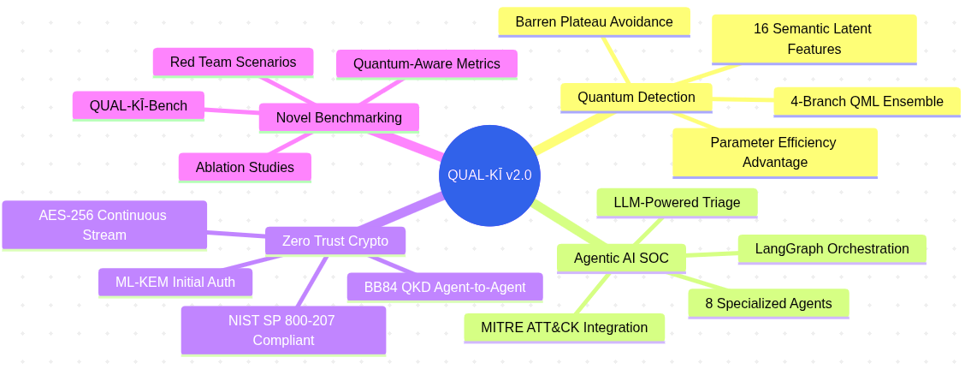
[!CAUTION] Critical Path Dependencies:
- QML Ensemble must achieve stable multiclass F1 before Detection Agent can be validated
- LangGraph Orchestrator must be functional before any inter-agent workflow testing
- BB84 QKD simulator must pass eavesdropper detection tests before claiming quantum-secure agent communication

Document Version: 1.0
Author: QUAL-KĪ Research Team
Next Review: Upon completion of Phase 1

