Task Report — Xon (Sprint 1: 7–27 May)

Context
Volunteering Rewards App · Express.js + PostgreSQL + React Native (Expo) + React (Vite)
Role: Infrastructure & Backend Developer — Workflow A, B, C backend APIs + all code generation
I am responsible for setting up the entire backend infrastructure, generating all code (backend + frontend scaffolding), coordinating deliveries to GitHub, and supporting teammates when they are stuck.

Task: INF-01 — Backend Project Scaffolding
Description: Set up the Express.js backend project with all required dependencies, folder structure, environment configuration, and server entry point.
Files created:
- backend/package.json — 19 dependencies (express, pg, bcrypt, jsonwebtoken, joi, cors, helmet, dotenv, express-rate-limit, uuid)
- backend/.env.example — Configuration template for DB, JWT, rate limit
- backend/index.js — Express entry point with middleware stack (helmet → cors → JSON → rate-limit → routes → 404 → error handler)
- backend/migrations/ — Directory for all 12 migration SQL files
- backend/src/ — Directory structure (config, routes, middleware, controllers, services, utils)
NPM scripts configured:
Command | Action
npm run dev | Start dev server with --watch (auto-restart)
npm start | Start server for production
npm run migrate | Create/update all 12 database tables
npm run seed | Load test data into database

Task: INF-02 — Database Connection
Description: PostgreSQL connection pool with health check.
API endpoint: GET /api/health
File created:
- backend/src/config/database.js — pg Pool with max 20 connections, 5s timeout, error logging, checkConnection() function

Task: INF-03 — Database Migrations (12 Tables)
Description: Create all 12 database tables with proper constraints, foreign keys, and indexes.
Files created — `backend/migrations/`:
# | File | Table | Key Features
001 | 001_create_roles.sql | roles | volunteer / organizer / admin
002 | 002_create_users.sql | users | points, volunteerqrcode (UUID), refresh_token, role FK
003 | 003_create_organizations.sql | organizations | approval workflow (pending/approved/rejected)
004 | 004_create_events.sql | events | organizer FK, points_value, capacity, status, category
005 | 005_create_event_registrations.sql | event_registrations | UNIQUE(userid, eventid)
006 | 006_create_attendance_logs.sql | attendance_logs | scantype CHECK (checkin / points_award), UNIQUE(user, event, type)
007 | 007_create_event_feedback.sql | event_feedback | rating 1-5, comment
008 | 008_create_event_qna.sql | event_qna | question/answer by different users
009 | 009_create_favorites.sql | favorites | UNIQUE(user, itemtype, itemid)
010 | 010_create_coupons.sql | coupons | pointsrequired, quantity, expiry, createdby FK
011 | 011_create_user_coupons.sql | user_coupons | 6-digit PIN per redemption, UNIQUE, expiry_date
012 | 012_create_redemption_logs.sql | redemption_logs | Immutable audit trail: pointsspent, action, actionby, ip_address

Migration runner: backend/src/utils/migrationRunner.js — reads and executes all .sql files in numeric order, safe to run multiple times (IF NOT EXISTS).
Output:
Found 12 migration(s)
▶ Running: 001_create_roles.sql → ✓ Completed
▶ Running: 002_create_users.sql → ✓ Completed
... (all 12 passed)
All migrations completed successfully.

Task: INF-04 — Seed Data Script
Description: Populate database with initial reference data for testing and demo.
File created: backend/src/utils/seed.js
Data loaded:
Category | Items | Details
Roles | 3 | volunteer, organizer, admin
Test users | 3 | Alice Volunteer (500pts), Bob Organizer, Carol Admin — all password: password123
Organization | 1 | Green Earth Society (approved)
Events | 3 | Beach Cleanup (20pts), Elderly Walk (15pts), Food Distribution (25pts)
Coupons | 3 | $5 FairPrice (100pts), Kopitiam Coffee Set (50pts), $10 GrabFood (200pts)

Each user also gets a unique UUID-based volunteer QR code for the QR scanning system.
Output:
▶ Seeding roles... ✓ Roles seeded
▶ Seeding test users... ✓ Test users seeded (password: password123)
▶ Seeding organization... ✓ Organization seeded
▶ Seeding events... ✓ Events seeded
▶ Seeding coupons... ✓ Coupons seeded
Seed complete. Happy coding!

Task: INF-05 — Git Branching Setup
Description: Establish branch structure for 4-person team workflow.
Reference file: GIT_BRANCHING_GUIDE.md (existing — reviewed and confirmed)
Branch structure:
main ← Clean backend code (source of truth)
xon ← Xon's working branch + reference docs
nurain ← Nurain's branch (merged from main)
vivian ← Vivian's branch (merged from main)
grace ← Grace's branch (merged from main)
GitHub repositories updated:
- main branch: 28 backend files pushed
- xon branch: backend + reference documents pushed
- nurain, vivian, grace branches: backend merged from main

Task: INF-06 — API Error Handler Middleware
Description: Global error handler for consistent JSON error responses across all APIs.
Files created:
- backend/src/middleware/errorHandler.middleware.js — Catches all errors, returns { error: true, message } with appropriate status code, hides internal details in production
- createError() factory — throw createError(400, "message") for operational errors in services
Error format (all endpoints):
{
"error": true,
"message": "Human-readable error description"
}
HTTP status codes used:
Code | Meaning
400 | Validation failure
401 | Unauthenticated (no token / invalid token)
403 | Forbidden (wrong role)
404 | Resource not found
409 | Conflict (duplicate email, etc.)
429 | Rate limited
500 | Internal server error

Task: AUTH-01 through AUTH-06 — Auth Module
Description: Complete authentication system with registration, login, JWT, role-based access, token refresh, and profile retrieval.

Files Created
Layer | File | Purpose
Utility | src/utils/jwt.js | Token generation & verification (access 15min, refresh 7d)
Middleware | src/middleware/auth.middleware.js | JWT verification → attaches req.user
Middleware | src/middleware/role.middleware.js | Role guard: authorize("admin")
Service | src/services/auth.service.js | Business logic: register, login, refresh, getProfile
Controller | src/controllers/auth.controller.js | HTTP request handling
Routes | src/routes/auth.routes.js | Route definitions

API Endpoints
Method | Endpoint | Auth | Description
POST | /api/auth/register | No | Register new volunteer account
POST | /api/auth/login | No (rate-limited: 10/15min) | Login with email + password
POST | /api/auth/refresh | No | Exchange refresh token for new pair
GET | /api/auth/profile | Yes (JWT) | Get current user's profile

Key Security Features
- Passwords hashed with bcrypt (12 salt rounds)
- JWT access tokens: 15-minute expiry
- JWT refresh tokens: 7-day expiry with rotation (old token invalidated on refresh)
- Refresh token reuse detection (revokes all tokens if mismatch detected)
- Login uses authStrict rate limiter (10 attempts per 15 minutes)
- No user enumeration on login (identical error for wrong email or password)
- Registration checks for duplicate email (409 Conflict)

Test Users
Email | Password | Role | Points
alice@test.com | password123 | Volunteer | 500
bob@test.com | password123 | Organizer | 0
carol@test.com | password123 | Admin | 0

Task: AUTH-10 — Rate Limiter Middleware
Description: Global and auth-specific rate limiting to prevent abuse.
File created: backend/src/middleware/rateLimiter.middleware.js
Two limiters:
Limiter | Scope | Limit | Applied to
global | All API routes | 100 requests per 15 minutes | Entire API
authStrict | Auth endpoints | 10 requests per 15 minutes | POST /api/auth/login

Verification: Postman API Testing
Collection file: backend/Volunteering_Rewards_API.postman_collection.json
7 test requests created:
# | Request | Expected Result
1 | GET /api/health | { "status": "ok" }
2 | POST /api/auth/register | 201 Created + user + tokens
3 | POST /api/auth/login (Alice) | 200 + user + tokens
4 | POST /api/auth/login (Bob) | 200 + user (organizer role)
5 | POST /api/auth/login (Carol) | 200 + user (admin role)
6 | GET /api/auth/profile | 200 + user details (uses auto-saved token)
7 | POST /api/auth/refresh | 200 + new token pair

Quick Test Sequence (1 minute)
#1 Health → #3 Login → #6 Profile
(Collection auto-saves accessToken from Login for use in Profile request.)

Postman Test Results
[Insert Postman screenshots here — one per endpoint tested]
Screenshot 1: GET /api/health — Response 200 OK
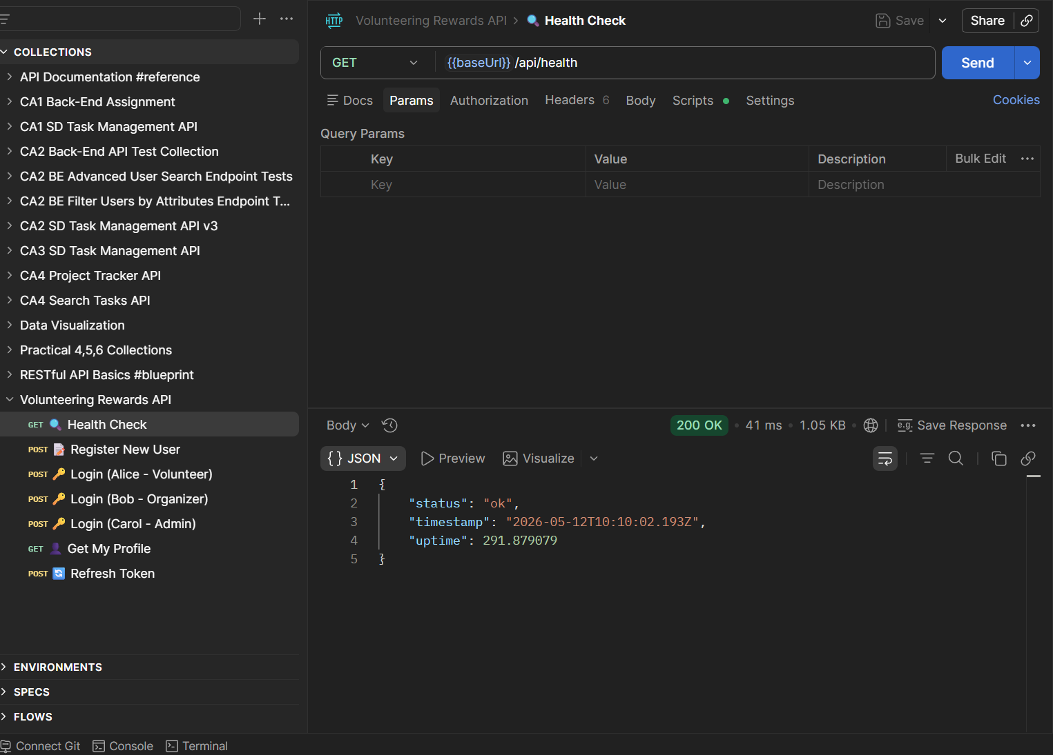

Screenshot 2: POST /api/auth/register — Response 201 Created and do not allow to create again Response 409 conflict.
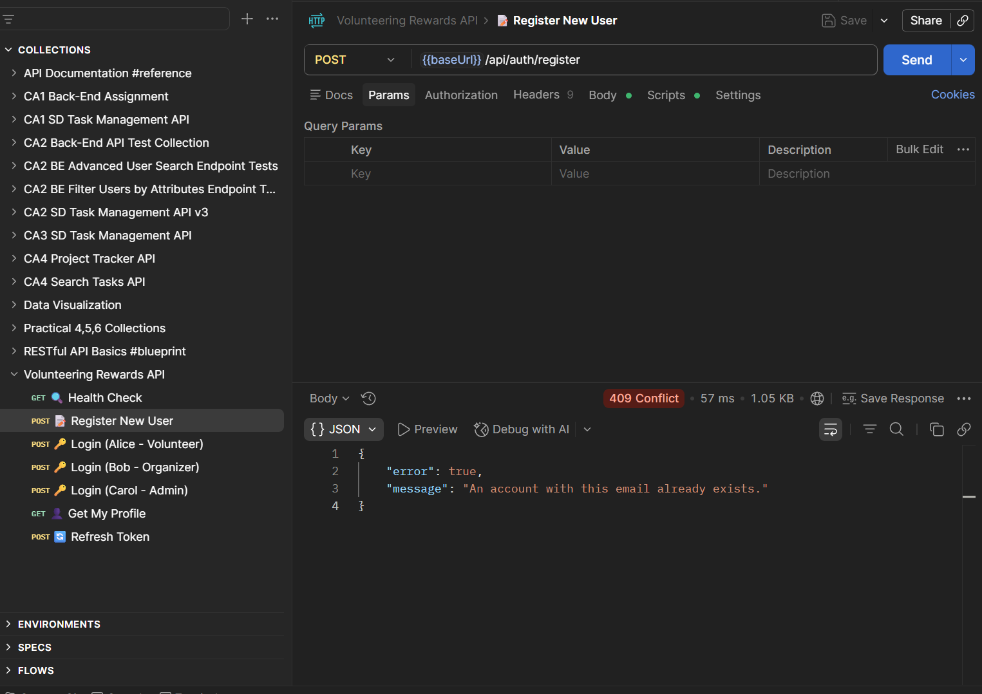

Screenshot 3: POST /api/auth/login (Alice) — Response 200 with tokens
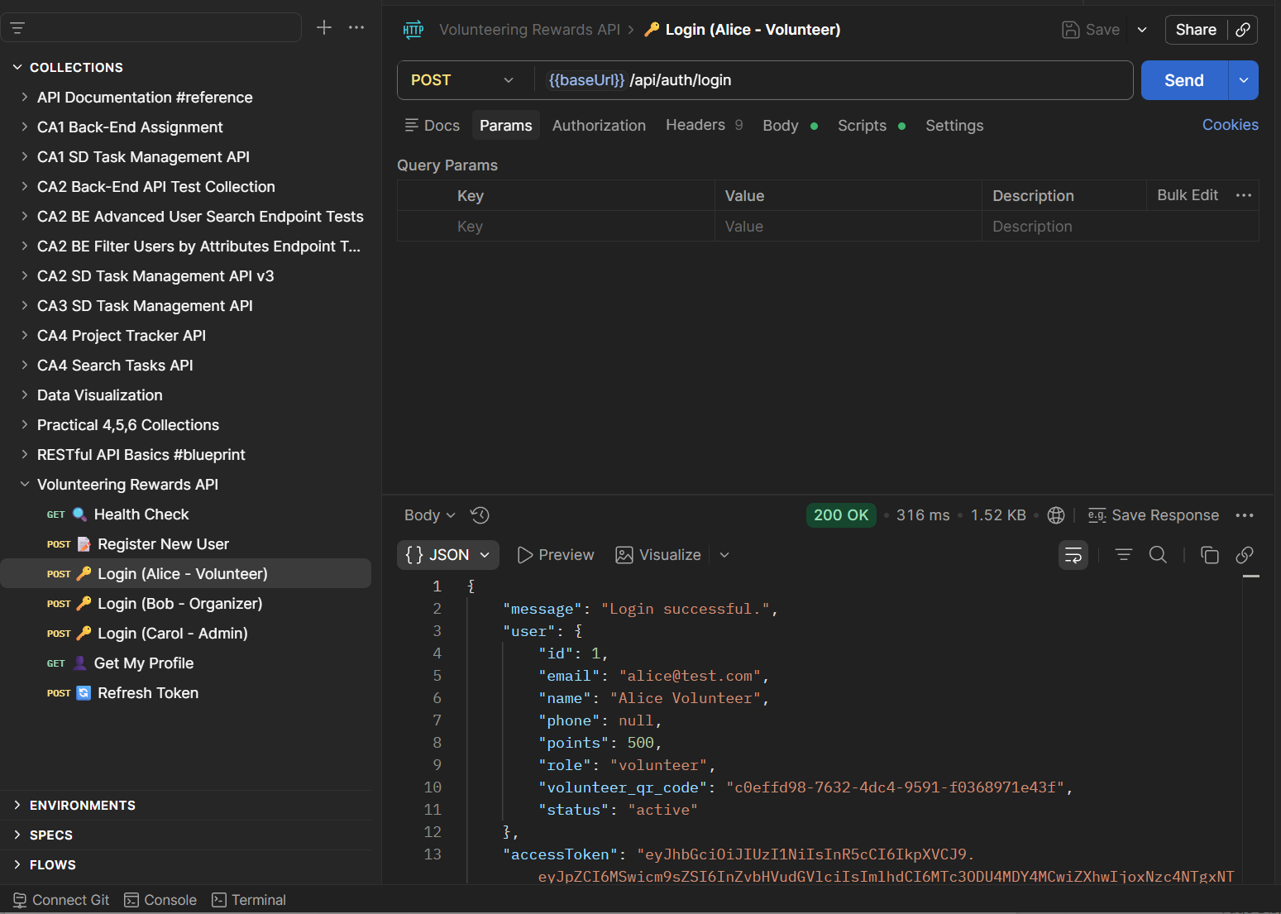

Screenshot 4: GET /api/auth/profile — Response 200 with user details
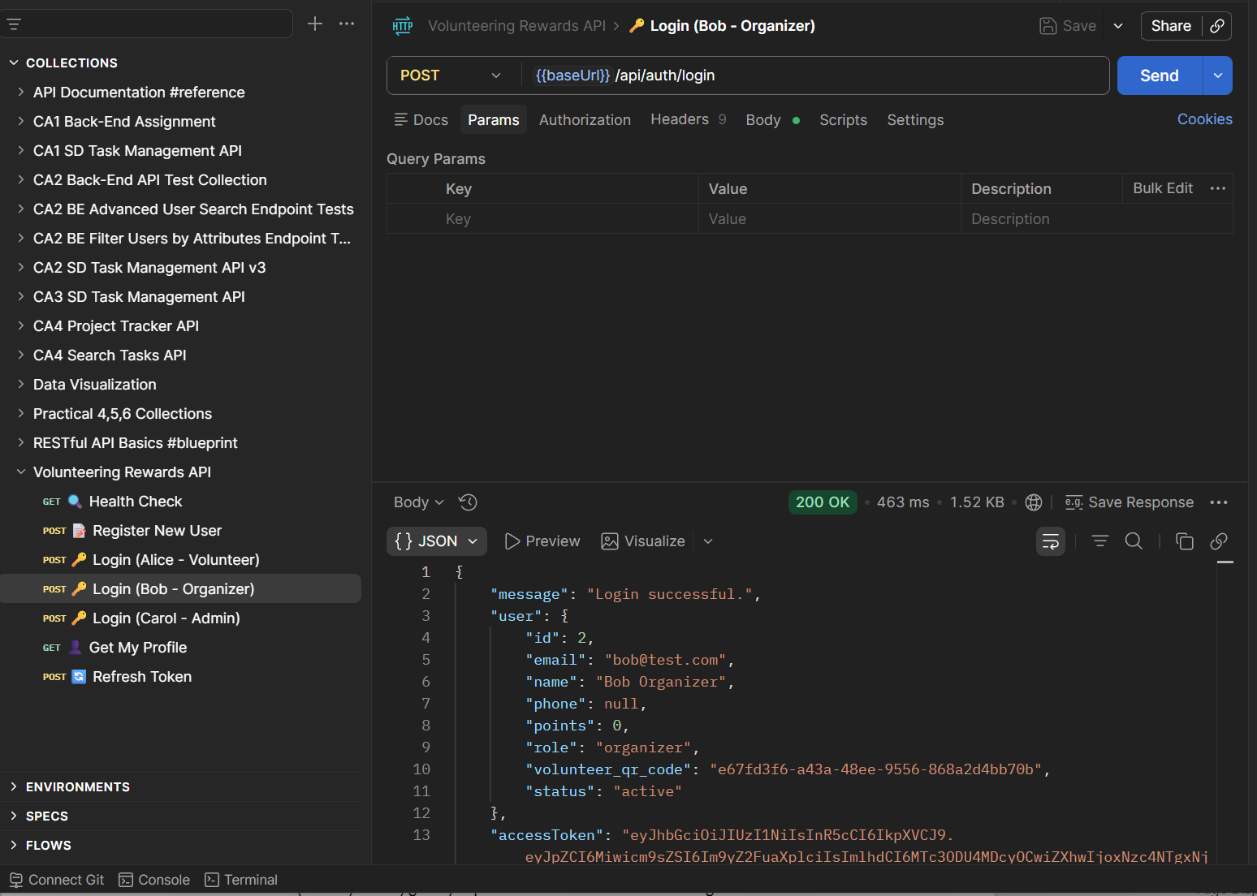

Screenshot 5: POST /api/auth/refresh — Response 200 with new tokens
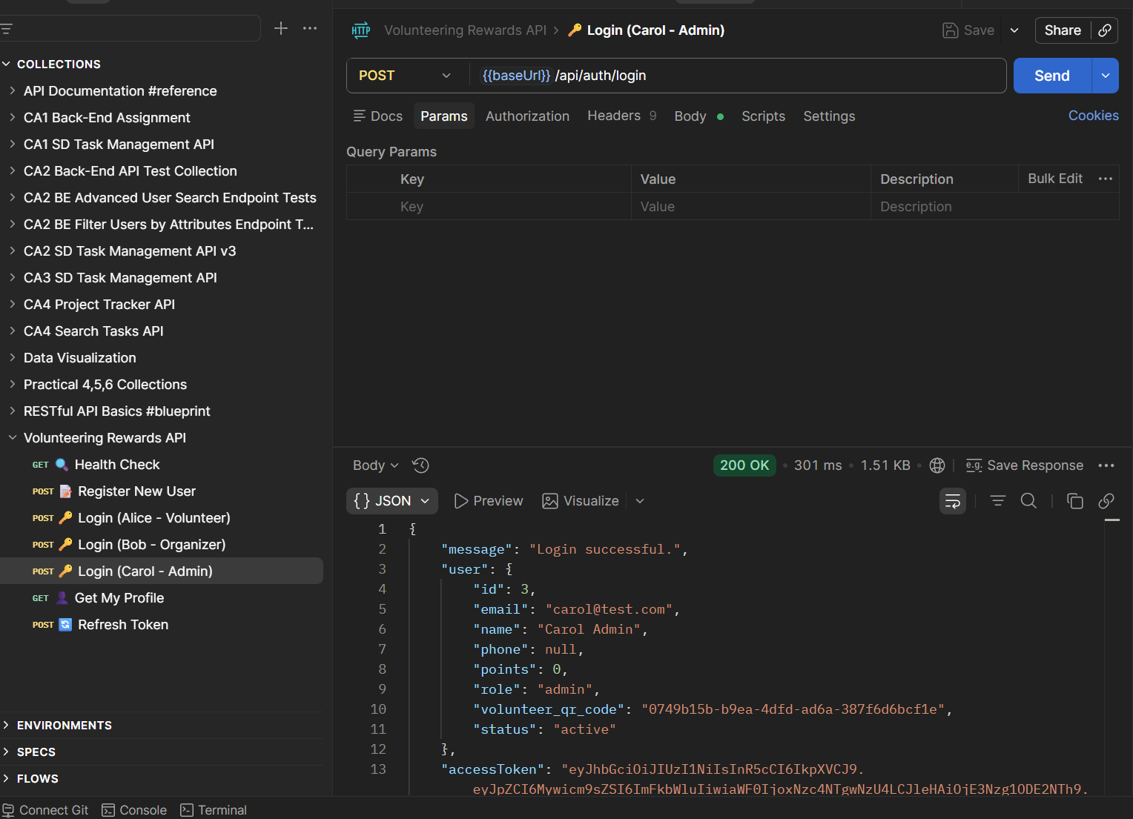

Please note that “Get my profile” is related to the “Alice” account. Therefore,
• Run #3 Login (Alice) first — this auto-saves the tokens into Postman's collection variables
• Then try #6 Get My Profile — it should now have the token
• Then #7 Refresh Token — same thing

GitHub Delivery
- main branch: All 28 backend files committed and pushed
- xon branch: Backend + reference documents
- All team branches (nurain, vivian, grace): Updated with latest main via merge
- DAILY_WORKFLOW.md added for team reference

Dependencies & Prerequisites
Requirement | Version
Node.js | 18+
PostgreSQL | 15+
npm | 9+

Setup commands:
cd backend
npm install
cp .env.example .env # then edit DB_PASSWORD
npm run migrate
npm run seed
npm run dev # Server starts on port 3000

Summary of Deliverables
ID | Task | Status
INF-01 | Backend project scaffolding | ✅ Done
INF-02 | Database connection + health check | ✅ Done
INF-03 | All 12 database migrations | ✅ Done
INF-04 | Seed data script | ✅ Done
INF-05 | Git branching setup | ✅ Done
INF-06 | Error handler middleware | ✅ Done
AUTH-01 | Registration API | ✅ Done
AUTH-02 | Login API | ✅ Done
AUTH-03 | JWT authentication middleware | ✅ Done
AUTH-04 | Role guard middleware | ✅ Done
AUTH-05 | Token refresh API | ✅ Done
AUTH-06 | Profile API | ✅ Done
AUTH-10 | Rate limiter middleware | ✅ Done

Total: 28 backend files, 13 tasks completed, server running on localhost:3000.

