Volunteering Rewards App — System Architecture (Phase 1)
Date: May 10, 2026 Version: 2.0 — Simplified Phase 1 Previous: Merchants/Cashiers removed, module registry/event bus replaced

1. Architecture Overview

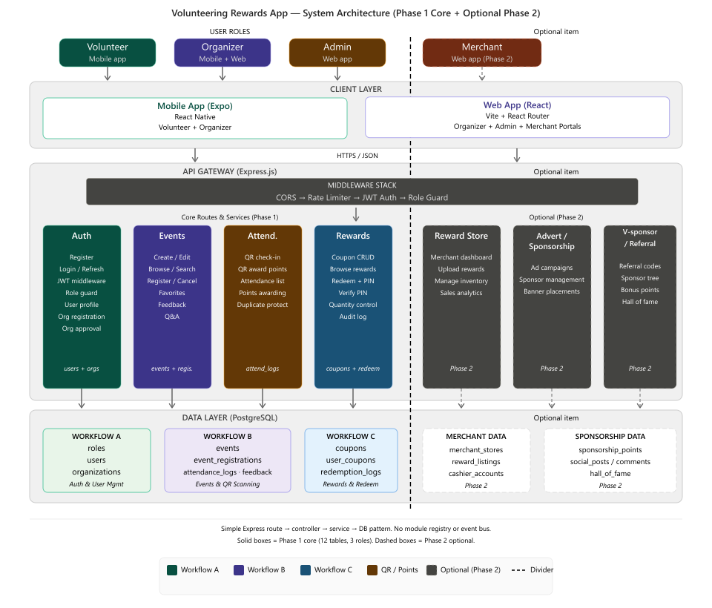

Key Design Principle
Simple, layered Express architecture. No module registry, no event bus/pub-sub. Each workflow (Auth, Events, Rewards) is a self-contained Express router with its own controller, service, and model layer. Routes → middleware → controllers → services → database.

2. Technology Stack
Layer | Technology | Purpose
Mobile | React Native (Expo) | Volunteer + Organiser mobile app
Web | React (Vite) | Organiser + Admin web portals
Backend | Node.js / Express.js | REST API server
Database | PostgreSQL (single DB) | All tables (12 core Phase 1)
Auth | JWT (access + refresh tokens) | Stateless authentication
Password hash | bcrypt | Secure password storage
QR codes | react-native-qrcode-svg (display) + expo-camera (scan) | Volunteer QR generation and scanning
PIN generation | crypto.randomInt(100000, 999999) | Secure 6-digit redemption PINs
File storage | URL-based (configurable backend) | Profile images, approval documents
API validation | Joi / Zod | Request body/query validation

Not in Phase 1 Scope
- ❌ Module registry — replaced by simple Express route mounting
- ❌ Event bus / pub-sub — replaced by direct service calls
- ❌ S3 storage — file URLs only, backend-agnostic
- ❌ Push notifications (FCM/APNs) — Phase 2
- ❌ SendGrid email service — Phase 2
- ❌ CI/CD pipeline — manual deploy via Git
- ❌ Redis — not needed for Phase 1 scale

3. Directory Structure
volunteering-rewards-app/
├── backend/
│ ├── src/
│ │ ├── index.js # App entry point, mounts all routers
│ │ ├── config/
│ │ │ └── database.js # PostgreSQL connection pool
│ │ ├── middleware/
│ │ │ ├── auth.js # JWT verification middleware
│ │ │ ├── roleGuard.js # Role-based access control
│ │ │ ├── rateLimiter.js # Rate limiting
│ │ │ └── errorHandler.js # Global error handler
│ │ ├── routes/
│ │ │ ├── auth.routes.js
│ │ │ ├── users.routes.js
│ │ │ ├── organizations.routes.js
│ │ │ ├── events.routes.js
│ │ │ ├── eventRegistrations.routes.js
│ │ │ ├── attendance.routes.js
│ │ │ ├── feedback.routes.js
│ │ │ ├── qna.routes.js
│ │ │ ├── favorites.routes.js
│ │ │ ├── coupons.routes.js
│ │ │ ├── userCoupons.routes.js
│ │ │ └── redemptionLogs.routes.js
│ │ ├── controllers/
│ │ ├── services/
│ │ └── utils/
│ ├── migrations/ # Database migration files
│ ├── seeds/ # Seed data scripts
│ └── package.json
├── mobile/ # Expo React Native app
│ ├── app/ # File-based routing (Expo Router)
│ │ ├── (auth)/ # Login, register
│ │ ├── (tabs)/ # Main tab navigation
│ │ │ ├── index.tsx # Home / dashboard
│ │ │ ├── events.tsx # Event browse
│ │ │ ├── rewards.tsx # Coupon browse
│ │ │ └── profile.tsx # User profile
│ │ ├── event/[id].tsx # Event detail
│ │ ├── reward/[id].tsx # Reward detail
│ │ └── qr-code.tsx # QR code display
│ ├── components/ # Shared UI components
│ ├── constants/ # Theme, config
│ └── package.json
├── web/ # React (Vite) web app
│ ├── src/
│ │ ├── pages/
│ │ │ ├── admin/ # Admin portal pages
│ │ │ └── organizer/ # Organizer portal pages
│ │ └── components/
│ └── package.json
└── README.md

4. Three-Workflow Architecture

Workflow A: Auth & User Management
POST /api/auth/register # Register (Volunteer/Organizer)
POST /api/auth/login # Login → returns JWT
POST /api/auth/refresh # Refresh access token
GET /api/auth/me # Get current user profile
PUT /api/users/:id # Update user
GET /api/users # List users (Admin only)
PUT /api/users/:id/status # Suspend/activate (Admin only)

# Organizations (Organizer registration)
POST /api/organizations # Register organization
GET /api/organizations # List organizations (Admin)
PUT /api/organizations/:id/approve # Approve/reject (Admin only)
PUT /api/organizations/:id # Update organization
Key design points:
- JWT payload: { sub: userId, role: 'volunteer'|'organizer'|'admin', iat, exp }
- Access token: 15-minute expiry. Refresh token: 7-day expiry with rotation.
- Token stored in mobile: expo-secure-store. Web: localStorage.
- Password hashing: bcrypt with 12 salt rounds.
- Organization registration requires document upload (PDF/image of official permit/IPC status).
- Admin reviews and approves/rejects organization applications.

Workflow B: Events & QR Scanning
# Events
GET /api/events # Browse events (search, filter, paginate)
GET /api/events/:id # Event detail
POST /api/events # Create event (Organizer only)
PUT /api/events/:id # Update event (Organizer only)
DELETE /api/events/:id # Cancel event (Organizer only)

# Event Registrations
POST /api/events/:id/register # Join event (Volunteer)
DELETE /api/events/:id/register # Cancel registration (Volunteer)
GET /api/events/:id/participants # List participants (Organizer only)

# Attendance / QR Scanning
POST /api/attendance/scan # Organizer scans volunteer QR
GET /api/events/:id/attendance # View attendance (Organizer only)

# Feedback
POST /api/events/:id/feedback # Submit feedback (Volunteer)
GET /api/events/:id/feedback # View feedback summary (Organizer)

# Q&A
POST /api/events/:id/questions # Ask a question (Volunteer)
PUT /api/qna/:id/answer # Answer a question (Organizer)
GET /api/events/:id/qna # List Q&A (public)

# Favorites
POST /api/favorites # Favorite an event or coupon
DELETE /api/favorites/:id # Remove favorite
QR Scanning Flow:
- Volunteer generates a unique QR code (UUID-based, stored in users.volunteer_qr_code)
- QR code displayed in mobile app (/qr-code screen)
- Organizer opens scanner in their app, scans volunteer's QR code
- POST /api/attendance/scan records: scan_type = 'check_in' or 'points_award'
- Points are awarded to volunteer's users.points column
- Attendance recorded in attendance_logs
Constraints (enforced by database UNIQUE):
- One check-in per volunteer per event
- One points award per volunteer per event (no double-scoring)

Workflow C: Rewards & Redemption
# Coupons (Admin-created rewards)
GET /api/coupons # Browse available coupons
GET /api/coupons/:id # Coupon detail
POST /api/coupons # Create coupon (Admin only)
PUT /api/coupons/:id # Update coupon (Admin only)

# Redemption
POST /api/redeem # Volunteer redeems points → receives PIN
POST /api/verify-pin # Admin verifies 6-digit PIN for issuance

# Redemption Logs (audit trail)
GET /api/redemption-logs # View audit trail (Admin only)
Redemption Flow:
- Volunteer browses available coupons (filtered: active, not expired, quantity > 0)
- Volunteer selects a coupon → confirm redemption
- Server checks: users.points >= coupons.points_required
- Server deducts points, decrements coupon quantity, generates 6-digit PIN
- PIN returned to volunteer via the app
- Volunteer presents PIN to claim reward physically
- Admin enters PIN into web portal → POST /api/verify-pin
- On success, PIN marked as used, reward is issued
PIN generation:
const pin = crypto.randomInt(100000, 999999).toString();
// Stored as plaintext (6-digit PIN, not a password)
// UNIQUE constraint on user_coupons.pin

5. Database Schema (12 Core Tables)
# | Table | Workflow | Purpose
1 | roles | A | Role definitions (Volunteer/Organizer/Admin)
2 | users | A | All users with profile, points, QR code
3 | organizations | A | Registered organizations with approval docs
4 | events | B | Volunteer events with date, capacity, points value
5 | event_registrations | B | Volunteer event booking/schedule
6 | attendance_logs | B | Check-in and points-award records
7 | event_feedback | B | Post-event ratings and comments
8 | event_qna | B | Questions and answers for events
9 | favorites | B | User favorites (events and coupons)
10 | coupons | C | Reward definitions created by Admin
11 | user_coupons | C | Individual redemption records with PIN
12 | redemption_logs | C | Audit trail for all redemption actions

Full table definitions: See DATABASE_TABLES_v2.md Visual ERD: See ERD_DIAGRAM_v2.mermaid

6. Points Model
users.points (INTEGER, DEFAULT 0, CHECK >= 0)
Earning points:
- Each event has a points_value field (e.g., 10 points per event)
- When organizer scans attendance with scan_type = 'points_award', that value is added to users.points and recorded in attendance_logs.points_awarded
- The total points balance is simply SELECT points FROM users WHERE id = ?
Spending points:
- On redemption, points are deducted: UPDATE users SET points = points - ? WHERE id = ?
- The deduction is recorded in redemption_logs with action = 'redeemed'
No separate points_ledger table. The points balance is a simple column. The audit trail for points earned is in attendance_logs, and for points spent is in redemption_logs. Phase 2 may add sponsorship_points for the referral system.

7. Roles & Permissions
Feature | Volunteer | Organizer | Admin
Register account | ✅ | ✅ | —
Create event | — | ✅ | ✅
Browse/join events | ✅ | ✅ | ✅
Scan QR (attendance) | — | ✅ | ✅
Earn points | ✅ | — | —
Redeem coupons | ✅ | — | —
Verify PIN (issuance) | — | — | ✅
Create coupons | — | — | ✅
Approve organizations | — | — | ✅
Manage users | — | — | ✅
View audit logs | — | — | ✅

8. Build Order (Vibe Coding)
This project follows a vibe coding approach:
- I (Claude) generate all application code from descriptions
- Team tests on real devices (Expo Go for mobile, browser for web)
- Team reports issues, I iterate
Phase | Workflow | What We Build | Duration
Phase 1 | Scaffold | Backend project, DB connection, migration runner, health check | Sprint 1
Phase 2 | Workflow A | Auth routes, JWT, user CRUD, organization registration + approval | Sprints 1-2
Phase 3 | Workflow B | Events CRUD, registration, QR scanning, attendance, feedback, Q&A | Sprints 2-3
Phase 4 | Workflow C | Coupon CRUD, redemption, PIN generation/verification, audit trail | Sprints 3-4
Phase 5 | Frontend | Mobile screens (tabs, event browse, QR, rewards), Web portals | Sprints 2-5
Phase 6 | Polish | Error handling, edge cases, seed data, presentation prep | Sprint 5

9. Key Differences from Previous Architecture
Aspect | Previous (v1) | Revised (v2)
Architecture pattern | Module registry + event bus/pub-sub | Simple Express routes → controllers → services → DB
Design/Testing/Integration lanes | Three separate tracks per member | Per-workflow ownership, everyone builds + tests their slice
Merchants | Present (merchant_id, cashier role) | Removed entirely (Phase 2)
Cashiers | Present (cashier PIN portal) | Removed (Admin handles PIN verification)
Points storage | points_ledger append-only table | users.points column + attendance_logs/redemption_logs audit
File storage | S3 bucket | URL-based (configurable)
Notifications | FCM/APNs + SendGrid | Removed (Phase 2)
CI/CD | Full pipeline | Manual deploy
Team structure | Dedicated Design lead (all 29 tasks) | Workflow-aligned ownership per member

Document version 2.0 — May 10, 2026

