Dennis Van Eecke  Functional Analyst | Full stack developer | 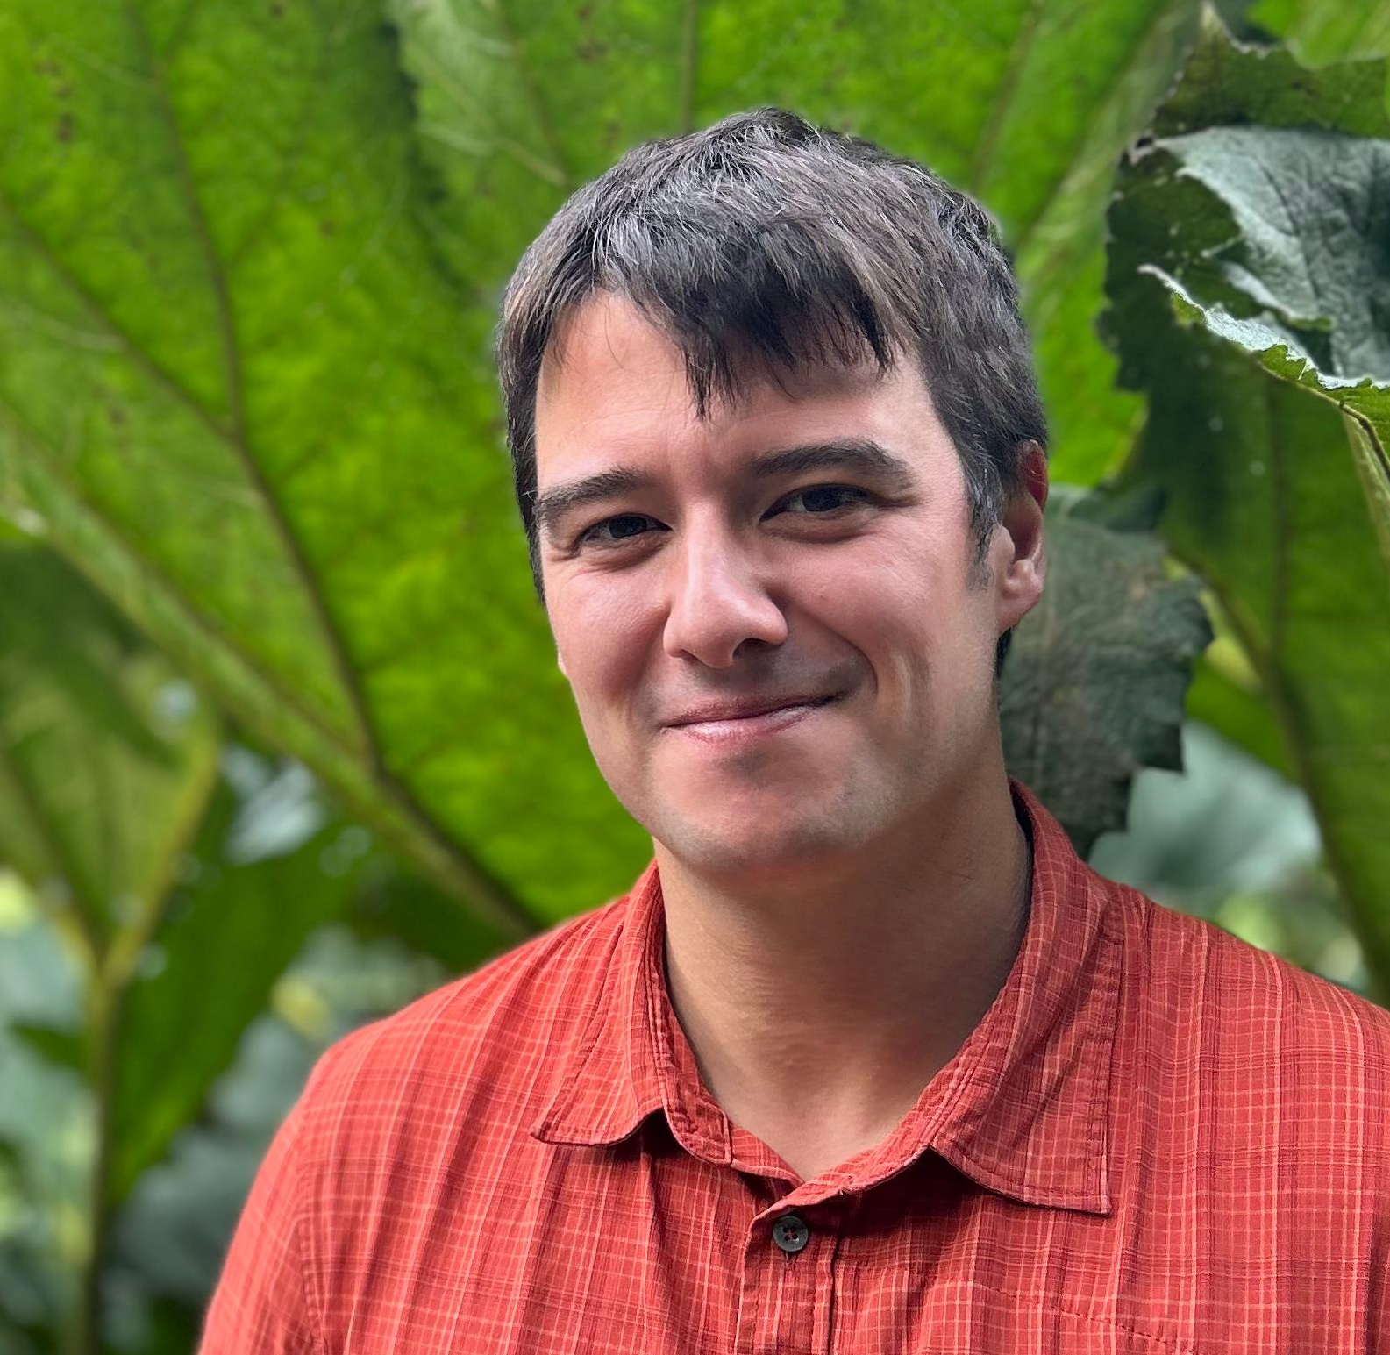

Professional summary
Working full time in various roles since 2012 (13 years of experience): Engineering, robotics, functional analysis of IT projects and grant applications, full stack development and consulting. Master of Engineering (UGENT), experienced in computer science and software development through experience.

Fields of expertise
- Functional analysis and research for IT related projects for web and industry
- Strength in translating business needs to tech solutions; communication on a high level, written and spoken
- Full stack software development (mostly JS/TS/Webstack) for web and industry (SPA’s); including DevOps and containerized (Docker, Docker compose) applications (mircoservices).
- Dutch and English (multi-year experience writing and developing grant applications for innovative IT).
- Cross disciplinary insight: Engineering and IT expertise; as proven in track record
- Engineering, robotics and industrial sensor networks with associated data processing and analysis
- Recent experience and study of AI technologies (as an API consumer: LLM’s. As a data engineer: Neural networks
- with Tensorflow)

Technical skills
- Programming & Frameworks: JavaScript/TypeScript, Python, React, Node.js, Angular, Ember and more
(Less recent: Java/Kotlin, CODESYS programming for PLC)
- DevOps & Deployment: Docker, Docker Compose, Amazon AWS using Terraform (IaC)
- Functional / Analytical Tools: Gitlab, JIRA, Confluence, diagramming software
- Data: SQL, SPARQL, MongoDB, Elastic, RDF triple store (Virtuoso), Jupyter Notebooks
- Engineering & Integration: PLCs, industrial control systems
- Mechanical/electrical interfacing using fieldbuses, some 3D CAD design
- MS Office of course. Especially Word.
- Soft Skills: Bilingual communication at native level, stakeholder alignment, grant application writing, technical documentation writing, product roadmap development, teaching and coaching

Professional experience
Recent: Typescript, Electron, Python, LLM use through API for images and language, Open source project,
- Codifly (08/2022 – 09/2025): Full stack developer and consultant
  - Full stack developer internal: React frontend, NodeJS backend (+PostgreSQL with ORM, GraphQL, TRPC)
  - Different consultancy jobs: Full stack developer, Devops (AWS IaC with Terraform, Docker, Docker compose)
- EY (05/2019 – 08/2022): IT project grant application senior consultant
  - I conceptually engineered large parts of innovative IT projects (translating business requirements into conceptual design for software)
  - Grant application writing in Dutch and English; including development of business plans and roadmaps
- Emergence Innovation: ERRIC (03/2018 – 04/2019): Freelance functional analyst
  - 50%: Freelance functional analyst for IoT project; bridge between management and implementer
  - 50%: Attempt an building commercial robotic behavioral framework
- QBMT/Zorabots (01/2016 – 01/2018): R&D Social robotics software developer
  - Full stack: Python backend with robotic control strategies, AngularJS frontend, Android frontend
  - Functional analysis of behavioral framework for Robot Pepper with Softbank NaoQi integration for vision, navigation, robot movements and android tablet
- Automotion (07/2014 – 12/2015): Motion control systems programmer
  - PLC programming of advanced motion control systems for fast moving machine
  - OPC, SCADA, Sercos III fieldbus devices
- Balta (11/2012 – 06/2014): Junior project and process engineer automation
  - Analysis and modelling latex application and textile printing production processing for improvements
  - PLC programming (IEC 61131-3) including custom built SQL connector library
  - 3D CAD design of metal and stainess parts

Recent and relevant projects
- Politiezone Antwerpen: Full stack development for web apps based on React with multi container backend with elaborate Docker Compose configurations. PostGres and Elastic as a data sources; RabbitMQ for messaging. Very large codebase. Worked specifically on a module which part part of the Focus app called FCM (Focus Case management) which managed heavily configurable casefiles for Police cases by means of declarative/imperative configuration files and adaptable behaviours.
- Agentschap binnenlands bestuur (ABB; Flemish gov.): Full stack development for web apps based on Ember with multi container backend with elaborate Docker Compose configurations. The apps used linked data (RDF, Semantic Web, Graph databases).
- Robotic framework behavior design: Business development as freelancer. Development of robotic behavior framework (before advent of LLM’s) using a mixed stack and containers. Mostly Python and with Softbank Robotic’s NaoQi or ROS (Robot Operating System) in mind.

Education
Higher education: Civil engineering 5-year program @ UGENT
- Master of Engineering (2010-2012): Mechanical construction
- Bachelor of Engineering (2007-2010): ‘Werktuigkunde-Elektrotechniek’ (nl.)
Secondary education: Wiskunde-Wetenschappen (ASO) @ St. Pieterscollege Blankenberge
Online certificate in Java (JVM; Kotlin, Groovy, Maven, ...), various courses (i.e. Datacamp, Courera) for Python, data science and engineering hobby level (Jupyter notebooks, Tensorflow, PyTorch, Pandas, ...)

Languages
- Dutch: Expert (native)  - English: Expert | - French: Functional  - German: Minimal

Hobbies and interests
- Hobby writer of kid’s books for one year  - (i.e. ‘7 Reuzen reeks’ (nl.))  - Interested in the study of using LLM technology for  - literature and diffusion models for illustration | - Hobby DIY; working with wood and Raspberry Pi etc.  - Hobby IT projects (LLM editing React based  - electron application, Open source)  - Sports: Cycling and general fitness
Belgian driving licenses A, B

Contact information
- Tel.: +32 471 99 61 66  - Private e-mail: dennis.vaneecke@gmail.com | - Region Blankenberge, Belgium

