Grille de satisfaction

  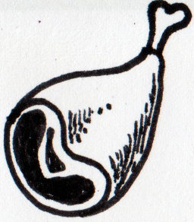  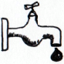  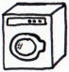    Critères | Tour 1 |  | Tour 2 |  | Tour 3 |  | Tour 4 |  | Tour 5 |  | Tour 6 |  | Tour 7 |  | Tour 8
Espéré / Satisfait | E | S | E | S | E | S | E | S | E | S | E | S | E | S | E | S
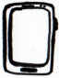
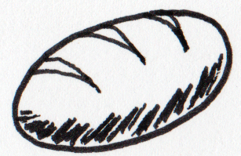
= +
Satisfaction

Population

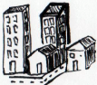
Besoins  :  x 3 = | Limites | par | total
= +
soit | /

Agriculture et assimilés
Zone de captage

Surface totale :
dont construite :
Soit surface de captage :

x3 =
 | Nombre | Coût |  |  |  |  |  | Production
 | Nombre |  | total |  | total |  | total | ou
Champs |  |  |  |  |  |  |  | x7
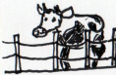  Élevage |  |  |  |  |  |  |  | x3
Total

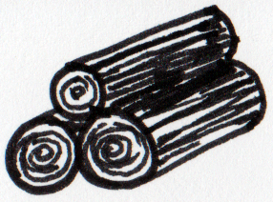
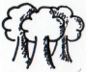
Coûts
Forêt

En construction : =
(délai : 1 tour)

Coupée : =

Production
Extraction

Mines et carrières
Éoliennes

x 5 =

Usure 1
2
3
4
5
6
7

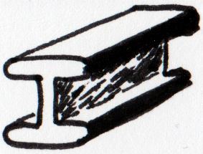  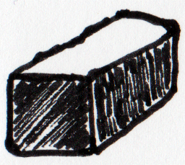  Nom  Coûts  Production | Age |  |  |  |  |  | coût |  |  | Production
Met 1
Met 2
Met 3
Met 4
Car 1
Met 5
Met 6
Met 7
Total
Production
Coûts
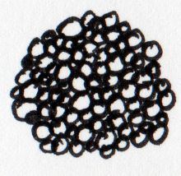  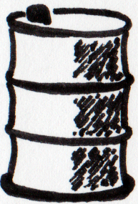  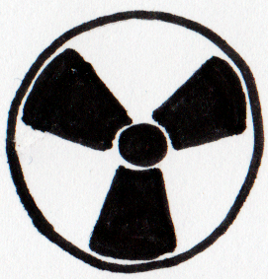  Nom  Production | Age |  |  |  |  | Coût |  |  | Prod. |  |  | Nom | Age |  |  |  |  | Coût |  |  |  | Prod.
Nuc 1 |  |  |  |  |  |  |  |  |  |  |  | EM 1
Raf 1 |  |  |  |  |  |  |  |  |  |  |  | EM 2
Raf 2 |  |  |  |  |  |  |  |  |  |  |  | HiFi 1
Nuc 2 |  |  |  |  |  |  |  |  |  |  |  | HiFi 2
Nuc 3 |  |  |  |  |  |  |  |  |  |  |  | HiFi 3
Nuc 4 |  |  |  |  |  |  |  |  |  |  |  | EM 3
Nuc 5 |  |  |  |  |  |  |  |  |  |  |  | HiFi 4
Raf 4 |  |  |  |  |  |  |  |  |  |  |  | EM 4
Raf 5 |  |  |  |  |  |  |  |  |  |  |  | EM 5
Nuc 6 |  |  |  |  |  |  |  |  |  |  |  | HiFi 5
Raf 6 |  |  |  |  |  |  |  |  |  |  |  | HiFi 6
Nuc 7 |  |  |  |  |  |  |  |  |  |  |  | HiFi 7
Nuc 8 |  |  |  |  |  |  |  |  |  |  |  | EM 6
Nuc 9 |  |  |  |  |  |  |  |  |  |  |  | HiFi 8
Nuc 10 |  |  |  |  |  |  |  |  |  |  |  | EM 7
Raf 7 |  |  |  |  |  |  |  |  |  |  |  | EM 8
Raf 8 |  |  |  |  |  |  |  |  |  |  |  | HiFi 9
Nuc 11
Raf 9
Nuc 12
Nuc 13
Nuc 14
Total |  |  |  |  |  |  |  |  |  |  |  | Total
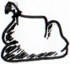
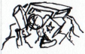
Déchets
x =
enfouissage
valorisation énergétique
recyclage
A enfouirEnfouis Restant
restant + nouveaux
+ + + = + +
x : + + + = + +
+ =
x : + =
Coûts
Production
nouveaux = total – (valorisation énergétique + recyclage)
=
=
/ :
Services
Pollution

Import
Ressource | Tour 1 |  | Tour 2 |  | Tour 3 |  | Tour 4 |  | Tour 5 |  | Tour 6 |  | Tour 7 |  | Tour 8
Ressource | Payé | Arrive | Payé | Arrive | Payé | Arrive | Payé | Arrive | Payé | Arrive | Payé | Arrive | Payé | Arrive | Payé | Arrive
Coût

Ressource | Tour 1 |  |  | Tour 2 |  |  | Tour 3 |  |  | Tour 4 |  |  | Tour 5 |  |  | Tour 6 |  |  | Tour 7 |  |  | Tour 8
Nécessaire / Capacité / Produit | N | C | P | N | C | P | N | C | P | N | C | P | N | C | P | N | C | P | N | C | P | N | C | P
= +


