**A Meta-Analysis of Studies Addressing the Impact of Glyphosate on Human, Animal, and Environment**

**Abstract**

**Introduction**

Chemical herbicides, particularly glyphosate, have become a ubiquitous aspect of modern industrial agriculture. Although glyphosate was discovered as a herbicide in the 1970s, the introduction of glyphosate resistant genetically modified crops in 1994 resulted in a nearly 15-fold increase in global glyphosate usage (Benbrook 2016). Glyphosate usage worldwide grew from approximately 67 million kilograms in 1995 to 826 million kilograms in 2014. Glyphosate, which is also known scientifically as N-(phosphonomethyl) glycine, is the active ingredient in a large number of commercial broad-spectrum systemic herbicides used for weed management. Glyphosate kills broadleaf weeds and grasses that compete with crops.

Monsanto chemists discovered it as a pesticide in 1970 and commercialized it under the trade name Roundup in 1974 for commercial agriculture and home usage (Stong 1990). Over the years, additional commercial/trade names of glyphosate such as Roundup Ultra®, Roundup UltraDRY®, Roundup UltraMAX®, Roundup WeatherMAX®, Touchdown w/IQ®, Cornerstone®, Clearout 41 Plus®, GlyphoMAX®, Glyfos Xtra® and Glyphomax Plus® have been sold on the market.

Glyphosate is an organophosphorus compound that inhibits the enzyme 5-enolpyruvoylshikimate-3-phosphate synthase (EPSPS), which catalyzes the aromatic amino acids tyrosine, tryptophan, and phenylalanine production in plants. Due to the absence of the 5-enolpyruvoylshikimate-3-phosphate synthase (EPSPS) pathway in humans, other mammals, fish, birds, and insects, glyphosate has traditionally been considered harmless to these species when applied in prescribed amounts for plants. Glyphosate based herbicides (GBH ) have been evaluated and approved by regulatory agencies such as the FDA and USDA, as evidenced by numerous published research papers, indicating that they are safe for humans, animals, and the environment (Knox et al 2013; Areal, Riesgo, and Rodrãguez-Cerezo 2013; Séra 2013).

Contrary to safety assurance from regulatory agencies and research, some studies have established that glyphosate interferes with a variety of metabolic processes in plants, animals, and other organisms that contain glyphosate residues. Glyphosate has been shown to disrupt the endocrine system, the balance of gut bacteria, and DNA, and is a known cause of cancer-causing mutations (Bohn et al 2014; Swanson et al 2014). Additionally, the WHO's International Agency for Research on Cancer recently concluded that glyphosate is "probably carcinogenic to humans."

In accordance with this, a group of highly regarded scientists (Myers et al 2016) issued a caution statement regarding emerging science concerning the safety and use of GBH, its mechanisms of action, toxicity in laboratory animals, and epidemiological studies, while considering the derivation of current human safety standards. In 2018, a California court determined and later upheld that Monsanto failed to disclose potential cancer risks associated with its Roundup herbicide and awarded claims that Roundup caused cancer (Glenna and Bruce 2021).

It is therefore necessary to examine why research on the effect of glyphosate on non-target organisms has been inconclusive and why science-based policies for the use and regulation of glyphosate have not developed into a key driver. In doing so, consideration should be given to factors such as the organization from which the research was conducted, funding organizations, the journal in which it was published, and the country in which the experiment was conducted. For instance, it has been demonstrated that public and private science organizations pursue distinct goals and incentives when conducting research, which can have an effect on the outcome (Glenna and Bruce 2021).

This study seeks to identify the determinants of the outcomes of scientific research to date regarding the potentially adverse impacts of GBH on human and animal health and the environment. Understanding the reason why science on this subject has been inconclusive, and was not able to establish itself (science) as the primary driver in formulating science-based policies and regulations is important for not only glyphosate regulation but also other subjects with divergent scientific backed findings.

**Methods**

To ascertain the factors that influence the outcome of scientific research on the potential adverse effects of GBH on human and animal health and the environment, we conducted a systematic review of published studies on the effects of glyphosate-based herbicides on humans, animals, the environment, and non-target organisms. The CrossRef application programming interface (API) was used in conjunction with the Habenero module in Python to search for the term "Glyphosate," followed by the selection of a subset of data that included only entries containing the terms "daily intake", "dose", "risk", "endocrine", "AMPA", "A.M.P.A.", "toxicology", "cancer", "health", "human", and "carcinogen".

Following the search process, a total of 1,523 entries (studies) were generated between 1987 and 2021, of which 503 were deemed appropriate or relevant for inclusion in the meta-analysis. Excluded searches were those that were not original experiments; additionally, studies that did not examine the effect or impact of glyphosate on humans, the environment, animals, or non-target organisms were excluded. The meta-analysis also excluded articles that were comments, responses to editors and authors of original experiments, articles on glyphosate regulatory and legal concerns, and articles reporting on cases of accidental and intentional glyphosate ingestion in medical journals.

This study applies a methodology that, to our knowledge, has not been adopted in conducting meta-analysis, reviews and analyses of this area of research, the Directed Acyclic Graphs (DAGs). The DAG approach has not caught on in the field of social sciences, economics and agricultural economics to be specific even though it presents an avenue to capture critical assumptions that demonstrate the path a researcher perceived the causal relationships (Imbens 2020). A directed acyclic graph (DAG) is a conceptual representation of a series of activities or factors employed to determine contemporaneous causal relationships between variables.

In causal structures, DAGs are used to represent a researchers' a priori hypotheses about the relationships between and among variables. A DAG is a graphic illustration of a graph with directed edges (arrows), linking nodes (variables), and their paths. Computer algorithms generate graphs containing nodes (vertices, variables) and edges between nodes to discover these causal relationships.

Let A, B and C represent nodes which are variables. The edges can be directed or undirected, and they represent a causal relationship between nodes (indicated by the marks). A path is an unbroken sequence of distinct nodes connected by edges; a directed path, such as the path from A to C (A→B→C) follows the edges in the direction indicated by the arrows. An undirected path, such as the A to C path, does not follow the direction of the arrows. Kinship terms are usually employed in the representation of the relationship within a path. If a directed path exists from A to C, then A is C's ancestor and C is A's descendant. In the case of the directed path A→B→C, A is a direct cause or parent of B, and B is a child of A and parent of C, whereas A is an indirect cause or ancestor of C. The node B is an intermediary or mediator variable on the directed route since it is located on the causal path between A and C.

Because no node may have an arrow pointing to itself, and all edges must be directed (contain arrows), DAGs are acyclic (Greenland et al 1999). In other words, there is no permissible directed path from any node to itself. The assumption that causes must come before effects is enforced by these rules. When assessing endogeneity from these graphs, variables with no causal input are exogenous, whereas variables with causal input are endogenous (Spirtes et al., 2000). A DAG is mathematically represented as the conditional independence by the recursive product decomposition, according to Miljkovic et al. (2016):

$$\operatorname{Pr}\left(v_{1},v_{2}…..v_{n}\right)=\prod_{i=1}^{n}{\operatorname{Pr}\left(v_{i}|pπ_{i}\right)}$$

where 𝑃𝑟 is the probability of the variables $\left(v_{1},v_{2}…..v_{n}\right)$. The product operator is denoted by Π, and $pπ_{i}$ denotes the realization of a subset of variables that produce $v_{i}$ in the order (i=1, 2....n). The work of Pearls’ (1995) on d-separation allows independencies and causes to be visually expressed. d-separation is a criterion for determining if a set A of variables is independent of another set B, given a third set C, given a certain causal network.

The concept is to identify "dependency" with "connectedness" (the presence of a connecting channel) and "independence" with "unconnected-ness" or "separation." Pearl (1995) suggests d-separation as a graphical representation of conditional independence. In other words, d-separation characterizes the conditional independence relations defined by the equation. If we construct a directed acyclic graph in which the variables corresponding to $pπ_{i}$ are represented as the parents (direct causes) of $v_{i}$, we may read off the graph the independencies suggested by the equation using the concept of d-separation (Pearl, 1995).

The DAGs in this study were created using the PC and Parallel PC algorithm methods implemented in Python. These two algorithms were selected because they enable us to determine the reliability of the directions and relationships in the data provided by the PC algorithm. The PC algorithm is broken into two phases: first, it learns a skeleton graph from data consisting entirely of undirected edges, and secondly, it orients the undirected edges to construct an equivalence class of DAGs (Spirtes et al 2000). The theoretical underpinning of the PC algorithm is that if there is no connection (edge) between nodes X and Y, then there exists a set of vertices Z that are either neighbors of X or Y and hence independent of X and Y. In other words, Z disassociates X and Y. The PC algorithm begins with a fully linked network and determines whether an edge should be eliminated or preserved using conditional independence tests. The PC algorithm determines the independence of two variables connected by an edge, X and Y, conditional on a subset Z of all X and Y's neighbors.

However, there are two significant drawbacks to the PC algorithm, particularly when applied to large biological datasets: the runtime of the PC algorithm, which is exponential in terms of the number of nodes (variables) when applied to high-dimensional datasets such as gene expression datasets, which was not a concern in our investigation. Second, the outcome of the PC method is variable ordered dependent, i.e. the result may change depending on the order of the variables in the input dataset. Colombo et al. (2012) demonstrated experimentally that approximately 40% of the edges (2000 edges) learned from a real gene expression dataset are not stable, i.e. these edges exist in less than half of the results produced with all possible node orderings.

To overcome this, the concept of parallelism has been employed, which is the process of breaking down a large work into several smaller subtasks and distributing them across multiple cores of the computer's CPU to perform in parallel. After that, the outcomes of all subtasks will be combined to make the outcome of the main task. The parallel PC algorithm suggested technique parallelizes the CI tests inside each level of the stable PC algorithm, not across levels. This approach is practical because conditional independence tests (CI) at a given level are self-contained. Because the graph is updated only at the conclusion of each level, the result of one CI test has no effect on the results of the others. As a result, the CI tests at a given level can be run concurrently without affecting the final outcome. Additionally, this approach has the advantage of pre-determining the number of CI tests for each level. This distributes the CI tests evenly over the available cores, allowing the parallelized approach to achieve the highest feasible speedup.

**Results**

The amount of research into the impact of GBH has expanded dramatically in recent years due to the importance of food safety (Zyoud et al 2016), as evidenced by this study, with fewer than ten publications per year prior to 2005 and 67 studies included in 2020. Three hundred and seventy-six studies, or 74.8 percent, reported that GBH could have adverse effects on humans, non-target creatures, or/and the environment, while 25.2 percent reported that GBH had no adverse effect; thus, when used at recommended doses, are considered safe for humans, animals, non-target creatures, and the environment. A total of 281 studies (55.86 percent) studied the impacts or effects of GBH on non-target species and the environment in general, including other plants, aquatic organisms, rodents, bees, and microorganisms. The human impact research examined any associations with cancer, hormonal abnormalities, and any other potential harm to human health that GBH may provide. The daily intake of glyphosate in food and water was examined in 14 of the 503 studies.

**Average Outcome of Research Institution**

In general, university researchers were the most active in conducting research on the impacts of GBH, followed by public institutions such as regulatory agencies and state-funded research organizations. Private sector affiliations organizations included laboratories, research institutions, and companies producing agricultural chemicals. Groups recognized as anti-glyphosate or producers of agricultural chemicals were identified in this category. Even though international agencies such as the European Food Safety Authority were identified, they comprise a minuscule component of the study hence dropped out.

The study acknowledges that some studies involve multiple authors from various institutions. To address this, we choose to identify each author's affiliation based on publicly available information in papers and to display all types of institutions per study. In all, 87.87 % of studies had at least one author who was linked with a university, followed by public and private institutions at 20.08 % and 4.72 %, respectively. As shown in a breakdown of the average outcome (adverse or no adverse effect), studies having at least one author from a university had the highest average outcome of 75.57 %, suggesting GBH had a detrimental effect on non-target organisms. This was followed by articles authored by individuals affiliated with public institutions, with 64.36 % of outcomes indicating that GBH had a variety of adverse effects. Private institution-based studies had the lowest average outcome or adverse impacts, with only 32% of their research indicating a negative effect of GBH.

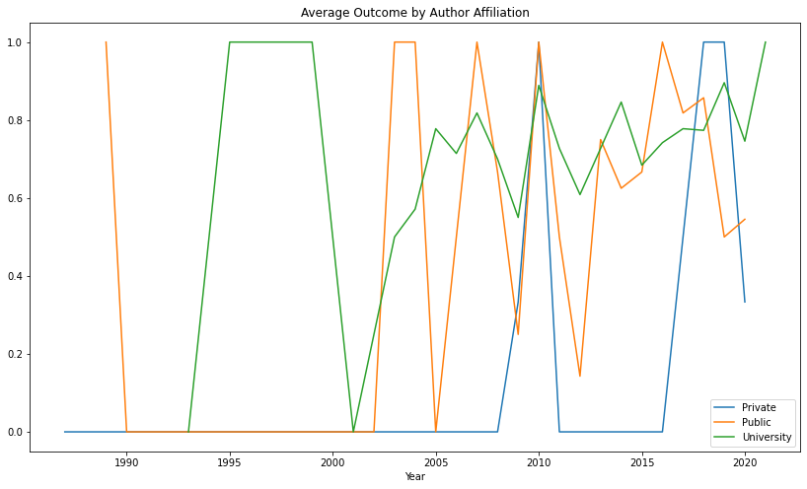

Figure Average Outcome per Institution of Study

To shed more light on the evaluation of study results by author affiliation, we present Figure 1, which depicts the progression of the major types of affiliation institutions and their associated outcomes across the time of analysis. The figure depicts a graph that exhibits a general upward trend throughout time. This is particularly noticeable in studies conducted with university-based authors after the year 2000. This is also true for research authored by members of public institutions. This is not the case with studies conducted by writers from private organizations, which generally have a negligible, if any, harmful effect. Previous research has proven that an author's affiliation with or the venue of a study, such as public or private research organizations, might influence the study's conclusion, as they seek various aims and incentives when conducting research (Glenn and Bruce, 2021)

**Average Outcome of Various Funding Sources**

In research, funding sources are a critical component of the study's outcome. Resnik (2000) asserts that there has been growing concern about the influence of financial interests and financing sources in research. Recent publications require writers to disclose the sources of financing for their research and disclose any potential conflicts of interest. While others have argued that conflicting interests could jeopardize research and outcomes, this analysis focuses exclusively on the average outcome by funding source. Our study identified the primary funding sources as public, university, private, and international, in descending order. For the purposes of this study, university sources of funding were defined as funding sources from a university or a department. While we recognize that these sources could ultimately come from public, private, or international sources, we stick with university sources because these were what was available and acknowledged during data extraction from the analyzed studies. Additionally, a study can be funded by multiple sources, with some studies disclosing no funding source at all, which has been incorporated into the analysis and discussion.

61.14 percent of the research included in this meta-analysis were funded by public sources. This was followed by university funding, which accounted for 24.65 percent of studies, and business sector funding, which accounted for 10.14 percent. This is congruent with the reality that governments have been the largest source of funding for research and development since World War II (Resnik 2000), indicating the importance of balancing privately funded research and increasing public input into government funding decisions. Our findings indicated that university-funded studies had the highest average outcome of 80.65 percent, showing that GBH had a detrimental influence. Additionally, 77.67 percent of studies supported by public monies proved that GBH was toxic to non-target organisms. Private financing funded 60.78 percent of research that found GBH had a negative effect on non-target organisms, which is a relatively low rate compared to other funding sources. This substantially higher outcome for funding sources compared to author of affiliation could be explained by the fact that public funds are important in financing, particularly co-financing, thus offsetting the effects of private funding.

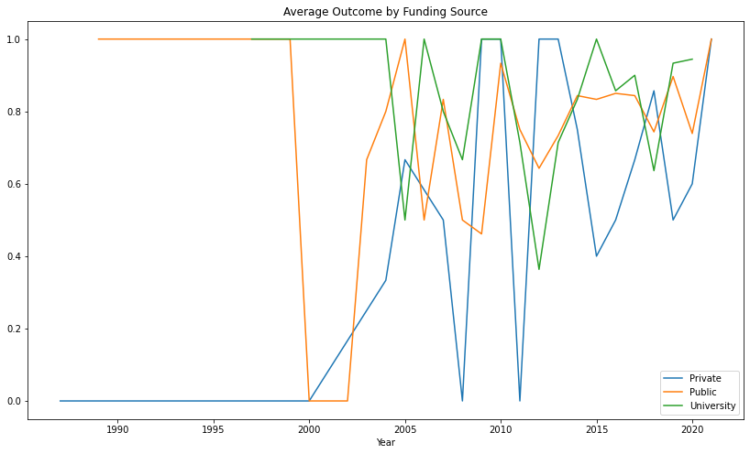

Figure Average Outcome of Various Funding Sources

In Figure 2, we also included a historical trend analysis of the average outcome for the various major financing sources. Prior to 2000, university and public sources tended to have high averages, implying that the majority of research had unfavorable outcomes, in contrast to private sources, which tended to have no negative effect. After 2000, the results have been mixed, but the increased trend in funding sources, particularly university and public monies, indicates that these funding sources are producing outputs revealing the adverse effect of GBH on non-target organisms. Private finance has seen a wave of volatility but is now converging to the top, signalling a reversal of previous outcomes. These findings can be attributed to the pursuit of various objectives and motivations for sponsoring and conducting research, as demonstrated by the financing organizations in this case, a public institution and commercial organizations (Glenn & Bruce 2021).

**Average Outcome of Countries**

Some countries stood out for their productive research into the effects of GBH. The country of origin was defined as the country in which the study was conducted, even if the authors were from a different country. Brazil was the top country, accounting for 102 (20.3 %) of the papers evaluated. Argentina (79; 15.7 %), the United States of America (63; 12 %), Canada (30; %), and France (24; 4.8%) rounded out the top five leading countries. Zyoud et al. (2016) found these five countries as the major producers of research into glyphosate safety in their bibliometric analysis, albeit in a different order. India had the highest average outcome of 90%, followed by Argentina, France, China, and Brazil with 88.61 %, 87.5 %, 86.36 %, and 80.39 % of studies revealing GBH had detrimental impacts, respectively. The remaining top ten most productive countries had over 70% of research suggesting detrimental effects, except for the USA and Canada, which had 55.55 % and 43.33 % of studies indicating adverse effects on non-target organisms, respectively.

To gain additional insight, we studied the average outcome for nations in two time periods, prior to and following 2010, and showed the results in Figure 3 with countries scaled by the average impact factor of studies conducted in the countries. According to our analysis, the majority of countries in the top ten have shifted slightly upward, showing a shift in the outcome of research following 2010. Among these is the instance of the United States of America and Canada; previous to 2010, the United States of America recorded only 25% of its research as having a harmful effect, compared to 69.77 % after 2010. Canada also noted an increase in the proportion of studies reporting harmful impacts, from 37.5% prior to 2010 to 45.45% following 2010.

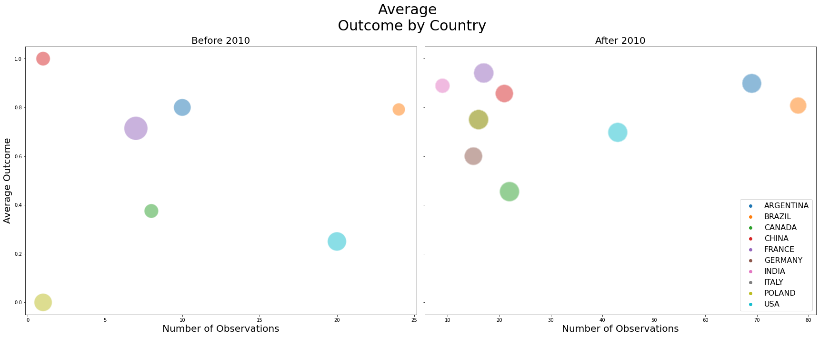

Figure Average Outcome of Top 10 Countries Scaled by Average Impact Factor of Journals of Studies

**Average Outcome of Journals**

The study investigated the average outcome for journal of publications. In doing so, it is critical to examine the journals that published the most papers included in this meta-analysis. The top five leading journals were Ecotoxicology and Environmental Safety (7.4%), Bulletin of Environmental Contamination and Toxicology (6.4 %), Aquatic Toxicology (4.6 %), Environmental Toxicology and Pharmacology (4.6%), and Planta Daninha (4.6%). Zyoud et al. (2016) found four of these top five journals as the most productive in their bibliometric analysis of GBH global intoxication research production from 1978 to 2015.

Additionally, we investigated the average outcome for the top journals in two time periods, prior to and following 2010, and showed the results in Figure 4 with journals scaled by the impact factor of the journal. According to our analysis, the majority of top journals increased somewhat in terms of the number of observations in the meta-analysis, indicating a change in the outcome of research following 2010, just as other metrics examined in this study did.

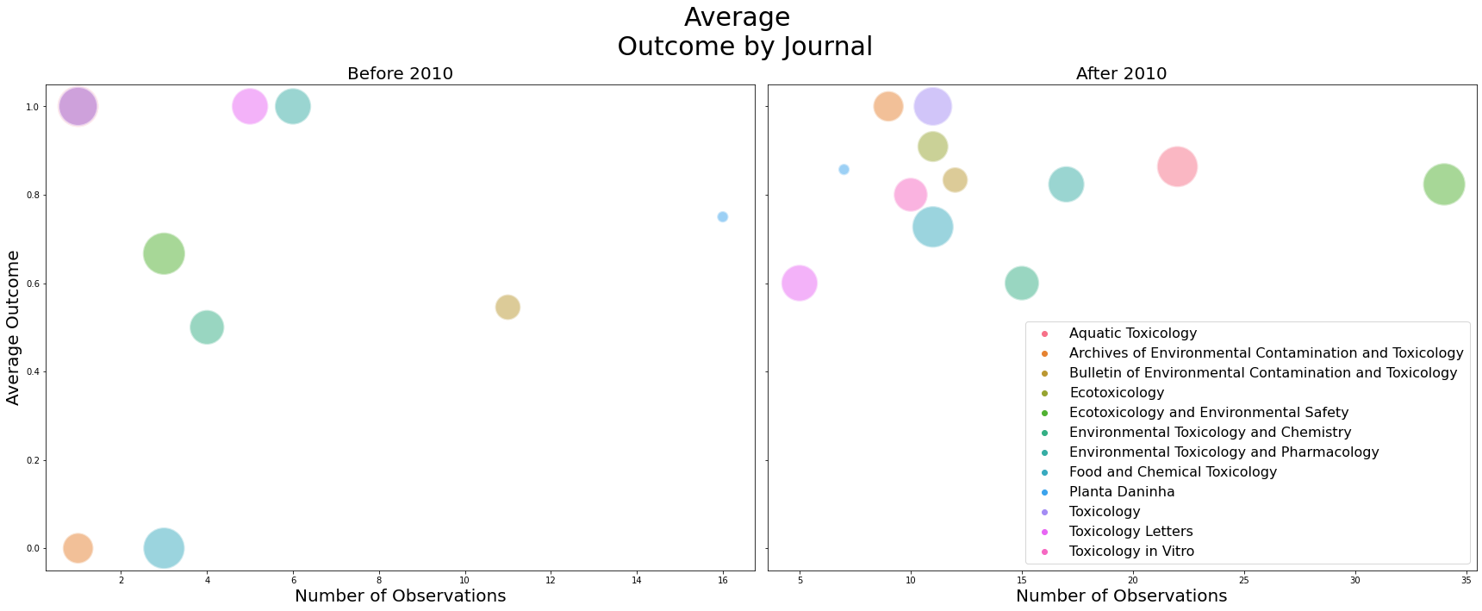

Figure Average Outcome for Top 10 Most Observed Journals Scaled by Average Impact Factor

To provide more general insight for all the papers included for the study, figure 5 was computed which presents studies by the impact factor of journals in which they were published for two-time frames (before 2010 and after 2010) by the general outcomes. This provides insight on the outcome per the influence of the journal being published in. The impact factor of a journal is a good measure of the quality and impact of the journal. The journals with the highest impact factors whose papers were considered for the meta-analysis include, Proceedings of the National Academy of Sciences (9.423), Journal of the National Cancer Institute (9.702), Water Research (9.15), Environmental Health Perspectives (8.326), and Environment International. These were high impact journals in their field. Publications in such journals are considered to be from authorities in a field and contribute to knowledge in that field.

As consistent with earlier analysis outcomes of adverse effect were more and evenly spaced across impact factors from about 1.00 to 4.00. More studies from journals with impact factor between 0.00 (journals with no impact factor) and 1.00 recorded that GBH had no adverse effect to non-target organisms. After 4.00 impact factor 2 journals each recorded adverse and no adverse effect of GBH.

After 2010, it can be concluded that studies on impact of GBH were published in higher impact journals since it had become a topical issue of scientific concern. Studies concluding that GBH had adverse effects where evenly distributed in journals with impact factor from 0.00 to about 5.00 after which few studies from 5.00 to 7.00 and 3 studies from journals with impact factor above 7 recorded adverse effect. Studies with no adverse effect were also evenly distributed even though less dense from journals with impact factors 0.00 to about 6.00 after which 4 studies were published in journals with impact factor between 7.00 and 9.00. Figure 5 provides the distribution of this analysis which shows no identifiable pattern.

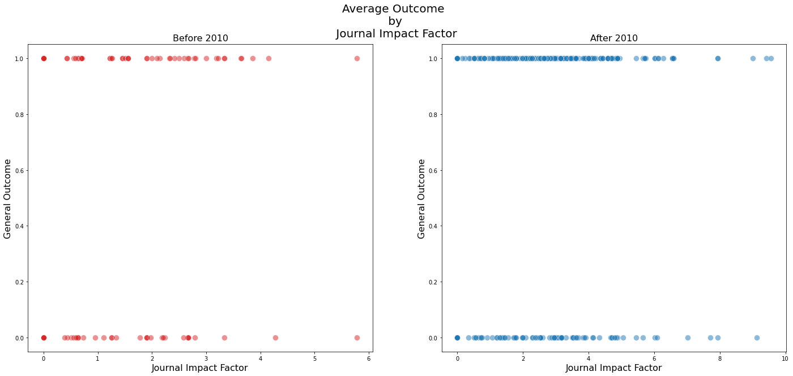

Figure 5 General Outcome for Studies and the Impact Factor of Journals Published in

According to Aksnes et al (2019), the number of citations is a good measure of the quality, importance, and impact of research or study in a field of study. The mean number of citations for the studies included in the study was 44, the least cited studies had no citation at all, and the highest being 691 citations, this meant the number of citations of the articles used in the current study were fairly cited. It is however important to note that the median number of citations was 17 which is much lower than the mean and presents a better estimation of central tendency due to a few studies having very high citations. From 6, the most cited papers were recorded adverse effect of GBH on non-target organisms during both time frames considered for the studies. This could be partially considered as papers which provided robust procedures, and conclusions to point that GBH had adverse effect received more attention from peers and hence were cited more often.

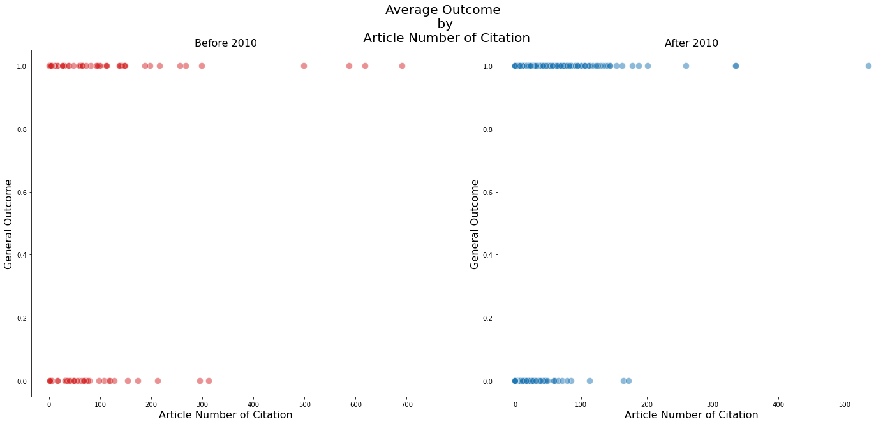

Figure 6 General Outcome of Studies and their Number of Citations

Results from DAGs

Conclusions

Data availability

Code availability

References

Acknowledgements

Author Information

Ethics declarations

Additional Information

Extended data figures and tables

Supplementary information

Rights and permissions

About this article

Comments