LANDS COMMISSION

CLIENTS DETAILS: Kodjo Barnor

CLIENTS NAME(s) Kodjo Barnor

GENDER: Male

NATIONALITY: Ghanaian

CELL PHONE NUMBER: 0244482229

RESIDENTIAL ADDRESS: Abgobga, Fitting Shop

ID TYPE: Passport

ID NUMBER: G2551945

E-MAIL: kodjobarnor@gmail.com

POSTAL ADDRESS: MD 202 Madina, Accra

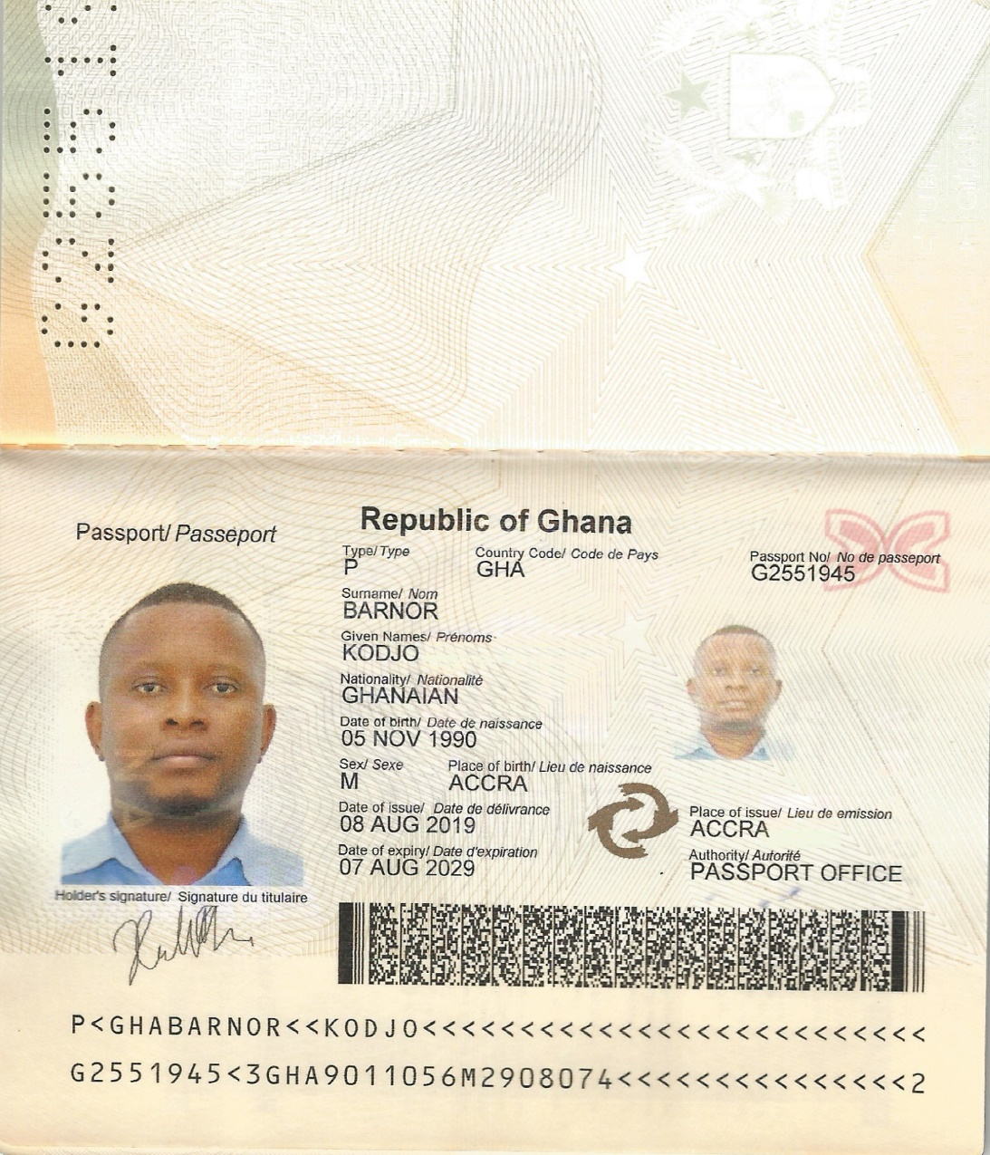

…………………………………………….

For Regional Lands Officer