The amount of research into the impact of GBH has expanded dramatically in recent years due to the importance of food safety (Zyoud et al 2016), as evidenced by this study, with fewer than ten publications per year prior to 2005 and 67 studies included in 2020. Three hundred and seventy-six studies, or 74.8 percent, reported that GBH could have adverse effects on humans, non-target creatures, or/and the environment, while 25.2 percent reported that GBH had no adverse effect; thus, when used at recommended doses, are considered safe for humans, animals, non-target creatures, and the environment. A total of 281 studies (55.86 percent) studied the impacts or effects of GBH on non-target species and the environment in general, including other plants, aquatic organisms, rodents, bees, and microorganisms. The human impact research examined any associations with cancer, hormonal abnormalities, and any other potential harm to human health that GBH may provide. The daily intake of glyphosate in food and water was examined in 14 of the 503 studies.

In general, university researchers were the most active in conducting research on the impacts of GBH, followed by public institutions such as regulatory agencies and state-funded research organizations. Private sector affiliations organizations included laboratories, research institutions, and companies producing agricultural chemicals. Groups recognized as anti-glyphosate or producers of agricultural chemicals were identified in this category. Even though international agencies such as the European Food Safety Authority were identified, they comprise a minuscule component of the study hence dropped out.

The study acknowledges that some studies involve multiple authors from various institutions. To address this, we choose to identify each author's affiliation based on publicly available information in papers and to display all types of institutions per study. In all, 87.87 % of studies had at least one author who was linked with a university, followed by public and private institutions at 20.08 % and 4.72 %, respectively. As shown in a breakdown of the average outcome (adverse or no adverse effect), studies having at least one author from a university had the highest average outcome of 75.57 %, suggesting GBH had a detrimental effect on non-target organisms. This was followed by articles authored by individuals affiliated with public institutions, with 64.36 % of outcomes indicating that GBH had a variety of adverse effects. Private institution-based studies had the lowest average outcome or adverse impacts, with only 32% of their research indicating a negative effect of GBH.

To shed more light on the evaluation of study results by author affiliation, we present Figure 1, which depicts the progression of the major types of affiliation institutions and their associated outcomes across the time of analysis. The figure depicts a graph that exhibits a general upward trend throughout time. This is particularly noticeable in studies conducted with university-based authors after the year 2000. This is also true for research authored by members of public institutions. This is not the case with studies conducted by writers from private organizations, which generally have a negligible, if any, harmful effect. Previous research has proven that an author's affiliation with or the venue of a study, such as public or private research organizations, might influence the study's conclusion, as they seek various aims and incentives when conducting research (Glenn and Bruce, 2021)

Fig 1

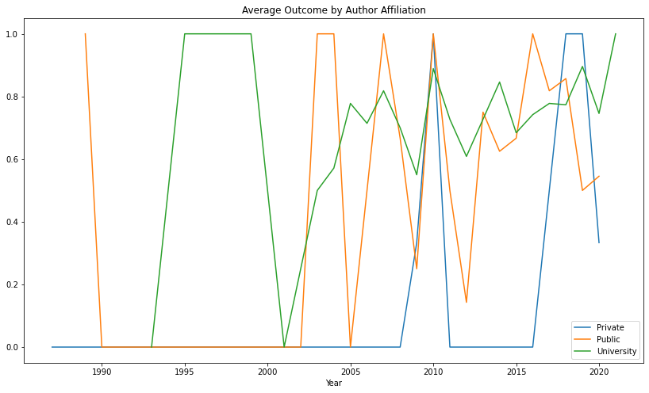

In research, funding sources are a critical component of the study's outcome. Resnik (2000) asserts that there has been growing concern about the influence of financial interests and financing sources in research. Recent publications require writers to disclose the sources of financing for their research and disclose any potential conflicts of interest. While others have argued that conflicting interests could jeopardize research and outcomes, this analysis focuses exclusively on the average outcome by funding source. Our study identified the primary funding sources as public, university, private, and international, in descending order. For the purposes of this study, university sources of funding were defined as funding sources from a university or a department. While we recognize that these sources could ultimately come from public, private, or international sources, we stick with university sources because these were what was available and acknowledged during data extraction from the analyzed studies. Additionally, a study can be funded by multiple sources, with some studies disclosing no funding source at all, which has been incorporated into the analysis and discussion.

61.14 percent of the research included in this meta-analysis were funded by public sources. This was followed by university funding, which accounted for 24.65 percent of studies, and business sector funding, which accounted for 10.14 percent. This is congruent with the reality that governments have been the largest source of funding for research and development since World War II (Resnik 2000), indicating the importance of balancing privately funded research and increasing public input into government funding decisions. Our findings indicated that university-funded studies had the highest average outcome of 80.65 percent, showing that GBH had a detrimental influence. Additionally, 77.67 percent of studies supported by public monies proved that GBH was toxic to non-target organisms. Private financing funded 60.78 percent of research that found GBH had a negative effect on non-target organisms, which is a relatively low rate compared to other funding sources. This substantially higher outcome for funding sources compared to author of affiliation could be explained by the fact that public funds are important in financing, particularly co-financing, thus offsetting the effects of private funding.

In Figure 2, we also included a historical trend analysis of the average outcome for the various major financing sources. Prior to 2000, university and public sources tended to have high averages, implying that the majority of research had unfavorable outcomes, in contrast to private sources, which tended to have no negative effect. After 2000, the results have been mixed, but the increased trend in funding sources, particularly university and public monies, indicates that these funding sources are producing outputs revealing the adverse effect of GBH on non-target organisms. Private finance has seen a wave of volatility but is now converging to the top, signaling a reversal of previous outcomes. These findings can be attributed to the pursuit of various objectives and motivations for sponsoring and conducting research, as demonstrated by the financing organizations in this case, a public institution and commercial organizations (Glenn & Bruce 2021).

Figure 2

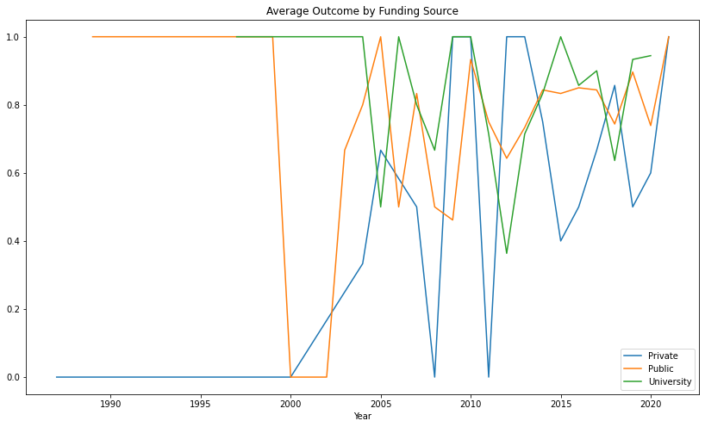

Some countries stood out for their productive research into the effects of GBH. The country of origin was defined as the country in which the study was conducted, even if the authors were from a different country. Brazil was the top country, accounting for 102 (20.3 %) of the papers evaluated. Argentina (79; 15.7 % ), the United States of America (63; 12 % ), Canada (30; % ), and France (24; 4.8% ) rounded out the top five leading countries. Zyoud et al. (2016) found these five countries as the major producers of research into glyphosate safety in their bibliometric analysis, albeit in a different order. India had the highest average outcome of 90%, followed by Argentina, France, China, and Brazil with 88.61 %, 87.5 %, 86.36 %, and 80.39 % of studies revealing GBH had detrimental impacts, respectively. The remaining top ten most productive countries had over 70% of research suggesting detrimental effects, except for the USA and Canada, which had 55.55 % and 43.33 % of studies indicating adverse effects on non-target organisms, respectively.

To gain additional insight, we studied the average outcome for nations in two time periods, prior to and following 2010, and showed the results in Figure 3 with countries scaled by the number of observations. According to our analysis, the majority of countries in the top ten have shifted slightly upward, showing a shift in the outcome of research following 2010. Among these is the instance of the United States of America and Canada; previous to 2010, the United States of America recorded only 25% of its research as having a harmful effect, compared to 69.77 % after 2010. Canada also noted an increase in the proportion of studies reporting harmful impacts, from 37.5% prior to 2010 to 45.45% following 2010.

Figure 3

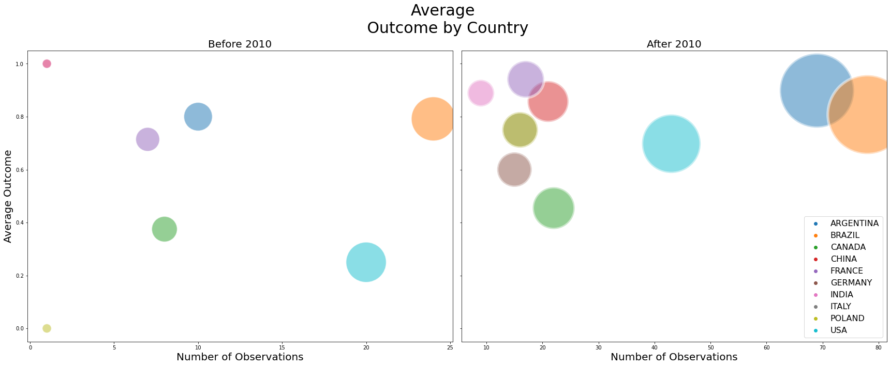

Additionally, it is critical to examine the journals that published the most papers included in this meta-analysis. The top five leading journals were Ecotoxicology and Environmental Safety (7.4%), Bulletin of Environmental Contamination and Toxicology (6.4 %), Aquatic Toxicology (4.6 %), Environmental Toxicology and Pharmacology (4.6%), and Planta Daninha (4.6%). Zyoud et al. (2016) found four of these top five journals as the most productive in their bibliometric analysis of GBH global intoxication research production from 1978 to 2015. Additionally, we investigated the average outcome for the top journals in two time periods, prior to and following 2010, and showed the results in Figure 4 with journals scaled by the number of observations. According to our analysis, the majority of top journals increased somewhat in terms of the number of observations in the meta-analysis, indicating a change in the outcome of research following 2010, just as other metrics examined in this study did.

Figure 4

