FitArchive – Project Write-up

By Xorpax

December 2024

Project Contents

Table of Contents
1. Project Overview 3
Abstract 3
2. Core Features 3
Introduction 3
Core Features 4
User Interface 4
3. Implementation Highlights 6
Technology Stack 6
Design Decisions 7
4. Project Development and Testing 7
Development Workflow 7
Feature Prioritisation 7
5. Future Enhancements and Concerns 7
6. Conclusion 7

1. Project Overview

Abstract

FitArchive is a personal project that aims to create a desktop application for tracking your exercise progress. While working to improve my physical health, I found that using a notebook and pen to log my workouts is only useful in the short term. It became increasingly difficult to continue writing down new personal records in an organised manner without running out of space. FitArchive will help me address this issue by saving my workout data and analysing it in an easy-to-digest way.

This app focuses on providing a platform to organise the information you require for your workouts, as well as giving the users the ability to track and visualise their progress. By automating chart creation and calculations, it frees up time that would otherwise be spent on manual calculations. The interface of FitArchive is interactive and includes all the essential functionalities needed to track progress, with an emphasis on simplicity and clean design to ensure ease of navigation for all users.

The application is developed in Python, as it is the programming language I am most proficient in, allowing me to bring the best version of FitArchive to life. All workout data is stored in a plain text CSV file. The primary libraries used in the development of FitArchive include Pandas for data manipulation, and CustomTkinter for the GUI.

2. Core Features

Introduction

Since FitArchive will be a GUI-based application designed with simplicity in mind, a significant focus will be placed on the user interface (UI). The goal is to provide an intuitive and straightforward experience, ensuring that even non-technical users can easily navigate and make full use of FitArchive’s features. The application will prioritise functionality while maintaining user-friendly and essential visuals.

Core Features

The primary functions of FitArchive are designed to track and manage workout data entered by the user, while offering easy-to-understand visualisation methods.

1. Workout logging:
- Users will be responsible for creating their track record for individual exercises. This consists of number of reps (repetitions), sets, weight used (optional), duration (optional), date, and more.
- This data will be stored in a plaintext CSV format, enabling easy manipulation and analysis using the Pandas library.
- Each workout will have its own section that allows for creating notes of any kind to help the users save any important information related to each exercise.
2. Progress tracking
- FitArchive will track key performance metrics over time, such as personal bests, number of workouts completed, and total volume lifted. This feature provides users with an ongoing record of their fitness journey, allowing them to see improvements in their performance and identify patterns.
3. Operations on workout data
- The application will offer different features which will be separated. The data can be viewed in an easy-to-read formatted way.
- Users will have the ability to choose from a variety of visualisation techniques for each exercise, including pie charts, bar charts, line charts, and more.

4. Goal setting and tracking
- FitArchive allows users to set fitness goals, whether they are based on increasing weights, repetition, or the number of workouts per week.
- This feature enables users to monitor their progress towards their goals and make adjustments to their training regimen as needed.

User Interface

Having a comprehensive yet simple interface is pivotal for FitArchive. The application is purely GUI-based, requiring a strong emphasis on user interface design. It needs to look appealing and be easy on the eyes. Given that users will likely engage with the app frequently, the design aims to reduce eye fatigue by implementing a dark theme. This ensures a comfortable viewing experience during extended usage while maintaining an aesthetically modern look.

The main layout of the application is as follows:
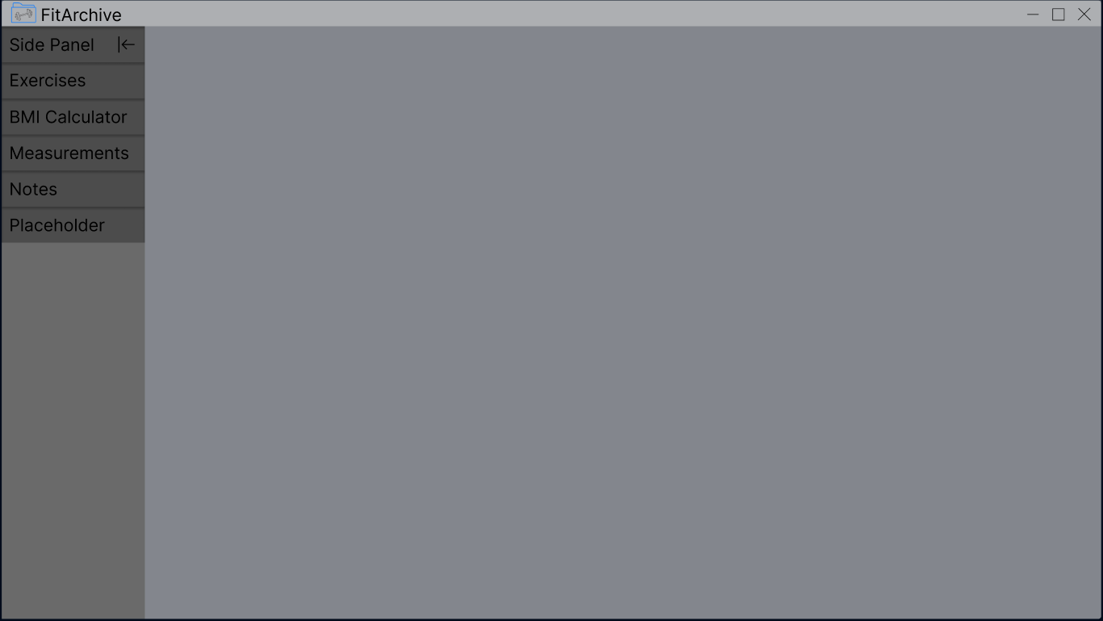

A side panel on the left-hand side will provide easy access to FitArchive’s features. This is done to declutter the main screen, which will focus on displaying one function at a time, creating a clear, focused view on the current task.

The side panel can be collapsed to minimise the space it occupies on the screen, providing users with more room to focus on the main task.

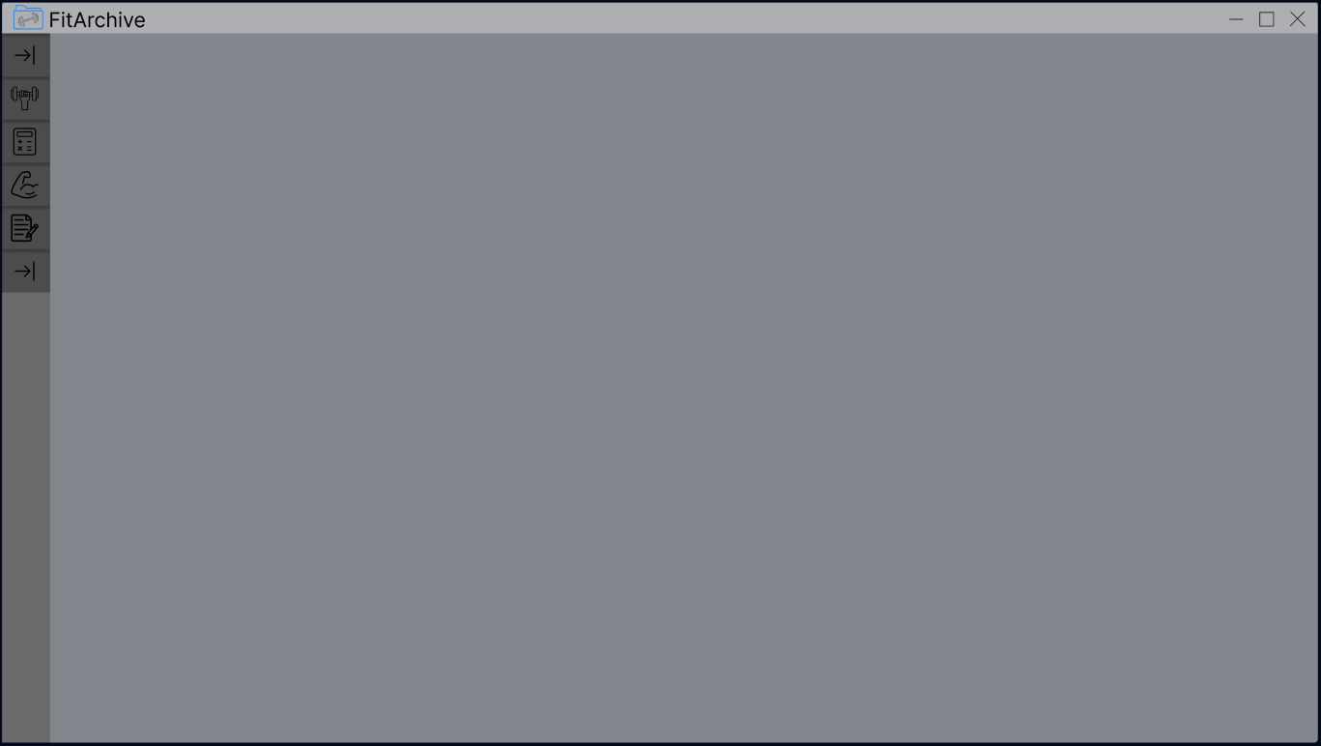
Adding new entries will be simple as selecting the appropriate entries that the user wants to include. This ties into the design philosophy of simplicity. For instance, adding an exercise could be kept separate from uploading exercise data to emphasise modularity and maintain clear separation of features.

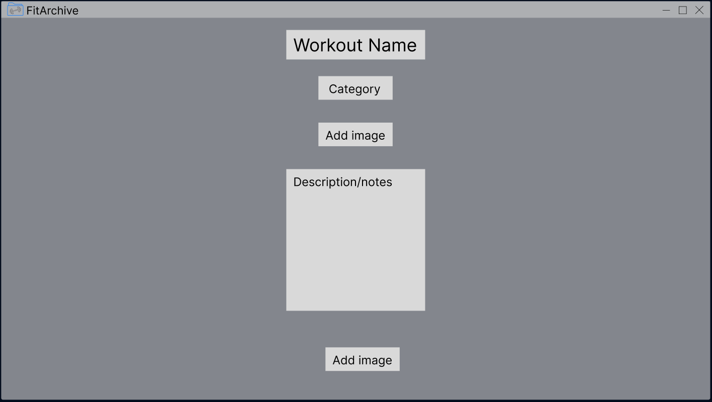
In summary, the UI will prioritise simplicity and ease of use, ensuring that users can easily navigate through the application. By modularising features and keeping the design clean, FitArchive aims to provide an intuitive and focused experience, making fitness tracking as seamless as possible.

3. Implementation Highlights
This section highlights the technology used to deliver FitArchive and explains the reasons for their selection.

Technology Stack
FitArchive is built using Python due to its simplicity, versatility and my existing knowledge of the language. Key technologies include:
- Pandas: This powerful library was chosen for managing exercise data, as it provides tools for handling and manipulating data stored in CSV format efficiently.
- CustomTkinter: Modern implementation of Tkinter proven useful in my past projects. It is used to build modern and clean graphical user interface (GUI), enabling a clean, user-friendly, and responsive design.
- Matplotlib: Incorporated to generate informative visualisations like graphs and charts, providing users with a clearer view of their workout progress.

Design Decisions
- The use of CSV file format for storage of exercise data was chosen due to its simplicity and ease of manipulation. Furthermore, it makes exporting and importing the data straightforward.
- CustomTkinter was selected for GUI development as it enables creating modern-looking interfaces with ease, and because I am already familiar with it and Tkinter.
These technologies and design choices lay the foundation for FitArchive’s development. As the project progresses, further refinements will be made to enhance functionality and user experience, but the current stack provides a strong base for building the application’s core features.

4. Project Development and Testing

Development Workflow
The development approach for FitArchive is an agile methodology, which aligns with my past experience and has proven effective for managing iterative development. This approach allows for more flexibility, enabling me to focus on core functionalities first and continuously improve the application based on testing and feedback.
This section will showcase the development process and the production code along with issues encountered during this process. I will use screenshots and/or codeblocks for reference.

Feature Prioritisation
When the idea for FitArchive came to life, the main features included adding exercises and their scores, i.e. weights used, reps, dates and more. The data would then be used to compare and assess personal bests over time. As the project has progressed, the plan has expanded to include additional features, such as a BMI calculator and data visualisation. Despite this, the priority remains with the original features, which I will build upon to eventually create a full fitness tracker.

Development

5. Future Enhancements and Concerns

6. Conclusion

