电子科技大学2016-2017学年第二学期期 末 考试 卷
考试科目： 数字逻辑设计及应用 考试形式：闭卷 考试日期： 2017 年 月 日
成绩构成比例：平时 40 %， 期中 20 %， 实验 0 %， 期末 40 %
本试卷由 九 部分构成，共 8 页。考试时长： 120 分钟 注： 不可使用计算器
题号 | 一 | 二 | 三 | 四 | 五 | 六 | 七 | 八 | 九 | 合计
得分

试题中涉及的MSI器件功能表见最后的附录（Appendix）。
得 分

一、单项选择题I（每小题2分，共12分）

1）A digital signal is . ( B )
A. a discrete signals in time B. a signal that is discrete both time and value
C. a discrete signal on the value D. a signal that is not discrete in time and value
2）In the following circuits, only is a combinational logic circuit. ( D )
A．flip-flop B．counter C．register D．decoder
3）Which of the following statements is correct? ( A )
A. The outputs of a Mealy machine depend on inputs as well as the states.
B. The outputs of a Mealy machine depend only on the states.
C. The outputs of a Moore machine depend on inputs as well as the states.
D. All of the above are wrong.
4）In the following latches or flip-flops, only can be used to form a shift register. ( A )
A. edge-triggered J-K flip-flop B. S-R latch with enable
C. S-R latch D. D latch
5）To implement a frequency divider（分频器） with a 1MHz input signal and a 1KHz output signal, requiring at least flip-flops. ( C )
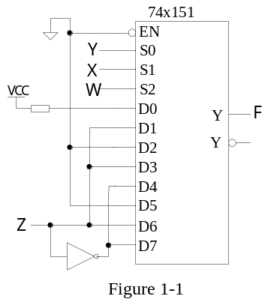A. 8 B. 9 C. 10 D. 11
6）The logical expression of the circuit shown in Figure 1-1
is ( C )。
A．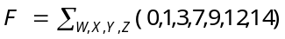
B．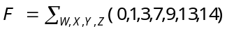
C．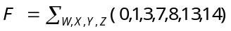
D．All of the above are wrong.

得 分
二、填空题（每小题3分，共18分）

- The logical expression corresponding to the hazard-free circuit that can realize the same logical function as
F = B'C'+ AC + A'B is（ F= B'C'+ AC + A'B+ BC+ A’C’ + AB’ 或 (A’+B’+C)(A+B+C’) ）.
2) A 5-bit linear feedback shift-register (LFSR) counter have ( 31 ) normal states.
3）The state transition diagram of a sequence detector is shown in Figure 2-1, X is input and Z is output. The sequence to be detected by the detector is（ 1000 ）.
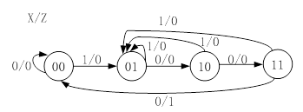
Table 2-1 Transition/output table
Q₂Q₁ | X
Q₂Q₁ | 0 | 1
00  01  10  11 | 10/1  00/0  01/0  10/0 | 01/0  10/0  00/1  00/0
Q₂*Q₁*/Y

Figure 2-1

4）Transition/output table for a sequential circuit is shown in Table 2-1, X is input and Y is output. The sequential circuit is a modulo-（ 3 ） up/down counter.
5）The circuit shown in Figure 2-2 is a modulo-（ 9 ）counter.
6）Analyze the circuit shown in Figure 2-3.The active-low output F=0, when the input binary number X(X2X1X0) and Y(Y2Y1Y0) meet the relationship of （ X=Y ）.
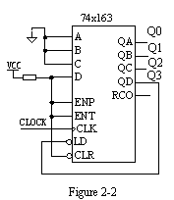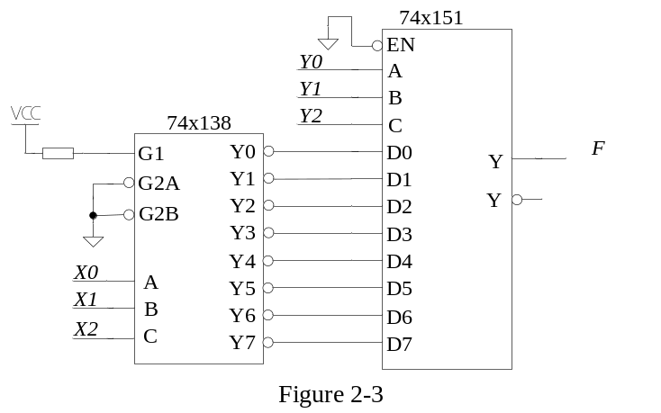

得 分
三、单项选择题II（每小题4分，共20分）

1）The state/output table of a clocked synchronization state machine is shown in Table 3-1. The flip-flops used in the state machine are triggered by rising edge. The input waveform of clock signal CLK and input X is shown in Figure 3-1. Assuming that the machine starts in state A, then which output waveform is correct ? ( B )
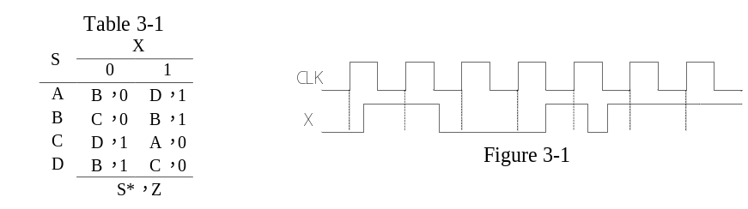
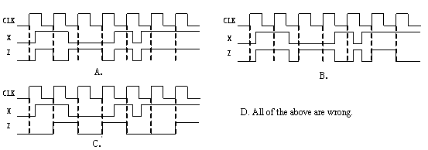
2）The input CLK, D, and the corresponding output Q on a storage element are shown in Figure 3-2, then the storage element is . ( D )
A. Positive（正）-edge-triggers D flip-flop B. D latch with enable active low
C. Negative（负）-edge-triggers D flip-flop D. D latch with enable active high
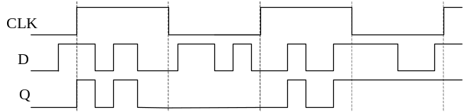
Figure 3-2
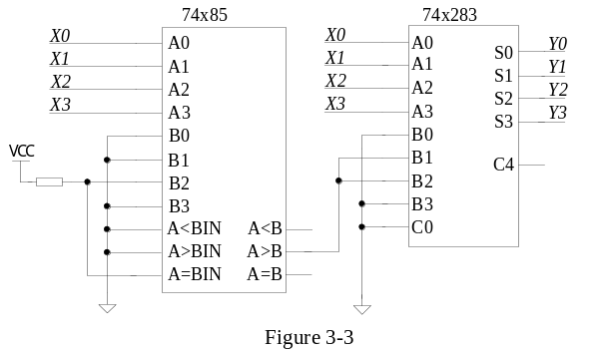3）A code converter circuit is shown in Figure 3-3. If the input X(X3X2X1X0) is a 8421BCD code, the output Y(Y3Y2Y1Y0) is . ( C )
A.4421BCD code
B.5421BCD code
C.2421BCD code
D.Excess-3 code

4）The logic diagram contains a DAC and a 4-bit counter 74X163 is shown in Figure 3-4. When the input of the 3-bit DAC is 001, the output voltage is 0.1V, and when the input number is 111, the output voltage is 0.7V. The output (Vout) waveform of the circuit shown in Figure 3-4 is . ( A )
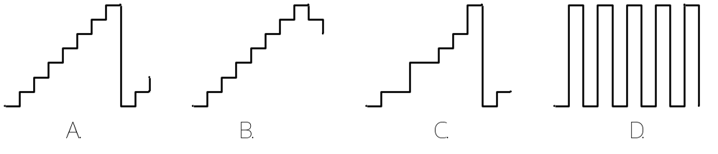
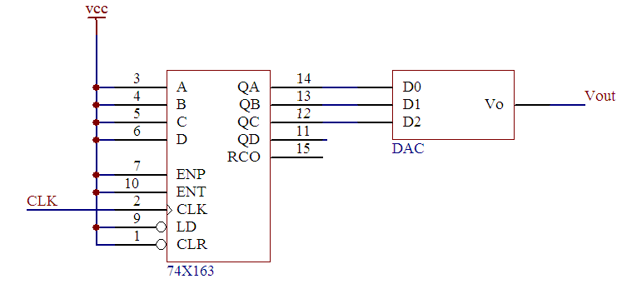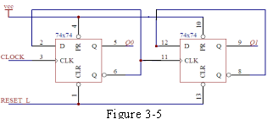
Figure 3-4
5）The circuit as shown in Figure 3-5 is a . ( A )
A. 2-bit ripple up counter B. 2-bit ripple down counter
C. 2-bit ring counter D. 2-bit Johnson counter
得 分
四、证明题（共5分）
Prove that X₁X₂’+X₂X₃’+X₃X₄’+X₄X₁’=(X₁+X₂+X₃+X₄)( X₁’ +X₂’+ X₃’ +X₄’)
真值表：
X1 | X2 | X3 | X4 | 等式左边 | 等式右边 | A₁ | A₀ | B₁ | B₀ | 等式左边 | 等式右边
0 | 0 | 0 | 0 | 0 | 0 | 1 | 0 | 0 | 0 | 1 | 1
0 | 0 | 0 | 1 | 1 | 1 | 1 | 0 | 0 | 1 | 1 | 1
0 | 0 | 1 | 0 | 1 | 1 | 1 | 0 | 1 | 0 | 1 | 1
0 | 0 | 1 | 1 | 1 | 1 | 1 | 0 | 1 | 1 | 1 | 1
0 | 1 | 0 | 0 | 1 | 1 | 1 | 1 | 0 | 0 | 1 | 1
0 | 1 | 0 | 1 | 1 | 1 | 1 | 1 | 0 | 1 | 1 | 1
0 | 1 | 1 | 0 | 1 | 1 | 1 | 1 | 1 | 0 | 1 | 1
0 | 1 | 1 | 1 | 1 | 1 | 1 | 1 | 1 | 1 | 0 | 0

得 分
五、时序电路分析题I（共10分）

Analyze the circuit of a clocked synchronous state machine shown in Figure 5, write the excitation equations, output equation, transition equations and construct a transition/output table.
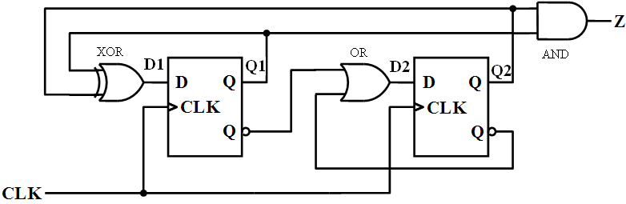
Figure 5
transition/output table
Q₁Q₂ | Q₁*Q₂* | Z
0 0 | 0 1 | 0
0 1 | 1 1 | 0
1 0 | 1 1 | 0
1 1 | 0 0 | 1

Solution:
excitation equations：
D1=Q1⊕Q2
D2=Q1’+Q2’
output equation：
Z=Q1⋅Q2
transition equations：
Q1*=Q1⊕Q2
Q2*=Q1’+Q2’

得 分
六、时序电路分析题II（共10分）

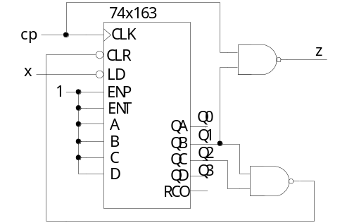The logic diagram which contains a 4 bit binary counter 74x163 is shown in Figure 6-1.
1）Assuming that the 74x163 counter starts in state 0000, and x is always 1, write the output sequence on Q3 Q2 Q1 Q0 for the next 8 clock ticks.
2）Please draw the timing diagram for Z in Figure 6-2, assuming that the delay time of the device is zero .
Figure 6-1
Solution:

1）0000→ ( 0001 ) → ( 0010 ) → ( 0011 ) → ( 0100 ) → ( 0101 ) → ( 0110 ) → ( 0000 ) → ( 0001 )

2）
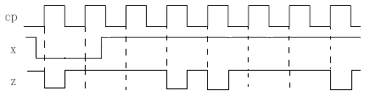或
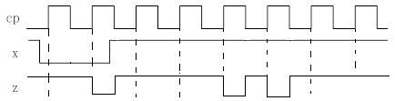
Figure 6-2
因为没有说从哪个状态开始，所以上面两个波形都可以。若初始状态中的Q1，Q2不等于11，则先置数再清零，然后计数，波形是上面一个；若初始状态中的Q1，Q2等于11，则先清零再置数，然后计数，波形是下面一个。

得 分
七、时序电路设计题I（共10分）

Design a synchronous circuit that has a single input variable and single output variable. The input data are received serially. Construct a minimal state/output table for a Moore sequential machine, that will detect the input sequences 011. If X=011 is detect, the output Z changes, assuming the initial output is 0. such as
X： | 0 | 0 | 1 | 1 | 0 | 1 | 0 | 1 | 1 | 0 | 1 | 1 | 0 | 0 | 0 | 1 | 1
Z： | 0 | 0 | 0 | 0 | 1 | 1 | 1 | 1 | 1 | 0 | 0 | 0 | 1 | 1 | 1 | 1 | 1 | 0 | 0
Please describe the state meaning and finish the minimal state/output table.(Hint: No more than 6 states are required.)
Solution: The minimal state/output table
State meaning | S | X |  | Z
State meaning | S | 0 | 1 | Z
初始态，未收到第1位有效码0，输出为0 | A | B | A | 0
收到0，输出为0 | B | B | C | 0
收到01，输出为0 | C | B | D | 0
未收到第1位有效码0，输出为1 | D | E | D | 1
收到0，输出为1 | E | E | F | 1
收到01，输出为1 | F | E | A | 1
 |  | S*

得 分
八、时序电路设计题II（共10分）

Design a controllable counter using the MSI shift register 74x194 and ONLY ONE gate . When the control input M=0, it is a 3-bit ring counter, and when M=1 is a 3-bit Johnson (twisted-ring) counter.
- Complete the circuit shown in figure 8.
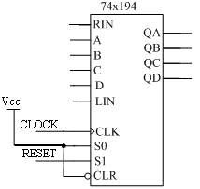
- 1)

Figure 8

2）The circuit can set the initial value with the RESET signal and set the initial value when RESET = ( ) .
3）Starting from the initial state set by the RESET signal, write the counting sequence when M = 0 and M = 1.
Solution:
1)
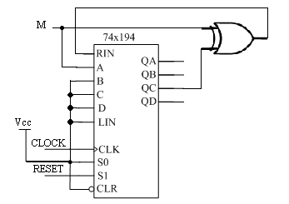
ABC有一个接M，其他接逻辑1均可。

2) The circuit can set the initial value when RESET = ( 1 ) .

3) M=0：环形计数器，计数序列：110→011→101→…
M=1：扭环形计数器，计数序列：111→011→001→000→100→110→……

得 分
九、时序电路设计题III（共5分）

A Mealy sequence detector can be designed using a shift register, and the output Z is 1 if and only if the input X is 1101 or 1111. Write the simplest logical expression of the output Z, and complete the circuit in Figure 9.（5分）

Solution: 1) The simplest logical expression of the output Z= ( Q2⋅Q1⋅X ) .
2)
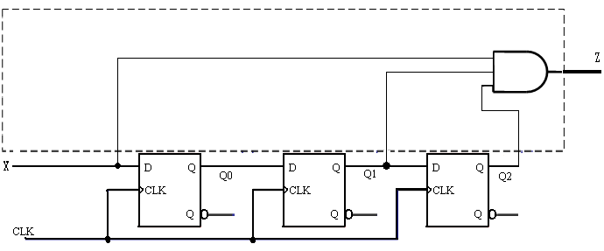
Figure 9

Appendix: functional table for some MSI
Truth table for a 74x151 8-input 1-bit multiplexer
Inputs |  |  |  | Outputs
EN_L | S2 | S1 | S0 | Y | Y_L
1 | x | x | x | 0 | 1
0 | 0 | 0 | 0 | D0 | D0’
0 | 0 | 0 | 1 | D1 | D1’
0 | 0 | 1 | 0 | D2 | D2’
0 | 0 | 1 | 1 | D3 | D3’
0 | 1 | 0 | 0 | D4 | D4’
0 | 1 | 0 | 1 | D5 | D5’
0 | 1 | 1 | 0 | D6 | D6’
0 | 1 | 1 | 1 | D7 | D7’

Function table for the 74x194 4-bit universal shift register
Inputs | Next state | Function
S1 S0 | QA* QB* QC* QD* | Function
0 0  0 1  1 0  1 1 | QA QB QC QD  RIN QA QB QC  QB QC QD LIN  A B C D | Hold  Shift right  Shift left  Load

Truth table for a 74x138 3-to-8 decoder
Inputs |  |  |  |  |  | Outputs
G1 | G2A_L | G2B_L | C | B | A | Y7_L | Y6_L | Y5_L | Y4_L | Y3_L | Y2_L | Y1_L | Y0_L
0 | x | x | x | x | x | 1 | 1 | 1 | 1 | 1 | 1 | 1 | 1
x | 1 | x | x | x | x | 1 | 1 | 1 | 1 | 1 | 1 | 1 | 1
x | x | 1 | x | x | x | 1 | 1 | 1 | 1 | 1 | 1 | 1 | 1
1 | 0 | 0 | 0 | 0 | 0 | 1 | 1 | 1 | 1 | 1 | 1 | 1 | 0
1 | 0 | 0 | 0 | 0 | 1 | 1 | 1 | 1 | 1 | 1 | 1 | 0 | 1
1 | 0 | 0 | 0 | 1 | 0 | 1 | 1 | 1 | 1 | 1 | 0 | 1 | 1
1 | 0 | 0 | 0 | 1 | 1 | 1 | 1 | 1 | 1 | 0 | 1 | 1 | 1
1 | 0 | 0 | 1 | 0 | 0 | 1 | 1 | 1 | 0 | 1 | 1 | 1 | 1
1 | 0 | 0 | 1 | 0 | 1 | 1 | 1 | 0 | 1 | 1 | 1 | 1 | 1
1 | 0 | 0 | 1 | 1 | 0 | 1 | 0 | 1 | 1 | 1 | 1 | 1 | 1
1 | 0 | 0 | 1 | 1 | 1 | 0 | 1 | 1 | 1 | 1 | 1 | 1 | 1

Function table for a 74x163 4-bit binary counter
Inputs |  |  |  | Current State | Next state | Output
CLR_L | LD_L | ENT | ENP | Q_{D} Q_{C} Q_{B} Q_{A} | Q_{D}* Q_{C}* Q_{B}* Q_{A}* | RCO
0 | X | X | X | X X X X | 0 0 0 0 | 0
1 | 0 | X | X | X X X X | D C B A | 0
1 | 1 | 0 | X | X X X X | Q_{D} Q_{C} Q_{B} Q_{A} | 0
1 | 1 | X | 0 | X X X X | Q_{D} Q_{C} Q_{B} Q_{A} | 0
1 | 1 | 1 | 1 | 0 0 0 0 | 0 0 0 1 | 0
1 | 1 | 1 | 1 | 0 0 0 1 | 0 0 1 0 | 0
1 | 1 | 1 | 1 | 0 0 1 0 | 0 0 1 1 | 0
1 | 1 | 1 | 1 | 0 0 1 1 | 0 1 0 0 | 0
1 | 1 | 1 | 1 | …………. | ………….. | 0
1 | 1 | 1 | 1 | 1 1 1 1 | 0 0 0 0 | 1

GENERAL DESCRIPTION FOR 74x283:
The 74x283 add two 4-bit binary words (An plus Bn) plus the incoming carry(C0). The binary sum appears on the sum outputs (S0 to S3) and the out-going carry (C4)according to the equation:
C0 + (A0 + B0) + 2(A1 + B1) + 4(A2 + B2) + 8(A3 + B3) = S0 + 2S1 + 4S2+ 8S3+ 16C4
Where (+) = plus.

