电子科技大学二零零八至二零零九学年第二学期期末考试

数字逻辑设计及应用课程考试题A卷 （120分钟） 考试形式：闭卷 考试日期 2009年7月6日

课程成绩构成：平时 20 分， 期中 20 分， 实验 0 分， 期末 60 分

一 | 二 | 三 | 四 | 五 | 六 | 七 | 八 | 九 | 十 | 合计
- TO FILL YOUR ANSWERS IN THE “[ ]” （2’ X10）
1. [21]₁₀=> [ 00011111 ]_{GRAY} ( Assumed the number system is 8-bit long )
2. if[X ]₁₀ = +91，then [X] _{two’s-complement} = [ 01011011 ]₂，[-X]_{two’s-complement} =[ 10100101 ]₂
( Assumed the number system is 8-bit long )
3. To design a “1001001” serial sequence generator by shift registers, the shift register should need ( 5 ) bit at least.
4. If use the simplest state assignment method for 133 states，then need at least[ 8 ]state variables。
5. If number [ A ] _{two’s-complement} =11111001 and [ B] _{two’s-complement}=11010101 ,
calculate [-A-B ] _{two’s-complement}, [-A+B ] _{two’s-complement} and indicate whether or not overflow occurs.
[-A-B ] _{two’s-complement}= [ 00111110 ], overflow: [ no ]
[-A+B ] _{two’s-complement}=[ 11011100 ], overflow: [ no ]
6. One state transition equation is Q*=JQ’+K’Q。If we use D flip-flop to complete the equation，the D input terminal of D flip-flop should be have the function D=[ JQ’+K’Q ]。
二. Combinational Circuit Analysis: [10]
1．A 3-input truth table is shown below. Find the minimal sum-of-products expression for the output F. [5]
解： 卡诺图： BA
C | B | A | F
0 | 0 | 0 | 0
0 | 0 | 1 | 0
0 | 1 | 0 | 0
0 | 1 | 1 | 1
1 | 0 | 0 | 0
1 | 0 | 1 | 1
1 | 1 | 0 | 1
1 | 1 | 1 | 1
 | 00 | 01 | 11 | 10
0 | 0 | 0 | 1 | 0
1 | 0 | 1 | 1 | 1

C

The output function F=AB+AC+BC

2．To find the minimal sum-of-products expression of F’ for F(X₁,X₂,X₃,X₄) =∑ (1,3,5,7,9,11,12,13,14,15), ( F’ is complement of F ) [5]

解：
函数F的卡诺图 函数F’的卡诺图
(X₁,X₂) (X₁,X₂)
 | 00 | 01 | 11 | 10
00 |  |  | 1
01 | 1 | 1 | 1 | 1
11 | 1 | 1 | 1 | 1
10 |  |  | 1
 | 00 | 01 | 11 | 10
00 | 1 | 1 | 0 | 1
01 | 0 | 0 | 0 | 0
11 | 0 | 0 | 0 | 0
10 | 1 | 1 | 0 | 1

(X₃,X₄)

F’=X₁’X₄’+X₂’X₄’

三. Try to finish logical function F(W,X,Y,Z) =_{WXYZ}（3,6,7,10,11,14）by one chip of 74X138 and one 8-input nand gate . [10 ]

解：
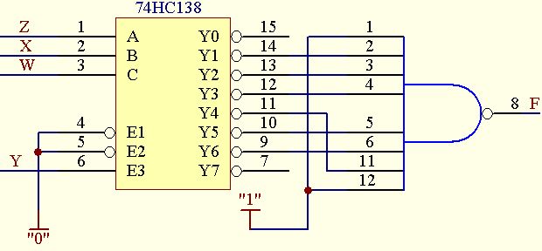F(W,X,Y,Z) =_{WXYZ}（3,6,7,10,11,14）
= W’X’YZ+ W’XYZ’+ W’XYZ+ WX’YZ’+ WX’YZ+ WXYZ’
=Y（W’X’ Z+ W’XZ’+ W’XZ+ WX’Z’+ WX’Z+ WXZ’）
= Y_{WXZ}（1,2,3,4,5,6）

四. 4_bit adder 74xx283’s function table is shown as below. Design a combinational circuit with 4_bit input Y{Y=(y₃y₂y₁y₀)} and 6_bit output Z{Z=(z₅,z₄,…z₁,z₀)} and to realize the function Z=6•Y, using one chip of 74283 and none logic gates.(0≤Y≤9) [10]
[GENERAL DESCRIPTION FOR 74XX283:
The 74HC283 add two 4-bit binary words (An plus Bn) plus the incoming carry. The binary sum appears on the sum outputs (SUM1 to SUM4) and the out-going carry (COUT)according to the equation:
CIN + (A1 + B1) + 2(A2 + B2) + 4(A3 + B3) + 8(A4 + B4) = SUM1 + 2SUM2 + 4SUM3+ 8SUM4+ 16COUT
Where (+) = plus.]

解：
Z=6•Y=(4+2)Y=4Y+2Y=( y₃y₂y₁y₀00)+(0 y₃y₂y₁y₀0)=( z₅,z₄,…z₁,z₀ )

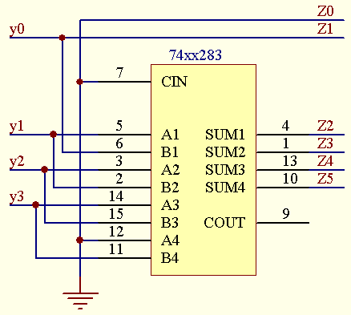

五. Clocked Synchronous State Machine Design [ 15 ]
1. Design a clocked synchronous state machine with the state/output table shown below, using D flip-flops. Use two state variables,Q1 Q2, with the state assignment shown as follows. Write transition/output table and excitation/output table. [6]
解：
transition/output table
Q₂ Q₁ | X
Q₂ Q₁ | 0 | 1
00 | 01/0 | 10/1
01 | 10/0 | 00/0
10 | 11/0 | 11/0
11 | 00/1 | 01/0
 | Q₂* Q₁*/Z

excitation/output table
Q₂ Q₁ | X
Q₂ Q₁ | 0
00 | 01/0 | 00/1
01 | 10/0 | 01/0
10 | 11/0 | 10/0
11 | 00/1 | 11/0
 | D₂D₁/Z

state/output table： state assignment：
S | X  S Q₂ Q₁  A 0 0  B 0 1  C 1 0  D 1 1
S | 0 | 1
A | B，0 | C，1
B | C，0 | A，0
C | D，0 | D，0
D | A，1 | B，0
 | S*，Z

2. The excitation/output table of a clocked synchronous state machine using D flip-flops shown as follow，Write the excitation equations and output equation. [9]
excitation/output table
Q₁Q₀ | X
Q₁Q₀ | 0 | 1
00 | 01/0 | 10/1
01 | 11/0 | 00/0
10 | 00/1 | 11/0
11 | 10/0 | 01/0
 | D₁D₀/Z

解：
K-map for D1
 | 00 | 01 | 11 | 10
0 | 0 | 1 | 1 | 0
1 | 1 | 0 | 0 | 1
Q₁Q₀
K-map for D0
 | 00 | 01 | 11 | 10
0 | 1 | 1 | 0 | 0
1 | 0 | 0 | 1 | 1
Q₁Q₀

The excitation equations and output equation：
K-map for Z
 | 00 | 01 | 11 | 10
0 | 0 | 0 | 0 | 1
1 | 1 | 0 | 0 | 0
Q₁Q₀
D1= Q₀X’+ Q₀’X
D0= Q₁’X’+ Q₁X
Z= Q₁Q₀’X’+ Q₁’Q₀’X

六. Clocked Synchronous State Machine Analysis [ 15 ]
1. Analyze the circuit of a clocked synchronous state machine shown below, write the excitation equations, output equation, transition equations and construct a transition/output table. [10]
解：
output equation
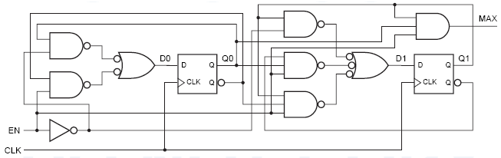MAX=EN·Q₁·Q₀
the excitation equations
D₀=EN’·Q₀+EN·Q₀’=EN⊕Q0
D₁= EN’·Q₁+EN·Q₀’ Q₁+ EN·Q₀ Q₁’
transition equations
Q₀*=EN’·Q₀+EN·Q₀’=EN⊕Q₀
Q₁*= EN’·Q₁+EN·Q₀’ Q₁+ EN·Q₀ Q₁’
transition/output table:
Q₁Q₀ | EN
Q₁Q₀ | 0 | 1
00 | 00/0 | 01/0
01 | 01/0 | 10/0
10 | 10/0 | 11/0
11 | 11/0 | 00/1
 | Q₁*Q₀*/MAX

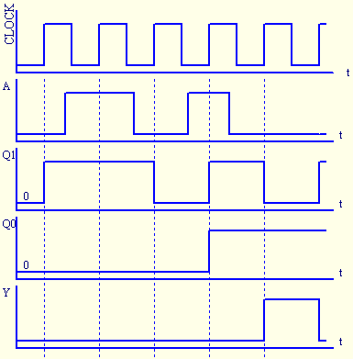 2. The transition equations and output equitation of a clocked synchronous state machine is shown as follows. Complete the timing diagram for Q₁,Q₀ and Y, assuming that the machine starts in state Q₁,Q₀=00 and flip-flops are positive-edge-triggered. [5]
transition equations：Q₀*=Q₀A’+Q₁’A
Q₁*=Q₁’+Q₁’Q₀A+Q₁Q₀’A
output equitation: Y=Q₁’Q₀
解： 如图
1.建立转换-输出表
Q₁Q₀ | A |  | Y
Q₁Q₀ | 0 | 1 | Y
00 | 10 | 11 | 0
01 | 11 | 11 | 1
10 | 00 | 10 | 0
11 | 01 | 00 | 0
 | Q₁*Q₀*
2.根据转换-输出表画波形图。
七．Construct a minimal state/output table OR a state diagram for a MEALY sequential machine, that will detect the following input sequences: x=0011 or 1100. If x=0011 or x=1100 is detected, then Z=1.The two input sequences may overlap one another. [10]
For example:
X： | 0 | 0 | 1 | 1 | 0 | 0 | 0 | 1 | 0 | 0 | 1 | 1 | 0 | 1 | 1 | 0 | 0 | 0 | 0
Z： | 0 | 0 | 0 | 1 | 0 | 1 | 0 | 0 | 0 | 0 | 0 | 1 | 0 | 0 | 0 | 0 | 1 | 0 | 0

解：
状态/输出表：
含义 | S | X
含义 | S | 0 | 1
初始状态 | INIT | S0，0 | S1，0
最新收到0 | S0 | S00，0 | S1，0
最新收到1 | S1 | S0，0 | S11，0
最新收到00 | S00 | S00，0 | S001，0
最新收到11 | S11 | S110，0 | S11，0
最新收到001 | S001 | S0，0 | S11，1
最新收到110 | S110 | S00，1 | S1，0
 |  | S*，Z

八.74X163 is a synchronous 4-bit binary counter with synchronous load and synchronous clear inputs, the basic function table is shown as follow. Design a modulo-10 counter, using one 74X163 and some necessary gates, and the counting sequence is 2-4-2-1BCD. Complete the design and draw a logic diagram. [10]

解：1、根据题目要求建立计数状态转换表，确定状态转换所需控制输入及数据输入。

Q_{D} Q_{C} Q_{B} Q_{A} |  |  |  | Q_{D}* Q_{C}* Q_{B}* Q_{A}* |  |  |  | LD_L | D | C | B | A
0 | 0 | 0 | 0 | 0 | 0 | 0 | 1 | 1 | d | d | d | d
0 | 0 | 0 | 1 | 0 | 0 | 1 | 0 | 1 | d | d | d | d
0 | 0 | 1 | 0 | 0 | 0 | 1 | 1 | 1 | d | d | d | d
0 | 0 | 1 | 1 | 0 | 1 | 0 | 1 | 1 | d | d | d | d
0 | 1 | 0 | 0 | 1 | 0 | 1 | 1 | 0 | 1 | 0 | 1 | 1
0 | 1 | 0 | 1 | 0 | 1 | 1 | 0 | 1 | d | d | d | d
0 | 1 | 1 | 0 | 0 | 1 | 1 | 1 | 1 | d | d | d | d
0 | 1 | 1 | 1 | 1 | 0 | 0 | 0 | 1 | d | d | d | d
1 | 0 | 0 | 0 | 1 | 0 | 0 | 1 | 1 | d | d | d | d
1 | 0 | 0 | 1 | 1 | 0 | 1 | 0 | 1 | d | d | d | d
1 | 0 | 1 | 0 | 1 | 0 | 1 | 1 | 1 | d | d | d | d
1 | 0 | 1 | 1 | 1 | 1 | 0 | 0 | 1 | d | d | d | d
1 | 1 | 0 | 0 | 1 | 1 | 0 | 1 | 1 | d | d | d | d
1 | 1 | 0 | 1 | 1 | 1 | 1 | 1 | 1 | d | d | d | d
1 | 1 | 1 | 0 | 1 | 1 | 1 | 1 | 1 | d | d | d | d
1 | 1 | 1 | 1 | 0 | 0 | 0 | 0 | 1 | d | d | d | d

2、根据前一步的结果，求得控制输入及数据输入信号的产生函数。
LD_L=(Q_{D}’Q_{C}Q_{B}’Q_{A}’)’
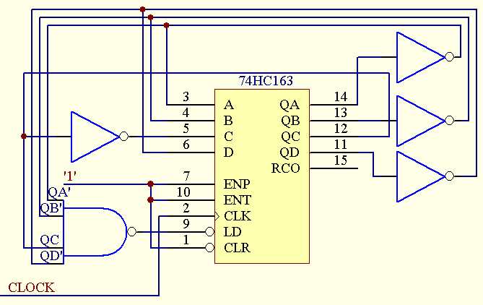D=Q_{D}’
C=Q_{C}’
B=Q_{B}’
A=Q_{A}’
3、作图

Function table for a 74X163
Inputs |  |  |  | Current State | Next state | Output
CLR_L | LD_L | ENT | ENP | Q_{D} Q_{C} Q_{B} Q_{A} | Q_{D}* Q_{C}* Q_{B}* Q_{A}* | RCO
0 | X | X | X | X X X X | 0 0 0 0 | 0
1 | 0 | X | X | X X X X | D C B A | 0
1 | 1 | 0 | X | X X X X | Q_{D} Q_{C} Q_{B} Q_{A} | 0
1 | 1 | X | 0 | X X X X | Q_{D} Q_{C} Q_{B} Q_{A} | 0
1 | 1 | 1 | 1 | 0 0 0 0 | 0 0 0 1 | 0
1 | 1 | 1 | 1 | 0 0 0 1 | 0 0 1 0 | 0
1 | 1 | 1 | 1 | 0 0 1 0 | 0 0 1 1 | 0
1 | 1 | 1 | 1 | 0 0 1 1 | 0 1 0 0 | 0
1 | 1 | 1 | 1 | …………. | ………….. | 0
1 | 1 | 1 | 1 | 1 1 1 1 | 0 0 0 0 | 1

The 2-4-2-1 BCD code table
D | B₃ | B₂ | B₁ | B₀
0 | 0 | 0 | 0 | 0
1 | 0 | 0 | 0 | 1
2 | 0 | 0 | 1 | 0
3 | 0 | 0 | 1 | 1
4 | 0 | 1 | 0 | 0
5 | 1 | 0 | 1 | 1
6 | 1 | 1 | 0 | 0
7 | 1 | 1 | 0 | 1
8 | 1 | 1 | 1 | 0
9 | 1 | 1 | 1 | 1

