电子科技大学二零零九至二零一零学年第 二 学期期 末 考试

数字逻辑设计及应用 课程考试题 A 卷（120分钟）考试形式：闭卷 考试日期2010年7月12日

课程成绩构成：平时 20 分， 期中 20 分， 实验 0 分， 期末 60 分

 | 一 | 二 | 三 | 四 | 五 | 六 | 七 | 八 | 九 | 十 | 合计 | 复核人签名
得分
签名

得 分
一、To fill your answers in the blanks（1’×25）

1. If [X]₁₀= - 110, then [X]_{two's-complement}=[ 10010010 ]₂,
[X]_{one's-complement}=[ 10010001 ]₂. (Assumed the number system is 8-bit long)
2. Performing the following number system conversions:
A. [10101100]₂=[ 000111010010 ]₂₄₂₁
B. [1625]₁₀=[ 0100100101011000 ]_{excess-3}
C. [ 1010011 ]_{GRAY} =[ 10011000 ]_{8421BCD}
3. If 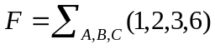, then F^{D}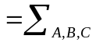( 1，4，5，6 )=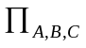(0，2，3，7 ).
4. If the parameters of 74LS-series are defined as follows: V_{OL}max = 0.5 V, V_{OH}min = 2.7 V, V_{IL}max = 0.8 V, V_{IH}min = 2.0 V, then the low-state DC noise margin is 0.3V ,the high-state DC noise margin is 0.7V .
5. Assigning 0 to Low and 1 to High is called positive logic. A CMOS XOR gate in positive logic is called XNOR gate in negative logic.
6. A sequential circuit whose output depends on the state alone is called a Moore machine.
7. To design a "001010" serial sequence generator by shift registers, the shift register should need
4 bit as least.
8. If we use the simplest state assignment method for 130 sates, then we need at least
8 state variables.
9. One state transition equation is Q*=JQ'+K'Q. If we use D flip-flop to complete the equation, the D input terminal of D flip-flop should be have the function D= JQ'+K'Q .
- Which state in Fig. 1 is ambiguous D
- A CMOS circuit is shown as Fig. 2, its logic function z= A’B’+AB
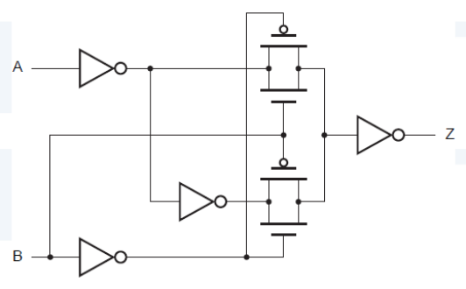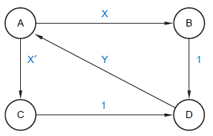
Fig. 1 Fig. 2
- If number [A]_{two's-complement} =01101010 and [B]_{one's-complement} =1001, calculate [A-B]_{two's-complement} and indicate whether or not overflow occurs.(Assumed the number system is 8-bit long)
[A-B]_{two's-complement} = 01110000 , overflow no
13. If a RAM’s capacity is 16K words × 8 bits, the address inputs should be 14 bits; We need 8 chips of 8K ×8 bits RAM to form a 16 K × 32 bits ROM..
14. Which is the XOR gate of the following circuit A .
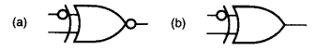
- There are 2^{n}－n invalid states in an n-bit ring counter state diagram.
- An unused CMOS NOR input should be tied to logic Low level or 0 .
- The function of a DAC is translating the Digital inputs to the same value of analog outputs.

二、Complete the following truth table of taking a vote by A,B,C, when more than two of A,B,C approve a resolution, the resolution is passed; at the same time, the resolution can’t go through if A don’t agree. For A,B,C, assume 1 is indicated approval, 0 is indicated opposition. For the F, assume 1 is passed, 0 is rejected.（5’）
A | B | C | F
0 | 0 | 0 | 0
0 | 0 | 1 | 0
0 | 1 | 0 | 0
0 | 1 | 1 | 0
1 | 0 | 0 | 0
1 | 0 | 1 | 1
1 | 1 | 0 | 1
1 | 1 | 1 | 1

三、The circuit to the below realizes a combinational function F of four variables. Fill in the Karnaugh map of the logic function F realized by the multiplexer-based circuit. (6’)
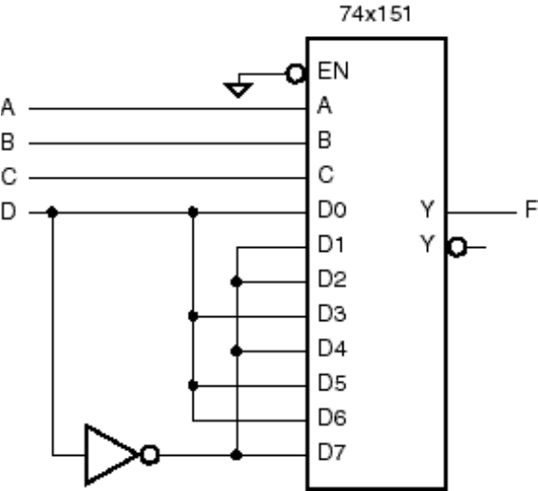
DC  BA | 00 | 01 | 11 | 10
00 |  | 1 |  | 1
01 | 1 |  | 1
11 |  | 1 |  | 1
10 | 1 |  | 1
F=D∑(0,3,5,6)+D’∑(1,2,4,7)

四、(A) Minimize the logic function expression
F = A·B + AC’ +B’·C+BC’+B’D+BD’+ADE(H+G) （5’）

F = A·B + AC’ +B’·C+BC’+B’D+BD’
= A·(B ’C)’ +B’·C+BC’+B’D+BD’
= A +B’·C+BC’+B’D+BD’+C’D (或= A +B’·C+BC’+B’D+BD’+CD’)

= A +B’·C+BD’+C’D (或= A + BC’+B’D+CD’)

(B) To find the minimum sum of product for F and use NAND-NAND gates to realize it（6’）
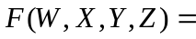Π(1,3,4,6,9,11,12,14)
WX  YZ | 00 | 01 | 11 | 10
00 | 1 |  |  | 1
01 |  | 1 | 1
11 |  | 1 | 1
10 | 1 |  |  | 1

F= X’Z’+XZ =( X’Z’+XZ)’’=(( X’Z’)’(XZ)’)’

五、Realize the logic function using one chip of 74LS139 and two NAND gates.（8’）
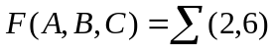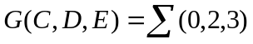
F(A,B,C)=C’∑(1,3) G(C,D,E)=C’∑(0,2,3)
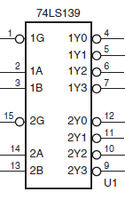
Function table for a 1/2 74x139
Inputs | Outputs
G_L B A | Y3_L Y2_L Y1_L Y0_L
1 X X | 1 1 1 1
0 0 0 | 1 1 1 0
0 0 1 | 1 1 0 1
0 1 0 | 1 0 1 1
0 1 1 | 0 1 1 1

六、Design a self-correcting modulo-6 counter with D flip-flops. Write out the excitation equations and output equation. Q₂Q₁Q₀ denote the present states, Q₂*Q₁*Q₀* denote the next states, Z denote the output. The state transition/output table is as following.（10’）
Q₂Q₁Q₀ | Q₂*Q₁*Q₀* | Z
000 | 100 | 0
100 | 110 | 0
110 | 111 | 0
111 | 011 | 0
011 | 001 | 0
001 | 000 | 1

激励方程式：D2=Q0’
D1=Q2
D0=Q1
修改自启动：D2=Q0 +Q2Q1’
D1=Q2+Q1Q0’
D0=Q1+Q2Q0
输出方程式：Z=Q1’Q0 （1分，错 -1分）

得 分
七、Construct a minimal state/output table for a moore sequential machine, that will detect the input sequences: x=101. If x=101 is detected, then Z=1.The input sequences DO NOT overlap one another. The states are denoted with S0~S3.（10’）
For example:

X： | 0 | 1 | 0 | 1 | 0 | 0 | 1 | 0 | 1 | 0 | 1 | 1 | 0 | 1 | 1 | 0 | 0 | 0 | 1 | 1 | ……
Z： | 0 | 0 | 0 | 1 | 0 | 0 | 0 | 0 | 1 | 0 | 0 | 0 | 0 | 1 | 0 | 0 | 0 | 0 | 0 | 0 | ……

S | X |  | Z
S | 0 | 1 | Z
S0 | S0 | S1 | 0
S1 | S2 | S1 | 0
S2 | S0 | S3 | 0
S3 | S0 | S1 | 1
 | S*

得 分
八、Please write out the state/output table and the transition/output table and the excitation/output table of this state machine.（states Q2 Q1=00~11, use the state name A~D）（10’）
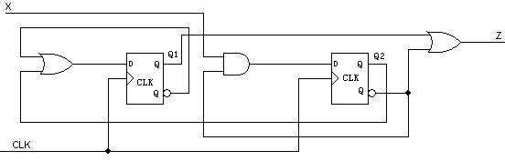

评分标准：
Transition/output table State/output table Excitation/output table
Q2Q1 | X |  | Z
Q2Q1 | 0 | 1 | Z
00 | 01 | 10 | 1
01 | 00 | 10 | 1
10 | 01 | 01 | 0
11 | 01 | 01 | 1
 | Q2*Q1*
S | X |  | Z
S | 0 | 1 | Z
A | B | C | 1
B | A | C | 1
C | B | B | 0
D | B | B | 1
 | S*
Q2Q1 | X |  | Z
Q2Q1 | 0 | 1 | Z
00 | 01 | 10 | 1
01 | 00 | 10 | 1
10 | 01 | 01 | 0
11 | 01 | 01 | 1
 | D2 D1

得 分
九、Clocked Synchronous State Machine Design（15’）
74x163 is a synchronous 4-bit binary counter with synchronous CLEAR input and LOAD input. LD_L=(Q_{B}Q_{C})', CLR_L=(Q_{D}Q_{B} )' in the following circuit.
1. Finish the logic circuit.
2. Draw the state diagram with all states of “Q3Q2Q1Q0” . (“Q3Q2Q1Q0” is the output of 74x163)
3. Write the sequence of Y. Y is the output of 74x151. (Assumed state of 74x163 start in Q3Q2Q1Q0=0000.)

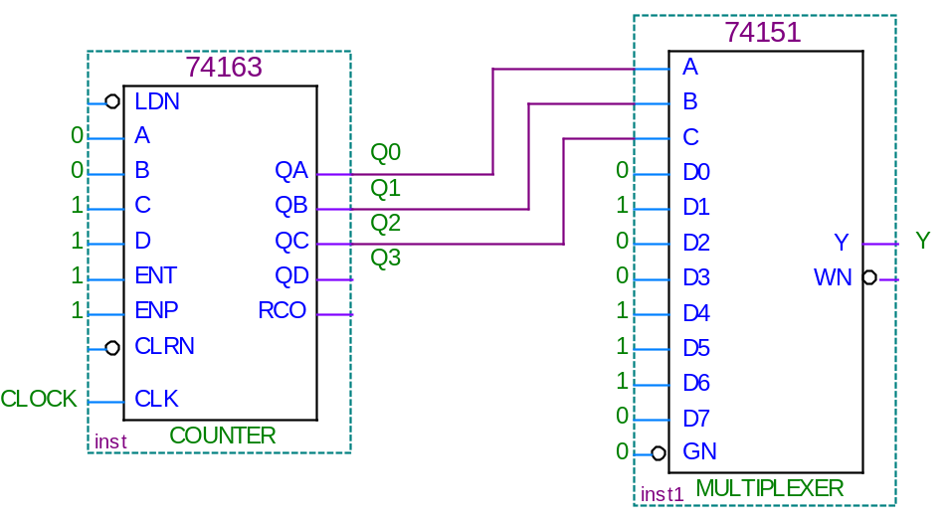

(1) Finish the logic circuit. LD_L=(Q_{B}Q_{C})', CLR_L=(Q_{D}Q_{B} )'
(2) Q3Q2Q1Q0:
0000—0001—0010—0011—0100—0101—0110—1100—1101—1110—0000
Function table for a 74x163
Inputs |  |  |  | Current State | Next state | Output
CLR_L | LD_L | ENT | ENP | Q_{D} Q_{C} Q_{B} Q_{A} | Q_{D}* Q_{C}* Q_{B}* Q_{A}* | RCO
0 | X | X | X | X X X X | 0 0 0 0 | 0
1 | 0 | X | X | X X X X | D C B A | 0
1 | 1 | 0 | X | X X X X | Q_{D} Q_{C} Q_{B} Q_{A} | 0
1 | 1 | X | 0 | X X X X | Q_{D} Q_{C} Q_{B} Q_{A} | 0
1 | 1 | 1 | 1 | 0 0 0 0 | 0 0 0 1 | 0
1 | 1 | 1 | 1 | 0 0 0 1 | 0 0 1 0 | 0
1 | 1 | 1 | 1 | 0 0 1 0 | 0 0 1 1 | 0
1 | 1 | 1 | 1 | 0 0 1 1 | 0 1 0 0 | 0
1 | 1 | 1 | 1 | …………. | ………….. | 0
1 | 1 | 1 | 1 | 1 1 1 1 | 0 0 0 0 | 1

- Y=0100111111

