电子科技大学2010 -2011学年第 二 学期期 末 考试 A 卷

课程名称：_数字逻辑设计及应用__ 考试形式： 闭卷 考试日期： 20 11 年 7 月 7 日 考试时长：_120___分钟
课程成绩构成：平时 30 %， 期中 30 %， 实验 0 %， 期末 40 %
本试卷试题由__六___部分构成，共__6___页。

题号 | 一 | 二 | 三 | 四 | 五 | 六 | 七 | 八 | 九 | 十 | 合计
得分

得 分
I. Fill your answers in the blanks (2’ X 10=20’)

1. A parity circuit with N inputs need N-1 XOR gates. If the number of “1” in an N logic variables set, such as A、B、C、…W, is even number, then0 .
2. A circuit with 4 flip-flops can store 4 bit binary numbers, that is, include 16 states at most.
3. A modulo-20 counter circuit needs 5 D filp-flops at least. A modulo-288 counter circuit needs 3 4-bit counters of 74x163 at least.
4. A 8-bit ring counter has 8 normal states. If we want to realize the same number normal states, we need a 4 bit twisted-ring counter.
5. If the input is 10000000 of an 8 bit DAC, the corresponding output is 5v. Then an input is 00000001 to the DAC, the corresponding output is 5/128 (0.0391) V; if an input is 10001000, the corresponding DAC output is 5.3125 V.

得 分
II. Please select the only one correct answer in the following questions.(2’ X 5=10)

1. We need ( B ) chips of 4K ×4 bits RAM to form a 16 K × 8 bits RAM.
A) 2 B) 8 C) 4 D) 16
2. To design a "01101100" serial sequence generator by shift registers, we need a ( A )-bit shift register as least.
A) 5 B) 4 C) 3 D) 6
3. For the following latches or flip-flops, ( B ) can be used to form shift register.
A) S-R latch B) master-slave flip-flop C) S-R latch with enable D) S’-R’ latch
4. Which of the following statements is correct? ( C )
A) The outputs of a Moore machine depend on inputs as well as the states.
B) The outputs of a Mealy machine depend only on the states.
C) The outputs of a Mealy machine depend on inputs as well as the states.
D) A), B), C) are wrong.
5. There is a state/output table of a sequential machine as the table 1, what the input sequences is detected? ( D )
A) 11110 B) 11010 C) 10010 D) 10110
Table 1

S | X
S | 0 | 1
A | A,0 | B,0
B | C,0 | B,0
C | A,0 | D,0
D | C,0 | E,0
E | C,1 | B,0
 | S*,Z

得 分
- Analyze the sequential-circuit as shown in figure 1. [15’]

- Write out the excitation equations, transition equations and output equation. [5’]
- Assume the initial state is Q₂Q₁=00, complete the timing diagram for Q₂ ,Q₁ and Z.( Don’t need consider propagation delay of each component) [10’]
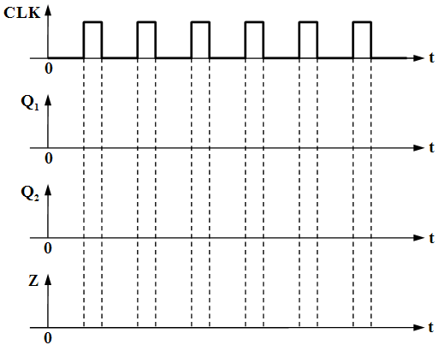
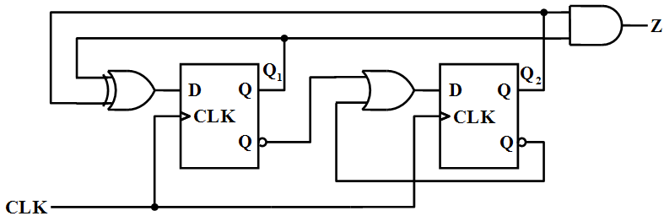

Figure-1

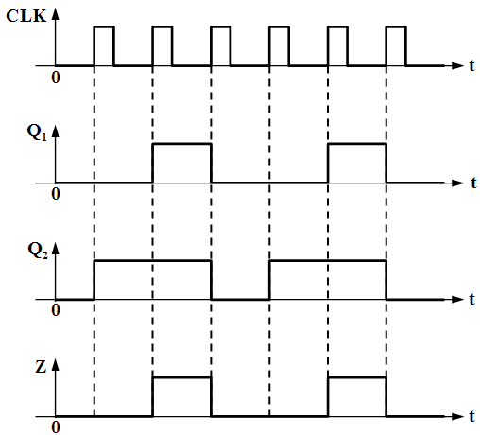

解答：
激励方程: D₁=Q₁⊕Q₂，D₂= Q/₁+ Q/₂
转移方程：Q₁ *= D₁=Q₁⊕Q₂，Q₂ *=D₂= Q/₁+ Q/₂
输出方程：Z= Q₁•Q₂

IV. Design a Mealy sequential detector with one input x and one output z. If and only if x continues to be 1111 or 1001, the output z is 1. Otherwise, the output z is 0. The overlap is permitted. Please describe the state meaning and finish the state/output table. [15]
Example： x：0 1 0 1 1 1 1 0 0 1 1 0 0 1 1 1 1 1
z：0 0 0 0 0 0 1 0 0 1 0 0 0 1 0 0 1 1

 |  | X
State meaning | S | 0 | 1
Initial | A | A,0 | B,0
Received 1 | B | C,0 | D,0
Received 10 | C | E,0 | B,0
Received 11 | D | C,0 | F,0
Received 100 | E | A,0 | B,1
Received 111 | F | C,0 | F,1
 |  | S*,Z
 |  | X
State meaning | S | 0 | 1
Initial | A | A,0 | B,0
Received 1 | B | D,0 | C,0
Received 11 | C | D,0 | E,0
Received 10 | D | F,0 | B,0
Received 111 | E | D,0 | E,1
Received 100 | F | A,0 | B,1
 |  | S*,Z
 |  | X
State meaning | S | 0 | 1
Initial | S0 | S0,0 | S1,0
Received 1 | S1 | S2,0 | S3,0
Received 10 | S2 | S4,0 | S1,0
Received 11 | S3 | S2,0 | S5,0
Received 100 | S4 | S0,0 | S1,1
Received 111 | S5 | S2,0 | S5,1
 |  | S*,Z

或其他状态排列完成方式

V. Analyze the circuit as shown below, which contains a 74x163 4-bit binary counter, a 74x138 decoder and a 74x153 4-input,1-bit multiplexer. When control input MN=10 for 74x153 multiplexer, [15’]
1. Write out the logic expression of 74x153’ output F. [5’]
2. Write out the sequence of states for the 74x161 in the circuit. [7’]
3. Describe the modulus(模) of the circuit. [3’]
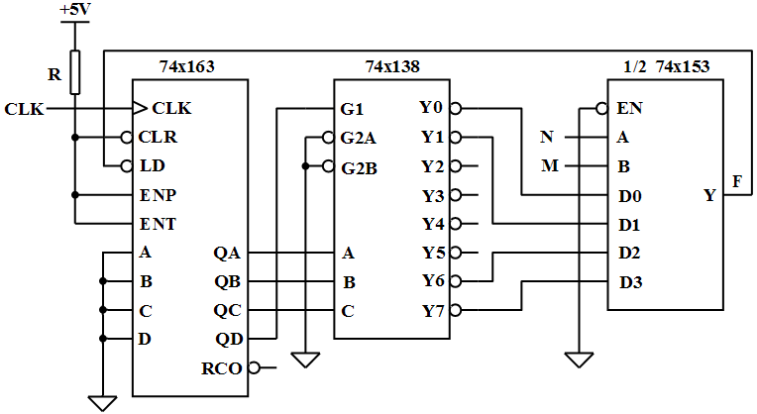

74X161的功能表
输入 |  |  |  | 当前状态 | 下一状态 | 输出
CLR_L | LD_L | ENT | ENP | QD QC QB QA | QD* QC* QB* QA* | RCO
0 | X | X | X | X X X X | 0 0 0 0 | 0
1 | 0 | X | X | X X X X | D C B A | 0
1 | 1 | 0 | X | X X X X | QD QC QB QA | 0
1 | 1 | X | 0 | X X X X | QD QC QB QA | 0
1 | 1 | 1 | 1 | 0 0 0 0 | 0 0 0 1 | 0
1 | 1 | 1 | 1 | 0 0 0 1 | 0 0 1 0 | 0
1 | 1 | 1 | 1 | 0 0 1 0 | 0 0 1 1 | 0
1 | 1 | 1 | 1 | 0 0 1 1 | 0 1 0 0 | 0
1 | 1 | 1 | 1 | …………. | ………….. | 0
1 | 1 | 1 | 1 | 1 1 1 1 | 0 0 0 0 | 1

解答：
F=D2=Y6/=(QDQCQBQA/)/
状态序列：0,1,2,3,4,5,6,7,8,9,10,11,12,13,14,0,1,2，…
M=15

得 分

VI. Design a minimal-cost modulo-5 synchronous counter with D flip-flops and necessary gates, the state transition sequence is 0→2→4→1→3→0→…with the binary code. [15’]
1. Fill out the transition/output table. [8’]
2. Write out the excitation equations and output equation. [4’]
3. List the complete transition/output table, and check the self-correct. [3’]
transition/output table：
Q2Q1Q0 | Q2*Q1*Q0* | Z
000 | 010 | 0
010 | 100 | 0
100 | 001 | 0
001 | 011 | 0
011 | 000 | 1
complete transition/output table:
Q2Q1Q0 | Q2*Q1*Q0* | Z
000 | 010 | 0
010 | 100 | 0
100 | 001 | 0
001 | 011 | 0
011 | 000 | 1
101 | 001 | 0
110 | 101 | 0
111 | 001 | 1

激励方程：D2=Q1⋅Q0’ D1= Q2’⋅Q1’ D0= Q2+Q1’⋅Q0
输出方程：Z=Q1Q0
检查自启动：当Q2Q1Q0=101，可得下一状态为001；当Q2Q1Q0=110，可得下一状态为101；当Q2Q1Q0=111，可得下一状态为001。电路能够自启动。

