电子科技大学2012 -2013学年第 二 学期期 末 考试 A 卷

课程名称：_数字逻辑设计及应用__ 考试形式： 闭卷 考试日期： 20 13 年 07 月 05 日
考试时长：_120___分钟
课程成绩构成：平时 30 %， 期中 30 %， 实验 0 %， 期末 40 %
本试卷试题由___七__部分构成，共__7___页。

题号 | 一 | 二 | 三 | 四 | 五 | 六 | 七 | 八 | 九 | 十 | 合计
得分
得 分
I. Fill out your answers in the blanks (3’ X 10=30’)

1. If a 74x138 binary decoder has 110 on its inputs CBA, the active LOW output Y5 should be ( 1 or high ).
2. If the next state of the unused states are marked as “don’t-cares” when designing a finite state machine, this approach is called minimal ( cost ) approach.
3.The RCO_L of 4-bit counter 74x169 is ( 0 or low ) when counting to 0000 in decreasing order.
4. To design a "001010" serial sequence generator by shift registers, the shift register should need
( 4 ) bit at least.
5. One state transition equation is Q*=JQ’+K’Q. If we use T flip-flop with enable to complete the equation，the enable input of T flip-flop should have the function EN=( JQ’+KQ ).
6. A 4-bit Binary counter can have ( 16 ) normal states at most, 4-bit Johnson counter with no self-correction can have ( 8 ) normal states, 4-bit linear feedback shift-register (LFSR) counter with self-correction can have ( 16 ) normal states.
7. If we use a ROM, whose capacity is 16 × 4 bits, to construct a 4-bit binary code to gray code converter, when the address inputs are 1001, ( 1101 ) will be the output.
8. When the input is 10000000 of an 8 bit DAC, the corresponding output voltage is 2V. The output voltage is ( 3.98 ) V when the input is 11111111.
得 分

II. Please select the only one correct answer in the following questions.(2’ X 5=10’)

1. If a 74x85 magnitude comparator has ALTBIN=1, AGTBIN=0, AEQBIN=0, A3A2A1A0=1101, B3B2B1B0=0111 on its inputs, the outputs are ( D ).
A) ALTBOUT=0, AEQBOUT=0, AGTBOUT=0 B) ALTBOUT=1, AEQBOUT=0, AGTBOUT=0
C) ALTBOUT=1, AEQBOUT=0, AGTBOUT=1 D) ALTBOUT=0, AEQBOUT=0, AGTBOUT=1
2. As shown in Figure 1, what would the outputs of the 4-bit adder 74x283 be ( B ) when A3A2A1A0=0100, B3B2B1B0=1110 and S/A=1.
A) C4=1, S3S2S1S0=0010 B) C4=0, S3S2S1S0=0110 C) C4=0, S3S2S1S0=1010
D) C4=0, S3S2S1S0=1110
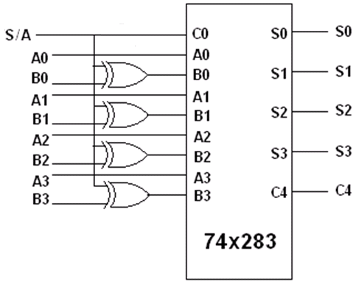
Figure 1
3. Which of the following statements is INCORRECT? ( A )
A) A D latch is edge triggered and it will follow the input as long as the control input C is active low.
B) A D flip flop is edge triggered and its output will not change until the edge of the controlling CLK signal.
C) An S-R latch may go into metastable state if both S and R are changing from 11 to 00 simultaneously.
D) The pulse applying to any input of an S -R latch must meet the minimum pulse width requirement.
4. The capacity of a memory that has 13 bits address bus and can store 8 bits at each address is ( B ).
A) 8192 B) 65536 C) 104 D) 256
5. Which state in Figure 2 is NOT ambiguous ( C ).
A) A B) B C) C and D D) C
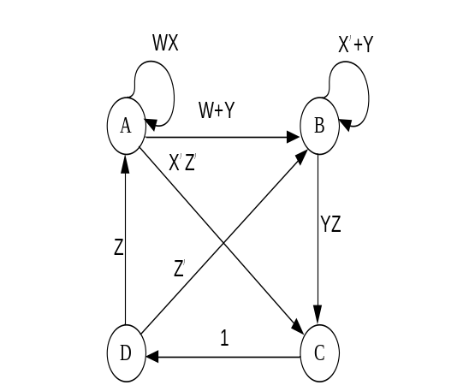
Figure 2
得 分

III. Analyze the sequential-circuit as shown in Figure 3, D Flip-Flop with asynchronous preset and clear inputs. [15’]
1.Write out the excitation equations, transition equations and output equation. [5’]
2.Assume the initial state Q₂Q₁=00, complete the timing diagram for Q₂ ,Q₁ and Z. [10’]
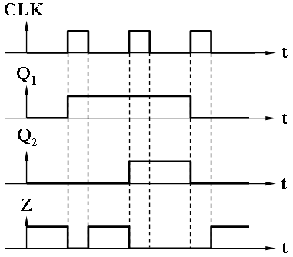

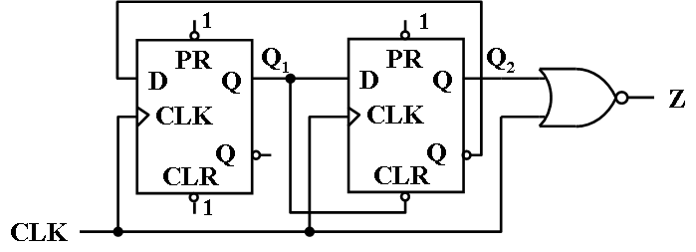

Figure 3

参考答案：
激励方程: D₁=Q₂/，D₂= Q₁
转移方程：Q₁ *= D₁=Q₂/，Q₂ *=D₂= Q₁
输出方程：Z= (CLK+Q₂)/

参考评分标准：
1. 5个方程正确得5分；每错一个扣1分，扣完5分为止；
2. Q₁、Q₂、Z的波形边沿判断正确，得3分，错一个，扣1分，扣完3分为止；每个上升沿和下降沿各0.5分，错1处扣0.5分，扣完7分为止。
得 分

IV. Analyze the sequential-circuit as shown below, which contains two 74x163 4-bit binary counter. [15’]
1. Write out the logic expression LD_L for U₁ and CLR_L for U₂.[4’]
2. Assume the initial state is 3₁₀, write out the state sequence for the circuit. [8’]
3. Describe the modulus for the circuit. [3’]
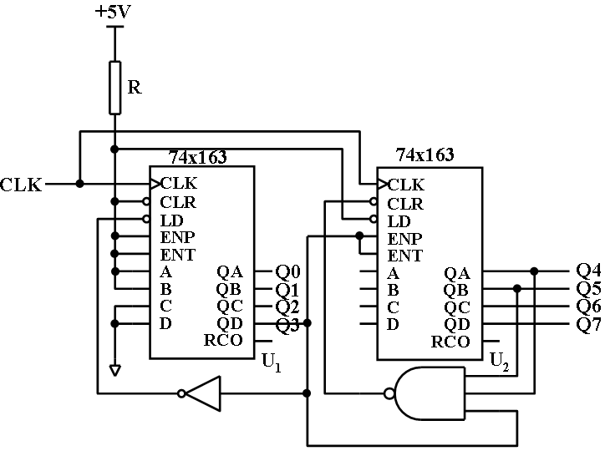

The function table for 74x163
Inputs |  |  |  | Current state | Next state | Outputs
CLR_L | LD_L | ENT | ENP | QD QC QB QA | QD* QC* QB* QA* | RCO
0 | X | X | X | X X X X | 0 0 0 0 | 0
1 | 0 | X | X | X X X X | D C B A | 0
1 | 1 | 0 | X | X X X X | QD QC QB QA | 0
1 | 1 | X | 0 | X X X X | QD QC QB QA | 0
1 | 1 | 1 | 1 | 0 0 0 0 | 0 0 0 1 | 0
1 | 1 | 1 | 1 | 0 0 0 1 | 0 0 1 0 | 0
1 | 1 | 1 | 1 | 0 0 1 0 | 0 0 1 1 | 0
1 | 1 | 1 | 1 | 0 0 1 1 | 0 1 0 0 | 0
1 | 1 | 1 | 1 | …………. | ………….. | 0
1 | 1 | 1 | 1 | 1 1 1 1 | 0 0 0 0 | 1

参考评分标准：
1. LD_L=Q₃/,CLR_L=(Q₅Q₄Q₃)/ [4’]
2. 状态序列：十六进制数表示：03,…08,13,…18,23,…28,33,…38,03,…08
或十进制数表示：3,…8,19,…24,35,…40,51,…56,3,…8[8’]
错1处扣1分，扣完为止。
3. m=24 [3’]
得 分

V. Design a sequence signal generator with self-correcting to generate a serial output sequence of 101100, using a 74x194 and a 74x151.[15’]
- List the transition table .[4’]
- Write out the canonical sum of feedback function LIN.[[4’]
- Draw the circuit diagram.[7’]

The function table for 74x194
Iutputs | Next state | Function
S1 S0 | QA* QB* QC* QD* | Function
0 0  0 1  1 0  1 1 | QA QB QC QD  RIN QA QB QC  QB QC QD LIN  A B C D | Hold  Shift right  Shift left  Load

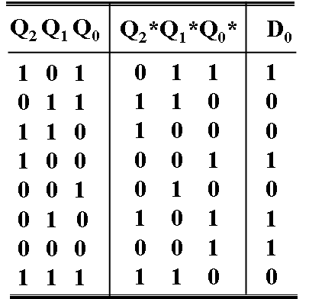
参考评分标准：
- 转移表正确4分，错1行扣0.5分。
2. 反馈函数正确LIN=D₀=∑_{m}(0,2,4,5) [4’]
3. 电路图正确7分，错1处扣0.5分，扣完为止。

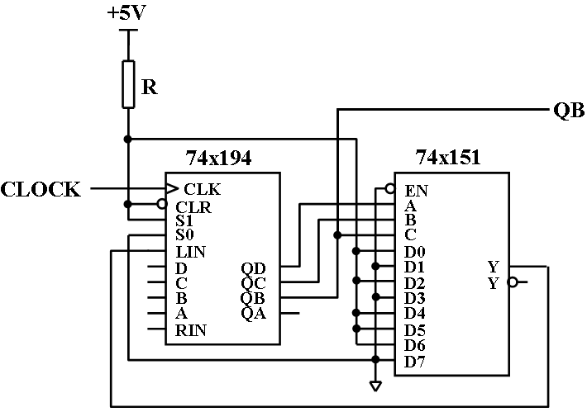

得 分

VI. Write out the state/output table for a Mealy machine that can detect the pattern 10101 or 10111 . The output Z=1 when the pattern is detected. Your model should also be able to detect overlapping sequences. (10’)
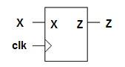
State meaning | S | X
State meaning | S | 0 | 1
Initial state | A | A, 0 | B, 0
Got 1 | B | C, 0 | B, 0
Got 10 | C | A, 0 | D, 0
Got 101 | D | E, 0 | F, 0
Got 1010 | E | A, 0 | D, 1
Got 1011 | F | C, 0 | B, 1
 |  | S*, Z

评分标准：
1.状态定义正确得3分；每错一处扣0.5分，扣完3分为止；
2.状态转移正确，得5分；每错一处扣0.5分，扣完5分为止；
3.输出正确，得2分；每错一处扣0.5分，扣完2分为止。

得 分

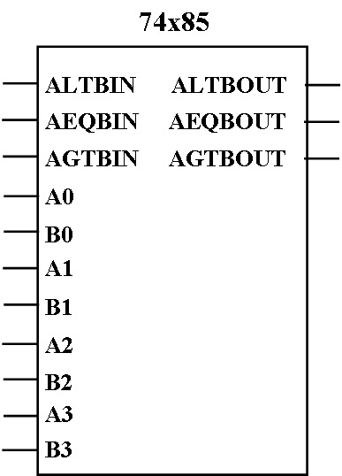
VII. Design a code converter with 2421 code to 8421 code，using a 74x85, a 74x283 and some gates if needed. [10’]
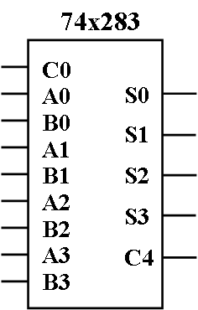
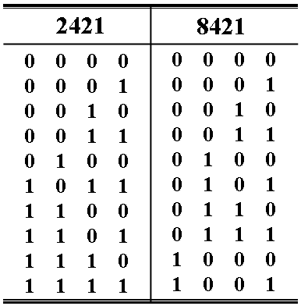

参考评分标准：

1.74x85级联输入端连接正确2分，比较值正确3分，74x283的C0端连接正确1分；
2.74x85的A3~A0与74x283的A3~A0连接正确2分；
3.74x85与74x283中间连接的电路正2分。
