电子科技大学2013 -2014学年第 二 学期期 末 考试 A 卷

课程名称：_数字逻辑设计及应用__ 考试形式： 闭卷 考试日期： 2015年 07 月 13 日
考试时长：_120___分钟
课程成绩构成：平时 20/30 %， 期中 20/30 %， 讨论 20/0 %， 期末 40 %
本试卷试题由__IV___部分构成，共__4__页。

题号 | I | II | III | IV | 合计
得分

得 分
I. Please fill the correct answers in the brackets “( )” . ( 4’ X 10 = 40’ )
1. For an 8-bit DAC (Digital Analog Converter), when the input is 01000000₂, its output voltage is 1.25V; If the input is 10100000₂ , the output voltage will be ( 3.125 或等效算式 )V.
2. A state transition equation is Q*=JQ’+K’Q. If we use D flip-flop to complete the equation，the input of D flip-flop should be D = ( JQ’+K’Q ).
3. For a counter with N flip-flops, it has at most ( 2^{n} ) states. If the counter is Johnson counter, it has ( 2n ) valid states.
4. After modification, an N-bit LFSR (Linear Feedback Shift Register) has ( 2^{n} 或 2^{n}-1 ) states.
5. D latch is also called transparent latch, it has two input signal D and C, one output signal Q. The relationship between the output Q and the input D is ( Q*=DC + QC' 或 C=1 Q*=D, C=0 Q*=Q, 部分正确得2分 ).
6. To build a 64K x 8 ROM, we need ( 16 ) 4K x 8 ROM .
7. Only when both two-bit inputs A(A1,A0) and B(B1,B0) are equal, the output AEQB is 1, so the logic expression of AEQB is ( （A1⊙B1）（A2⊙B2）或其他等效表达，部分正确得2分 ).
8. State/output table for a sequential circuit is shown as table 1. X is input and Z is output. Assume that the initial state is S₀, if the input sequence is X=10110110, the output sequence should be ( 10001110 8位或9位均算正确 ).
9. Transition/output table for a sequential circuit is shown in Table 2, X is input and Y is output, the sequential circuit is a modulus ( 4 ) up/down counter.

Table 1 State/output table
X  S_{n} | 0 | 1
S₀  S₁  S₂  S₃ | S₁/0  S₁/0  S₂/0  S₀/1 | S₀/1  S₂/0  S₃/0  S₂/0
S_{n+1}/Z
Table 2 Transition/output table
X  Q₂Q₁ | 0 | 1
00  01  10  11 | 11/1  00/0  01/0  10/0 | 01/0  10/0  11/0  00/1
Q₂*Q₁*/Y

.参考评分标准：
每空4分，错一个扣4分, 个别小题评分标准详见各小题。
得 分

II. Choose the correct answer and fill the item number in the brackets.

(3’ X 5=15 )
1. With N flip-flops , ( A ) has the outputs that can be used as 1-out-of-N codes directly.
A. Ring counter B. Johnson counter
C. LFSR(Linear Feedback Shift Register) D. N-bit binary counter
2. If state S1 and S2 are equivalent states, it means ( D 选 A B C 各1分，部分正确 ) for all input combinations.
A. their outputs are the same B. their next states are the same
C. their next states are the equivalent states D. both A and B and C
3. For a D flip-flop, if the frequency of clock is 10MHz, the frequency of its output signal Q is ( B 选 B 、C 均算正确 ) MHz
A. 10 B.5 C. 2.5 D. 20
4. When using shift registers to periodically generate sequence “0100101”, it requires at least ( A ) flip-flops.
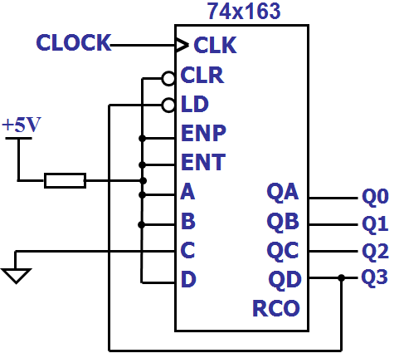
A. 6 B. 3 C. 4 D. 5
5. According to figure 1, the modulus of the counter is
( B )
A. 5 B. 6 C.7 D. 9

参考评分标准：
每小题3分，错一个扣3分, 个别小题评分标准详见各小题。
Figure 1
得 分

III. Analyze the sequential-circuit as shown below. [26’]
1.Write out the excitation equations, transition equations and output equation. [10’]
2.List out transition/output table. [8’]
3.Assume the initial state Q₂Q₁=00, complete the timing diagram for Q₁ ,Q₂ and Z. [8’]
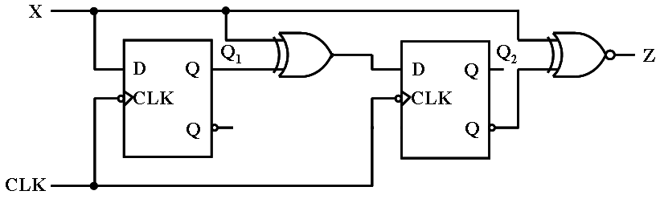

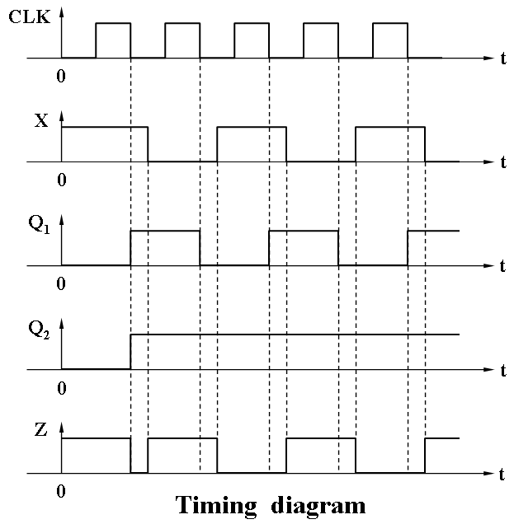

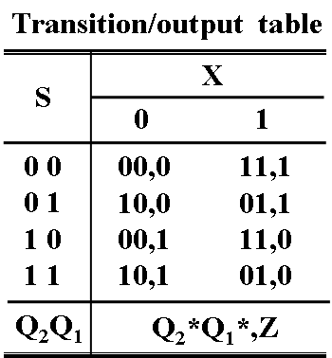

参考评分标准：
- 每个方程2分，共10分。错一个扣2分，
扣完10分止。
激励方程: D₁=X，D₂= X⊕Q₁
转移方程：Q₁ *= D₁=X，Q₂ *= D₂ = X⊕Q₁
输出方程：Z= X⊕Q₂
2.转移/输出表每个空0.5分，共8分。错一个扣0.5分，扣完8分止。
3.每个波形上升沿或下降沿1分，共8分。错一个扣1分，扣完8分止。
得 分
IV. Design a Mealy machine for a sequence detector with a serial input sequence of 1011 or 1101 using a 74x194, a AND and a XOR gate, the sequence may be overlap. The output Z=1 ,when the sequence of 1011 or 1101 is detected, and Z=0 otherwise . Please select shift left mode for the 74x194.(15’)
1.List out the states and states meaning.[3]
2. List out the minimal state/output table. [7’]
2. Write out the logic expression of output Z(X,QB,QC,QD).[3’]
3.Draw the circuit diagram.[6’]
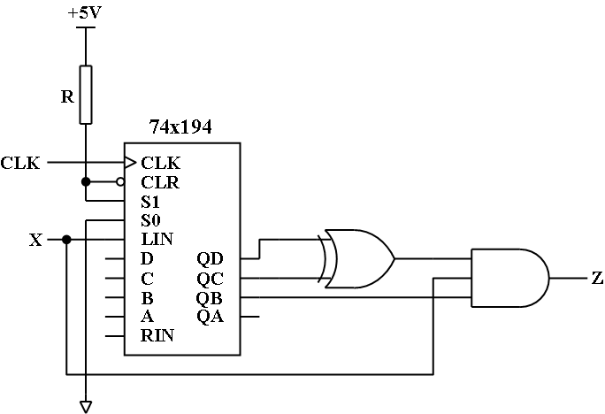

The function table of 74x194
Iutputs | Next state | Function
S1 S0 | QA* QB* QC* QD* | Function
0 0  0 1  1 0  1 1 | QA QB QC QD  RIN QA QB QC  QB QC QD LIN  A B C D | Hold  Shift right  Shift left  Load

参考评分标准：
- 状态含义正确3分，每个0.5分。错一个扣0.5分，扣完3分止。
- 状态转移/输出表正确（7分），每个状态和输出0.5分。错一个扣0.5分，扣完7分止。
The minimal state/output table
State meaning | S | X
State meaning | S | 0 | 1
Initial state | STA | STA, 0 | X1, 0
Got 1 | X1 | X10, 0 | X11, 0
Got 10 | X10 | STA, 0 | X101, 0
Got 11 | X11 | X110, 0 | X11, 0
Got 101 | X101 | X10, 0 | X11, 1
Got 110 | X110 | STA, 0 | X101, 1
 |  | S*, Z

2. Z(X,QB,QC,QD)=XQB(QC⊕QD) （3分）每一项1分。错一项扣1分，扣完3分止。
3.电路图正确（6分） 每个连接线1分，错一个扣1分，扣完6分止。

