电子科技大学2015-2016 学年第 二 学期期 末 考试 A 卷
考试科目： 数字逻辑设计及应用 考试形式： 闭卷 考试日期： 2016 年 6 月 29 日
成绩构成比例：平时 30/20 %， 期中 30/20 %， 小班研讨 20 %， 期末 40 %
本试卷由 V 部分构成，共 5 页。考试时长： 120 分钟 注：
题号 | I | II | III | IV | V | 合计
得分

得 分

I. Please fill out the correct answers in the brackets “( )” . ( 4’ X 10 = 40’ )

1. If a T flip flop with an enable input EN is constructed by a D flip flop, then the input

D=( EN⊕Q ).

2. If the minimal output voltage increment of an 8-bit DAC is 0.02V, then the output voltage is

( 77*0.02 或 1.54 ) V, when the input is 01001101.

3. A 16Kx8 ROM, which can implement a combinational circuit with ( 14 ) inputs and

( 8 ) outputs at most, can be built by ( 4 ) 8Kx4 ROMs .

4. To design a "1101001110" serial sequence generator, ( 4 ) flip flops are need at least.

5. A 4-bit linear feedback shift-register (LFSR) counter with no modification can have

( 15 ) valid states.

6. To build a modulo -256 counter, it requires at least ( 8 ) flip flops.

7. A ( mealy ) state machine is a sequential circuit whose output depends on the state

and inputs.

8. There are ( 2^{n}-2n ) invalid states for an n-bit Johnson counter.

每个空格4分，错一个，扣4分。

得 分

I I. Choose the correct answer and fill the item number in the brackets.

(3’ X 5=15’ )

1. According to the circuit as shown in Fig.1, the output F is ( a )

a. 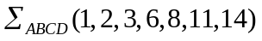 b. 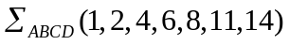

c. 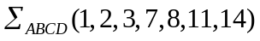 d. 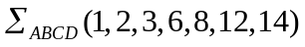

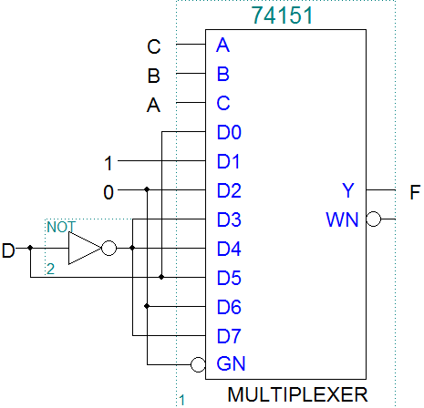

Fig.1

2. If a modulus-4 counter is got from the circuit as shown in Fig.2, then the inputs M and N should

be ( c )

a. 00 b. 01 c. 10 d. 11

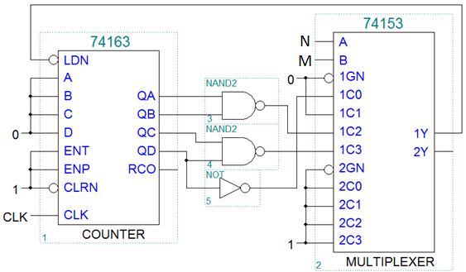

Fig.2
3. Which of the following device is a combinational circuit? ( a )
a. parity circuit b. shift register c. counter d. flip flop
4. When a modulus-60 up/down counter is designed, it requires at least ( b ) flip-flops.
a. 5 b. 6 c. 11 d. 12
5. For the initial state Q1Q2=00 as shown in Fig.3, the periodic sequence of the output F is ( d )
a. 0001 b. 0110 c. 0101 d. 0011
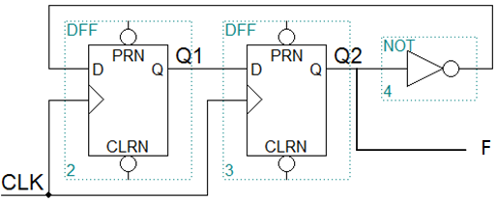
Fig.3

每个小题3分，错一个，扣3分。

得 分

III. A combinational circuit is shown as below, which contains a 74x85 comparator and a 74x283 adder. [13’]
1.Write out the logic expression of ALTBOUT, AEQBOUT and AGTBOUT.[6’]
2. List out the truth table for the circuit.[5’]
3. Indicate the logic function of the circuit.[2’]
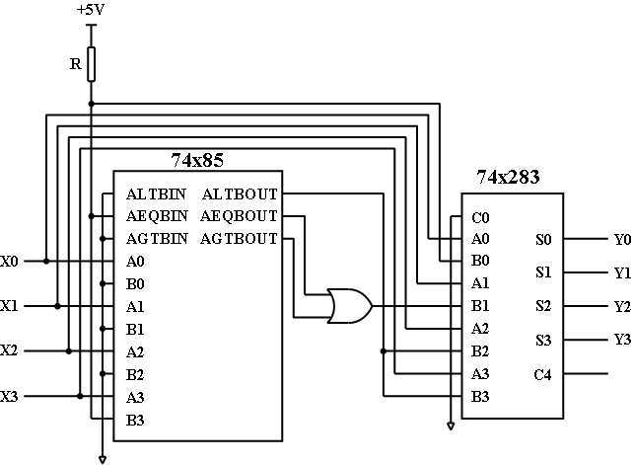
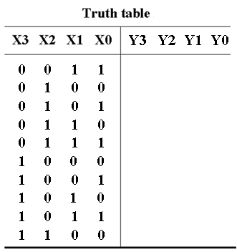

参考评分标准：
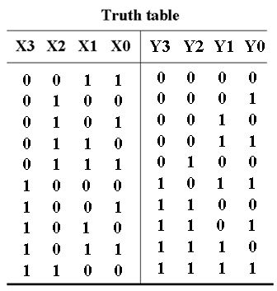
1. 逻辑表达式正确6分，每一个2分。
ALTBOUT=X3/,
AEQBOUT=X3X2/X1/X0/,
AGTBOUT=X3(X2+X1+X0)
2. 真值表正确5分，错一个扣0.5分。

2.电路功能描述正确2分：余3码转换为2421码。

得 分

IV. Analyze the sequential-circuit as shown below. [22’]
1.Write out the excitation equations, transition equations and output equation. [8’]
2.List out transition/output table. [8’]
3.Assume the initial state Q₂Q₁=00, complete the timing diagram for Q₁ ,Q₂ and Z. [6’]

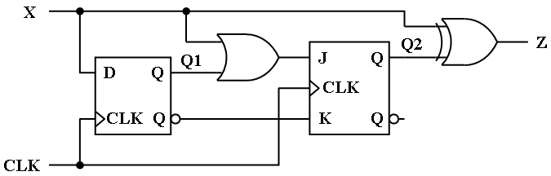

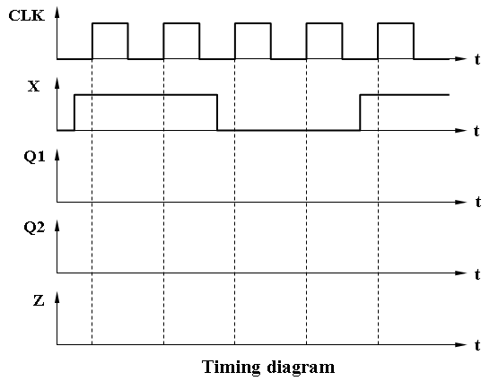
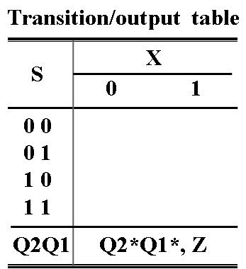

参考评分标准：
- 激励方程: D=X（1分），J2= X+Q1，K2=Q1/ ，（2分，错一处扣1分，扣完2分止）
转移方程：Q1 *= D=X（1分），Q2 *= J2Q2/+K2/Q2=XQ2/+Q1（2分，错一处扣1分，扣完2分止）
输出方程：Z= X⊕Q2（2分，错一处扣1分，扣完2分止）
2.转移/输出表新状态和输出每个空0.5分，共8分。错一个扣0.5分，扣完8分止。
3.每个波形2分，共6分。上升沿错误，整体扣1分；每个波形的翻转沿错误，扣0.5分，扣完该波形的得分为止。
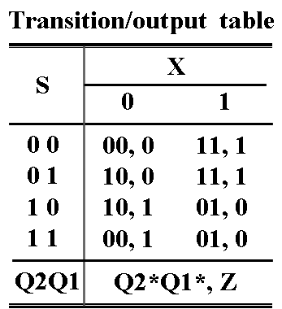
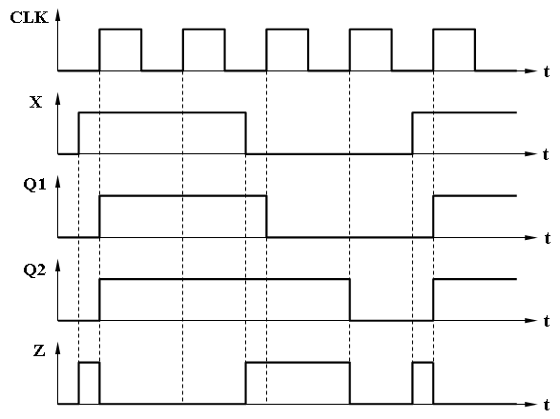

得 分

V. Design a sequence signal generator with self-correcting to generate two serial output sequence Z = 011010 using only a 74x194 and a 74x151. Please select shift left mode for the 74x194 [10’]
1.List out the transition table for Z and write out the minterm list of the feedback function LIN(QB,QC,QA) [6’]
2.Draw a schematic diagram for the circuit.[4’]
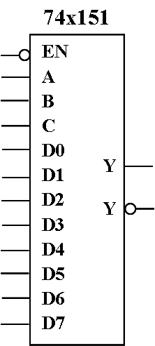
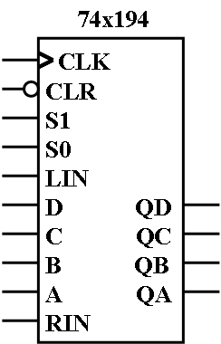

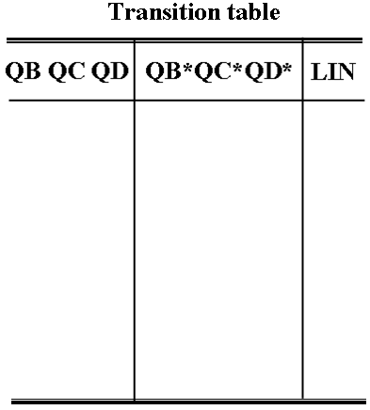
The function table for 74x194
Iutputs | Next state | Function
S1 S0 | QA* QB* QC* QD* | Function
0 0  0 1  1 0  1 1 | QA QB QC QD  RIN QA QB QC  QB QC QD LIN  A B C D | Hold  Shift right  Shift left  Load

参考评分标准：
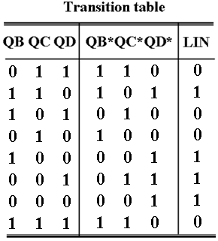
- 转移表正确4分，错1行扣0.5分，扣完4分止。

2. 反馈函数正确得2分，LIN=∑_{(QB,QC,QD)}(0,1,4,6)
错1个扣0.5分，扣完2分止。

3. 电路图正确4分，错1处扣0.5分，扣完为止。
