电子科技大学2015-2016学年第 二 学期期 末 考试 卷
考试科目： 数字逻辑设计及应用 考试形式： 闭卷 考试日期： 年 月 日
成绩构成比例：平时 40 %， 期中 20 %， 实验 0 %， 期末 40 %
本试卷由 部分构成，共 页。考试时长： 120 分钟 注：
题号 | 一 | 二 | 三 | 四 | 五 | 六 | 七 | 八 | 九 | 合计
得分
试题中涉及的MSI器件功能表见最后的附录（Appendix）。
得 分
一、填空题（每小题2分，共10分）

- Assigning 0 to Low and 1 to High is called positive logic. A CMOS 2-input XOR gate in positive logic is called （ XNOR或 同或 ）gate in negative logic.
- We need（ 8 ）chips of 8K×8 bits RAM to form a 32 K ×16 bits RAM.
- When the input of an 8 bit DAC is 01000000, the corresponding output voltage is 1.28V. The range of output voltage for the DAC is 0V~ ( 5.1 )V.
- To design a "01101100" serial sequence generator by shift registers, we need a ( 5 )-bit shift register as least.
- If the current state of a J-K flip-flop is “1”，and the control inputs J=K=1，then Q*=( 0 ) after the clock signal is enabled.

得 分
二、单项选择题（每小题2分，共10分）

1. Which of the following statements is correct? ( C )
A) The outputs of a Moore machine depend on inputs as well as the states.
B) The outputs of a Mealy machine depend only on the states.
C) The outputs of a Mealy machine depend on inputs as well as the states.
D) A), B), C) are wrong.
2. For the following latches or flip-flops, can NOT be used to form shift register. （ B ）
A) edge-triggered J-K flip-flop B) D latch with enable
C) master/slave S-R flip-flop D) T flip-flop
3. An asynchronous counter differs from a synchronous counter in . ( A )
A) the method of clocking B) the value of the modulus
C) the type of flip-flop used D) the number of states in its sequence
4. Which state in Figure 2.4 is NOT ambiguous. ( D )
A) state A B) state B C) state C D) state C and state D
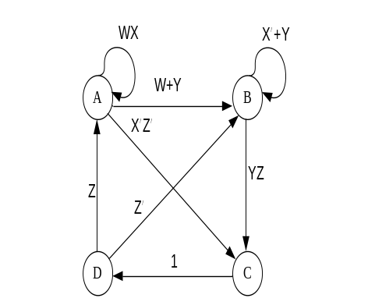
Figure 2.4
5. The following logic expressions is equal, and the hazard-free one is . ( D )
A) F=B’C’+AC+A’B B) F=A’C’+BC+AB’
C) F=A’C’+BC+AB’+A’B D) F=B’C’+AC+A’B+BC+AB’+A’C’

得 分
三、组合电路设计题（共15分）

Design a combinational circuit with two 2-bit unsigned numbers inputs, A (A=A₁A₀) and B (B=B₁B₀), and a 4-bit unsigned number output Y (Y=Y₃Y₂Y₁Y₀), and to realize the function Y=2A+3B.
- Please write the truth table for the circuit. (8’)
Truth table （真值表）
A₁ | A₀ | B₁ | B₀ | Y₃ | Y₂ | Y₁ | Y₀ | A₁ | A₀ | B₁ | B₀ | Y₃ | Y₂ | Y₁ | Y₀
0 | 0 | 0 | 0 | 0 | 0 | 0 | 0 | 1 | 0 | 0 | 0 | 0 | 1 | 0 | 0
0 | 0 | 0 | 1 | 0 | 0 | 1 | 1 | 1 | 0 | 0 | 1 | 0 | 1 | 1 | 1
0 | 0 | 1 | 0 | 0 | 1 | 1 | 0 | 1 | 0 | 1 | 0 | 1 | 0 | 1 | 0
0 | 0 | 1 | 1 | 1 | 0 | 0 | 1 | 1 | 0 | 1 | 1 | 1 | 1 | 0 | 1
0 | 1 | 0 | 0 | 0 | 0 | 1 | 0 | 1 | 1 | 0 | 0 | 0 | 1 | 1 | 0
0 | 1 | 0 | 1 | 0 | 1 | 0 | 1 | 1 | 1 | 0 | 1 | 1 | 0 | 0 | 1
0 | 1 | 1 | 0 | 1 | 0 | 0 | 0 | 1 | 1 | 1 | 0 | 1 | 1 | 0 | 0
0 | 1 | 1 | 1 | 1 | 0 | 1 | 1 | 1 | 1 | 1 | 1 | 1 | 1 | 1 | 1

2) Find the minimal sum-of-products （最简积之和）expression of Y₃. (3’)

Y₃=B₁B₀+A₀B₁+A₁B₁+A₁A₀B₀

3) The circuit can be built with a single 74x283 and no other gates. Draw the logic diagram for the circuit. (4’)
GENERAL DESCRIPTION FOR 74x283:
The 74x283 add two 4-bit binary words (An plus Bn) plus the incoming carry(C0). The binary sum appears on the sum outputs (S0 to S3) and the out-going carry (C4)according to the equation:
C0 + (A0 + B0) + 2(A1 + B1) + 4(A2 + B2) + 8(A3 + B3) = S0 + 2S1 + 4S2+ 8S3+ 16C4
Where (+) = plus.
参考电路如下图（还有其他连接方式）：
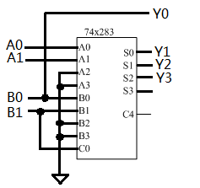

得 分

四、时序电路分析题（共20分）

1. Analyze the circuit of a clocked synchronous state machine shown in Figure 4.1, write the excitation equations, output equation, transition equations and construct a transition/output table. （10’）
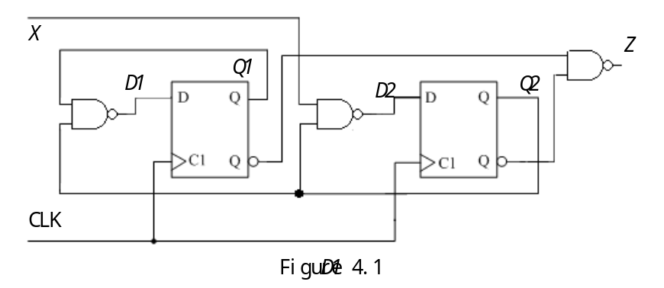
transition/output table
Q1Q2 | X
Q1Q2 | 0 | 1
0 0 | 11,0 | 11,0
0 1 | 11,1 | 10,1
1 0 | 11,1 | 11,1
1 1 | 01,1 | 00.1
 | Q1*Q2*,Z

excitation equations：
D1=( Q1·Q2 )’=Q1’+Q2’ （1分）
D2=( X·Q2 )’=X’+Q2’ （1分）
output equation：
Z=( Q1’·Q2’ )’=Q1+Q2 （2分）
transition equations：
Q1*=D1=( Q1·Q2 )’=Q1’+Q2’ （1分）
Q2*=D2=( X·Q2 )’=X’+Q2’ （1分）

2. The transition/output table of a clocked synchronous state machine is shown as table 4. Complete the timing diagram for Y, assuming that the machine starts in state Q1Q0=00 and flip-flops are positive-edge-triggered.（5’）
Table 4 transition/output table
Q1Q0 | A
Q1Q0 | 0 | 1
00 | 01，0 | 11，0
01 | 01，0 | 11，0
10 | 01，1 | 00，0
11 | 10，0 | 00，1
 | Q1*Q0*，Y

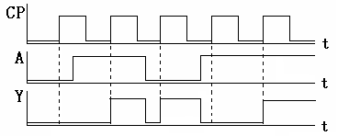

3、Construct a state/output table equivalent to the state diagram shown in Figure 4.2.（5’）
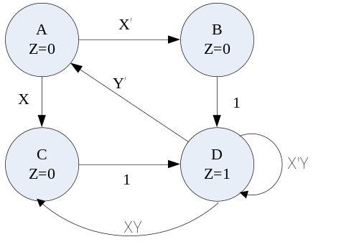
state/output table
S | XY |  |  |  | Z
S | 00 | 01 | 10 | 11 | Z
A | B | B | C | C | 0
B | D | D | D | D | 0
C | D | D | D | D | 0
D | A | D | A | C | 1
 | S*

Figure 4.2

得 分

五、时序电路设计I题（共10分）

1. Design a clocked synchronous state machine with the state/output table shown in table 5.1, using D flip-flops. Use two state variables,Q1 Q2, with the state assignment A=00,B=01,C=11,D=10. Complete the transition/output table and excitation/output table. (6’)
transition/output table
Q1Q2 | X
Q1Q2 | 0 | 1
00 | 01,0 | 11,1
01 | 11,0 | 00,0
11 | 10,0 | 10,0
10 | 00,1 | 01,0
 | Q1*Q2*,Z

excitation/output table
Q1Q2 | X
Q1Q2 | 0 | 1
00 | 01,0 | 11,1
01 | 11,0 | 00,0
11 | 10,0 | 10,0
10 | 00,1 | 01,0
 | D1D2,Z

Table 5.1 state/output table
S | X
S | 0 | 1
A | B，0 | C，1
B | C，0 | A，0
C | D，0 | D，0
D | A，1 | B，0
 | S*，Z

- Design a clocked synchronous state machine with the excitation/output table shown in Table 5.2, using two D flip-flops, ONE 74x138 and some NAND gates. Complete the logic diagram in figure 5. (4’)
Table 5.2 excitation/output table
Q1 Q2 | X |  | Z
Q1 Q2 | 0 | 1 | Z
0 0 | 0 0 | 0 1 | 0
0 1 | 0 1 | 1 0 | 0
1 0 | 1 0 | 1 1 | 0
1 1 | 1 1 | 0 0 | 1
 | D1 D2

D1=∑_{X,Q2,Q1}(1,3,5,6)
D2=∑_{X,Q2,Q1}(2,3,4,5)
Z=∑_{X,Q2,Q1}(3,7)

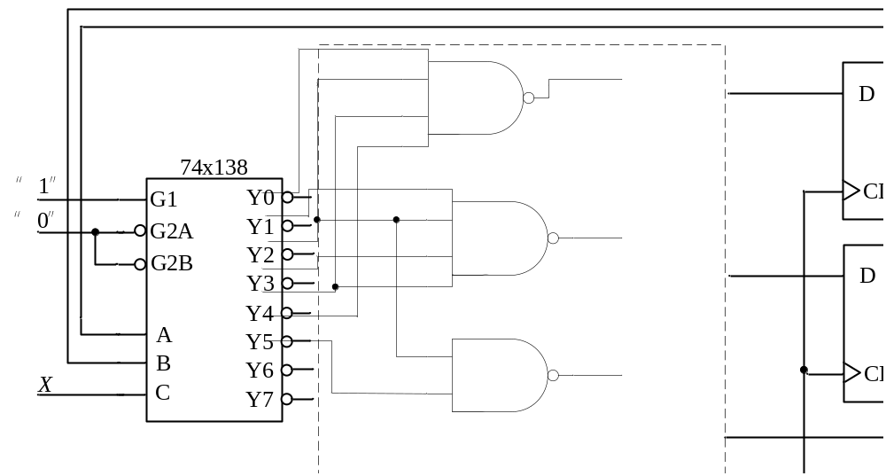

figure 5

六、时序电路设计II题（共10分）
得 分

Construct a minimal state/output table for a Mealy sequential machine, that will detect the following input sequences: X=1010 or 1000. If input sequence X=1010 is met, cause Z1=1. If input sequence X=1000 is met, cause Z2=1. Each input sequence may overlap with itself or the other sequence. Please describe the state meaning and finish the minimal state/output table.

X: | 0 | 1 | 0 | 1 | 0 | 0 | 0 | 1 | 1 | 0 | 1 | 1 | 0 | 0 | 0 | 1 | 0 | 1 | 0 | 0
Z1: | 0 | 0 | 0 | 0 | 1 | 0 | 0 | 0 | 0 | 0 | 0 | 0 | 0 | 0 | 0 | 0 | 0 | 0 | 1 | 0
Z2: | 0 | 0 | 0 | 0 | 0 | 0 | 1 | 0 | 0 | 0 | 0 | 0 | 0 | 0 | 1 | 0 | 0 | 0 | 0 | 0
The minimal state/output table
State meaning | S | X
State meaning | S | 0 | 1
Initial | A | A，00 | B,00
收到1 | B | C，00 | B，00
收到10 | C | D，00 | E，00
收到100 | D | A．01 | B，00
收到101 | E | C，10 | B，00
 |  | S*, Z1 Z2

七、74x163应用题I（共10分）
得 分

A 74x163 counter is hooked up with inputs ENP, ENT, A and D always HIGH, inputs B and C always LOW, input LD_L=(QB·QC)’,and input CLR_L=(QC·QD)’. The CLK input is hooked up to a free-running clock signal.
- Complete the logic diagram shown in figure 7. Assuming that the 74x163 counter starts in state 0000,write the output sequence on Q3 Q2 Q1 Q0 for the next 15 clock ticks. (5’)

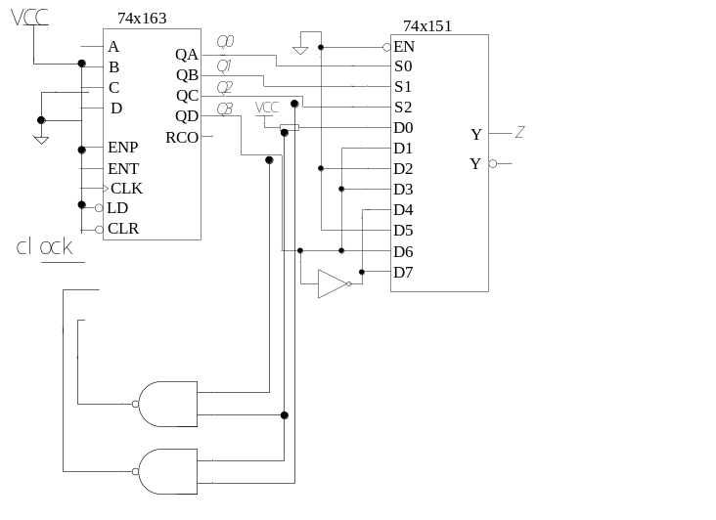
figure 7
0000→ ( 0001 ) → ( 0010 ) → ( 0011 ) → ( 0100 ) → ( 0101 ) → ( 0110 ) → ( 1001 ) → ( 1010 ) → ( 1011 ) → ( 1100 ) → ( 0000 ) → ( 0001 ) → ( 0010 ) → ( 0011 ) → ( 0100 )
- Using Karnaugh map to show the input and output relationship of 74x151 shown in Figure 7. Complete the Karnaugh map shown below. (4’)
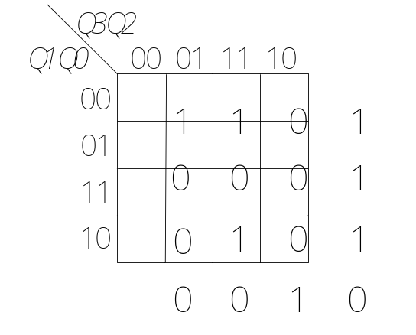

3. The circuit is a sequence signal generator. Write the sequence of Z. (1’)
the sequence of Z：10001001010

八、74x163应用题II（5分）
得 分

Design a clocked synchronous circuit with two inputs, a 16MHz clock signal, MCLK, and a select signal, SEL, and can provide a new clock signal, UCLK, whose frequency would be 8MHz or 4MHz depending on the value of SEL. And UCLK was required to have a 50% duty cycle（占空比）at both frequencies. Using only ONE 74x163 and NO other components.

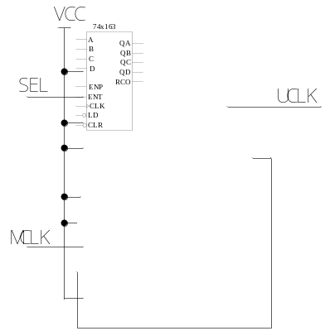
SEL=1，输出8MHz；SEL=0，输出4MHz；

九、74x194应用题（10分）
得 分

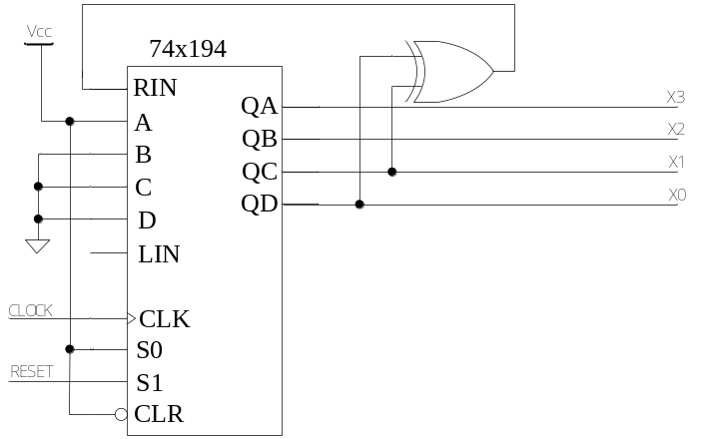
Figure 9.1

- The logic diagram for a 4-bit （ C ）counter is shown in Figure 9.1. (2’)
- ring B. twisted-ring C. LFSR D. binary

2. Starting with state 0001, write the sequence of states on X3 X2 X1 X0 for the next 15 clock ticks for this counter .(3’)
X3 X2 X1 X0：
0001→ ( 1000 ) → ( 0100 ) → ( 0010 ) → ( 1001 ) → ( 1100 ) → ( 0110 ) → ( 1011 ) → ( 0101 ) → ( 1010 ) → ( 1101 ) → ( 1110 ) → ( 1111 ) → ( 0111 ) → ( 0011 ) → ( 0001 )

3. This counter can be modified to have 16 states, including the state 0000. In the circuit, an extra XOR gate and another gate connected to the necessary outputs. Please complete the logic diagram in Figure 9.2 to show how to connect. (5’)

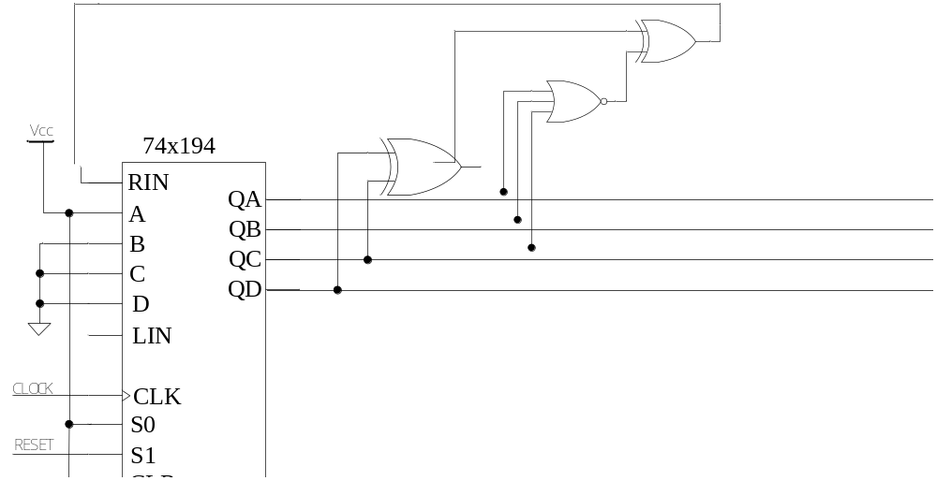
Figure 9.2

Appendix: functional table for some MSI
Function table for the 74x194 4-bit universal shift register
Inputs | Next state | Function
S1 S0 | QA* QB* QC* QD* | Function
0 0  0 1  1 0  1 1 | QA QB QC QD  RIN QA QB QC  QB QC QD LIN  A B C D | Hold  Shift right  Shift left  Load

Truth table for a 74x151 8-input 1-bit multiplexer
Inputs |  |  |  | Outputs
EN_L | S2 | S1 | S0 | Y | Y_L
1 | x | x | x | 0 | 1
0 | 0 | 0 | 0 | D0 | D0’
0 | 0 | 0 | 1 | D1 | D1’
0 | 0 | 1 | 0 | D2 | D2’
0 | 0 | 1 | 1 | D3 | D3’
0 | 1 | 0 | 0 | D4 | D4’
0 | 1 | 0 | 1 | D5 | D5’
0 | 1 | 1 | 0 | D6 | D6’
0 | 1 | 1 | 1 | D7 | D7’

Truth table for a 74x138 3-to-8 decoder
Inputs |  |  |  |  |  | Outputs
G1 | G2A_L | G2B_L | C | B | A | Y7_L | Y6_L | Y5_L | Y4_L | Y3_L | Y2_L | Y1_L | Y0_L
0 | x | x | x | x | x | 1 | 1 | 1 | 1 | 1 | 1 | 1 | 1
x | 1 | x | x | x | x | 1 | 1 | 1 | 1 | 1 | 1 | 1 | 1
x | x | 1 | x | x | x | 1 | 1 | 1 | 1 | 1 | 1 | 1 | 1
1 | 0 | 0 | 0 | 0 | 0 | 1 | 1 | 1 | 1 | 1 | 1 | 1 | 0
1 | 0 | 0 | 0 | 0 | 1 | 1 | 1 | 1 | 1 | 1 | 1 | 0 | 1
1 | 0 | 0 | 0 | 1 | 0 | 1 | 1 | 1 | 1 | 1 | 0 | 1 | 1
1 | 0 | 0 | 0 | 1 | 1 | 1 | 1 | 1 | 1 | 0 | 1 | 1 | 1
1 | 0 | 0 | 1 | 0 | 0 | 1 | 1 | 1 | 0 | 1 | 1 | 1 | 1
1 | 0 | 0 | 1 | 0 | 1 | 1 | 1 | 0 | 1 | 1 | 1 | 1 | 1
1 | 0 | 0 | 1 | 1 | 0 | 1 | 0 | 1 | 1 | 1 | 1 | 1 | 1
1 | 0 | 0 | 1 | 1 | 1 | 0 | 1 | 1 | 1 | 1 | 1 | 1 | 1

Function table for a 74x163 4-bit binary counter
Inputs |  |  |  | Current State | Next state | Output
CLR_L | LD_L | ENT | ENP | Q_{D} Q_{C} Q_{B} Q_{A} | Q_{D}* Q_{C}* Q_{B}* Q_{A}* | RCO
0 | X | X | X | X X X X | 0 0 0 0 | 0
1 | 0 | X | X | X X X X | D C B A | 0
1 | 1 | 0 | X | X X X X | Q_{D} Q_{C} Q_{B} Q_{A} | 0
1 | 1 | X | 0 | X X X X | Q_{D} Q_{C} Q_{B} Q_{A} | 0
1 | 1 | 1 | 1 | 0 0 0 0 | 0 0 0 1 | 0
1 | 1 | 1 | 1 | 0 0 0 1 | 0 0 1 0 | 0
1 | 1 | 1 | 1 | 0 0 1 0 | 0 0 1 1 | 0
1 | 1 | 1 | 1 | 0 0 1 1 | 0 1 0 0 | 0
1 | 1 | 1 | 1 | …………. | ………….. | 0
1 | 1 | 1 | 1 | 1 1 1 1 | 0 0 0 0 | 1

