电子科技大学2017 -2018 学年第 2 学期期 末 考试 A 卷
考试科目： 数字逻辑设计及应用 考试形式：闭卷 考试日期： 2018 年 07 月 05 日
本试卷由 V 部分构成，共 页。考试时长： 120 分钟
成绩构成比例：平时成绩 60 %，期末成绩 40 %。注： 不能携带词典、计算器
题号 | I | II | III | IV | V | 合计
得分

得 分
I. Please fill out the correct answers in the brackets “( )” . ( 3’ X 10 = 30’+10’)
1. 74x280 is a parity circuit. If its inputs are 010011001, then its output ODD is ( 0 )
2. After correcting, an N-bit LFSR counter may has ( 2^{N} ) valid states.
3. The modulus of the circuit shown in Fig. 1 is ( 16 ), where Q3Q2Q1Q0 are state variables, and RCO is the output. The FSM is a ( moore ) (mealy/moore) machine.
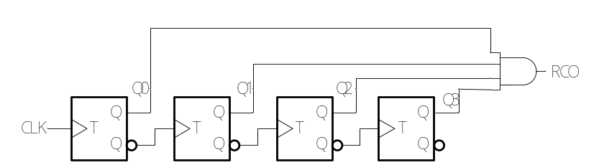
Fig. 1
4. Given the circuit shown in Fig. 2, its output F=∏_{ABC}( 3,5,6,7 ).
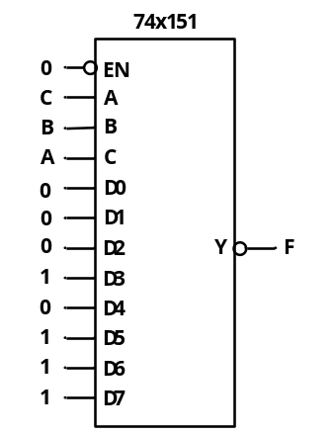
Fig. 2
5. To build a counter with modulus 1026, ( 11 ) flip flops are required at least.
6. Given the circuit shown in Fig. 3, where 74x85 is a 4-bit magnitude comparator, and 74x283 is a 4-bit adder. If X₃X₂X₁X₀=1011, then Y₃Y₂Y₁Y₀=( 0101 )
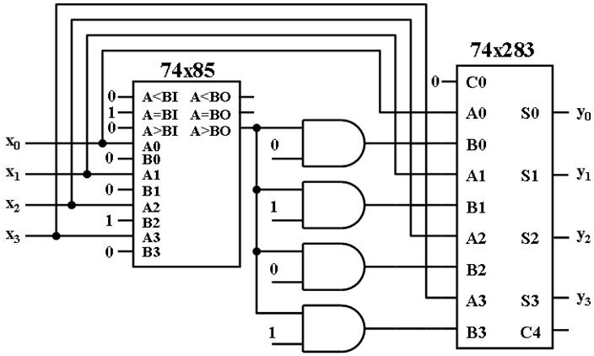
Fig. 3
7. The minimum incremental voltage of a 8-bit DAC is 0.02V, the output voltage range for the DAC is ( 0 ~ 5.1 )V.
8. The modulus of the counter shown in Fig. 4 is ( 8 ).
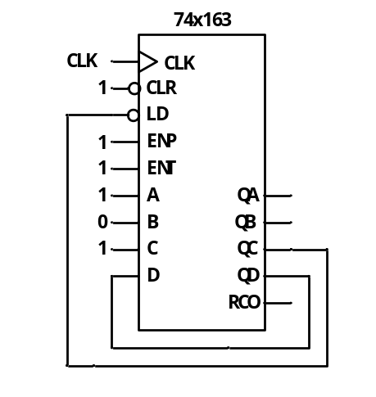
Fig. 4
9. For a 5-bit binary ascending counter, if the initial state is 00000, then the state is ( 01001 ) at the end of 169 positive edge of the clock.
10. Verilog module for a 2-to-4 binary is shown below,the enable input g is active high,the 2 bits input code a is active high and the 4 bits output code y_l is active low. There are several errors in the module, please find the errors and correct the errors. [10’]
module decorder2to4(g,a,y_l); //1
input g; //2
input [1:0] a; //3
output [3:0] y_l; //4
reg [3:0] y_l=4'h1111; //5
always @ (g and a) //6
begin //7
if (g==1) //8
case (a) //9
3:y_l=4'b0111; //10
2:y_l=4'b1110; //11
1:y_l=4'b1101; //12
0:y_l=4'b1110; //13
otherwise:y_l=4'b1111; //14
endcase //15
else //16
y_l=4'b1111; //17
end //18
moduleend //19
please write the number of error line and the correct codes on the underlines.
line is error，Modified to:
line is error，Modified to:
line is error，Modified to:
line is error，Modified to:
line is error，Modified to:

function table
inputs |  |  | outputs
g1 | a₁ | a₀ | y₀_l | y₁_l | y₂_l | y₃_l
0 | x | x | 1 | 1 | 1 | 1
1 | 0 | 0 | 0 | 1 | 1 | 1
1 | 0 | 1 | 1 | 0 | 1 | 1
1 | 1 | 0 | 1 | 1 | 0 | 1
1 | 1 | 1 | 1 | 1 | 1 | 0

参考评分标准：
line（ 5）is error，Modified to: （ reg [3:0] y_l=4'b1111; ）
line（ 6）is error，Modified to: （ always @ (g or a) ）
line（ 11）is error，Modified to: （ 2:y_l=4'b1011; ）
line（ 14 ）is error，Modified to: （ default:y_l=4'b1111; ）
line（ 19 ）is error，Modified to: （ endmodule ）
判断对一处得1分，改对1处得1分

以下为正确代码，已验证
module decorder2to4(g,a,y_l); //1
input g; //2
input [1:0] a; //3
output [3:0] y_l; //4
reg [3:0] y_l=4'b1111; //5
always @ (g or a) //6
begin //7
if (g==1) //8
case (a) //9
3:y_l=4'b0111; //10
2:y_l=4'b1011; //11
1:y_l=4'b1101; //12
0:y_l=4'b1110; //13
default:y_l=4'b1111; //14
endcase //15
else //16
y_l=4'b1111; //17
end //18
endmodule //19

得 分

I I. Choose the correct answer and fill the item number in the brackets. (3’ X 5=15’ )

1. A modulus 10 counter with 4 flip flops has ( A ) invalid states.
A. 6 B. 8 C. 10 D. 12
2. To design a modulus 60 up/down counter, ( D ) flip flops are required at least.
A. 12 B. 8 C.7 D. 6
3. Given a RAM with 1024 bits, if its outputs are y₀ y₁, then its inputs are ( B )
A. A₀~A₇ B. A₀~A₈ C. A₀~A₉ D. A₀~A₁₀
4. the state diagram shown in Fig. 5 has ( C ) ambiguous states.
A. 1 B. 2 C. 3 D. 4
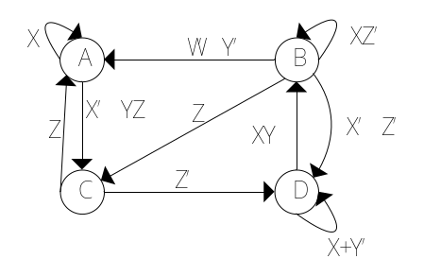
Fig. 5
5. If a D flip-flop is constructed by a JK flip-flop, then the inputs of the JK flip-flop are ( C ).
A. J=D', K=D' B. J=D', K=D C. J=D, K=D' D. J=D, K=D

得 分

III. Analyze the sequential-circuit as shown below. [18’]
1. Write out the excitation equations and output equation. [6’]
2. List out transition/output table and draw a state diagram. [5’]
3. Assume the initial state Q2Q1=00, draw the timing diagram for Q2 ,Q1 and Z. [5’]
4. Indicate the logic function of the circuit.[2’]
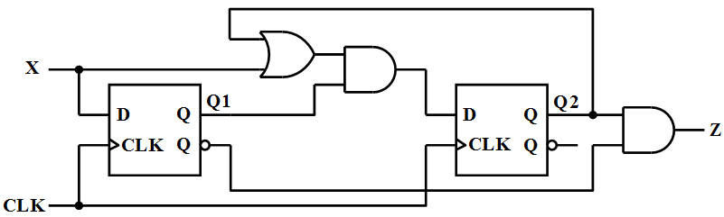
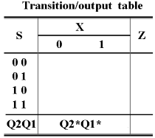
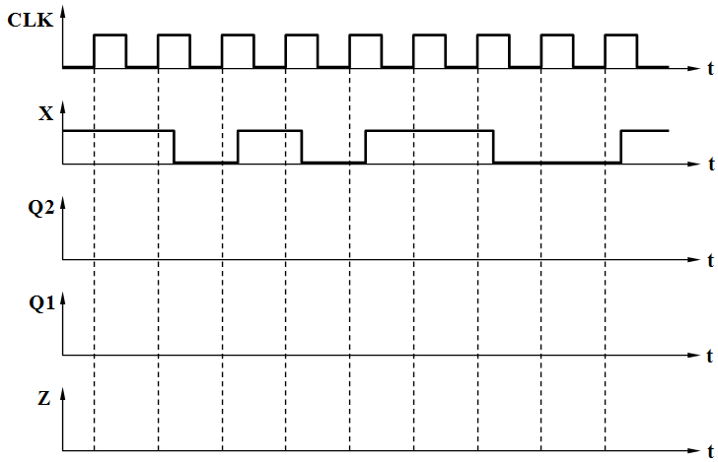

参考评分标准：
1.激励方程: D1= X（2分），D2= (X+Q2)Q1（2分），输出方程Z= Q2Q1/（2分）
2.转移/输出表和状态图(5分)，定义状态S0=00，S1=01，S2=10，S3=11，
每个状态1分共4分，输出1分。
3.定时图(5分)，Q2、Q1的波形各2分，Z的波形1分。若时钟沿错误则整体扣1分。
4.功能描述（2分）：Moore型（1分），110检测（1分）。
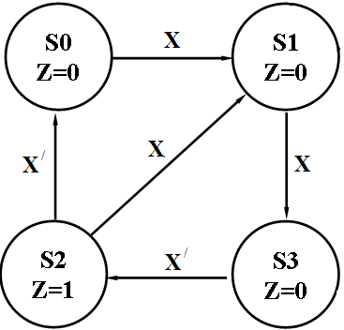
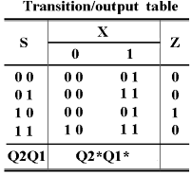

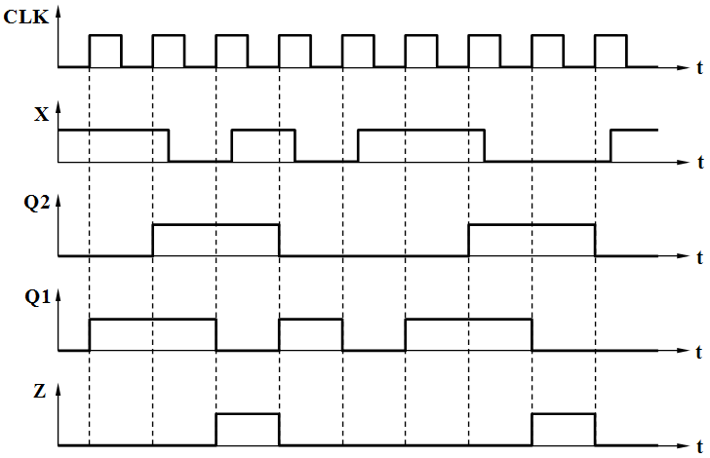

得 分

IV. Analyze the sequential-circuit as shown below, which contains two 74x163 4-bit binary counter. [6’]
1. Write out the logic expression of LD_L(RCO1，RCO2) for U₁ and U₂.[2’]
2. Assume the initial state is 196₁₀, write out the state sequence in a cycle for the circuit. [2’]
3. Indicate the modulus for the circuit. [2’]
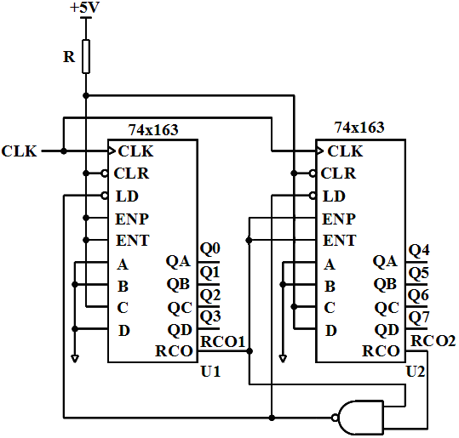
The function table for 74x163
Inputs |  |  |  | Current state | Next state | Outputs
CLR_L | LD_L | ENT | ENP | QD QC QB QA | QD* QC* QB* QA* | RCO
0 | X | X | X | X X X X | 0 0 0 0 | 0
1 | 0 | X | X | X X X X | D C B A | 0
1 | 1 | 0 | X | X X X X | QD QC QB QA | 0
1 | 1 | X | 0 | X X X X | QD QC QB QA | 0
1 | 1 | 1 | 1 | 0 0 0 0 | 0 0 0 1 | 0
1 | 1 | 1 | 1 | 0 0 0 1 | 0 0 1 0 | 0
1 | 1 | 1 | 1 | 0 0 1 0 | 0 0 1 1 | 0
1 | 1 | 1 | 1 | 0 0 1 1 | 0 1 0 0 | 0
1 | 1 | 1 | 1 | …………. | ………….. | 0
1 | 1 | 1 | 1 | 1 1 1 1 | 0 0 0 0 | 1

参考评分标准：
1. LD_L（RCO1，RCO2）=（RCO1·RCO2）/（2分）
2. 状态序列： 196,197,198…253,254,255,196（2分）
3. modulus=60（2分）

得 分

V. Design a sequence signal generator with self-correcting to generate a serial output sequence Z = 110100 using only a 74x194 and a 74x151. Please select shift right mode for the 74x194 .[21’]
1.List out the transition table and draw a full state diagram.[9’]
2. Write out the minterm list of the feedback function RIN(QC,QB,QA). [4’]
3.Draw a schematic diagram for the circuit.[8’]
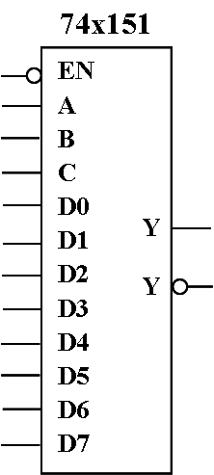
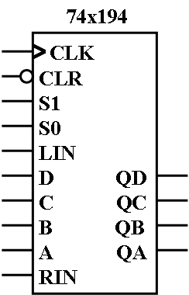

The function table for 74x194
Iutputs | Next state | Function
S1 S0 | QA* QB* QC* QD* | Function
0 0  0 1  1 0  1 1 | QA QB QC QD  RIN QA QB QC  QB QC QD LIN  A B C D | Hold  Shift right  Shift left  Load

参考评分标准：
- 转移表（5分）移位关系正确1分；每个状态转移关系0.5分；
全状态图（4分）。每个状态转移关系0.5分；

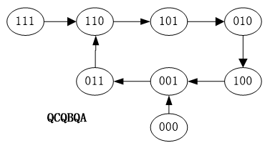
QCQBQA | QC*QB*QA* | RIN
110 | 101 | 1
101 | 010 | 0
010 | 100 | 0
100 | 001 | 1
001 | 011 | 1
011 | 110 | 0
000 | 001 | 1
111 | 110 | 0
有个别同学将Z序列110100←，的移动方向弄反了变成110100→，如果后面的设计都正确，则没有扣分；

- 反馈函数RIN=∑_{(QC,QB,QA)}(0,1,4,6) 或RIN=∑_{(QA,QB,QC)}(0,1,3,4)（4分），每个1分。
写反的情况：RIN=∑_{(QC,QB,QA)}(0,2,4,5) 或RIN=∑_{(QA,QB,QC)}(0,1,2,5)

3. 电路图8分，
194的CLK,CLR_L,S1S0和151的EN_L，2分，没有全对，酌情扣分。
Z输出标注1分；
RIN连接标识1分；
QCQBQA接CBA及D0~D7，4分；原则上CBA的连接2分，D0~D7的连接2分，两者需要配合；如果只连接CBA， D不接，则全部扣完。

