电子科技大学2016-2017学年第一学期期末考试A卷参考解答
考试科目：数字逻辑设计及应用考试形式：闭卷考试日期： 2017年1月10日
成绩构成比例：平时20/30%， 期中20/30%， 小班研讨20/0%， 期末40%
本试卷由V部分构成，共6页。考试时长：120分钟 注：可以带纸质英文字典,不使用计算器
题号 | I | II | III | IV | V | 合计
得分

得分

I. Please fill out the correct answers in the bracket “（）”. (For 1-8, 2’ X 12 =24, For 9-12, 4’X 4 =16,total 40’)
1. For an8-bit DAC, its output voltage is 1.00V when the input is 01100100. If the input is 10001010, the corresponding output voltage will be ( 1.38 )V.
2. If a ROM has 8-bit address inputs and 4-bit data outputs, then it can be used to implement ( 4 ) combinational logic functions. Its capacity is ( 1024 ) bits.
3.A 5-bit Johnson counter without self-correcting has ( 10 ) valid states at most.A 4-bit ring counter without modification has ( 4 ) states in the cycle at most.
4. Parity circuit can be used to detect errors during data transfer. Suppose that a 9-bit parity code with 8-bit information data and 1-bit parity is implemented in one data transfer system and the receiver get a data string 010011001 without error indicated, then the parity circuit realize a ( even ) (odd/even) parity.
5. The 74x85 is a 4-bit magnitude comparator. If input A=B, and the less-than output ALTBOUT=1, then the cascading inputs should be AGTBIN = ( 0 ), AEQBIN =( 0 ) and ALTBIN = ( 1 ).
6. The 74x148 is an 8-input priority encoder with active low inputs and outputs. If its I0,I4 and I7 inputs are activated then the output code is ( 000).
7. To design a modulo-44 counter requires ( 6 ) D flip-flops at least. Also, the counter can be constructed by two 4-bit binary counter of 74x163, witch one cleared to zero when counting to 1010 and another loaded with ( 1100 ) when RCO=1.
8.A sequential circuit whose output depends only on its state is called a ( moore) state machine.
9. A 4-bit LFSR counter with feedback equation D0=Q3⊕Q2 yields a modulo-( 15 ) counter.
10. A sequence pulse generator circuit is shown in Figure 1. Assume the initial state of the circuit is Q3Q2Q1Q0 =1101 , the output sequencein Q3 is (11010 or 10101 ).
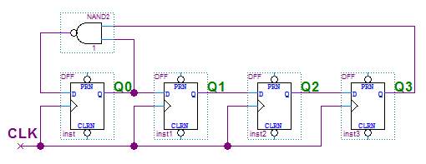
Figure 1
11. A sequential circuit implemented a function F is shown in Figure 2. The function is F=.
Table 1
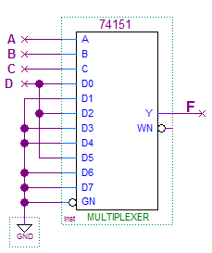
S | S* | Z
A | B | 0
B | C | 0
C | A | 1
D | A | 0
Figure 2.
12. According to the state/output table shown in Table 1, there are ( 3 ) states in the cycle.

得分

II. Please choose the only correct answer and fill the item number in the barackets. (3’X5=15’)
1. How many states are ambiguous according to the state diagram shown in Figure 3 ? ( B )
A. 1 B. 2 C. 3 D. 4
2. To design a “10011110” sequence pulse generator by shift registers, we need a ( B )-bit shift register at least.
A. 3 B. 4 C. 5 D.6
3. The modulus of the circuit shown in Figure 4 is ( C ).
A. 4 B. 5 C. 6 D.14

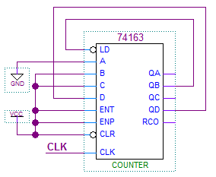
A
B
C
D
Y
Y’
XY
X
XY’
X
Figure 3. Figure 4.
X’
Y

Function table for 74X163
Inputs |  |  |  | Current State | Next state | Output
CLR_L | LD_L | ENT | ENP | Q_{D} Q_{C} Q_{B} Q_{A} | Q_{D}* Q_{C}* Q_{B}* Q_{A}* | RCO
0 | X | X | X | X X X X | 0 0 0 0 | 0
1 | 0 | X | X | X X X X | D C B A | 0
1 | 1 | 0 | X | X X X X | QD QC QB QA | 0
1 | 1 | X | 0 | X X X X | QD QC QB QA | 0
1 | 1 | 1 | 1 | 0 0 0 0 | 0 0 0 1 | 0
1 | 1 | 1 | 1 | 0 0 0 1 | 0 0 1 0 | 0
1 | 1 | 1 | 1 | 0 0 1 0 | 0 0 1 1 | 0
1 | 1 | 1 | 1 | 0 0 1 1 | 0 1 0 0 | 0
1 | 1 | 1 | 1 | …………. | ………….. | 0
1 | 1 | 1 | 1 | 1 1 1 1 | 0 0 0 0 | 1

4. Which of the following statements is CORRECT? ( D )
A. An edge-triggered D flip-flop never goes into metastable status.
B. A master/slave J-K flip-flop keep the current status when input J=1 and K=1.
C. if S is asserted, an S-R latch is forced to logic stats Q=1.
D. A D latch will follow the input as long as the control input C is active.
5. The state/output table of a clocked synchronous state machine is shown in Table 2. Suppose that the initial state of the state machine is “A”, When input sequence is X=”10101110”, the corresponding output sequence Z will be ( A ).
A. 00010010 B. 00110010 C. 01000110 D. 00100010

Table 2.
 | X
S | 0 | 1 | Z
A | B | D | 0
B | C | B | 0
C | B | A | 1
D | B | C | 0
 | S*

得分

III. Analyze the clocked synchronous state machine as shown below. (15’)
(1) Write out the excitation equations, transition equations and output equation. [2’]
(2) List out the transition/output table. [4’]
(3) Assume the initial state Q1Q0 is 00, draw the timing diagram for Q0, Q1 and Z. [7’]
(4) Indicate the function for the logic circuit. [2’]

D0
CLK
Q0
Q0
D1
CLK
Q1
Q1
X
Z
CLK

【参考答案】
(2) 每格0.5分，共4分。
Transition/output table
Q1Q0 | X
Q1Q0 | 0 | 1
00 | 01/0 | 00/0
01 | 01/0 | 10/0
10 | 01/1 | 00/0
11 | 01/1 | 10/0
 | Q1*Q0*/Z

(1) 激励方程每个0.5分，转移方程共0.5分，输出方程0.5分，
共2分。
激励方程: D0 = X' D1 = X·Q0
转移方程: Q0 = X' Q1 = X·Q0
输出方程: Z = X'·Q1
CLK
X
Q0
Q1
Z

(3) Q1和Q0每个触发沿0.5分，
Z每个变化沿0.5分，共7分。

(4) 电路功能：可重叠的010序列
检测。(2分)
得分

VI. Design a 2-bit Gray-code up/down counter with two D Flip-flops and some gates. Q1Q0 represent the counter value in Gray-code. M is the up/down select input. When M=1, the counter counts in ascending Gray-code order and then the output Z will be 1 when counter value reaches 3. When M=0, the counter counts in descending Gray-code order and then the output Z will be 1 when counter value reaches 0. (15’) (1) List out the transition/output table. [4’]
(2) Fill out the Karnaugh maps. [3’]
(3) Write out the transition equations, excitation equations and output equation. [4’]
(4) Draw the logic circuit diagram. [4’]

【参考答案】
(1) 每行1分，共4分。
Transition/output table
Q1Q0 | M
Q1Q0 | 0 | 1
00 | 10/1 | 01/0
01 | 00/0 | 11/0
11 | 01/0 | 10/0
10 | 11/0 | 00/1
 | Q1*Q0*/Z

(2) 每个卡诺图1分，共3分。
10010110
Q1Q0
M
0
00
01
11
10
1
Q1*
00111100
Q1Q0
M
0
00
01
11
10
1
Q0*

10000001
Q1Q0
M
0
00
01
11
10
1
Z

(3) 转移方程每个1分，激励方程每个0.5分，输出方程1分，共4分。
转移方程：Q0* = M'·Q1+M·Q1' 或M⊕Q1 Q1* = M'·Q0'+M·Q0 或M⊙Q0
激励方程：D0 = M'·Q1+M·Q1' 或M⊕Q1 D1 = M'·Q0'+M·Q0 或M⊙Q0
输出方程：Z = M'·Q1'·Q0'+M·Q1·Q0' 或 Q0'·(M⊙Q1)
(4) 略。（共4分）

得分

V. Design an “101110” sequence generator with the shortest path self-correction only using one 74x194 and one 74x151. 74x194 will work in shift left mode. QA of 74x194 will be the sequence output. (18’)
(1) Fill out LIN in the simple transition table for 74x194. [7’]
(2) Write out the maxterm list of the feedback function for LIN. [1’]
(3) Fill out the K-maps. [3’]
The function table for 74x151
Iutputs |  |  |  | Outputs
EN_L | C | B | A | Y | Y_L
1 | x | x | x | 0 | 1
0 | 0 | 0 | 0 | D0 | D0’
0 | 0 | 0 | 1 | D1 | D1’
0 | 0 | 1 | 0 | D2 | D2’
0 | 0 | 1 | 1 | D3 | D3’
0 | 1 | 0 | 0 | D4 | D4’
0 | 1 | 0 | 1 | D5 | D5’
0 | 1 | 1 | 0 | D6 | D6’
0 | 1 | 1 | 1 | D7 | D7’

(4) Draw the logic circuit diagram. [7’]
【参考答案】
(1) 上面六行2分，下面六行每行0.5分，共7分。
Simple transition table for 74x194
QA | QB | QC | QD | LIN
1 | 0 | 1 | 1 | 1
0 | 1 | 1 | 1 | 0
1 | 1 | 1 | 0 | 1
1 | 1 | 0 | 1 | 0
1 | 0 | 1 | 0 | 1
0 | 1 | 0 | 1 | 1
0 | 0 | 0 | 0 | 1
0 | 0 | 0 | 1 | 1/0
0 | 0 | 1 | 0 | 1
0 | 0 | 1 | 1 | 1
0 | 1 | 0 | 0 | 1
0 | 1 | 1 | 0 | 1
1 | 0 | 0 | 0 | 1
1 | 0 | 0 | 1 | 1/0
1 | 1 | 0 | 0 | 1
1 | 1 | 1 | 1 | 0

The function table for 74x194
Iutputs |  | Next state |  |  |  | Function
S1 | S0 | QA* | QB* | QC* | QD* | Function
0 | 0 | QA | QB | QC | QD | Hold
0 | 1 | RIN | QA | QB | QC | Shift right
1 | 0 | QB | QC | QD | LIN | Shift left
1 | 1 | A | B | C | D | Load

(2) LIN = ∏QA,QB,QC,QD (m7, m9, m13, m15) (1分)
(3) 第一个卡诺图1分，第二个卡诺图2分，共3分。
11111/0101/010011111
QAQB
QCQD
00
00
01
11
10
01
11
10
LIN
11QA’/1/0QA’1011
QB
QCQD
00
0
1
01
11
10
LIN

(4) 74x194输入端1分，74x151输入端每个0.5分，共7分。
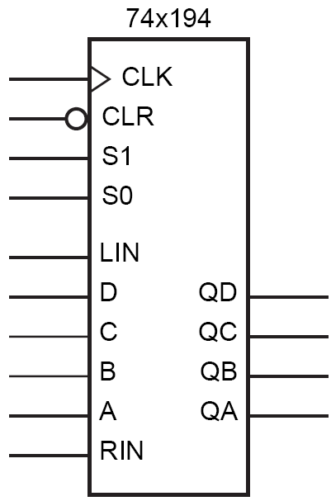
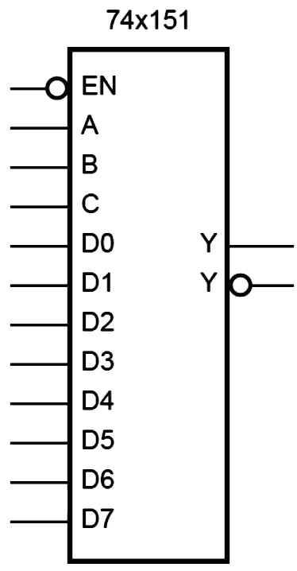
Vcc
Clock
Vcc
Sequence output
QA/1/0

