The resources have become low. Now you go out in search of a new home. You will have to manage your oxygen, food and fuel to reach your destination, as the planets on the way will only provide you with the bare minimum.
Good luck and god speed!

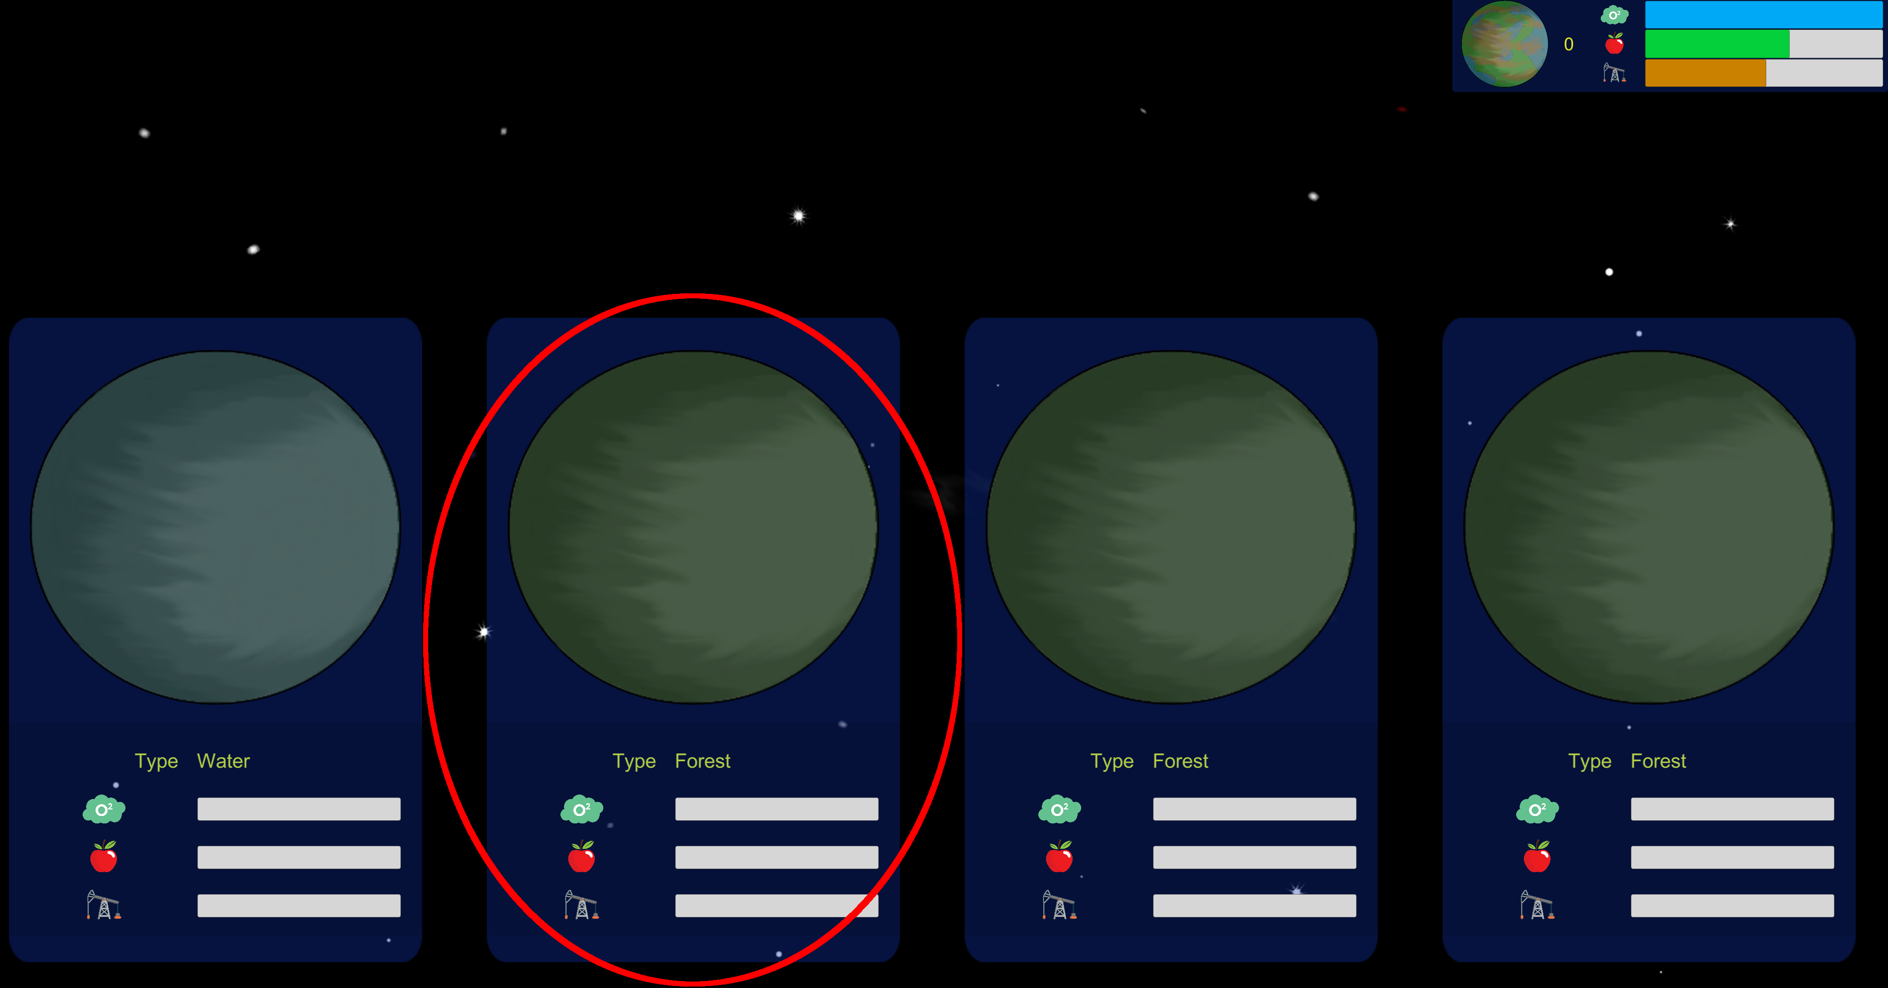
Your first step is to select your next target, you will be presented with the choice of 4 planets. You wont know much about them, so in a first step you will have to scan one.
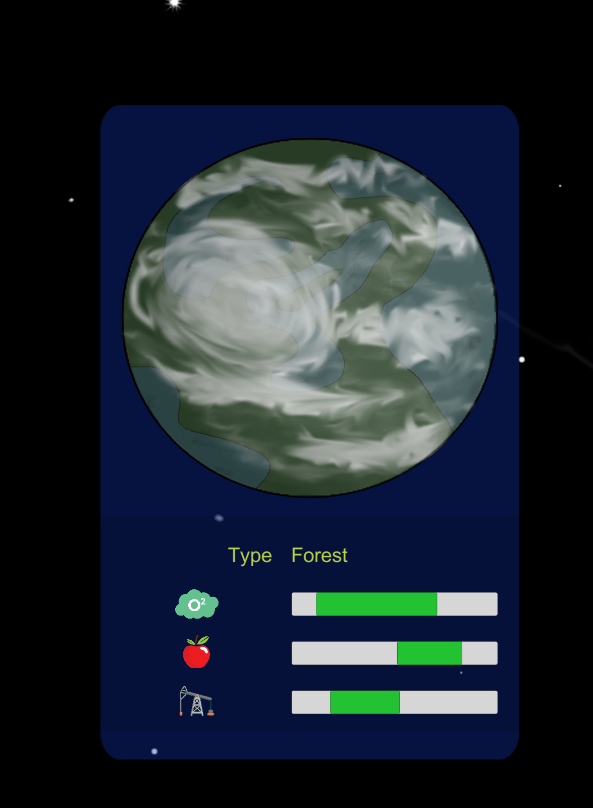
After scanning you will know the range of the resources this planet will contain. You have now the option to scan another planet for it’s resources. Or you can click on the scanned planet to fly there.
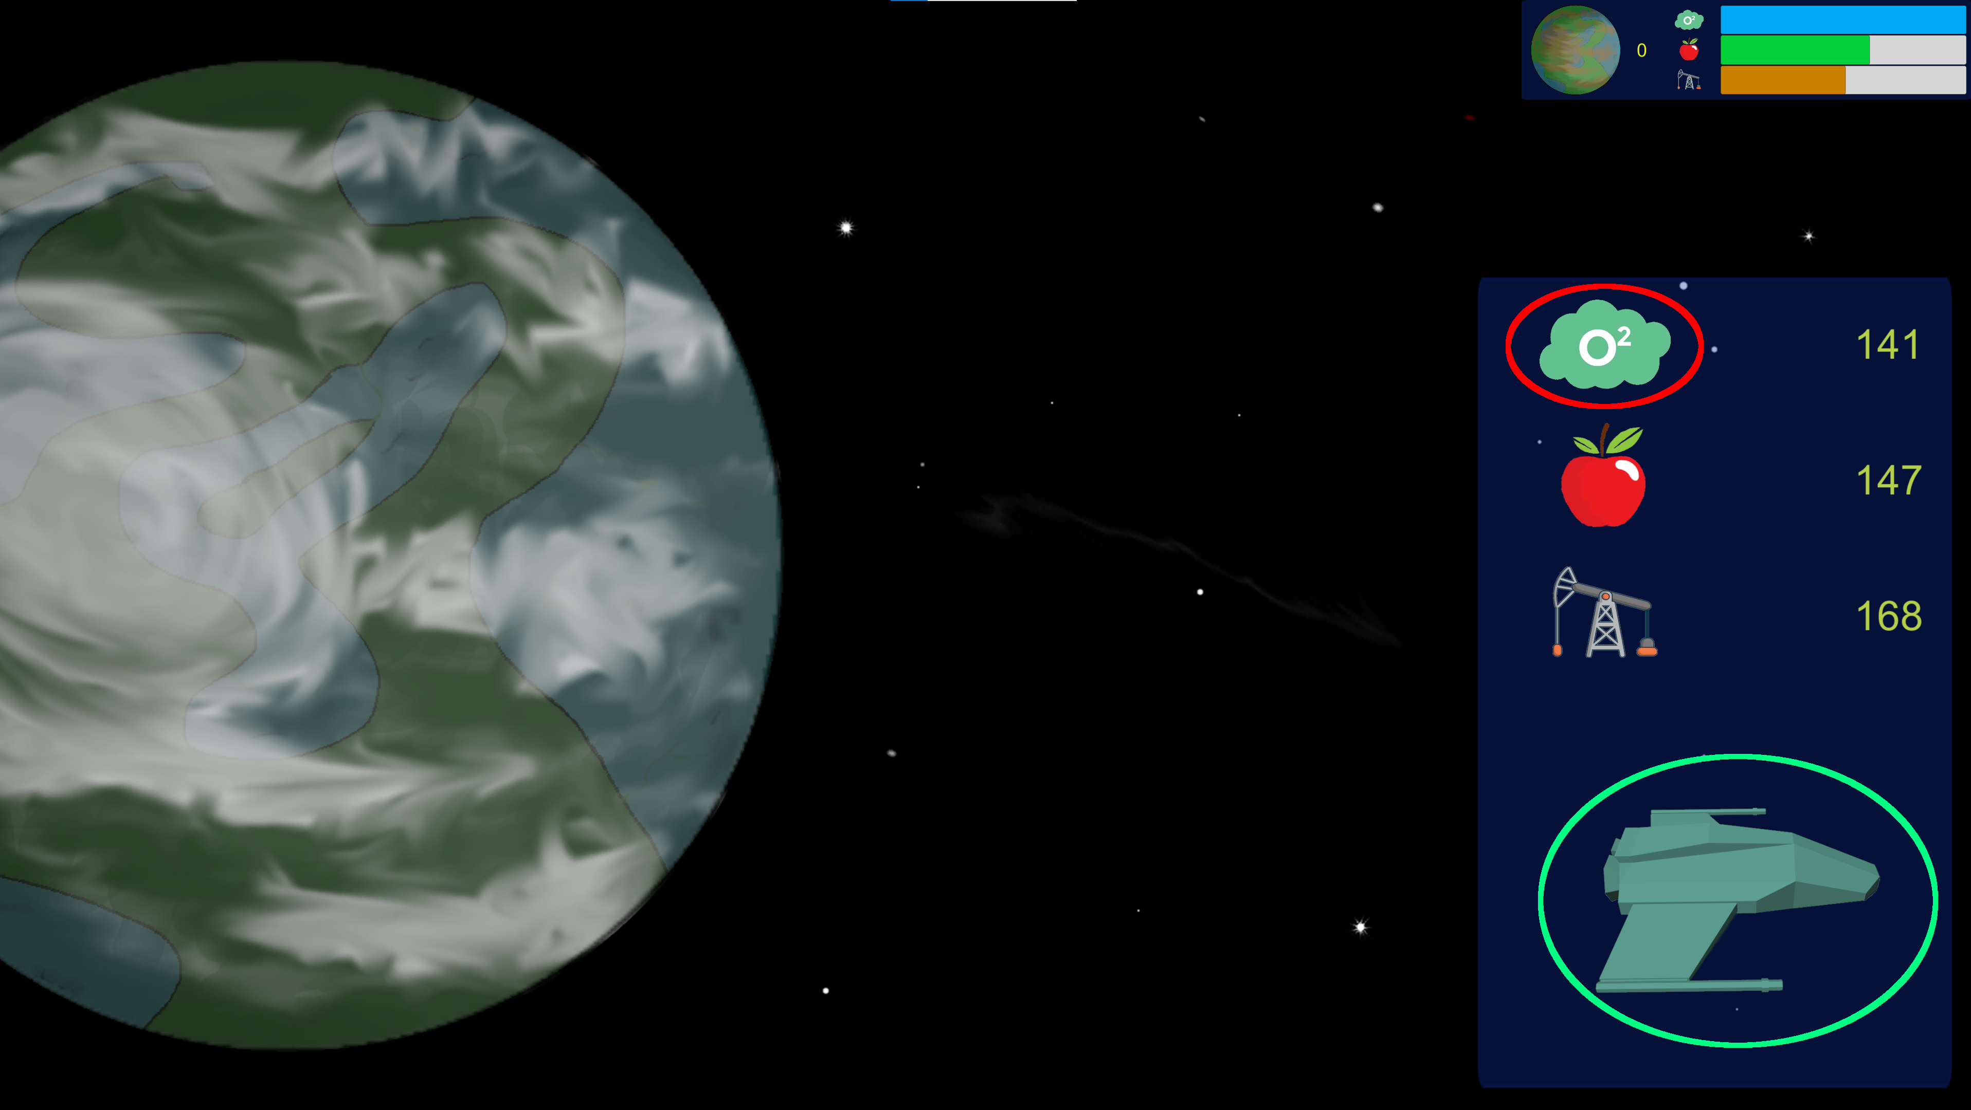
On the planet you can gather resources and when your done you can leave it again.

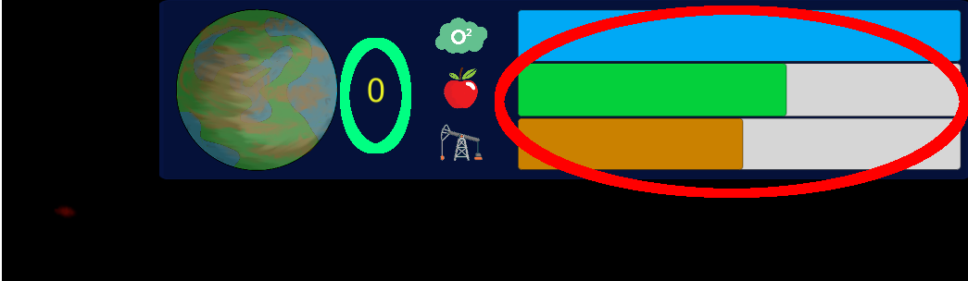

If you managed to keep your resources from reaching zero and have visited 20 planets you will win.

