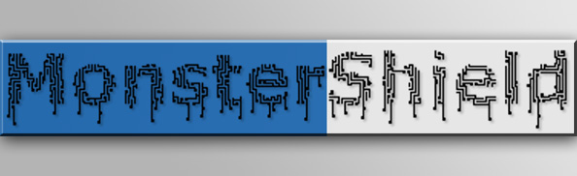

MonsterShield

Quick Start Guide

8/29/2013

HauntSoft

Jason Tatum

1. **Connect MonsterShield to Arduino:** Carefully connect the Arduino to the MonsterShield. The MonsterShield has 2 banks of 8 pins and 2 banks of 6 pins on the bottom of the board that are designed to connect to the Arduino. Hold the Arduino in one hand and hold the MonsterShield in the other. Line up the MonsterShield so that the end with MP3 module connector is opposite the end on the Arduino that has the power & USB connectors. Make sure that the right-most pins on the MonsterShield line up with the right-most headers on the Arduino. Make sure the pins are lined up and seat the MonsterShield all the way down. Note that some Arduinos can accept additional pins that the MonsterShield does not have. It should look like this when properly connected:

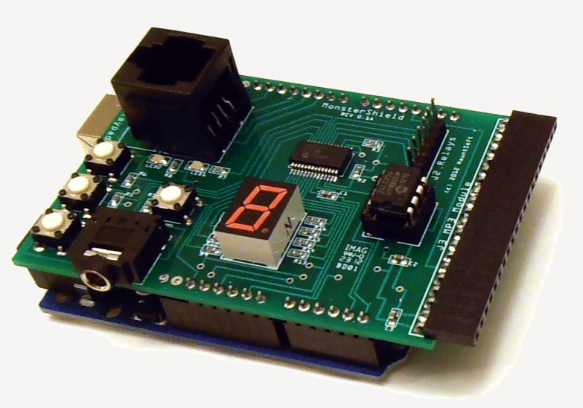

1. **Connect Relay Module to MonsterShield**: Connect one end of the included ribbon cable to the J2 6-pin header so that the red wire on the ribbon cable goes to the left-most pin (labeled GND) on the MonsterShield. Insert the other end of the cable to 6-pin header on the relay module so that the red wire is connected to the pin that is labeled GND. If you have a multi-colored cable, just make sure the same color wire is connected to the GND pins on both the MonsterShield and the relay module.

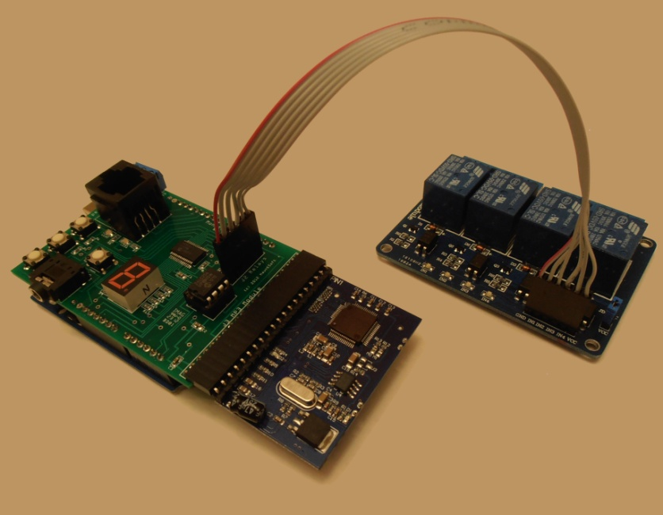

1. **Connecting devices to be controlled by the relays:** How you connect devices to the relays depends on what devices you plan to control and what the power requirements are. You can connect devices to be normally closed (power is on normally, but power switches off when relay is turned on) or normally open (power is off normally, but power switches on when relay is turned on). Here are some common ways to connect devices to the relay module:

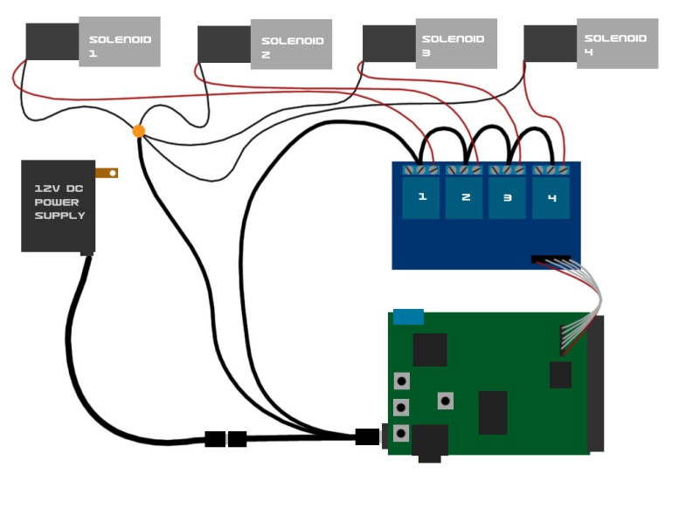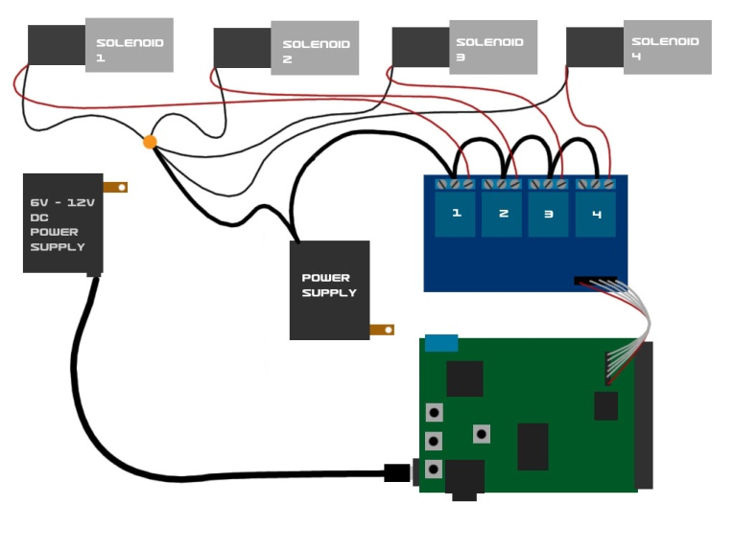

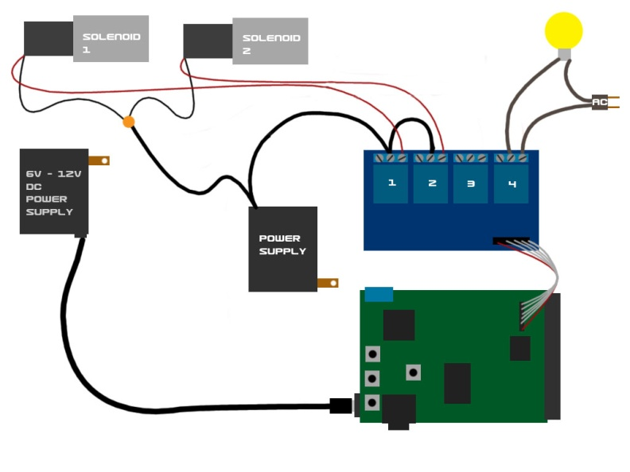

1. **Connect Trigger:** Connect a trigger (such as a motion sensor, push button, or beam sensor) to the J1 blue screw terminals on the MonsterShield. The screw terminals are labeled as **+5V**, **Trigger**, and **GND**. Note that some trigger types only require the +5 and the Trigger terminals (such as a beam sensor or a push button). Triggers that require +5V to operate will use all 3 terminals (such as the Parallax PIR motion sensor). If your trigger has different power requirements (such as a beam sensor that requires 12V), you will need to connect a separate power supply to the trigger (or if it is a 12V trigger you can use the 12V 2A power supply and the splitter cable to provide power to the trigger) and you use the +5V and the Trigger terminals on the switched leads for the trigger. For example, the Fright Props beam sensor has 5 wires. Two wires supply 12V power to the sensor. The other 3 wires are common, normally open, and normally closed. You would use only the common and normally open or the common and normally closed (but not all 3 at the same time), and these would be wired to the +5V and the Trigger terminals, but it doesn’t matter which wire goes to which of the terminals.

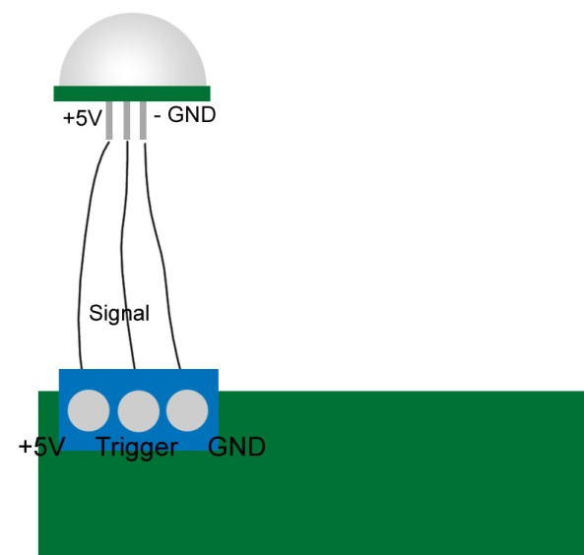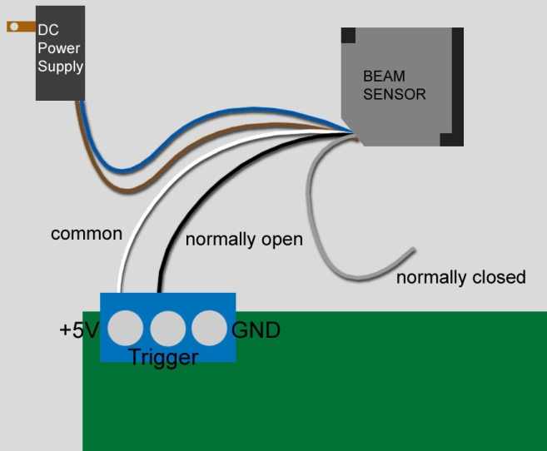

1. **Connect Optional MP3 module**: If you purchased the optional MP3 module, connect it to the J3 MP3 Module header on the MonsterShield so that the SD card slot is on the bottom. Note that it is easier to install and remove the SD card from the MP3 module with the MP3 module removed from the MonsterShield. Copy MP3 files to your SD card and name them 000.mp3 through 014.mp3. The 3 digit number corresponds to the animation slot it will be played with.

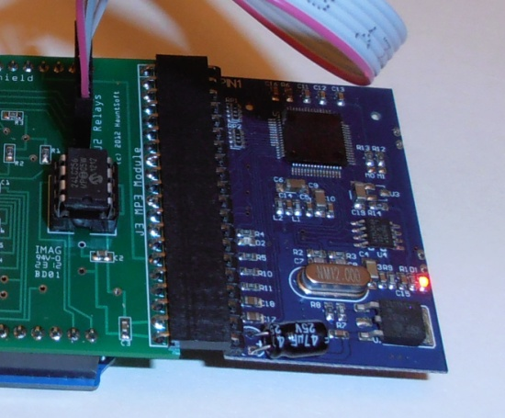

Connect a 1/8” stereo jack to the MonsterShield and connect this to a powered amplifier or speaker system. Note that the output from this jack is headphone level, which means it is pre-amplified for headphones. This may cause damage or distortion to sensitive equipment that is not designed to handle this level. This can be addressed by using a small adapter cable that has a built-in volume control. Adjust the volume until the distortion disappears.

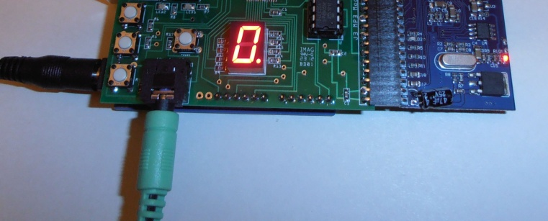

1. **Connect Power to Arduino:** Connect your power source (6V DC to 12V DC) to the Arduino. If you are using the 12V 2A power supply and the optional splitter cable, connect the splitter cable between the power supply and the Arduino. Make sure that the bare leads on the other end of the cable are not touching each other. The MonsterShield will power up and should display “-“ for a second or two. It may also flash “F” for a few seconds, which indicates it is performing an automatic factory reset. When complete, the MonsterShield should display a “0”. If the single digit display does NOT display any digit and LED2 is flashing on and off, then this means you have not loaded the MonsterShield code onto the Arduino. You will need to download the firmware from <http://www.hauntsoft.com/downloads> and you will need to install it using the Arduino IDE (which can be obtained from <http://www.arduino.cc>).
2. **Using the optional keypad:** Attach the optional keypad using a standard cat5 network cable. When connected, the keypad has two modes: Normal & Record.
   1. In Normal mode, you can cycle through all the animation slots by using the first 2 buttons (next and previous). The 3rd button acts as a toggle for enabling or disabling the currently selected animation slot. The 4th button manually triggers the prop. Pressing the 4th button while an animation is running will stop the animation.
   2. Pressing the 5th button will prepare the MonsterShield to record animation on the currently selected slot. See the **Recording Animation** below.

Now test your animation by pressing the play button.

1. **Manually triggering your prop:** Press the “mode/trigger” button on the MonsterShield or the “play/stop” button on the keypad to manually trigger your prop. Pressing these buttons again will interrupt and stop the animation from playing.
2. **Selecting an animation slot:** Press and release the “prev/enable” button or the “next/ambient” buttons on the MonsterShield repeatedly to cycle through the animation slots. Don’t hold these buttons down because this activates their secondary functions. You can also press the “Prev” and “Next” buttons on the keypad to cycle through the animations.
3. **Recording an animation**: Select the animation slot you wish to record and press the *Record* button on the keypad. You will first be prompted to make 3 selections:
   1. **Bank Selection:** First the MonsterShield will begin flashing the letter “b” on the display. This is the bank selection prompt. Press the *Out 1* button to select bank 0 on the MonsterShield. If you have a MonsterShield Expander board connected, you could also press *Out 2*, *Out 3*, or *Out 4* to select banks 1, 2, or 3. The selected bank number will begin flashing. Press and release the record button to confirm the selected bank. Note: If you do not have a MonsterShield Expander board attached, you could skip this and just press the record button and bank 0 will be selected automatically.
   2. **Relay Selection:** Now the MonsterShield will begin flashing the letter “r” on the display. This is the relay selection prompt that allows you to select which relay output / track you want to record animation to. If you would like to record animation on all relays for the selected bank, just press the record button again. If you would like to only record animation for a single relay on the bank (and ignore inputs on the other relays), then select the relay you want to program by pressing *Out 1*, *Out 2*, *Out 3*, or *Out 4*. Press the record button to confirm the relay selection.
   3. **Record Mode**: Now the MonsterShield will begin flashing the letter “c” on the display. This is the recording mode prompt. There are 3 options:
      1. **Mode 0: Overlay** – This lays down animation on top of what was already previously recorded. If you had previously recorded events on the selected relay/tracks but want to record addition events on the same track, you can use this option. During recording, previous events on these relays/tracks will be played while allowing you record new events on top.
      2. **Mode 1: Wipe selected relay track** – This clears all previous animation from the selected relays/tracks but keeps the animation data for all the other relays/tracks.
      3. **Mode 2: Wipe entire animation** – This clears all of the animation for all banks and all relays letting you start from scratch for this animation.

Press *Out 1*, *Out 2*, or *Out 3* to select the recording mode you desire. Then press the *Record* button to begin recording the animation.

The letter “P” will begin flashing on the display to indicate you are now in **Record Program** mode. Press and release the *Out 1, Out 2, Out 3, and Out 4* buttons to turn the relay outputs on and off as desired. When finished recording, press the *Record* button again.

1. **Disabling or Enabling an animation slot**: Select the animation slot you want to enable or disable. You can tell if an animation slot is enabled or disabled by the decimal point on the single digit display. If a slot is enabled, the decimal point will be lit. To toggle the slot between enabled & disabled, simply press and hold the “prev/enable” button on the MonsterShield for 1 second and then release. You can also press the “enable” button on the keypad to toggle the slot.
2. **Setting Playback mode**: There are currently 3 playback modes: Sequential, Single, & Random. You can cycle between the playback modes by pressing and holding the “mode/trigger” button on the MonsterShield for more than 1 second and releasing. The MonsterShield will flash “P” and “1”, “2”, or “3”. “1” means sequential mode (the default). Each time the prop is triggered, the MonsterShield will advance to the next slot after the animation has finished playing. “2” means random mode. Each time the prop is triggered, the MonsterShield will randomly select which animation to play. “3” means single mode. The MonsterShield will stay on this slot every time it is triggered. If Ambient mode is turned on, then slot 0 will never be selected when the prop is triggered.
3. **Ambient mode**: Ambient Mode turns animation slot 0 into an ambient animation that plays in a continuous loop. When the prop is triggered, the slot 0 animation is interrupted and the triggered animation plays. When the triggered animation is finished, the MonsterShield will go back to playing animation slot 0 in a continuous loop. You can toggle the ambient animation on & off by pressing and holding the “nxt/ambient” button on the MonsterShield for more than 1 second and releasing. WARNING: Make SURE you have recorded an animation on slot 0 before turning ambient mode on. If you forget to do this, the MonsterShield could go into an endless loop that cannot be interrupted. You will have to perform a factory reset which will initialize all settings to the defaults and will wipe out all animation on the MonsterShield. If the letter “E” flashes for several seconds when you attempt to turn on Ambient mode, it means the MonsterShield detected no animation on slot 0 and aborted the Ambient mode.
4. **Performing a Factory Reset**: If you need to perform a factory reset, press and hold the “prev/enable” button on the MonsterShield and then press and release the “reset” button while continuing to hold the “prev/enable” button. The MonsterShield will reset and begin performing a factory reset to the defaults. When the letter “F” begins rapidly flashing, you may release the “prev/enable” button. After a few seconds, the MonsterShield will begin flashing “F” once a second. This is prompting you to confirm how many animation slots you want to configure on the MonsterShield. Your options are 1, 2, 3, 4, 5, 6, 7, 8, 9, A (10), B (11), C (12), D (13), E (14), and F (15). F is the default. You can cycle through the available selections using the “prev/enable” and “nxt/ambient” buttons. To confirm your selection, press the “mode/trigger” button. If no user selection is made after 10 seconds, then the MonsterShield will configure itself to the default of 15 slots. Generally speaking, the fewer slots you configure the MonsterShield for, the longer each animation can be.
5. **Connecting to your computer:** Before you can begin using the MonsterShield with your computer, you will have to install the Arduino drivers. These drivers are included and automatically installed with the MonsterShield software version 1.0.0.4 and later. The drivers are also available by downloading the Arduino IDE:
   1. Download the Arduino IDE from <http://www.arduino.cc> and unzip it to your computer.
   2. Connect the MonsterShield to your computer using a standard USB printer cable. Windows will detect that a new piece of hardware has been added. You will need to tell Windows to look in the Arduino directory’s “drivers” subdirectory.
   3. Windows should then find and install the appropriate driver for your Arduino.

***SPECIAL NOTES IF YOU HAVE THE MONSTERSHIELD EXPANDER BOARD:***

1. Connect additional relay modules to the headers marked bank 1, bank 2, and bank 3. Bank 0 is the relay bank on the main MonsterShield board itself. Bank 4 can only be utilized by writing your own custom code.
2. The MonsterShield Expander should be seated between the Arduino and the MonsterShield.
3. You can populate 0, 1, or 2 additional EEPROM chips on the MonsterShield Expander board. Currently only the 24LC256 chip is supported, but we will be adding support for larger chips in the future. You must install the chip(s) (if not already installed) with the notch facing the power-side of the Arduino.
4. There are 2 additional removable terminal blocks on the Expander board. The block facing the power side of the Arduino is used to provide external 5V power to additional relay modules. If you are using more than 1 relay module, you must connect a 5V 1A (high amperage is okay) to the 5V and GND terminals on this terminal block. DO NOT connect more than 5V or you will damage the relay circuits! It is recommended that you power the main MonsterShield before powering the expander board. This prevents all the additional relays from turning on during power up.

For further information, please review the full manual which can be obtained from <http://www.hauntsoft.com/downloads.aspx> or by installing the MonsterShield Editor software.