Project Card Game Proposal

Student: Nguyen Pham

Group: WMAD Jr. B

1. Proposed Card Game: Tiến Lên (Killer 13)
2. Game Overview
   1. Introduction

Killer 13 is the most popular game in Vietnam. It does not require luck as many as other card games, it focuses more on cognitive thinking.

* 1. Players and Cards

Players: There will be 4 number of players in total.

Card: Standard 52-card deck

* 1. Objectives
* The objective of this game is to get rid of all your cards (13 cards/person) by playing various combinations. There are seven types of combinations you can use: a solo card (which is one card not regarding any suits), a double set (which is two cards with same face values not regarding any suits), a triple set (which is three cards with same face values not regarding any suits), a sequence (which is a sequence of at least three cards in numerical order not regarding any suits), a four of a kind (which is four cards of the same value) and a consecutive pair (which is more than 2 double sets).
* The ranking of face value is from the lowest to highest: 3 4 5 6 7 8 9 J Q K A 2. (2 is the strongest face value in this game). Moreover, the suits have rank too (from highest to lowest): Hearts ♥, Diamonds ♦, Clubs ♣, Spades ♠.The card number takes precedence over the suit, so the 10♠ is higher than the 9♥. Therefore, the 2♥ is the highest single card in the game.
  1. Gameplay:
* A person who has a 3♠can start with any kind of combinations he/she wants.
* After that, the next player has to draw out the same combination as the previous one but with higher value.
* The player can decide to draw or not. If not, then the next player is going to draw. A player who has passed can not play anymore until the new turn starts.
* When a player plays a combination and all of the other players have passed, he/she can control the next combination and play.
* The first player to draw out all 13 cards will be the winner and 1st place, after that, the next player can start a new combination to make a new turn; the game still continues to choose the 2nd, 3rd and last place.
  1. Link to Game Mechanics

Website: <https://en.wikipedia.org/wiki/Ti%E1%BA%BFn_l%C3%AAn>

* 1. Sample Game Set up

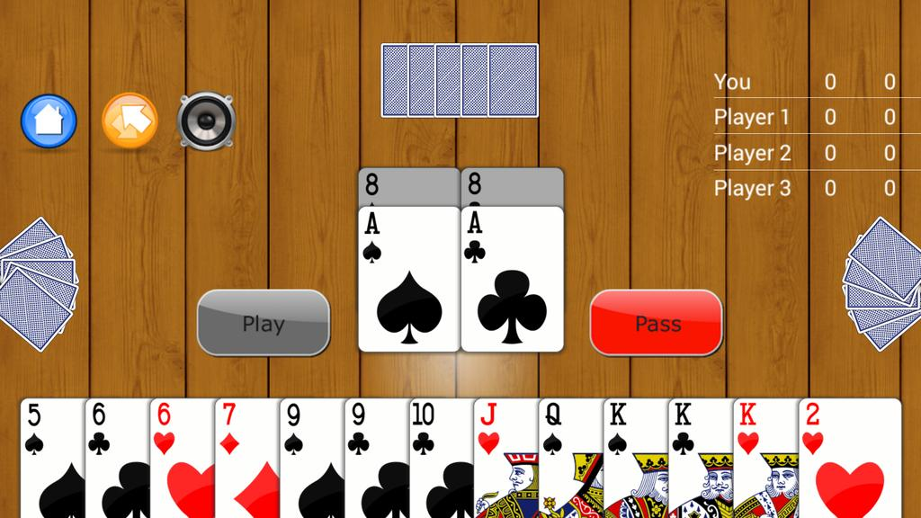

1. Video for Reference

YOUTUBE: <https://www.youtube.com/watch?v=z2Jas5t-8Yw>