Die Lieferung umfasst insgesamt 22 Solarmodule 310 Wp

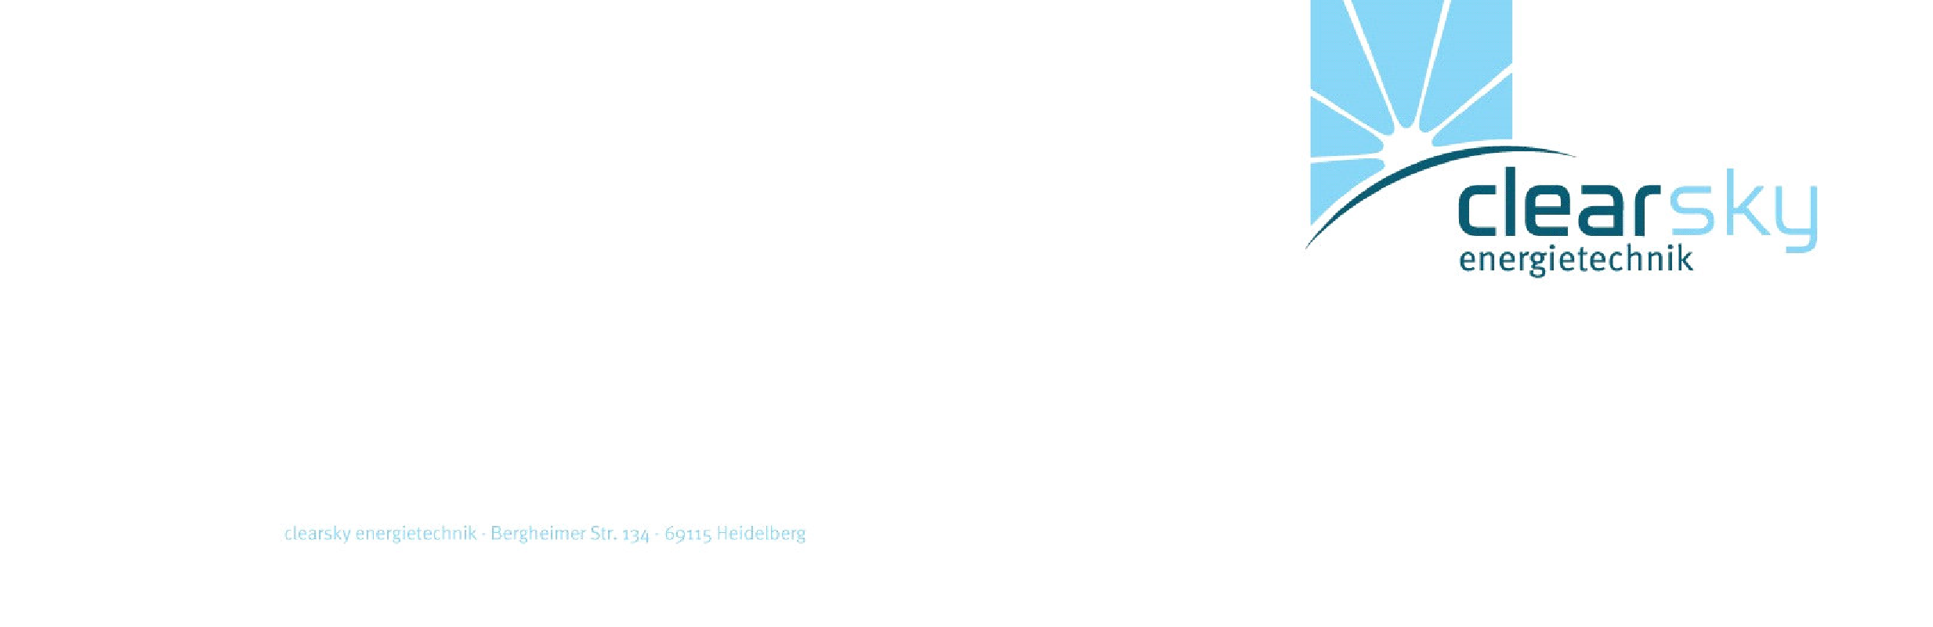

clearsky energietechnik UG • Bergheimer Str. 134 • 69115 Heidelberg

c

lear

sky energietechnik

GmbH

●

Im Schuhmachergewann 15

●

69123

Heidelberg

Kommission:

Rau, Fürstenfeldbruck

|  |  |  |  |  |  |  |
| --- | --- | --- | --- | --- | --- | --- |
| **Bezeichnung** | **Seriennr.** | **Pmpp** | **Voc** | **Isc** | **Vmpp** | **Impp** |
| IBC MonoSol 310 VL5 | 9B17C073510617 | 310,74 | 39,91 | 9,99 | 32,30 | 9,62 |
| IBC MonoSol 310 VL5 | 9B17C073510683 | 311,29 | 39,90 | 10,10 | 32,35 | 9,62 |
| IBC MonoSol 310 VL5 | 9B17C073510606 | 312,23 | 40,06 | 10,12 | 32,33 | 9,66 |
| IBC MonoSol 310 VL5 | 9B17C073510676 | 311,55 | 39,94 | 10,11 | 32,26 | 9,66 |
| IBC MonoSol 310 VL5 | 9B17C073510552 | 311,19 | 40,07 | 10,08 | 32,23 | 9,65 |
| IBC MonoSol 310 VL5 | 9B17C073510675 | 310,81 | 39,93 | 10,03 | 32,31 | 9,62 |
| IBC MonoSol 310 VL5 | 9B17C073510612 | 311,64 | 39,89 | 10,11 | 32,50 | 9,59 |
| IBC MonoSol 310 VL5 | 9B17C073510594 | 310,10 | 39,91 | 10,08 | 32,25 | 9,62 |
| IBC MonoSol 310 VL5 | 9B17C073510170 | 310,46 | 39,89 | 10,09 | 32,30 | 9,61 |
| IBC MonoSol 310 VL5 | 9B17C073510635 | 311,55 | 39,84 | 10,11 | 32,31 | 9,64 |
| IBC MonoSol 310 VL5 | 9B17C073510627 | 311,51 | 39,85 | 10,13 | 32,39 | 9,62 |
| IBC MonoSol 310 VL5 | 9B17C073510459 | 310,22 | 39,90 | 10,09 | 32,03 | 9,69 |
| IBC MonoSol 310 VL5 | 9B17C073510028 | 311,51 | 39,77 | 10,06 | 32,22 | 9,67 |
| IBC MonoSol 310 VL5 | 9B17C073510011 | 311,05 | 39,90 | 10,06 | 32,19 | 9,66 |
| IBC MonoSol 310 VL5 | 9B17C073510021 | 312,21 | 39,81 | 10,12 | 32,22 | 9,69 |
| IBC MonoSol 310 VL5 | 9B17C073510636 | 311,47 | 40,07 | 10,11 | 32,12 | 9,70 |
| IBC MonoSol 310 VL5 | 9B17C073510416 | 310,03 | 39,94 | 10,11 | 32,57 | 9,52 |
| IBC MonoSol 310 VL5 | 9B17C073510501 | 311,54 | 39,94 | 10,05 | 32,32 | 9,64 |
| IBC MonoSol 310 VL5 | 9B17C073510640 | 310,10 | 39,75 | 10,12 | 32,04 | 9,68 |
| IBC MonoSol 310 VL5 | 9B17C073510692 | 311,10 | 39,85 | 10,11 | 32,34 | 9,62 |
| IBC MonoSol 310 VL5 | 9B17C073510686 | 310,88 | 39,89 | 10,12 | 32,22 | 9,65 |
| IBC MonoSol 310 VL5 | 9B17C073510582 | 310,66 | 39,92 | 10,05 | 32,16 | 9,66 |