# Base on：

* XE version 1.5
* Subversion: <http://xe-core.googlecode.com/svn/branches/1.5.0>
* Revision: 10018

# Legend：

* The single procedure

Define constant variable

* The procedure has sub procedure diagram (tip:ctrl+click left to the sub procedure)

Require config.inc.php

file

* The procedure specific description:
* Var setting:
  + Module/act/mid/document_srl/module_srl/entry
* Code notation



# Modify list:

|  |  |  |
| --- | --- | --- |
|  |  |  |
| Version 1.0 | **Zhang Jin** | **2012-02-06** |
| The XE Request flow chart on detail | | |
| Version 1.1 | **Zhang Jin** | **2012-02-09** |
| Add the code description in the diagram | | |

# REQEST LIFE CYCLE

http Request start



Define constant var



Require config.inc.php

file



Context Class construct and initialization

Is SSO

Authentication?

(is Single sign-on)

No

yes

ModuleHandler

Initialization

Successful

End for Request：

1. close session
2. close DB resource



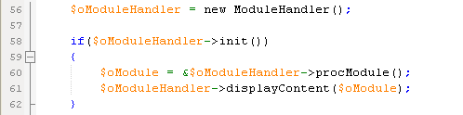

Yes

Execute module action procedure

No

Display module contents



Context Class close function :

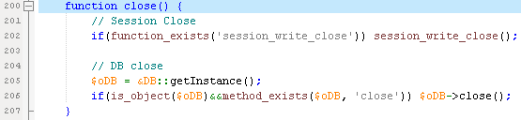

# Config.inc.php: /xe-core-1.5/config/config.inc.php

Error Report level setting



If __ZBXE__ defined

No

Exit script

Yes



Define version /path … constant(include the constants defined in package.inc.php)



Etc…

Define debug/CDN/QUERY LOG/TEST/PROXY… Parameters





If __XE_LOADED_CLASS__ defined

Loading

func.inc.php

No

No

If __DEBUG__ is true





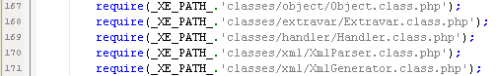

Yes

Start Record Time of __elapsed_class_load__



Etc…

Loading

func.inc.php

Loading

func.inc.php

Record Time of __elapsed_class_load__

# Context Class: /xe-core-1.5/classes/context/Context.class.php

* Construct the Context Class:

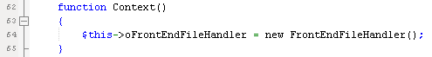

Construct a new FrontEndFileHandler

set FrontEndFileHandler variable of context

* Initialization the Context Class:
* Cookie setting($_COOKIE);
* Language setting();
* Setting Request Method (GET/POST/XMLRPC/JSON);
* setRequestArgument(REQUEST/XmlRpc/JSON/UPLOAD);
* loadDBInfo : Load from the db.config.php and setDBInfo;
* set lang_type to the cookie

Setting the context variables

No

If XE is installed

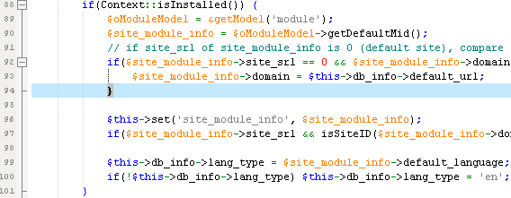

Set authentication information in Context and session

Yes

Initial session handler

No

If use db session

Loading language file of modules/module/lang

Set the language selected to Cookie and session

Yes

get virtual site information





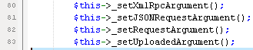





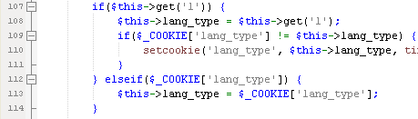



* Session handler:
  + Open/Close/Read/Write/Destroy/Gc function defination

These functions defined in SessionController/

sessionModel

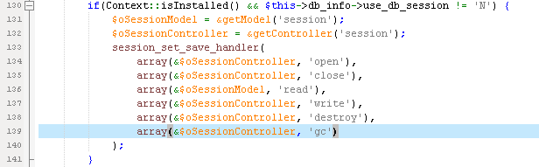



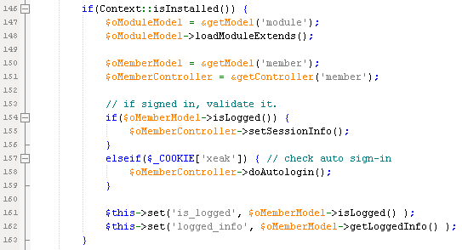

If is GET request

No

Yes

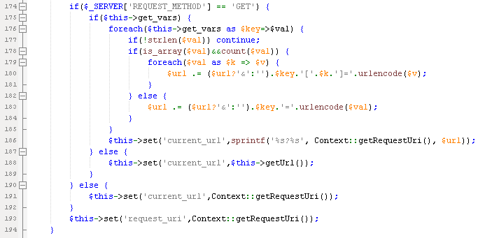

Load lang xml file in the common path



Set allow rewrite option

Set url and uri path

# ModuleHandler Class: /xe-core-1.5/classes/module/ModuleHandler.class.php

* Construct the ModuleHandler Class:
* Var setting:
  + Module/act/mid/document_srl/module_srl/entry

Setting the moduleHandler variables

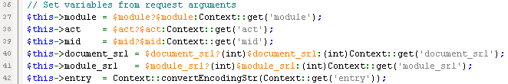

Yes

Validate variable above is XSS leak

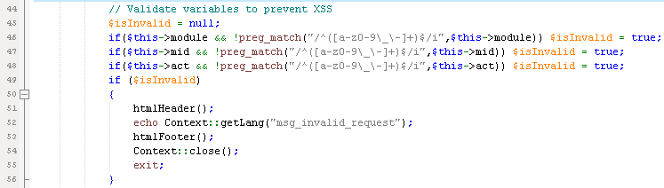

echo error message

No

Execute addon(before module initialization)

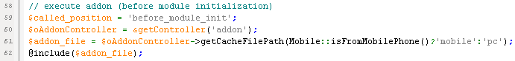

Exit script

* Initialization the ModuleHandler Class:



get the variables

* Var getting:
  + oModuleModel
  + site_module_info

If document_srl in request var

Yes

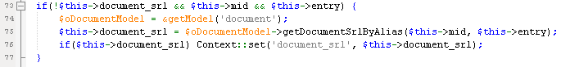

No

Get alian document_srl by Alias

Get Module info by document_srl/mid succeed

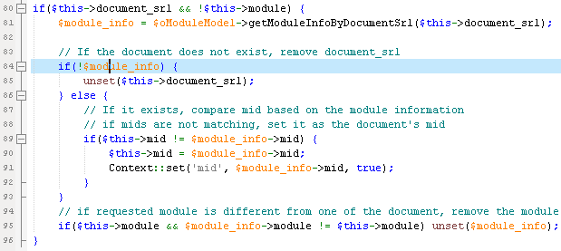

No

Set error message

Yes

Etc…

Initial the module information

* Var setting:
  + setBrowserTitle
  + addHtmlHeader
  + getModulePartConfig
  + module info
* Redirect to the site default page

OR

* 404 error message setting (return false)

Return true

* the ModuleHandler Class “procModule”:

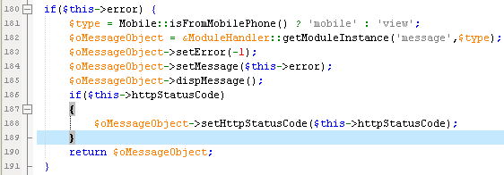

If occur error in the initialization procedure

Yes

No

Check if has admin menu and the cache for the menu

Yes

Read module configuration in module.xml file

If find out the Module’s action

Get other prams defined in xml file

Return error message Obj

Return error message Obj

No

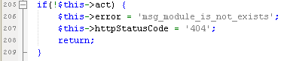

* Find action:
  + Using action in xml
  + Using default action in xml

Return error message Obj

Yes

If is admin manage page request and denied_admin in session

start

* Other prams:
  + Action type
  + Action ruleset
  + Kind(is admin action)
  + Is mobile action

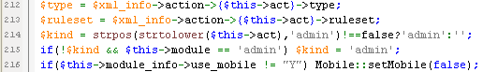

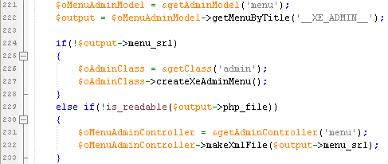

Create the admin menu and cache

Yes

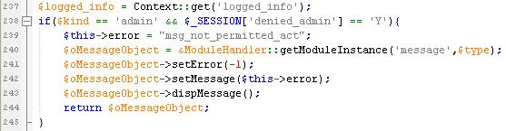

No

No

Request for the View and case for using mobile phone

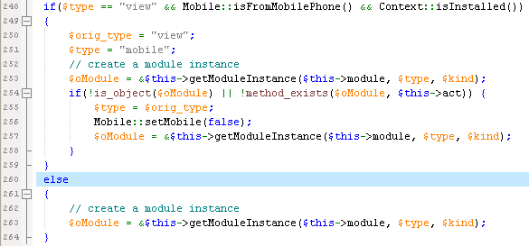

Create the module object

Yes

Create the mobile module object

If module object create succeed

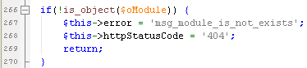

No

Return error message Obj

Yes

Yes

If action in module object

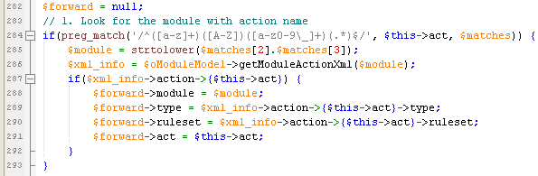

No

Find out the action info in forward table

t

Yes



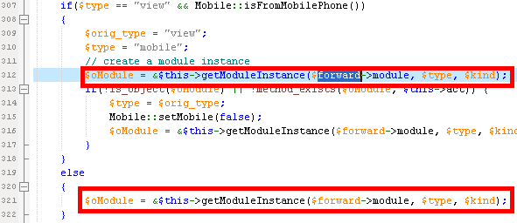

Reset the module object with forward info(redirect to the forward)

No

If default action exist

No

Return error message Obj

Yes

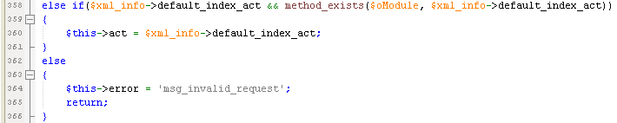

Set action as default action

If has rule set and the rule set file

No

Yes

Validate the rule set

Yes

Set module info:

Action/module info from xml

If from view and use mobile/not a admin type action

No

Yes

Add a mobile/module html Footer

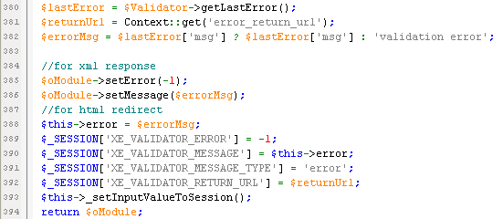

No

Set session validate error message

Return error message Obj





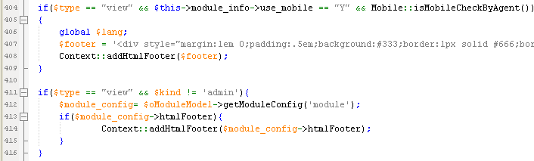



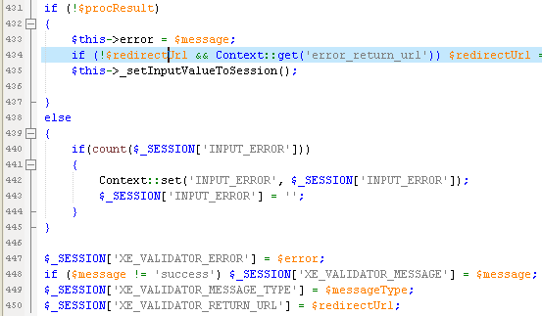

Yes

Set error message to session

Return module object

Set successful message to session

No

If proc procedure has error

No

Yes

If not a XMLRPC/JSON request

Execute the module object proc procedure

Set a error message to context

No

Yes

If has failed message in session



* the ModuleHandler Class displayContent:

If param module not set or not a object

No

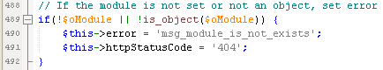

Yes

Set error message

If module not install and DB not connect

No



Yes

Set error message



No

If module after trigger call fail

Set error message

Yes

start



Yes

No

No

Redirect to the error return url

If other error occurred

If find out the (mobile)layout srl but no layout file

Yes

Set object as message object to show error message

Yes

If not a XMLRPC/JSON call

get information of the layout, and set the layout information

No

Yes

If the error message had occurred

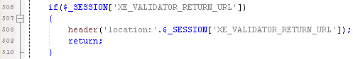

No

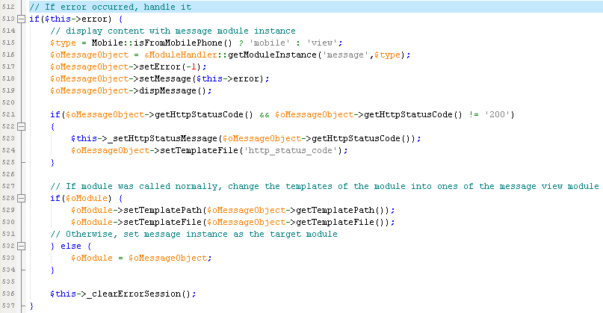

* Set layout information:
  + Input extra_vars into $layout_info
  + Set menus into context
  + Set $layout_info to Context
  + Set module’s layout path and file
  + Set edited layout file

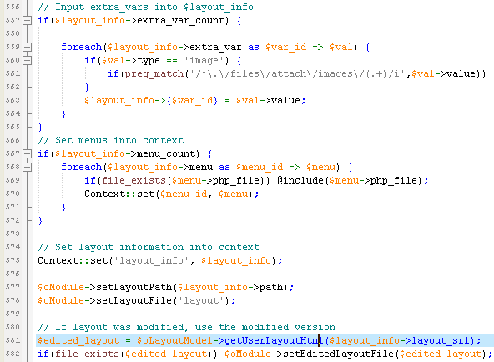

Set layout edited file



Display the content using displayHandler object

Yes

Print content

Set layout info

If layout_srl exist

No

# ModuleObject Class:

* “proc” procedure in Module Object Class

If set stop_proc

Yes



Proc procedure fails Return false

No

If module before triggers call succeed

No

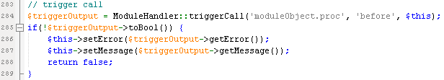

Set error message

Yes

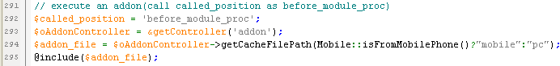

execute an addon(call called_position as before_module_proc)

Proc procedure fails Return false

If action function exist in module

No

Proc procedure fails Return false

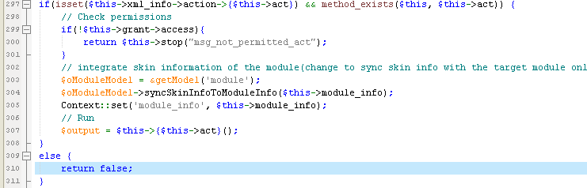

Yes

Check module permission

No

Yes

Proc procedure fails Return error message object

Combine skin information with module information

Run the module action

execute api methods of the module if view action is and result is XMLRPC or JSON

Return true

Proc procedure fails Return false

Set error message

No

Yes

If module Running return error object

execute an addon(call called_position as after_module_proc)

Proc procedure fails Return false

Set error message

No

Yes

If module after triggers call succeed

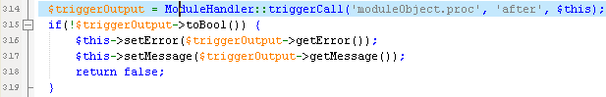



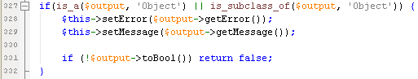

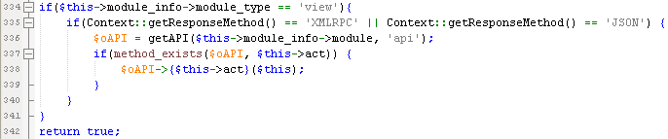

# DisplayHandler object class:

# /xePath/classes/display/DisplayHandler.class.php

* 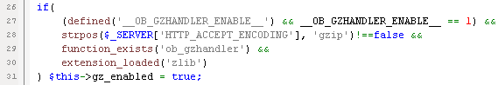printContent procedure:

Set if gzip encoding supported

* + The request method type:
    - Xml request
    - XMLRPC request
    - JSON request
    - general HTTP request

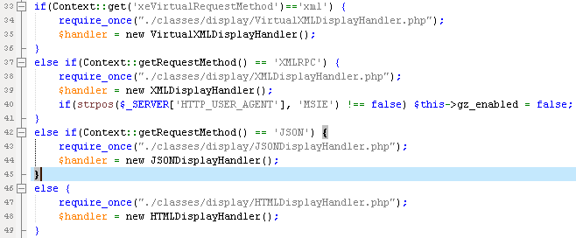

Extract contents to display by the request method

Produce compliant content according to the request type(toDoc procedure)





Call display before Tringger

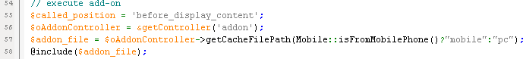

Call addon as position “before_display_content”

If prepareToPrint procedure exist in handler

Yes

No



Call prepareToPrint procedure

If gzip encoding supported

No

s

Yes

Gzip encode Header output

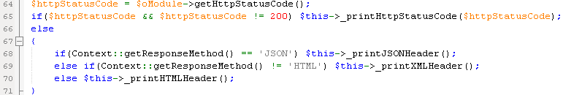

No

If http status is 200(successful request)

Print http status code header

Yes

Print http header according to request type

If __DEBUG__ is enable

No



Yes

Print debug message

Call trigger display after

If gzip encoding supported

Print gzip output

No



Print result directly

Yes



# ****DisplayHandler Class object:

HTMLDisplayHandler class: /xe-core-1.5/classes/display/HTMLDisplayHandler.php

JSONDisplayHandler class: /xe-core-1.5/classes/display/JSONDisplayHandler.php

VirtualXMLDisplayHandler class: /xe-core-1.5/classes/display/VirtualXMLDisplayHandler.php

XMLDisplayHandler class: /xe-core-1.5/classes/display/XMLDisplayHandler.php

# toDoc procedure:

Template has two type:

* Theme skin type template
* Module skin type template
* HTMLDisplayHandler Class toDoc procedure:

Get TemplateHandler class instance



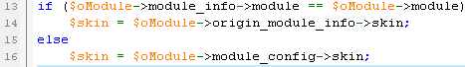

Find out template file and path

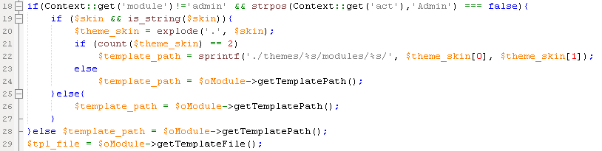

Compile the template file

If the module is frontend not admin page



No



* The .x class has some default style like button/background

Yes

Add .x class div to the output’s outer



No

If has layout_srl

Get layout info:

path/file/layout module/srl/edited layout file

Yes

If debug type is 3

No

If has layout

No

Set output variable to the content in the Context class



Yes

Open a Timer









If layout faceoff

Set layout to context

Yes

No

Do activateFaceOff

Yes





Load edited layout css file if it exit





Compile layout

Load layout_path and layout_file

No

If debug type is 3



Yes

Calculate the

__layout_compile_elapsed__

If is IE browser and use ssl optional or ENFORCE_SSL

No

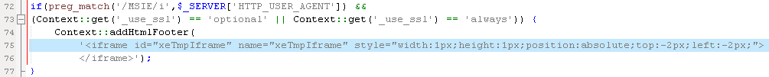

Yes

Add iframe tag to the footer html



Return output

* JSONDisplayHandler Class toDoc procedure:

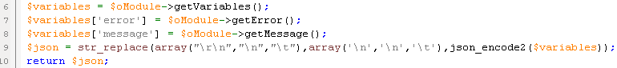

Get object module’s variables

Set error and message to the variables

Return json code

* VirtualXMLDisplayHandler Class toDoc procedure:

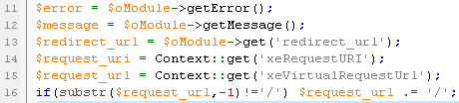

get error/message/redirectUrl/requesturi/requesturl to the variables

If has error or request not success

No

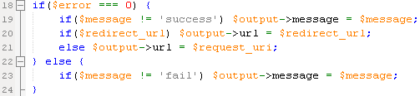

Yes

Request uri

Set error message and set url to redirect_url

If has message add message to the html

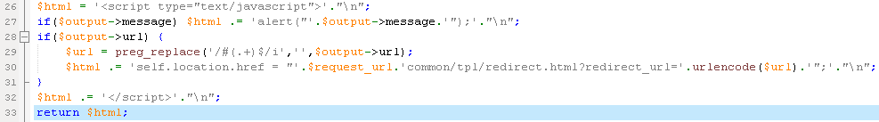

If has url redirect url to the html

Return html

* XMLDisplayHandler Class toDoc procedure:

Get object module’s variables



Set xml root element/error/message element





Make variable to Xml body as a xml element

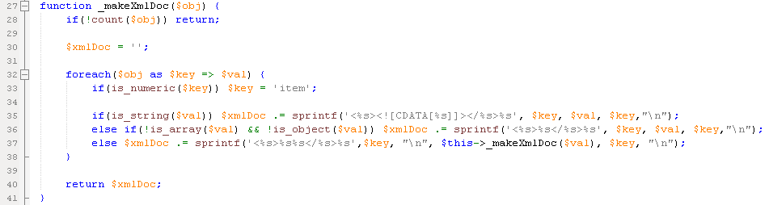

Return xml Doc



# prepareToPrint procedure:

* HTMLDisplayHandler Class prepareToPrintprocedure:

No

If debug type is 3

Open a Timer

Yes





move <style ..></style> in body to the header

change a meta fine(widget often put the tag like <!--Meta:path--> to the content because of caching)



If allow rewrite

No

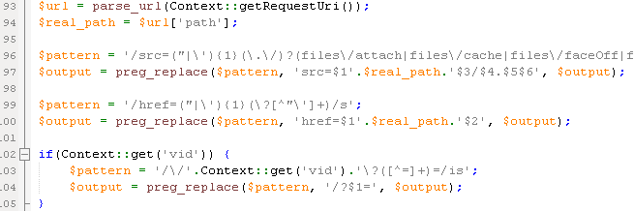

Yes

handles a relative path generated by using the rewrite module

prevent the 2nd request due to url(none) of the background-image



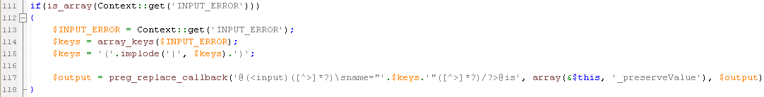

If input error is array

No

Yes

Build error info to the html

Yes

No

If debug type is 3

Calculate the

__trans_content_elapsed__



Remove unnecessary information



Set icon

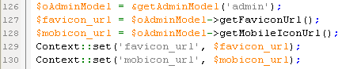

Set content output to the context



If not a mobile template



No

Yes

Compile a mobile template

Load default js file



Add MetaTag

Compile a mobile template



replace the user-defined-language

# TemplateHandler class object:

# /xe-core-1.5/classes/template/TemplateHandler.class.php

* Compile procedure:

Set global variable $__templatehandler_root_tpl



If debug type is 3

No



Open a Timer

Yes



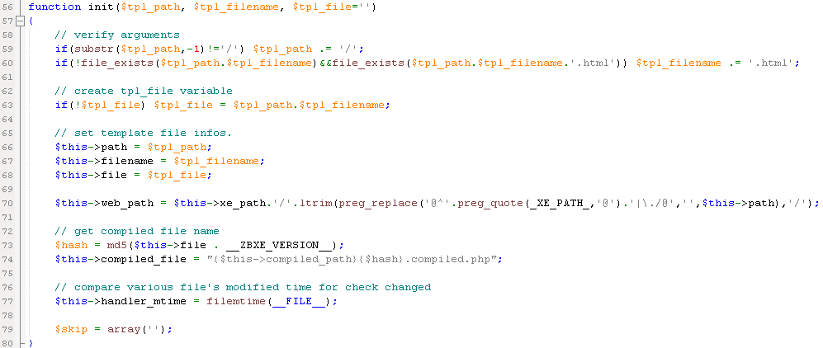

Initial templateHandler:path/filename/file/compiledFile/handlerTime

If target file not exist

No

Yes

Return error message





Set globle variables if it is null

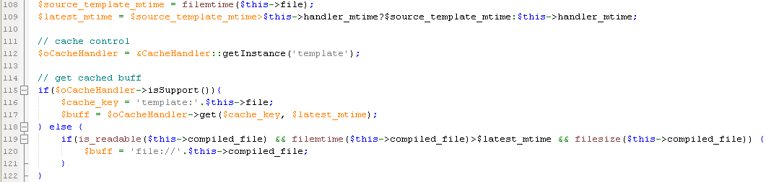

Get cache file by file time

No

If has cache

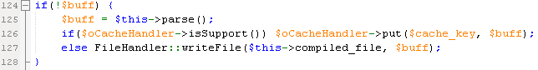

Yes

Parse cache:

replace comments/

replace value of src in img/input/script tag

replace loop and cond template syntax

include, unload/load, import

remove block which is a virtual tag and remove comments

form auto generation

prevent from calling directly before writing into file

If is support cache type

No



write compiled template file

Yes

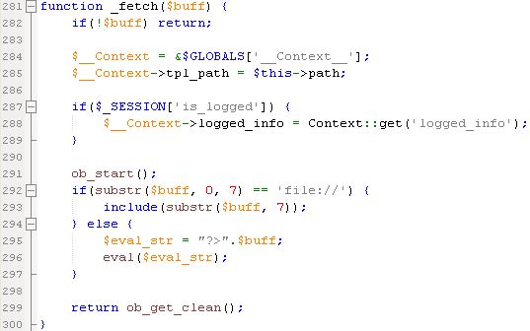

Cache template by put function

using ob_* function to setting output

No

If __templatehandler_root_tplequal to file



Setting the variable as NULL

No

If debug type is 3

Calculate the

__template_elapsed__



Yes

Return output

