# **WHAT IS RUBY?**

**Ruby is a cross-platform interpreted language which has many features in common with other ‘scripting’ languages such as Perl and Python. It has an ‘English language’ style syntax which looks somewhat Pascal-like at first sight. It is thoroughly object oriented, and has a good deal in common with the great-granddaddy of ‘pure’ OO languages, Smalltalk. It has been said that the lan-guages which most influenced the development of Ruby were: Perl, Smalltalk, Eiffel, Ada and Lisp. The Ruby language was created by Yukihiro Matsumoto (commonly known as ‘Matz’) and it was first released in 1995.**

# **Install Guide**

## Install on windows

1. **Download the tools**

Download the development installer tools: the one click installer & Development kit

The position of installers’ link: <http://rubyforge.org/projects/rubyinstaller/>

File List:

[rubyinstaller-1.9.3-p0.exe](http://rubyforge.org/frs/download.php/75465/rubyinstaller-1.9.3-p0.exe) the Ruby installer for windows

[devkit-3.4.5r3-20091110.7z](http://rubyforge.org/frs/download.php/66888/devkit-3.4.5r3-20091110.7z) The develop kit tool for windows

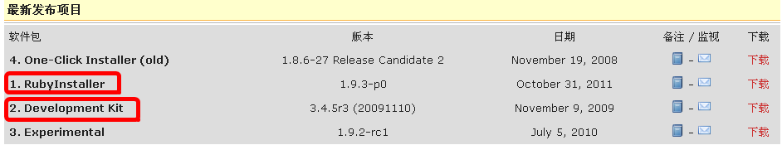

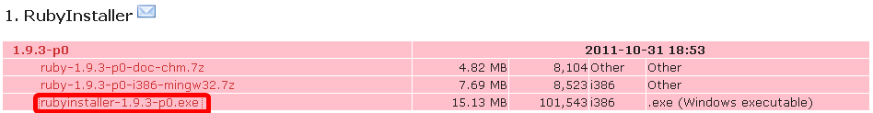

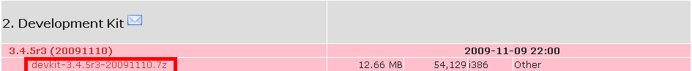

1. **Install the Ruby installer**

Run the command to sure the installation is success: ruby –v

C:\Documents and Settings\Administrator\桌面\Snap6.png

1. **Install the Dev kit**

Dev kit is a windows executable program, which creates **native extensions** for your Ruby gems, which uses C-complier

* + 1. Extract the Dev kit tools to the path, and install the tools
    2. Run the command under the extracted path:

> [ruby](http://biancheng.dnbcw.info/ruby/) dk.rb init

This will create the **config.yml** inside install path. Now all the Ruby versions will be inside that file, so that the dev kit will create native extensions for them. To check that, open that file and at the end of it, you will see these lines:

- d:\ruby  
- d:\Users\PC-name\.pik\rubies\Ruby-187-p330  
- d:\Users\PC-name\.pik\rubies\Ruby-192-p0

* + 1. Than running the following command to complete the installation:

> ruby dk.rb install

1. **Install GEMS**

A Ruby Gem is a software package, commonly called a “gem”. Gems contain a packaged Ruby application or library. The Ruby Gems software itself allows you to easily download, install, and manipulate gems on your system. It makes the gems packages’ installation just use a simple command.

* The position of gems installation : <http://rubyforge.org/projects/rubygems/>
* After that to insure the install is competed:

C:\Documents and Settings\Administrator\桌面\Snap7.png

After gems install, all ruby packages can use gem to be installed. There are 2 way to install the ruby gem package – the remote installation, and the local installation.

P.S.: The gems has its own community- <http://rubygems.org/>. Use this community to study Ruby development is a good choice.

1. **Rails install**

Rails is a web-application framework for the MVC pattern that includes both a template engine, controller framework, and object-relational mapping package. Everything needed to develop web-apps that can run on CGI, FastCGI and mod_ruby.

* + Remote installation:

>gem install rails –remote

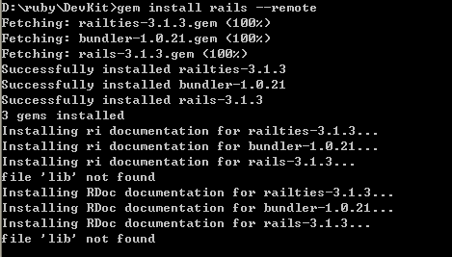

p.s.: the warning ‘file lib not found’ is coursed by the installation can’t find the document path. Use command option ‘--no-ri’ & ‘--no-rdoc’ can remove the warning.

* + Local installation:
    1. Install the rails use the installer:

If you download the package from the rubyforge(<http://rubyforge.org/>), and then run the installation.

C:\Documents and Settings\Administrator\桌面\Snap10.png

* + 1. Install the Rails use gem

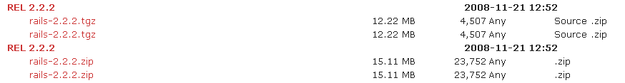

Download the ‘.zip’ or ‘.tgz’ file to the rails install path, rename the file to ‘rails.zip’ or ‘rails.tgz’ than run the command:

C:\Documents and Settings\Administrator\桌面\Snap12.png

* + Check the rails

C:\Documents and Settings\Administrator\桌面\Snap13.png

1. Web server setting & start
   1. Mongrel install

Mongrel is an open-source HTTP library and web server written in Ruby by Zed Shaw. It is used to run Ruby web applications and presents a standard HTTP interface. This makes layering other servers in front of it possible using a web proxy, a load balancer, or a combination of both, instead of having to use more conventional methods employed to run scripts such as FastCGI or SCGI to communicate. This is made possible by integrating a custom high-performance HTTP request parser implemented using Ragel.

(From Wikipedia- <http://en.wikipedia.org/wiki/Mongrel_%28web_server%29>)

* + Install mongrel(preview version)

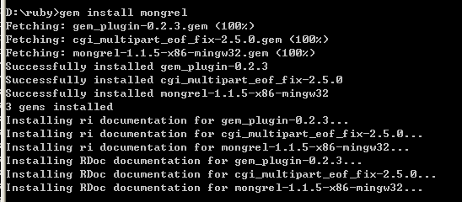

If the following step has a problem of ‘lack a mongrel dll file’, please use the command under:

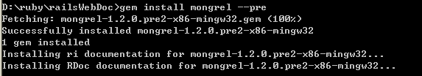

* + Start the mongrel server



* 1. WEBrike start

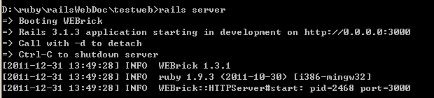

1. Create a sample web application
   * Enter the path of sample application
   * Run the command:

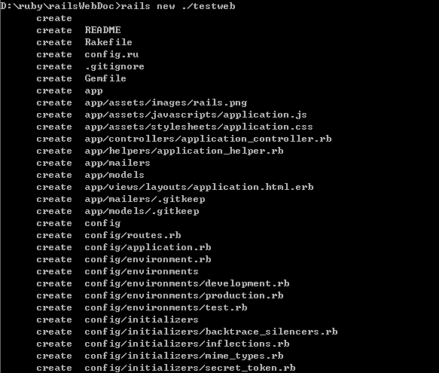

* + Create a new Hello world Controller

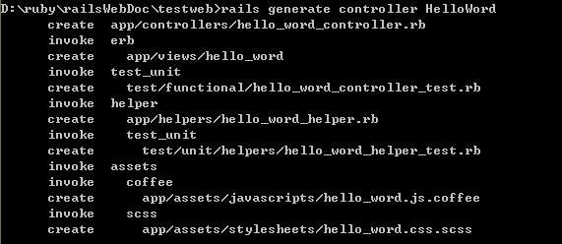

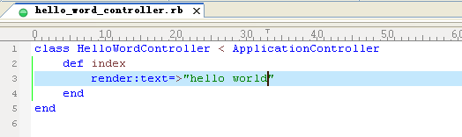

* + View the web application on the web site

Rails use default port 3000 of localhost. Use the url ‘localhost:3000’ to test the web site is ok.

* Default page:

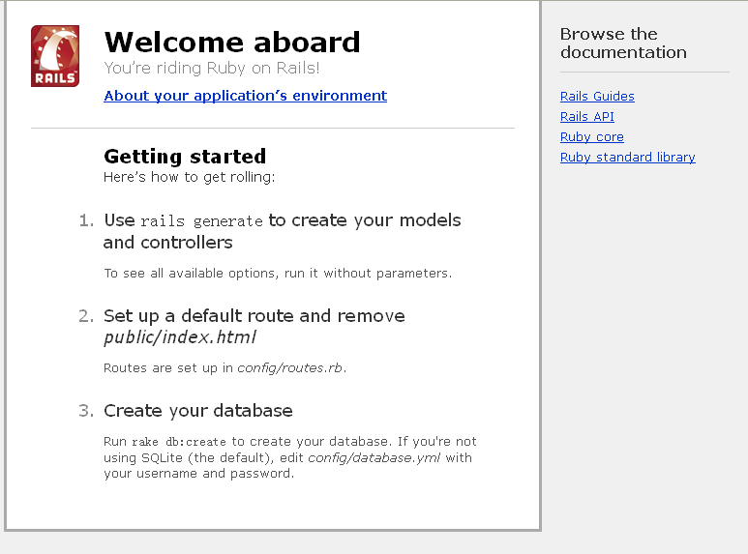

1. Accessories tools:
   1. [Gem-Fast](http://www.iteye.com/topic/797489)

[Use Curl to accelerate the speed of gem install](http://www.iteye.com/topic/797489)

Post of introduction’s URL(Chinese): <http://www.iteye.com/topic/797489>

Project URL: ﻿<http://github.com/dazuiba/gem-fast>

