PROGENITOR OF THE ATOMIC BOMB:YOU THOUGHT IT WAS EINSTEIN RIGHT?.. NO, CHECK OUT THE GENIUS THAT DEVISED IT.

Leo Szilard (1898 - 1964)

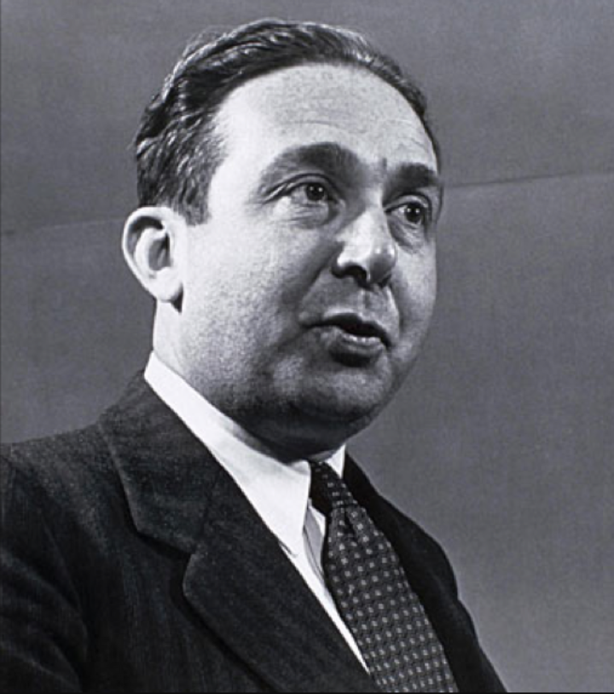
Leo Szilard was born in Budapest, Hungary, on February 11, 1898. Due to racial quotas, he had to go to the Institute of Technology in Berlin due to racial quotas, where he met several brilliant physicists such as Albert Einstein and Max Planck. Szilard earned his doctorate in physics in 1922. He and Einstein became close friends.

By 1933, Szilard was forced to resign and fled to London to escape Nazi persecution. Probably the first scientist to think seriously of building real atomic bombs, Szilard was struck by the possibility of a nuclear chain reaction on September 12, 1933, while he was waiting for a red light in London. Reportedly, the thought had occurred to Szilard as a result of his having been annoyed by Ernest Rutherford's dismissal of any talk of atomic energy as "moonshine."

With the news that German scientists had discovered nuclear fission, Szilard immediately set up a series of experiments, in collaboration with Enrico Fermi, to see if the theory was correct. He first attempted to create a chain reaction using beryllium and indium, but neither yielded the reaction he expected. In 1936, he assigned the chain-reaction patent, to the British Admiralty to ensure its secrecy.

Szilard eventually fled to the United States, where he accepted a teaching position at Columbia University in 1938. Instrumental in the development of the Manhattan Project, he conceived the idea of sending a confidential letter to Franklin D. Roosevelt, warning him about the possibility of an atomic bomb and encouraging the U.S. development of such a program, and obtained Albert Einstein's endorsement in August 1939. He continued his work with Fermi at the Metallurgical Laboratory to construct the first nuclear reactor. After learning about fission in 1939, he concluded that uranium would be the element capable of the chain reaction.

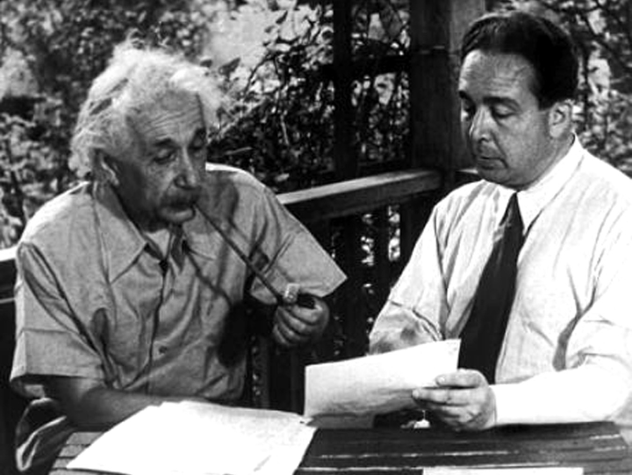

szilard and eistein, apparently poring over the letter which eistein would submit to the president

Later, Szilard moved to the University of Chicago to continue to work on developing the bomb. There, along with Fermi, he helped construct the first “neutronic reactor,” a uranium and graphite “pile” in which the first self-sustaining nuclear chain reaction was achieved in 1942. He and Fermi were co-holders of the reactor's patent.

As the war continued, Szilard became increasingly annoyed at the fact that he was losing power over his scientific developments to the military, and he clashed many times with General Leslie Groves. In 1943, Szilard became a naturalized citizen of the U.S. By 1945, it was clear that the U.S. was planning to use the bomb against Japan. Szilard began a campaign against its use. He circulated petitions among the scientists demanding greater scientific input on the future use of atomic weapons.

In 1947, Szilard decided to leave physics for molecular biology, working extensively with Aaron Novick. He continued to work toward peaceful uses of atomic energy and international arms control. In 1957, he helped create the Salk Institute for Biological Studies, spending his last years as a fellow there. Szilard died in his sleep of a heart attack on May 30, 1964.

CODE - Albania7

