UNBELIEVABLE BUT TRUE!!! : MAN PUTS HAND INTO MOLTEN ORE, AND COMES OUT UNSCATHED, CHECKED OUT THE REASON WHY...
Everyone likes a good party trick, but the star of a viral Reddit video set a new standard for mind-boggling stunts when he passed his bare hand through a stream of molten metal. In the video, posted to r/WTF on Wednesday, a bald-headed man, hanging out in a metal smelting plant, removes his protective gloves, crouches by a small waterfall of glowing, white-hot metal, and smacks the stream with his naked hand like a bear pawing at a river. He does it three times and doesn’t even flinch.

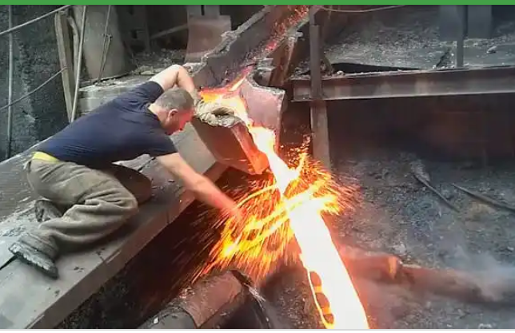

Upon seeing a video like this, the natural impulse is to think: This shit is fake! But Reddit’s heroic metal-smacker, whose video was uploaded to the unfiltered video-sharing site LiveLeak, could actually have pulled this stunt off using a physics phenomenon known as the Leidenfrost Effect.
The Leidenfrost Effect, named for the 18th-century German scientist Johann Gottlob Leidenfrost that discovered it, describes the remarkably potent natural shield that’s created between a hot liquid and a cooler surface when they first come into contact.
According to Leidenfrost, the reason the man’s hand doesn’t melt off is because the interaction between the hot metal and his hand causes water to rapidly evaporate from the surface of his skin, creating a powerful but transient cloud of water vapor that protects it.
He can’t keep his hand beneath the metal for too long, of course, because the flesh only holds so much water. Once it’s used up, there’s nothing left to produce the protective barrier of water vapor, and so the molten metal contacts the skin directly, turning this stunt into one-way ticket to Darth Vader-ville.
posted to r/WTF on Wednesday, a bald-headed man, hanging out in a metal smelting plant, removes his protective gloves, crouches by a small waterfall of glowing, white-hot metal, and smacks the stream with his naked hand like a bear pawing at a river. He does it three times and doesn’t even flinch.
Upon seeing a video like this, the natural impulse is to think: This shit is fake! But Reddit’s heroic metal-smacker, whose video was uploaded to the unfiltered video-sharing site LiveLeak, could actually have pulled this stunt off using a physics phenomenon known as the Leidenfrost Effect.
The Leidenfrost Effect, named for the 18th-century German scientist Johann Gottlob Leidenfrost that discovered it, describes the remarkably potent natural shield that’s created between a hot liquid and a cooler surface when they first come into contact.
According to Leidenfrost, the reason the man’s hand doesn’t melt off is because the interaction between the hot metal and his hand causes water to rapidly evaporate from the surface of his

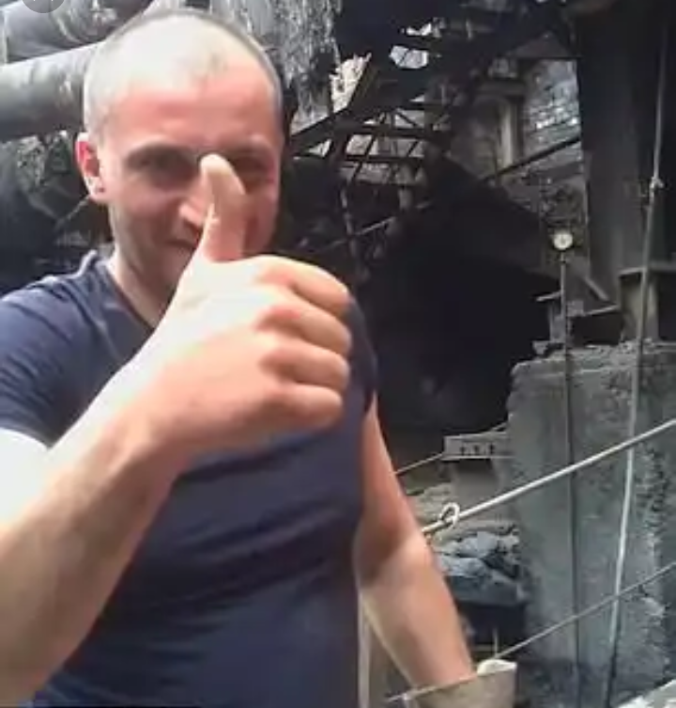

skin, creating a powerful but transient cloud of water vapor that protects it.
He can’t keep his hand beneath the metal for too long, of course, because the flesh only holds so much water. Once it’s used up, there’s nothing left to produce the protective barrier of water vapor, and so the molten metal contacts the skin directly, turning this stunt into one-way ticket to Darth Vader-ville.
A transient cloud of vapor briefly creates a barrier between the hot surface and the liquid (or, in the metal-smacker's case, the hot liquid and the cool surface).
What’s peculiar about, is the fact that the man does the trick three times. Normally, people who do this stunt first dip their hand in water before inserting it into molten metal (usually lead) in order to ensure that there’s enough water to create that protective vapor layer. It could be that he passes his hand through the stream quickly enough that the moment of skin-metal contact is super brief, or perhaps he’s got more moisture in his hands than most people. Whatever the case, this is probably not something you want to try yourself.
You can see the Leidenfrost Effect occur in other, safer situations, however — pretty much anywhere a liquid contacts a medium that’s hotter than its boiling temperature (because at this point, the liquid is guaranteed to evaporate on contact).
You’re most likely to see it when you scatter droplets of water on a pan that’s heated to over 100 degrees Celsius: the droplets dance around, buoyed by the thin film of vapor beneath it, and actually take slightly longer to evaporate than they would if the pan was heated to below 100 degrees.
CODE - Argentina9

