CARLOS KRAISER: THE PROFESSIONAL FOOTBALLER THAT NEVER PLAYED A MATCH IN HIS CAREER
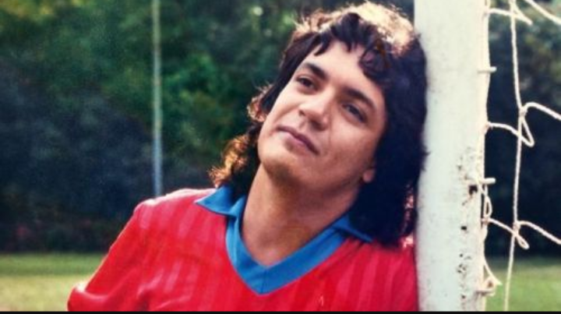



Millions of children all around the world share the same dream: becoming a professional footballer. Most realise soon enough that it is nothing but a pipe dream, but many still go through years of blood, sweat and tears before encountering the ultimate pain of being discarded when they have nothing more left to give.
In Brazil, the competition is stronger than most. In the big cities, it is not just a dream. For many, it is a necessity, one of the few real ways to escape the devastating poverty of Rio de Janeiro or Sao Paulo’s favelas. Only the very best, the supremely talented, have any chance of making a living from the game.
At least, that is usually the case. There is one man, however, who had absolutely no footballing ability whatsoever, and yet somehow managed to convince managers and clubs all over the world of the exact opposite for over 20 years. This is the story of the greatest footballer never to have played.
Carlos Henrique Raposo was born on 2nd April 1963 in Rio Pardo, Brazil. His early life was much like any other young Brazilian’s… other than when he was kidnapped and taken to Rio de Janeiro in the 1970s – or so he claims. Because, as you will soon discover with this man’s incredible story, the line between truth and fiction is not always clear.
Raposo was a football fan, of that there is no doubt. As a child, he could always be found playing on the dusty pitches of the Favelas. He even earned the nickname ‘Kaiser’, as he played and looked and the German legend Franz Beckenbauer. At least that’s what he says. Other sources claim it was given to him as he looked like a popular contemporary beer bottle.
When he approached his middle to late teens, however, Kaiser knew he didn’t have what it took to make it at the top on the field. It was off the field where his true talents lied. He was charismatic, engaging and, most of all, an incredibly convincing storyteller. These talents would end up taking him to all four corners of the globe.
His first professional contract was signed with Mexican side Puebla, when he was just 16 years old. This is where his ‘injuries’ began. This was Kaiser’s go-to trick to avoid actually have to kick a ball in competitive action. Whenever he was close to being called in to action, a mysterious muscle twinge, for example, would crop up, sending Raposo back to the dressing room – just where he wanted to be.
Of course, there was only so much each team was willing to take. He didn’t stay on the books of any club for longer than three years, according to records, meaning that he was always on the move, sometimes as quickly as possible.
Once his contract was terminated in Mexico, he returned to his native Brazil, more specifically Rio. This was where his ‘career’ began to take off. Both Flamengo and Botafogo, two of the country’s, and even the continent’s, biggest teams, employed Kaiser, despite the numerous injuries he always appeared to carry.
“How were two of Brazil’s biggest clubs duped by a man who could not play football?”, you may ask. The answer is two-fold. Firstly, the era that Kaiser lived in made it far easier to exaggerate the truth, and even downright lie. Today’s generation can check any information at the click of a button thanks to the wonders of the internet. In the 1980s, however, it was a completely different story. It was far more difficult to come across any detailed records, and so to prove that Kaiser had never played for some of the teams he had professed to, such as 1984 Copa Libertadores winners Independiente and French side Gazelec Ajaccio, was a task that most club owners did not want to take up.
The second reason for his lengthy career despite never playing a game was down to another one of Raposo’s many talents: networking. He made it his aim to do everything in his power to give off the impression that he was a professional. To do so, he needed to know renowned people within the game. And so, he went about getting to know some of the biggest names in Brazil. World Cup winners Carlos Alberto and Bebeto were both friends of Kaiser, with others such as Ricardo Rocha enjoying his company.
Perhaps his closest affinity was to Renato Gaucho, one of the stars of the Brazilian game at the time. Gaucho was somewhat of a hero to Kaiser. The latter even went about impersonating his illustrious idol in order to gain access to Rio’s most prestigious nightclubs. And it also worked with the ladies, with Gaucho’s name and Kaiser’s passing resemblance to the man enough to get many a woman in to bed.
Gaucho eventually found out what Kaiser was up to when he himself was denied entry to one of his usual haunts when a bouncer told him that he was already inside. He even confronted Kaiser, but it seemed he admired his audacity. The two went on to be close friends.
The footballers with whom he spent his time had all worked hard to make it to where they were, yet Kaiser was blagging a career in the game, and they all knew it. You would have thought that a grudge would be held against him. However, the reality was often the opposite. Kaiser was treated just like any other player by those at almost all of his clubs. They loved having him around, and his ability to surround himself with beautiful women – he claims to have slept with over 1000 – made him a useful acquaintance to have.
After his ‘spell’ at Ajaccio, where he claims to have been the club’s top goalscorer, he returned to his homeland, landing a contract at Bangu in the late 80s. Based once again in Rio, the club was owned by notorious gang leader Castor De Andrade. With the blood of numerous people on his hands, this was clearly not a man to be messed with.
That didn’t deter our hero, however. He once again relied on his trusty ‘injuries’. But De Andrade
was not one to not get his own way. He had brought Kaiser in to play, on the premise that he had the quality to turn his team around, and the gangster would not take no for an answer. Finally, it seemed, Carlos Kaiser had met his match.
One night, Raposo was out partying when Bangu’s then coach, Moises, called him up in the early hours of the morning to tell him that De Andrade had demanded he be in squad for that day’s game against Curitiba. Kaiser, petrified, told his manager he was injured and would be unable to do so, but Moises assured him that he would only be on the bench and would not have to actually make a foray on to the field of play.
Under intense 40-degree heat, Bangu waned. Within five minutes, Curitiba had built up a 2-0 lead. De Andrade had seen enough. He called his manager from the stands and told him to bring on Kaiser. So Moises sent the ‘farce footballer’ to warm up.
The gig, it seemed, was up. As soon as Kaiser would step on to the field, it would be apparent that he was comically out of his depth, and would prove that he had lied about his achievements to one of the most dangerous men in the whole of Brazil. It wouldn’t just be his football career that would be in danger. It would be his life.
Kaiser was desperate. As he warmed up in front of Curitiba’s fans, who were giving him all kinds of abuse, he saw his way out. He jumped over the fence and began fighting with the fans. The referee had no other choice but to send him off.
He had avoided the pitch, but there would be no way he would be able to avoid the wrath of De Andrade. Livid, the gangster stormed the dressing room following the match, making a beeline towards Kaiser, who knew his time in Bangu was coming to an end. But he made one last attempt to appease his boss. He told De Andrade, who he said was like a father to him, that he had fought with the fans to save his honour, as they had been accusing the criminal of being a crook. The explanation was the last stand of a man who had nowhere else to turn.
And yet, somehow, it worked. De Andrade just smiled and left the dressing room. Despite Kaiser’s contract being up just a week later, De Andrade called his supervisor and told him to double the player’s contract and extend it for six months. Against all of the odds, Kaiser had come up smelling of roses.
It was one of many examples showing how Kaiser managed to stay in the game. At the end of the day, he managed to manipulate people, and always had ways of getting himself out of tight situations. He may not have had the gift of football, but he certainly had the gift of the gab.
Kaiser continued to travel far and wide, ‘playing’ for illustrious teams such as Flamengo, as well as for lesser-known teams in places such as Japan. And every time, he never played a minute, but still remained on the books for the six or so months he was in each location.
On at least one occasion, he was employed in the knowledge that he was terrible. Vasco de
Gama, another famous Brazilian side, were having trouble with one of their players, who was an alcoholic. Despite his party lifestyle, Kaiser was teetotal. As such, he was brought in to help turn his teammate’s life around.
He continued to remain a familiar name, even appearing on Mesa Redonda, Brazil’s equivalent of Match of the Day, as an analyst. In the late 90s and early 00s, his time was coming to an end. With the advance of the Internet and Kaiser’s dwindling fitness, he retired at the right time.
He now works in Rio De Janeiro as a personal instructor. In true Kaiser style, of course: he only takes on female clients. And it seems he hasn’t lost any of his charm or attraction. Everyone in Brazil’s biggest city seems to have a story about Kaiser, as displayed in Louis Myles’ documentary “Kaiser: the Greatest footballer never to have played football”. It is no surprise that someone decided to record his story. It is a tale that is bewildering in its outlandishness, a story

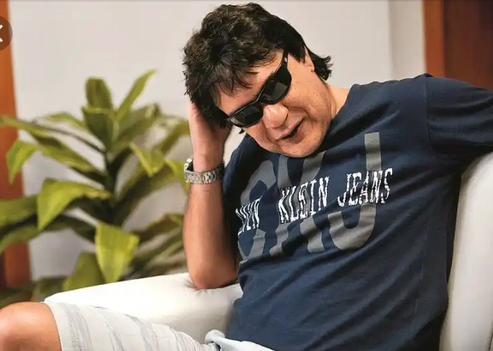



that needs to be seen to be believed.
There are many questions over where he was actually employed, especially during his time outside of Brazil. In the documentary, a former teammate at Ajaccio admits that Kaiser had actually never set foot in Corsica at all. At the end of the day, however, it is not important whether some of the finer details were actually true. Speaking to the Brazilians, Myles was able to establish, that, on the most part, the story checked out. Kaiser had managed to bag a life as a footballer. In the end, he set out everything that he wanted to achieve. What that actually was, depends on how you look at it.
CODE - Bolivia7

