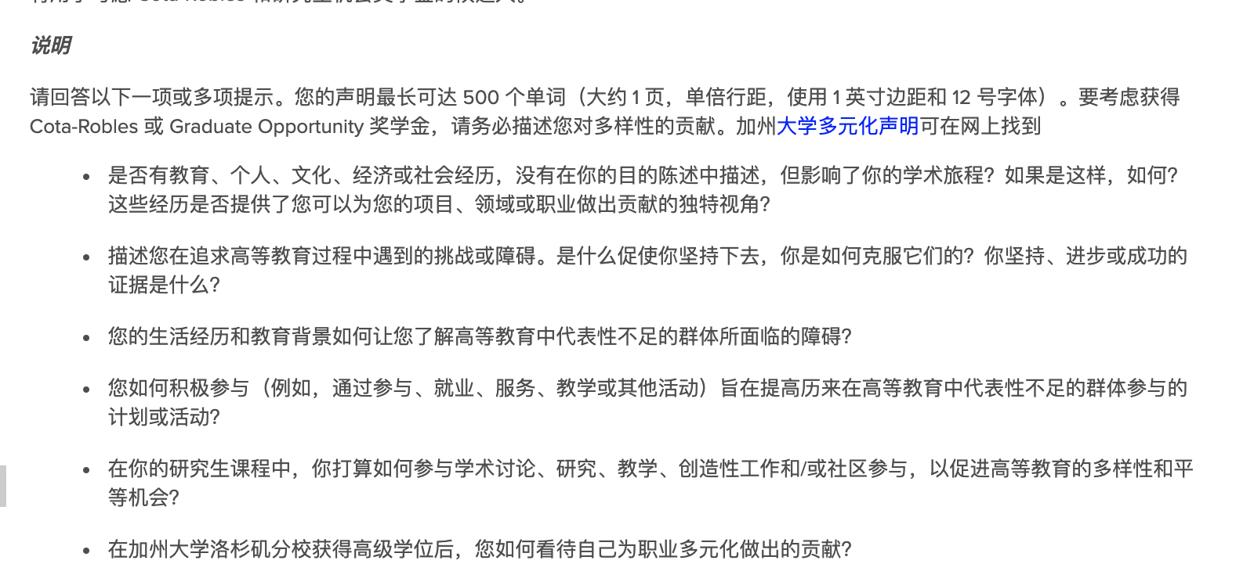

* Are there educational, personal, cultural, economic, or social experiences, not described in your Statement of Purpose, that have shaped your academic journey? If so, how? Have any of these experiences provided unique perspective(s) that you would contribute to your program, field or profession?
* Describe **challenge(s) or barriers** that you have faced in your pursuit of higher education. What motivated you to **persist**, and how did you **overcome** them? What is the **evidence** of your persistence, progress or success?
* How have your life experiences and educational background informed your understanding of the barriers facing groups that are underrepresented in higher education?
* How have you been actively engaged (e.g., through participation, employment, service, teaching or other activities) in programs or activities focused on increasing participation by groups that have been historically underrepresented in higher education?
* How do you intend to engage in scholarly discourse, research, teaching, creative efforts, and/or community engagement during your graduate program that have the potential to advance diversity and equal opportunity in higher education?
* How do you see yourself contributing to diversity in your profession after you earn your advanced degree at UCLA?

Life sometimes presents overwhelming obstacles, but my ability to overcome any bump with a smile on my face has been my greatest strength. Maintaining an optimistic outlook has introduced me to new opportunities, made me a better learner, leader, and communicator, and helped me get through everyday life. My key is "Be patient" when facing negative emotions and transfer them by writing a diary, listening to music, taking a trip, and sharing them with my close friends. For me, music is a life regulator that helps me to accept various feelings, embrace nature, and become more open-minded. I am also a free writer as I love to organize my thoughts in life and study, and I am willing to convey my spirits and experiences to others.

During college, I was the League Secretary in my class for four consecutive years, where I organized several public activities such as the "Talking Show", "Formal Presentation", "Community Service", and my favorite show-"Singing Aloud". Indeed, I met with several troubles like pre-schedule, publicity, and live management. However, with cumulated experience, I can hold them with great confidence and eventually be honored by committees of the university as an Outstanding Secretary of the Youth League. Moreover, I actively participated in extracurricular activities, such as ACM programming and the Student Innovative Project, which enhanced my academic knowledge. Therefore, I achieved a GPA of 3.66/4.0, ranked top 5 among the students of our major (5/156), and obtained the National Scholarship and Outstanding Student Scholarship.

After I entered graduate school, I identified my areas of interest and spent more effort improving my professional skills to prepare for my future career. I was involved in various academic activities, such as BigData Competition, DeeCamp AI Lab, and TAL AI Lab, during which I came across several excellent researchers and Ph.D. students. I realized the power of open-source, which guided my way to pursue my Ph.D. and become an active contributor of the open-source community.

When I decided to apply Ph.D., my family and friends were shocked as they thought it crazy for reasons like age, COVID-19, finances, etc. However, I understand this decision began one year ago and is solemn, well-prepared, and promised. I never regard age or gender as barriers to pursuing my dream, as higher education should be for everyone with desire, motivation, and passion. Moreover, I seized the opportunity to work with different professors and Ph.D. students to better prepare myself for future research, during which I developed my research sensitivity and hands-on research skills and brought my academic results to top conferences.

UCLA has top computer science programs in artificial intelligence, and I want to join one of the largest communities of talented students and professors who are interested in the same research questions as I am. I will extend my experience in future research as described in the SOP, in which I describe three guide questions about making machines understand nature. More importantly, I have been intrigued by the culture of UCLA, which embraces diversity and promotes equivalence of education.